TIER 1 BENEFIT HUB CONTENT

**For minor text updates in Drupal**

***Example:*** updating a phone number, rates data, a few words or sentences

VHA, VBA, and NCA digital teams: Jennifer Heiland-Luedtke, Jeff Grandon, Misty Sweet, Adrianne Hooten, Scott Brunner, Eric Lee, Brett Lee, Jessica Tangitau, Tanekwa Bournes

1. VHA, VBA, or NCA digital team makes the update directly in Drupal.*   
   *Alternatively, can initiate request to the VA.gov Sitewide Content team via email. In this scenario, the Sitewide Content team creates a GitHub ticket to track the work.
2. Save the change as “Draft.” Include a brief note in Drupal under “Revision log message” about what was changed.   
     
   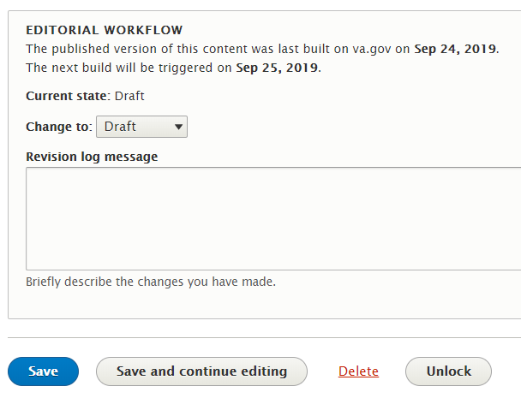
3. For VBA and NCA, email Randi Hecht Randi.hecht@va.gov and Beth Potts [beth.potts@va.gov](mailto:beth.potts@va.gov) to review and edit for [VA.gov content style guide](https://design.va.gov/content-style-guide/) standards. (CC: [rhecht@governmentcio.com](mailto:rhecht@governmentcio.com)). For VHA, email Randi Hecht [Randi.hecht@va.gov](mailto:Randi.hecht@va.gov) and Danielle Thierry [danielle.thierry@va.gov](mailto:Danielle.Thierry@va.gov) to review and edit for [VA.gov content style guide](https://design.va.gov/content-style-guide/) standards.
   * Include the Drupal preview URL. It will look something like this: **/preview?nodeId=864**
   * If the Sitewide Content team makes the change in Drupal, Randi, Beth, or Danielle will email the SME/requestor the preview URL to review; and if applicable, CC the relevant VHA/VBA/NCA digital team POC.
4. Randi, Beth, or Danielle does a quality check and changes the state to “publish” for deployment.   
   Best practice: We always have a Sitewide Content person who did NOT work on the changes do the quality check.
5. Update goes live with the next deployment. These currently occur 4 times daily (Monday through Friday, 9 a.m. ET, 11 a.m. ET, 1:45 p.m. ET, 4 p.m. ET) but will eventually move to every hour, Monday through Friday, from 8 a.m. ET to 8 p.m. ET.
   * Emergency-related updates (like natural disaster alerts) are manually deployed right away.
6. Randi, Beth, or Danielle emails SME and VHA, VBA, and NCA digital team POC that the update has been published.

TIER 1 BENEFIT HUB CONTENT

**For nuanced, more complex updates or new pages**

***Example:*** benefit information that requires special attention; terminology changes that affect many different pages or many different benefit categories or is global; something that needs coordination across multiple business lines or administrations

1. TYPICAL PRE-DRUPAL STEPS:

* Business contacts the VHA, VBA, and NCA digital team directly. (Or in some cases, it could be the VA.gov Sitewide Content team that initiates; example: parity and legacy rewriting.)
* VHA/VBA/NCA digital team syncs with the VA.gov Sitewide Content team.
* Research/discovery phase, if needed: VHA/VBA/NCA digital team, SME, and Sitewide Content team collaborate on content.
  + This may include Sitewide Content team conducting a content audit, IA research, SEO research, and stakeholder conversations. Sitewide Content team creates GitHub issue/epic/ticket to track work.

1. Business provides Sitewide Content team draft content (or vice versa, depending on conversation with stakeholder). SME and Sitewide Content person work on editing new content in the new VA.gov style.
   * This can happen in Drupal or in Word doc, depending on how many pages and how complex.
2. Sitewide Content person makes the update or builds the new page in Drupal. (Unless the content was drafted in Drupal in step 2.)
3. The person updating Drupal saves as “Draft” and emails SME a preview link and CC VHA/VBA/NCA digital team for awareness.
   * Depending on complexity of content, the Sitewide Content team may also schedule a call for a walk-through.
4. SME reviews the preview page; provides feedback to the Sitewide Content person—either via email (if simple) or via a meeting (if complex).
   * Collaboration continues until user-friendly, SEO optimized, and accurate state is reached.
5. Randi does a quality check (proofread); makes minor copyedits in Drupal or provides Sitewide Content person working on page questions/feedback via email or GitHub ticket.   
   Best practice: We always have a Sitewide Content person who did NOT work on the changes do the final review.
6. Sitewide Content person incorporates any changes as needed.
7. Randi, Beth, or Danielle emails SME, and the relevant VHA/VBA/NCA digital team a final preview URL prior to changing state to “publish.”
8. Update or new page goes live with the next deployment. These currently occur 4 times daily (Monday through Friday, 9 a.m. ET, 11 a.m. ET, 1:45 p.m. ET, 4 p.m. ET) but will eventually move to every hour, Monday through Friday, from 8 a.m. ET to 8 p.m. ET.
   * Randi, Beth, or Danielle emails SME and VHA, VBA, and NCA digital team POC that the update has been published.