## [Typeahead](https://www.nngroup.com/articles/site-search-suggestions/) - Best Practices

Typeahead benefits:

1. **Pick an appropriate term, which will show them good results,** rather than making up a query which might have no results or poor results
2. **Decrease** [**interaction cost**](https://www.nngroup.com/articles/interaction-cost-definition/), because they can type less
3. **Avoid typos,** because they don’t need to type out the entire query themselves
4. **Use less mental effort to search,** because they can simply [recognize](https://www.nngroup.com/articles/recognition-and-recall/) the right words or phrasing they want

### Don’t Suggest Bad Results

Suggested terms that return zero results, or irrelevant results, are worse than unhelpful — they sidetrack users and are downright irritating.

### Use Text Styling to Differentiate Between Typed Query Text and Suggested Terms

The type of suggestions your site offers should help you determine how to style the suggestions.

* If your suggested search feature only **appends characters to the end** of the user’s text to finish the query, then you should **highlight the suggested characters**.
* If, instead, your suggested search feature will **suggest popular queries that contain** the user’s text anywhere in the query, it’s best to **highlight the user’s query.**

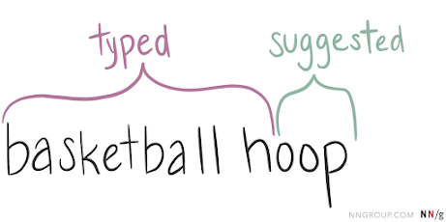

### 

If the characters are added after the typed word, the suggested characters/words are emphasized . Ex: 'disability b'

disability b**enefits**

disability b**enefits rating**

disability b**enefits letter**

If the user's typed word can appear anywhere on the typeahead suggestion, the user's typed word/characters should be emphasized. Ex: 'disability b'

**disability b**enefits

compensation rates for **disability b**enefits

apply for **disability b**enefits

### Include Scope in Search Suggestions

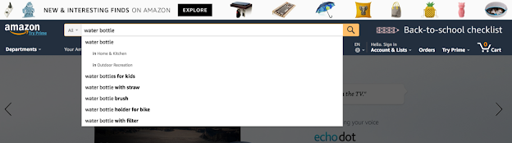

This approach worked well because all three levels were linked. The user could choose between three slightly different options:

* search for “water bottle” without any scope
* search for “water bottle” in the Home & Kitchen scoped category
* search for “water bottle” in the Outdoor Recreation scoped category

### Consider Including More than Simple Query Recommendations

Beyond just completing a user’s query, the search suggestions dropdown can include links to other types of related content. For example, B&H Photo Video uses a huge, full-width search suggestion dropdown that provided query suggestions, but also linked to:

* Category pages
* Product-detail pages
* Resources/articles

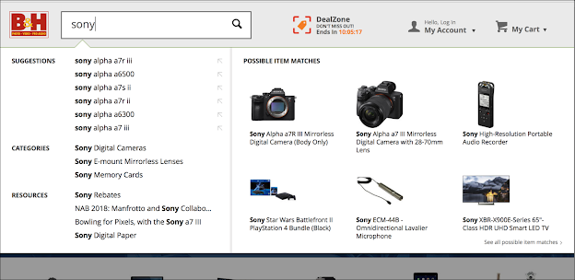

On mobile:  
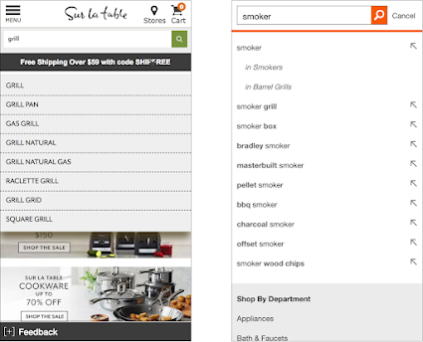

## Comparative analysis - TYPEAHEAD

1. Healthcare - [Zocdoc](https://www.zocdoc.com/)
2. Organization - [AARP](https://www.aarp.org/)
3. Ecommerce - [Costco](https://www.costco.com/)
4. University - [MIT Sloan Management Review](https://sloanreview.mit.edu/)
5. Health Organization - [WHO](https://www.who.int/)

## Zocdoc

Selecting the search bar, before typing anything, produces a dropdown with the categories, “Popular specialties” and “More specialties (a-z)”.

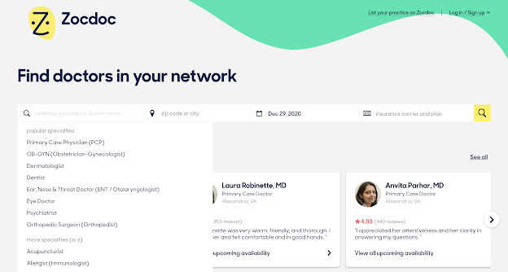

Typing a search term produces results for types of specialties, exams, synonyms that do not include the search term, and specialists.

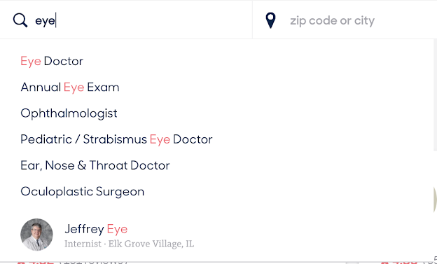

Hovering over a typeahead term fills in the term in the search box.

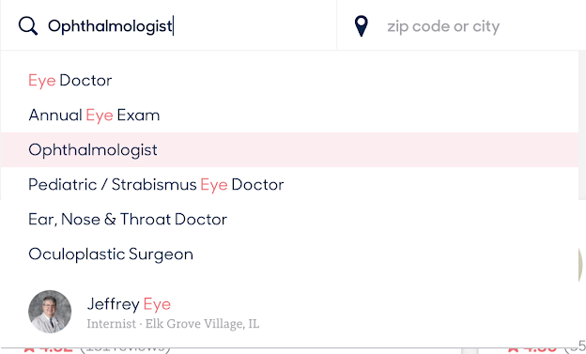

Zocdoc shows a red dotted line under misspelled words and includes typeahead suggestions, including a suggestion with the correct spelling below.

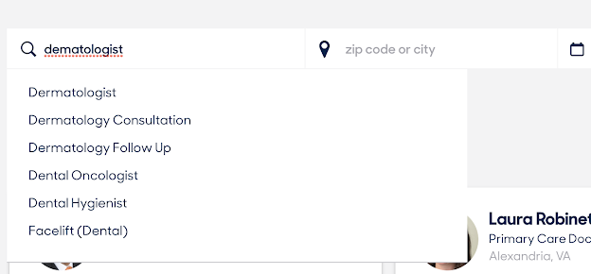

If the user moves forward with the misspelled word, it proceeds with the assumed search term without “did you mean?” format.

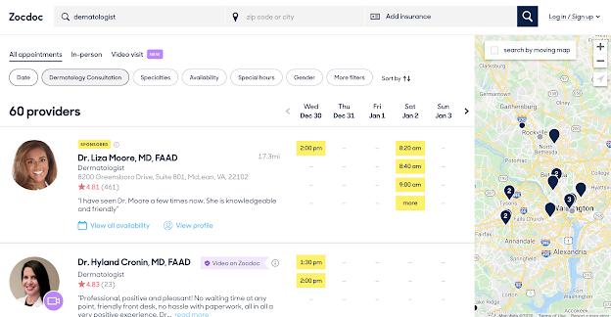

## AARP

Search box is accessible by clicking on a magnifying glass icon in the upper right corner of the site.

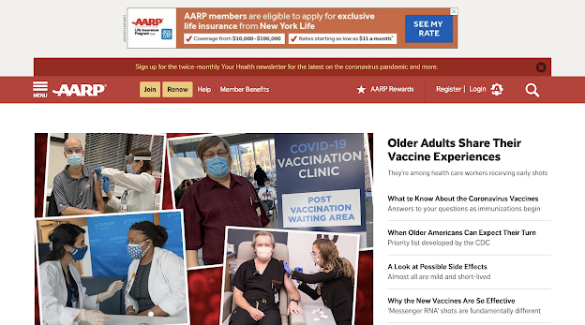

Clicking on the magnifying glass icon reveals a search box underneath the magnifying glass icon. A second click or tab is required to start typing within the search box.

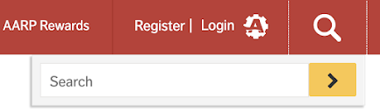

Typeahead features both the word “benefits” as well as several search terms that include “benefits”. Typed letters appear as a normal weighted font and any additional letters are in bold.

Hovering over a typeahead term places an underline on the search term.

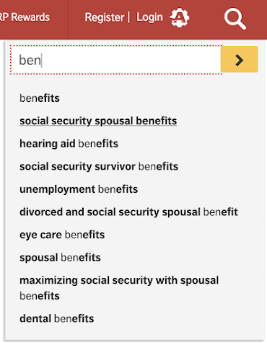

AARP shows a red dotted line under misspelled words and includes typeahead suggestions, including a suggestion with the correct spelling below.

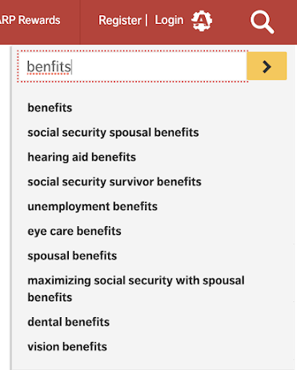

If the user moves forward with the misspelled word, it proceeds to the search results page that repeats the misspelled word, “8 Results for "benfits"”. Underneath it, it includes a link to a search results page with the correct spelling, “Did you mean: benefits”.

Typeahead is not offered on the search results page.

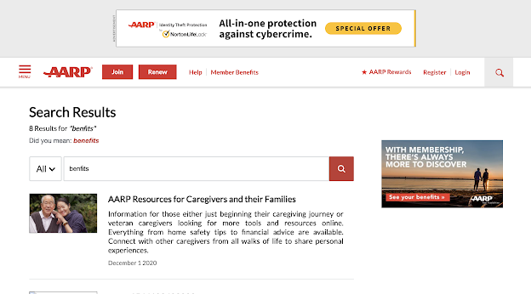

Search results page after clicking on “Did you mean: benefits”.

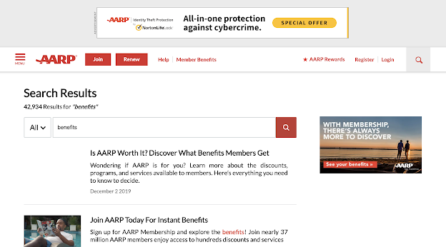

## Costco

A wide search bar is featured next to the logo.

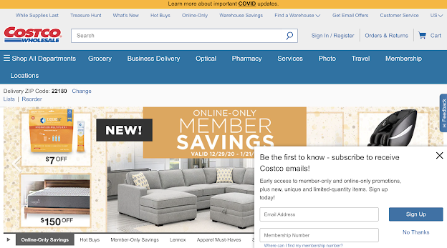

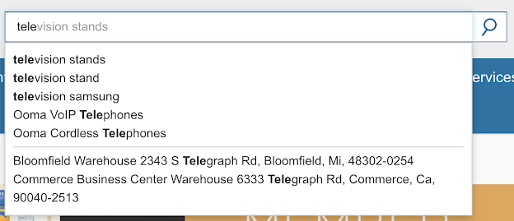

Does not alert the user that they misspelled a word, does not provide typeahead suggestions for misspelled words.



Once the user searches a misspelled word, it states that there were no results for the misspelled word and that it is showing results for the corrected word.

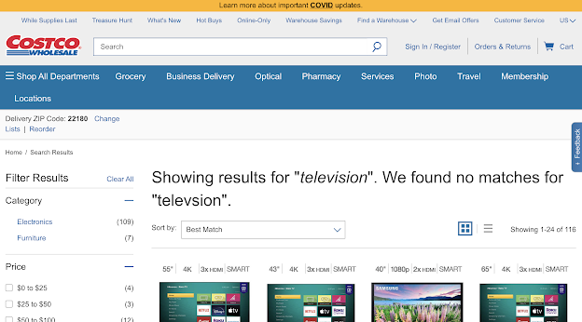

## 

## MIT Sloan Management Review

A magnifying glass icon along with the text “SEARCH” is located on the upper right side of the site.

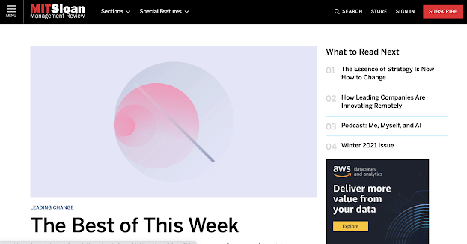

Clicking on the search link immediately launches a modal completely outside of the original layout. In regards to typeahead, the user is not offered a dropdown list of search terms, the search bar is immediately filled out with the rest of a search term and the search results are shown before the user completely types out a search term.

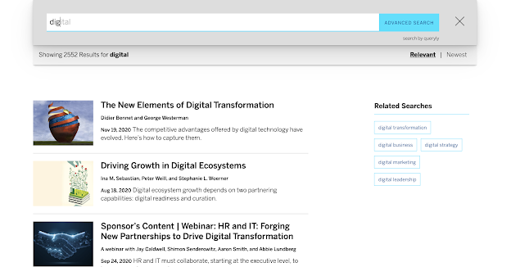

The user is not notified of a misspelled word (no red underline or ‘did you mean?’ text) and is shown results for the term with the corrected spelling.

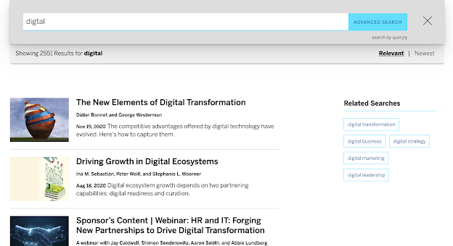

## WHO

A magnifying glass icon on the right corner of the top bar acts as the search button.

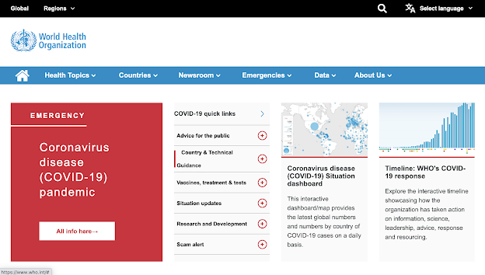

The search bar expands over the magnifying glass icon. The search bar offers no typeahead experience or red underline on misspelled words.



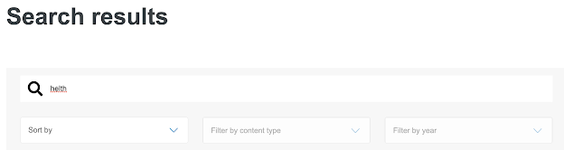

On the search results page, users are shown a red underline on misspelled words. They are also shown typeahead suggestions which range from helpful to randomly selected snippets. Any misspelled words are not corrected or offered a ‘Did you mean?’ link.

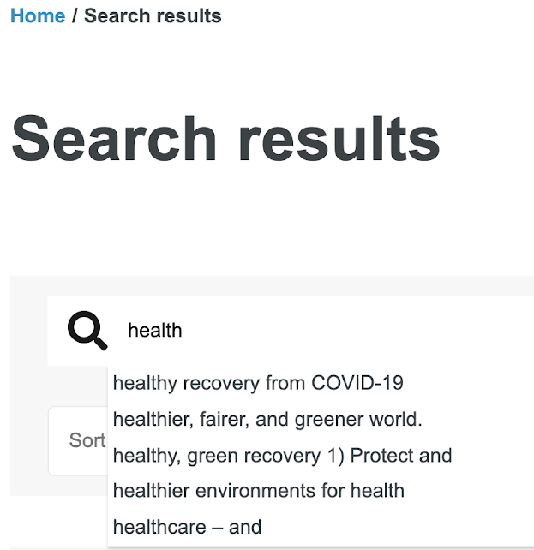

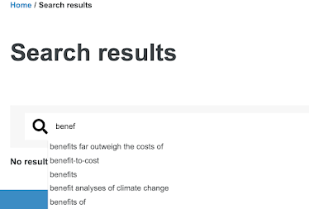

There is another search engine that is hidden on a COVID-19 subpage, it is not linked from the primary search. A red underline is not shown on misspelled words. Once a user searches a misspelled word, they are shown a ‘Did you mean?’ link.

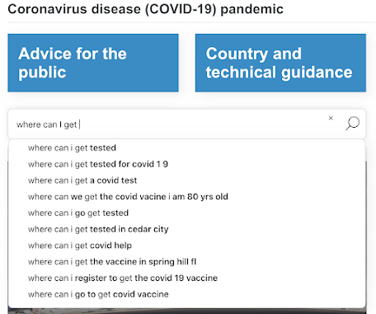

On the search results page for this additional search experience, users are often not immediately shown search results links. They are often shown more questions with an accordion feature that can be expanded. 