**Zero reinstatement measurements and inspection units**

This interim solution has been introduced into Street Manager to manage subsumed and combined sites. This solution should also be utilised when a site has been confirmed as interim, when it was actually permanent, and; when works were planned with excavation and no excavation was necessary to complete the works.

1. **Subsumed and combined sites**

Where two or more sites with interim reinstatement are combined into a single permanent reinstatement, an existing site should be updated with the overall dimensions of the permanent reinstatement and each of the other sites should be updated with zero measurements.

Where the promoter is prevented from carrying out planned interim to permanent reinstatement of a site because the road has been resurfaced or because the site has been subsumed within another promoter’s works/reinstatement then the affected site/s should be updated with zero measurements.

Inspection units should be updated appropriately, and in cases where all existing sites have been subsumed, the inspection units should be updated to zero.

1. **Site submitted as interim in error**

In cases where a user has submitted a final reinstatement as interim in error, for example, a user takes a phone call from a team member with all the details of a completed reinstatement and enters the details into Street Manager, some time later, the same team member telephones and says he/she made a mistake and the site was permanent not interim. In this scenario, the existing interim site should be updated to zero measurements and a new site created with the correct details.

1. **Works stopped with no excavation when planned with excavation**

When works are planned with excavation and the works were completed without any excavation being necessary, until further enhancements are made in Street Manager a site should be added recording zero measurements and zero inspection units.

Once the zero-measurement functionality has been used a **general topic type comment should be recorded. The comment should begin ‘Zero Measurement site(s)** – ‘ followed by either ‘ site subsumed by xxxxxxxxx’, ‘Combined site with site number xx’, reinstatement recorded as interim in error’ or ‘works completed without the need for excavation (screw fit meter for instance)

**Screenshots of process**

Please note that the process of setting or amending reinstatement measurements to zero can be done before, or after, the works stop has been submitted.

Scenario 1 a– subsumed single site

1. In scenario 1a, a granted permit application is already in place, the user has logged the works start and now needs to update the interim site as the road has been resurfaced recently.

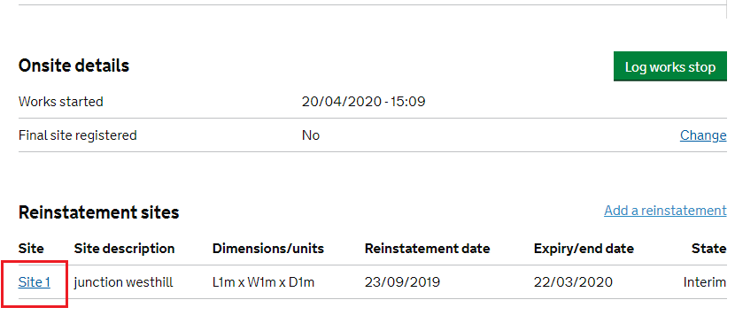

1. Select the site and then select ‘update reinstatement’.

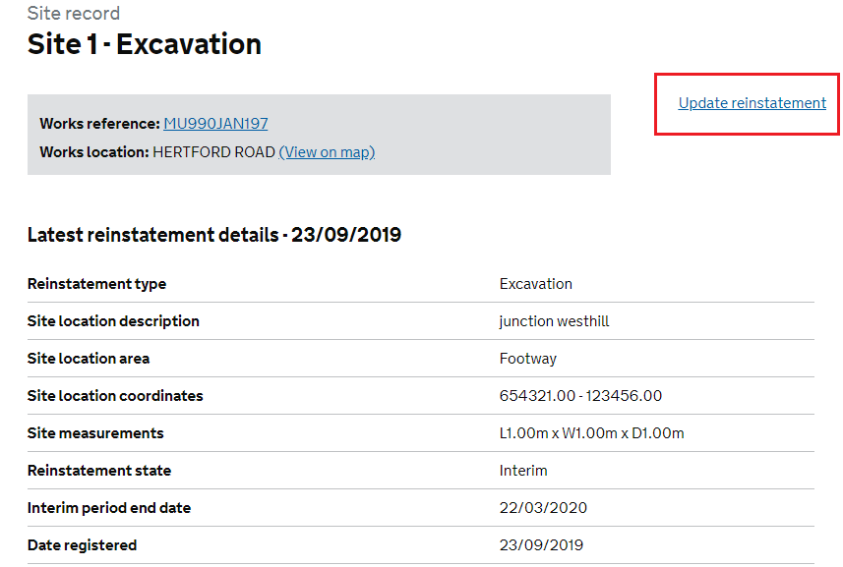

1. This will take you to a screen where the reinstatement details are editable.

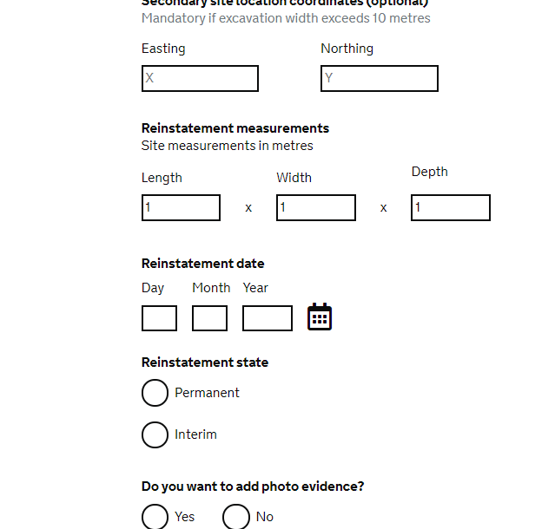

1. Change the reinstatement measurements to 0 x 0 x 0, select the date works was planned as the reinstatement date and register as permanent. As in this example there was only one site to subsume the total inspection units should be recorded as 0.

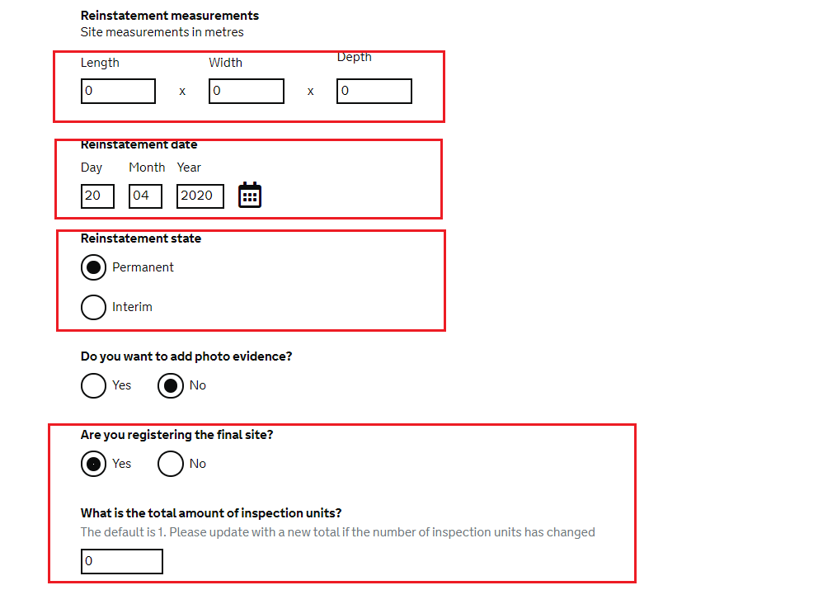

1. Once the reinstatement has been submitted, go to the Works Record and add a comment

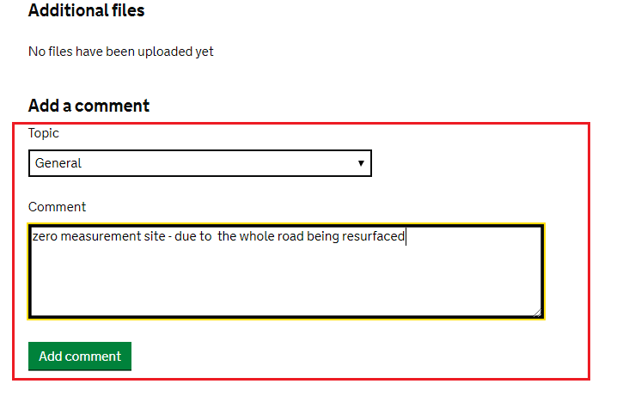

Scenario 1b – combined sites

1. In scenario 1b, a granted permit application is already in place, the user has logged the works start and now needs to update the interim sites. There are two interim sites which have been combined into one site due to the proximity rule.

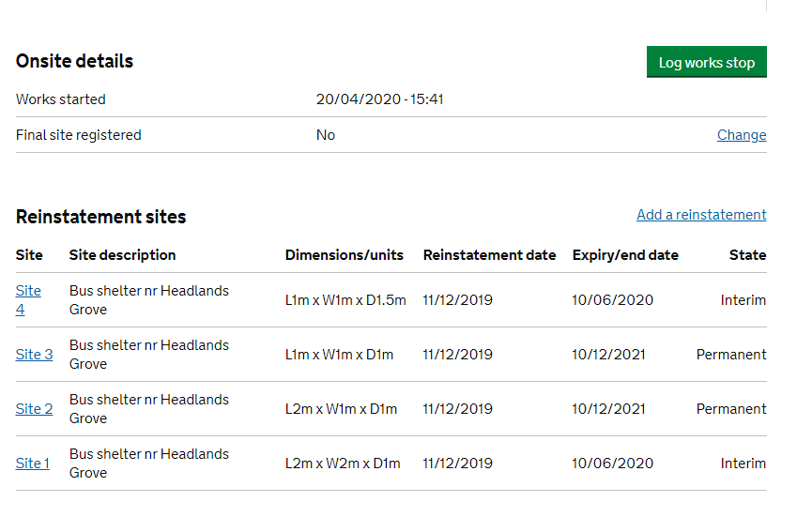

1. Select the first site and select ‘update reinstatement’

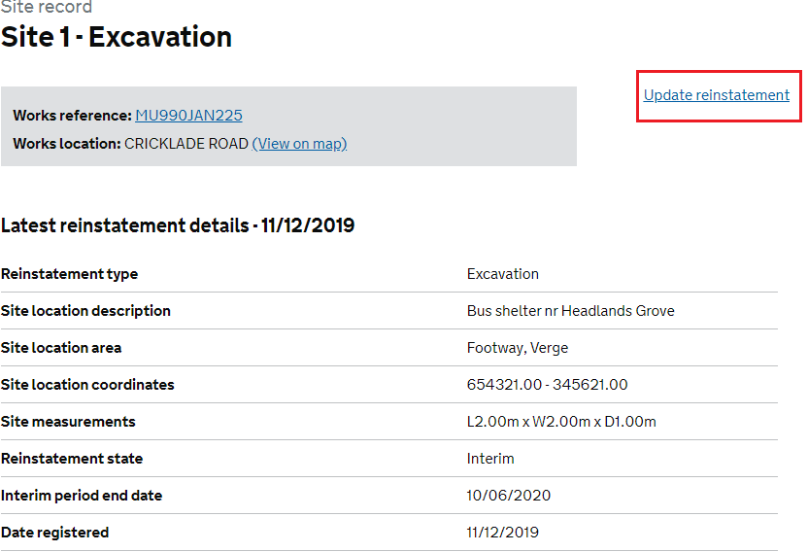

1. This will take you to a screen where the reinstatement details are editable.

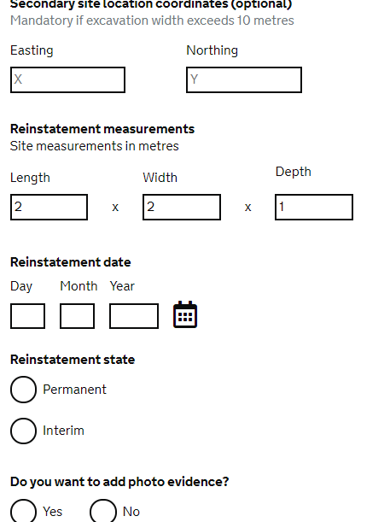

1. The new measurements after combining the two interim sites on the footway are 3.5 x 2 x 1.5, update the measurements, add in the reinstatement date, and reinstatement state to permanent. There is an interim site to update so select No on the question ‘are you registering the final site’

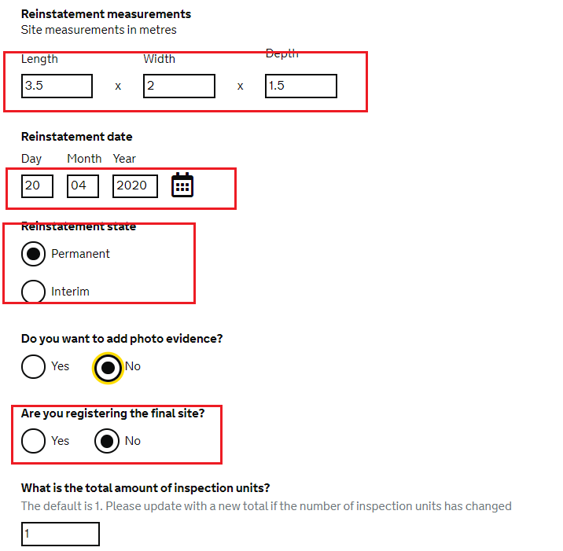

1. Submit the reinstatement and then select site 4 – the remaining interim site, click on ‘update reinstatement’. Change the reinstatement measurements to 0 x 0 x 0, select the reinstatement date and register as permanent. As this is the last site to be updated, select Yes to the final site question. The inspection units do not require a change.

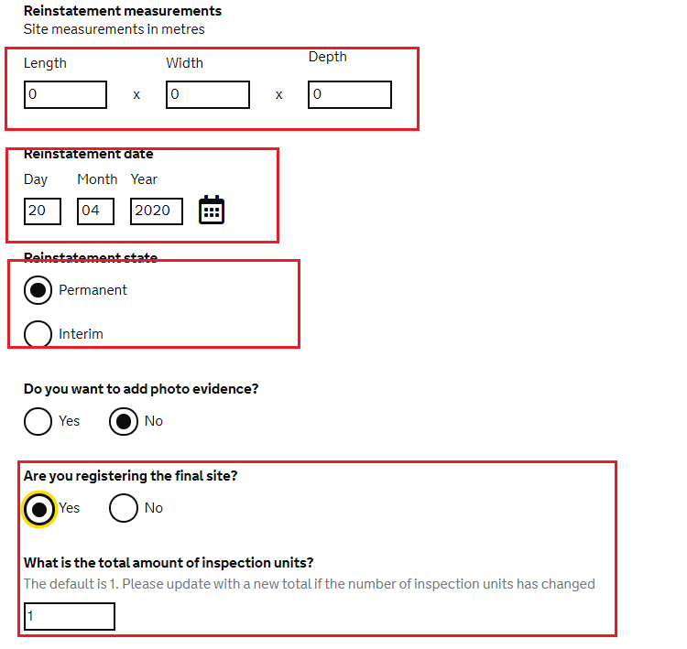

1. Once the reinstatement has been submitted, go to the Works Record and add a comment

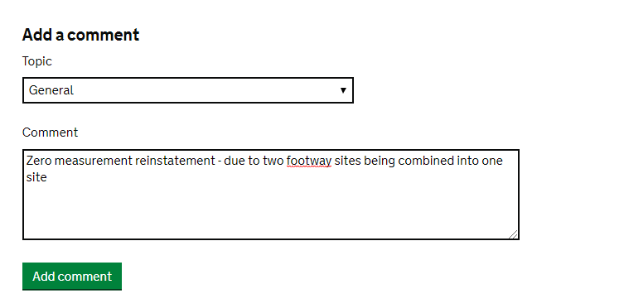

Scenario 2 – site recorded as interim in error

In this scenario, the user has recorded the site as interim and submitted the reinstatement. The user then receives a phone call the next day from the supervisor telling her that the site is permanent not interim.

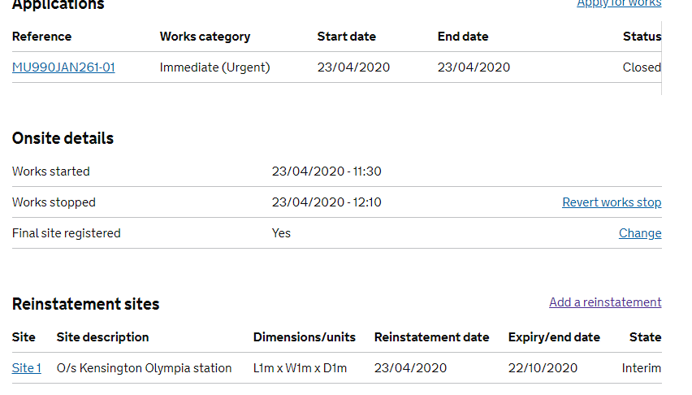

1. Select the site that has been recorded incorrectly

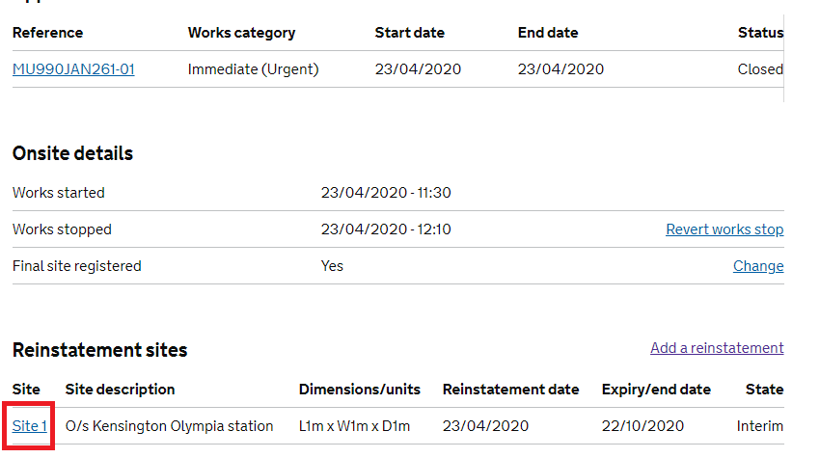

1. Select ‘Update reinstatement’

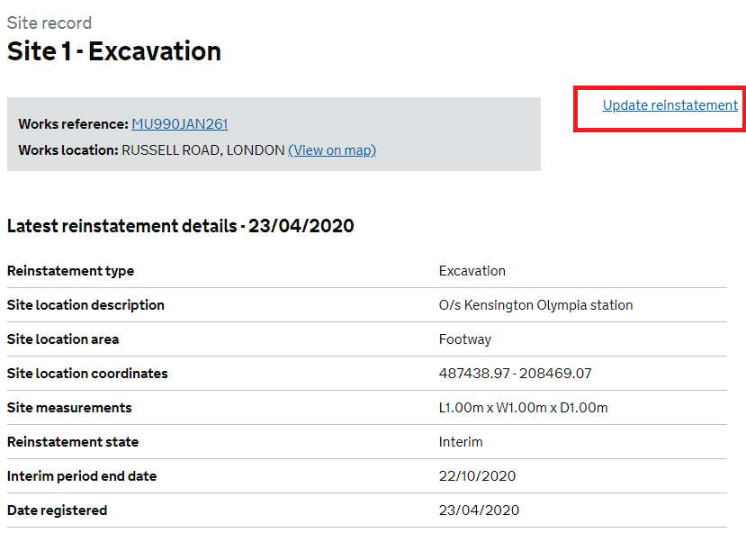

1. This will take you to a screen where the reinstatement details are editable and some fields are pre-populated with the details from the interim reinstatement.

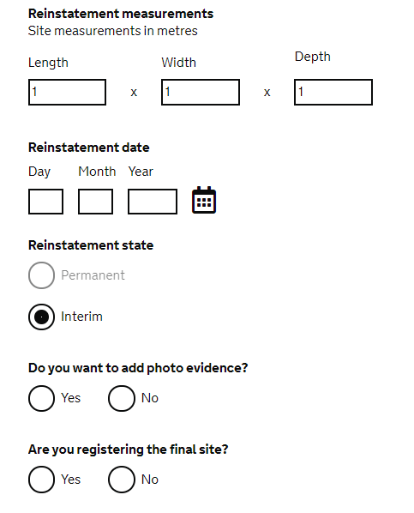

1. Amend the measurements to 0 x 0 x 0, add the reinstatement date, select ‘No’ to ‘are you registering the final site?’ and then select continue.

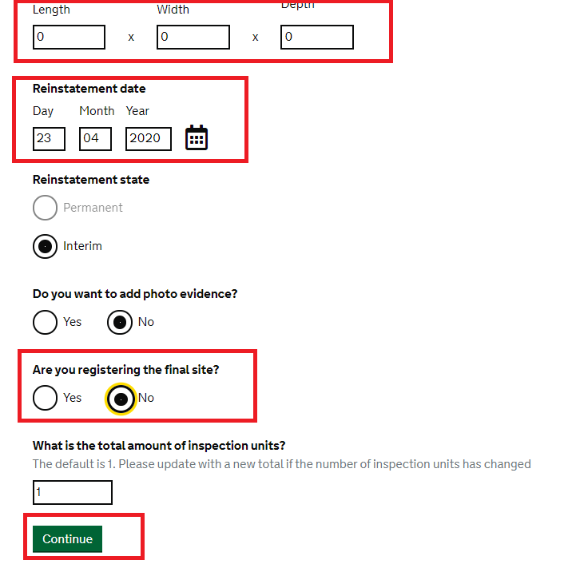

1. After submitting reinstatement add a comment to the works record

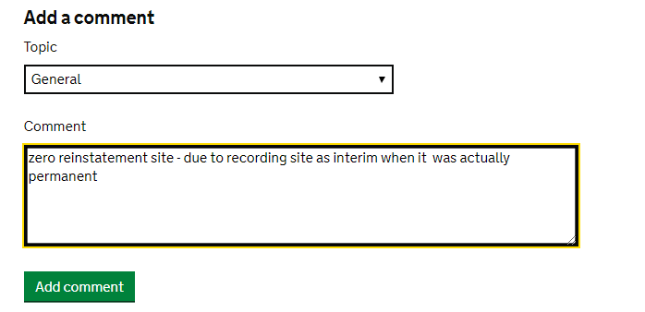

1. Next, add a new reinstatement with the correct details. From the Works record page, select ‘add a reinstatement’.

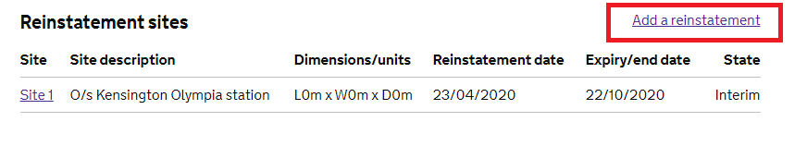

1. Complete all fields required to register a permanent reinstatement. Review and submit.

Scenario 3 – planned excavation works closed without the need to excavate

Until enhancements are made to SM recording a zero measurement site allows works which were planned with excavation and were completed without the need for excavation to be recorded in SM.

1. In this scenario, a permit has applied for with excavation. The supervisor of the works, notifies the SM user that the works did not require excavation (e.g. screw fit). The user needs to log the works stop **and** notify the authority that no excavation took place.

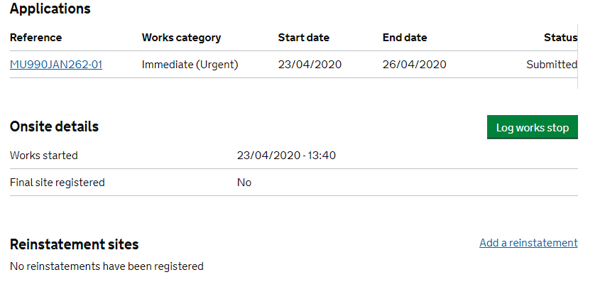

1. Click on the Log works stop button and enter the appropriate date and time.

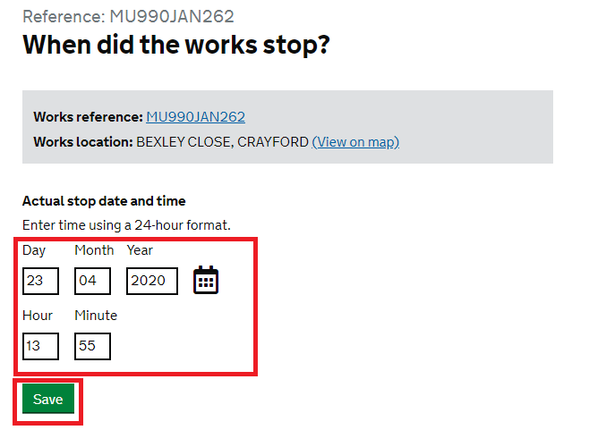

1. From the works record click on the ‘add a reinstatement’ button

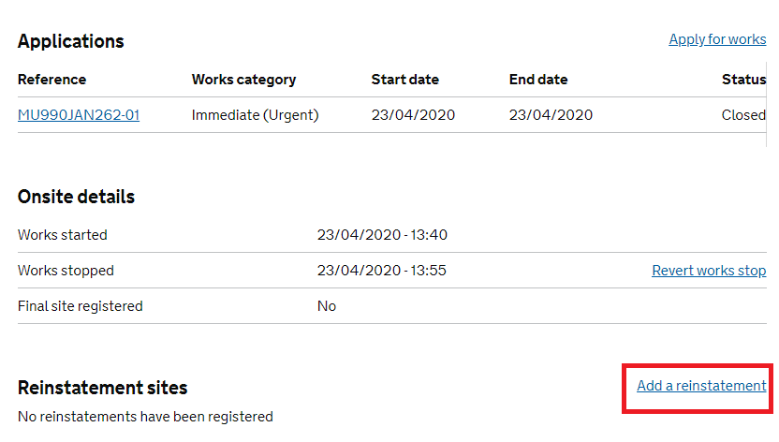

1. To reach the reinstatement details screen, select excavation type as excavation

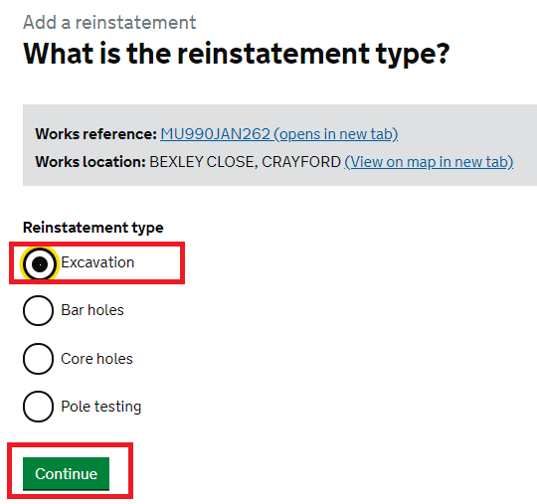

1. Complete the site location coordinates – use the coordinates on the planned application.

Complete the measurements as 0 x 0 x 0

Add the date the works were completed into the Reinstatement date

Select Permanent as the reinstatement state

Record inspection units as 0

Select Yes to the final site question and submit.

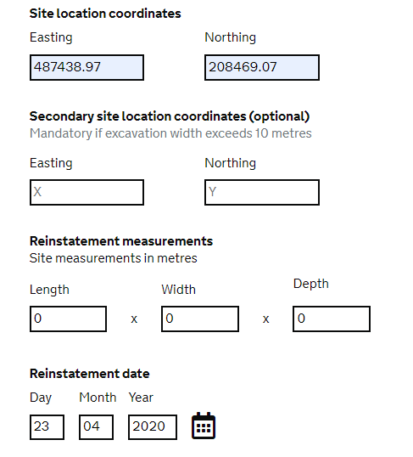

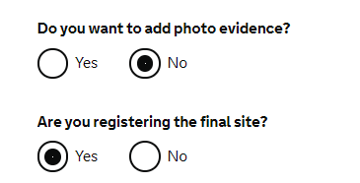

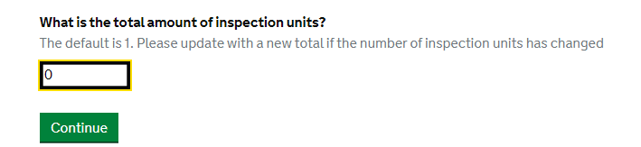

1. From the works record a comment

