1. 阅读下列用例的事件流描述，完成下列问题：

Use Case Name : AnnounceTournament

Basic Flow of Events:

1. The LeagueOwner requests the creation of a tournament.

2. The system checks if the LeagueOwner has exceeded the number of tournaments in the league or in the arena. If not, the system presents the LeagueOwner with a form.

3. The LeagueOwner specifies a name, application start and end dates during which Players can apply tournament, start and end dates for conducting the tournament, and a maximum number of players.

4. The system asks the LeagueOwner whether an exclusive sponsorship should be sought and,if yes, presents a list of Advertisers who expressed the desire to be exclusive sponsors.

5. If the LeagueOwner decides to seek an exclusive sponsor, he selects a subset of the names of the proposed sponsors.

6. The system notifies the selected sponsors about the upcoming tournament and the flat fee for exclusive sponsorships.

7. The system communicates their answers to the LeagueOwner.

8. If there are interested sponsors, the LeagueOwner selects one of them.

9. The system records the name of the exclusive sponsor and charges the flat fee for sponsorships to the Advertiser's account. From now on, all advertisement banners associated with the tournament are provided by the exclusive sponsor only.

10. If no sponsors were selected (either because no Advertisers were interested or the LeagueOwner did not select any), the advertisement banners are selected at random and charged to each Advertiser’s account on a per unit basis.

11. Once the sponsorship issue is closed, the system prompts the LeagueOwner with a list of groups of Players, Spectators, and Advertisers that could be interested in the new tournament.

12. The LagueOwner selects which groups to notify.

13. The system creates a home page in the arena for the tournament. This page is used as an entry point to the tournament (e.g., to provide interested Players with a form to apply for the tournament and to interest Spectators into watching matches).

14. At the application start date, the system notifies each interested user by sending them a link to the main tournament page. The Players can then apply for the tournament with the ApplyForTournament use case until the application end date.

**【问题1】**图1是根据前3条事件流描述的竞赛创建流程画出的顺序图；图2是根据4-10条事件流描述的赞助关系确立流程画出的顺序图。请从表1选出适当的英文消息名将图中的空白处填写完整。（只需将序号和相应的消息名称写在答题册上）。

**【问题2】**根据图1和图2画出通信图(协作图)，可以分别画，也可以统一画一个。

**【问题3】**画出参与类图(VOPC)，要求在其中列出所有的类、类的操作以及类之间的关系，对关联关系要求标注两端角色的多重性(Multiplicity)。

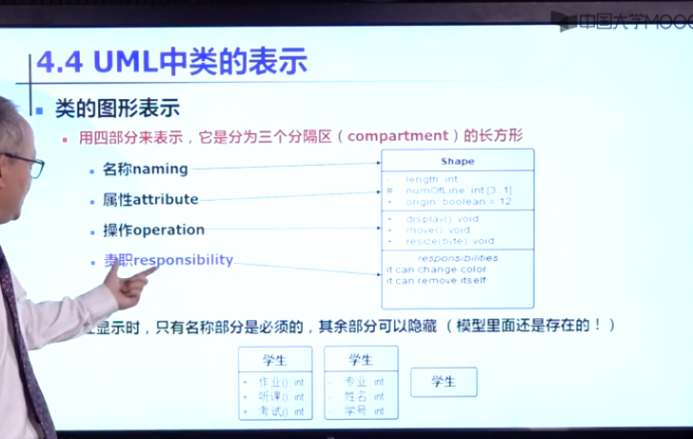

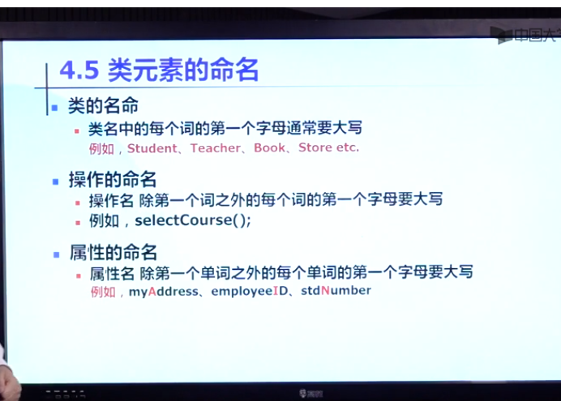

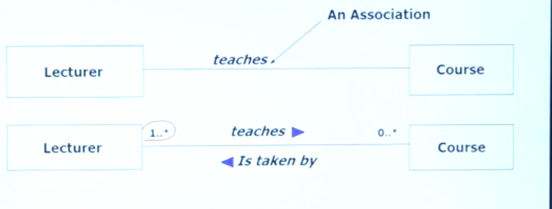

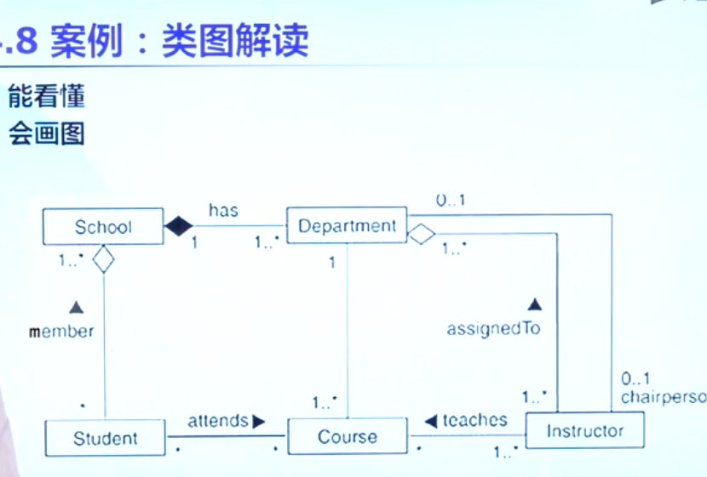

空心：组合

实心：聚合

####------------------顺序图---------------###

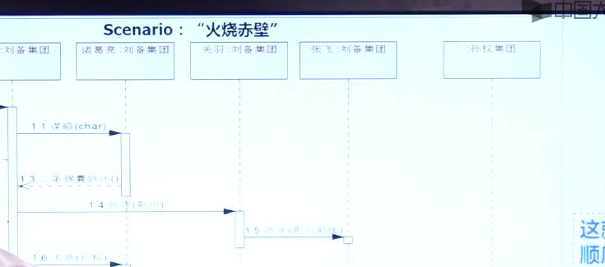

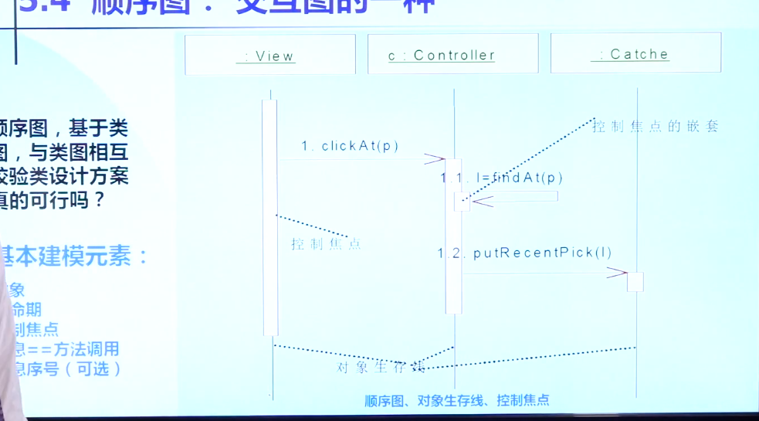

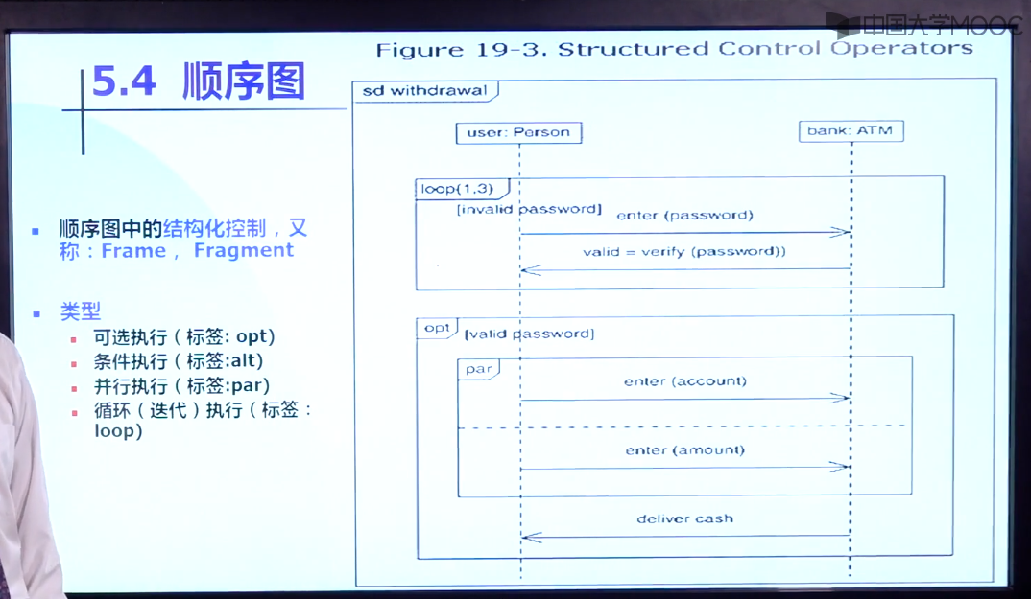

##通信图####

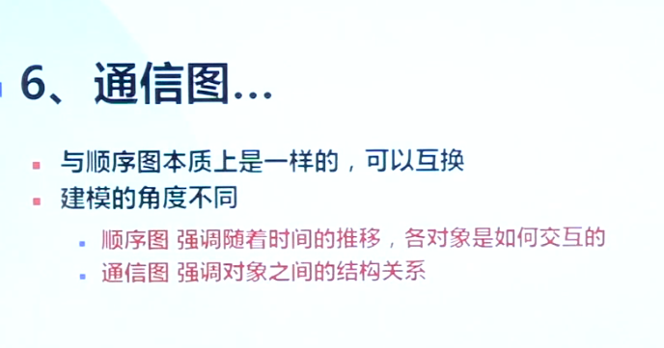

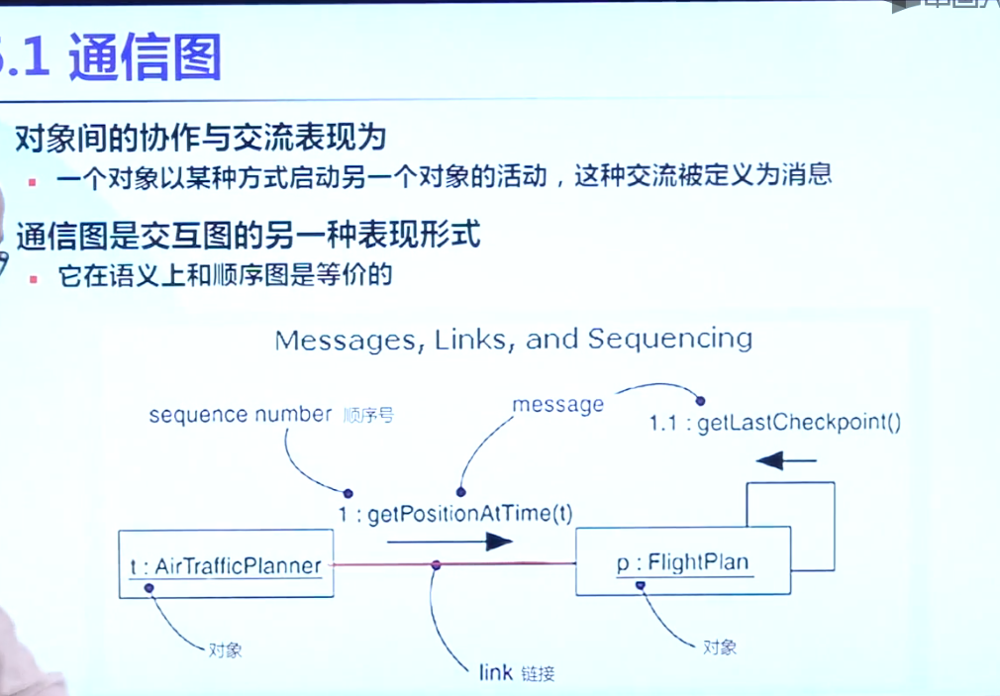

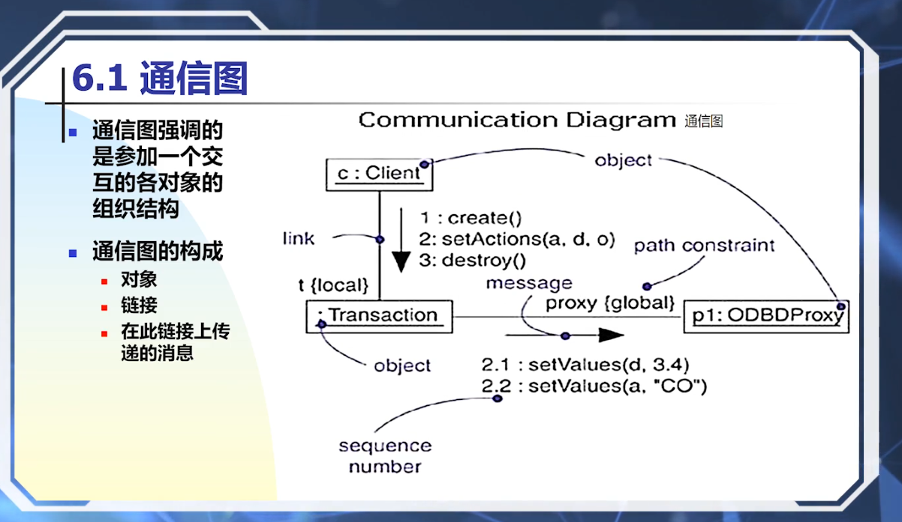

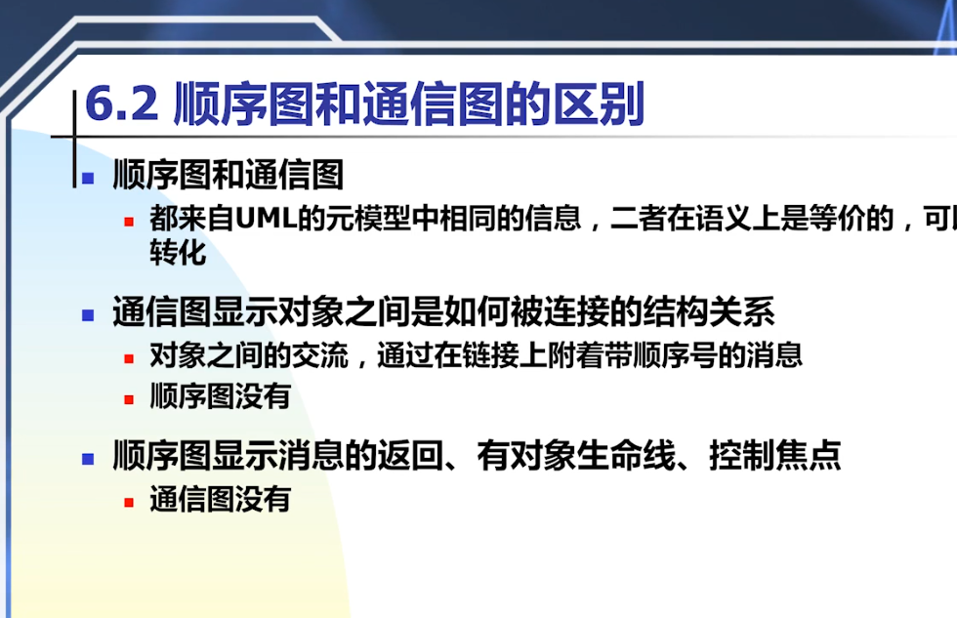

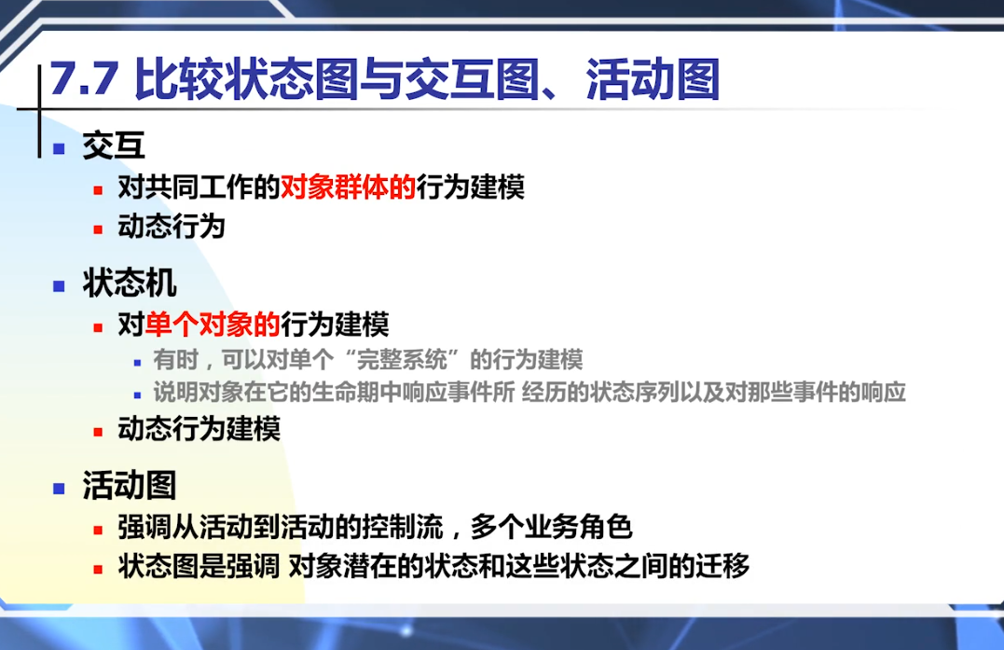

表1 消息列表

|  |  |  |  |
| --- | --- | --- | --- |
| 检查最大竞赛数 | checkMaxTournament( ) | 创建 | create( ) |
| 将决定通知赞助人 | notifySponsorOfDecision( ) | 确定赞助关系 | setSponsorship(sponsor) |
| 请求独家赞助 | requestExclusiveSponsor( ) | 设置竞赛起止时间 | setDates(StartDate, EndDate) |
| 通知参赛者 | notifyPlayer( ) | 查找感兴趣的独家赞助 | findInterestedExclusiveSponsors( ) |
| 通知社团会长(关于感兴趣的赞助) | notifyLeagueOwener( ) | 创建竞赛 | createTournament(name,startDate, endDate, maxp) |



图1 创建竞赛



图2 确定赞助商

2. 阅读下列“报告紧急情况”用例的事件流描述，完成下列问题：

Use Case Name : ReportEmergency

Basic Flow of Events:

1. The FieldOfficer activates the “Report Emergency” function of her terminal.

2. The System responds by presenting a form to the officer. The form includes an emergency type menu (general emergency, fire, transportation), a location, incident description, resource request, and hazardous material fields.

3. The FieldOfficer completes the form by specifying minimally the emergency type and description fields. The FieldOfficer may also describe possible responses to the emergency situation and request specific resources. Once the form is completed, the FieldOfficer submits the form by pressing the “Send Report” button, at which point the Dispatcher is notified.

4. The Dispatcher reviews the information submitted by the FieldOfficer and creates an Incident in the database by invoking the OpenIncident use case. All the information contained in the FieldOfficer’s form is automatically included in the Incident. The Dispatcher selects a response by allocating resources to the Incident (with the AllocateResources use case) and acknowledges the emergency report by sending a short massage to the FieldOfficer. The Acknowledgment indicates to the FieldOfficer that the EmergencyReport was received, an Incident created, and resources allocated to the Incident. The Acknowledgment includes the resources (e.g., a fire truck) and their estimated arrival time.

5. The FieldOfficer receives the Acknowledgment and the selected response.



图3 报告紧急情况顺序图



图4 报告紧急情况顺序图（图3续）



图5 报告紧急情况顺序图（图4续）

表1 消息列表

|  |  |  |  |
| --- | --- | --- | --- |
| 按下按钮 | press（） | 提交报告给调度员 | submitReportToDispatcher ( ) |
| 创建 | create( ) | 创建事件 | createIncident( ) |
| 填写表格内容 | fillContents( ) | 报告确认 | acknowledgeReport( ) |
| 提交表格 | submit ( ) | 解散 | dismiss( ) |
| 提交报告 | submitReport( ) | 结束报告事务 | endReportTransaction( ) |

**【问题1】**图3至图5是根据上述事件流描述画出的顺序图。请从表1选出适当的英文消息名将图中的空白处填写完整。

**【问题2】**根据图3画出部分通信图(即无需综合考虑图4和图5)。

**【问题3】**画出参与类图(VOPC)，要求在其中列出所有的类、类的操作以及类之间的关系，对关联关系要求标注两端角色的多重性(Multiplicity)。