**Task 2: Components**

**Courses page implementation**

Our goal is to create whole page with video courses list. Use ng-cli commands to get it easier.

Please use mocked array of courses implemented as property of courses page components.  
Don’t forget to use Interface of course item created previously.  
Create item class that implements your interface.  
At least you will have next fields (naming can be different):

* Id
* Title
* Creating date
* Duration (min)
* Description

You should implement markup + styles + simple logic for components below. Feel free to change components scheme by agreement with your mentor.   
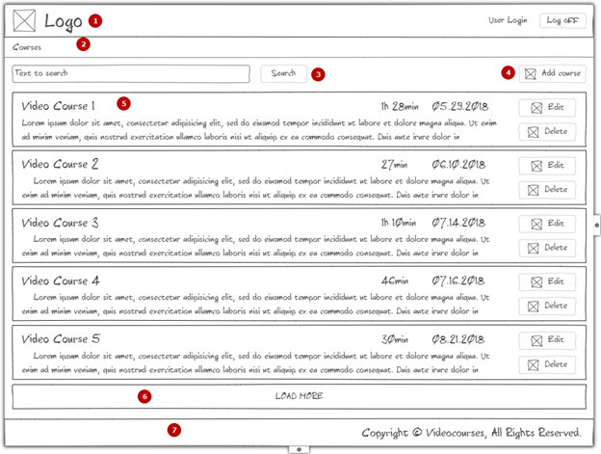

1. Header that includes logo element, User Login and log off button.  
   Leave user login as is (text placeholder)
2. Breadcrumbs
3. Search control with input and action button.  
   Place input field, button find and add course button.  
   Bind [()] input field with component property.  
   On Find click - console.log input value
4. Add new course button.
5. Video Course plate.  
   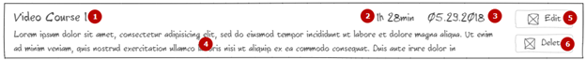
   1. Title
   2. Duration
   3. Date
   4. Description
   5. Edit button
   6. Delete button

Implement @Input for course-item  
Use {{object.property}} construction to show all related information (title, duration, date, description)  
Edit course - not implemented, markup only  
Delete - use @Output to call method on parent component  
You should console.log course id in video courses page component

6. Load more button – simple handler with console log

7. Footer

You can use courses page component directly without using routing.  
Place <courses-page></courses-page> into app component.  
  
Learn some lifecycle hooks during implementing component.  
Try to declare courses without array then assign empty array in constructor and after that assign fake values on ngOnInit hook.

Place console.log statement in hooks (<https://angular.io/docs/ts/latest/guide/lifecycle-hooks.html>) to understand ordering.  
Use ngFor to iterate through your fake items and pass it to the course item component.

Please refer to ng-cli and angular styleguide:  
<https://cli.angular.io/><https://angular.io/guide/styleguide>

Please find suggested design for this task. It’s not necessary to follow but can be helpful.  
<https://epam-my.sharepoint.com/:f:/p/nikita_reshetnikov/EswIvUgc52lOifeSaCceuKEBv-K4LZ_dzwqyY9a4TRL7_w?e=mSpjkg>

Criteria for evaluation

1. Nothing changed
2. Added some simple markup + css without splitting into components. Unable to run app.
3. Partially done with critical issues
4. Added implementations for all components with some major issues
5. Done all above without major issues