**Task 4: Directives and Pipes**

Courses page enhancements

Directives:

1. Create custom directive to change course plate border based on createdDate.  
   If creationDate < currentDate && creationDate >= currentDate - 14days - fresh course (use green border)  
   If creationDate > currentDate - upcoming course (use blue border) (in this case creationDate means date that the course will be released)  
   Otherwise - no changes
2. Add no data message using ngIf.

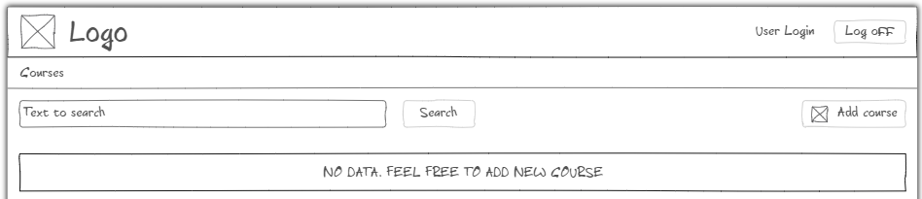

1. Add topRated field to the course item. If true - show star icon, change background color using ngClass.

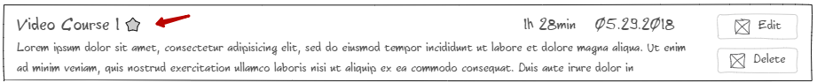

Pipes:

1. Use built-in pipe to uppercase video course name.
2. Create duration pipe. Should take duration in minutes and format output in   
   hh h mm min. (ex: 1h 15min). In case of duration less than 1h display only minutes.
3. Use built-in date pipe for course date. Change mock data to have datetime creationDate field instead of preformatted string.  
   
   1. Create orderBy pipe. Use creationDate field to order courses.
4. Change find behavior  
     
   Filter courses list by name when user enters some text in the field ‘search’ and presses the ‘Find’ button. (try to use pipes in the component class not in the template)

Criteria for evaluation

1. Nothing changed
2. Implemented built-in directives and pipes. App not started.
3. Built-in + partially custom pipes and directives. Major issues
4. Built-in + custom. Done all with some issues. orderBy not implemented.
5. Done all above including orderBy pipe without major issues

Extra task:

Proceed with unit testing. Now you have your custom directives and pipes. It’s time to cover them with unit tests.

Since it’s an easy topic - please see this related materials:

<https://angular.io/guide/testing#attribute-directive-testing>

<https://angular.io/guide/testing#pipe-testing>

Have fun :)