##### **Task 1: Intro**

1. Create a repository at GITHUB/BITBUCKET/GIT.EPAM.COM
2. Install ng-cli: npm install -g @angular/cli
3. Use ng-cli to create initial a project
4. Run the project by executing “ng serve”
5. Explore a project structure
6. Setup TS lint according to your preferences (indentation, spacing...) with the agreement with your mentor
7. Take a look at the mock up:  
   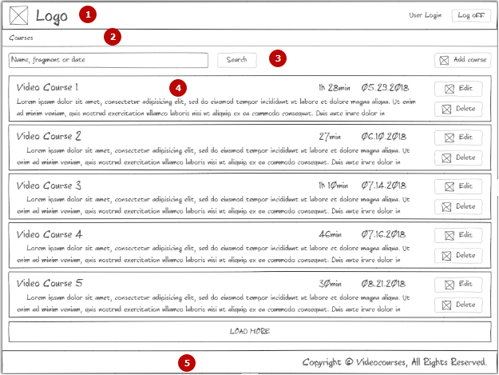  
   1. Header that includes a logo, a website name, an user login and a “log off” button  
   2. Breadcrumbs component  
   3. Toolbox that includes an input for search, a “search” button and a “add course” button  
   4. List of courses. Course item  
   5. Simple footer

##### Think how to break down a whole page into small pieces

1. Create the project structure including all presented on the image components using ng-cli generate component
2. Create header, footer, fake logo components
3. Create courses page component
4. Create a course typescript interface based on the mock up. All fields are presented at the page  
   You will have the next fields in the interface:
   * Id
   * Title
   * Creation date
   * Duration (min)
   * Description
5. Create a user entity typescript interface. User entity has the next fields:
   * Id
   * First Name
   * Last Name
6. Create classes that implements interfaces.
7. Make sure that serve, build works for your application

Criteria for evaluation

1. Nothing done
2. Created a repository
3. Added a base project structure. Application can be started on a localhost
4. Added fake implementations for components
5. Done all above including interface and classes without major issues