1. Sign up on XSEDE Portal:

<https://portal.xsede.org/#/guest>

Skip this, if you already have an account. Once you have username, ask to be allotted to an allocation. Skip this, if you are already on an allocation.

2. Set up Duo: Steps are mentioned with details and screenshot in the following link.

<https://portal.xsede.org/mfa>

Note: If Duo is not set up, XSEDE may not allow you to login thru ssh.

3. Login to Comet by first connecting with XSEDE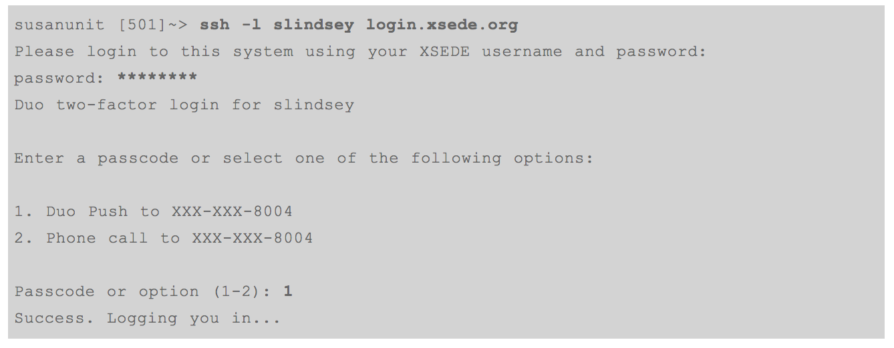

You should receive an update via your app saying "Request waiting: Tap to respond." Tap this, then tap the "Approve" prompt on the next screen.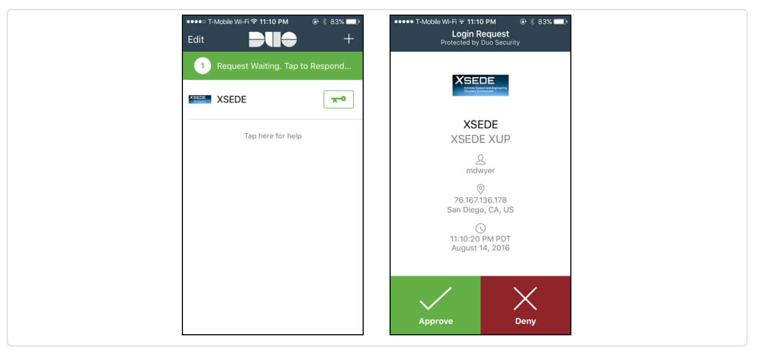

You should now be logged into the XSEDE SSO hub. From here you can open a gsissh session to any of your allocated resources.

[ando@ssohub ~]$ gsissh comet

Last login: Thu Aug 15 13:53:31 2019 from js-168-51.jetstream-cloud.org

Rocks 6.2 (SideWinder)

Profile built 16:45 08-Feb-2016

Kickstarted 17:27 08-Feb-2016

WELCOME TO

__________________ __ _______________

-----/ ____/ __ \/ |/ / ____/_ __/

--/ / / / / / /|_/ / __/ / /

/ /___/ /_/ / / / / /___ / /

\____/\____/_/ /_/_____/ /_/

*******************************************************************************

[1] Example Scripts: /share/apps/examples

[2] Filesystems:

(a) Lustre scratch filesystem : /oasis/scratch/comet/$USER/temp_project

(Preferred: Scalable large block I/O)

*** Meant for storing data required for active simulations

*** Not backed up and should not be used for storing data long term

*** Periodically clear old data not required for active simulations

(b) Compute/GPU node local SSD storage: /scratch/$USER/$SLURM_JOBID

(Meta-data intensive jobs, high IOPs)

(c) Lustre projects filesystem: /oasis/projects/nsf

(d) /home/$USER : Only for source files, libraries, binaries.

*Do not* use for I/O intensive jobs.

[3] Comet User Guide: http://www.sdsc.edu/support/user_guides/comet.html

******************************************************************************

[ando@comet-ln3 ~]$

4. Method 2: Log in directly to XSEDE hub

5. Transferring files from local to remote using Terminal.

One need to be in the directory of the folder that need to do a transferring from the local machine

C:\Users\Amber\Desktop\eFAST> scp Model_efast_T1D.m ODE_efast.m [bpm15q@comet.sdsc.xsede.org](mailto:bpm15q@comet.sdsc.xsede.org):/home/bpm15q

[ando@comet-ln3 ~]$ ls

matlab.25725732.comet-13-01.out test_par.csv test_sbatch.sh

matlab.25725889.comet-13-11.out test_sbatch.m

6. Transferring using Globus

Log in globus using

<https://www.globus.org/>

Log in with the existing XSEDE profile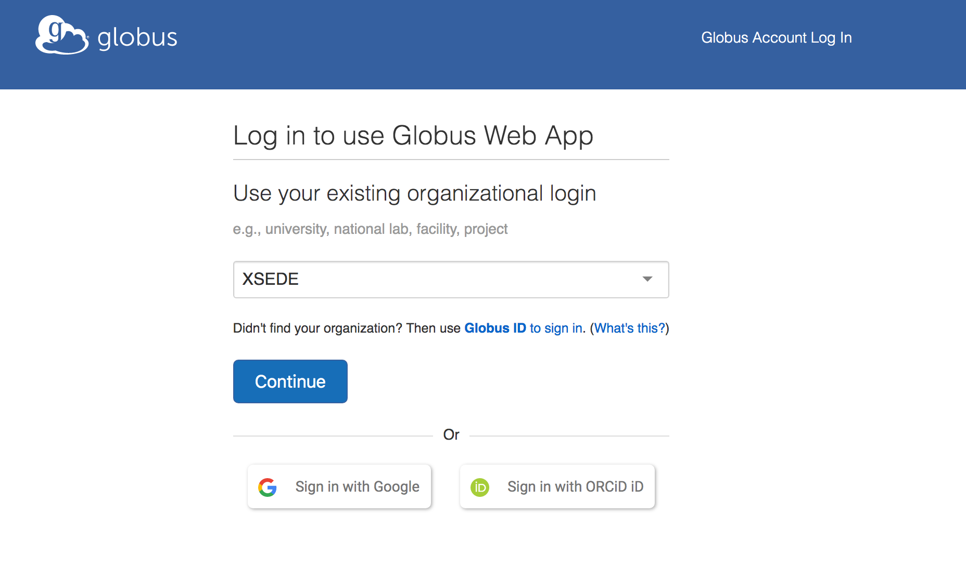

You will then be directed to XSEDE webpage to sign in with XSEDE credentials

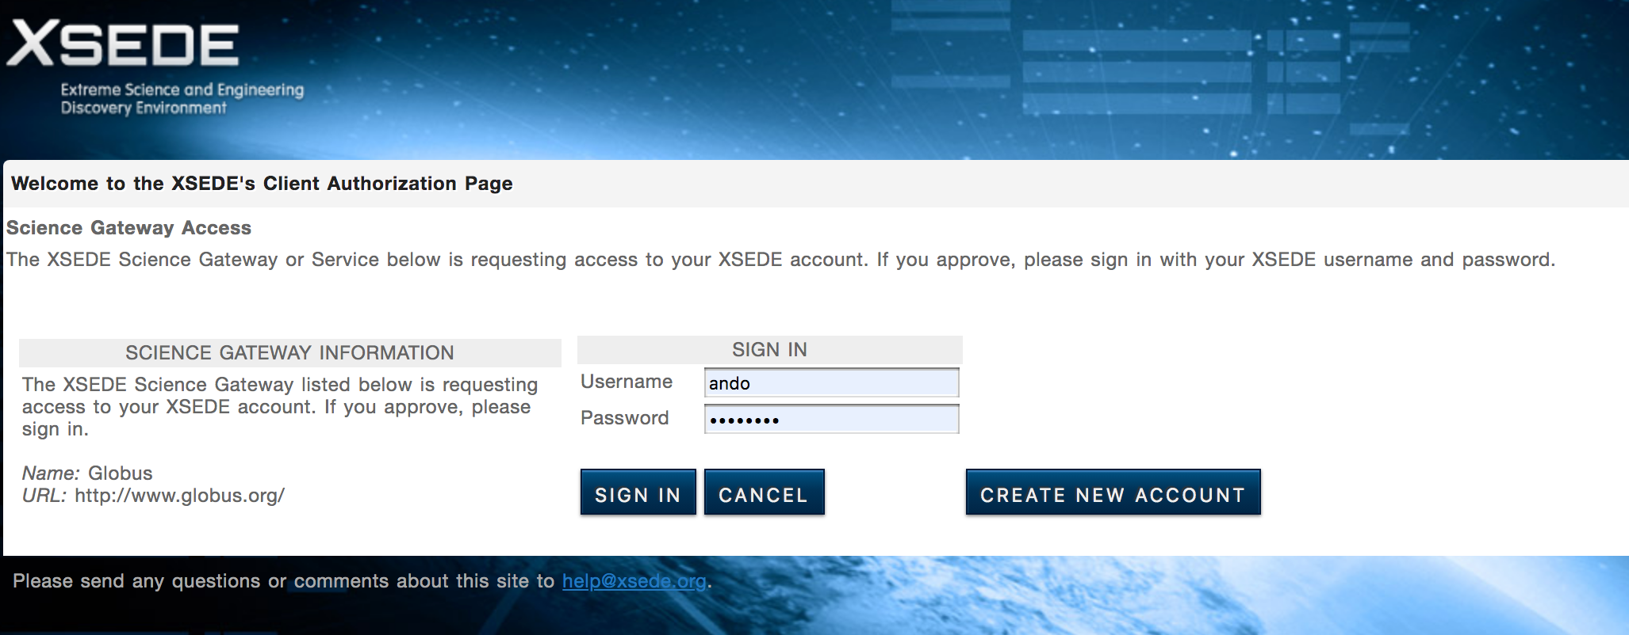

After you’ve signed up and logged in to Globus, you’ll begin at the File Manager.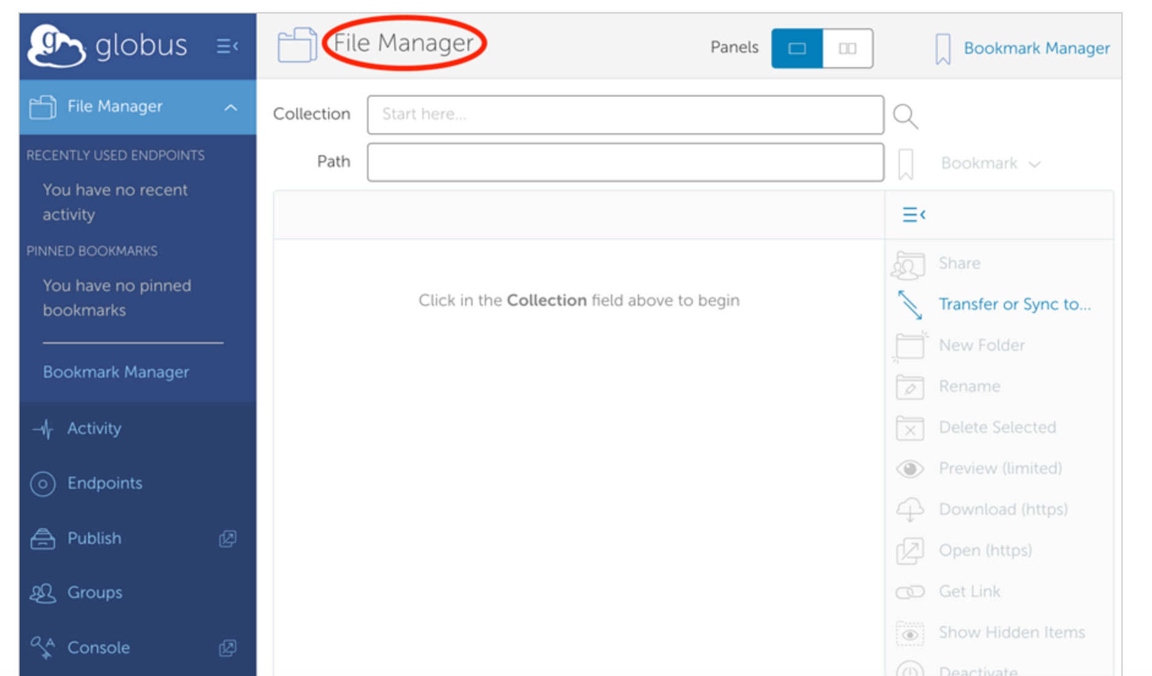

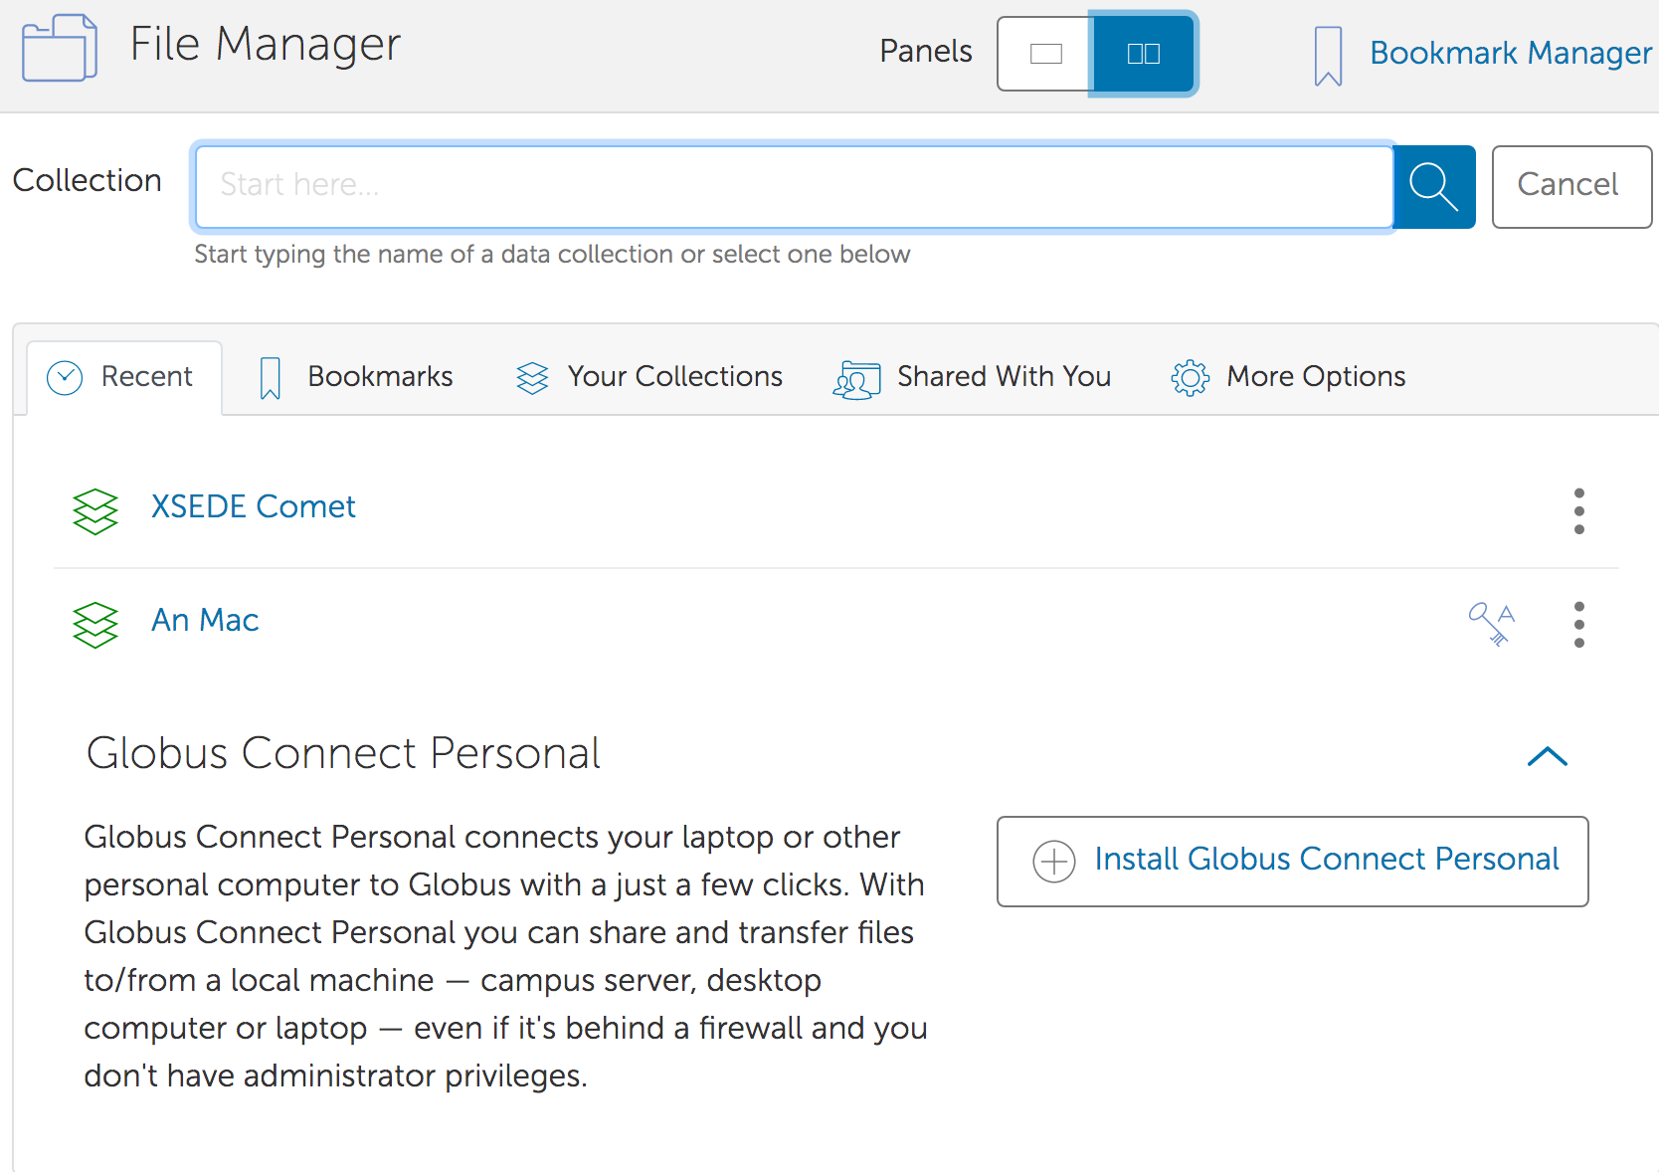

Here is my personal laptop that has already set up

Click here to start set up the local machine as an endpoint

Install Globus Connect Personal: Once click on Install Globus Connect Personal, you will be directed to follow the following steps

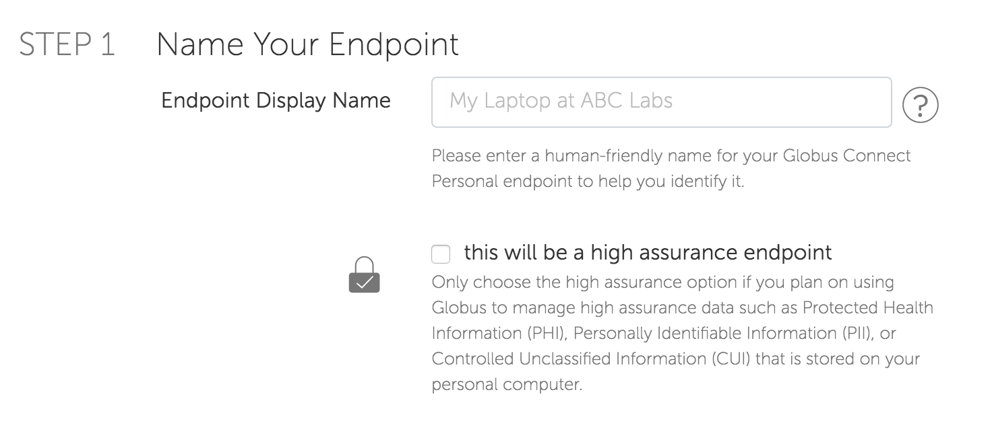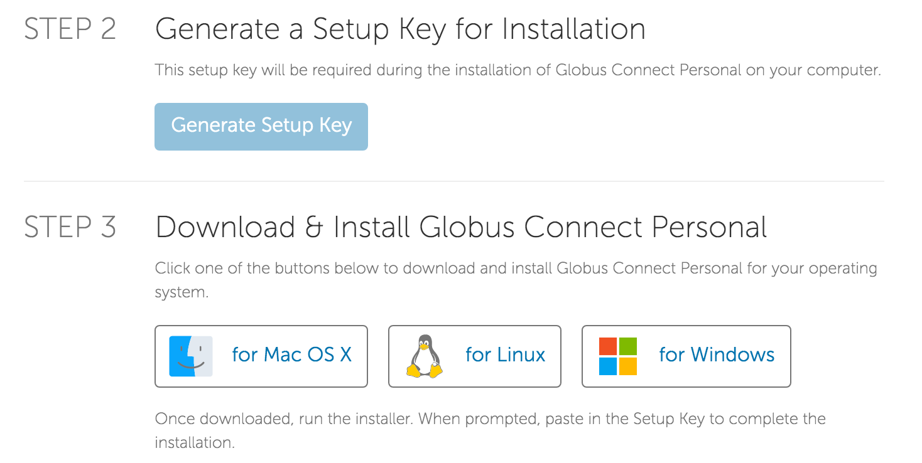

Follow installation instruction after downloading Globus. Then you will be ready to transfer file

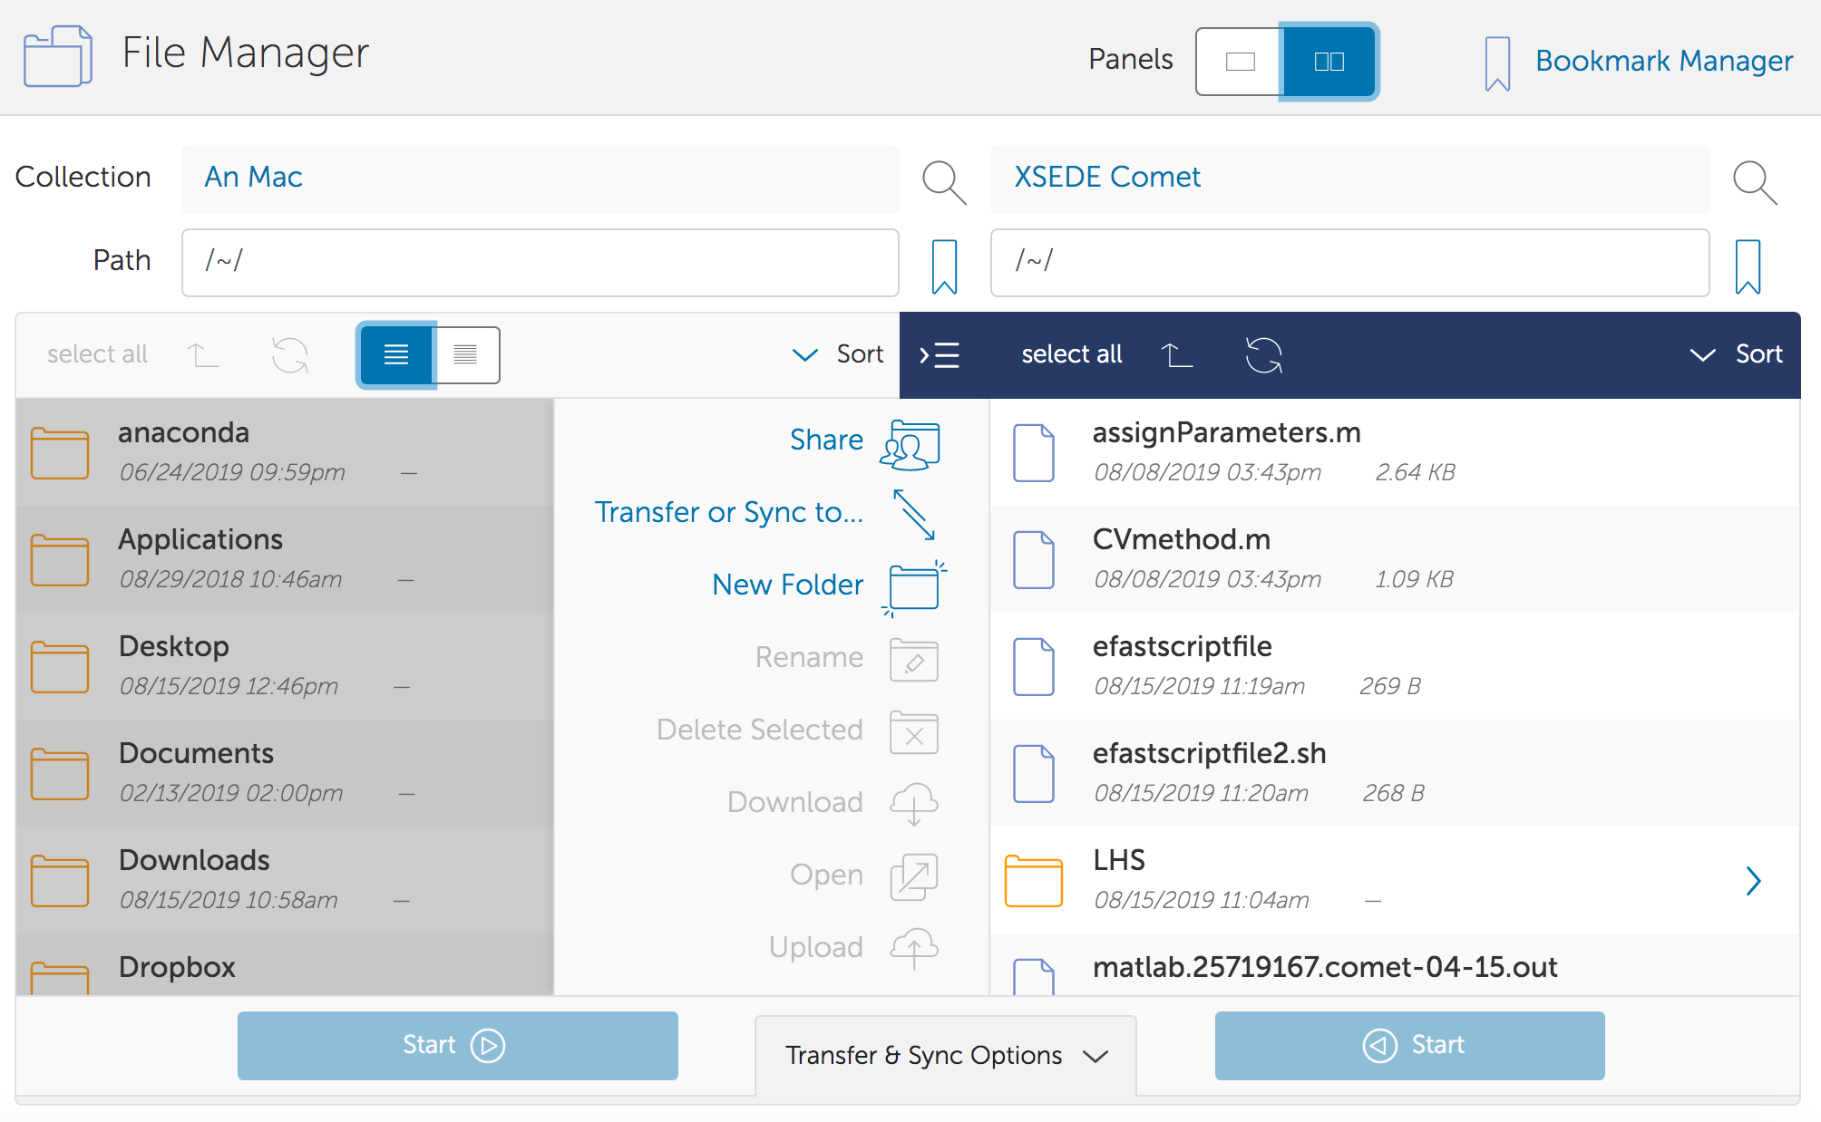

local machine

remote computer

click on the file needs to transfer

then click start

7. Submit work.

#!/bin/bash

#SBATCH --job-name="efast-multi"

#SBATCH --output="matlab.%j.%N.out"

#SBATCH --partition=compute

#SBATCH --nodes=1

#SBATCH --export=ALL

#SBATCH --ntasks-per-node=24

#SBATCH -L matlab:1

#SBATCH -t 48:00:00

ulimit -u 2048

module load matlab

matlab -nodesktop -nodisplay -r "run test_parfor;quit"

Write a scheduler bash script to submit work. For example, parfor_sbatch.sh, note the following crucial items:

* #SBATCH -t 48:00:00: limit time for the job to work on XSEDE is 48 hours. If your work takes longer time than this, you have to request extended time with the cap at 7 days.
* ulimit -u 2048 extended the maximum of processors available for users, which allows parallel computing to work
* #SBATCH --nodes=10 will allocate 1 nodes (aka computers) for the job. Try to use less than 10.
* #SBATCH --export=ALL I think you will want all the outputs, to play it safe.
* #SBATCH --ntasks-per-node=24 There are 24 cores on these supercomputers. Matlab will use however many cores it needs. The code will probably run faster if you use the maximum amount of cores, even on just 1 node.
* #SBATCH --output="matlab.%j.%N.out" will generate the output of the file after the job is finished running. %j is the job number (out of all the jobs ever submitted to Comet), %N probably has something to do with the node you’re currently using.
* module load matlab: load matlab to the environment
* matlab -nodesktop -nodisplay -r "run test_parfor;quit”: open matlab and run the file test_parfor.m. This is a simple example of how your matlab file is supposed to look like in order for parallelization to work

parpool % initiate cluster

tic % time tracker

n = 200;

A = 500;

a = zeros(1,n);

parfor i = 1:n % instead of for loop, we use parfor loop instead

a(i) = max(abs(eig(rand(A))));

end

toc

8. Running SBATCH file:

[ando@comet-ln2 ~]$ sbatch parfor_sbatch.sh

9. Check the queue:

[ando@comet-ln2 ~]$ squeue -u ando

JOBID PARTITION NAME USER ST TIME NODES NODELIST(REASON)

25724307 compute efast-mu ando PD 0:00 10 (Resources)

PD: pending

R: run

If you want to cancel the job simple write: scancel JOBID