

Subject: Slip Resistance of Floor Care Products Manufactured and
Marketed by JohnsonDiversey

All floor coatings, floor sealers, floor restorers and floor maintainers manufactured and marketed by JohnsonDiversey meet the slip resistance requirements set forth in ASTM D-2047, “The Static Coefficient of Friction of Polish-Coated Surfaces as Measured by the James Machine.” The ASTM (American Society of Testing and Materials), the CSPA (Consumer Specialty Products Association), UL (Underwriters Laboratories), and agencies of the federal government (OSHA, Occupational Safety and Health Administration; GSA, General Services Administration) accept this method and safety standard of 0.5 (as measured by this method, only) as “having traditionally been recognized as providing non-hazardous walkways for pedestrians.” The GSA specifies that all floor coatings used in government facilities meet this standard. Products meeting this standard are universally accepted for use in schools, nursing homes, hospitals, retail stores, hotels, airports and other critical commercial applications. In accordance with federal trade practice rules set forth by the FTC, products that meet this standard may be classified as slip resistant or slip retardant or terms of similar meaning. Dry walkway slip resistance is defined as meeting the ASTM standard of 0.5. The ability of any particular floor care product manufactured and marketed by JohnsonDiversey to meet this standard is not dependent on factors such as application method, skill of the user, number of coats, amount of product used or other variables related to application.

Sincerely yours,
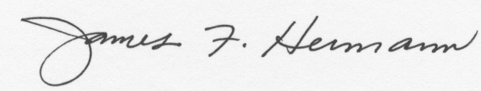
James F. Hermann
Manager, Floor Care Innovation/Risk Management
Global Research and Development
JohnsonDiversey, Inc.

