RT_SLAM_AVOC - Design Document

Author: Abhishek Chauhan

List of Figures

Figure 1: Architecture.png

Figure 2: CSS.png

Figure 3: Component architecture.png

Figure 4: Components.drawio.png

Figure 5: Data Streaming.png

Figure 6: Mock api request flow.png

Figure 7: Project Orchestration.png

Figure 8: React App Entry Point - index.js.png

Figure 9: Request flow .drawio.png

Figure 10: SLAM System Architecture.png

Figure 11: build process flow.png

Figure 12: container setup.png

Figure 13: disconnect websocket.png

Figure 14: global css structure.png

Figure 15: multi stage build.png

Figure 16: package.json.png

Figure 17: polling & rendering.png

Figure 18: rendering flow.png

Figure 19: reportWebVitals.js - Sequence Flow.png

Figure 20: sequence flow.png

Figure 21: structure app.js.png

Figure 22: structure(1).png

Figure 23: structure(2).png

Figure 24: structure(3).png

Figure 25: structure.png

Figure 26: vehicle_pose.png

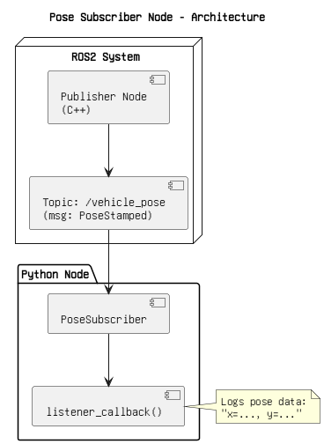

Figure 1: Architecture.png

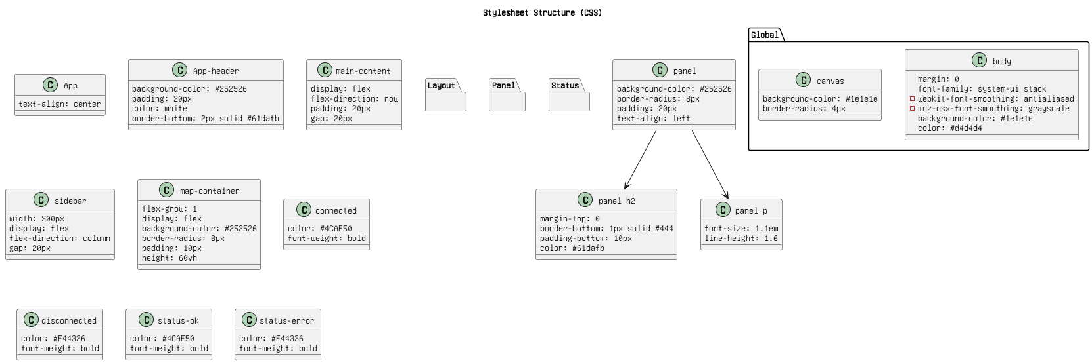

Figure 2: CSS.png

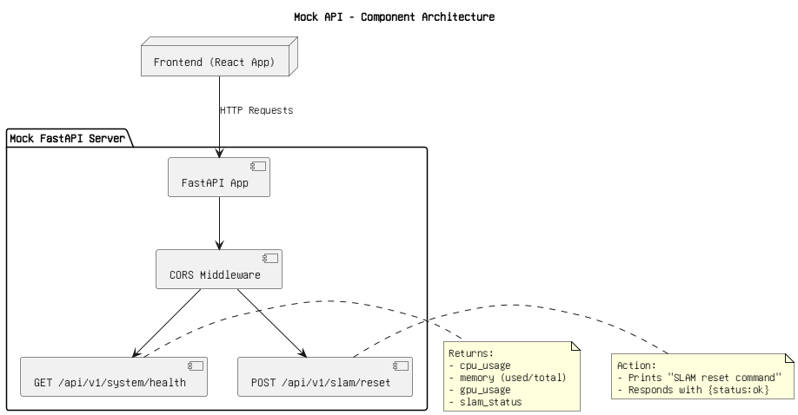

Figure 3: Component architecture.png

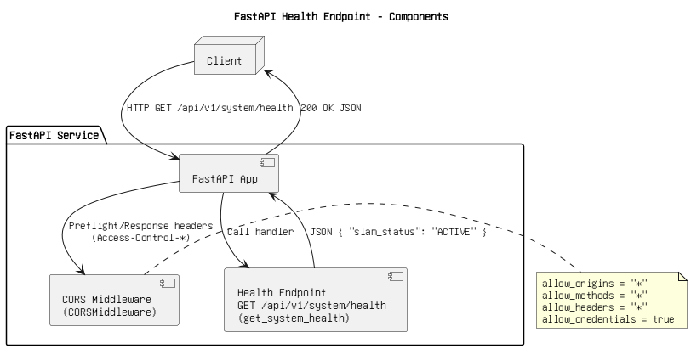

Figure 4: Components.drawio.png

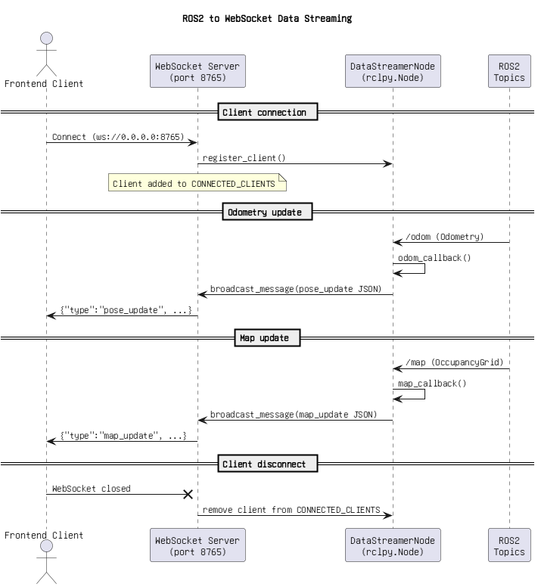

Figure 5: Data Streaming.png

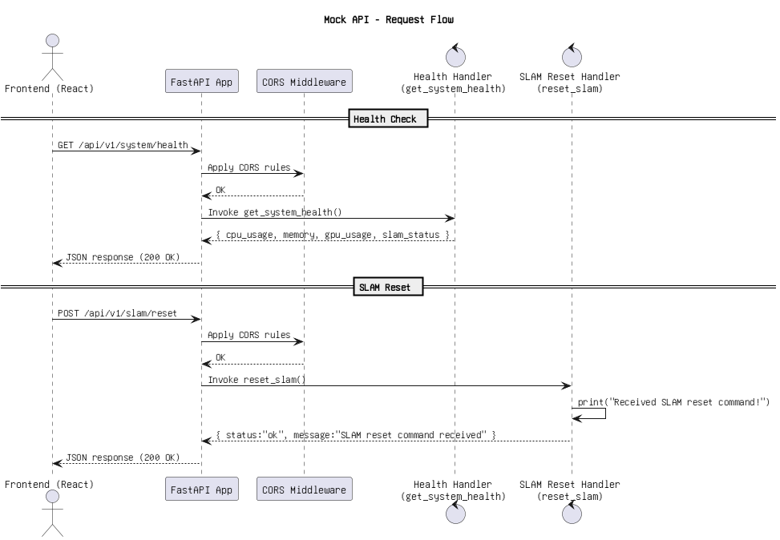

Figure 6: Mock api request flow.png

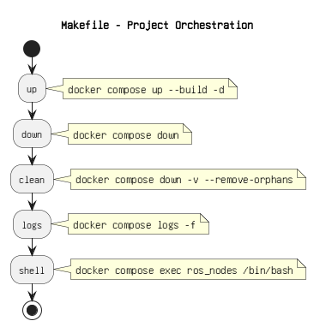

Figure 7: Project Orchestration.png

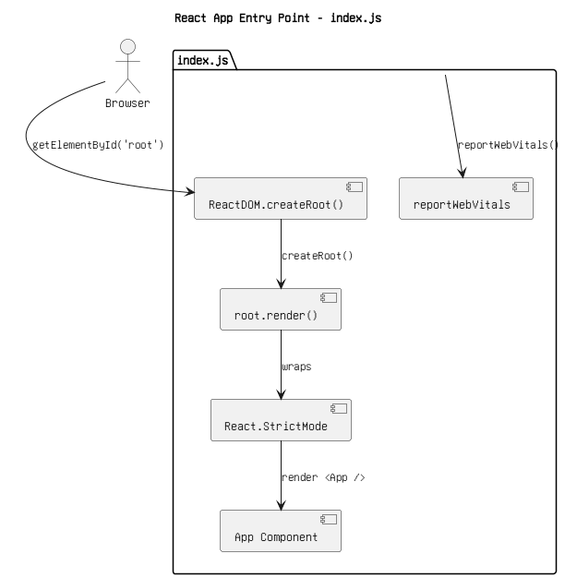

Figure 8: React App Entry Point - index.js.png

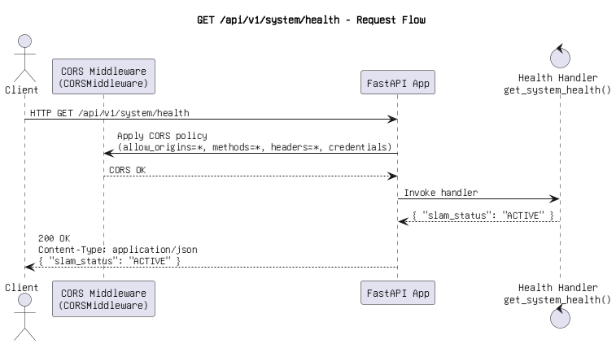

Figure 9: Request flow .drawio.png

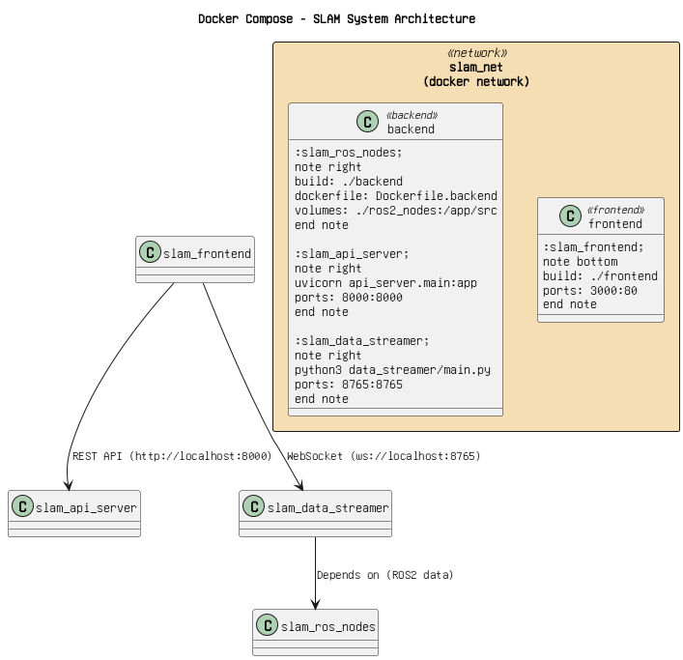

Figure 10: SLAM System Architecture.png

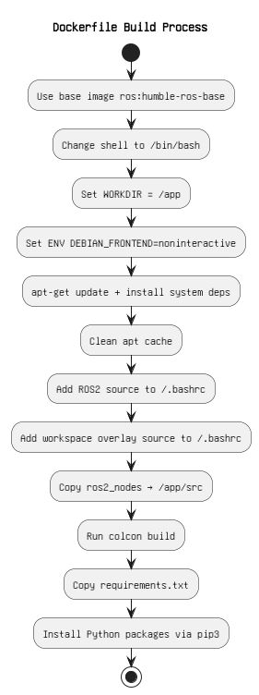

Figure 11: build process flow.png

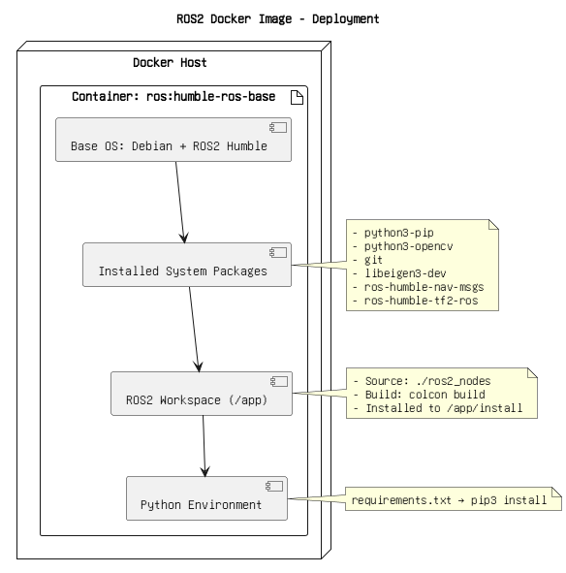

Figure 12: container setup.png

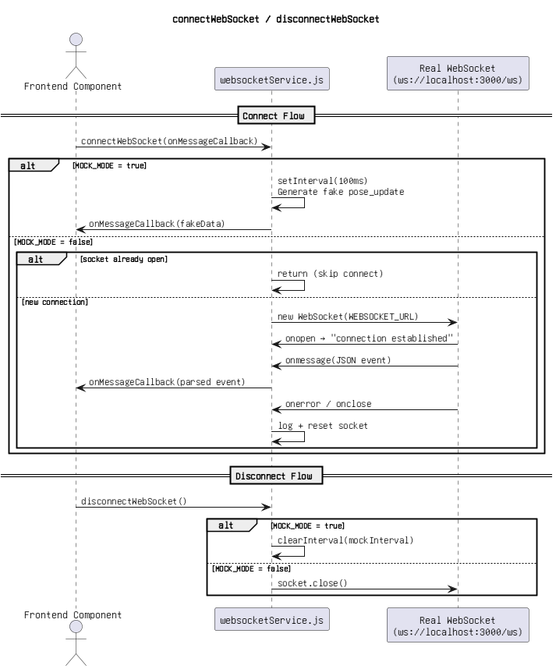

Figure 13: disconnect websocket.png

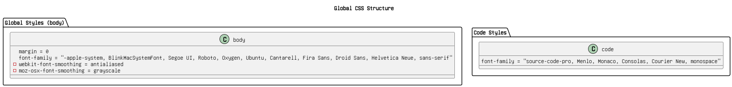

Figure 14: global css structure.png

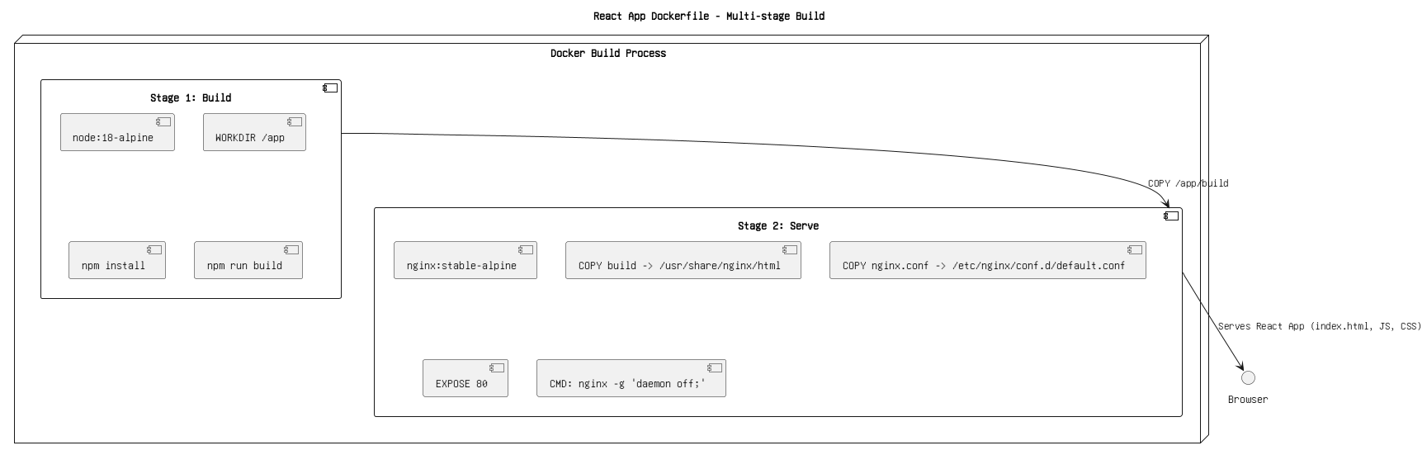

Figure 15: multi stage build.png

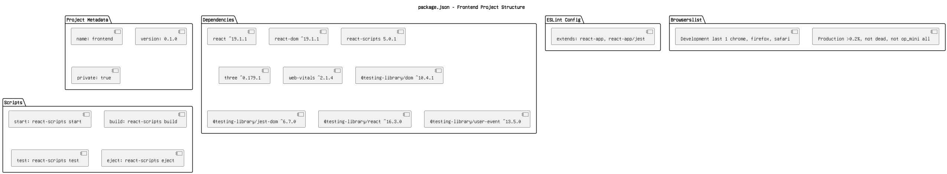

Figure 16: package.json.png

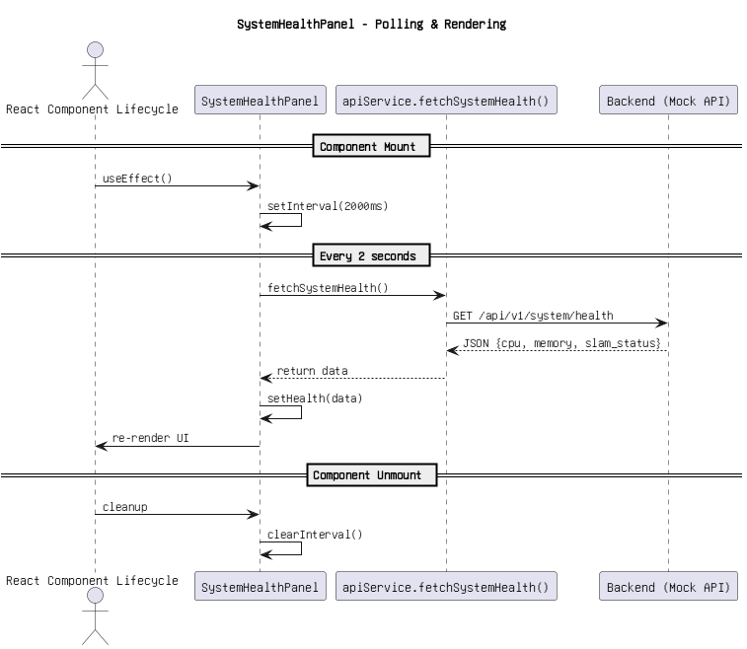

Figure 17: polling & rendering.png

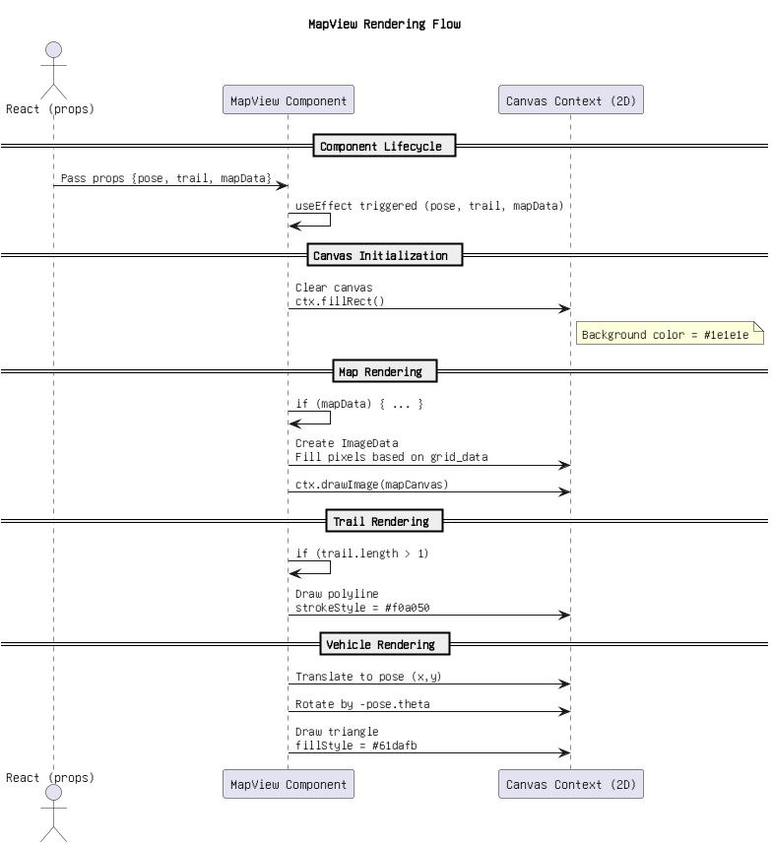

Figure 18: rendering flow.png

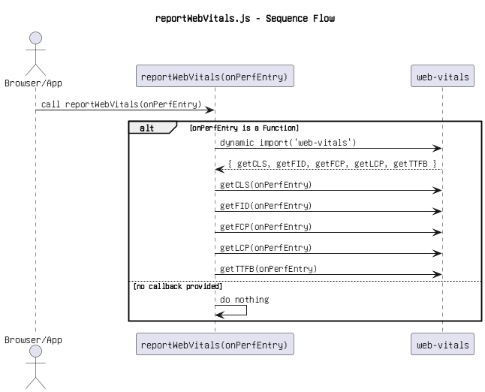

Figure 19: reportWebVitals.js - Sequence Flow.png

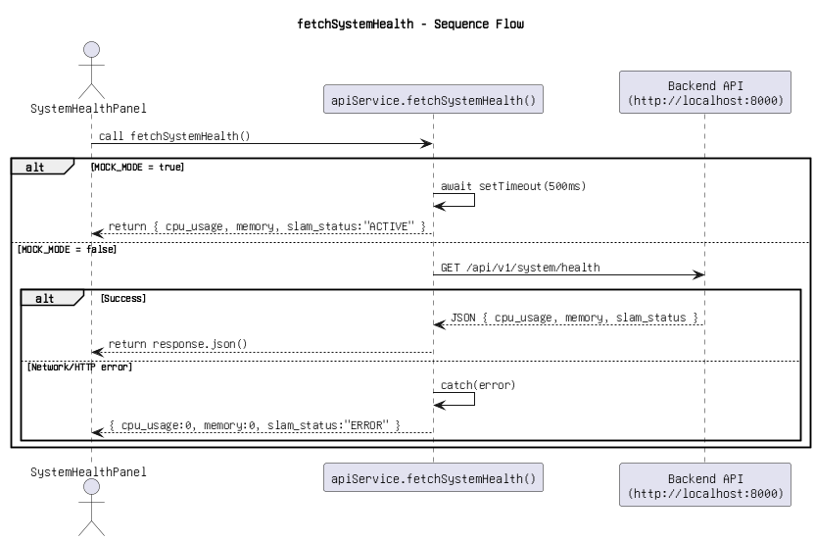

Figure 20: sequence flow.png

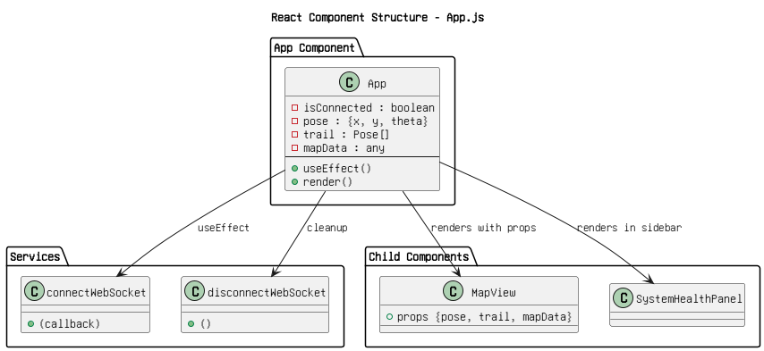

Figure 21: structure app.js.png

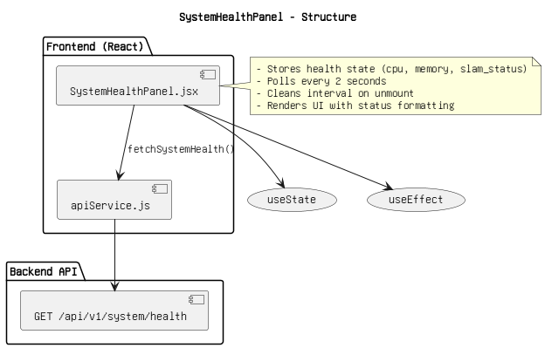

Figure 22: structure(1).png

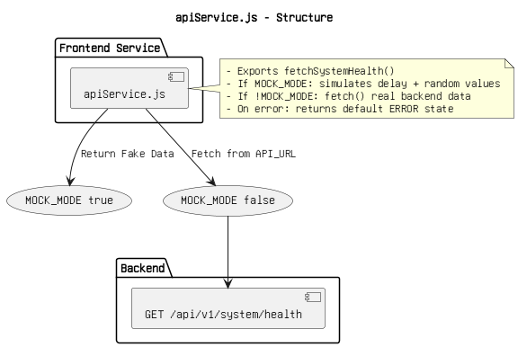

Figure 23: structure(2).png

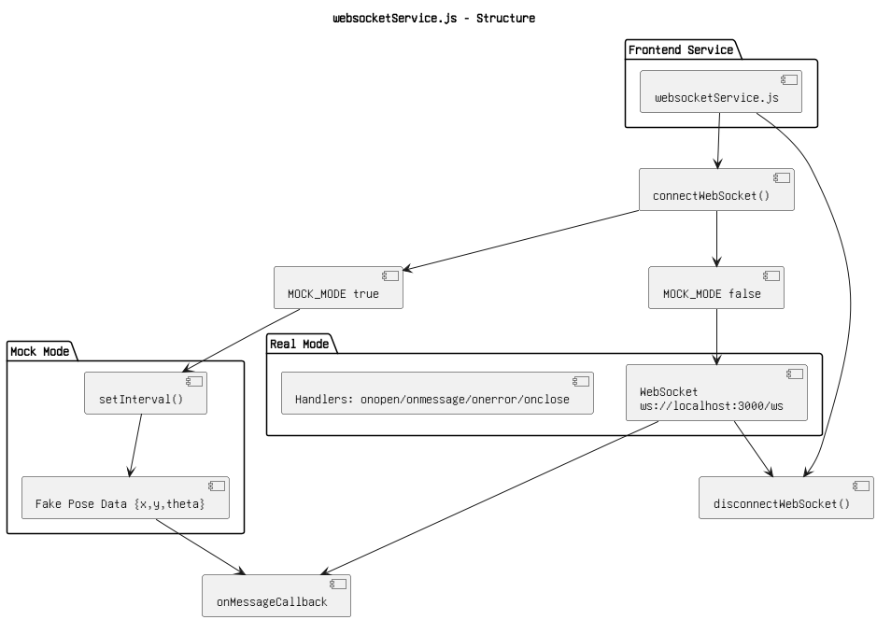

Figure 24: structure(3).png

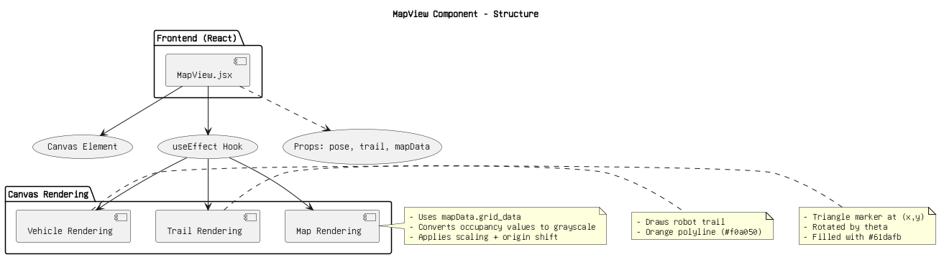

Figure 25: structure.png

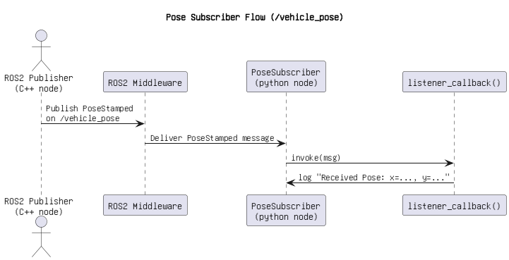

Figure 26: vehicle_pose.png