Vhealth Plus QT QML - Design Document

Author: Abhishek Chauhan

List of Figures

Figure 1: BackgroundPulse.png

Figure 2: Gauge.qml.drawio.png

Figure 3: GlowNeedleMaterial.drawio.png

Figure 4: HUDOverlay.drawio.png

Figure 5: MusicWidgetdrawio.drawio.png

Figure 6: NeedleEntity.drawio.png

Figure 7: RedlineShaderEffect.drawio.png

Figure 8: Telemetry3DController.drawio.png

Figure 9: VHealthDashboard.drawio.png

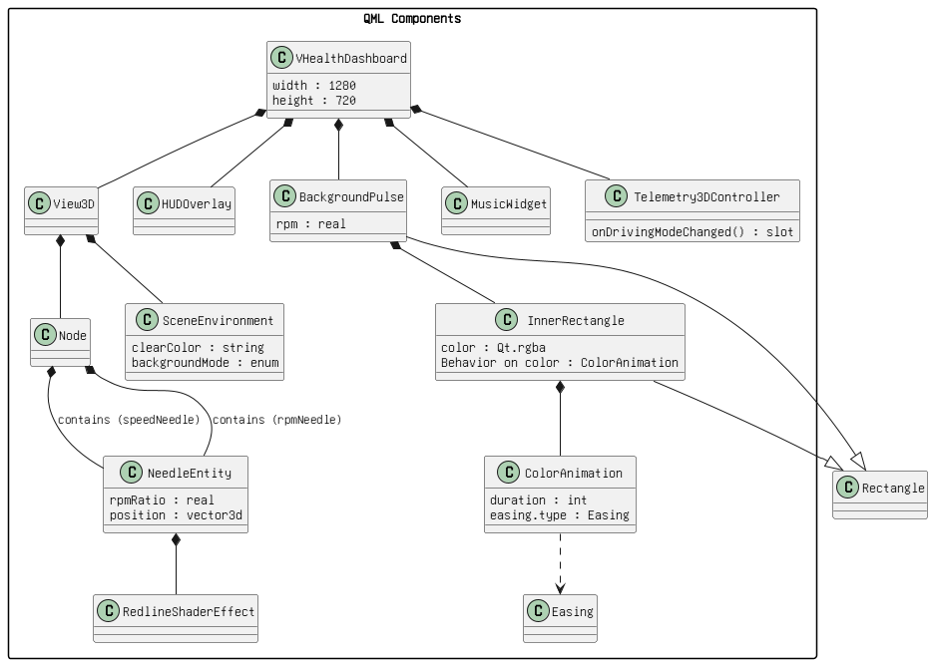

Figure 1: BackgroundPulse.png

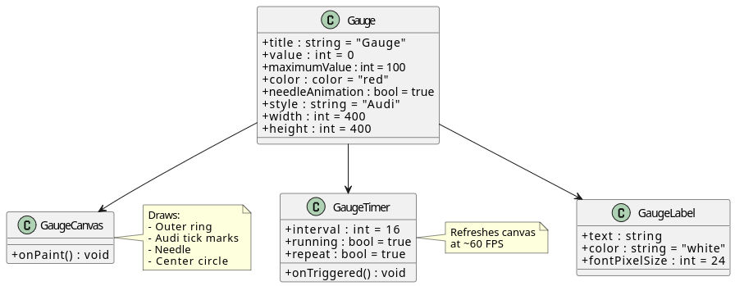

Figure 2: Gauge.qml.drawio.png

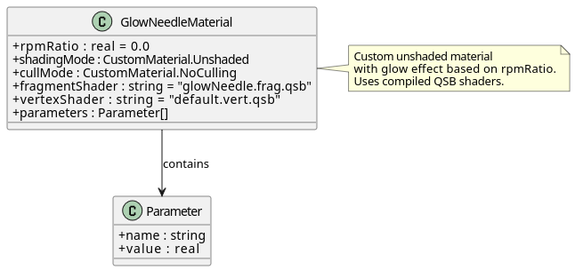

Figure 3: GlowNeedleMaterial.drawio.png

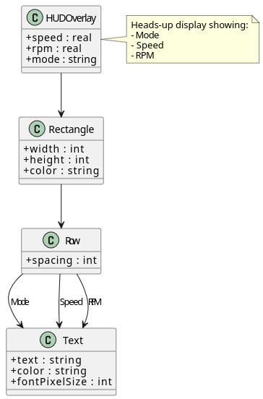

Figure 4: HUDOverlay.drawio.png

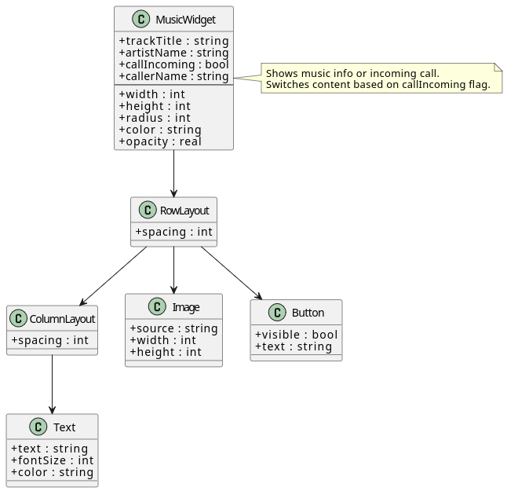

Figure 5: MusicWidgetdrawio.drawio.png

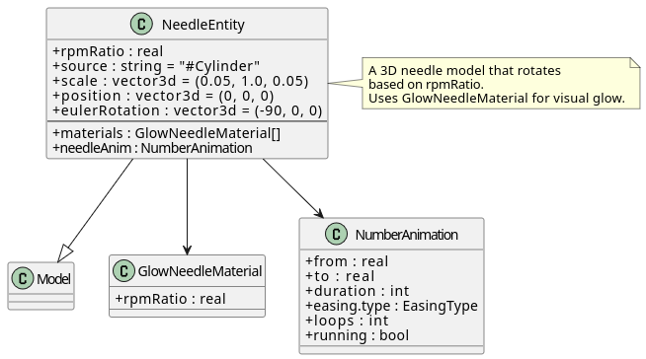

Figure 6: NeedleEntity.drawio.png

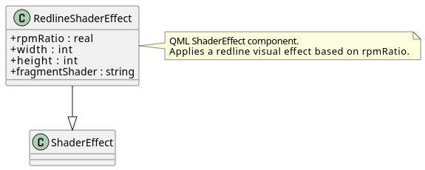

Figure 7: RedlineShaderEffect.drawio.png

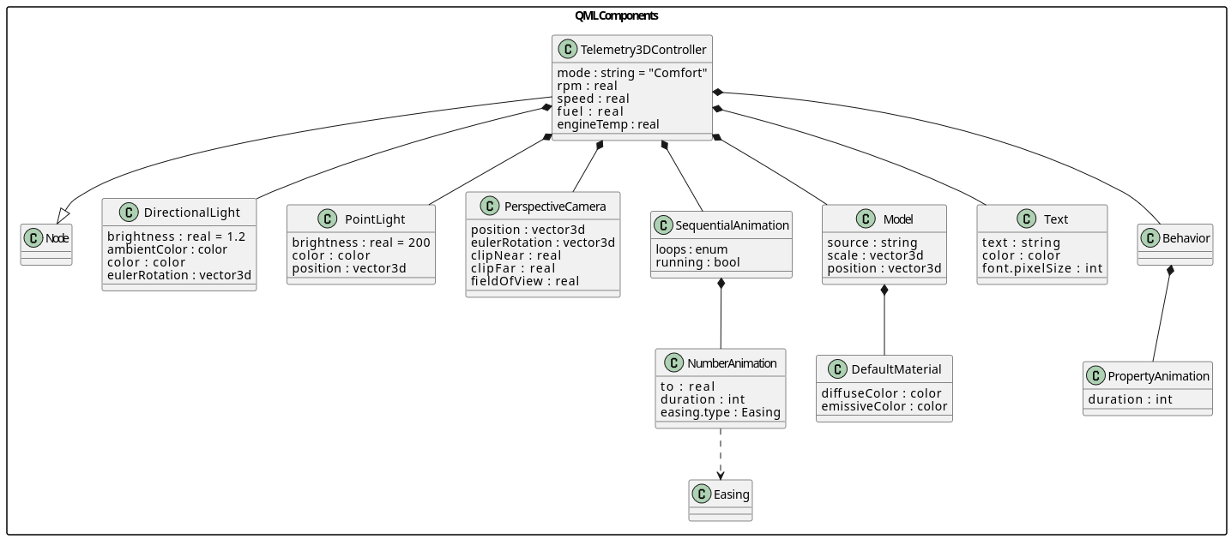

Figure 8: Telemetry3DController.drawio.png

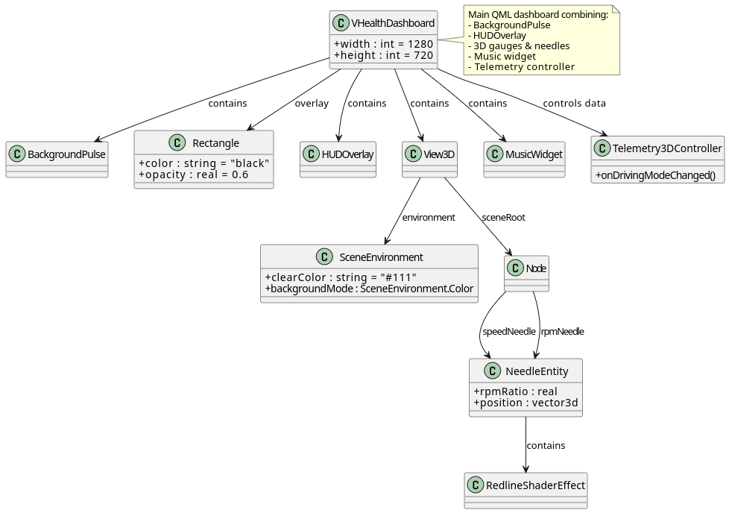

Figure 9: VHealthDashboard.drawio.png