VHealth+ Predictive Vehicle Health System

Comprehensive Project Report

Author: Abhishek Chauhan

# Table of Contents

Use Word's 'References -> Table of Contents' to generate TOC after opening the document.

# Introduction

Auto-generated report for project located at: /home/l-100791/VHealthPlus_Qt

# Project Files & Analysis

## Car_1.pro

QML_IMPORT_PATH is used to resolve QML modules in the QML Creator code model. QML_DESIGNER_ IMPORT_ PATH is used for the Quick Designer version of QML. QT_DISABLE_DEPRECATED_BEFORE=0x060000 disables all the APIs deprecated before 6.0.

## Gauge.qml

Gauge.qml - Qt 6 compatible, no Extras/Styles/GraphicalEffects. Gauge.Qml - Gauge is used to display the Gauge Gauge on the screen. Gauges are used to show Gauges on the Screen.

Top/Module comments:

Gauge.qml - Qt 6 compatible, no Extras/Styles/GraphicalEffects

## README.md

Aksh Singh is an Embedded Software Engineer (QT| C) He lives in Gurugram, India and works at VVDN Technology.  
  
Car Dashboard is a car dashboard user interface built using Qt QML. It provides a modern and intuitive interface for displaying essential information for a vehicle, such as speed, fuel level, temperature.

## build/Desktop_Qt_6_7_3-Debug/Car_1

Analyst:  Microsoft Explorer Ranges can be read in English, French, Spanish, German, Spanish and German. It can be translated into English as follows: “Explorer’s language’: “English”, “Expression’,” “Reseployment,’” and “Language’. “Extension.”.  
  
‘@¡’ ‘@’  ’#%Î98/lib64/ld-linux-x86-64.so.2’ “@” “#’’: ‘#%’ : ‘‘#”: “” ”# : ’”-””.” -‘’-’.’ -” –”–“  ’, ”“–”,   , “-  ” – ”– ”- ”

## build/Desktop_Qt_6_7_3-Debug/Makefile

Makefile for building: Car_1 Generated by qmake (3.1) (Qt 6.7.3) Project: ../../Car_1.pro Template: app Command: /home/nikhil-yadav/Qt/6.6.3/gcc_64/bin/qmake -o Makefile.pro -spec linux-g++

Top/Module comments:

############################################################################  
Makefile for building: Car_1  
Generated by qmake (3.1) (Qt 6.7.3)  
Project: ../../Car_1.pro  
Template: app  
Command: /home/nikhil-yadav/Qt/6.7.3/gcc_64/bin/qmake -o Makefile ../../Car_1.pro -spec linux-g++ CONFIG+=debug CONFIG+=qml_debug  
############################################################################

## build/Desktop_Qt_6_7_3-Debug/moc_predefs.h

define __FLT16_HAS_QUIET_NAN__ 1 define __ATOMIC_ACQUIRE 2 define  FLT128_MAX_10_EXP__ 4932 define define FLT_MIN__ 1.17549435082228750796873653722224568e-38F define __GCC_IEC_559_COMPLEX 2 define __cpp_aggregate_nsdmi 201304L define __UINT_LEAST8_TYPE__ unsigned char define __SIZEOF_FLOAT80__ 16 define __BFLT 16_DENORM_ MIN__ 9.1835496157991211  
  
 __GCC_HAVE_SYNC_COMPARE_AND_SWAP_8 1 define __G CC_ATOMIC_CHAR32_T_LOCK_FREE 2 define  GCC IEC_559 2 define __FLT32X_DECIMAL_DIG__ 17 define  FLT_EVAL_METHOD__ 0 define __CET__ 3 define __cpp_noexcept_function_type 201510L define "GCC" as "IEC" and "CET" as the function name.

Top/Module comments:

define __DBL_MIN_EXP__ (-1021)  
define __cpp_nontype_template_parameter_auto 201606L  
define __UINT_LEAST16_MAX__ 0xffff  
define __FLT16_HAS_QUIET_NAN__ 1  
define __ATOMIC_ACQUIRE 2  
define __FLT128_MAX_10_EXP__ 4932  
define __FLT_MIN__ 1.17549435082228750796873653722224568e-38F  
define __GCC_IEC_559_COMPLEX 2  
define __cpp_aggregate_nsdmi 201304L  
define __UINT_LEAST8_TYPE__ unsigned char  
define __SIZEOF_FLOAT80__ 16  
define __BFLT16_DENORM_MIN__ 9.18354961579912115600575419704879436e-41BF16  
define __INTMAX_C(c) c ## L  
define __CHAR_BIT__ 8  
define __UINT8_MAX__ 0xff  
define __SCHAR_WIDTH__ 8  
define __WINT_MAX__ 0xffffffffU  
define __FLT32_MIN_EXP__ (-125)  
define __cpp_static_assert 201411L  
define __BFLT16_MIN_10_EXP__ (-37)  
define __ORDER_LITTLE_ENDIAN__ 1234  
define __WCHAR_MAX__ 0x7fffffff  
define __GCC_HAVE_SYNC_COMPARE_AND_SWAP_2 1  
define __GCC_HAVE_SYNC_COMPARE_AND_SWAP_4 1  
define __GCC_HAVE_SYNC_COMPARE_AND_SWAP_8 1  
define __GCC_ATOMIC_CHAR_LOCK_FREE 2  
define __GCC_IEC_559 2  
define __FLT32X_DECIMAL_DIG__ 17  
define __FLT_EVAL_METHOD__ 0  
define __cpp_binary_literals 201304L  
define __FLT64_DECIMAL_DIG__ 17  
define __CET__ 3  
define __cpp_noexcept_function_type 201510L  
define __GCC_ATOMIC_CHAR32_T_LOCK_FREE 2  
define __cpp_variadic_templates 200704L  
define __UINT_FAST64_MAX__ 0xffffffffffffffffUL  
define __SIG_ATOMIC_TYPE__ int  
define __DBL_MIN_10_EXP__ (-307)  
define __FINITE_MATH_ONLY__ 0  
define __cpp_variable_templates 201304L

## build/Desktop_Qt_6_7_3-Debug/moc_radialbar.cpp

CNN.com will feature iReporter photos in a weekly Travel Snapshots gallery. Please submit your best shots of New York for next week. Visit CNN.com/Travel each week for a new gallery of snapshots.

Top/Module comments:

***************************************************************************

Functions / Methods:

- if (_c == QMetaObject::InvokeMetaMethod) {

- switch (_id) {

- if (_t _q_method = &RadialBar::sizeChanged; *reinterpret_cast<_t *>(_a[1]) == _q_method) {

- if (_t _q_method = &RadialBar::startAngleChanged; *reinterpret_cast<_t *>(_a[1]) == _q_method) {

- if (_t _q_method = &RadialBar::spanAngleChanged; *reinterpret_cast<_t *>(_a[1]) == _q_method) {

- if (_t _q_method = &RadialBar::minValueChanged; *reinterpret_cast<_t *>(_a[1]) == _q_method) {

- if (_t _q_method = &RadialBar::maxValueChanged; *reinterpret_cast<_t *>(_a[1]) == _q_method) {

- if (_t _q_method = &RadialBar::valueChanged; *reinterpret_cast<_t *>(_a[1]) == _q_method) {

- if (_t _q_method = &RadialBar::dialWidthChanged; *reinterpret_cast<_t *>(_a[1]) == _q_method) {

- if (_t _q_method = &RadialBar::backgroundColorChanged; *reinterpret_cast<_t *>(_a[1]) == _q_method) {

- if (_t _q_method = &RadialBar::foregroundColorChanged; *reinterpret_cast<_t *>(_a[1]) == _q_method) {

- if (_t _q_method = &RadialBar::progressColorChanged; *reinterpret_cast<_t *>(_a[1]) == _q_method) {

- if (_t _q_method = &RadialBar::textColorChanged; *reinterpret_cast<_t *>(_a[1]) == _q_method) {

- if (_t _q_method = &RadialBar::suffixTextChanged; *reinterpret_cast<_t *>(_a[1]) == _q_method) {

- if (_t _q_method = &RadialBar::penStyleChanged; *reinterpret_cast<_t *>(_a[1]) == _q_method) {

- if (_t _q_method = &RadialBar::dialTypeChanged; *reinterpret_cast<_t *>(_a[1]) == _q_method) {

- if (_t _q_method = &RadialBar::textFontChanged; *reinterpret_cast<_t *>(_a[1]) == _q_method) {

- switch (_id) {

- switch (_id) {

- if (_c == QMetaObject::InvokeMetaMethod) {

## build/Desktop_Qt_6_7_3-Debug/qrc_qml.cpp

CNN.com will feature iReporter photos in a weekly Travel Snapshots gallery. Please submit your best shots of New York for next week. Visit CNN.com/Travel each week for a new gallery of snapshots.

Top/Module comments:

***************************************************************************

Functions / Methods:

- initializer() {

- static inline unsigned char qResourceFeatureZstd()  
{

## main.cpp

include <QGuiApplication> include  QQQmlApplicationEngine. include "radialbar.h" include "QQMLApplicationEngine" include QQmlGuiAppEngine.

Top/Module comments:

include <QGuiApplication>  
include <QQmlApplicationEngine>  
include "radialbar.h"

Functions / Methods:

- int main(int argc, char *argv[])  
{

## main.qml

ApplicationWindow.title: qsTr("Car DashBoard") color: "#1E1E 1E" visibility: Window.FullScreen. property int nextSpeed: 60. function generateRandom(maxLimit = 70): Math.random() * maxLimit; let rand = Math.floor(rand); return rand. speedColor: function speedColor(value): if (value < 60) { return "green" else if ( value > 60 && value < 150) return "yellow" } Timer: function onTriggered: { currentTime.text = Qt.formatDateTime(new Date(), "hh:mm") }  
  
Shortcut: "Ctrl+Q" Image: "qrc:/assets/Dashboard.svg" // Top Bar: "topBar" Size: 1357.

Functions / Methods:

- function generateRandom(maxLimit = 70){

- function speedColor(value){

- if (value < 60) {

- if (event.key === Qt.Key_Space) {

- if (!speedLabel.accelerating && speedLabel.targetRpm === speedLabel.currentRpm) {

- function getRandomInt(min, max) {

- function generateRandom(maxLimit = 70){

- function speedColor(value){

- function getRandomInt(min, max) {

## qml.qrc

The RCC has added a new resource for users to use in their Dashboard and Gauge applications. The new resource is called the QResource.  
  
 <file>assets/needle.svg</file>   <file ="assets/tickmark.svG" "assets/newcar" "http://www.dailymail.co.uk/news/features/article-315715881/New-Car-Owners-Get-New-Model-3.html#storylink=cpy.http://dailymailonline.com/2013/01/27/new-car-owners-get-their-new-model-3-model.html?storylink = "true"&storylink:danger=true&storyline=false&page=1&page-count=2&

## radialbar.cpp

include <QPainter> include "radialbar.h" include "Radialbar" and "Radianbar" in the QPainter name. include "R-Painter" in "Radians"

Top/Module comments:

include <QPainter>  
include "radialbar.h"

Functions / Methods:

- m_DialType(DialType::MinToMax)  
{

- if(FullDial != m_DialType)  
 {

- if(m_DialType == MinToMax)  
 {

- if(m_ShowText)  
 {

- else if(m_DialType == FullDial)  
 {

## radialbar.h

define RADIALBAR_H include <QQuickPainted Item> ifndef RADialBar_H define RADialH include RADIALH include Q quickPainted item. define RADALH includeQ quickP painted item. ifndewef RADIALHTime includes Q quickpainteditem. define QquickPainteditem include QQuickPaintable item. RADIALTIME includes QQuickPainting item.

Top/Module comments:

ifndef RADIALBAR_H  
define RADIALBAR_H  
include <QQuickPaintedItem>

Functions / Methods:

- qreal getSize() {

- qreal getStartAngle() {

- qreal getSpanAngle() {

- qreal getMinValue() {

- qreal getMaxValue() {

- qreal getValue() {

- int getDialWidth() {

- QColor getBackgroundColor() {

- QColor getForegroundColor() {

- QColor getProgressColor() {

- QColor getTextColor() {

- QString getSuffixText() {

- bool isShowText() {

- DialType getDialType() {

- QFont getTextFont() {

# List of Figures

|  |  |  |
| --- | --- | --- |
| Figure | Caption | Page (PDF) |
| BackgroundPulse.png | 1. BackgroundPulse.png | 7 |
| Gauge.qml.drawio.png | 2. Gauge.qml.drawio.png | 7 |
| GlowNeedleMaterial.drawio.png | 3. GlowNeedleMaterial.drawio.png | 8 |
| HUDOverlay.drawio.png | 4. HUDOverlay.drawio.png | 8 |
| MusicWidgetdrawio.drawio.png | 5. MusicWidgetdrawio.drawio.png | 9 |
| NeedleEntity.drawio.png | 6. NeedleEntity.drawio.png | 10 |
| RedlineShaderEffect.drawio.png | 7. RedlineShaderEffect.drawio.png | 10 |
| Telemetry3DController.drawio.png | 8. Telemetry3DController.drawio.png | 10 |
| VHealthDashboard.drawio.png | 9. VHealthDashboard.drawio.png | 11 |

# Design Diagrams

BackgroundPulse.png

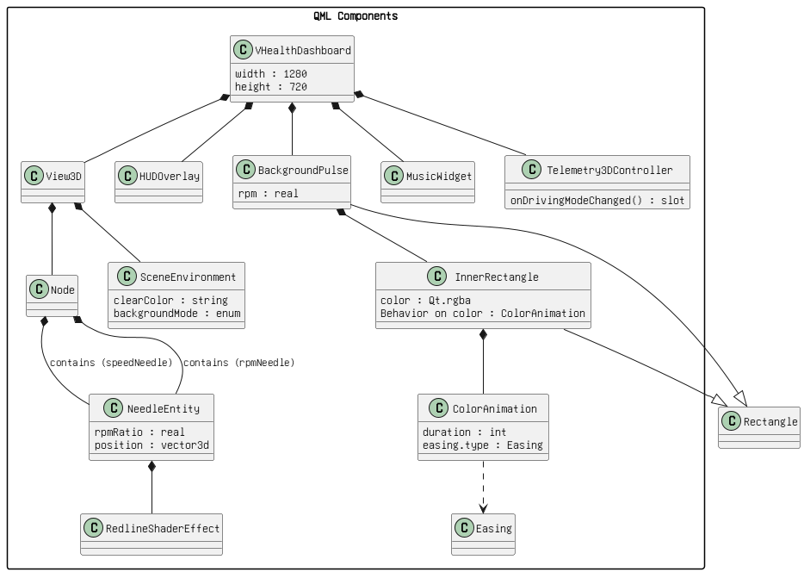

Figure: 1. BackgroundPulse.png

Gauge.qml.drawio.png

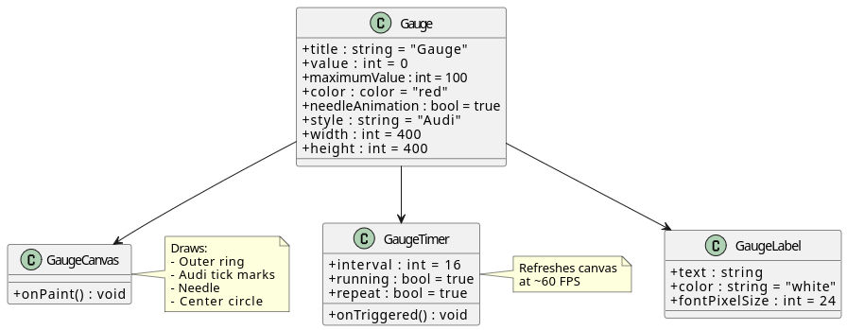

Figure: 2. Gauge.qml.drawio.png

GlowNeedleMaterial.drawio.png

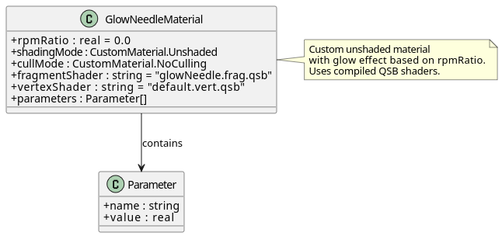

Figure: 3. GlowNeedleMaterial.drawio.png

HUDOverlay.drawio.png

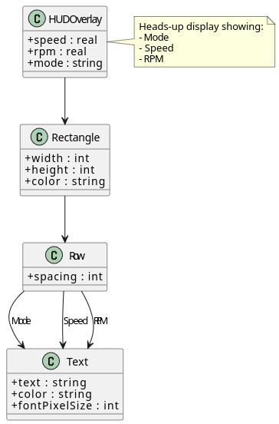

Figure: 4. HUDOverlay.drawio.png

MusicWidgetdrawio.drawio.png

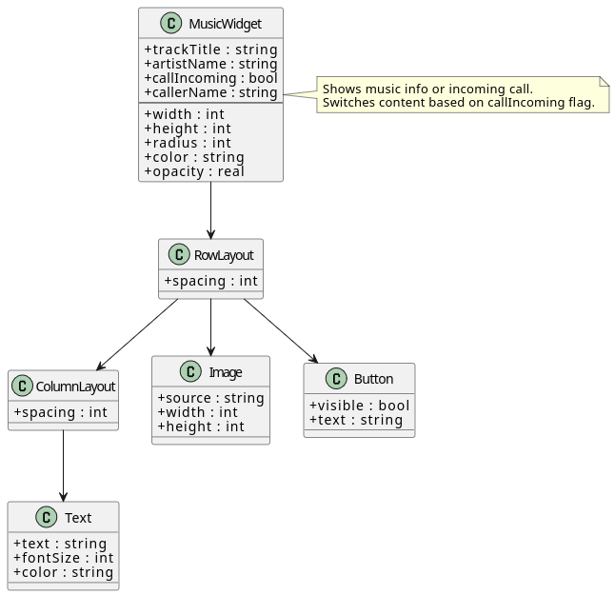

Figure: 5. MusicWidgetdrawio.drawio.png

NeedleEntity.drawio.png

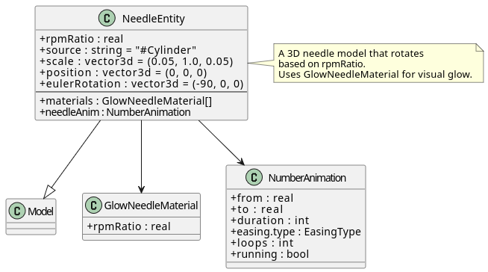

Figure: 6. NeedleEntity.drawio.png

RedlineShaderEffect.drawio.png

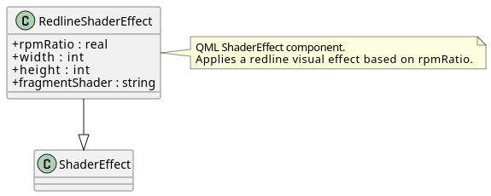

Figure: 7. RedlineShaderEffect.drawio.png

Telemetry3DController.drawio.png

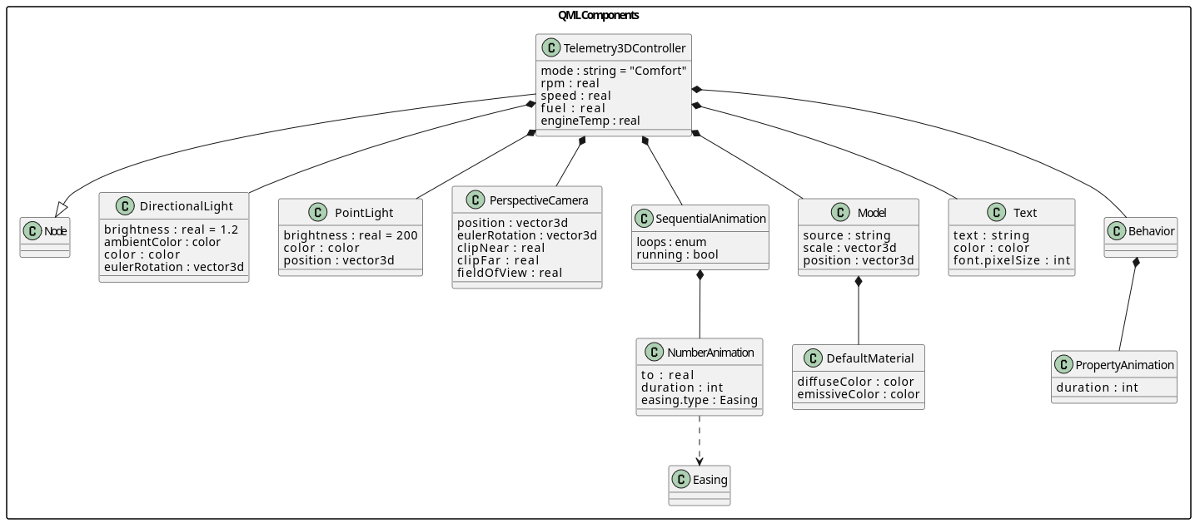

Figure: 8. Telemetry3DController.drawio.png

VHealthDashboard.drawio.png

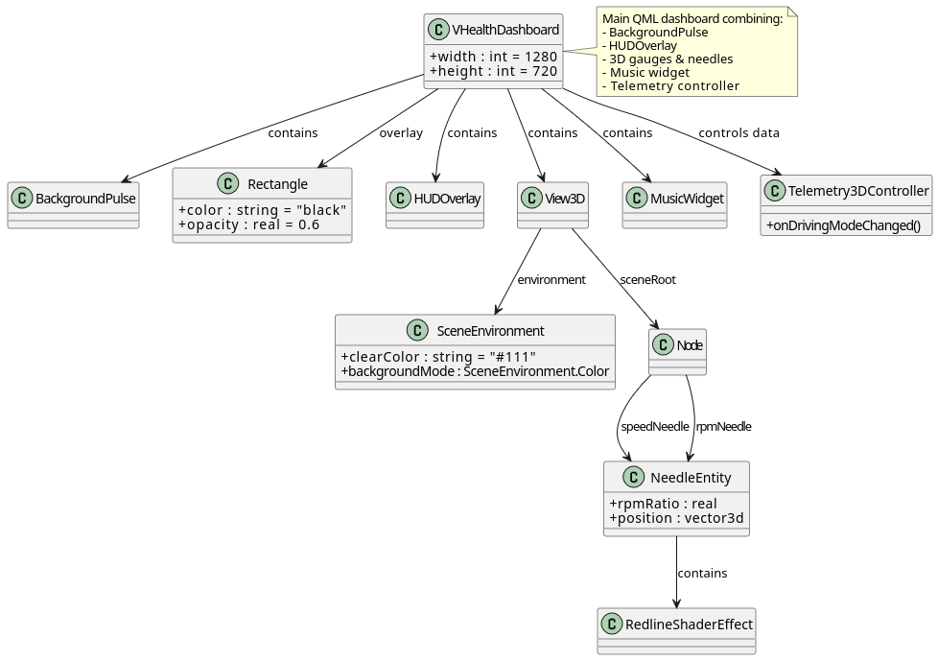

Figure: 9. VHealthDashboard.drawio.png