Analyst Base - Design Document

Author: Abhishek Chauhan

List of Figures

Figure 1: DC grouped by profiles.png

Figure 2: Docker compose.png

Figure 3: check class versions.png

Figure 4: debug clj.png

Figure 5: debug test.png

Figure 6: deps graph clj.png

Figure 7: deps graph.png

Figure 8: dev add load cloj.png

Figure 9: explain.clj.png

Figure 10: generate.clj.png

Figure 11: h2.clj.png

Figure 12: helpers.clj.png

Figure 13: liquidbase.png

Figure 14: malli.clj.png

Figure 15: memory.png

Figure 16: mermaid.clj.png

Figure 17: metabase dev environment.png

Figure 18: migrate test.png

Figure 19: migrate.clj.png

Figure 20: model track.clj.png

Figure 21: model tracking.png

Figure 22: module score.png

Figure 23: modulrization.png

Figure 24: plus one detection.png

Figure 25: portal.png

Figure 26: private.things.clj.png

Figure 27: process samples workflow.png

Figure 28: prototype.png

Figure 29: prototype.test.png

Figure 30: render.png

Figure 31: routes.png

Figure 32: toucan2 monitor.png

Figure 33: util.png

Figure 34: viewers.png

Figure 35: with perm .png

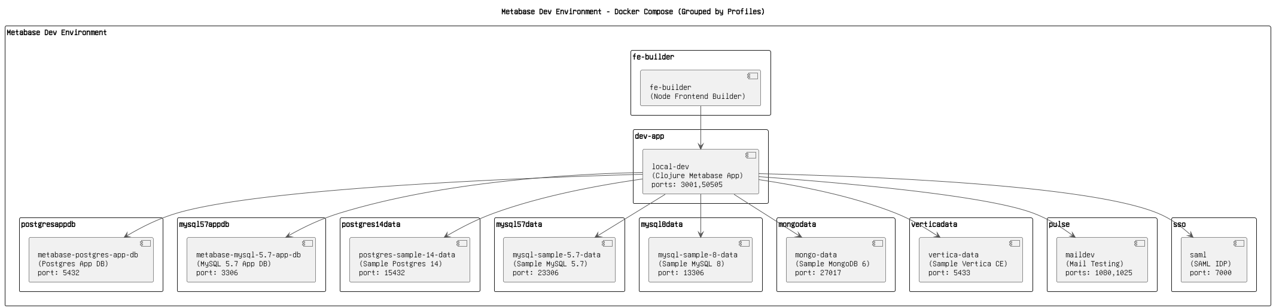

Figure 1: DC grouped by profiles.png

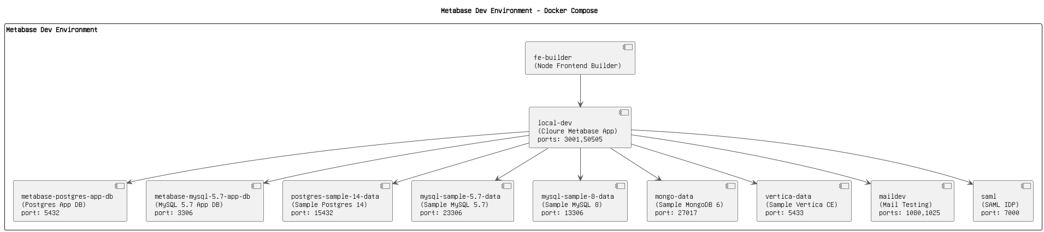

Figure 2: Docker compose.png

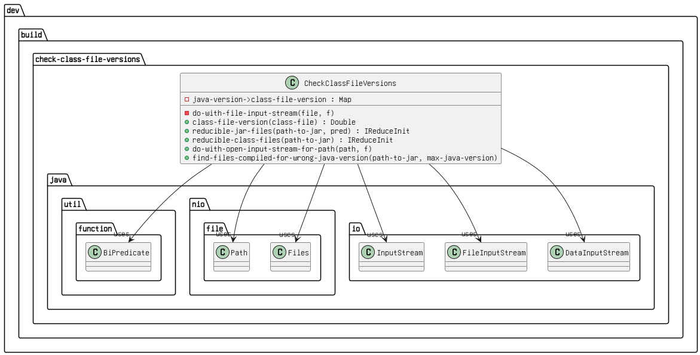

Figure 3: check class versions.png

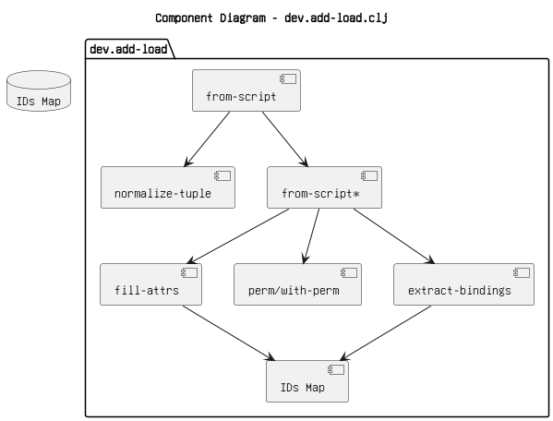

Figure 4: debug clj.png

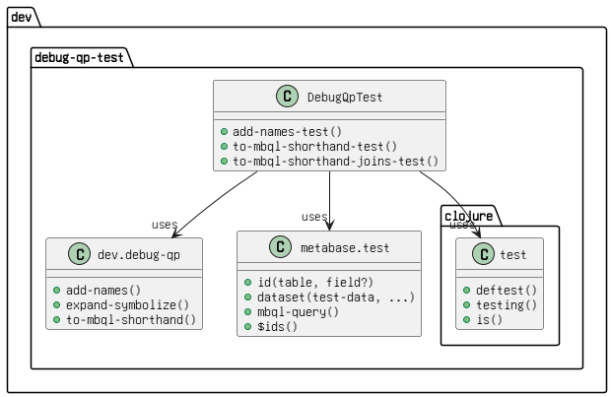

Figure 5: debug test.png

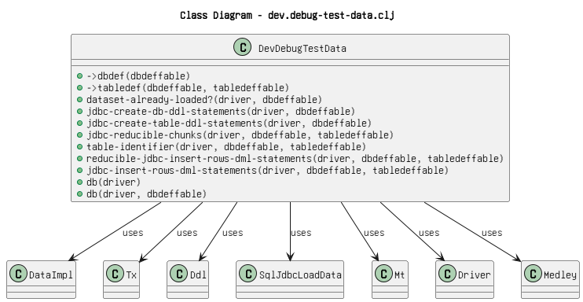

Figure 6: deps graph clj.png

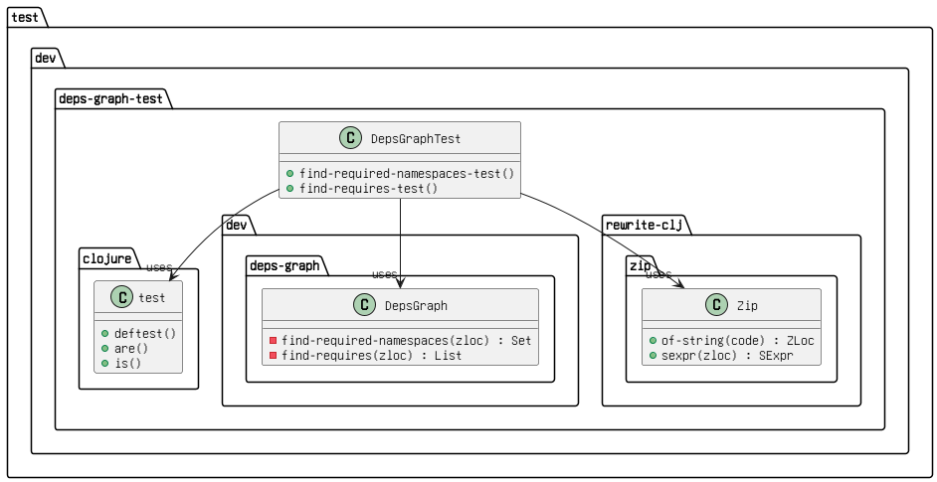

Figure 7: deps graph.png

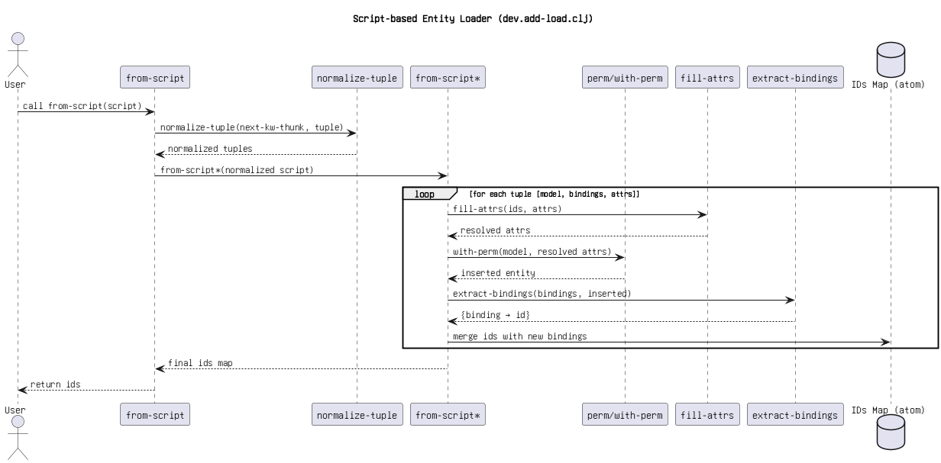

Figure 8: dev add load cloj.png

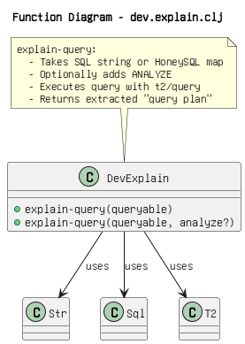

Figure 9: explain.clj.png

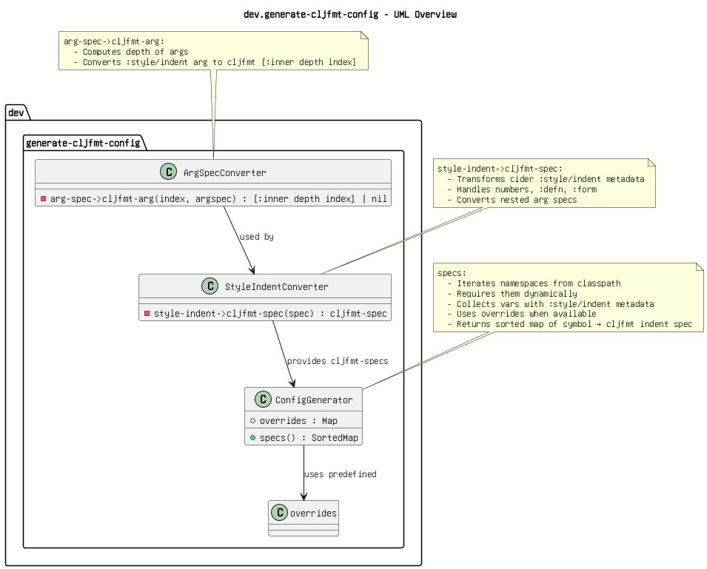

Figure 10: generate.clj.png

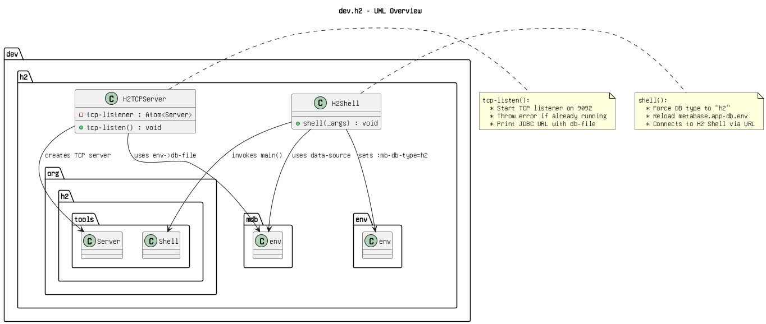

Figure 11: h2.clj.png

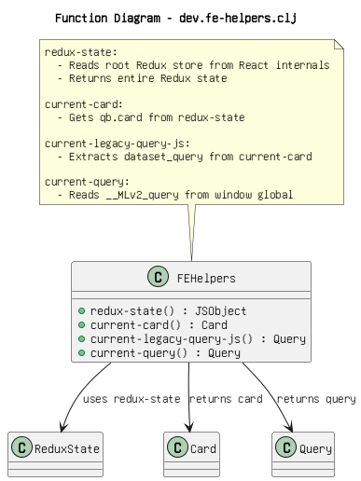

Figure 12: helpers.clj.png

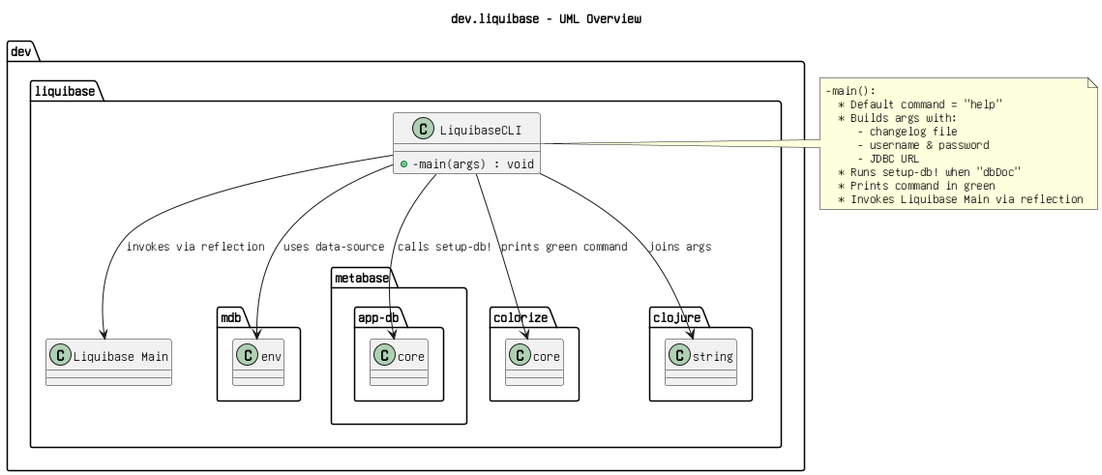

Figure 13: liquidbase.png

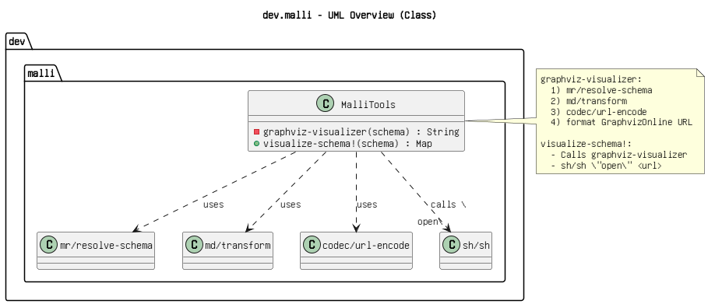

Figure 14: malli.clj.png

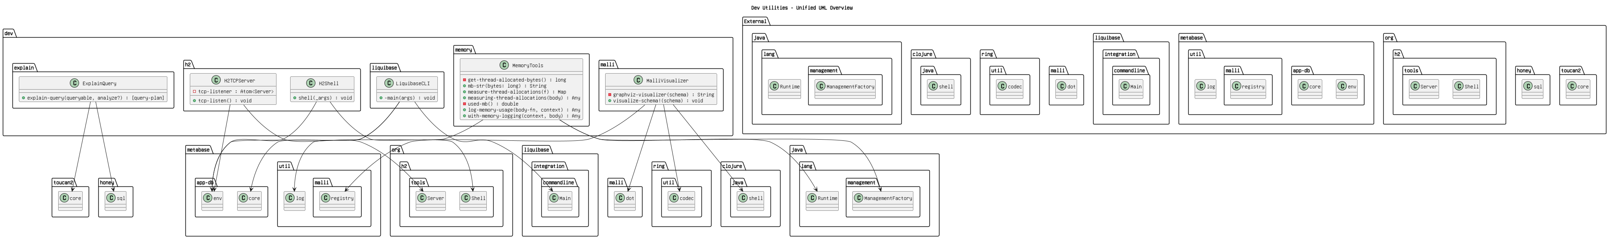

Figure 15: memory.png

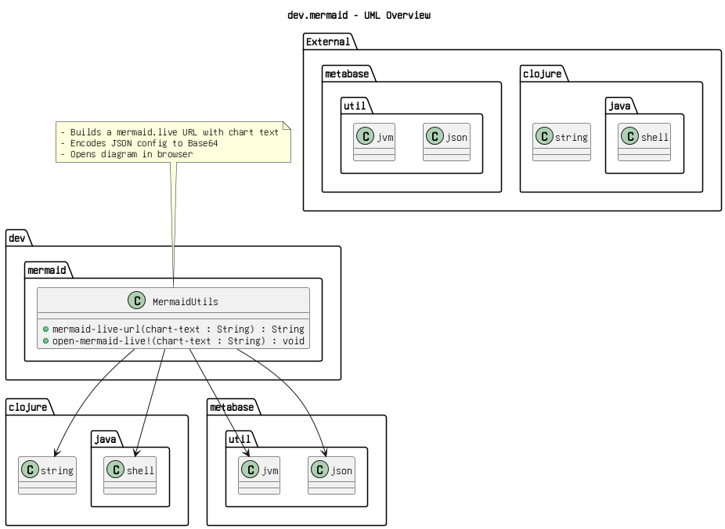

Figure 16: mermaid.clj.png

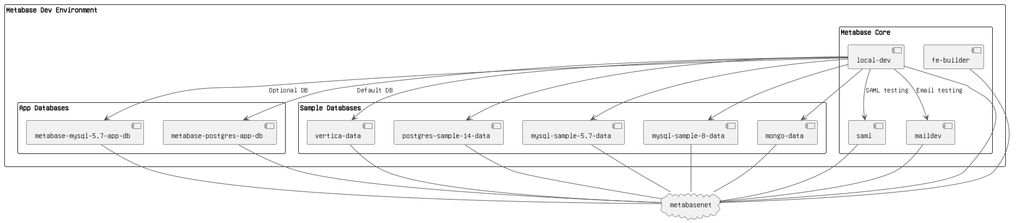

Figure 17: metabase dev environment.png

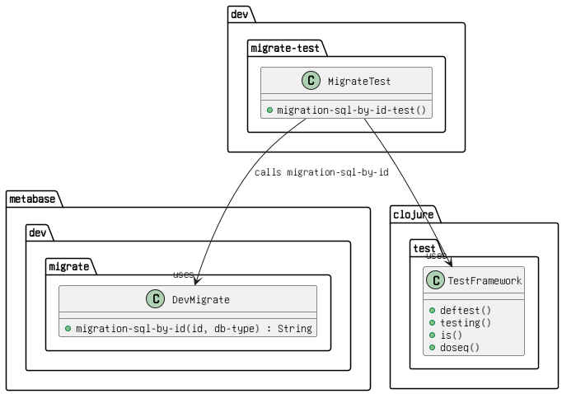

Figure 18: migrate test.png

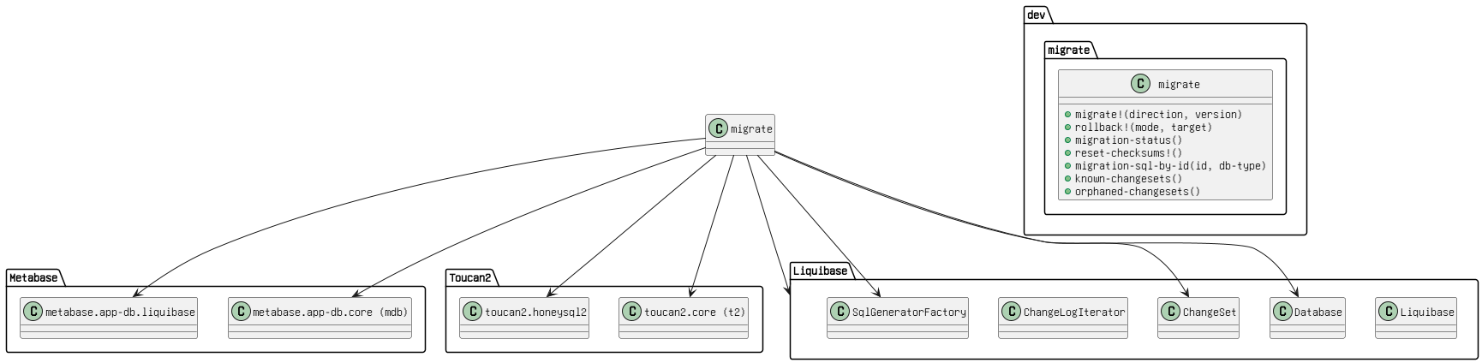

Figure 19: migrate.clj.png

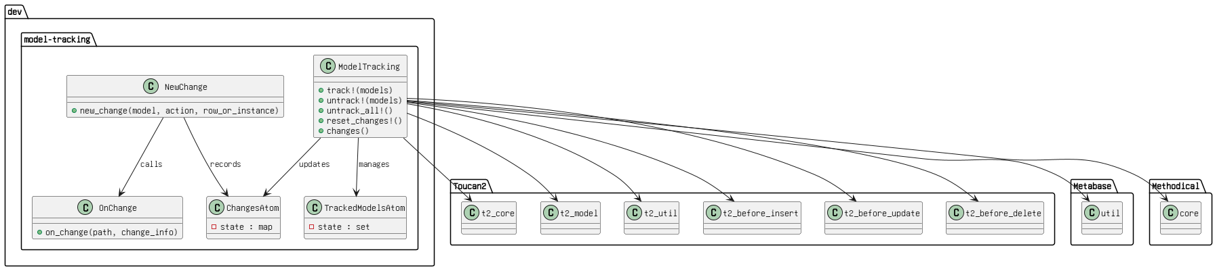

Figure 20: model track.clj.png

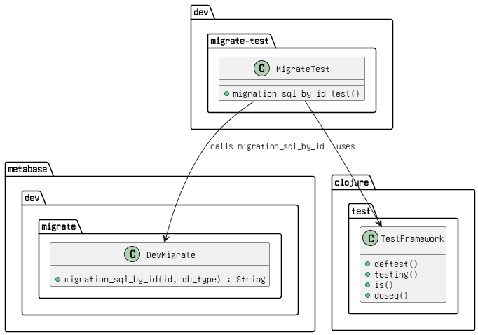

Figure 21: model tracking.png

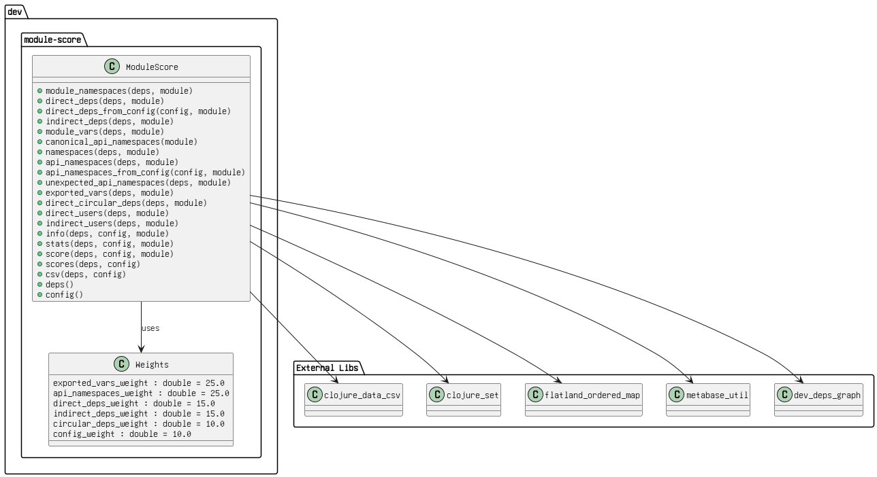

Figure 22: module score.png

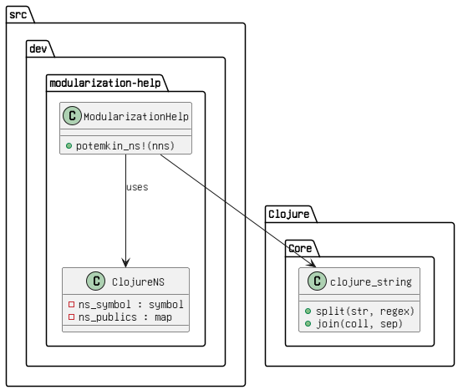

Figure 23: modulrization.png

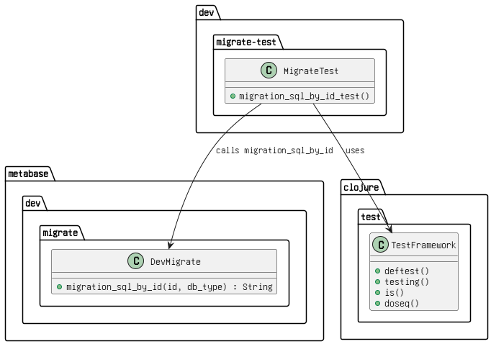

Figure 24: plus one detection.png

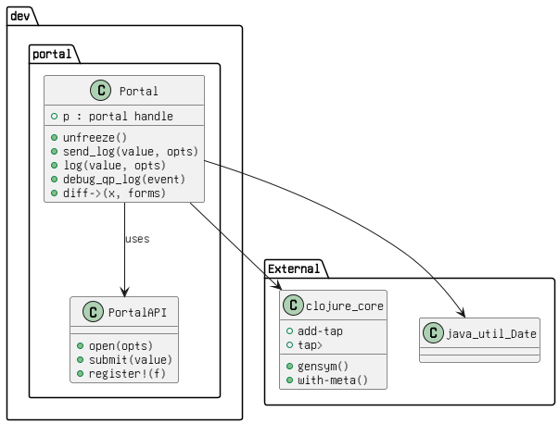

Figure 25: portal.png

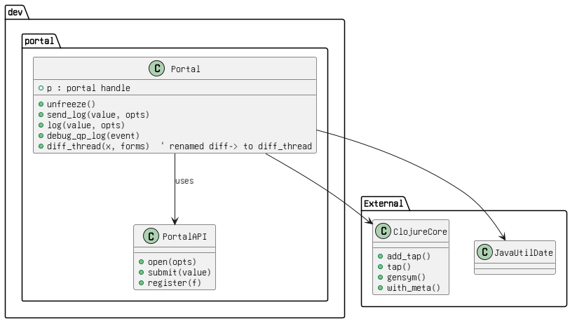

Figure 26: private.things.clj.png

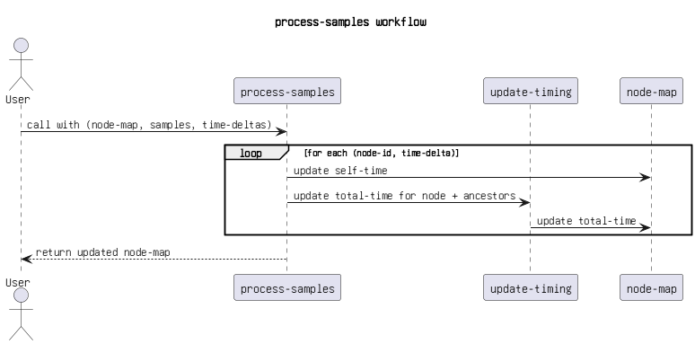

Figure 27: process samples workflow.png

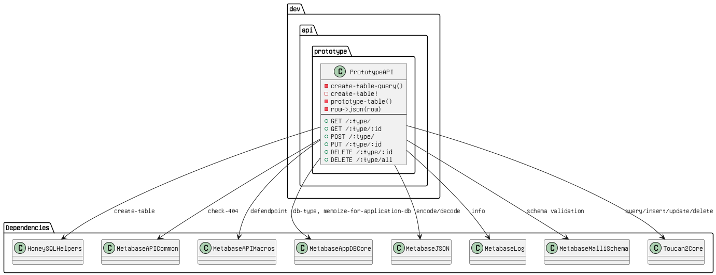

Figure 28: prototype.png

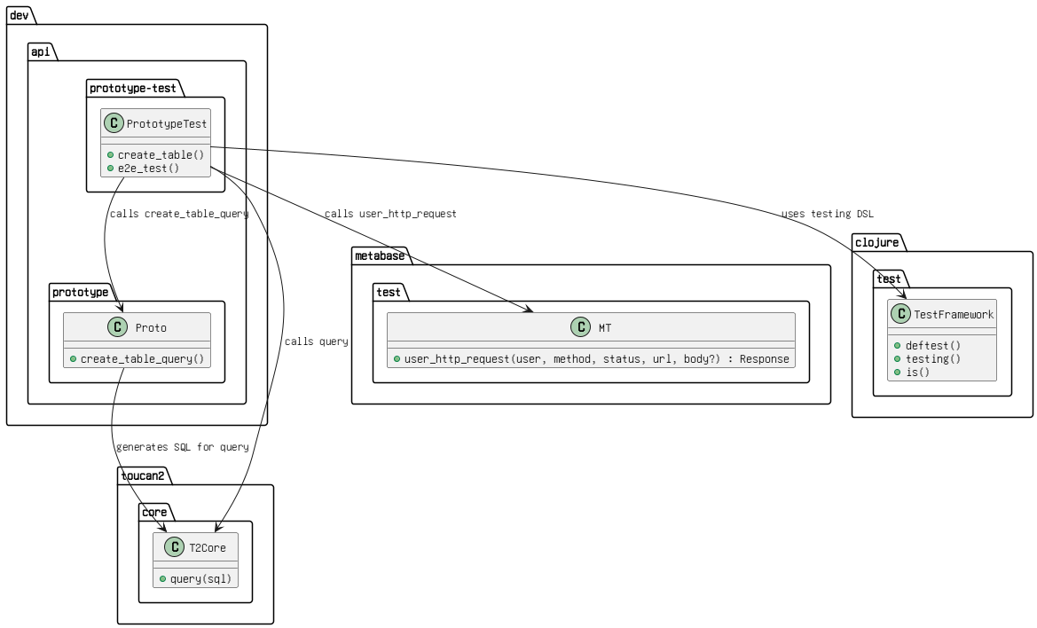

Figure 29: prototype.test.png

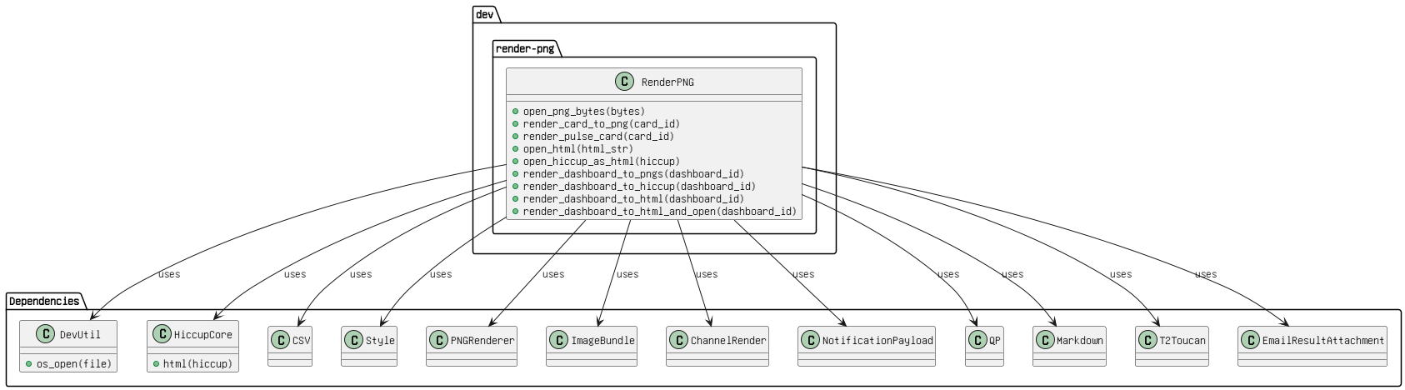

Figure 30: render.png

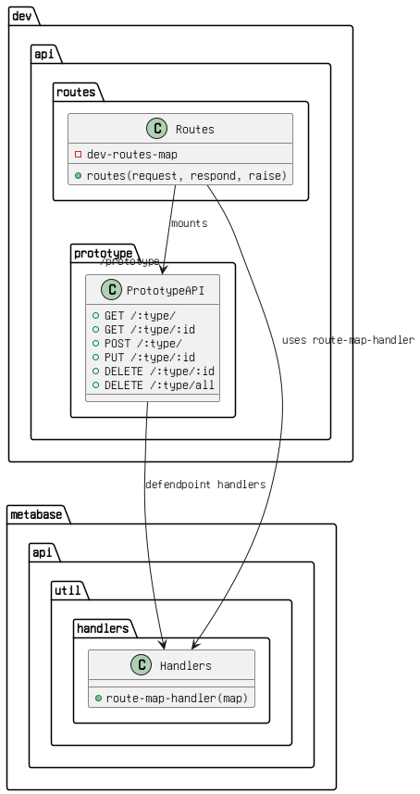

Figure 31: routes.png

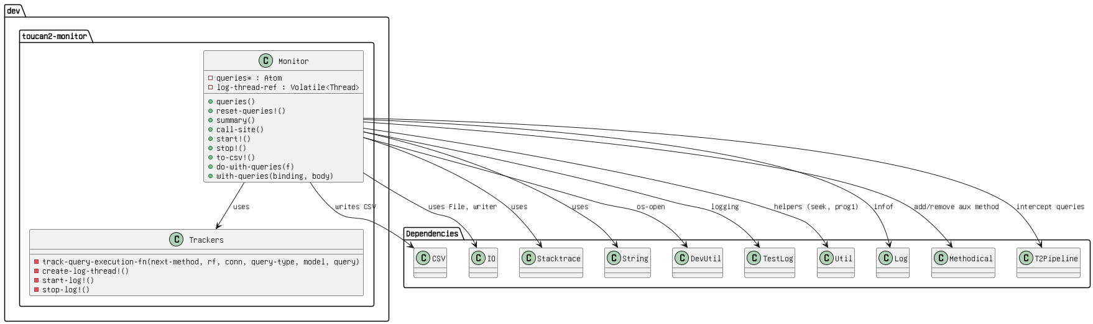

Figure 32: toucan2 monitor.png

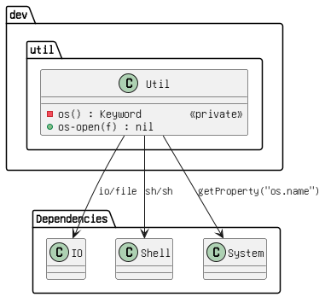

Figure 33: util.png

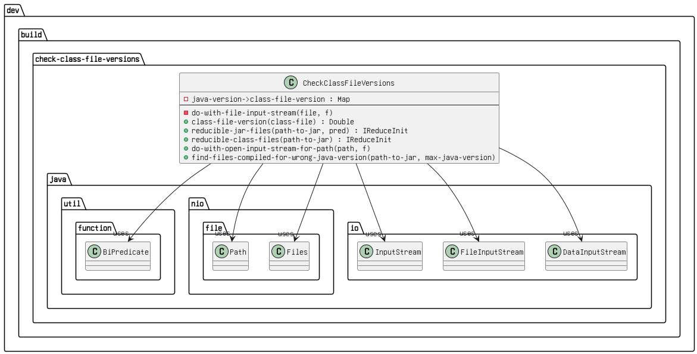

Figure 34: viewers.png

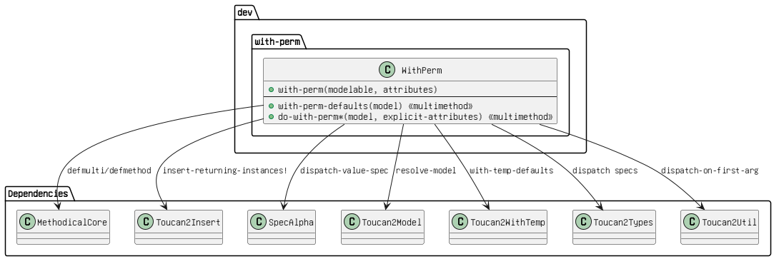

Figure 35: with perm .png