TECHNICAL ARCHITECTURE DOCUMENT
DeployWhisper
Complete Tech Stack, System Architecture & AI Skills Engine
Pure Python Stack | Streamlit + FastAPI + LiteLLM + AI Skills
Version 1.0 | April 2026 | Confidential

Table of contents
Table of contents 2
1. Architecture overview 3
1.1 Design philosophy 3
1.2 System layers 3
1.3 Why Streamlit, not React 4
2. Complete tech stack 5
2.1 Core dependencies 5
2.2 Parser and analysis dependencies 5
2.3 Development dependencies 5
3. Project structure 7
4. AI skills engine architecture 9
4.1 Skill file format 9
4.2 Skill loader implementation 9
4.3 Skill injection into LLM prompt 11
4.4 Skill inventory 11
4.5 Custom skill authoring 12
5. Data flow architecture 13
5.1 Request lifecycle 13
6. Database schema 14
7. Deployment architecture 14
7.1 Docker setup 14
7.2 Run commands 15
8. Security architecture 16
9. Extensibility guide 16
9.1 Adding a new IaC parser 16
9.2 Adding a new LLM provider 16
9.3 Adding a new AI skill 16
10. Technology decision log 17

1. Architecture overview

1.1 Design philosophy
Pure Python + AI Skills — Zero JavaScript
The entire application is built in Python. Streamlit serves as the frontend, FastAPI as the API layer, and LiteLLM as the LLM abstraction. A new AI Skills engine injects deep, tool-specific domain knowledge into the LLM context, transforming a generic model into a specialist DevOps reviewer that understands Terraform provider quirks, K8s admission pitfalls, Ansible idempotency rules, and more.

1.2 System layers
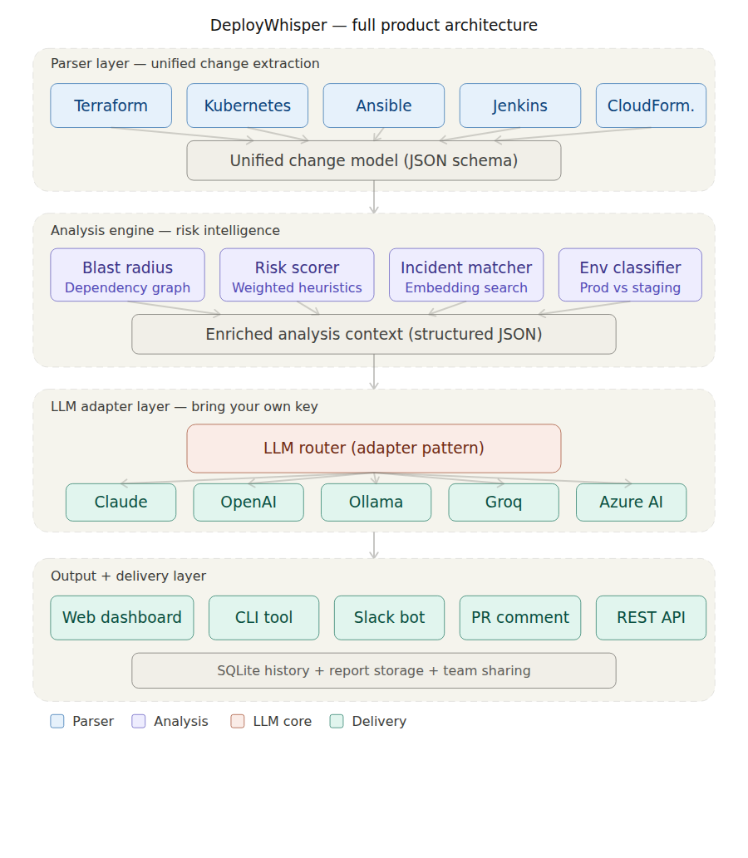
Figure 1: DeployWhisper system architecture — four-layer pipeline from IaC parsers to AI-powered risk dashboard
Layer | Technology | Responsibility | Communication
Presentation | Streamlit | Dashboard UI, file upload, settings | Direct Python calls to backend modules
API | FastAPI | REST endpoints for CLI, Slack, CI/CD | JSON over HTTP for external integrations
Analysis Engine | Pure Python | Parsing, risk scoring, blast radius | Python dataclass objects between modules
AI Skills Engine | Markdown + Python | Tool-specific knowledge injection | Loads skill files into LLM system prompt dynamically
LLM Layer | LiteLLM | Multi-provider LLM abstraction | Standardized completion() calls
Persistence | SQLite + SQLAlchemy | History, incident DB, configuration | ORM queries via SQLAlchemy

1.3 Why Streamlit, not React
- Single language: The entire team writes Python. No context-switching to JavaScript/TypeScript.
- Zero build tooling: No webpack, no Vite, no npm. Runs with: streamlit run app.py
- Built-in components: Charts, tables, file upload, forms, metrics gauges, layout columns — all native.
- Rapid iteration: Hot reload on file save. No compile step.
- Production-proven: Used at Snowflake, Uber, JP Morgan in production dashboards.
- Custom viz when needed: streamlit-agraph for graph viz, Plotly for gauges, or embed any HTML/JS component.

2. Complete tech stack

2.1 Core dependencies
Package | Version | Purpose | Rationale
python | 3.11+ | Runtime | Pattern matching, tomllib, performance improvements
streamlit | 1.42+ | Frontend dashboard | Full-featured Python UI framework with zero JS
fastapi | 0.115+ | REST API server | Async support, auto OpenAPI docs, Pydantic integration
uvicorn | 0.34+ | ASGI server | Production-grade async server for FastAPI
litellm | 1.60+ | LLM abstraction | Unified API for 100+ LLM providers
sqlalchemy | 2.0+ | ORM / database | Type-safe ORM with SQLite backend
pydantic | 2.10+ | Data validation | Schema validation for all data contracts

2.2 Parser and analysis dependencies
Package | Version | Purpose
python-hcl2 | 5.0+ | Parse HCL/Terraform files when JSON plan is unavailable
pyyaml | 6.0+ | YAML parsing for Kubernetes, Ansible, and CloudFormation
deepdiff | 8.0+ | Deep structural comparison for K8s manifest and CFN template diffs
ruamel.yaml | 0.18+ | Round-trip YAML parsing for Ansible (preserves comments and structure)
networkx | 3.4+ | Graph data structure for blast radius dependency traversal (BFS/DFS)
plotly | 6.0+ | Interactive charts: risk gauge, change breakdown bar, trend lines
streamlit-agraph | 0.0.45+ | Interactive network graph for blast radius visualization

2.3 Development dependencies
Package | Version | Purpose
pytest | 8.0+ | Unit and integration testing for parsers, skills, risk scorer, and LLM narrator
pytest-benchmark | 5.1+ | Performance benchmarking for parser throughput requirements (FR-10)
ruff | 0.8+ | Linting and formatting (replaces flake8 + black + isort)
mypy | 1.14+ | Static type checking for all Python modules
python-dotenv | 1.0+ | Load .env file for API keys during development

3. Project structure
deploywhisper/
├── app.py # Streamlit entry point
├── server.py # FastAPI entry (CLI/API mode)
├── config.py # Settings, env vars, LLM config
├── requirements.txt
├── Dockerfile
├── docker-compose.yml
│
├── parsers/
│ ├── base.py # UnifiedChange Pydantic model
│ ├── registry.py # Auto-detect parser from file
│ ├── terraform_parser.py
│ ├── kubernetes_parser.py
│ ├── ansible_parser.py
│ ├── jenkins_parser.py
│ └── cloudformation_parser.py
│
├── skills/ # AI Skills knowledge base
│ ├── __init__.py
│ ├── loader.py # Skill discovery + injection
│ ├── base_skill.py # BaseSkill abstract class
│ ├── terraform.md # Terraform domain knowledge
│ ├── kubernetes.md # K8s domain knowledge
│ ├── ansible.md # Ansible domain knowledge
│ ├── jenkins.md # Jenkins domain knowledge
│ ├── cloudformation.md # CFN domain knowledge
│ ├── git.md # Git context knowledge
│ ├── docker.md # Container knowledge
│ └── custom/ # Team-specific skill overrides
│ └── .gitkeep
│
├── analysis/
│ ├── blast_radius.py # NetworkX graph + BFS
│ ├── risk_scorer.py # Weighted heuristic scoring
│ ├── incident_matcher.py # Embedding similarity search
│ └── env_classifier.py # Prod/staging/dev detection
│
├── llm/
│ ├── narrator.py # LiteLLM + skill-enhanced prompt
│ ├── prompts.py # System prompts + output schema
│ └── providers.py # Provider config + validation
│
├── models/
│ ├── database.py # SQLAlchemy engine + session
│ ├── schemas.py # Pydantic API schemas
│ └── tables.py # SQLAlchemy ORM models
│
├── ui/
│ ├── components/ # Streamlit UI components
│ ├── pages/ # Multi-page app routes
│ └── styles/theme.py # Streamlit theming
│
├── samples/ # Pre-built demo scenarios
└── tests/
├── test_parsers/
├── test_skills/
├── test_analysis/
└── test_integration/

4. AI skills engine architecture
Core concept
AI Skills are structured markdown files containing curated domain knowledge about specific DevOps tools. When the system detects that a user uploaded Terraform files, the Terraform skill is loaded into the LLM system prompt. This gives the AI the same deep expertise that a senior engineer has about tool-specific pitfalls, best practices, and failure modes.

4.1 Skill file format
Each skill is a markdown file with a structured frontmatter header and organized knowledge sections:
# skills/terraform.md

---
skill: terraform
version: 1.0
triggers: [.tf, .tfvars, terraform-plan.json]
token_budget: 1500
---

## Critical risk patterns
- Security group with 0.0.0.0/0 on any port = CRITICAL
- IAM policy with Action: '*' or Resource: '*' = CRITICAL
- RDS instance without deletion_protection = HIGH
- S3 bucket without block_public_access = HIGH
- EC2 instance in public subnet without SG restriction = HIGH

## State-sensitive operations
- Resources with prevent_destroy lifecycle = flag if being destroyed
- Resources with ignore_changes = warn that drift may exist
- Backend configuration changes = CRITICAL (state loss risk)
- Provider version changes = MEDIUM (behavior may change)

## Common failure modes
- Plan/apply divergence when using data sources with changing values
- Module version upgrade changing resource addresses (forces recreate)
- Count/for_each index shift causing unintended destroys
- State lock contention in CI/CD with concurrent pipelines

## Provider-specific risks
- AWS: eventual consistency on IAM (5-10 second propagation delay)
- AWS: RDS modifications may require reboot (check apply_immediately)
- GCP: project-level IAM bindings are authoritative (removes others)
- Azure: resource group deletion cascades to all contained resources

4.2 Skill loader implementation
# skills/loader.py
import os
from pathlib import Path
from typing import Optional

SKILLS_DIR = Path(__file__).parent
CUSTOM_DIR = SKILLS_DIR / 'custom'

# Map file extensions to skill names
TRIGGER_MAP = {
'.tf': 'terraform', '.tfvars': 'terraform',
'.yaml': ['kubernetes', 'ansible', 'cloudformation'],
'.yml': ['kubernetes', 'ansible', 'cloudformation'],
'Jenkinsfile': 'jenkins',
'Dockerfile': 'docker',
'.diff': 'git', '.patch': 'git',
}

def detect_skills(filenames: list[str]) -> set[str]:
"""Auto-detect which skills to load from file names."""
skills = set()
for name in filenames:
ext = Path(name).suffix or Path(name).name
matched = TRIGGER_MAP.get(ext, [])
if isinstance(matched, str):
skills.add(matched)
else:
skills.update(matched)
skills.add('git') # Always load Git skill
return skills

def load_skill(name: str) -> Optional[str]:
"""Load a skill file. Custom overrides take precedence."""
custom = CUSTOM_DIR / f'{name}.md'
default = SKILLS_DIR / f'{name}.md'
path = custom if custom.exists() else default
if not path.exists():
return None
content = path.read_text()
# Strip frontmatter
if content.startswith('---'):
end = content.index('---', 3)
content = content[end+3:].strip()
return content

def build_skill_context(filenames: list[str]) -> str:
"""Build combined skill context for LLM prompt."""
skills = detect_skills(filenames)
sections = []
for name in sorted(skills):
content = load_skill(name)
if content:
sections.append(
f'## {name.upper()} SKILL KNOWLEDGE\n{content}'
)
return '\n\n'.join(sections)

4.3 Skill injection into LLM prompt
The narrator module builds the system prompt by combining the base SRE persona with dynamically loaded skills:
# llm/narrator.py
import litellm, json
from skills.loader import build_skill_context
from llm.prompts import BASE_SYSTEM_PROMPT, OUTPUT_SCHEMA

def analyze(changes: list, filenames: list, config) -> dict:
# Build skill-enhanced prompt
skill_context = build_skill_context(filenames)
system_prompt = (
f'{BASE_SYSTEM_PROMPT}\n\n'
f'# TOOL-SPECIFIC KNOWLEDGE\n'
f'Use the following domain expertise to inform '
f'your risk analysis. Apply these patterns when '
f'evaluating the changes below.\n\n'
f'{skill_context}\n\n'
f'# OUTPUT FORMAT\n{OUTPUT_SCHEMA}'
)

response = litellm.completion(
model=config.llm_model,
api_key=config.llm_api_key,
api_base=config.llm_api_base,
messages=[
{'role': 'system', 'content': system_prompt},
{'role': 'user', 'content': json.dumps(changes)},
],
response_format={'type': 'json_object'},
temperature=0.3,
)
return json.loads(
response.choices[0].message.content
)

4.4 Skill inventory
Skill | Trigger | Key knowledge areas | Example risk the skill catches
Terraform | .tf, .tfvars | Provider risks, state ops, lifecycle rules | Security group change opening 0.0.0.0/0 on port 5432 flagged as CRITICAL with AWS-specific propagation delay warning
Kubernetes | .yaml (K8s) | Workload safety, RBAC, network policy | Deployment missing readiness probe with maxUnavailable=100% flagged as HIGH risk for full outage during rollout
Ansible | .yml (playbook) | Module danger, idempotency, inventory | Task using shell module targeting all production hosts without changed_when guard flagged as HIGH
Jenkins | Jenkinsfile | Gates, credentials, agent security | Removed input() approval step before production deploy stage flagged as CRITICAL with rollback complexity increase
CloudFormation | .yaml (CFN) | Replacements, deletion policy, IAM | DynamoDB table change requiring replacement without DeletionPolicy:Retain flagged as CRITICAL data loss risk
Git | Always loaded | Commit context, author, branch, secrets | .env file detected in commit, blocked from LLM transmission; force-push detected on main branch flagged as warning
Docker | Dockerfile | Image safety, build risks, compose | Container running as root with host network access flagged as HIGH; unpinned base image tag flagged as MEDIUM

4.5 Custom skill authoring
Teams can extend or override any built-in skill by placing a markdown file with the same name in the skills/custom/ directory:
- Custom skills take precedence over built-in skills with the same filename.
- Teams can add entirely new skills (e.g., pulumi.md, helm.md, argocd.md) that auto-load when matching file extensions are detected.
- Custom skills follow the same markdown format with frontmatter, making them easy to author without any Python code.
- A skill authoring guide and template are provided in the repository documentation.

5. Data flow architecture

5.1 Request lifecycle
Step | Component | Input | Output
1 | File upload | Raw files (.tf, .yaml, Jenkinsfile) | File bytes + detected tool type
2 | Parser registry | File bytes + tool type | Routes to correct parser
3 | Tool parser | Raw file content | List[UnifiedChange] normalized objects
4 | Risk scorer | List[UnifiedChange] | Risk score (0–100) + risk level
5 | Blast radius mapper | Changes + dependency graph | List[AffectedNode] with depth
6 | Env classifier | Resource names + paths | Environment enum + multiplier
7 | Incident matcher | Change summary embedding | List[MatchedIncident] with scores
8 | Skill loader | Detected file extensions | Combined skill context string for LLM
9 | LLM narrator | Analysis context + skill context | RiskReport with narrative and rollback
10 | Dashboard render | RiskReport dataclass | Streamlit UI with all panels
11 | Persistence | RiskReport | SQLite row in analysis_history

6. Database schema
SQLite with SQLAlchemy ORM. Auto-created at ./data/deploywhisper.db on first run.
class AnalysisReport(Base):
__tablename__ = 'analysis_reports'
id = Column(Integer, primary_key=True)
created_at = Column(DateTime, default=datetime.utcnow)
risk_score = Column(Integer)
risk_level = Column(String(20))
narrative = Column(Text)
top_risk = Column(Text)
changes = Column(JSON)
blast_radius = Column(JSON)
rollback_plan = Column(JSON)
rollback_complexity = Column(Integer)
tools_used = Column(JSON)
skills_loaded = Column(JSON) # NEW: which skills were used
file_count = Column(Integer)
llm_provider = Column(String(50))
llm_model = Column(String(100))
go_no_go = Column(String(20))
content_hash = Column(String(64)) # NEW: for caching (FR-10)

class IncidentRecord(Base):
__tablename__ = 'incidents'
id = Column(Integer, primary_key=True)
date = Column(DateTime)
title = Column(String(255))
severity = Column(String(20))
description = Column(Text)
embedding = Column(JSON)
tags = Column(JSON)

7. Deployment architecture

7.1 Docker setup
# Dockerfile
FROM python:3.11-slim
WORKDIR /app
COPY requirements.txt .
RUN pip install --no-cache-dir -r requirements.txt
COPY . .
EXPOSE 8501 8000
CMD ["streamlit", "run", "app.py",
"--server.port=8501", "--server.address=0.0.0.0"]

# docker-compose.yml
services:
deploywhisper:
build: .
ports:
- '8501:8501'
- '8000:8000'
environment:
- LLM_PROVIDER=${LLM_PROVIDER:-claude}
- LLM_MODEL=${LLM_MODEL:-claude-sonnet-4-20250514}
- LLM_API_KEY=${LLM_API_KEY}
volumes:
- ./data:/app/data
- ./skills/custom:/app/skills/custom

7.2 Run commands
Mode | Command | Use case
Dashboard | streamlit run app.py | Interactive web UI for browser-based analysis
API server | uvicorn server:app --port 8000 | REST API for CLI tools, Slack bots, CI/CD
CLI | python -m deploywhisper analyze plan.json | Headless analysis from terminal, outputs JSON
Docker | docker compose up -d | Containerized deployment with persistent storage

8. Security architecture
Security is implemented as a functional requirement (FR-11), not an afterthought. Key enforcement points:
- API keys: Environment variables or session-state only. Never persisted to disk, database, or logs.
- Data minimization: Parsers extract structured metadata. Raw IaC content never leaves the local machine.
- Sensitive file detection: Git skill auto-detects .env, private keys, kubeconfig and blocks LLM transmission.
- Air-gap mode: Ollama local deployment ensures zero network egress for classified environments.
- Log sanitization: Application logs contain timestamps, filenames, scores, and errors only.
- Content hashing: SHA-256 hash of input content used for cache keys; original content not stored in cache.

9. Extensibility guide

9.1 Adding a new IaC parser
- Step 1: Create parsers/new_tool_parser.py implementing parse(content) -> list[UnifiedChange]
- Step 2: Register file extension in parsers/registry.py AUTO_DETECT_MAP
- Step 3: Create matching skills/new_tool.md with domain knowledge
- Step 4: Add trigger extension to skills/loader.py TRIGGER_MAP
No changes needed in the analysis engine, LLM narrator, or dashboard. Everything consumes the UnifiedChange interface.

9.2 Adding a new LLM provider
If LiteLLM supports the provider (100+ supported), you only need to add the provider to the config dropdown and its environment variable to .env.example. Zero code changes to the narrator.

9.3 Adding a new AI skill
Drop a markdown file in skills/custom/ with frontmatter specifying trigger extensions. The loader auto-discovers and injects it. No Python code required.

10. Technology decision log
Decision | Chosen | Rationale
Frontend | Streamlit | Pure Python, zero JS build tooling, built-in charts/tables/uploads, hot reload, production-proven at Snowflake and Uber
Backend API | FastAPI | Async, auto OpenAPI docs, native Pydantic integration, same language as frontend
LLM layer | LiteLLM | Single completion() call for 100+ providers. No per-provider adapter code
AI Skills | Markdown files | Human-readable, version-controlled, customizable without Python. Token-efficient injection into LLM context
Database | SQLite + SQLAlchemy | Zero setup, file-based, sufficient for single-team use
Visualization | Plotly + agraph | Plotly for charts (Python-native), agraph for interactive network graphs
Testing | pytest + benchmark | Industry standard for Python, plus benchmark plugin for FR-10 parser throughput verification

