Power Cube

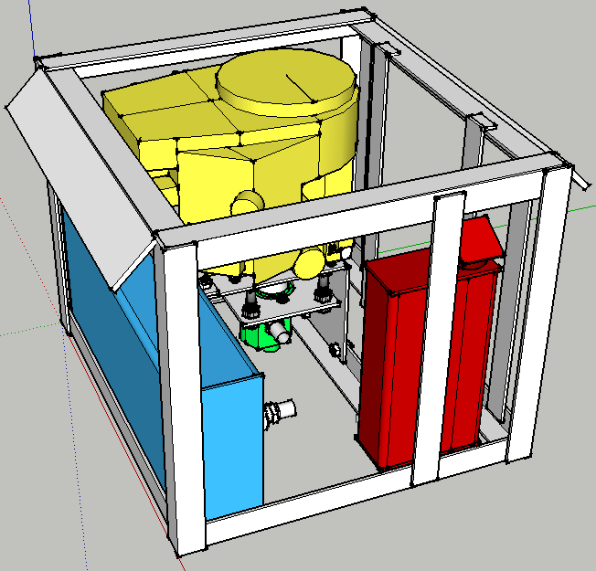

Version 4

Contents
Table of Contents
Power Cube 1
Contents 2
Introduction 3
Bill Of Materials 4
Discrete parts 4
Steel 5
Subassembly Fabrication 6
Assembly 8
User Guide 15

Introduction

The Power Cube is an universal, self-contained power unit that consists of an engine coupled to a hydraulic pump for providing power in the form of hydraulic fluid at high pressure. It connects via quick couplers and quick-connect hydraulic hoses to devices such as:

- LifeTrac
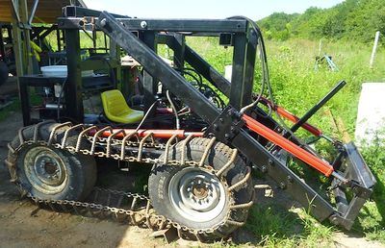
- CEB Press
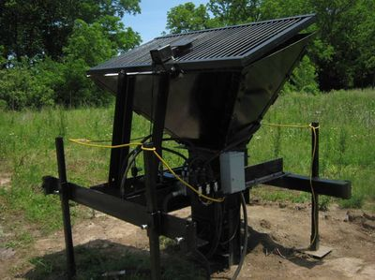
- Sawmill
  - 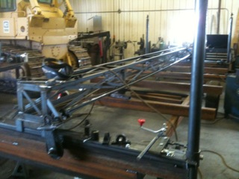

This document provides information for building and using a Power Cube as part of the Open Source Ecology (OSE) project.

Check the OSE website for updates to this document:

http://opensourceecology.org/wiki/File:Powercube.odt

Bill Of Materials

Discrete parts

Name | Qty | Dimensions | Manufacturer / Retailer | Part No.
Engine | 1 | 28 HP | Briggs & Stratton | 49M777 Series
Solid Shaft Coupling | 1 | 1 1/8” x 5/8” | Sweiger Shop | Custom
Hydraulic Pump | 1 | 0.976 cu in | SurplusCenter.com | 9-1766-B
SAE 10M x 3/4” NPTF Adapter | 1 | 3/4” NPTM | SurplusCenter.com | 9-6405-10-12
3/4" NPTF Return Filter & Head | 1 | 20 GPM | SurplusCenter.com | 9-059
14 GPM Hydraulic Tank Strainer | 1 | 1 1/2” F x 1” M | SurplusCenter.com | 9-7290-100
3/4" NPTM TO 3/4" NPTM 90 Elbow | 1 | ¾” | SurplusCenter.com | 9-5500-10-12
JIC 12M x 3/4 NPTM 90 ELBOW | 1 | 12M x 3/4” | SurplusCenter.com | 9-2501-12-12
3/4" Quick Coupler S40-6 F/F | 1 | 3/4” | SurplusCenter.com | 928-C
1/4" NPT Quick Coupler S40-2 | 1 | 1/4” | SurplusCenter.com | 9-6314
1/4 NPTM TO 3/4 NPTF ADAPTER | 1 | 1/4” x 3/4” NPT | SurplusCenter.com | 9-5405-12
NPT Weld-In Tank Flange | 1 | 1 1/2” | SurplusCenter.com | 9-7843-24
NPT Weld-In Tank Flange | 2 | 3/4” | SurplusCenter.com | 9-7843-12
NPT Weld-In Tank Flange | 1 | ¼” | SurplusCenter.com | 9-7843-4
Hose barb | 1 | ¼" NPTM x 1/4" | SurplusCenter.com | 455-AA
1" Hose Barb to SAE 12M Adapter | 1 | 1” Hose x SAE 12M | SurplusCenter.com | 9-4604-16-12
1" Hose Barb to 1" NPTM Adapter | 1 | 1” x 1” NPTM | SurplusCenter.com | 9-4404-16-16
Hydraulic Suction Hose | 1 | 3' | SurplusCenter.com | 9-1279
Hydraulic Oil Cooler | 1 | Approx 12” x 15” | SweigerShop.com | Custom
JIC 12F X JIC 12F 3000 PSI HYD HOSE | 1 | 3/4” x 12” | SurplusCenter.com | 951-2212
3/4" NPT PLASTIC TANK BREATHER | 1 | 3/4” | SurplusCenter.com | 9-7957-12
3/4" X 3/4" X 3/4" NPTF TEE | 1 | 3/4" x 3/4" x 3/4" | SurplusCenter.com | 9-5605-12-12-12
3/4" NPT HEX NIPPLE | 4 | 3/4” | SurplusCenter.com | 9-5404-12-12
JIC 12M x 3/4" NPTM 90 Elbow | 1 | 3/4” | SurplusCenter.com | 9-2501-12-12
JIC 12M x JIC 12M UNION | 1 | JIM 12M | SurplusCenter.com | 9-2404-12-12
Solenoid | 1 |  | SurplusCenter.com | 11-1108
12 Volt radiator fan | 1 | 12” - 14” | Auto Part
Rubber Fuel Line | 1 | 24” | Auto Part
Battery | 1 | 5" x 7.5" x 7.5" | Walmart | UIP-7
Galvanized Nipple | 4 | 1” | Home Depot | 64310
Galvanized Elbow | 2 | 1” | Home Depot | 510-003HN
Galvanized Washer | 4 | 2 ½” | ?? | ??
Galvanized Round | 2 | 2” | ?? | ??
Teflon Tape | 1 roll | ½” wide | Home Depot | ??
1 Gauge Wire | 30” | 1 gauge | Auto Part | ??
1 gauge ring connector  - or -  Copper tubing | 6  - or -  9” | 1 gauge  - or -  3/8” | Auto Part | ??
Ignition Switch | 1
12 V Fan Switch | 1
Bolt (Angle iron attach) | 4 | ½” x 2” x 12 TPI
Nut (Angle iron attach) | 4 | ½” x 12 TPI
Washer flat | 8 | ½”
Bolt (Engine mount) | 4 | ¼” x 2” 16 TPI
Nut (Engine mount) | 4 | ¼” x 16 TPI
Bolt (Hydraulic motor mount) | 4 | ¾” x 3.5” x 12 TPI
Nut (Hydraulic motor mount) | 8 | ¾” 12 TPI
Lock washer (Hydraulic motor mount) | 4 | ¾”
Nut (Fan mount) | 4
Bolt (Fan mount) | 4
Bolt (Solenoid mount) | 2
Tractor Enamel: Glossy Black | 1 | pint

Steel
Type | Thickness | Width | Total Length (rounded up)
Angle | ¼" | 2" x 2” | 408" (34 ft)
Angle | 1/8” | 2” x 2” | 6”
Plate | ¼" | 8" | 38" (4ft)
Plate | ¼” | 2” | 120” (10 ft)
Plate | ¼" | 6" | 24" (2 ft)
Plate | 3/8” | 4” | 54” (5 ft)
Tube | ¼” | 4” x 8” | 14 ½” (2 ft)
Tube | ¼” | 6” x 12” | 27 ½” (Hydraulic reservoir)
Tube | 1/8” | 4” | 2” (black pipe)
Tube | 1/8” | 1 9/16” | 12” (Galvanized Muffler Pipe)
Tube | 1/8” | 6 cm | 14” (Galvanized Muffler Pipe)
Expanded Steel | 13 gauge | 12” | 22” (Oil cooler grill)

Subassembly Fabrication
Many of the items listed in the Bill Of Materials require preparation before use in assembly of the Power Cube. This includes drilling and cutting steel up to 3/8” in thickness. These are the parts for assembling a Power Cube. Parts without special detail are not illustrated.

- Engine and Hydraulic Pump mounts
  - ¼” x 8” x 12” Plate
  - ¼” x 8” x 9” Plate
  - ¼” x 2” x 2” x 8” Angle
  - ¼” x 2” x 2” x 29” Angle
  - ¼” x 8” x 8” Plate
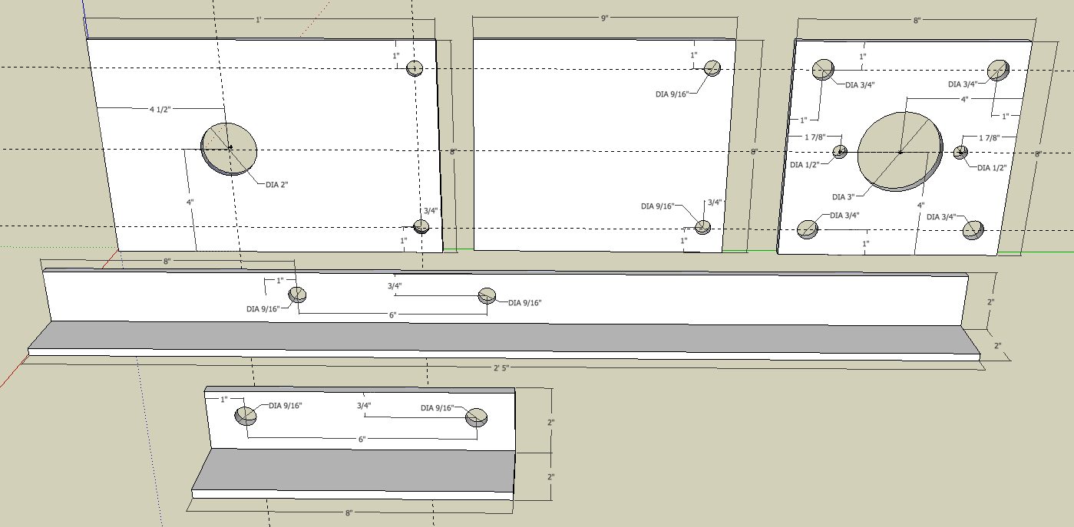

- Quick attach mounts
  - [2] 3/8” x 4” x 27” Plates
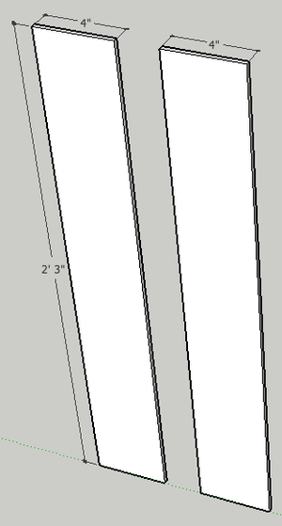

- Fuel tank
  - [2] ¼” x 4” x 8” Plates
  - 4” x 8” x 14 ½” Tube
  - ¼” x 2” x 24” Plate
  - All welds assembling the tank must be quality welds, as they must not leak. Be careful not to “over weld” the tank to the mount.
  - Clean the inside of the ¼” x 4” x 8” tube and the two ¼” x 4” x 8” plates – anything left on these surfaces will end up in the gasoline and could clog the engine when started. Tack and weld the plates on each end of the tube, taking care to orient the top plate with the filler hole as shown in the diagram below.
  - Weld the 1/4” tank flange to the hole in the side of the tank tube.
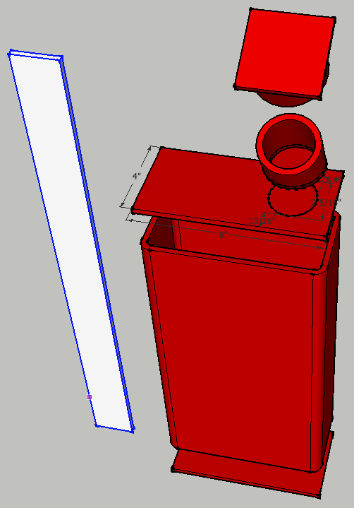
- Oil Cooler Mount
  - [2] ¼” x 2” x 24” Plates
  - [2] ¼” x 2” x 1” Plates
  - [2] ¼” x 2” x 22” Plates (Note: the holes in these plates may need adjustment based on oil cooler mounting holes)
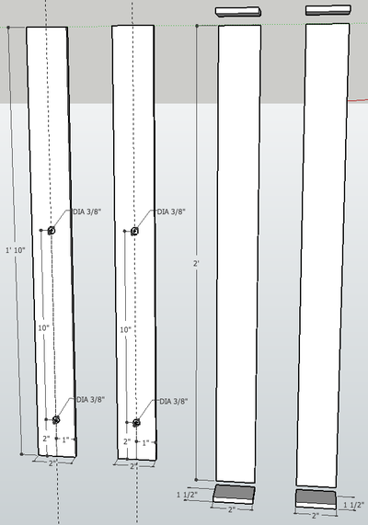

- Key Switches and Choke Brackets
  - [3] 1/8” x 2” x 2” x 2” Angle
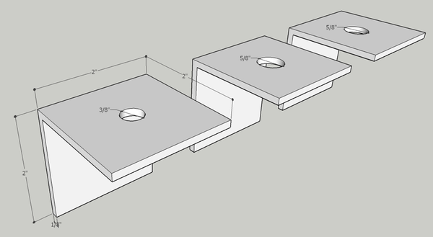
- Electrical cables
  - The connectors can be purchased from an auto parts store – be aware that they usually require a crimper to attach to the cables. Alternatively, 3/8” copper tubing can be used in 1 ½” long pieces instead. Strip 1 ½” insulation from the cable, fully insert fully into 1 ½” copper tube, flatten end with a hammer and drill hole.
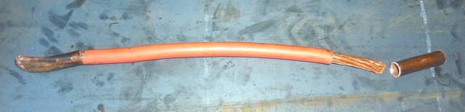
  - [2] 1 gauge cables: 11” (verify length first!)
  - 1 gauge cable: 8 ½” (verify length first!)
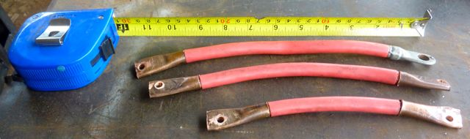
- Battery Mounts
  - [2] ¼” x 2” x 2” x 4 3/4” Angle
  - [2] ¼” x 2” x 5/8” Plate
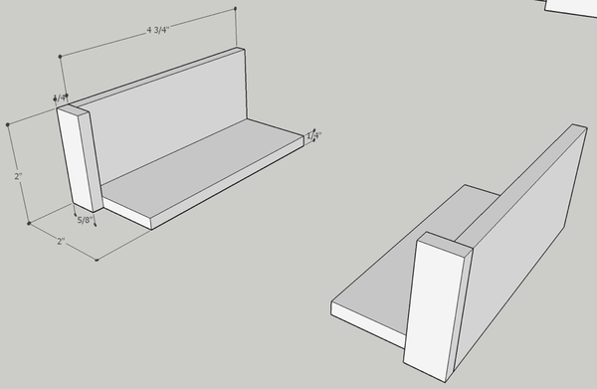
- Oil filter Assembly
  - Assemble as shown, using teflon tape on all threaded components.
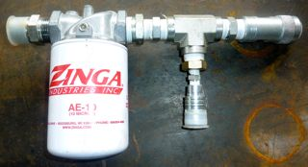
  - The parts for this are (from left to right):
    - 1” nipple
    - Oil filter and header
    - 1” to ¾” reducer
    - ¾” nipple
    - ¾” T adapter
    - ¾” to 3/8” recucer
    - ¼” quick connect
    - ¾” T adapter
    - ¾” quick connect
- Hydraulic reservoir
  - [2] ¼” x 6” x 12” Plates
  - ¼” x 6” x 12” x 27 ½” Tube
  - All welds assembling the reservoir must be quality welds that do not leak. Be careful not to “over weld” the reservoir.
  - Clean the inside of the tube and the two end plates – anything on these surfaces will end up in the hydraulic oil and could damage the pump or cylinders.
  - Tack and weld the 6” x 12” plates to both ends of the 6” x 12” tube. Pay attention to the orientation of the plate with the filler hole and the side of the tube with other holes – see the diagram below.
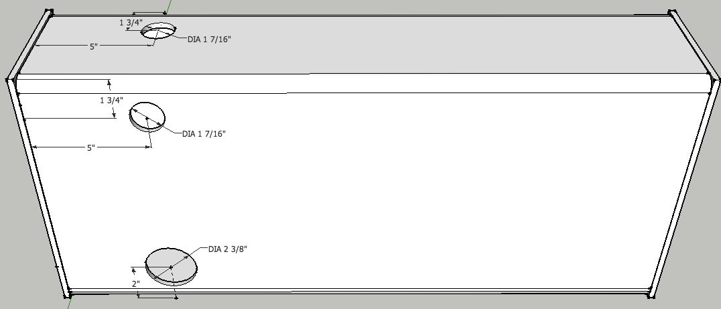

  - Tack and weld the strainer extension tube to the tank, centered around the strainer hole.
  - Insert the strainer into the flange and insert it into the strainer extension tube – verify that it slides without binding or bottoming and that the flange is flush with the end of the tube. Remove the strainer from the flange, then tack and weld the flange to the tank.
CAUTION: Keep the strainer away from the welding, as its thin wires burn easily.
  - Install the suction strainer and the hose barb with the hose barb pointing toward the hydraulic pump (Photo below is for assembly, hose barb is oriented differently).
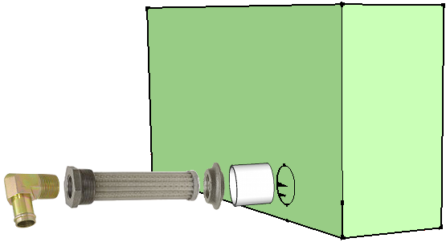

Assembly
Power Cube assembly requires all the parts listed in the Bill Of Materials to be available and prepared as detailed in the “Fabrication” section (above). Assembly requires a welder (electric or torch) capable of welding metal 3/8” thick.
An optional jig can be used to aid in assembly. See Appendix 1 for details.

- Frame
  - Top / Bottom Rectangles
Position two ¼” x 2” x 2” x 29” pieces angle iron on top of two 27” angle pieces as shown below. Check that all joints are square, then tack and weld joints.
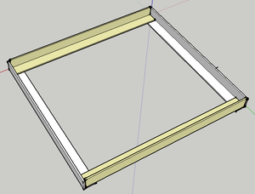

  - With one welded rectangle on the bottom, position two 24” pieces outside corner joints as shown below. Check that the angles are square, then tack and weld. Note: The optional jig makes this much easier and accurate. Repeat the prior procedure and this one for another half of the frame assembly.
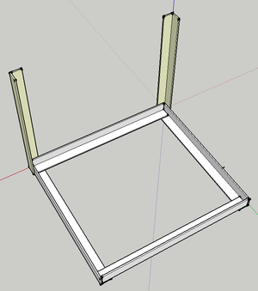

  - Position the second rectangle as shown below, then tack and weld. Inspect all corners to verify secure welds.
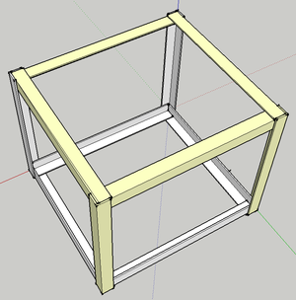

- Gas tank
  - Screw the 1/4" hose barb into the 1/4 NPT flange welded into the gas tank.
  - Perform a “soap bubble” test on the tank. Securely cover the larger hole (use something like strong tape), pressurize the tank using the smaller hole and cover the tank surface with soapy water. Look closely for new bubbles, mark any leaks and re-weld securely. Repeat soap bubble test if re-welded.
  - Tack and weld the gas tank mount (¼” x 2” x 24” plate) to the frame. Position it so the gas tank is 1" from the nearest vertical angle iron support.
  - Tack and weld the gas tank to the gas tank mount as shown below.
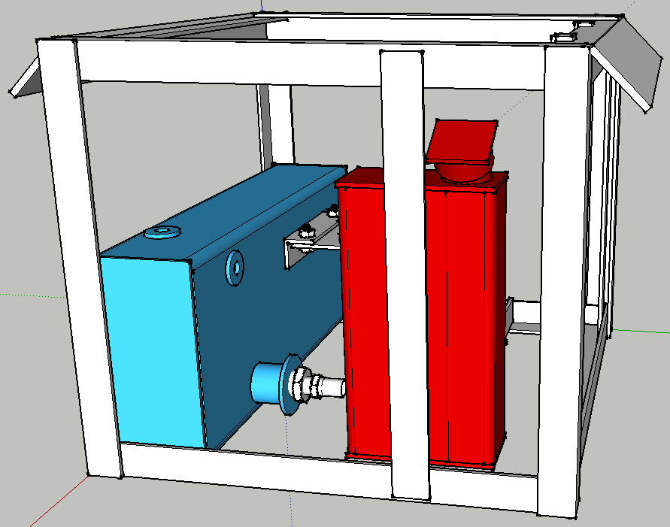

- Hydraulic reservoir
The reservoir should already be pre-assembled and ready for installation.
  - Perform a “soap bubble” test on the tank by securely covering the larger hole (use something like strong tape), pressurizing the tank using the smaller hole and cover the tank surface with soapy water. Mark any leaks and re-weld securely. Repeat soap bubble test if re-welded.
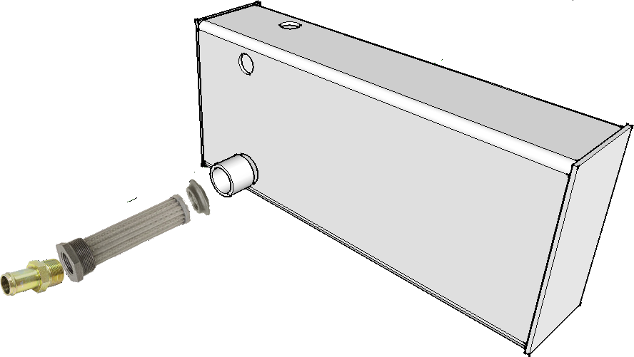
  - Secure the hydraulic tank to the frame with clamps, then weld it with 4 x 1” welds. The tank is ¼” and it can be easily damaged by over-heating. Spacers may be needed on the sides near the top to keep everything snug.
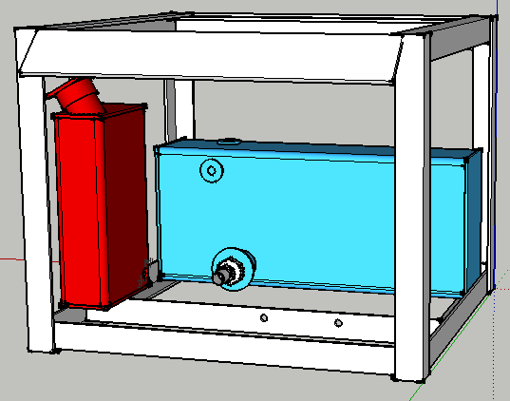

- Engine Mounts and Hydraulic Pump Mount
  - Bolt the ¼” x 2” x 2” x 8” plate to the ¼” x 2” x 2” x 29” angle as shown using 1/2” x 2” bolts:
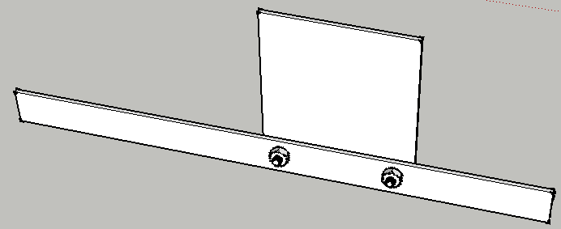
  - Bolt the ¼” x 8” x 12” plate to the 8" angle as shown using 1/2” x 2” bolts:

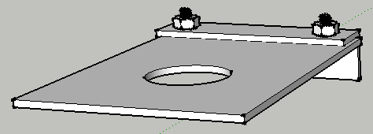
  - Align the plate edges and secure at 90 degree angle and weld. We use welding magnets to hold the plates at 90 degrees:
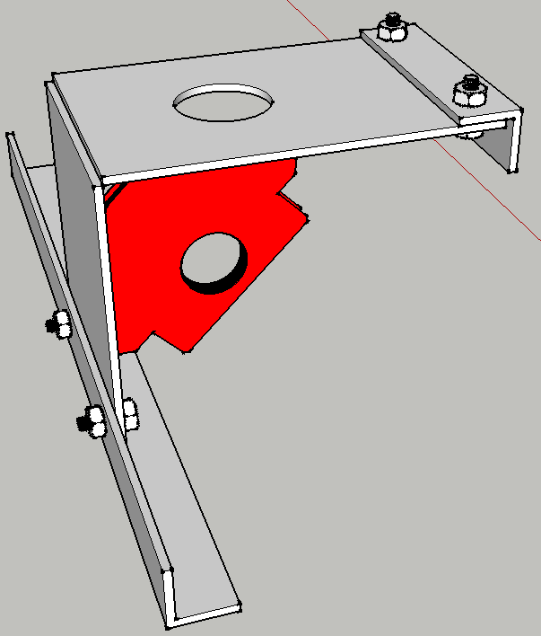
  - Mount the engine to the engine plate using [4] 5/16” x 2” bolts. The method for mounting may depend on your engine. See the following video for details:
http://youtu.be/DO6wbwOjWNA
  - Examine the engine shaft – it should be 2” long. If longer, cut the shaft to extend no more than 2” from the case. This length is necessary for the coupling. Put the larger keystock in the engine shaft and slide the shaft coupling on the engine shaft and tighten the allen screws to hold it in place.
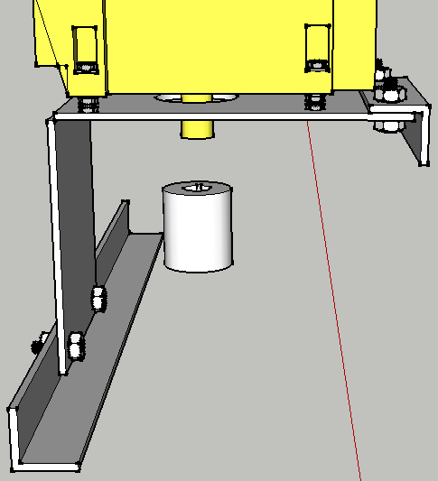
  - Assemble the 8” x 8” pump plate as shown with [4] ¾” x 3.5” bolts and [8] 3/4” nuts, [8] washers and [4] lockwashers. Tighten the nuts to hold the plate firmly:
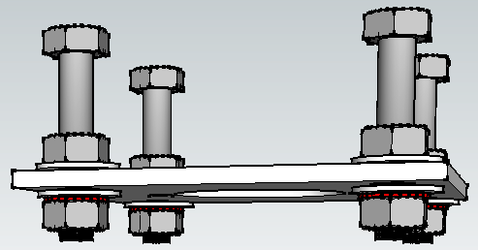
  - Mount the pump to the pump plate using [2] 7/16 bolts, nuts and washers:
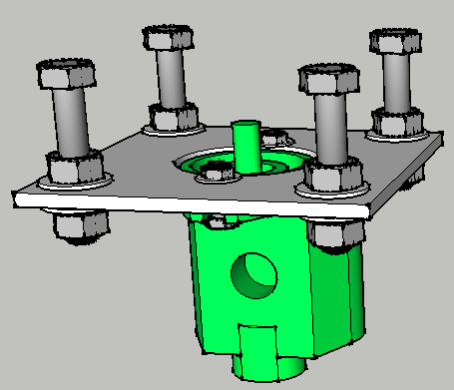
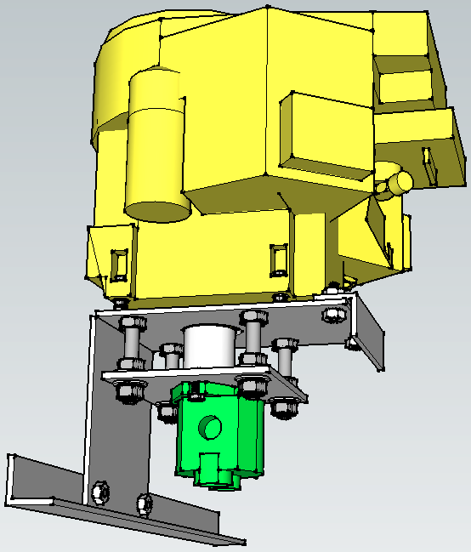
  - Make sure the key is in the pump shaft and slide the pump shaft into the bottom of the shaft coupling and tighten its allen screws. The bolt heads should just be touching the bottom of the engine plate. Tack and weld the bolt heads to the engine plate.
  - Lower the engine/pump assembly into the frame. Adjust it so the engine plate is parallel with the frame and weld the 8” angle iron to the reservoir and the 29” angle iron to the frame.
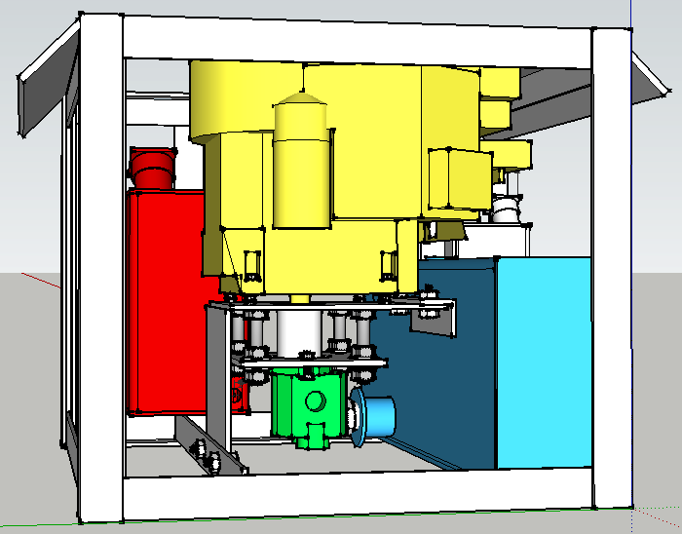
- Battery mount
  - Weld the ¼” x 2” x 5/8” plates to the ends of the ¼” x 2” x 2” x 4 3/4” plates as shown below.
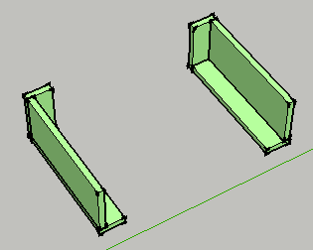

  - Weld the two mounts to the angle iron and tank to form a rectangle for the battery as shown below.
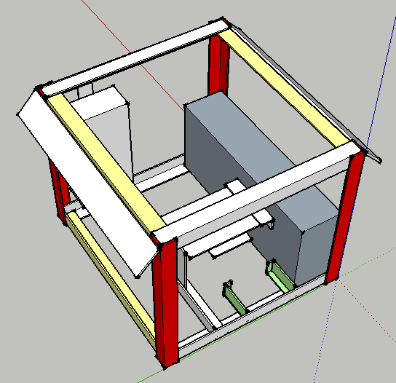
  - After the mount has cooled, lower the battery into the rectangle to verify a proper fit.
- Oil cooler and fan mounts
  - Position the two ¼” x 2” x 22” plates to the outside of the frame, adjust so the oil cooler mounting bolts match the holes in the plates and is positioned as in the diagram below. Tack and weld the mounts in to the frame. Verify that the oil cooler bolts match the holes in the mounts.
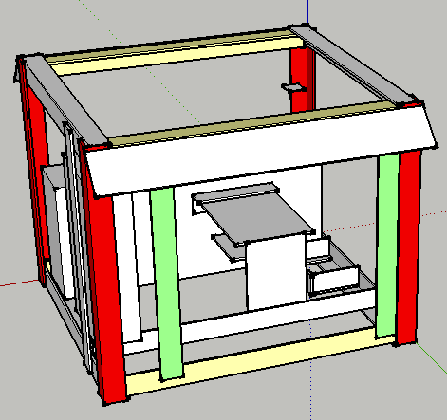
  - Use the mounting holes in the fan shroud and the oil cooler width for positioning the mounting plates as shown in the diagram below. Position the four ¼” x 2” x 1” plates, then tack and weld. Position the two ¼” x 2” x 24” plates against the 1” plates, then tack and weld. Place the fan on the supports and mark the mounts with bolt hole positions. Place the bolt heads against the fan mounting plate and weld in place. Verify that the bolts match the holes in the fan. Inside the frame, adjust the fan position to position fan shroud ¼” from oil cooler fins. Be careful with radiator as the delicate fins are easily bent and damaged.
  - Place the 9 gauge x 12” x 22” expanded steel grill in front of the oil cooler mounting plates, positioned to cover the entire oil cooler and check if any holes are necessary to secure with oil cooler mounting bolts.
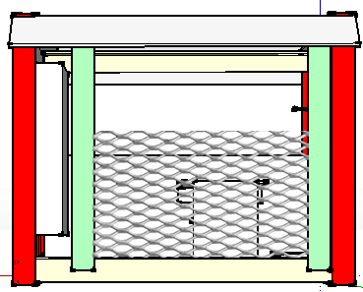
- Screw the filter assembly into the flange on the side of the hydraulic reservoir.
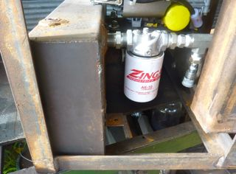
- Connect the 1” suction hose between the strainer and the pump intake.
- Connect a male ¾” quick connect hydraulic coupler to the pump output.
- Connect a female ¾” to ¾” elbow to the cooler port nearest the battery cage.
- Connect one end of the ¾” x 1' hydraulic hose to the second cooler port, then connect the other end of the ¾” x 1' hydraulic hose to filter assembly.
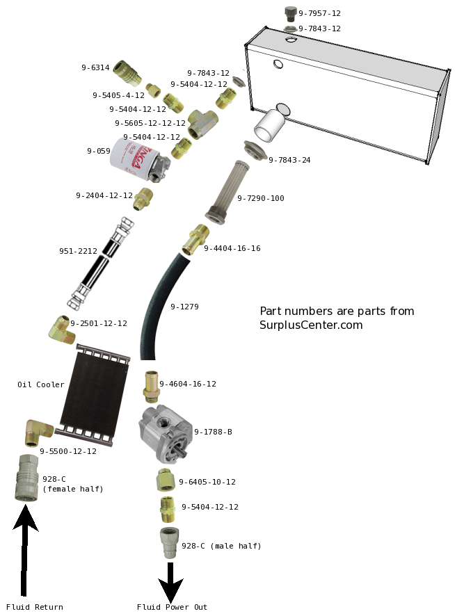
- Weld the 1/8” x 2” x2” x 2” angle brackets to the frame in the positions shown below. Pay special attention to the hole sizes, as the bracket for the choke has a smaller hole.
<image>
- Weld the solenoid mounting bolts to the hydraulic reservoir as shown below.
<image>
- Wire the switches.
- Fix the throttle control, connect to throttle plate.

User Guide
This section is intended for the end user of the Power Cube.

- Caution
  - Weight
  - Hydraulic hazards
  - Ventilation
- Mounting
  - Quick attach connector
- Initial startup and testing
  - Initial Setup
    - Gasoline
    - Hydraulic Fluid
    - Battery Connection
  - Startup
  - Hydraulic Test
- Routine use
- Maintenance
  - Engine Oil
  - Hydraulic Fluid
- Troubleshooting
  - Engine won't start
  - Loud noise
  - No hydraulic power

Appendix

Frame Assembly Jig

The welding “jig” in the image below is helpful to insure square angles while assembling the Power Cube. It is very useful if building multiple Power Cubes.
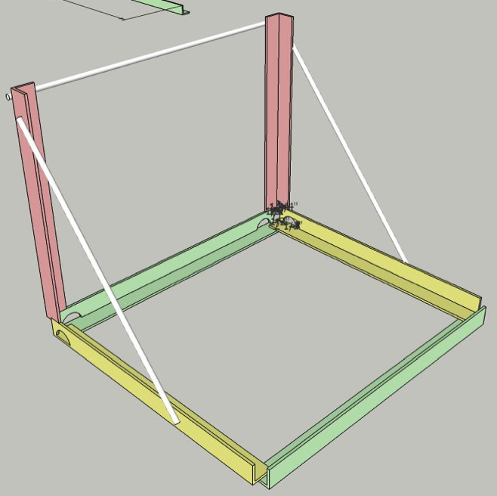

Note the corner holes that provide access for welding:
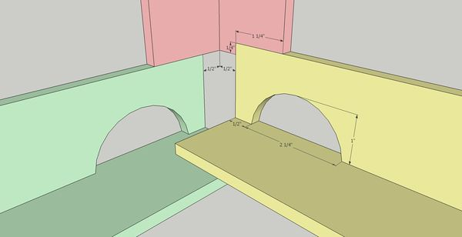

Materials List
- ¼” x 2” x 2” Angle Iron: 14'
- ½" Rebar: 7' 2”
Cut List
Type | Length | Dimensions | Quantity | Color
Angle | 22" | ¼” x 2 x 2" | 2 | (red)
Angle | 26" | ¼” x 2” x 2” | 2 | (yellow)
Angle | 29" | ¼” x 2" x 2 | 2 | (green)
Rebar | 30.5" | ½" | 1
Rebar | 27" | ½" | 2

