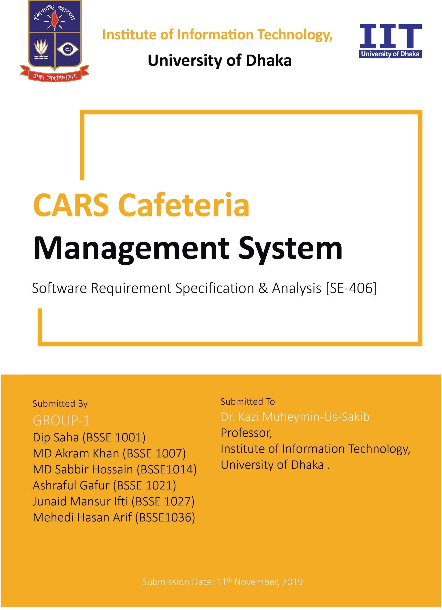

Contents

|  |  |  |
| --- | --- | --- |
| **Contents** |  | **7** |
| INTRODUCTION . . . . . . . . . . . . . . . . . . . . . . . . . . . . . . . . . . | .8 |  |
| PURPOSE . . . . . . . . . . . . . . . . . . . . . . . . . . . . . . . . . . . . | .8 |  |
| INTENDED AUDIENCE . . . . . . . . . . . . . . . . . . . . . . . . . . . | .8 |  |
| CONCLUSION . . . . . . . . . . . . . . . . . . . . . . . . . . . . . . . . . | .9 |  |
| INCEPTION OF CCMS . . . . . . . . . . . . . . . . . . . . . . . . . . . . . . | .9 |  |
| INTRODUCTION . . . . . . . . . . . . . . . . . . . . . . . . . . . . . . . | .10 |  |
| INCEPTION OF CARS Cafeteria Management System . . . . . . . . . . . | .10 |  |
| IDENTIFY THE CLIENT OF OUR PROJECT . . . . . . . . . . . | .10 |  |
| ICEBREAKING . . . . . . . . . . . . . . . . . . . . . . . . . . . . | .10 |  |
| IDENTIFYING THE STAKEHOLDERS OF THE CCMS . . . . . | .11 |  |

IDENTIFYING THE MULTIPLE VIEWPOINTS OF THE STAKE- HOLDER 11

CONCLUSION 13

ELICITATION OF CCMS 13

COLLABORATIVE REQUIREMENTS GATHERING 14

Quality Function Deployment 14

Normal requirements: 14

Expected requirements 16

2

Exciting requirements 16

Usage Scenario: 17

CARS Cafeteria Management System 17

1. Account Management: 17
   1. Create Account: 17
   2. Verification: 18
   3. Update Account: 18
   4. Password Recovery: 18
   5. Log in: 18
2. Ordering: 19
3. Reservation: 19
4. Payment: 20
5. Memo : 20
6. Delivery : 20
7. Database: 21
8. Additional Features: 21
9. Administrative Management: 22
   1. Menu: 22
   2. Inventory Management: 22

Use Case Diagram 22

DEFINITION OF USE CASE 22

Primary Actor 23

Secondary Actor 23

Description of use case diagram level-1: 25

Description of use case diagram level-1.1: 27

Description of use case diagram level-1.1.4: 29

Description of use case diagram level-1.2: 30

Description of use case diagram level-1.2.2: 31

Description of use case diagram level-1.3: 32

Description of use case diagram level-1.3.1: 33

Description of use case diagram level-1.4: 34

Description of use case diagram level-1.4.3: 35

Description of use case diagram level-1.5: 36

Description of use case diagram level-1.6.1: 38

Description of use case diagram level-1.6.2: 39

Description of use case diagram level-1.7: 40

Activity Diagram 41

CARS Cafeteria Management System (CCMS) 41

Definition of Activity Diagram 41

Account Management 43

Password recovery 44

Ordering 45

Payment 46

Reservation 47

Delivery 49

Administrative management 50

Information management 51

Swimlane Diagram 52

Definition : 52

SID(Swimlane ID): 1.1 52

SID: 1.1.4 53

SID: 1.2 54

SID: 1.3.1 55

SID: 1.3.2 56

SID: 1.4 56

SID: 1.5 57

SID: 1.6 58

SID: 1.7 59

Data Based Modelling 60

DATA MODELING CONCEPT : 60

DATA OBJECTS 60

Data object identification : 61

Final data object : 64

Data Object Relationship: 66

ER Diagram: 67

Definition of ER Diagram 67

Schema Diagram 69

CLASS-BASED MODELING 70

Noun list from Cafeteria Management System 70

Verb list 71

General classification 73

Selection Criteria 75

Attribute and Method Identification 77

Analysis 82

CRC card 82

CLASS CARDS 88

Table: Class Card for CCMS Class 89

Table: Class Card for Admin Class 90

Table: Class Card for Teacher Class 91

Table: Class Card for Officer Class 92

Table: Class Card for Order Class 93

Table: Class Card for Reservation Class 94

Table: Class Card for Account Class 95

Table: Class Card for Delivery Class 96

Table: Class Card for Admin_Database Class 97

Table: Class Card for User_Database class 98

Table: Class Card for VIrtual_Cart Class 98

Table: Class Card for SSL_COMMERZ Class 99

Table: Class Card for Cafeteria’s_Transaction_Account Class 99

Table: Class Card for Email Class 100

Table: CLass Card for SMS Class 100

Table: Class Card for Payment Class 101

Table: Class Card for GPS Class 101

CRC Diagrams 102

Diagram ID: 1 102

Diagram ID: 2 102

Diagram ID: 3 103

Diagram ID: 4 104

Diagram ID: 5 104

Diagram ID: 6 105

|  |  |  |
| --- | --- | --- |
| Diagram ID: 7 . | . . . . . . . . . . . . . . . . . . . . . . . . . . . . . . . . . | .106 |
| Diagram ID: 8 . | . . . . . . . . . . . . . . . . . . . . . . . . . . . . . . . . . | .106 |
| Diagram ID: 9 . | . . . . . . . . . . . . . . . . . . . . . . . . . . . . . . . . . | .107 |
| Diagram ID: 10 | . . . . . . . . . . . . . . . . . . . . . . . . . . . . . . . . . | .107 |

BEHAVIORAL MODELING OF CCMS 108

Event Table: 108

State Transition 114

ID : 1 114

ID : 2 114

ID : 3 114

ID : 4 115

ID : 5 115

ID : 6 116

ID : 7 116

ID : 8 117

ID : 9 117

ID : 10 118

ID : 11 118

ID : 12 120

ID : 13 121

ID : 14 121

ID : 15 122

ID : 16 122

Sequence Diagram: 123

# INTRODUCTION

This chapter is a part of our software requirement specification for the

project “Cars Cafeteria Management System” . In this chapter we will focus on the intended audience for this project.

### PURPOSE

This document briefly describes the Software Requirement Analysis of

Cars Cafeteria Management System. It contains the functional, non-functional and the supporting requirements and establishes a requirement’s baseline for the development of the system. The requirements contained in the SRS are independent, uniquely numbered and organized by topics. The SRS serves as an official means of communicating user requirements to the developer and provides a common reference point for both the developer team and the stake- holder community. The SRS will evolve over time as users and developers work together to validate, clarify and expand its contents.

### INTENDED AUDIENCE

* This SRS report is intended for several audiences including the users(Teachers & Officers) , admin(Cafeteria’s manager), project managers, developers and testers.
* The users and admin will use this SRS to verify that the developer team has created a product that is acceptable to the customer.
* The project managers of the developer team will use this SRS to plan

milestones and a delivery date, and ensure that the developing team is on track during development of the system.

* The designers will use this SRS as a basis for creating the system’s de- sign.The designers will continually refer back to this SRS to ensure that the system they are designing will fulfill the customer’s needs.
* The developers will use this SRS as a basis for developing the system’s functionality. The developers will link the requirements defined in this SRS to the software they create to ensure that they have created a software that will fulfill all of the customer’s documented requirements.
* The testers will use this SRS to derive test plans and test cases for each documented requirement. When portions of the software are complete, the testers will run their tests on that software to ensure that the software fulfills the requirements documented in this SRS. The testers will again run their tests on the entire system when it is complete and ensure that all requirements documented in this SRS have been fulfilled.

### CONCLUSION

This analysis of the audience helped us to focus on the users who will be using our analysis. This overall document will help each and every person related to this project to have a better idea about the project.

# INCEPTION OF CCMS

In this chapter, the Inception part of the SRS will be discussed briefly.

### INTRODUCTION

CARS Cafeteria is a Cafeteria for teacher and Officers located at Mokarram Bhaban ,University of Dhaka.Teaches and Officers from different departments have their lunch in this Cafeteria and different types of events or parties are also held here by booking the whole cafeteria in the evening hours.Several employees work under one manager in this Cafeteria.

### INCEPTION OF CARS Cafeteria Management System

At the beginning of our project, we entered the inception stage. This stage

includes, how the project will be started and their scope and limitations. The main goal of this phase is to identify the requirements, demand and

establish some sort of mutual understanding between the software team and the stakeholders of the Cars Cafeteria. In order to make this phase effective we took the following steps:

* Identifying the client of our project
* Icebreaking
* Identifying the stakeholders of the CARS Cafeteria
* Identifying the multiple viewpoints of stakeholders

**IDENTIFY THE CLIENT OF OUR PROJECT**

Admin of the CARS Cafeteria can be identified as a client of our project.Teachers and Officers can be viewed as stakeholders.

**ICEBREAKING**

Icebreaking refers to the fact that to diminish the communication barrier

between two persons. It is a crucial part since it denotes the

acceptation of our proposal. We started this phase by talking with the stake- holders with context free languages. Their behavior, respond to our question impacted the whole system.

**IDENTIFYING THE STAKEHOLDERS OF THE CCMS**

Stakeholder refers to any person or group who will be affected directly or indirectly by the system. Stakeholders include end-users who interact with

the system and everyone else in an organization who may be affected by its installation. The CARS Cafeteria have limited number of stakeholders.They are:

* Teachers
* Officers
* Manager of CARS Cafeteria

**IDENTIFYING THE MULTIPLE VIEWPOINTS OF THE STAKEHOLDER**

Different stakeholders expect different benefits from the system as every person has his own point of view. So, we have to recognize the requirements from multiple viewpoints. Different viewpoints of the stakeholders about the expected software are given below:

### CARS Cafeteria’s Viewpoint:

* First and foremost, a really friendly user interface
* Desktop and Mobile,both platform based software if affordable
* Provide signal when any grocery item is out of stock
* Store information about the employees and the teachers/officers
* Calculate total buy and sell amount of a month and show the whole cost and benefits periodically
* Easy Reservation Management
* Secured and Automated Transaction System directly connected to the Cafeteria’s account
* Easy Transaction History Storing
* Automated Memo Giving System

### Users’ Viewpoint:

* Easy and Fast Interface
* Mobile Platform Based Software
* Availability of Food Delivery directly to office rooms
* Secured Online payment
* Cash On Delivery System
* Easy Reservation System to book for any official ceremony

### CONCLUSION

The primary goal of this project is to model and design a software for the teach- ers and officers of the University(Specially science faculties) to ease lunch order system and For Managers to easily manage multiple orders and reservations.

For these reasons,The software will be as

simple as a teacher can easily be able to use this and the managers can maintain it without any annoyance. The software will be designed in such a way as it takes very little time to manage. To make this software project successful, collaboration with stakeholders was a main priority that what they want, how the software will work, how it can be more convenient, how it will save time and energy, etc.

# ELICITATION OF CCMS

We have seen Question and Answer (Q& A) approach in the previous chapter, where the inception phase of requirement engineering has been described. The main task of this phase is to combine the elements of problem solving, elab- oration, negotiation and specification. The collaborative working approach of the stakeholders is required to elicit the requirements. We have finished the following tasks for eliciting requirements-

* Collaborative Requirements Gathering
* Quality Function Deployment
* Usage Scenarios(Story)

### COLLABORATIVE REQUIREMENTS GATHERING

We have met with many stakeholders in the Inception phase such as the man- ager,teachers and officers. These meetings created an indecisive state

for us to elicit the requirements. To solve this problem, we have met with

the stakeholders (who are acting a vital role in the whole process) few times to elicit the requirements.

### Quality Function Deployment

Quality Function Deployment (QFD) is a technique that translates the needs of the customer into technical requirements for software. Ultimately the goal of QFD is to translate subjective quality criteria into objective ones that can be quantified and measured and which can then be used to design and manufacture the product. It is a methodology that concentrates on

maximizing customer satisfaction from the software engineering process. So, we have followed this methodology to identify the requirements for the

project. The requirements, which are given below, are identified successfully by the QFD.

**Normal requirements:**

Normal requirements are generally the objectives and goals that are stated for a product or system during meetings with the customer. The presence of these requirements fulfills customers’ satisfaction. These are the normal requirements for our project.

* Users will create an account by providing their credentials.
* A predefined account will be given to system admin.
* System will verify the user’s credentials from database.
* Users can update his/her profile.
* Users can recover their password if forgotten.
* Users must be logged in before doing any operation.
* Users can order food online.
* A memo will be provided after order confirmation.
* Order details will be added into virtual cart.
* Users can reserve table(s) for lunch through online.
* Users can book whole cafeteria after lunch through online.
* If any user reserves cafe which is already booked, he will be assigned into queue. First queued user will be notified after every booking cancellation.
* Users can pay bills through “SSL Commerz” and cash on delivery.
* If any users cancel order or reservation, he will be refunded.
* Estimated time of food delivery will be prompted in the user’s display.
* Staff info, user info, every transaction details will be stored into admin database.
* A replica of user info, order memo and transaction history will be stored in user database.
* If a user updates his/her info, it will be updated in user database first and then the same update will be replaced into Admin Database automatically.
* Admin can manage everyday menu.
* Inventory management.
* If a food is out of stock it will be shown as stocked out.

**Expected requirements**

These requirements are intrinsic to the product or system and may be so ele- mentary that the customer does not explicitly state them. Their absence

will be a cause for significant dissatisfaction. Below the expected requirements for our project are briefly described-

* The system will be secured.
* Delivery time for every delivery will be estimated by GPS
* Several users can request for tables and cafeteria at the same time.
* Responsiveness of the System will be expeditious.
* Transaction history of Non Registered users will also be recorded .
* Interactive and attractive graphical user interface.

**Exciting requirements**

These requirements are for features that go beyond the customer’s expectations and prove to be very satisfying when present. Following are some exciting requirements of our project:-

* If a user order certain items frequently, it will be prompted in the user’s homepage.
* All relevant food items according to user’s taste will be suggested.
* After analyzing the orders of previous one month from the users, the sys- tem will show the mostly ordered food items in the admin’s homepage.

### Usage Scenario:

# CARS Cafeteria Management System

CCMS (Cars Cafeteria Management System) is an automated system where CARS cafeteria will be managed. This is intended to ease both the Manage- ment (administrator) and Teachers/Officers (Users) to interact, make orders, reservations etc with each other more conveniently.

### Account Management:

* 1. **Create Account:**

**User Perspective:** A user must create an account to enter into the system. He/she needs to provide the following information to create account-

* Full name
* Mobile number
* Email address
* Teacher/Officer id
* Password
* Department name
* Room number & Location

After providing the information, admin will verify and send a confirmation code to the provided mobile number. By inputting this code, account will be created. **Admin Perspective:** An account for the administrator will be given to the cafeteria management with a predefined username and password.

* 1. **Verification:**

System will verify the user’s credentials from teachers’ database of Dhaka Uni- versity.

* 1. **Update Account:**

User can update his/her profile. He/she can change his/her following information-

* Email
* Mobile number
* Password
* Room number
  1. **Password Recovery:**

A user can recover his/her password if forgotten, by using his/her email or mo- bile phone number. User can click on “Forget Password” Button and choose from two options-“1.Recover Through Email, 2.Recover Through Mobile Number” **Through Email:** A recovery link will be sent to user’s email, if user clicks on “Recover Through Email” button. User will then input a new password and his/her password will be updated in Database.

**Through Mobile:** An OTP will also be sent to the user’s mobile number , if a user clicks on “Recover Through Mobile” button. User will have to input the OTP within 1 minute and then he/she will have to input a new password. His/her password will be updated in Database.

* 1. **Log in:**

A user can log into the system by using his/her registered email-id or phone number and password.

An administrator can login with the predefined username and password given by the system authorities.

### Ordering:

To order, user must be logged in to the system. There will be daily menu provided by the cafeteria management which will include pricing and stock alert(if a food is out of stock it will be shown as stocked out).User can choose to order food from the menu according to his/her taste. He/she can also select quantity. After choosing, the food will be added to virtual cart and the amount of bill to be paid will be shown. He/she can pay the bill using any authorized payment system (Described in the following section “Payment” ) or he/she can also avail Cash-On Delivery (COD) service. If the user takes “Cash-on Delivery” service he/she must confirm that before payment and will have to pay some extra charge for delivery.

If user chooses to pay using online payment system, his/her order will be con- firmed after payment. Else if user chooses COD service, his/her order will be confirmed instantly.

After order confirmation, A memo will be given to the user.

User can only give orders for food before 12.30 p.m. No order will be taken after this certain time.

User can also cancel order after payment, but it must have to be before 12.30

p.m. He/she will be refunded if cancelled before time.

### Reservation:

For reservation, user must log in. Then he/she can choose one or multiple table numbers to book. After booking tables, he/she must provide the customized menu and quantity of people. User can also book the whole Cafeteria after lunch hour for any big occasions or ceremonies.

User must book before 48 hours for an event. Payment will be calculated based on the venue rate and customized food menu rate. Advance payment of 30% must be done within 2 hours of reservation confirmation. He/she will be notified through email and sms about confirmation of reservation.

To cancel the reservation, he/she must notify it before 36 hours to get refunded. If any user wants to reserve tables which are already booked, the user will be assigned into the booking queue. If the user who reserves in the first place

cancels the reservation in time, the queued user next to him/her will be notified

and the table(s) will be reopened for booking. Each reservation has a reservation id.

### Payment:

**Online Payment:** External Sub-System “SSL Commerz” will be integrated for online payment method. Cafeteria’s Transaction accounts will be added to SSL Commerz and users will just have to pay by logging into their account using this system.

Notification email and sms will be sent to user after every transaction by SSL Commerz.It will also be automatically added to admin database by SSL Com- merz system.

**On-Site Payment:** User can also pay on spot if he/she goes to the cafeteria by himself/herself. After payment he can choose any table (not reserved). A memo will be provided including order number.

**Cash-On Delivery**: User can pay cash to the delivery man if he chooses Cash On Delivery.

For cancellation before a certain time, they will be refunded within 3-4 working hours.If a user fails to pay within the specific time, his/her reservation will be cancelled automatically.

### Memo :

After confirmation of each order, a memo will be prompted to the user including the following information-

* Order id
* Food item with price
* Quantity
* Total price

In case of office delivery, a printed copy of memo will be provided to the user through the delivery man.

1-SSLCOMMERZ uses industry standard Secure Sockets Layer (SSL) technology which is used worldwide for securing

data encryption. It is also PCI DSS v3.2 compliant which is the highest grade of recognition of Data Security compliance in the Payment Card Industry

In case of on spot payment, a printed copy of memo will be given to the user

hand to hand after payment.

### Delivery :

**User perspective:** Users can request for room delivery inside the university campus. For this service, he/she has to pay a delivery charge (25/-). Estimated time of food delivery will be prompted in the user’s display.

**Admin perspective:** Admin can deliver the order in two ways-

* By staff
* By “Pathao Food Service”

System will track the location from where the user has requested, through GPS. If requested location is within 200m radius of CARS Cafeteria, then Staff will be sent to deliver foods.

Otherwise, foods will be sent by “Pathao Food Service.”After confirming the delivery, the staff or “Pathao” riders will communicate with the user and deliver the order.

### Database:

**Admin Database:** Staff info and User info will be stored in admin database. Every reservation details will also be stored in admin database.

Delivery staff numbers will be given input everyday and will be stored in database. . If a staff goes for room delivery, the availability count for the staff will be automatically deducted by admin input. After each office deliv- ery, when staff will come back to the cafeteria, admin will update the database again.

Every order memo will be stored distinctly in the database. Admin will be able to see the sum of transactions happened in a day.After every order paid,either through delivery-man or pathao or on the spot ,the transaction detail will be added into Admin Database.

**User Database:** Every order memo and transaction history will be stored in User Database. A replica of user info from admin database will also be stored in User Database for security consolidation. If a user updates his/her info, it will be updated in user database first and then the same update will be replaced into Admin Database automatically.

### Additional Features:

* If a user order certain items frequently, it will be prompted in the user’s homepage.
* All relevant food items according to user’s taste will be suggested.
* After analyzing the orders of previous months from the users, the system will show the mostly ordered food items in the admin’s homepage.

### Administrative Management:

* 1. **Menu:**

The menu will be fixed for a day. If any change is required, then admin will update the menu. The availability of food items will be displayed when the user wants to order.

After every order is confirmed (Online/Offline), menu will be updated and the quantity of items confirmed will be deducted from the availability count. If any order is cancelled, the availability of the food items will also be updated.

* 1. **Inventory Management:**

Administrator will input count of his/her stored grocery items. He/she will update counts everyday. By this, he/she will be able to track which item is going to be stocked out or which item is abundantly stocked.

# Use Case Diagram

### DEFINITION OF USE CASE

A Use Case captures a contract that describes the system behavior under various conditions as the system responds to a request from one of its stakeholders. In essence, a Use Case tells a stylized story about how an end user interacts with the system under a specific set of circumstances. A Use Case diagram simply describes a story using corresponding actors

who perform important roles in the story and makes the story understandable for the users. The first step in writing a Use Case is to define that set of “actors” that will be involved in the story. Actors are the different people that use the system or product within the context of the function and behavior that is to be described. Actors represent the roles that people play as the system operators. Every user has one or more goals when using system.

### Primary Actor

Primary actors interact directly to achieve required system function and derive the intended benefit from the system. They work directly and frequently with the software.

### Secondary Actor

Secondary actors support the system so that primary actors can do their work. They either produce or consume information.

Use Case diagrams give the non-technical view of overall system.

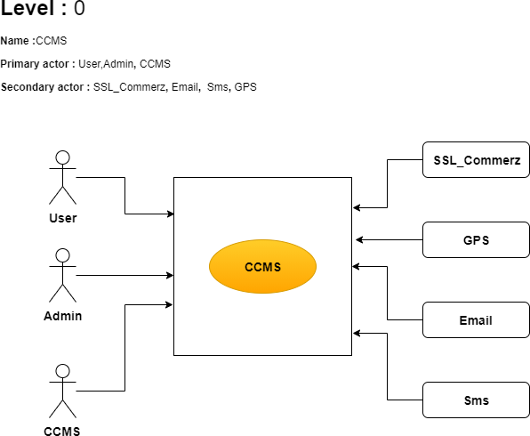

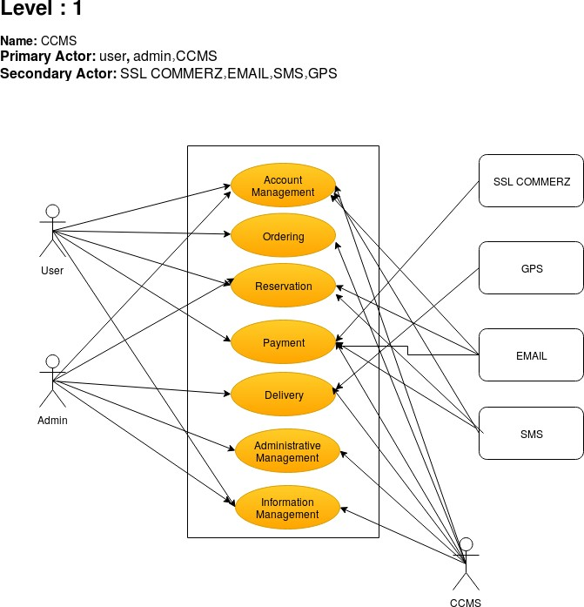

### Description of use case diagram level-1:

1. **Account management :** Users must create an account and then log into the system. He/she can update his/her profile, can recover password if forgotten. Admin will verify his/her provided credentials.
2. **Ordering :** Users will log into the system and can order food for lunch before 12:30 p.m.. He can pay through SSL Commerz or cash-on delivery or on-site payment. He/she

can cancel the order.

1. **Reservation :** After logging into the system, users can book one or more tables for lunch. Users can also book whole cafeteria after lunch hour. He must book before 48 hours before an event. Advance payment of 30% must be done within 2 hours of reservation confirmation.
2. **Delivery :** If users request for delivery service, admin will deliver through “Pathao” or staff.
3. **Administrative management :** Admin will update menu and perform inventory management.
4. **Information management :** Staff information , user information, transaction informa- tion, reservation details, available stuff count, order memo will be stored in the database.
5. **Payment:**User can pay online using any approved and trusted account through “SSL Commerz”

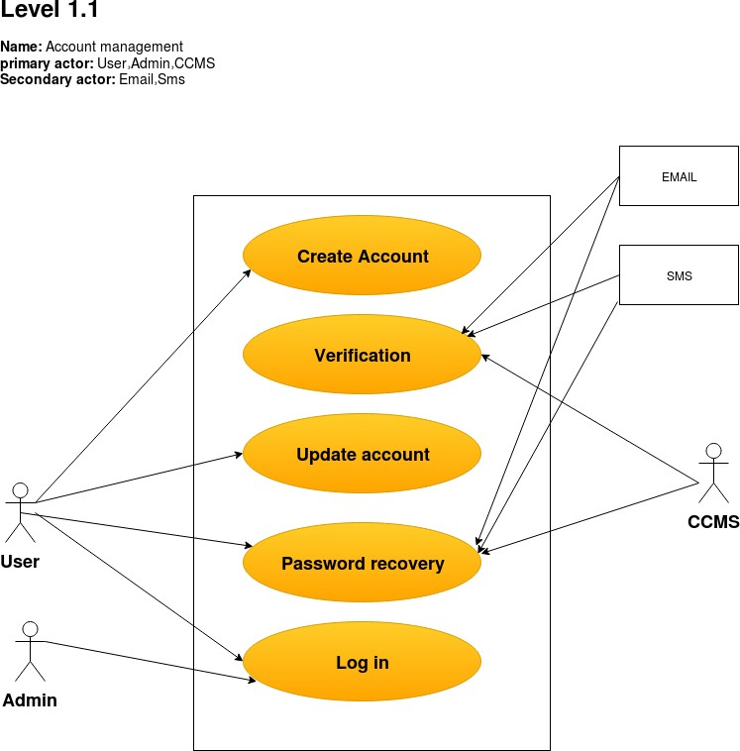

### Description of use case diagram level-1.1:

**Create account :** To create an account, users must provide following credentials: full name, mobile number, email address, teacher/officer id, password, department name, room number and location. Admin will verify and send a confirmation code to the provided mobile number. By inputting this code, account will be created. An account for the admin will be given with a predefined username and password.

**Verification :** System will verify the user’s credentials from teacher’s and officer’s database

of Dhaka University.

**Update account :** Users can update his/her email, mobile number, password and room number.

**Password recovery :** A user can recover his/her password if forgotten, by using his/her email or phone number.

**Log in :** Users will log into the system by using his/her registered email-id/ phone number and password.

**Action Reply :**

**Action:** User provides credentials.

**Reply:** System will check the validity of the given credentials. For valid information system will allow user(Student or Teacher) to create an account and log into the account.

**Action:** User provides invalid credentials.

**Reply:** System will show error message and allows to try again.

**Action:** User provides credentials for update.

**Reply:** System will check the validity of the given credentials and after validation updates the given info.

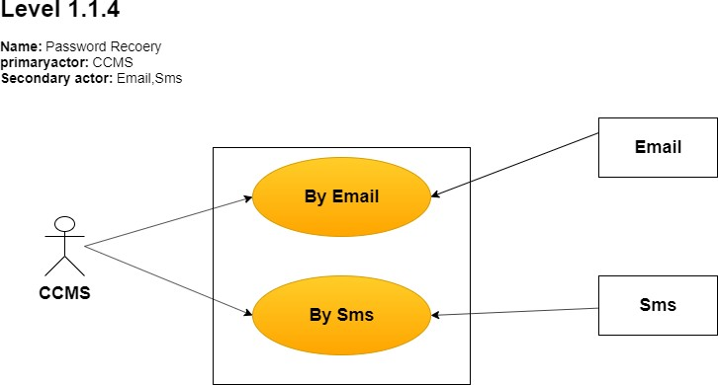

**By email :** System will send a recovery link to the user’s email if he/she clicks on “Forget Password” button. User will then input a new password and his/her password will be updated in database.

**By phone :** An OTP will be sent to the user’s mobile number concurrently, if a user clicks on “Forgot Password” button. User will have to input the OTP within 1 minute and then he/she will have to input a new password. His/her password will be updated in Database.

**Action Reply :**

**Action:** User requests for password recovery.

**Reply:** System will send an OTP or recovery link.

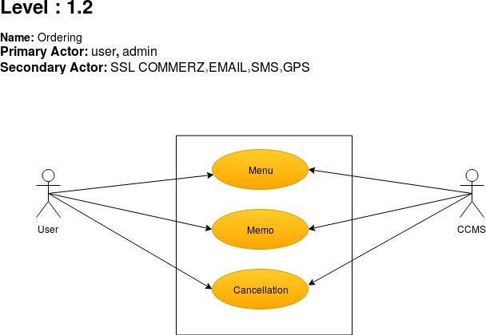

**Menu :** User can choose to order food from the menu according to his/her taste. He/she can also select quantity.

**Memo** : After confirmation of each order, a memo will be prompted to the user including the following information : Order id, food item with price, quantity, total price.

**Cancellation :** Users can cancel order after payment, but it must have to be before 12:30

p.m. .He/she will be refunded if cancelled before time.

**Action Reply :**

**Action:** User chooses food and confirms the order.

**Reply:** System prompts memo. **Action:** User cancels order in time. **Reply :** System refunds money.

**Action:** User cancels order after a fixed time.

**Reply :** System doesn’t refund money.

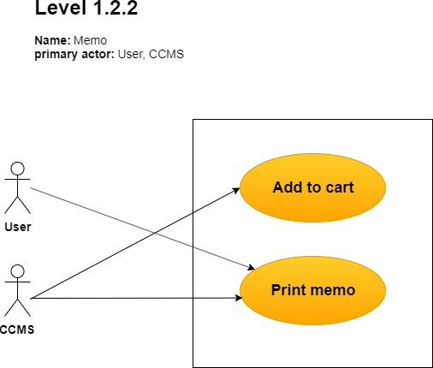

**Add to cart :** After choosing, the food will be added to virtual cart and the amount of bill to be paid will be shown.

**Print memo :** In case of office delivery, a printed copy of memo will be provided to the user through the delivery man. In case of on spot payment, a printed copy of memo will be given to the user hand to hand after payment.

**Action Reply:**

**Action:** User requests for office delivery.

**Reply :** System prints a memo.

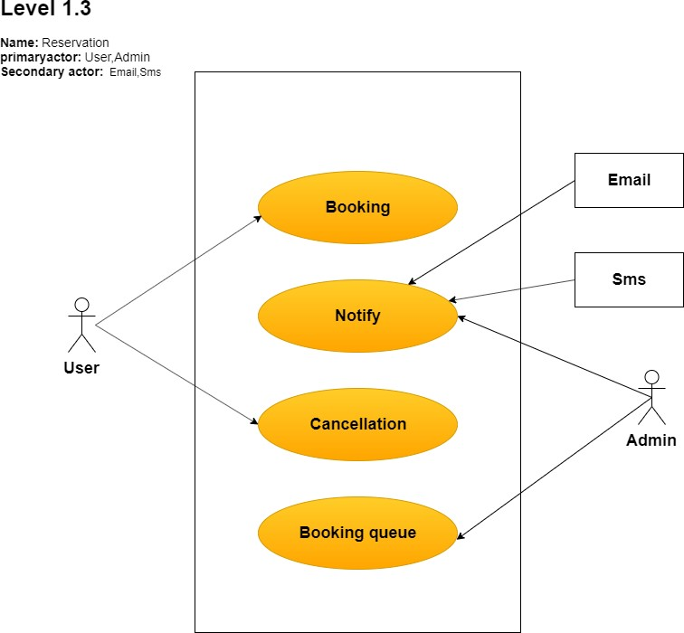

**Booking :** User can book one or more tables for lunch or can book whole cafeteria after lunch hour.

**Notify :** Admin will notify user after booking confirmation, cancellation through email/sms.

**Cancellation :** Users can cancel the reservation 36 hours before the event to get refunded.

**Booking queue :** If any user wants to reserve tables which are already booked, then the user will be assigned into the booking queue. If the user who ordered in the first place cancels the order in time, the queued user next to him/her will be notified and the table(s) will be reopened for booking.

**Action Reply:**

**Action:** Users book tables.

**Reply:** Admin will notify users about confirmation.

**Action:** Users cancel reservation in time.

**Reply:** Admin notifies about cancellation , refunds money and manages queue.

**Action:** Users cancel reservation after a fixed time.

**Reply:** Admin doesn’t refund money .

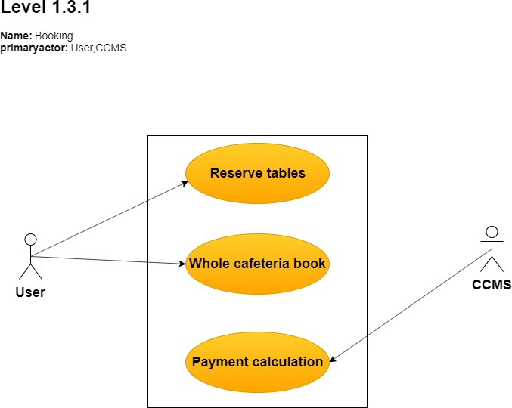

### Description of use case diagram level-1.3.1:

**Reserve tables :** Users can book one or more tables. Then he will select food menu and quantity of people.

**Whole cafeteria book :** User can also book the whole Cafeteria after lunch hour for any big occasions or ceremonies. User must book before 48 hours for an event.

**Payment calculation :** Payment will be calculated according to hall rent, food item and quantity of people.

**Action Reply:**

**Action:** Users book tables , select food menu and quantity of people.

**Reply:** System confirms the booking and calculates the payment.

**Action:** Users book whole cafeteria, select food menu and quantity of people.

**Reply:** System confirms the booking and calculates the payment.

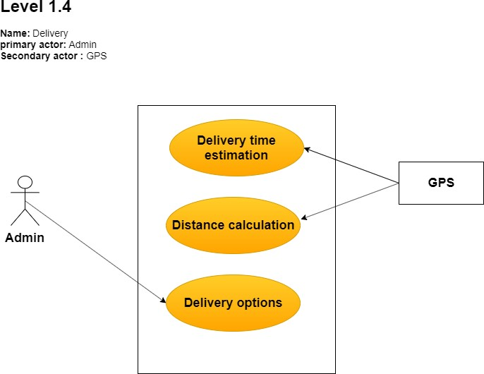

### Description of use case diagram level-1.4:

**Delivery time estimation :** A delivery time will be estimated by GPS and prompted in user’s display.

**Distance calculation :** Distance from CARS will also be calculated through GPS.

**Delivery options :** Admin will choose one delivery option according to distance.

**Action Reply:**

**Action:** Admin chooses a delivery option.

**Reply:** Delivery will be done according to admin’s choice.

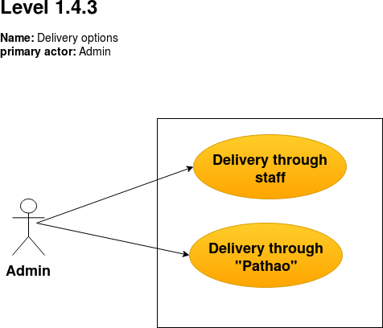

### Description of use case diagram level-1.4.3:

**Through staff :** If the distance is less than 200 meters, admin delivers the food through staff.

**Through** “**Pathao**” **:** If the distance is greater than 200 meters, admin delivers the food through Pathao.

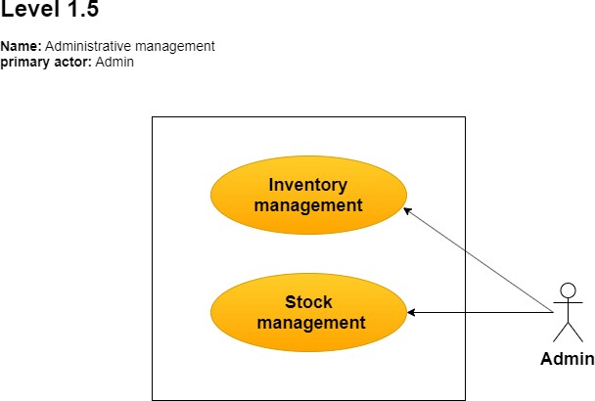

### Description of use case diagram level-1.5:

**Inventory management :** Administrator will input count of his/her stored grocery items. He/she will update counts everyday. By this, he/she will be able to track which item is going to be stocked out or which item is abundantly stocked.

**Stock management :** The menu will be fixed for a day. If any change is required, then admin will update the menu. The availability of food items will be displayed when the user wants to order.

After every order is confirmed (Online/Offline), menu will be updated and the quantity of items confirmed will be deducted from the availability count. If any order is cancelled, the availability of the food items will also be updated.

**Action Reply:**

**Action:** Admin updates the menu.

**Reply:** Users will see the updated menu .

**Action:** Admin inputs the count of stored grocery items.

**Reply:** Admin database will be updated.

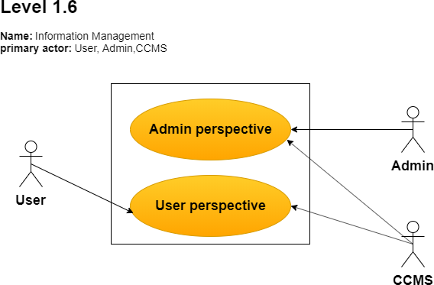

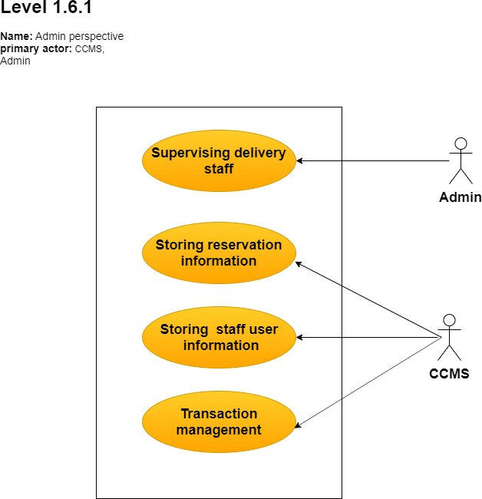

**Storing staff and user’s information :** Staff information and user information will be stored in admin database.

**Storing reservation information :** Every reservation details will also be stored in admin database.

**Supervising delivery staff :** Delivery staff numbers will be given input everyday and will be stored in database. If a staff goes for room delivery, the availability count of the staff will be automatically deducted by admin input. After each office delivery, when staff will come back to the cafeteria, admin will update the database again.

**Transaction Management:**

**Action Reply:**

**Action:** Admin inputs delivery staff numbers every day.

**Reply:** Admin database will be updated. **Action:** Admin updates delivery staff numbers. **Reply:** Admin database will be updated.

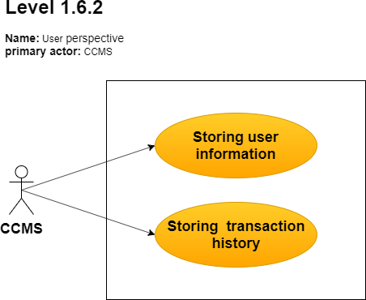

**Storing user information :** A replica of user info from admin database will also be stored in User Database for security consolidation. If a user updates his/her info, it will be updated in user database first and then the same update will be replaced into Admin Database automatically.

**Storing transaction history :** Every order memo and transaction history will be stored in User Database.

**Action Reply:**

**Action:** User updates his/her info

**Reply:** User database will be updated as well as admin database.

**Action:** Order memo and transaction history is created.

**Reply:** User database will be updated.

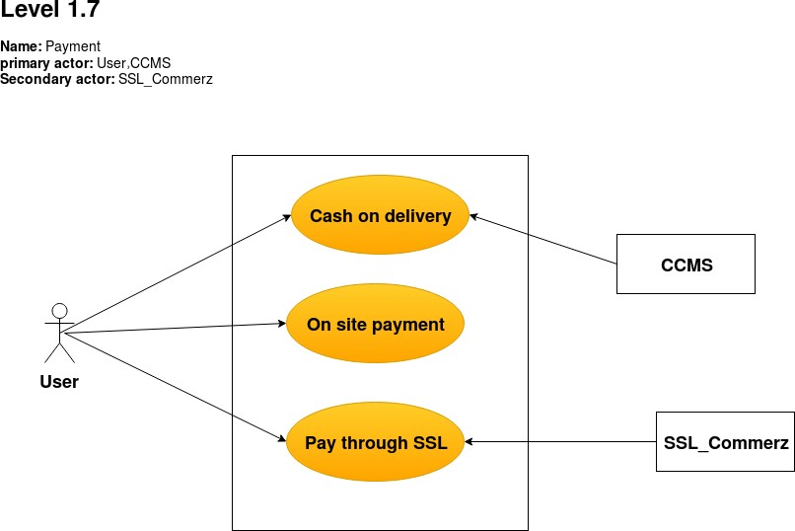

**Payment :** Orders will be confirmed after payment. Users can pay through “SSL Commerz”

or cash-on delivery or on-site payment. A notification will be sent to user’s email and phone after order confirmation .

### Description of use case diagram level-1.7:

**Cash-on delivery :** User can pay cash to the delivery man if he chooses Cash On Delivery. If he chooses cash-on delivery service, he has to pay extra delivery charge.

**On-site payment :** User can also pay on spot if he/she goes to the cafeteria by him- self/herself. After payment he can choose any table (not reserved). A memo will be provided including order number.

**Pay through SSL :** External Sub-System “SSL Commerz” will be integrated for payment method. Cafeteria’s Transaction accounts will be added to “SSL Commerz” and users will just have to pay by logging into their account using this system. Notification email and sms will be sent to user after every transaction by “SSL Commerz” .It will also be automatically added to admin database by “SSL Commerz” system

**Action Reply:**

**Action:** Users pay through “SSL Commerz” . **Reply:** Notification email and sms will be sent. **Action:** Users pay through “SSL Commerz” .

**Reply:** Admin database will be updated automatically.

# Activity Diagram

### CARS Cafeteria Management System (CCMS)

### Definition of Activity Diagram

Activity diagrams are graphical representations of workflows of stepwise activities and actions with support for choice, iteration and concurrency.

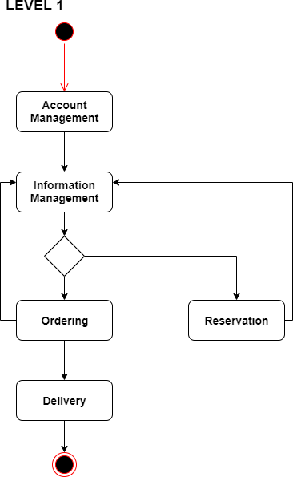

**Level :** 1

**Name:** CCMS

**Reference:** Use Case level 1

### Account Management

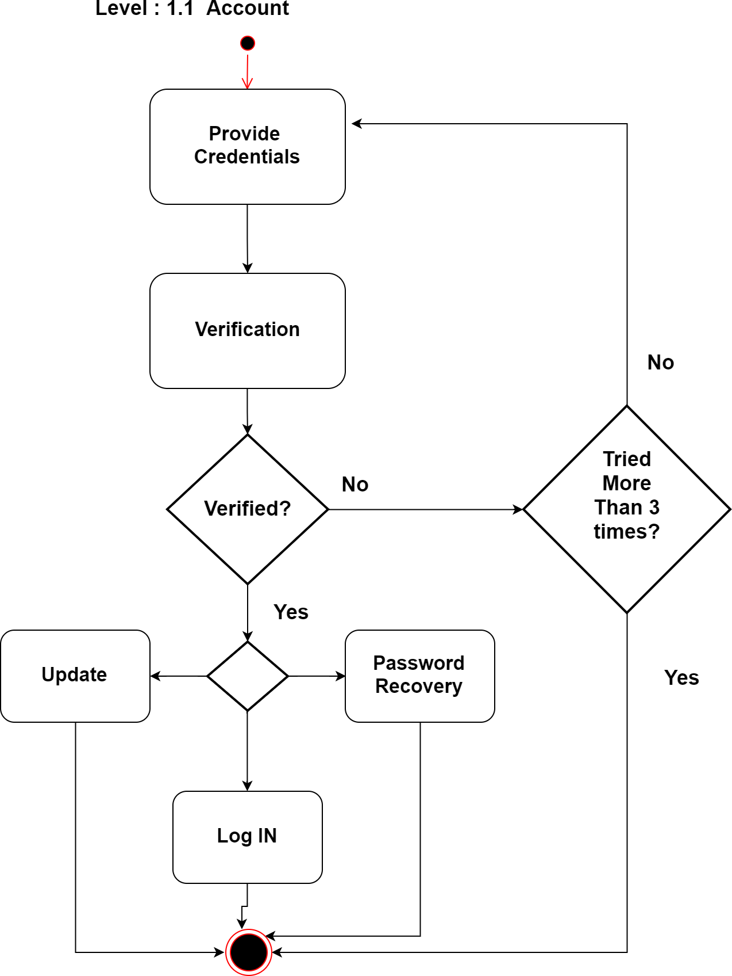

**Level :** 1.1

**Name:** Account Management

**Reference:** Use Case level 1.1

### Password recovery

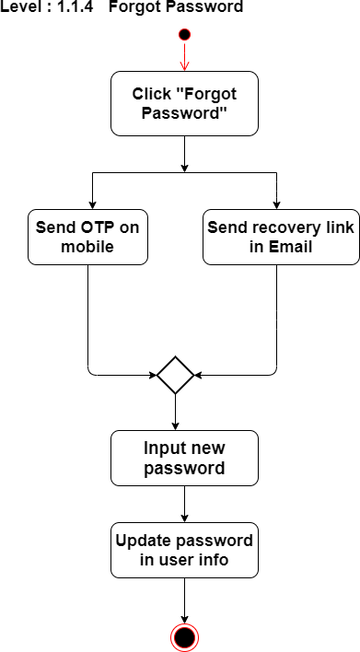

**Level:** 1.1.4

**Name :** Password recovery

**Reference:** Use Case level 1.1.4

### Ordering

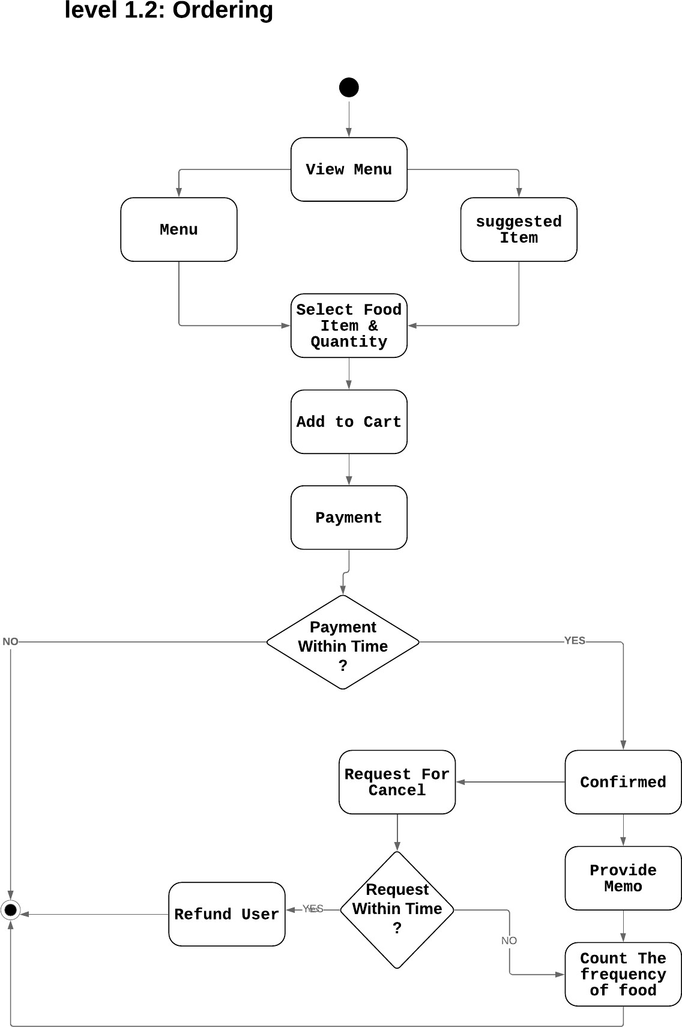

**Level:** 1.2

**Name :** Ordering

**Reference:** Use Case level 1.2

### Payment

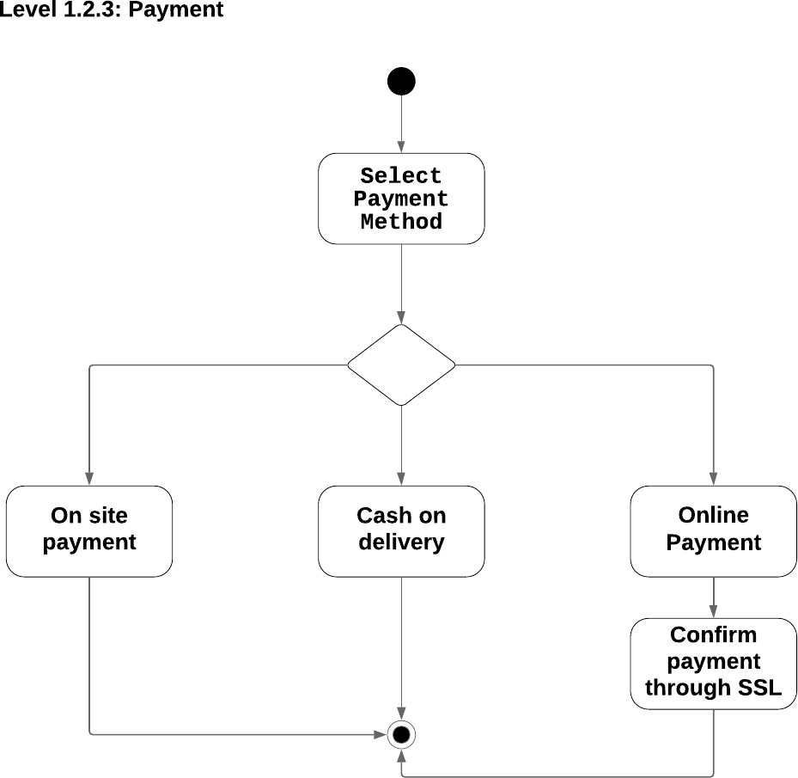

**Level** : 1.2.3

**Name** : Payment

**Reference:** Use Case level 1.7

### Reservation

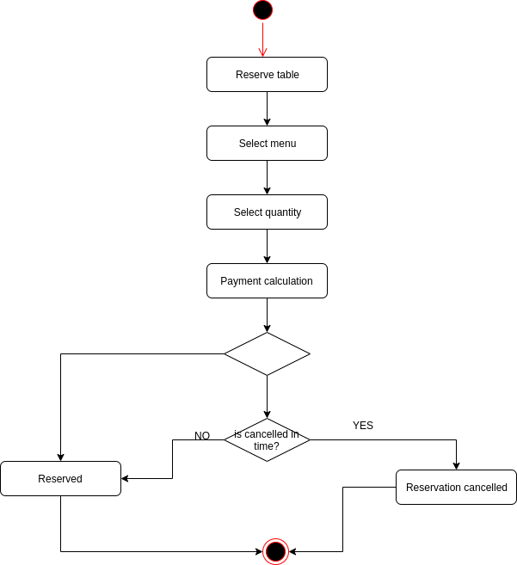

**Level:** 1.3.1

**Name :** Reservation_1

**Reference:** Use Case level 1.3

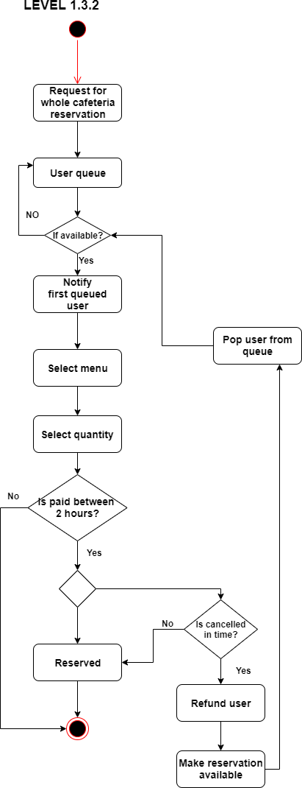

Page 48 of 126

**Level:** 1.3.2

**Name :** Reservation_2

**Reference:** Use Case level 1.3

### Delivery

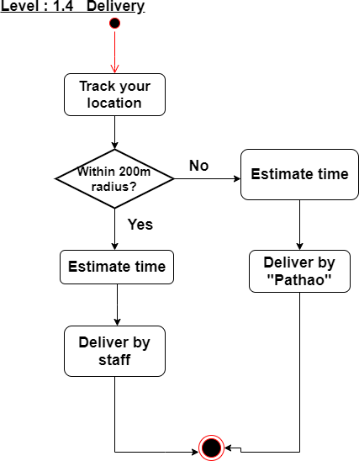

**Level:** 1.4

**Name :** Delivery

**Reference:** Use Case level 1.4

### Administrative management

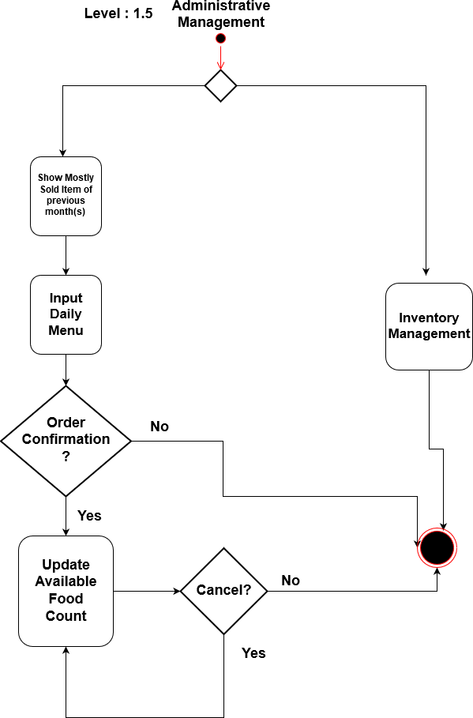

**Level :** 1.5

**Name :** Administrative management

**Reference:** Use Case level 1.5

### Information management

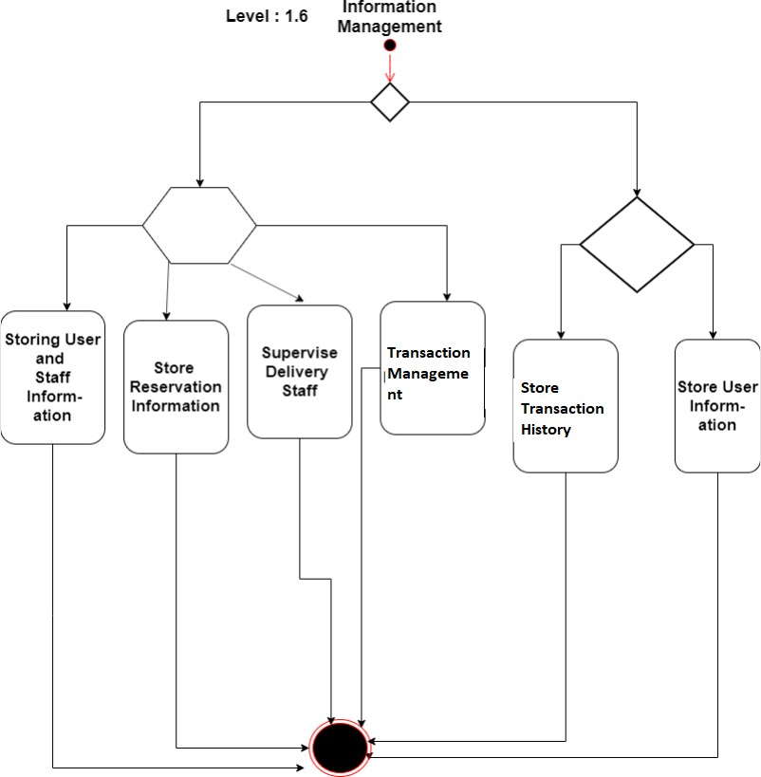

**Level :** 1.6

**Name :** Information management

**Reference:** Use Case level 1.6

# Swimlane Diagram

### Definition :

A swimlane diagram is a type of flowchart that delineates who does what in a process. Using the metaphor of lanes in a pool, a swimlane diagram provides clarity and accountability by placing process steps within the horizontal or vertical “swimlanes” of a particular employee, work group or department. It shows connections, communication and handoffs between these lanes, and it can serve to highlight waste, redundancy and inefficiency in a process.

### SID(Swimlane ID): 1.1

**Name :** Account

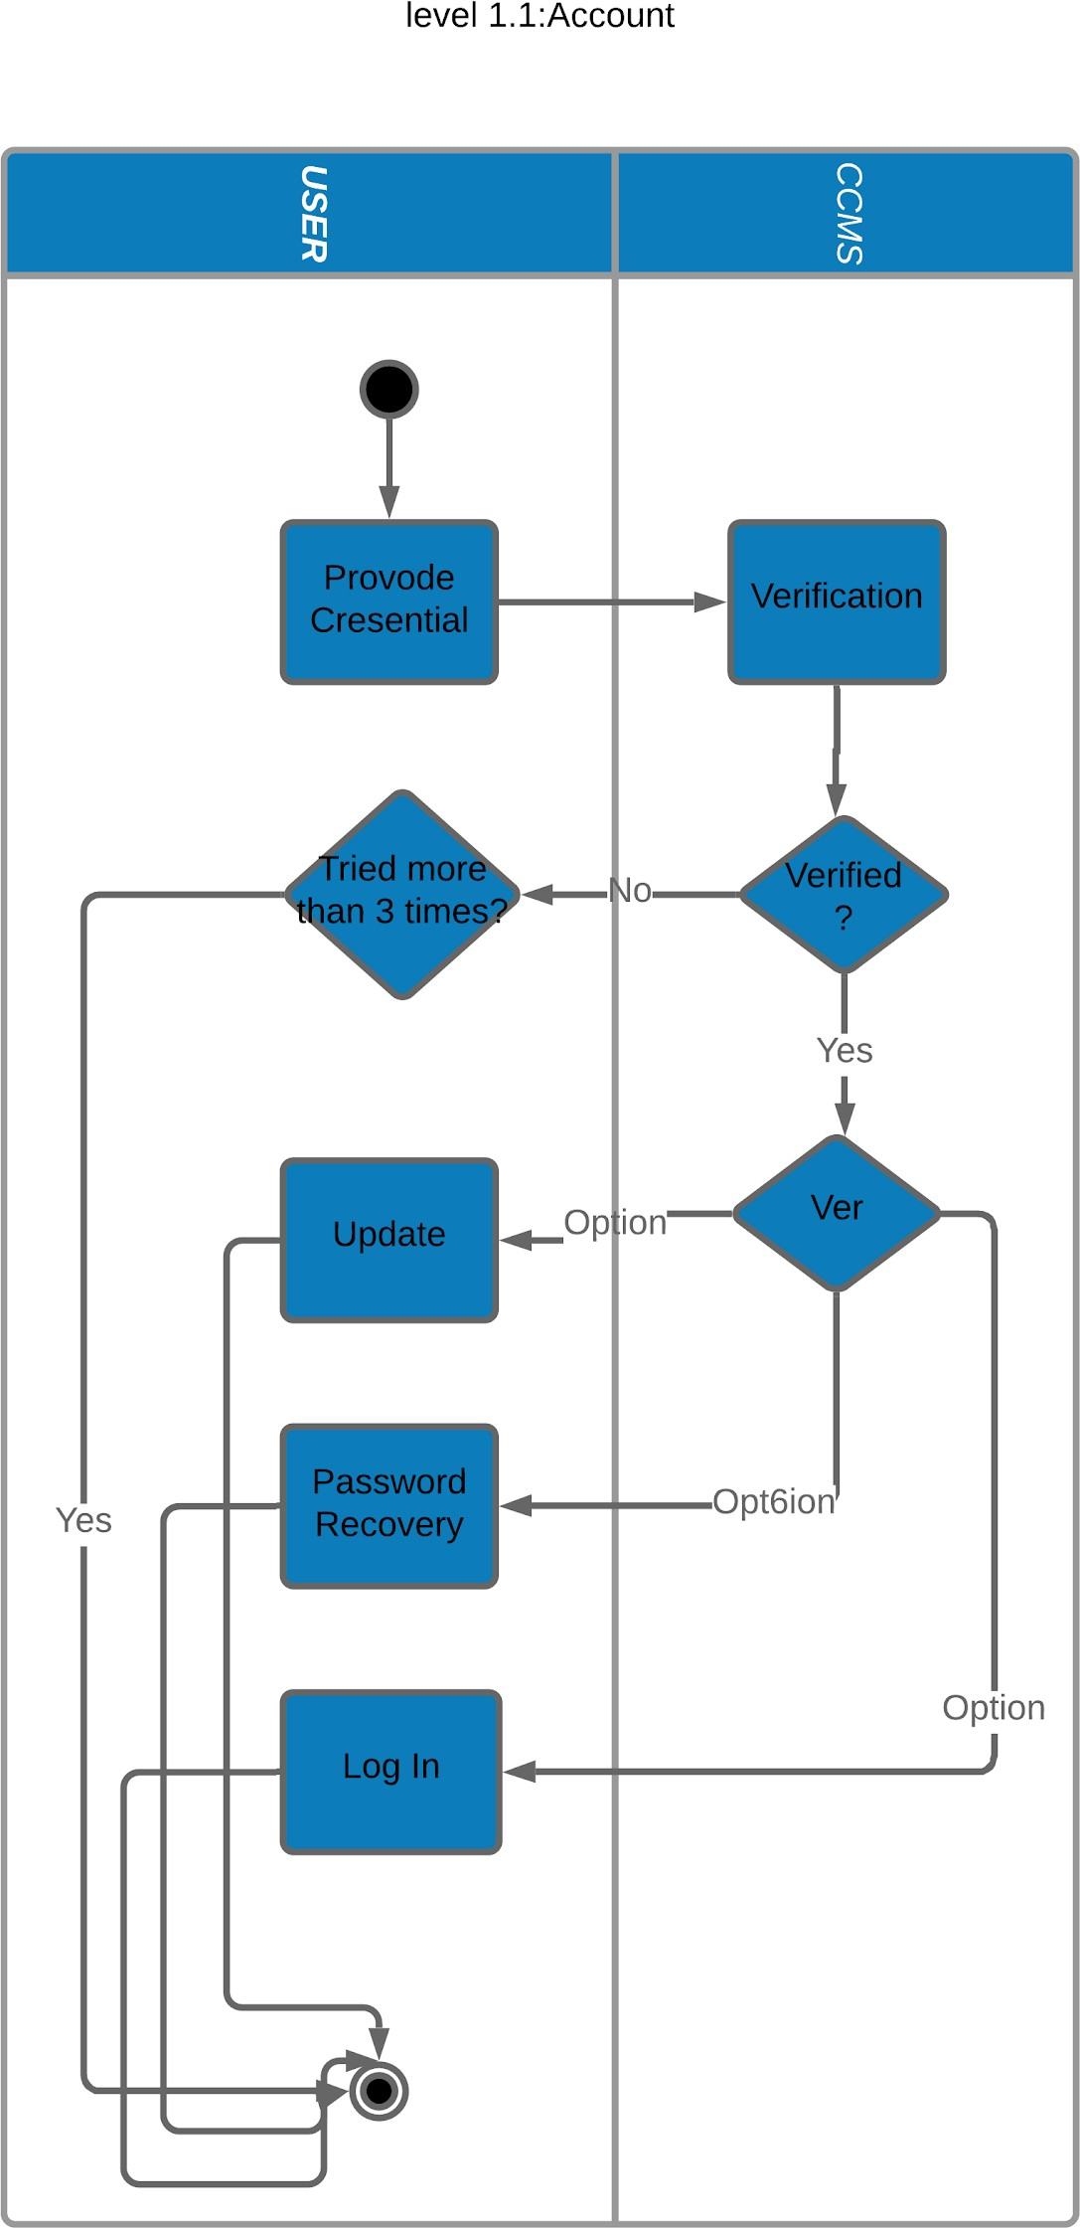

**Reference:** Use Case & Activity level 1.1

### SID: 1.1.4

**Name :** Password Recovery

**Reference:** Use Case & Activity level 1.1.4

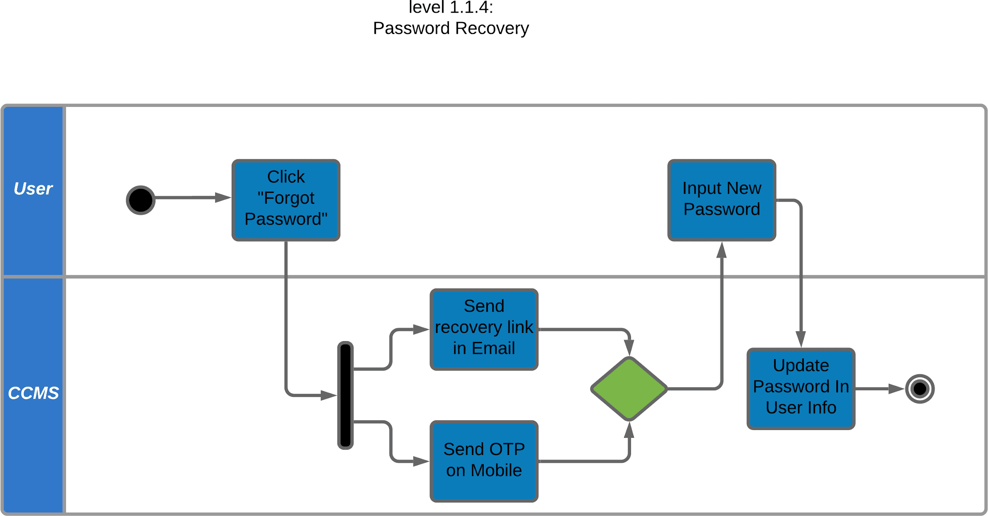

### SID: 1.2

**Name :** Ordering

**Reference:** Use Case & Activity level 1.2

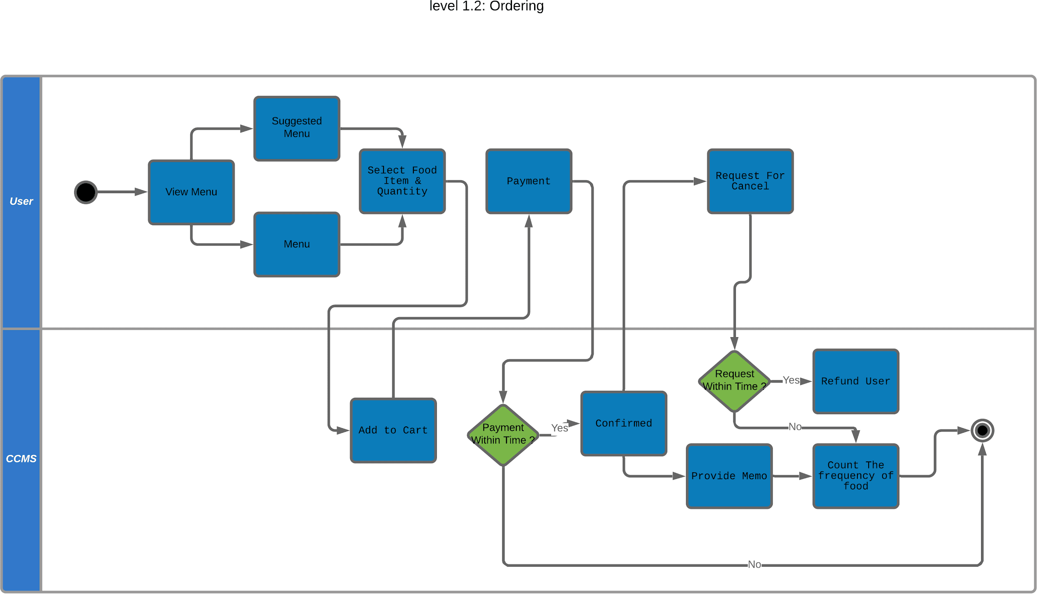

### SID: 1.3.1

**Name :** Reservation 1

**Reference:** Use Case level 1.3 & Activity 1.3.1

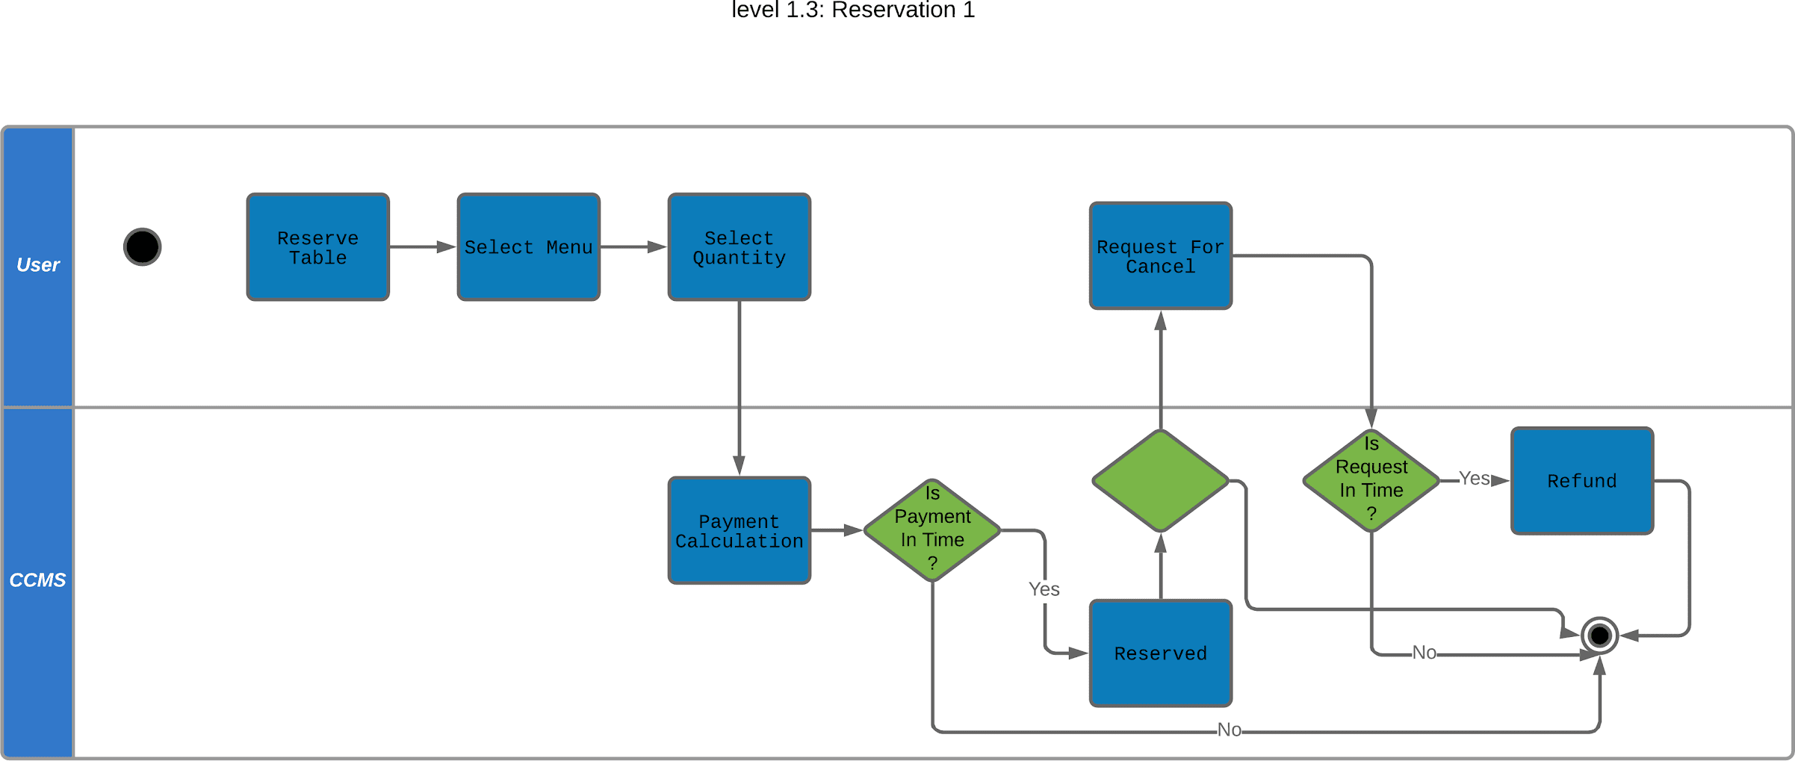

### SID: 1.3.2

**Name :** Reservation 2

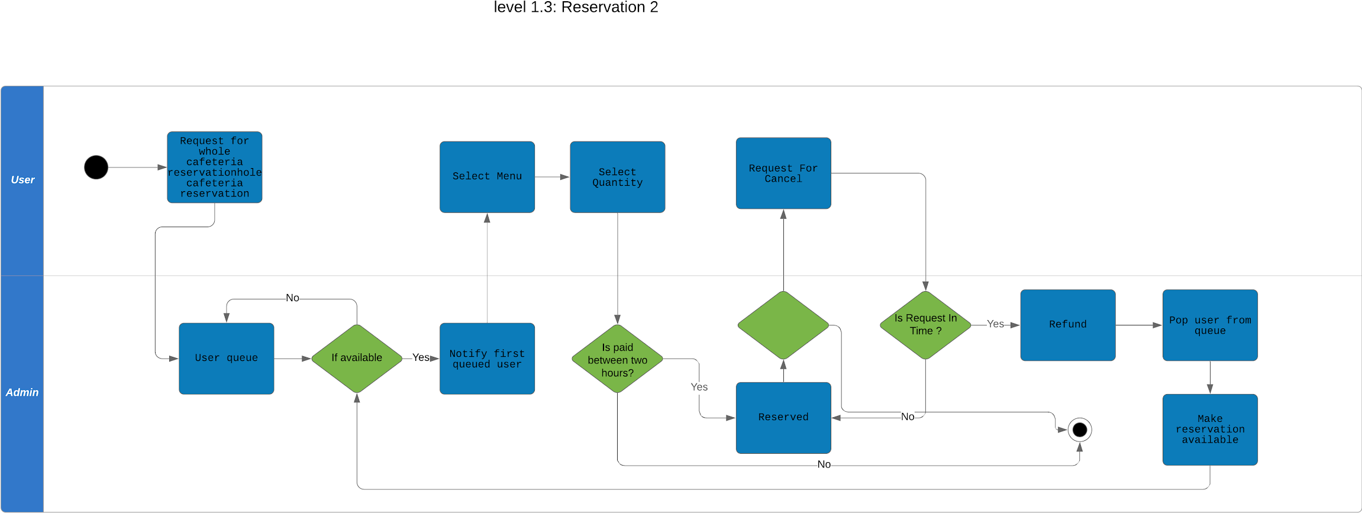

**Reference:** Use Case level 1.3 & Activity 1.3.2

### SID: 1.4

**Name :** Delivery

**Reference:** Use Case & Activity level 1.4

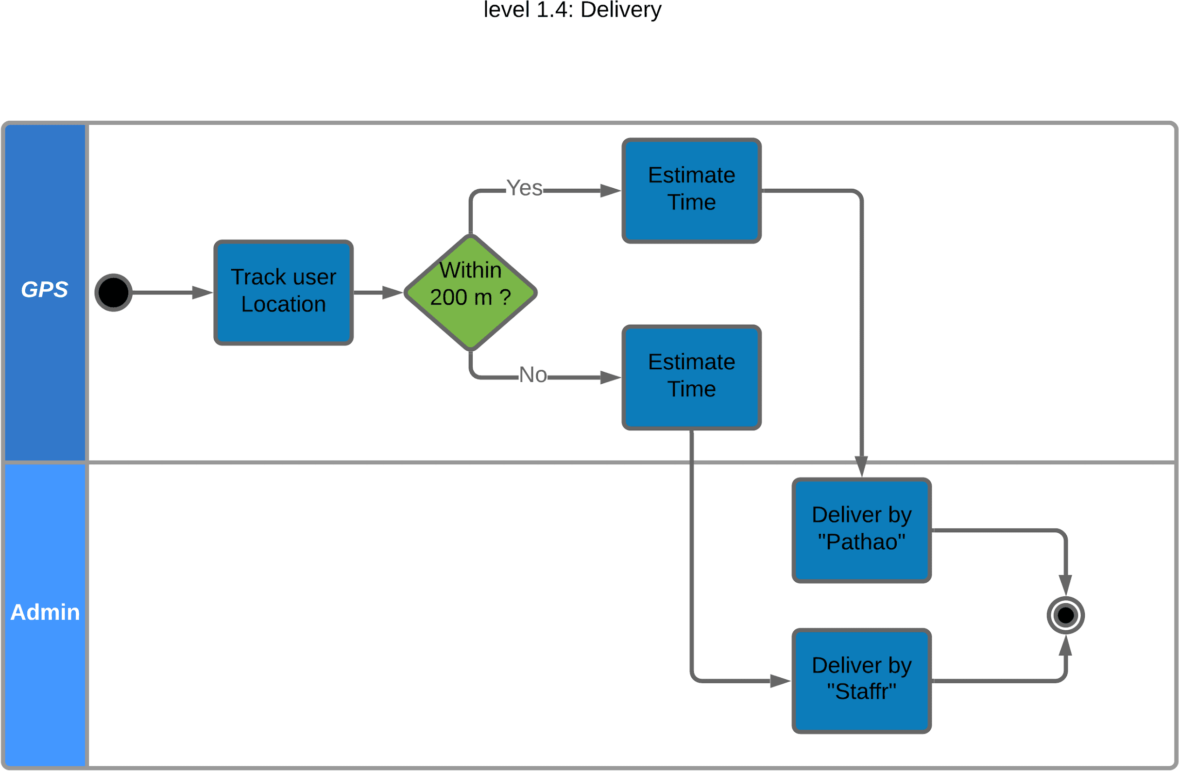

### SID: 1.5

**Name :** Administrative Management

**Reference:** Use Case & Activity level 1.5

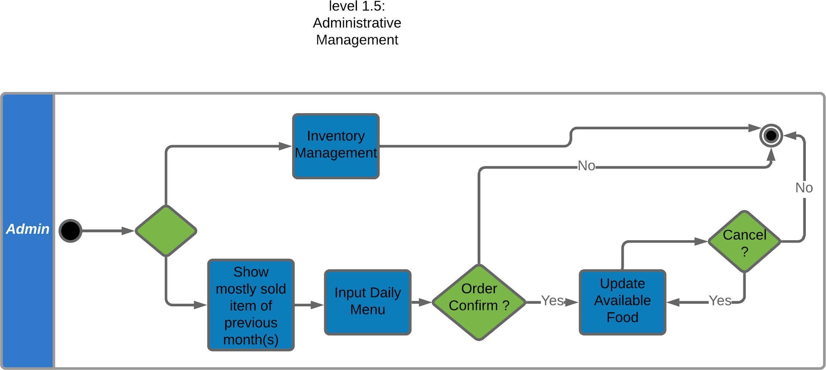

### SID: 1.6

**Name :** Information Management

**Reference:** Use Case level 1.6

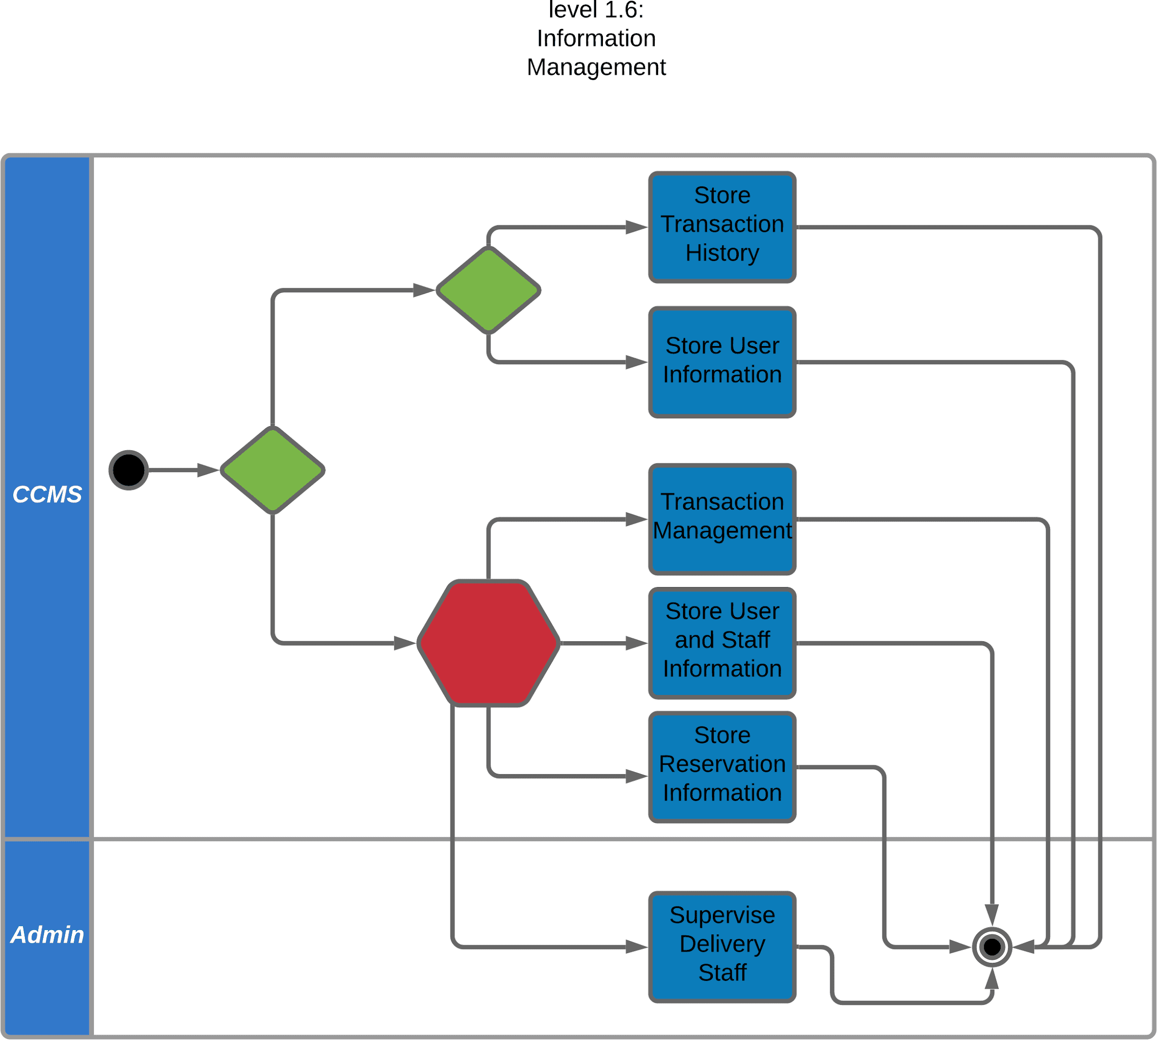

### SID: 1.7

**Name :** Payment

**Reference:** Use Case level 1.7 & Activity Level 1.2.3

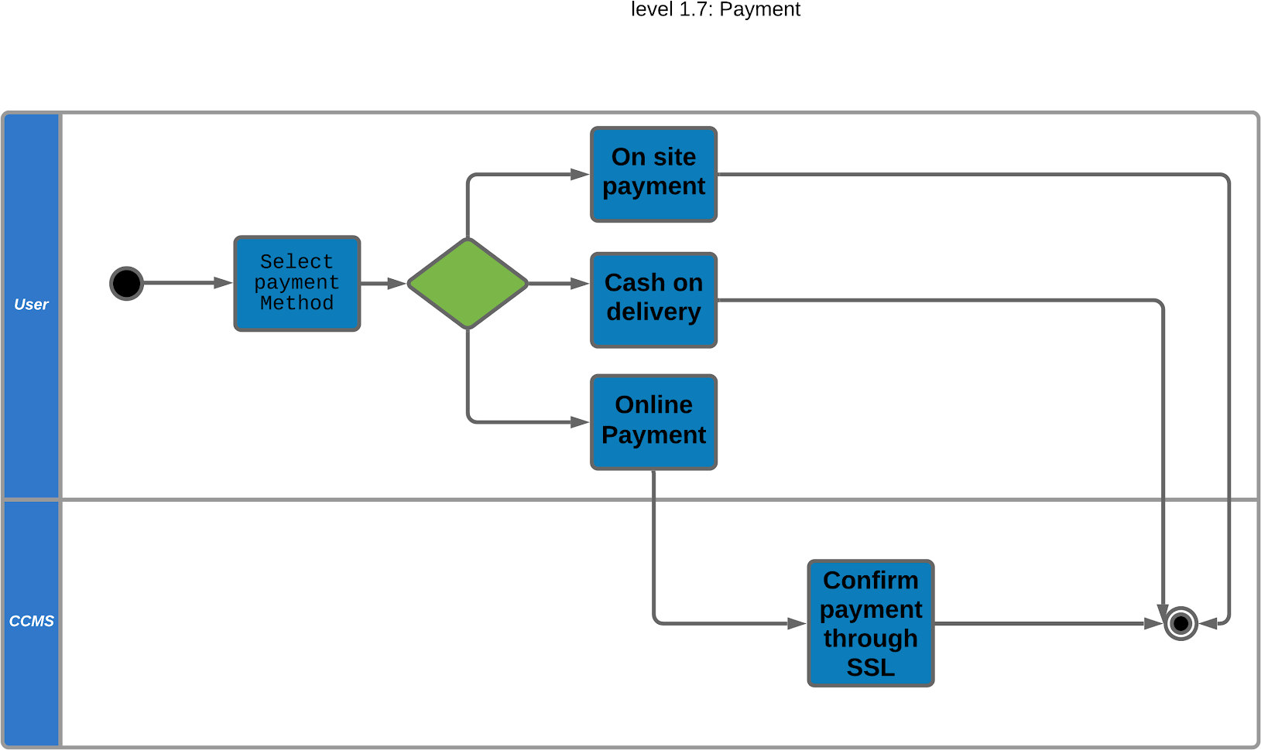

# Data Based Modelling

### DATA MODELING CONCEPT :

If software requirements include the necessity to create, extend or interact with a database or complex data structures need to be constructed and manipulated, then the software team chooses to create data models as part of overall requirements modeling. The entity- relationship diagram (ERD) defines all data objects that are processed within the system, the relationships between the data objects and the information about how the data objects are entered, stored, transformed and produced within the system.

### DATA OBJECTS :

A data object is a representation of composite information that must be understood by the software. Here, composite information means information that has a number of different

properties or attributes. A data object can be an external entity, a thing, an occurrence, a role, an organizational unit, a place or a structure.

### Data object identification :

|  |  |  |  |
| --- | --- | --- | --- |
| **Serial** | **Noun** | **Problem(p solution(s) space** | **)/ Attribute** |
| 1 | CCMS | p |  |
| 2 | CARS cafeteria | p |  |
| 3 | admin | s | 9,10,11,14,19 |
| 4 | teacher | s | 9,10,11,12,14,15,16,17,  19 |
| 5 | order | s | 19,34,33,79,82 |
| 6 | reservation | s | 80,19,51,37,38,74,79,81,  39,82 |
| 7 | account | p |  |
| 8 | information | p |  |
| 9 | full name | s |  |
| 10 | mobile number | s |  |
| 11 | email address | s |  |
| 12 | teacher id | s |  |
| 13 | officer id | s |  |
| 14 | password | s |  |
| 15 | department name | s |  |
| 16 | room number | s |  |
| 17 | location | s |  |
| 18 | Verification code | s |  |

|  |  |  |  |
| --- | --- | --- | --- |
| 19 | username | s |  |
| 20 | credentials | p |  |
| 21 | database | p |  |
| 22 | Dhaka University | p |  |
| 23 | employees | p |  |
| 24 | grocery item | s |  |
| 25 | SSL Commerz | s |  |
| 26 | Cafeteria’s trans- action account | s |  |
| 27 | Secured and en- crypted protocol | p |  |
| 28 | Notification email | s |  |
| 29 | Notification sms | s |  |
| 30 | user | p |  |
| 31 | payment | p |  |
| 32 | book table | p |  |
| 33 | memo | s | 34,37,38,49,39 |
| 34 | Order id | s |  |
| 35 | Delivery man | p |  |
| 36 | Cash on delivery | p |  |
| 37 | Food item | s |  |
| 38 | quantity | s |  |
| 39 | Total price | s |  |
| 40 | office delivery | p |  |
| 41 | cancellation | p |  |
| 42 | transaction | s | 83,84,34,80 |
| 43 | profile | p |  |

|  |  |  |  |
| --- | --- | --- | --- |
| 44 | Recovery link | s |  |
| 45 | OTP | s |  |
| 46 | menu | s | 37,38,49 |
| 47 | stock | s |  |
| 48 | Virtual cart | s |  |
| 49 | price | s |  |
| 50 | delivery | p |  |
| 51 | Table number | s |  |
| 52 | occasion | p |  |
| 53 | ceremony | p |  |
| 54 | event | p |  |
| 55 | Booking queue | p |  |
| 56 | First place | p |  |
| 57 | Queued user | p |  |
| 58 | Room delivery | p |  |
| 59 | University campus | p |  |
| 60 | service | p |  |
| 61 | Delivery charge | s |  |
| 62 | Estimated time | s |  |
| 63 | User’s display | p |  |
| 64 | staff | s |  |
| 65 | GPS | s |  |
| 66 | “Pathao” rider | p |  |
| 67 | Admin database | s |  |
| 68 | User database | s |  |
| 69 | Delivery staff number | s |  |

|  |  |  |  |
| --- | --- | --- | --- |
| 70 | Availability count | s |  |
| 71 | Sum of transactions | s |  |
| 72 | Transaction history | p |  |
| 73 | Replica of user info | p |  |
| 74 | Quantity of people | s |  |
| 75 | Administrative management | s |  |
| 76 | Inventory management | s | 24,38 |
| 77 | verification | s |  |
| 78 | Officer | s | 9,10,11,13,14,15,16,17,  19 |
| 79 | Confirmation Time | s |  |
| 80 | Reservation id | s |  |
| 81 | Event time | s |  |
| 82 | Request time | s |  |
| 83 | Transaction id | s |  |
| 84 | Transaction amount | s |  |

### Final data object :

1. Admin
2. Teacher
3. Officer
4. Order
5. Reservation
6. Memo
7. Transaction
8. Menu
9. Inventory management

### Data Object Relationship:

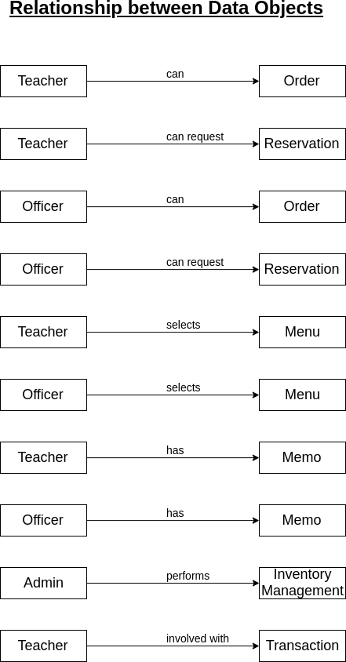

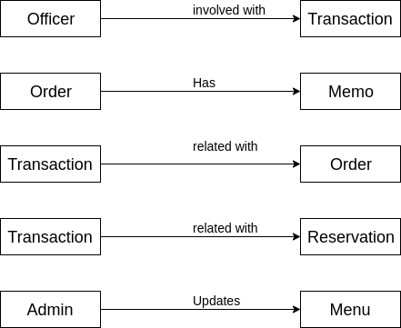

### ER Diagram:

### Definition of ER Diagram

An Entity Relationship (ER) Diagram is a type of flowchart that illustrates how “entities”

such as people, objects or concepts relate to each other within a system.

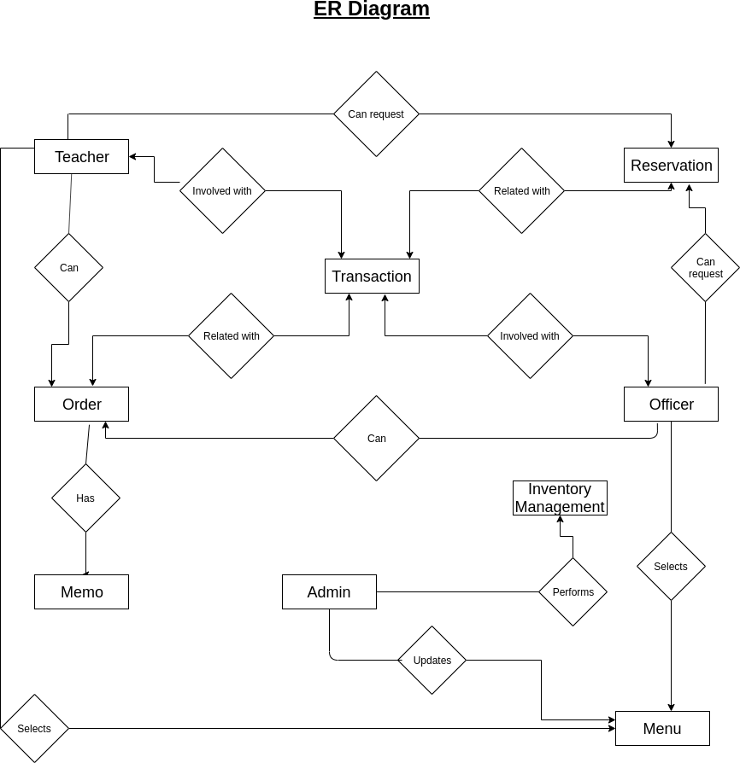

### Schema Diagram

|  |  |  |  |
| --- | --- | --- | --- |
| **Data Object** | **Attribute** | **Type** | **Size** |
| Admin | -full name  -mobile number  -email address  -username  -password | Varchar Varchar Varchar Varchar Varchar | 40  40  40  40  40 |
| Teacher | -full name  -mobile number  -email address  -teacher id  -password  -department name  -room number  -location  -username | Varchar Varchar Varchar Varchar Varchar Varchar Number Varchar Varchar | 40  40  40  40  40  40  40  40 |
| Officer | -full name  -mobile number  -email address  -officer id  -password  -department name  -room number  -location  -username | Varchar Varchar Varchar Varchar Varchar Varchar Number Varchar Varchar | 40  40  40  40  40  40  40  40 |
| Order | -Order id  -username  -memo  -Request time  -Confirmation time | Varchar Varchar Memo  Date & time Date & time | 40  40 |
| Reservation | -Reservation id  -username  -food item  -quantity  -total price  -table number  -quantity of people  -confirmation time  -event time  -request timePage 69 of | Varchar Varchar List Number Number Number Number Time Time T12i6me | 40  40 |
| Memo | -order id  -food item | Varchar  Varchar | 40  40 |

# CLASS-BASED MODELING

**CLASS BASED MODELING CONCEPT :**

Class-based modeling represents the objects that the system will manipulate, the operations that will be applied to the objects, relationships between the objects and the collaborations that occur between the classes that are defined.

### Noun list from Cafeteria Management System

|  |  |  |  |
| --- | --- | --- | --- |
| **No** | **Noun** | **No** | **Noun** |
| 1 | CCMS | 20 | credentials |
| 2 | CARS cafeteria | 21 | database |
| 3 | admin | 22 | Dhaka University |
| 4 | teacher | 23 | employees |
| 5 | order | 24 | grocery item |
| 6 | reservation | 25 | SSL Commerz |
| 7 | account | 26 | Cafeteria’s trans- action account |
| 8 | information | 27 | Secured and en- crypted protocol |
| 9 | full name | 28 | Notification email |
| 10 | mobile number | 29 | Notification sms |
| 11 | email address | 30 | user |
| 12 | teacher id | 31 | payment |
| 13 | officer id | 32 | book table |
| 14 | password | 33 | memo |
| 15 | department name | 34 | Order id |
| 16 | room number | 35 | Delivery man |
| 17 | location | 36 | Cash on delivery |
| 18 | Verification code | 37 | Food item |

*continued on next page*

*continued from previous page*

|  |  |  |  |
| --- | --- | --- | --- |
| 19 | username | 38 | quantity |
| 39 | Total price | 59 | University campus |
| 40 | office delivery | 60 | service |
| 41 | cancellation | 61 | Delivery charge |
| 42 | transaction | 62 | Estimated time |
| 43 | profile | 63 | User’s display |
| 44 | Recovery link | 64 | staff |
| 45 | OTP | 65 | GPS |
| 46 | menu | 66 | “Pathao” rider |
| 47 | stock | 67 | Admin database |
| 48 | Virtual cart | 68 | User database |
| 49 | amount | 69 | Delivery staff number |
| 50 | delivery | 70 | Availability count |
| 51 | Table number | 71 | Sum of transactions |
| 52 | occasion | 72 | Transaction history |
| 53 | ceremony | 73 | Replica of user info |
| 54 | event | 74 | Quantity of food |
| 55 | Booking queue | 75 | Administrative management |
| 56 | First place | 76 | Inventory management |
| 57 | Queued user | 77 | verification |
| 58 | Room delivery | 78 | Officer |
|  |  | 79 | reservation id |

### Verb list

|  |  |  |  |
| --- | --- | --- | --- |
| **No** | **Verb** | **No** | **Verb** |
| 1 | Create Account | 31 | show(stock) |
| 2 | Provides info | 32 | choose item |
| 3 | verify info | 32 | select(quantity) |
| 4 | send code | 33 | add(to cart) |
| 5 | input code | 34 | pay(bill) |
| 6 | update info | 35 | deliver |
| 7 | change | 36 | confirm(order) |
| 8 | recover (password) | 37 | give(memo) |
| 9 | send(recovery link) | 38 | cancel(order) |
| 10 | click(link) | 39 | refund |
| 11 | input(password) | 40 | reserve |
| 12 | update(database) | 41 | book(table,cafeteria) |
| 13 | send(otp) | 42 | choose(table) |
| 14 | input(new otp) | 43 | notify(cancellation) |
| 15 | log in | 44 | assign(to booking queue) |
| 16 | order | 45 | reopen(booking queue) |
| 17 | provide(menu) | 46 | communicate |
| 18 | integrate | 47 | store (staff and user info) |
| 19 | send(transaction email) | 48 | store (reservation de- tails) |
| 20 | add (admin database) | 49 | count (staff) |
| 21 | go (to cafe) | 50 | deduct |

*continued on next page*

*continued from previous page*

|  |  |  |  |
| --- | --- | --- | --- |
| 22 | choose (payment type) | 51 | come |
| 23 | cancel (automati- cally) | 52 | see |
| 24 | prompt memo | 53 | add (transaction de- tail) |
| 25 | input (grocery item) | 54 | store (user database) |
| 26 | update (count) | 55 | update (user database) |
| 27 | request (delivery) | 56 | replace(admin database) |
| 28 | prompt (estimated time) | 57 | fix |
| 29 | track | 58 | update menu |
| 30 | display | 59 | deduct (food item) |

### General classification

Candidate classes were then characterized in seven general classification. The seven general characteristics are as follows:

* 1. External entities
  2. Things
  3. Events
  4. Roles
  5. Organizational units
  6. Places
  7. Structures

Potential nouns to become a class after general classification criteria :

|  |  |
| --- | --- |
| Noun | General Classification |
| CCMS | 4 |
| admin | 4,7 |
| teacher | 4,7 |
| officer | 4,7 |
| order | 3 |
| reservation | 3 |
| account | 2,7 |
| delivery | 3 |
| cancellation | 3 |
| transaction | 3 |
| profile | 2,7 |
| menu | 1,2 |
| stock | 2 |
| virtual cart | 2 |
| booking queue | 2 |
| database | 2,7 |
| admin database | 2,7 |
| user database | 2,7 |
| employee | 4,5,7 |
| grocery item | 1 |
| SSL Commerz | 1,3 |
| Cafeteria’s transaction account | 1 |
| email | 1,3 |
| sms | 1,3 |
| user | 4,5,7 |

*continued on next page*

|  |  |
| --- | --- |
| payment | 3 |
| memo | 2 |
| cash on delivery | 3 |
| staff | 4,5,7 |
| GPS | 1 |
| Replica of user info | 2 |
| Administrative management | 3 |
| Inventory management | 3 |
| verification | 3 |

### Selection Criteria

The candidate classes are then selected as classes by six Selection Criteria. A candidate class generally becomes a class when it fulfills around three charac- teristics.

1.Retain information 2.Needed services 3.Multiple attributes 4.Common attributes 5.Common operations 6.Essential requirements

Potential general classified nouns to become a class after selection criteria :

*continued on next page*

|  |  |
| --- | --- |
| Noun | Selection criteria |
| CCMS | 1,2,6 (selected) |
| admin | 1-6 (selected) |
| teacher | 1-6 (selected) |
| officer | 1-6 (selected) |
| order | 1,2,3,6 (selected) |
| reservation | 1,2,3,6 (selected) |
| account | 1-6 (selected) |
| delivery | 2,3,6 (selected) |
| cancellation |  |
| transaction | 1,3 |
| profile | 1,3,4 |
| menu | 1 |
| stock | 1 |
| virtual cart | 1,3,2 (selected) |
| booking queue | 2 |
| admin database | 1-6 (selected) |
| user database | 1-6 (selected) |
| employee |  |
| grocery item |  |
| SSL Commerz | 2, 6 (selected) |
| Cafeteria’s transaction account | 1,6 (selected) |
| email | 2,5,6 (selected) |
| sms | 2,5,6 (selected) |
| user | 1-6 |
| payment | 3,4,5,6 (selected) |

*continued on next page*

|  |  |
| --- | --- |
| memo | 1 |
| cash on delivery |  |
| staff |  |
| GPS | 6 (selected) |
| Replica of user info |  |
| Administrative management | 6 |
| Inventory management |  |
| verification | 2,6 |

### Attribute and Method Identification

|  |  |  |
| --- | --- | --- |
| Class name | Attribute | Method |

*continued on next page*

|  |  |  |
| --- | --- | --- |
| CCMS |  | +verify_info()  +notify_user()  +send_otp()  +send_link()  +update_user_ database()  +update_admin_ database()  +provide_menu()  +display_stock()  +add_to_cart()  +provide_memo()  +notify_after_ transaction()  +prompt_memo()  +update_item_count()  +display_most_ consumed_food()  +display_relevant_food()  +analyze_order() |
| Admin | -full_name -  mobile_number -  email_address - user_name  -password | +login()  +notify_after_ cancellation()  +notify_after_ confirmation()  +input_grocery_item()  +update_grocery_item()  +fix_menu()  +update_menu()  +input_staff_count()  +update_staff_count()  +call_delivery() |

*continued on next page*

|  |  |  |  |
| --- | --- | --- | --- |
| Teacher | -full_name  -mobile_number  -email_address  -teacher_id department_name  -room_number location  -password |  | +create_account() |
|  | +recover_password() |
|  | - | +update_info() |
|  | +login() |
|  | - | +order() |
|  | +choose_payment_type() |
|  |  | +request_delivery() |
|  |  | +pay() |
|  |  | +cancel() |
|  |  | +reserve() |
| Officer | -full_name mobile_number  -email_address  -officer_id department_name  -room_number location  -password | - | +create_account()  +recover_password() |
|  | - | +update_info() |
|  | +login() |
|  | - | +order() |
|  | +choose_payment_type() |
|  |  | +request_delivery() |
|  |  | +pay() |
|  |  | +cancel() |
|  |  | +reserve() |
| Order | -order_id -  food_item_with_price  -quantity  -total_price  -isConfirmed  -isCancelled - payment_type  -order_time  -isRefunded | | +display_menu()  +choose_item() |
|  | +select_quantity() |
|  | +store_order_detail() |
|  | +auto_cancel() |
|  | +refund_user() |

*continued on next page*

|  |  |  |
| --- | --- | --- |
| Reservation | -reservation id  -total_people  -total_table  -reservation_type  -menu  -isInQueue  -isConfirmed  -isCancelled  -payment_type  -reservation_time | +reserve_table()  +reserve_whole_cafe()  +customize_menu()  +manage_queue()  +refund()  +store_reservation_ detail()  +auto_cancel()  +calculate_amount() |
| Account | -full_name  -mobile_number -  email_address - teacher_id/officer_id  -department_name  -room_number  -location  -password | +getFull_name()  +setFull_name()  +getMobile_number()  +setMobile_number()  +getEmail_address()  +setEmail_address()  +getTeacher/officer_id()  +setTeacher/officer_id()  +getDepart- ment_name()  +setDepartment_name()  +getRoom_number()  +setRoom_number()  +getLocation()  +setLocation()  +getPassword()  +setPassword() |
| Delivery | -delivery_time -  delivery_number - delivery_location | +staff_delivery()  +pathao_delivery() |

*continued on next page*

nt()

|  |  |  |
| --- | --- | --- |
| Admin_ Database | -staff_number  -memo_number | +transaction_history()  +store_staffInfo()  +update_staff()  +calc_transaction()  +store_groceryInfo() |
| User_ Database | -memo_number | +transaction_history()  +update_info() |
| Virtual_Cart | -food_quantity  -total_amount  -estimated_deliveryTime  -delivery_location  -contact_info | +calculate_amount()  +prompt_virtual_cart() |
| SSL_ COMMERZ | -isTransaction_ completed  -isNotified | +make_transaction()  +notify_admin()  +add_payment_to_accou |
| Cafeteria’s_ Transaction_ Account | -transaction_ dailyCount  -transaction_  weeklyCount  -transaction_ monthlyCount | +update_ dailyCount()  +update_ weeklyCount()  +update_ monthlyCount() |
| Email |  | +send_confirmation() |
| SMS |  | +send_confirmation() |
| Payment | -payment_type  -isPayment_completed  -payment_time  -transaction_id | +notify_user()  +online_payment()  +cash_on_delivery() |
| GPS | -distance  -estimated_time | +call_GPS()  +display_distance_time() |

**Analysis**

## All classes included in class based diagram are selected as class for our system.

### CRC card

|  |  |  |
| --- | --- | --- |
| **Class name** | **Responsibility** | **Collaborator** |

*continued on next page*

|  |  |  |
| --- | --- | --- |
| CCMS | * verifying infor- mation * notifying user * sending otp and recovery link * updating user and admin database * providing menu * displaying stock * adding to cart * providing memo * notifying after transaction * prompting memo * deducting item * Displaying mostly con- sumed food * Displaying all relevant food * Analyzing or- der of previous month | Teacher, Officer, SMS, Email, Ad- min_database, User_database, Ad- min, Virtual_cart, Order, Payment |

*continued on next page*

|  |  |  |
| --- | --- | --- |
| Admin | * Inventory man- agement * notifying after confirmation and cancella- tion * managing daily menu * staff manage- ment * invoking deliv- ery method | Teacher, Officer, Admin_database, SMS, Email, Cafe- teria’s_ Transaction_account |
| Teacher | * Ordering food * Payment * Reservation | Account, Payment, Order, Reservation, Delivery |
| Officer | * Ordering food * Payment * Reservation | Account, Payment, Order, Reservation, Delivery |

*continued on next page*

|  |  |  |
| --- | --- | --- |
| Order | * Display menu * Storing order details * Cancelling or- der * Refunding or- der | Teacher, Officer, User_database, Admin_database, Payment |
| Reservation | * Managing reser- vation * Managing booking queue * Refunding user * Storing reserva- tion details * Cancelling reservation * Calculating reservation pay- ment | Teacher, Officer, User_database, Admin_database, Payment |
| Account | * Creating ac- count * Updating pro- file * Viewing profile |  |

*continued on next page*

|  |  |  |
| --- | --- | --- |
| Delivery | * Managing deliv- ery methods | GPS, CCMS |
| Admin_Database | * Storing transac- tion history * Storing staff Info * Storing reserva- tion details * Updating staff count * Calculating pe- riod wise trans- action * Storing Grocery Info | Payment, Order, Reservation, Ac- count, Admin , CCMS |
| User_Database | * Storing user’s transaction his- tory * Storing up- dated info | Payment, Order, Reservation, Ac- count, CCMS |

*continued on next page*

## t,

|  |  |  |
| --- | --- | --- |
| Virtual_Cart | * Calculating amount * Prompting vir- tual cart | Order, Teacher, Of- ficer |
| SSL_COMMERZ | * Making trans- action * Notifying ad- min about pay- ment comple- tion * Adding paid amount to cafe- teria’s transac- tion account | Cafeteria’s_ Transaction_Accoun  Payment, Admin |
| Cafeteria’s_Transacti | on_Account   * Storing daily transaction count * Prompting pe- riod wise count | Payment |
| Email | * Sending confir- mation email |  |

*continued on next page*

|  |  |  |
| --- | --- | --- |
| SMS | * Sending confir- mation sms |  |
| Payment | * Managing user’s payment method | SSL_COMMERZ,  Teacher, Officer, SMS, Email |
| GPS | * Calling exter- nal subsystem “GPS” |  |

### CLASS CARDS

After identifying our final classes we have generated the fol- lowing class cards.

|  |  |
| --- | --- |
| CCMS | |
| Attribute | Method |
|  | +verify_info()  +notify_user()  +send_otp()  +send_link()  +update_user_database()  +update_admin_database()  +provide_menu()  +display_stock()  +add_to_cart()  +provide_memo()  +notify_after_transaction()  +prompt_memo()  +update_item_count()  +deduct_staff_count()  +display_most_consumed_foo  +display_relevant_food()  +analyze_order() |
| Responsibilities | Collaborator |
| * verifying information * notifying user * sending otp and recovery link * updating user and admin database * providing menu * displaying stock * adding to cart * providing memo Page 89 * notifying after transaction * prompting memo | Teacher Officer SMS  Email Admin_Database  User_Database Admin Virtual_cart  Order Payment  of 126 |

d()

|  |  |
| --- | --- |
| Admin | |
| Attribute | Method |
| -full_name  -mobile_number  -email_address  -user_name  -password | +login()  +notify_after_cancellation()  +notify_after_confirmation()  +input_grocery_item()  +update_grocery_item()  +fix_menu()  +update_menu()  +input_staff_count()  +store_order_ reservation_detail()  +update_staff_count()  +call_delivery() |
| Responsibilities | Collaborator |
| * Inventory management * notifying after confirma- tion and cancellation * managing daily menu * staff management * invoking delivery method | Teacher Officer  Admin_Database  SMS  Email Cafeteria’s_  Transaction_Account |

|  |  |
| --- | --- |
| Teacher | |
| Attribute | Method |
| -full_name  -mobile_number - email_address -teacher_id  -department_name - room_number -location  -password | +create_account()  +recover_password()  +update_info()  +login()  +order()  +choose_payment_type()  +request_delivery()  +pay()  +cancel()  +reserve() |
| Responsibilities | Collaborator |
| * Ordering food * Payment * Reservation | Account Payment  Order Reservation Delivery |

|  |  |
| --- | --- |
| Officer | |
| Attribute | Method |
| -full_name -mobile_number  -email_address -officer_id  -department_name - room_number -location  -password | +create_account()  +recover_password()  +update_info()  +login()  +order()  +choose_payment_type()  +request_delivery()  +pay()  +cancel()  +reserve() |
| Responsibilities | Collaborator |
| * Ordering food * Payment * Reservation | Account Payment  Order Reservation Delivery |

|  |  |
| --- | --- |
| Order | |
| Attribute | Method |
| -order_id -  food_item_with_price - quantity  -total_price  -isConfirmed  -isCancelled -payment_type  -order_time  -isRefunded | +display_menu()  +choose_item()  +select_quantity()  +store_order_detail()  +auto_cancel()  +refund_user() |
| Responsibilities | Collaborator |
| * Display menu * Storing order details * Cancelling order * Refunding order | Teacher Officer  User_Database  Admin_Database Payment |

|  |  |
| --- | --- |
| Reservation | |
| Attribute | Method |
| -total_people  -total_table  -reservation_type  -menu  -isInQueue  -isConfirmed  -isCancelled  -payment_type  -reservation_time | +reserve_table()  +reserver_whole_cafe()  +customize_menu()  +manage_queue()  +refund()  +store_reservation_detail()  +auto_cancel()  +calculate_amount() |
| Responsibilities | Collaborator |
| * Managing reservation * Managing booking queue * Refunding user * Storing reservation details * Cancelling reservation * Calculating reservation payment | Teacher Officer  User_Database  Admin_Database Payment |

|  |  |  |
| --- | --- | --- |
| Account | | |
| Attribute | | Method |
| -full_name  -mobile_number email_address teacher_id/officer_id department_name room_number  -location  -password | -  -  -  - | +getFull_name() |
| +setFull_name() |
| +getMobile_number() |
| +setMobile_number() |
| +getEmail_address() |
| +setEmail_address() |
| +getTeacher/officer_id() |
| +setTeacher/officer_id() +get- |
| Department_name() |
| +setDepartment_name() |
| +getRoom_number() |
| +setRoom_number() |
| +getLocation() |
| +setLocation() |
| +getPassword() |
| +setPassword() |
| Responsibilities | | Collaborator |
| * Creating account * Updating profile * Viewing profile | |  |

|  |  |
| --- | --- |
| Delivery | |
| Attribute | Method |
| -delivery_time  -delivery_number - delivery_location | +staff_delivery()  +pathao_delivery() |
| Responsibilities | Collaborator |
| * Managing delivery meth- ods | GPS CCMS |

|  |  |
| --- | --- |
| Admin_Database | |
| Attribute | Method |
| -staff_number  -memo_number | +transaction_history()  +store_staffInfo()  +reservation_details()  +update_staff()  +calc_transaction()  +store_groceryInfo() |
| Responsibilities | Collaborator |
| * Storing transaction history * Storing staff Info * Storing reservation details * Updating staff count * Calculating period wise transaction * Storing grocery info | Payment  Order Reservation Account Admin CCMS |

|  |  |
| --- | --- |
| User_Database | |
| Attribute | Method |
| -memo_number | +transaction_history()  +update_info() |
| Responsibilities | Collaborator |
| * Storing user’s transaction history * Storing updated info | Payment  Order Reservation Account CCMS |

**Table: Class Card for VIrtual_Cart Class**

|  |  |
| --- | --- |
| Virtual_Cart | |
| Attribute | Method |
| -food_quantity  -total_amount  -estimated_deliveryTime  -delivery_location  -contact_info | +calculate_amount()  +prompt_virtual_cart() |
| Responsibilities | Collaborator |
| * Calculating amount * Prompting virtual cart | Order Teacher Officer |

|  |  |
| --- | --- |
| SSL_COMMERZ | |
| Attribute | Method |
| -isTransaction_completed  -isNotified | +make_transaction()  +notify_admin()  +add_payment_to_account() |
| Responsibilities | Collaborator |
| * Making transaction * Notifying admin about payment completion * Adding paid amount to cafeteria’s transaction ac- count | Cafeteria’s_  Transaction_Account , Payment,  Admin |

**Table: Class Card for Cafeteria’s_Transaction_Account Class**

|  |  |
| --- | --- |
| Cafeteria’s_Transaction_Account | |
| Attribute | Method |
| -transaction_dailyCount  -transaction_weeklyCount  -transaction_monthlyCount | +update_dailyCount()  +update_weeklyCount()  +update_monthlyCount() |
| Responsibilities | Collaborator |
| * Storing daily transaction count * Prompting period wise count | Payment |

|  |  |
| --- | --- |
| Email | |
| Attribute | Method |
|  | +send_confirmation() |
| Responsibilities | Collaborator |
| * Sending confirmation email |  |

**Table: CLass Card for SMS Class**

|  |  |
| --- | --- |
| SMS | |
| Attribute | Method |
|  | +send_confirmation() |
| Responsibilities | Collaborator |
| * Sending confirmation SMS |  |

|  |  |
| --- | --- |
| Payment | |
| Attribute | Method |
| -payment_type  -isPayment_completed  -payment_time  -transaction_id | +notify_user()  +online_payment()  +cash_on_delivery() |
| Responsibilities | Collaborator |
| * Managing user’s payment method | SSL_COMMERZ  Teacher Officer SMS  Email |

**Table: Class Card for GPS Class**

|  |  |
| --- | --- |
| GPS | |
| Attribute | Method |
| -distance  -estimated_time | +call_GPS()  +display_distance_time() |
| Responsibilities | Collaborator |
| * Calling external subsystem   “GPS” |  |

# CRC Diagrams

### Diagram ID: 1

**Name:** CCMS

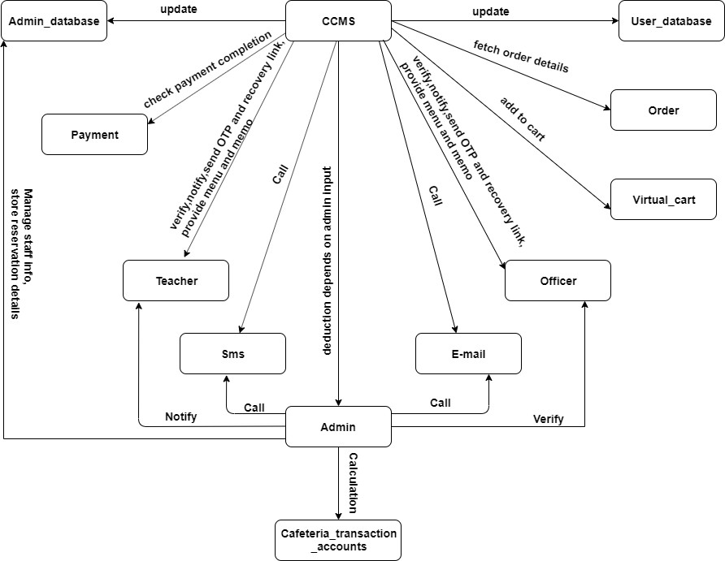

### Diagram ID: 2

**Name:** Account

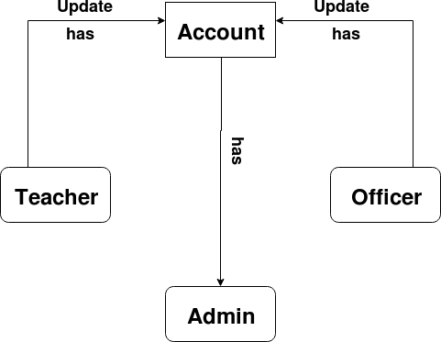

### Diagram ID: 3

**Name:** Order

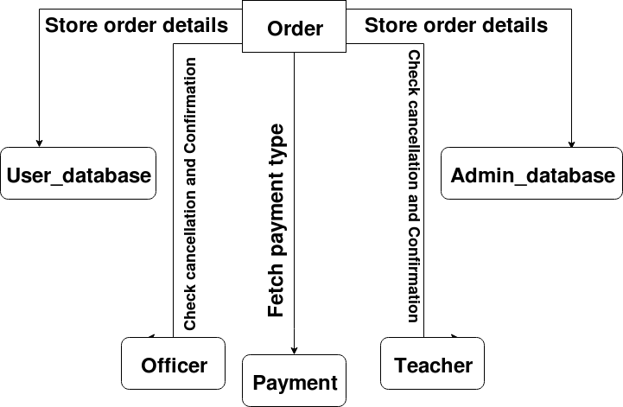

### Diagram ID: 4

**Name:** Payment

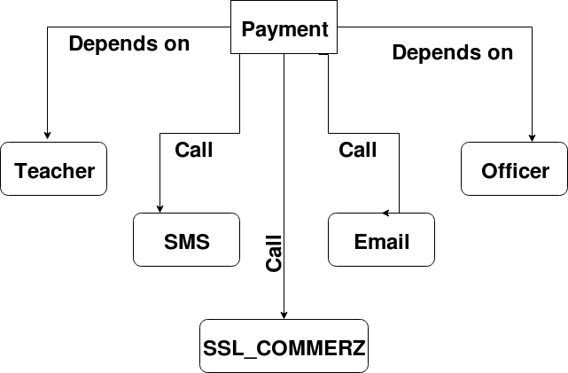

### Diagram ID: 5

**Name:** Reservation

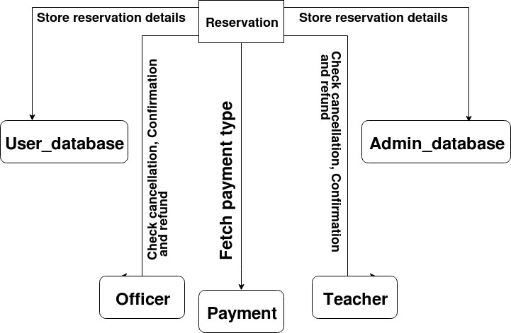

### Diagram ID: 6

**Name:** Virtual Cart

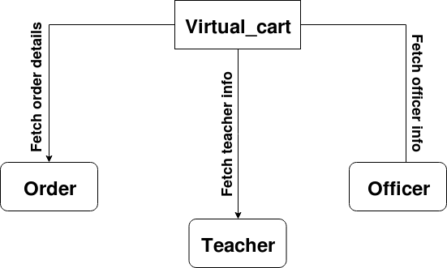

### Diagram ID: 7

**Name:** Cafeteria’s Transaction Account

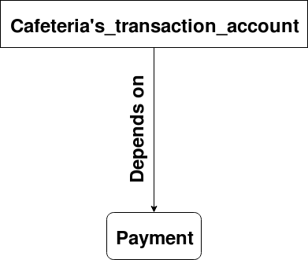

### Diagram ID: 8

**Name:** Delivery

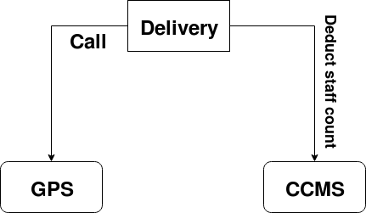

### Diagram ID: 9

**Name:** User database

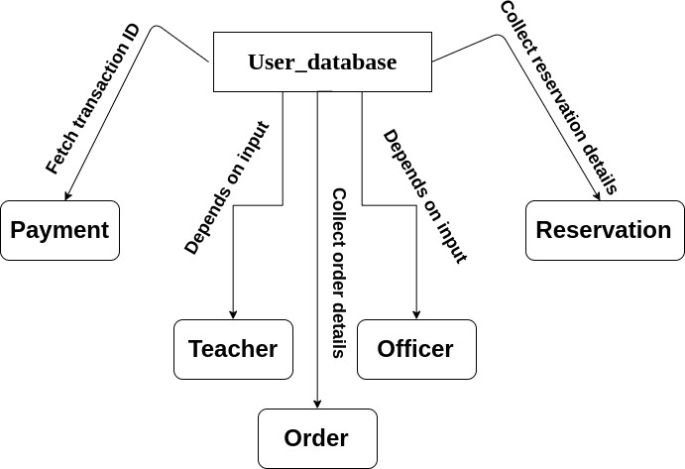

### Diagram ID: 10

**Name:** Admin database

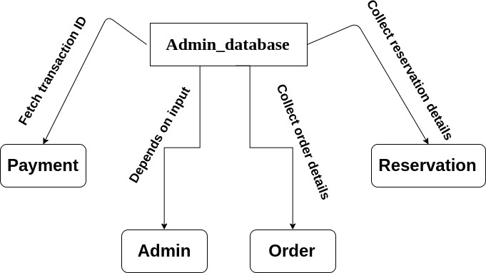

# BEHAVIORAL MODELING OF CCMS

### STATE TRANSITION DIAGRAM :

State diagram represents active states for each class the events (triggers). For this we iden- tified all the events, their initiators and collaborators.

### Event Table:

*continued on next page*

**Initiator CollaboratorAssociated**

**method**

**State Name**

**Event**

**no.**

**SL**

*continued on next page*

|  |  |  |  |  |  |
| --- | --- | --- | --- | --- | --- |
| 1 | Will create an ac- count | Create_ account | Teacher, Officer | CCMS,  Account, Email, SMS | +create_ account()  +verify_ info()  +notify_ user()  +send_  confirmation() |
| 2 | Will provide infor- mation | Provide_ info | Teacher, Officer |  | +create_ account() |
| 3 | Users’ credentials Will be verified | Verify_ info | CCMS |  | +verify_ info() |
| 4 | Will be able to up- date information | Update_ info | Teacher, Officer | Account, CCMS | +update_ info()  +setFull_ name()  +setMobile_ number()  +setEmail_ address()  +setTeacher/officer_ id()  +setDepartment_ name()  +setRoom_ number()  +setLocation() |
| 5 | Will be able to re- cover password | Recover_ password | Teacher, Officer | SMS,  Email, CCMS | +recover_  password()  +send_ otp()  +send_  link() |
| 6 | Will login to sys- tem | logIn_ to_system | Teacher, Officer, Admin |  | +login() |

*continued on next page*

|  |  |  |  |  |  |
| --- | --- | --- | --- | --- | --- |
| 7 | Will be able to or- der food | Order_ food | Teacher, Officer | Order | +order()  +display_ menu()  +choose_ item()  +select_  quantity() |
| 8 | Will provide daily menu | Provide_ menu | Admin |  | +fix_ menu()  +update_  menu() |
| 9 | Will be able to choose food item and quantity | Choose_ item | Teacher, Officer | Admin_ database | +display_ menu()  +choose_ item()  +select_  quantity() |
| 10 | Will add to vir- tual cart | Add_to  _cart | CCMS | Order | +choose_ item()  +select_ quantity()  +add_to  _cart() |
| 11 | Bill will be shown | Show_ bill | Virtual  _cart |  | +calculate_ amount()  +prompt_  virtual_cart() |
| 12 | Can pay the bill | Pay_ bill | Teacher, Officer | Payment, SSL_ COMMERZ | +pay()  +online_payment()  +cash_on_ delivery()  +make_ transaction()  +notify_admin() |
| 13 | Order will be con- firmed | Confirm_ order | CCMS | SMS,  Email | +notify_ after_transaction()  +send_  confirmation() |

*continued on next page*

|  |  |  |  |  |  |
| --- | --- | --- | --- | --- | --- |
| 14 | Memo will be given | Give_ memo | CCMS | Admin_ Database, User_ Database | +provide_ memo()  +transaction_  history() |
| 15 | Will be able to cancel order | Cancel_ order | Teacher, Officer |  | +cancel() |
| 16 | Will be refunded | Refund_ money | Reservati Order | oCna, feteria’s_ Transaction_ Account, SSL_ COMMERZ | +refund_ user()  +make_ transaction()  +notify_ admin()  +add_payment  _to_account() |
| 17 | Can reserve multi- ple tables | Reserve_ table | Teacher, Officer | Reservation | +reserve()  +reserve_table()  +customize_ menu() |
| 18 | Can book the whole cafeteria | Book_ cafeteria | Teacher, Officer | Reservation | +reserve()  +reserve_  whole_cafe() |
| 19 | Will provide cus- tomized menu | Choose_ item | Teacher, Officer | Reservation | +customize_ menu() |
| 20 | Payment will be calculated | Calculate_ bill | Virtual  _cart,  Reserv ation |  | +calculate_ amount() |
| 21 | Will be notified | Notify_ user | Admin, CCMS | SMS,  Email | +notify_after  _transaction()  +send_ confirmation() |
| 22 | Will be able to cancel reservation | Cancel_ reservation | Teacher, Officer | Reservation | +cancel()  +refund() |
| 23 | Will be assigned  into the booking queue | Assign_ in_queue | Reserv ation | Teacher, Officer | +manage_ queue() |

|  |  |  |  |  |  |
| --- | --- | --- | --- | --- | --- |
| 24 | Will pay  through “SSL COMMERZ” | Pay_ Through_ SSL | Payme nt | Teacher, Officer, SSL_ COMMERZ | +pay()  +online_ payment()  +make_ transaction()  +notify_ admin()  +add_payment_  to_account() |
| 25 | Pay onsite | Pay_ onsite | Admin | Admin_ database | +transaction_ history() |
| 26 | Can avail Cash-on delivery | Cash_ On_ delivery | Teacher, Officer | Admin | +cash_on  _delivery() |
| 27 | Memo will be prompted | Prompt_ memo | CCMS |  | +prompt_ memo() |
| 28 | Memo will be printed | Print_ memo | Admin | CCMS | +provide_ memo() |
| 29 | Can request for room delivery | Room_ delivery | Teacher, Officer | Delivery | +request_ delivery() |
| 30 | Estimated time will be prompted | Estimate_ time | GPS |  | +call_GPS()  +display_ distance_time() |
| 31 | Can choose deliv- ery method | Delivery_ method | Delivery | GPS,  Admin | +staff_ delivery()  +pathao_ delivery() |
| 32 | Location will be tracked | Track_ location | GPS | Delivery, Virtual_ cart | +call_GPS() |
| 33 | Delivery through staff | Delivery_ Through_ staff | Delivery | Admin | +staff_delivery() |
| 34 | Delivery through  “Pathao” | Delivery_ Through_ pathao | Delivery | Admin | +pathao_delivery() |
| 35 | All info will be stored | Store_ all_info | CCMS | Admin_ database, User_ database | +update_user  _database()  +update_ admin_database() |

*continued on next page*

|  |  |  |  |  |  |
| --- | --- | --- | --- | --- | --- |
| 36 | Staff number will be counted | Count_ Staff_ number | Admin | Admin_ database | +input_staff  _count()  +update_staff  _count()  +store_ staffInfo()  +update_  staff() |
| 37 | Sum of transac- tions will be cal- culated | Calculate_ transactions | Cafeteria’ Transacti Account | sA_dmin_ odna_tabase | +update_ dailyCount()  +update_ weeklyCount()  +update_  monthlyCount() |
| 38 | Store order memo and transaction history | Store_ transactions | Order,  Reserva tion | Admin_ Database, User_ database | +store_reservation  _detail()  +store_order  _detail() |
| 39 | replica of user database will be made | Make_ replica | CCMS | Admin_ database, User_ database | +update_ user_database()  +update_  admin_database() |
| 40 | menu will be up- dated | Update_ menu | Admin |  | +update_menu |
| 41 | availability of food item will be displayed | Display_ Available  _food | CCMS |  | +display_stock() |
| 42 | availability of gro- cery items will be counted | Count_ grocery | Admin | Admin_ database | +input_grocery  _item()  +update_grocery  _item() |
| 43 | Prompt mostly consumed item | Mostly_ Consumed  _item | CCMS | Order | +display_most  _consumed_food() |
| 44 | Display all rele- vant food accord- ing to user’s taste | Display_ Relevant_ food | CCMS | Order | +display_ relevant_food() |
| 45 | System will an- alyze previous months order | Analyze_ order | CCMS | Order | +analyze_ order() |

### State Transition

**ID : 1**

**Name** : Admin

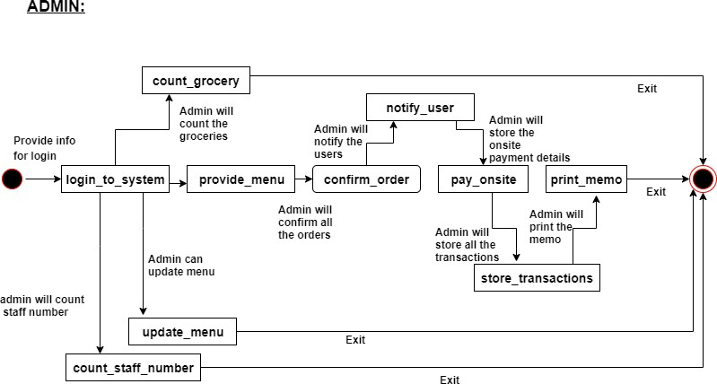

### ID : 2

**Name** : SSL COMMERZ

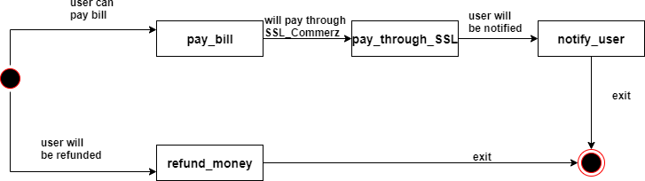

### ID : 3

**Name** : Admin_database

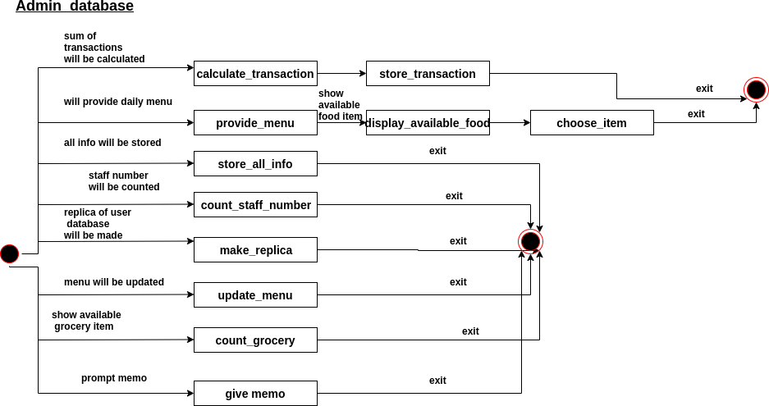

### ID : 4

**Name** : Delivery

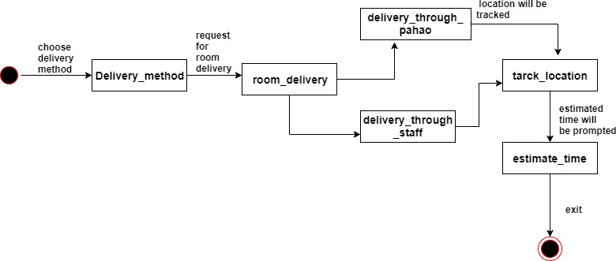

### ID : 5

**Name** : Cafeteria’s transaction account

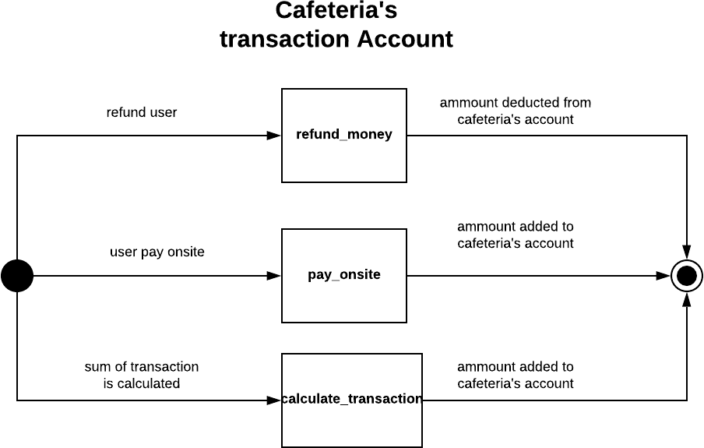

### ID : 6

**Name** : GPS

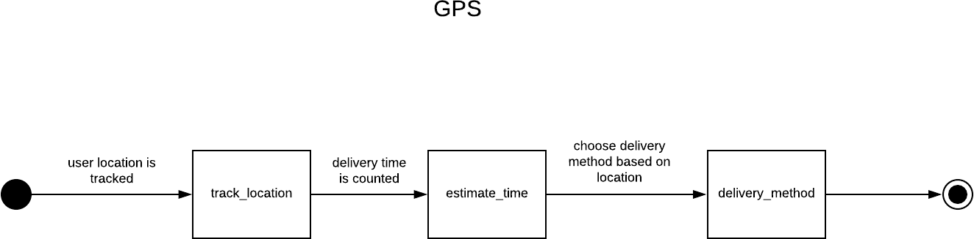

### ID : 7

**Name** : Email/SMS

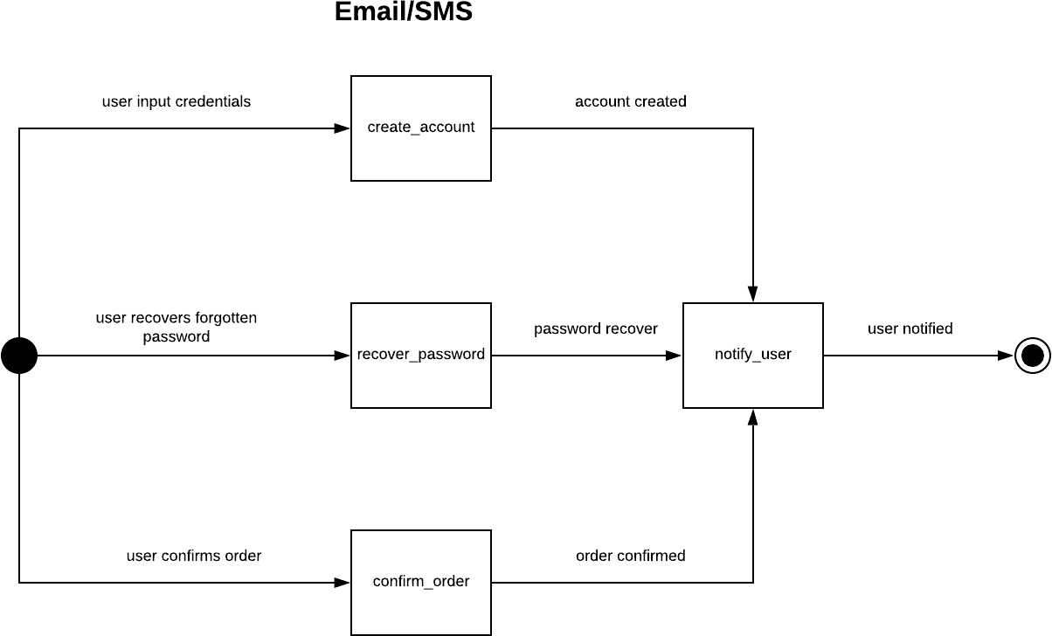

### ID : 8

**Name** : Account

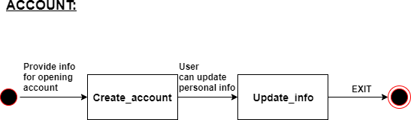

### ID : 9

**Name** : Reservation

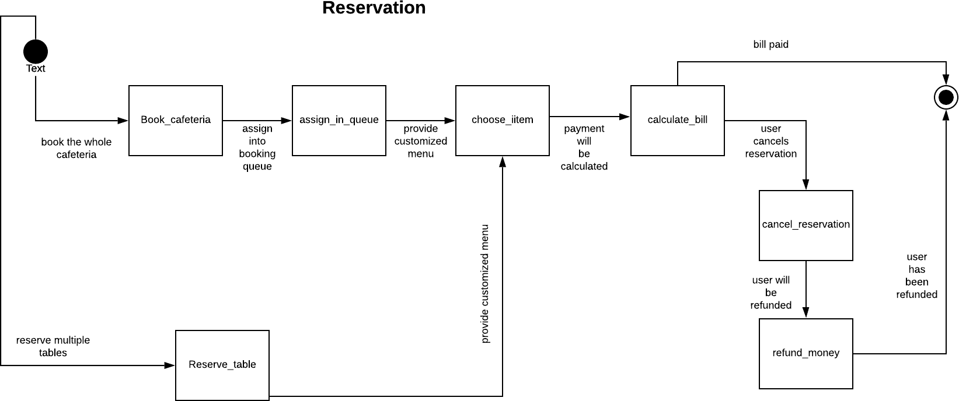

### ID : 10

**Name** : User_database

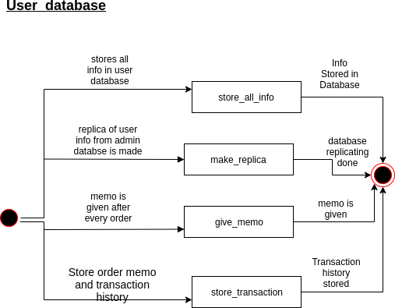

### ID : 11

**Name** : CCMS

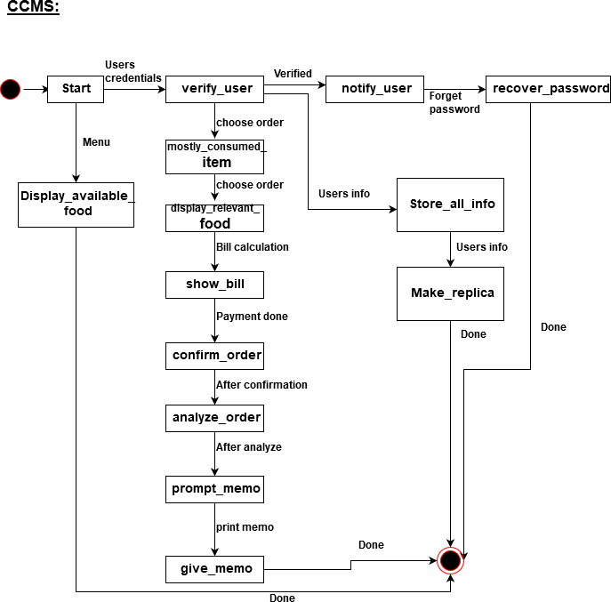

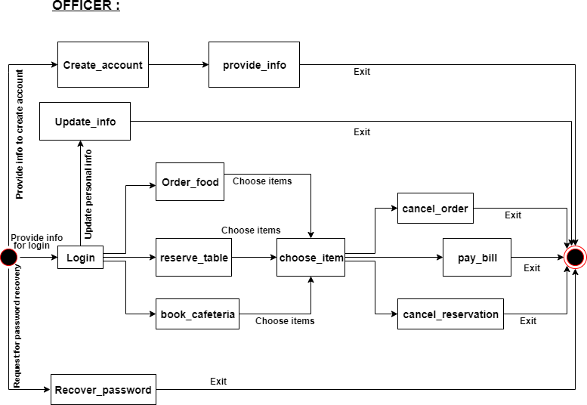

**Name** : Officer

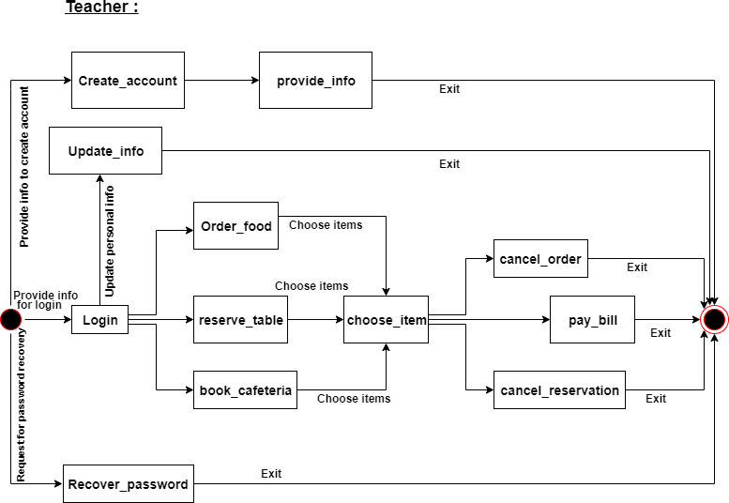

**Name** : Teacher

### ID : 14

**Name** : Order

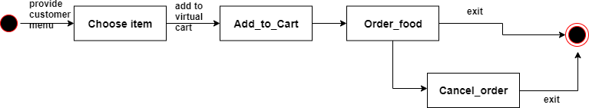

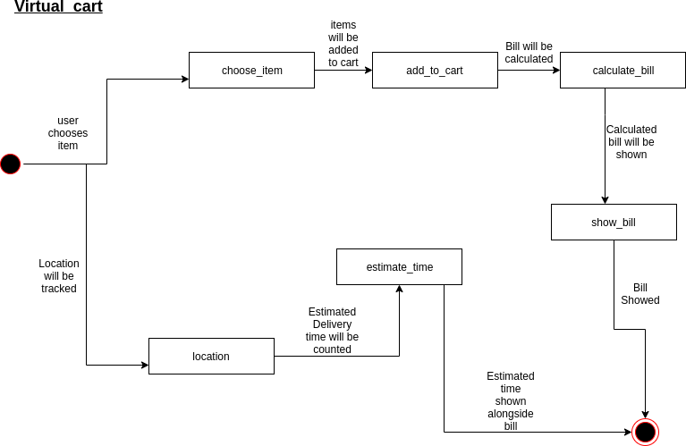

**Name** : Virtual cart

### ID : 16

**Name** : Payment

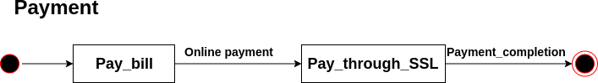

# Sequence Diagram:

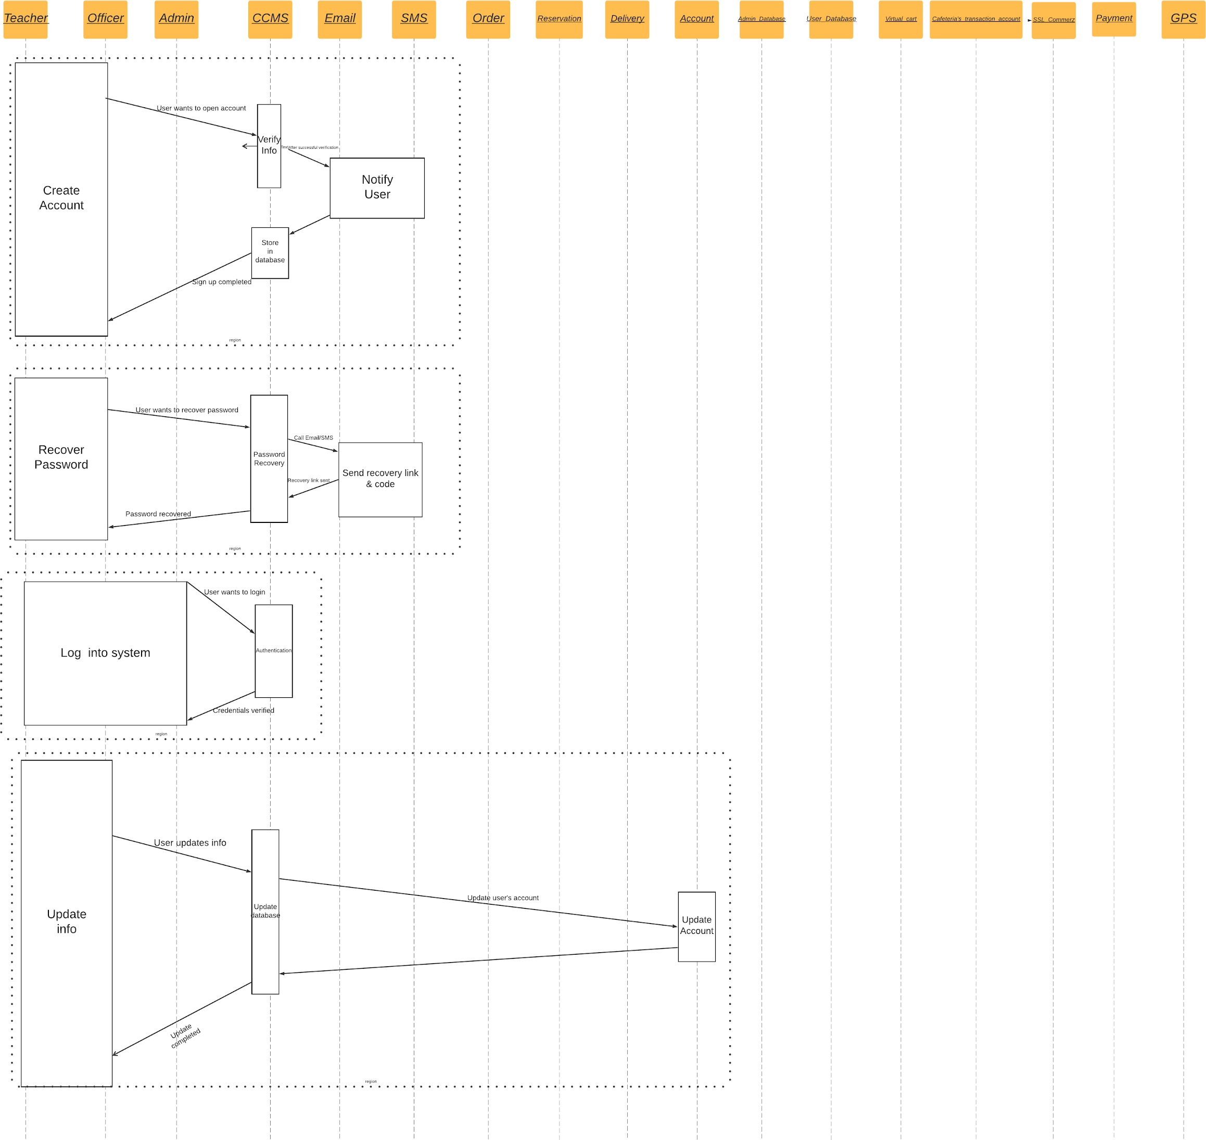

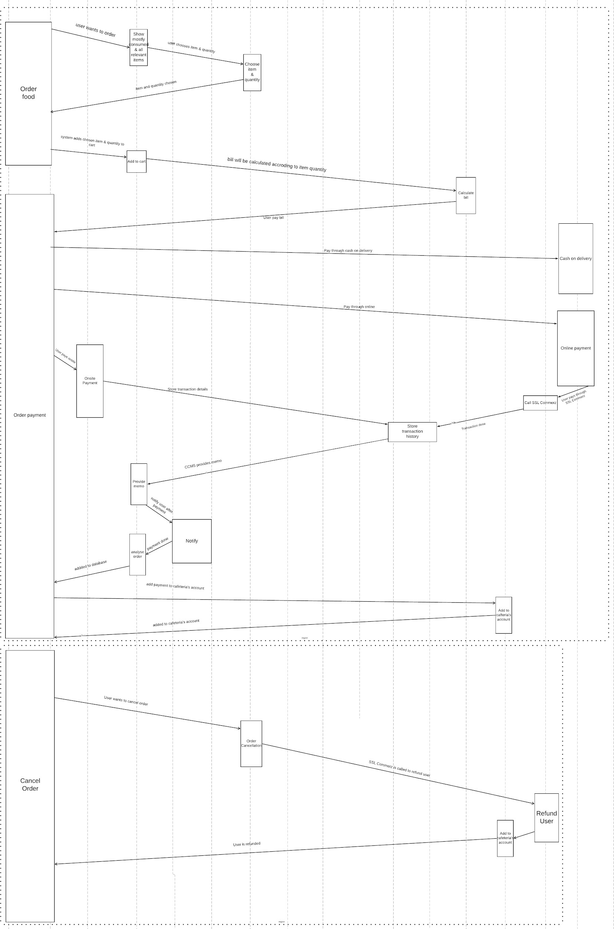

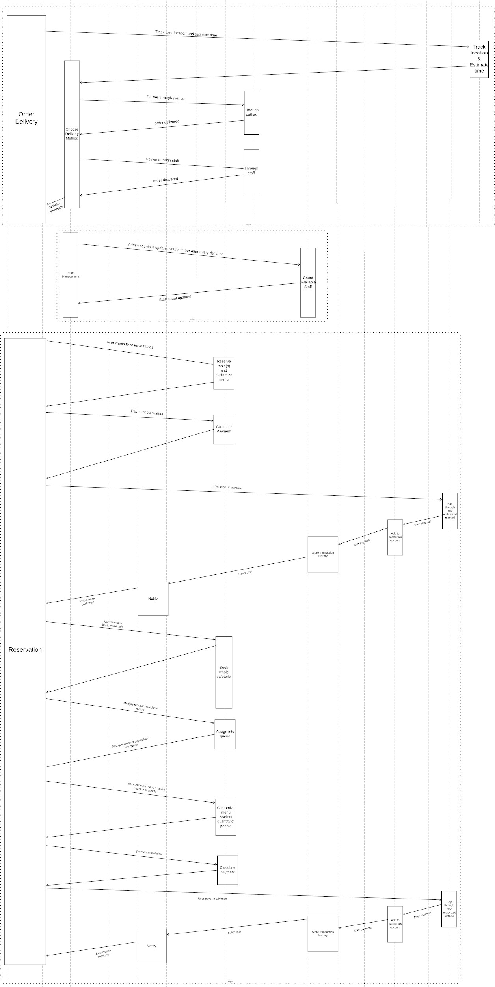

Page 125 of 126

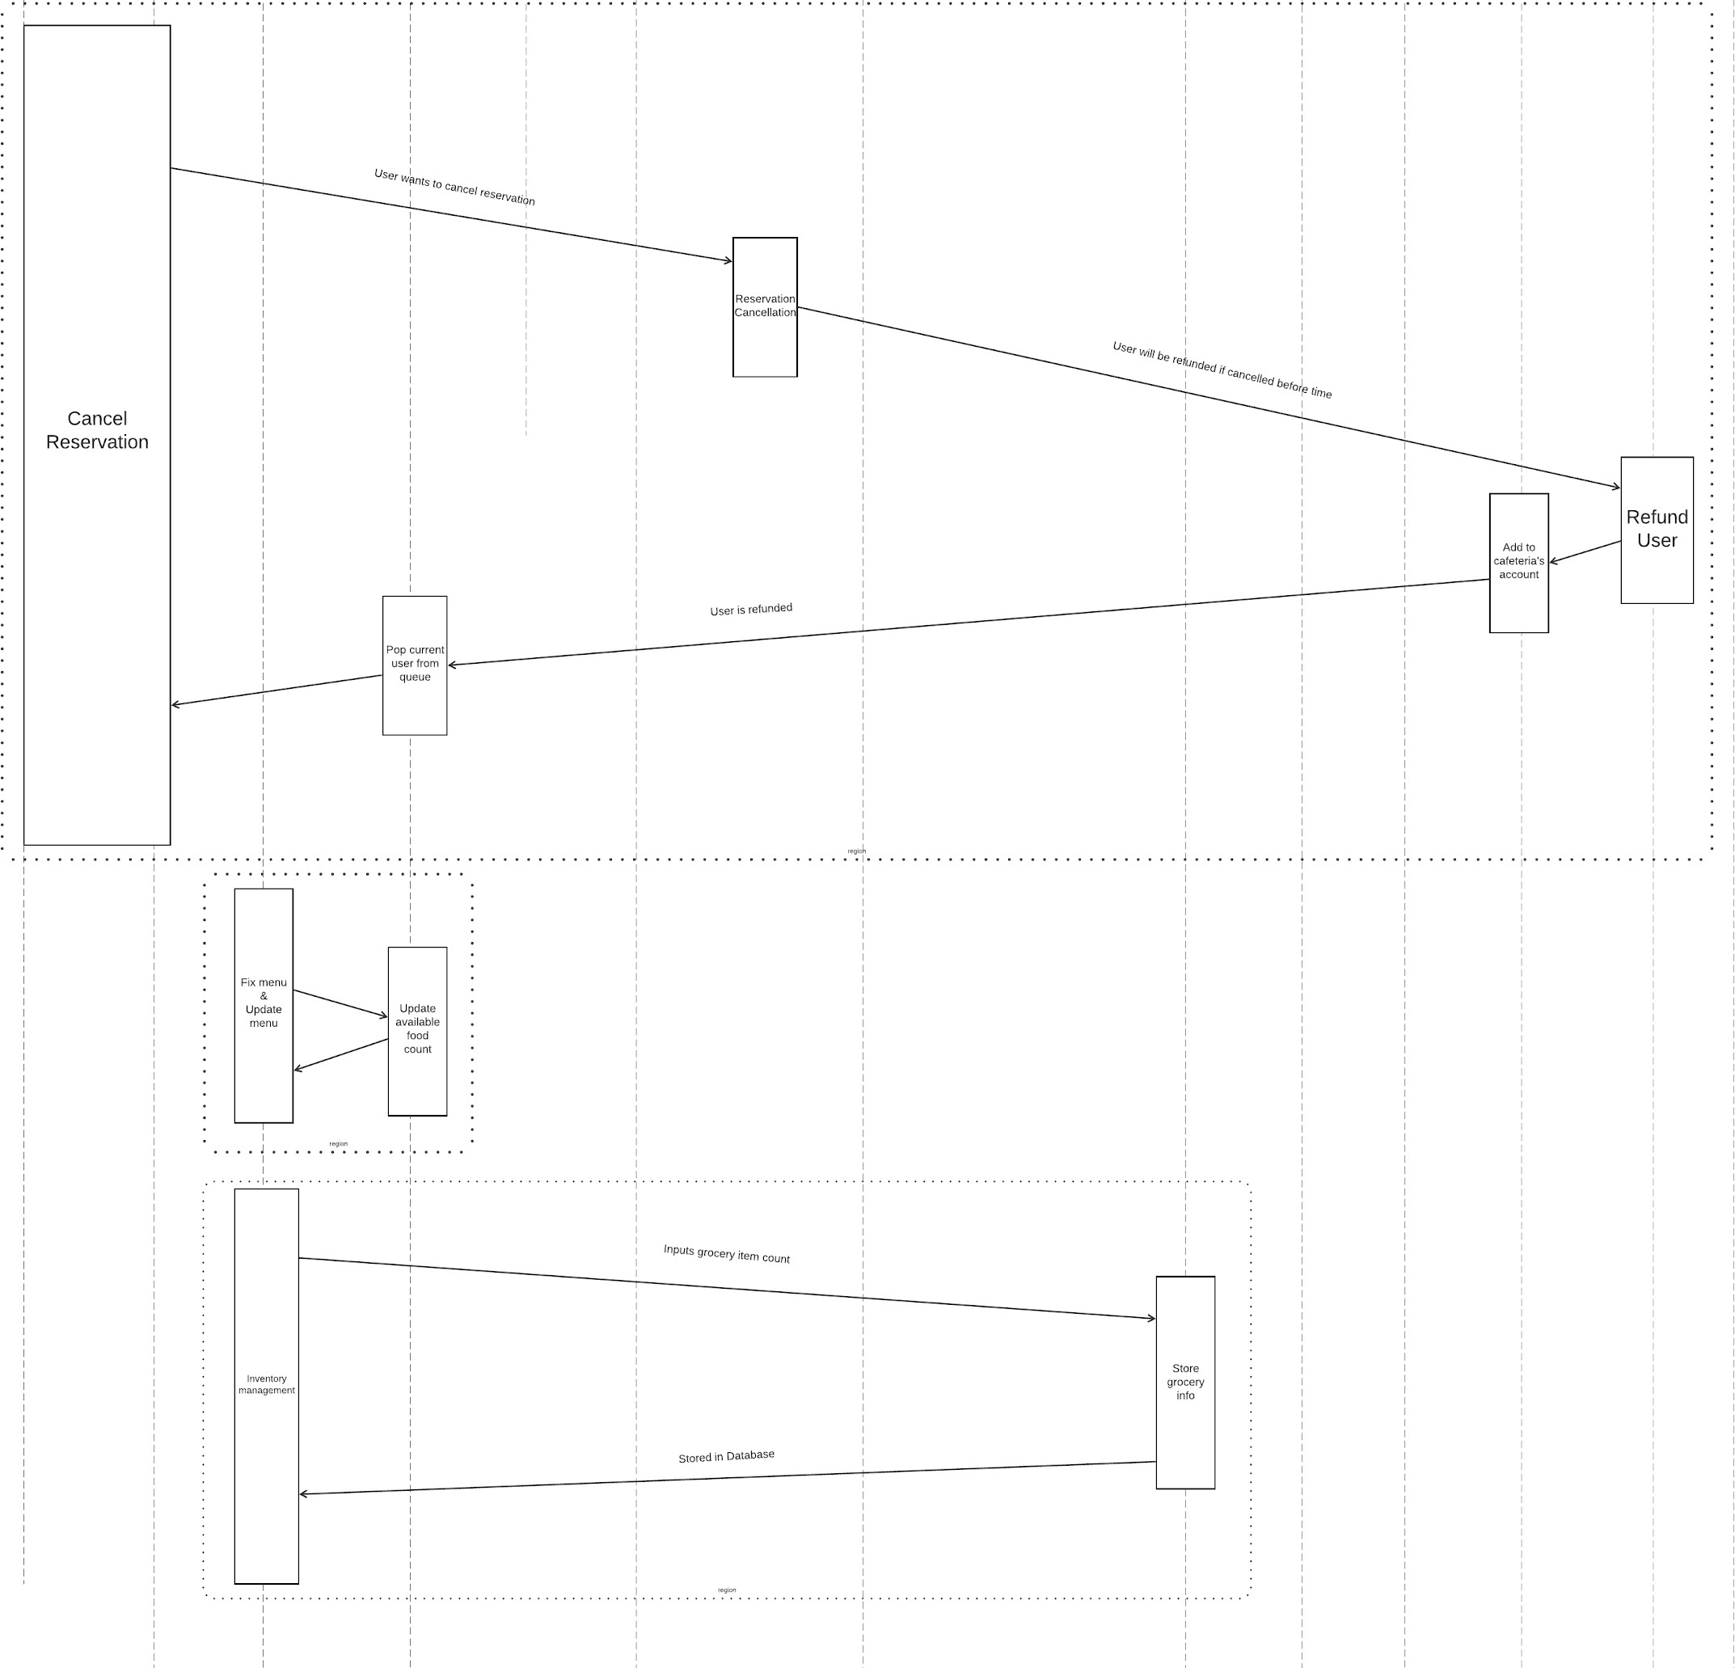

Page 126 of 126