Deepesh Oli
Enterprise L3 Spine-Leaf Data Center Network Design, OSPF Redundancy & Troubleshooting Project
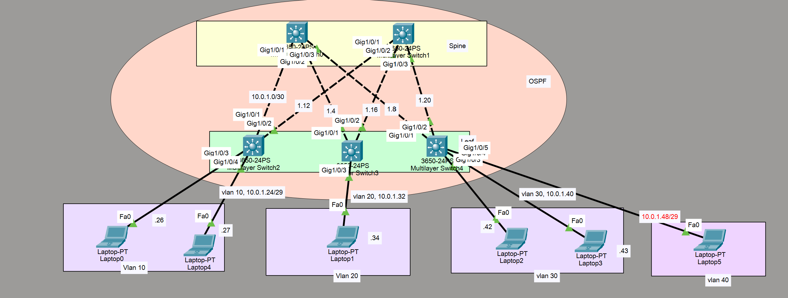

Netmask: 255.255.255.252
Link | Subnet | Spine IP | Leaf Ip
Spine-1 <->Leaf-1 | 10.0.1.0/30 | 10.0.1.1 | 10.0.1.2
Spine-1 <->Leaf-2 | 10.0.1.4/30 | 10.0.1.5 | 10.0.1.6
Spine-1 <->Leaf-3 | 10.0.1.8/30 | 10.0.1.9 | 10.0.1.10
Spine-2 <->Leaf-1 | 10.0.1.12/30 | 10.0.1.13 | 10.0.1.14
Spine-2 <->Leaf-2 | 10.0.1.16/30 | 10.0.1.17 | 10.0.1.18
Spine-2 <->Leaf-3 | 10.0.1.20/30 | 10.0.1.21 | 10.0.1.22

Netmask: 255.255.255.248
Link | Subnet | Vlan ip | Access Devices
Leaf-1 <-> vlan 10 | 10.0.1.24/29 | 10.0.1.25 | .26, .27
Leaf-2 <-> vlan 20 | 10.0.1.32/29 | 10.0.1.33 | .34,.35
Leaf-3 <-> vlan 30 | 10.0.1.40/29 | 10.0.1.41 | .42,.43

Troubleshooting the connections
Issue #1: Laptop 5 could not ping Network 10.0.1.24/29
- Symptom: ping failure
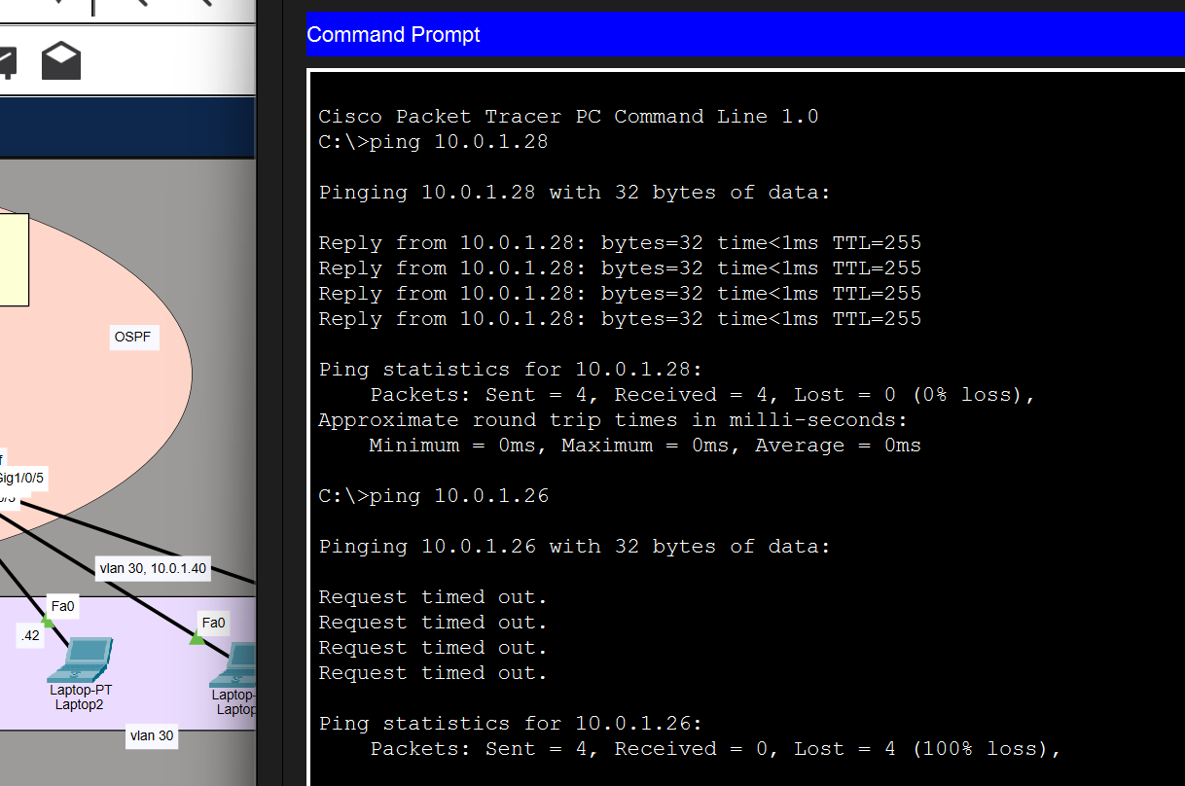
- Investigation: ping to other network works but unreliable, mostly packet drops
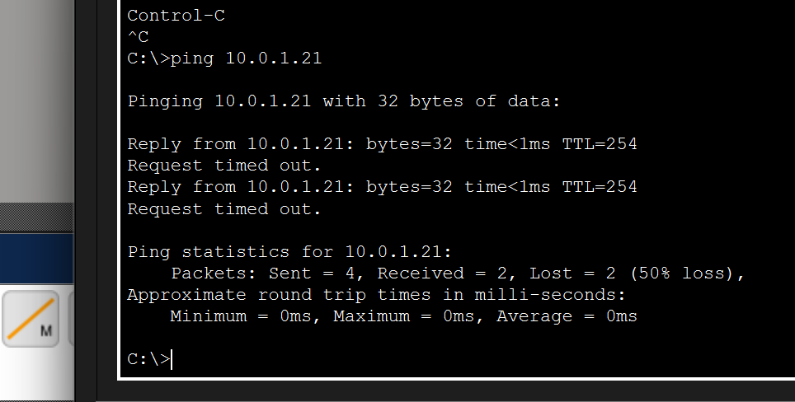
- Root cause: Laptop 5 of the leaf node 3 was in the same vlan 10 and network as laptops in leaf 1.
- Fix: Changed vlan and network of laptop5
- Verification: pinging works on all networks.

Issue #2: [short title]
- Symptom: Network is slow, pinging is hit or miss among all the networks
- Expected: ping among all the subnets
- Investigation: ping from laptop 0 to spine-2 10.0.1.21, 50 percent packet loss
- 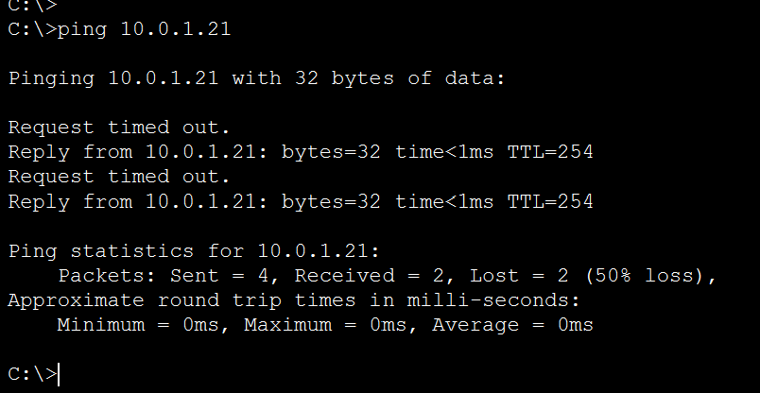
- Root cause: vlans and network overlap between two leaf nodes
- Fix: shutdown of g 1/0/5 interface of leaf-3 and changed the vlan and network of g1/0/5 interface
- Verification: ping to laptop 0 (10.0.1.26) works
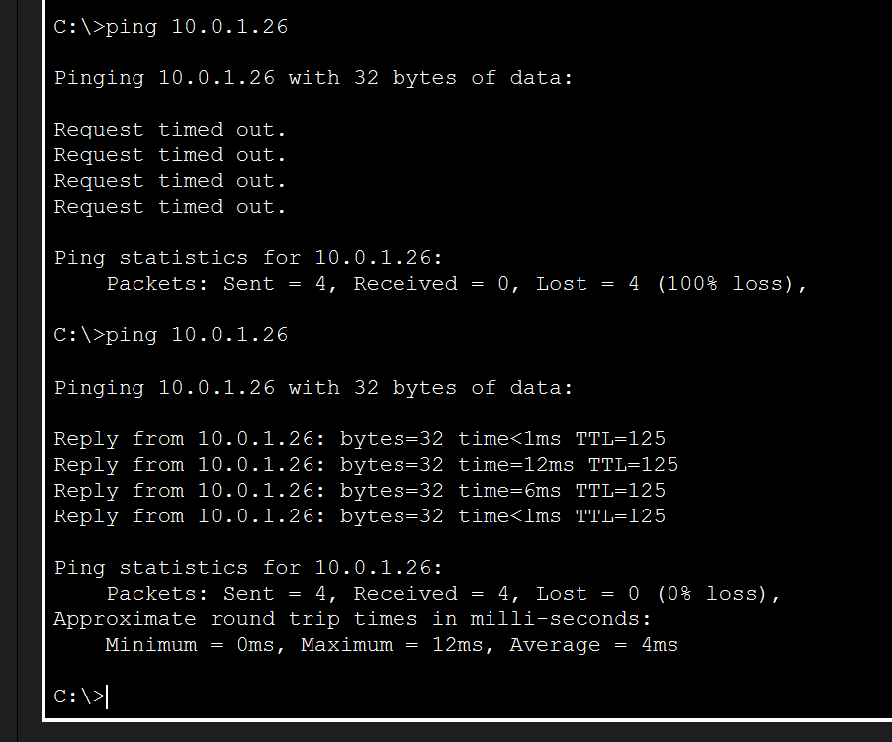

What I learned/achieved from this spine/leaf architecture
Spine-leaf provides equal cost, equal hop count, a predictable and simple way for every traffic.
Scalability is huge factor because we can increase port count by increasing leaf and bandwidth by increasing spines.
Every path is leaf->spine->leaf, so latency is always the same and predictable.
All paths are equal cost, so ECMP uses every spine at once. Redundancy and bandwidth are the same thing.
It scales independently: add leaves for more ports, add spines for more bandwidth.
Losing a spine costs 1/N of capacity, not connectivity.
Spine-to-spine links are useless, because every spine already reaches every leaf directly.
Connecting leaf to leaf or spine to spine breaks equal cost, equal hop property, creates bottleneck, makes design completed, difficult to identify problem and also scalability is affected.
The design is mostly used in modern datacenter architecture providing all above benefits.
The ping between same vlan at the ends of leaf was not achieved, because arp request on the same subnet does not go beyond the default gateway.
Limitation:
Packet Tracer limitations
- No VXLAN / EVPN overlay support so true data center overlay was not achieved.
- System limitation: I am using windows 11 arm based processor, so I couldn’t use EVE-NG and GNS3g for vxlan/evpn capabilities
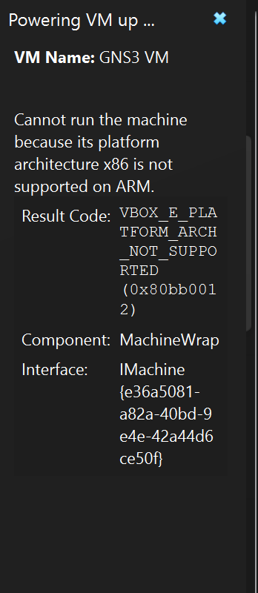

Configuration
IP Address configuration
Switch 0  ip routing  int range g1/0/1-3  no switchport  int g1/0/1  ip add 10.0.1.1 255.255.255.252  int g1/0/2  ip add 10.0.1.5 255.255.255.252  int g1/0/3  ip add 10.0.1.9 255.255.255.252 | switch 1  ip routing  int range g1/0/1-3  no switchport  int g1/0/1  ip add 10.0.1.13 255.255.255.252  int g1/0/2  ip add 10.0.1.17 255.255.255.252  int g1/0/3  ip add 10.0.1.21 255.255.255.252
Switch 2  ip routing  int range g1/0/1-3  no switchport  int g1/0/1  ip add 10.0.1.2 255.255.255.252  int g1/0/2  ip add 10.0.1.14 255.255.255.252 | Switch 3  ip routing  int range g1/0/1-3  no switchport  int g1/0/1  ip add 10.0.1.6 255.255.255.252  int g1/0/2  ip add 10.0.1.18 255.255.255.252
Switch 4
ip routing
int range g1/0/1-3
no switchport
int g1/0/1
ip add 10.0.1.10 255.255.255.252
int g1/0/2
ip add 10.0.1.22 255.255.255.252

Ospf configuration
switch 0  hostname Spine-1  int lo0  ip add 1.1.1.1 255.255.255.255  ex  router ospf 1  int g1/0/1  ip ospf 1 area 0  int g1/0/2  ip ospf 1 area 0  int g1/0/3  ip ospf 1 area 0  do wr | switch 1  hostname Spine-2  int lo0  ip add 2.2.2.2 255.255.255.255  ex  router ospf 1  int g1/0/1  ip ospf 1 area 0  int g1/0/2  ip ospf 1 area 0  int g1/0/3  ip ospf 1 area 0  do wr
Switch 2  hostname leaf-1  int lo0  ip add 3.3.3.3 255.255.255.255  ex  router ospf 1  int g1/0/1  ip ospf 1 area 0  int g1/0/2  ip ospf 1 area 0  do wr | switch 3  hostname leaf-2  int lo0  ip add 4.4.4.4 255.255.255.255  ex  router ospf 1  int g1/0/1  ip ospf 1 area 0  int g1/0/2  ip ospf 1 area 0  do wr
switch 4
hostname leaf-3
int lo0
ip add 5.5.5.5 255.255.255.255
ex
router ospf 1
int g1/0/1
ip ospf 1 area 0
int g1/0/2
ip ospf 1 area 0
do wr

Leaf vlan config
Leaf-1  int range g1/0/3-4  switchport mode access  switchport access vlan 10  vlan 10  name Science  int vlan 10  ip add 10.0.1.25 255.255.255.248  no shut | Leaf-2  int range g1/0/3-4  switchport mode access  switchport access vlan 20  vlan 20  name Finance  int vlan 20  ip add 10.0.1.33 255.255.255.248  no shut | leaf-3  int range g1/0/3-4  switchport mode access  switchport access vlan 30  vlan 30  name IT  int vlan 30  ip add 10.0.1.41 255.255.255.248  no shut

Vlan config
int vlan 10  ip ospf 1 area 0  ex  router ospf 1  passive-interface vlan 10  do wr | int vlan 20  ip ospf 1 area 0  ex  router ospf 1  passive-interface vlan 20  do wr | int vlan 30  ip ospf 1 area 0  ex  router ospf 1  passive-interface vlan 30  do wr

