TCP Connectivity Troubleshooting & Packet Analysis | Wireshark
Deepesh Oli
Diagnosed TCP connectivity failures using Wireshark, netstat, and Test-NetConnection; analyzed SYN, RST/ACK, and TCP three-way handshake behavior to identify a non-listening service and verify connectivity after remediation.
- Objectives
The objective of this project is to troubleshoot a TCP service connectivity problem using Windows networking tools and Wireshark. The project examines TCP packets during a failed connection, identifies the cause of the failure, applies a solution, and verifies that TCP connectivity is restored.
- Lab Environment
The lab was performed on a Windows computer using Wireshark, Command Prompt, and PowerShell. TCP port 9999 was selected as a temporary test port. The tests were performed through the local loopback interface so that the client and test service could operate on the same computer.
- Checking if any service is listening on port 9999
On cmd: netstat -ano | findstr :9999
The finding: No TCP application/service is listening on port 9999 which is to be expected.
- Trying tcp connection on local host port:9999
powershell Test-NetConnection localhost -Port 9999
Result:
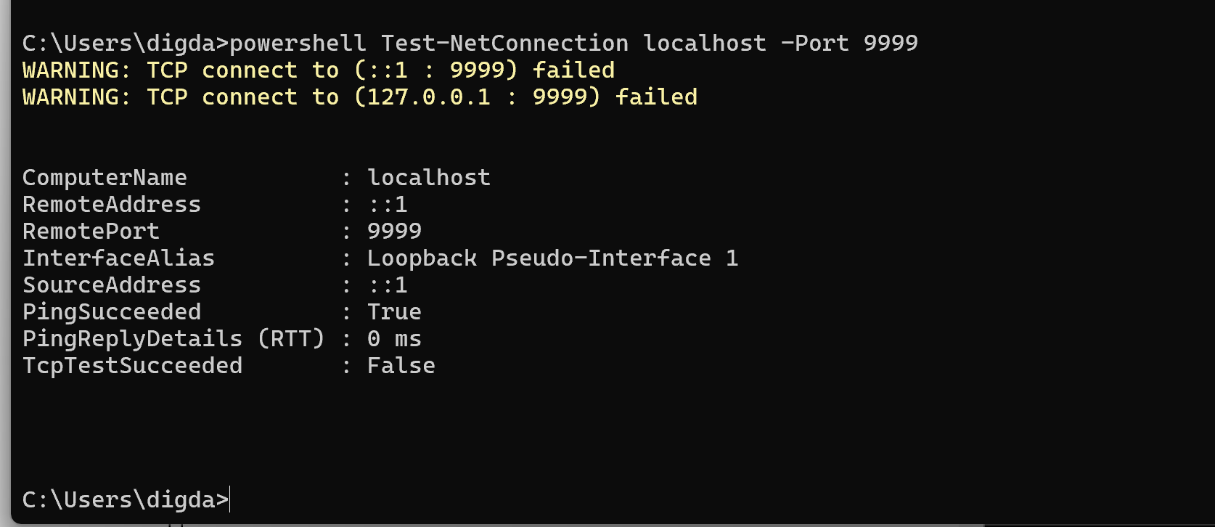

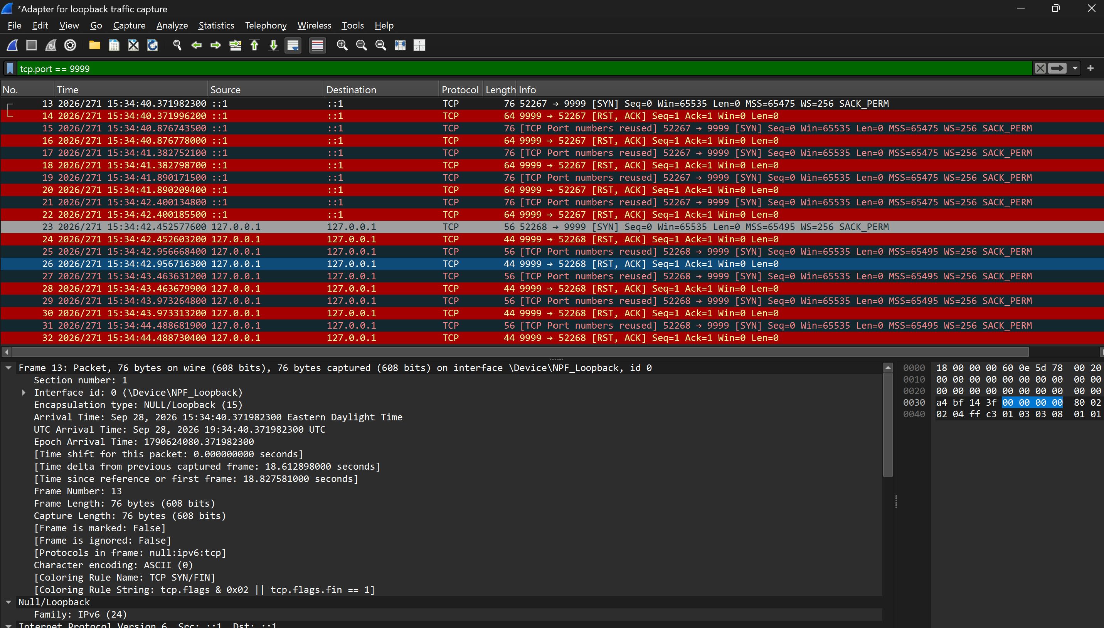

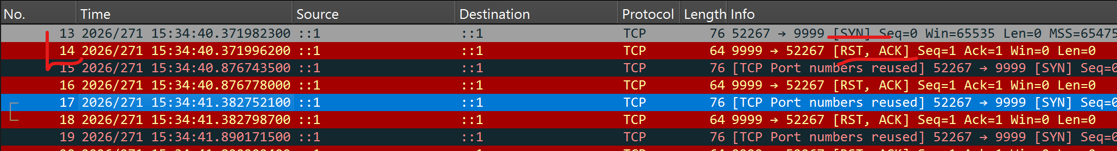

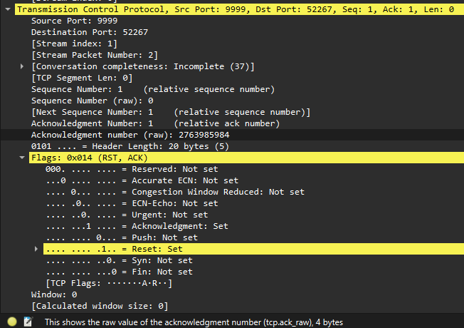
Client-> localhost | SYN
Localhost-> Client | RST, ACK

The TCP connection was rejected/reset and was not established. The packet capture showed that the client first transmitted a TCP SYN packet to destination port 9999. Instead of receiving the expected SYN-ACK, the client received a RST-ACK response. Packet was received but ack was rejected.
- Fixing the issue:
Creating temporary TCP service on port 9999
I typed following command one PowerShell
$listener = [System.Net.Sockets.TcpListener]::new([System.Net.IPAddress]::Loopback,9999)
$listener.Start()
$client = $listener.AcceptTcpClient()
This started a service that listens on port 9999
Command Provided: netstat -ano | findstr :9999
The command prompt shows listening state on port 9999
- Verification
Testing the connection again on port 9999
Command: powershell Test-NetConnection localhost -Port 9999
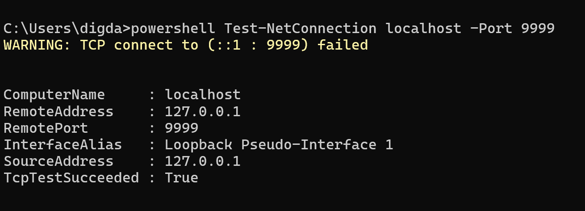
TCPTestSucceeded: True
ON wireshark, we can see
At first, it failed, but after sometime, it displayed syn, syn-ack, ack message so the troubleshooting and setting up of tcp listening on port 9999 was successful.
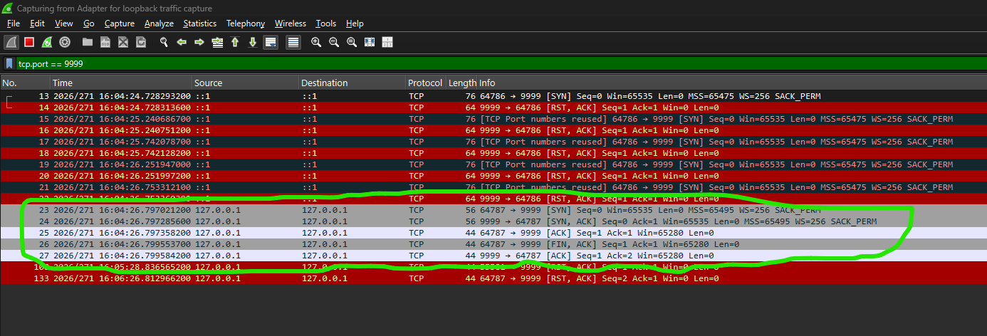
The successful syn-ack is displayed using the green outline.
Now stopping service on powershell
$listerner.stop()
- Conclusion
This project demonstrated TCP connectivity troubleshooting using Wireshark and Windows networking tools. Wireshark identified the failed connection through SYN and RST-ACK packets, while netstat confirmed that no service was listening on port 9999. After starting the TCP service, a successful three-way handshake confirmed that connectivity was restored.

