Linux Server Administration and Troubleshooting
VirtualBox ubuntu-26.04.1-live-server-arm64
Deepesh Oli
Project Overview
I configured two virtual machines, one being admin and other being linux server. The main objective was to demonstrate server administration, diagnose and troubleshoot different network connectivity, Nginx, storage and firewall rules. Admin virtual machine is used to connect to the sever remotely, checking service, port, functionalities and applying fix.
Tools used
Ubuntu Linux, VirtualBox, Netplan, static IPv4 addressing, SSH, systemd service management, Nginx, TCP port inspection, UFW firewall rules, filesystem capacity analysis, disk detection, and mounting an existing filesystem.
Network Design
The Ubuntu Server uses two network interfaces, each serving a different purpose. The first interface uses VirtualBox NAT and receives an IP address automatically through DHCP, such as 10.0.2.15/24. This interface provides the server with Internet access for downloading updates and installing packages. The second interface uses a Host-Only network and is assigned a static IP address, such as 192.168.56.10/24. This interface creates a private network between the virtual machines and the host computer. Later, the Admin Server will use 192.168.56.20/24, allowing the two servers to communicate directly while keeping their lab traffic separate from Internet connectivity.
Implementation
Configuring Administrator and Server
VM Name: server  Username: serverdeepesh  Password: admin  Hostname: server  Domain name: myguest.virtualbox.org | VM Name: admin  Username: admindeepesh  Password: admin  Hostname: admin  Domain name: myguest.virtualbox.org

Component | Role | Private Address
Windows host | Runs VirtualBox and access VMs | 192.168.56.1/24
Server VM | Runs services like Nginx | 192.168.56.10/24
Admin VM | Ubuntu client, manages server | 192.168.56.20/24
Data disk | Secondary Virtual disk mounted at /data | Size: Approx 2 GB

Important info
A Host-Only network is a private virtual network created by VirtualBox. My laptop itself becomes one device on this virtual network through a VirtualBox virtual adapter, while the VMs are other devices on the same subnet. This allows the laptop and VMs to communicate directly, while a separate NAT adapter provides Internet access.
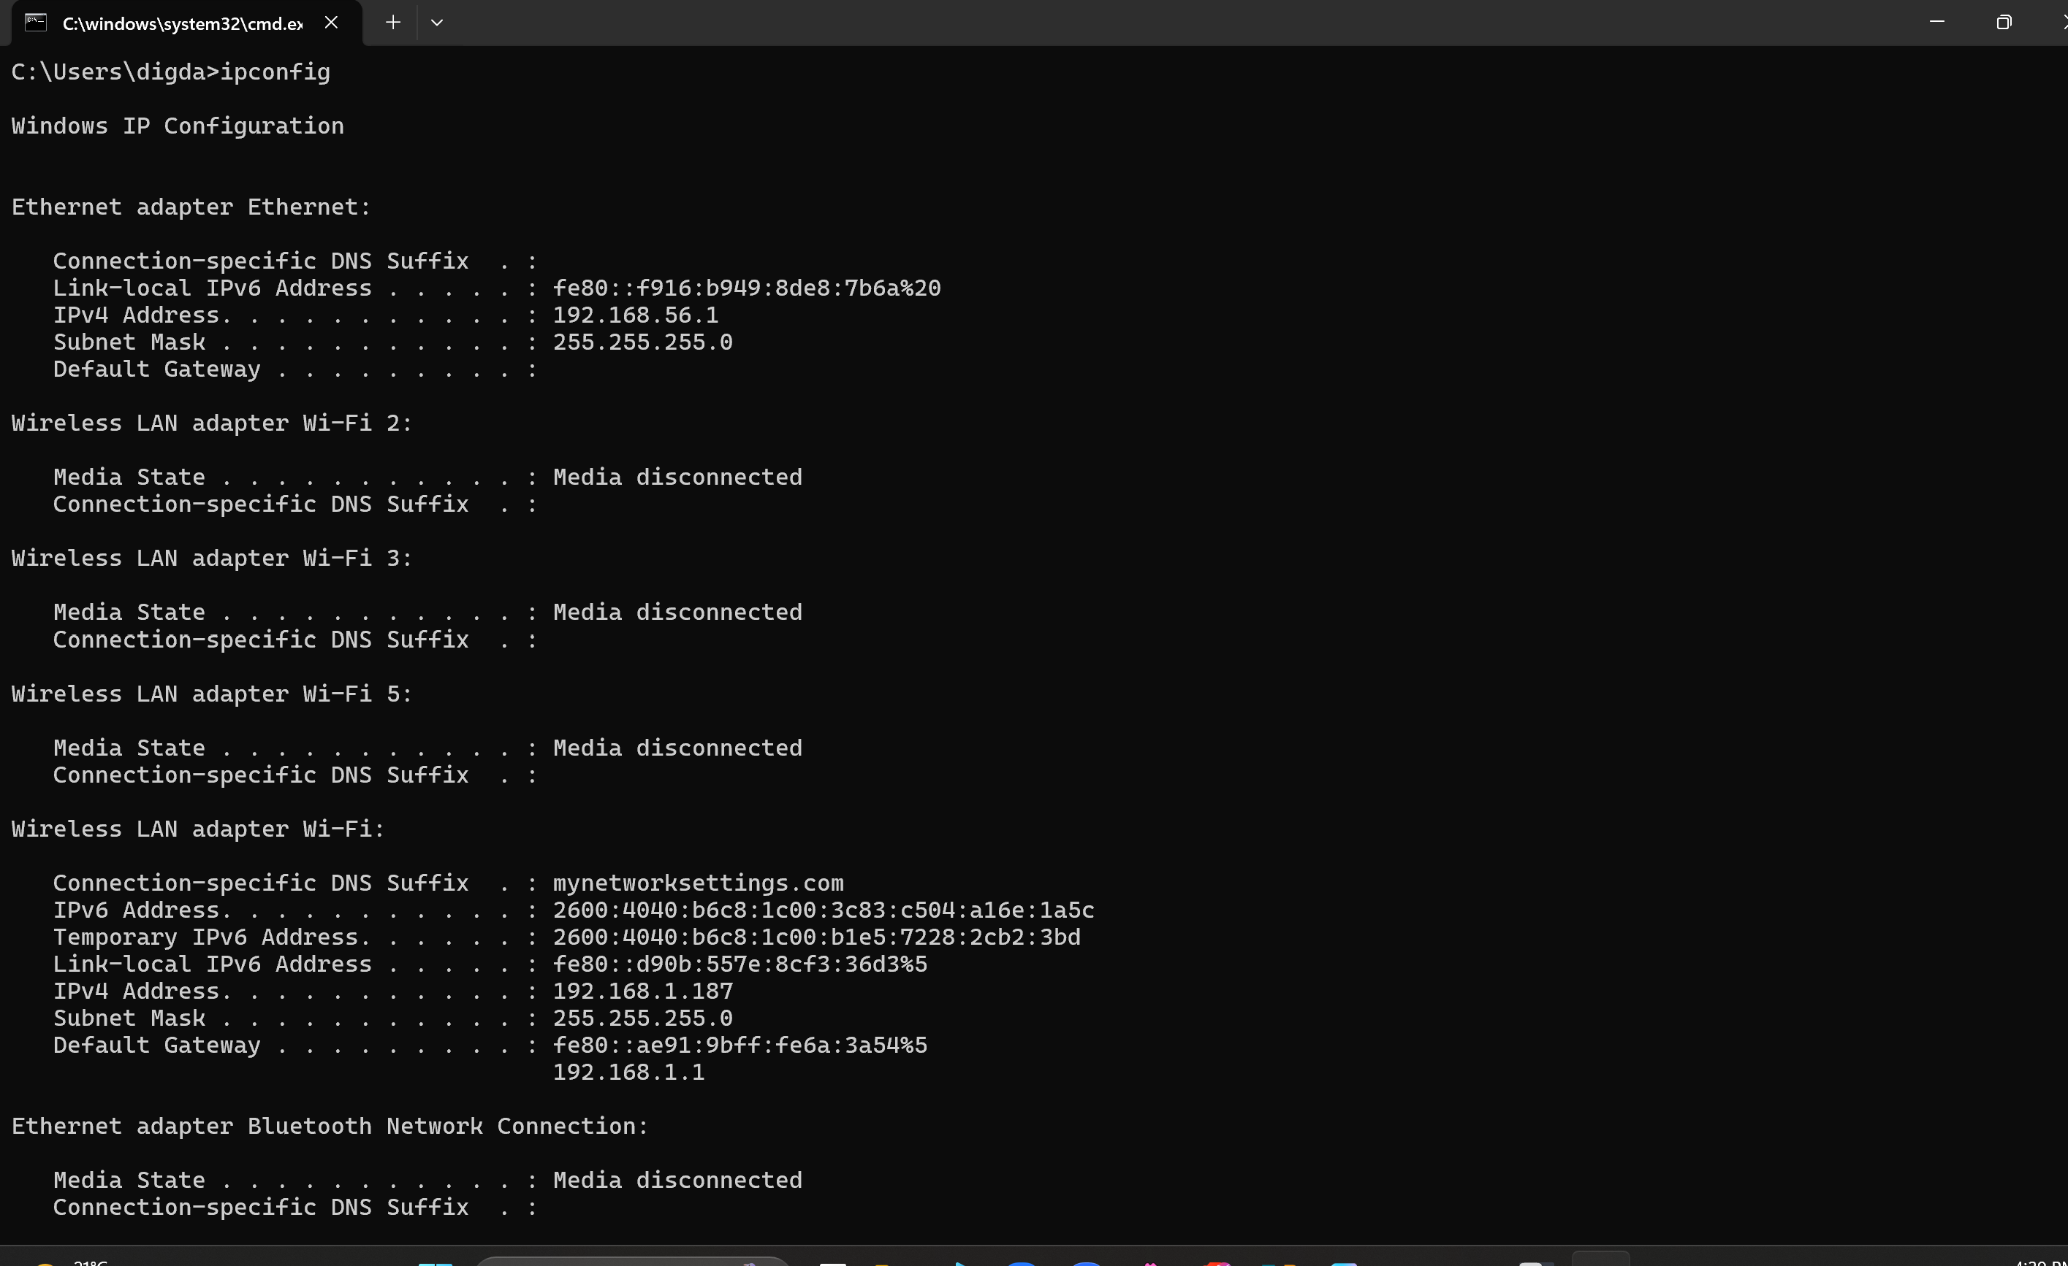
The virtual box created virtual network of 192.168.56.0/24
And my laptop Ip is 192.168.56.1
On my Windows laptop, the VirtualBox Host-Only network appears in ipconfig as Ethernet adapter Ethernet, with IP address 192.168.56.1/24. This is a virtual network adapter created by VirtualBox, not my physical Ethernet connection. It makes my laptop a device on the 192.168.56.0/24 virtual network, so it can communicate directly with my Ubuntu VMs. My actual Wi-Fi connection is separate and uses 192.168.1.187, while the Ubuntu Server will use 192.168.56.10 on the Host-Only network.
Ubuntu Server Network Configuration
I configured two network adapters for the Ubuntu Server in VirtualBox. The first adapter uses NAT, which allows the server to access the Internet through my computer. The second adapter uses Host-Only networking, which creates a private network between my Windows computer and the Ubuntu Server.
- I configured my Ubuntu Server VM with two network adapters in VirtualBox:
  - NAT → Internet access
  - Host-Only → Private communication between Windows and Ubuntu
- I identified the Ubuntu network interfaces:
enp0s8 → NAT
enp0s9 → Host-Only
- I checked my Windows network configuration using:
ipconfig
- I found the VirtualBox Host-Only adapter on Windows:
enp0s8 → NAT interface
enp0s9 → Host-Only interface
- I opened the Ubuntu Netplan configuration:
sudo nano /etc/netplan/00-installer-config.yaml
- I kept enp0s8 configured with DHCP for Internet access.
- I configured enp0s9 with a static IP:
IP address: 192.168.56.10/24
- I tested and applied the network configuration:
sudo netplan try
- I verified the IP configuration:
ip -4 addr
- I checked the routing table:
ip route
- I tested connectivity between Ubuntu and the Windows Host-Only adapter:
ping -c 4 192.168.56.1
- The ping was successful, confirming that the Ubuntu Server could communicate with my windows laptop through the private Host-Only network while still using NAT for Internet access.
Server IP: 192.168.56.10/24
Setting up administrator
Same steps were used and static ip address assigned is 192.168.56.20/24
Admin pc
enp0s9:
dhcp4: false
addresses:
- 192.168.56.20/24
ssh admin@192.168.56.20
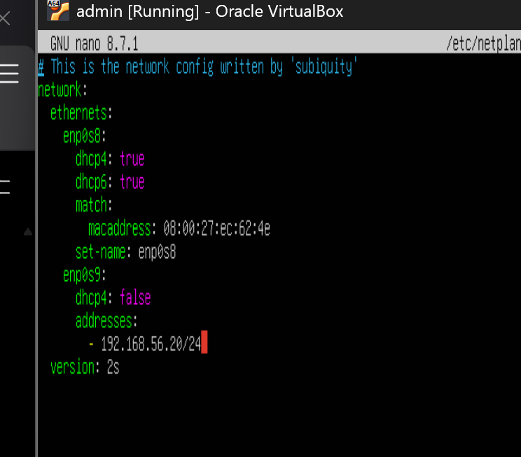

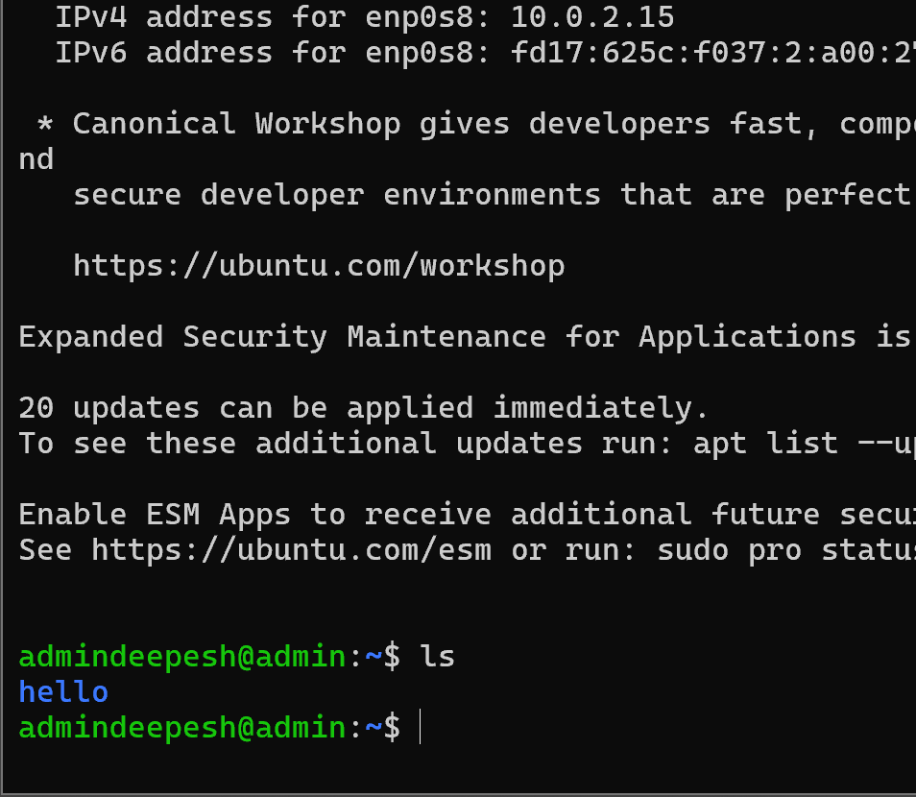
Pinging from admin pc to server using static ip (successful)
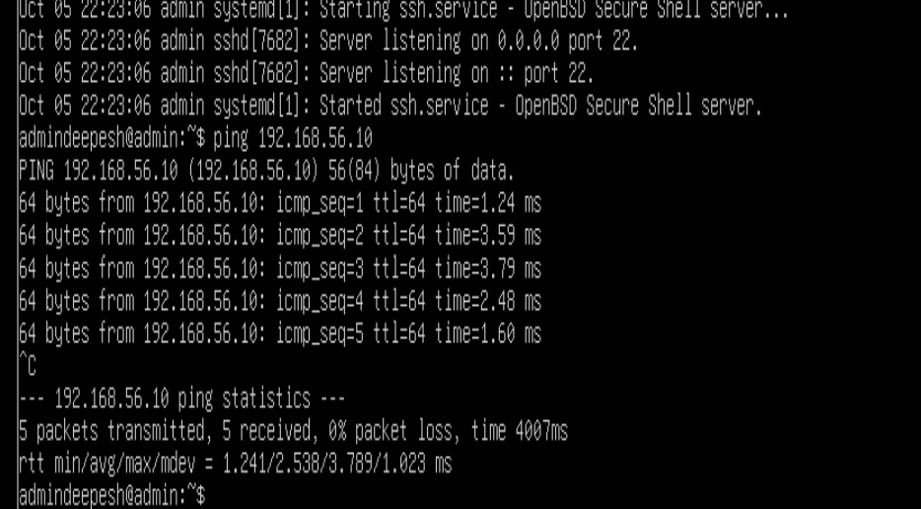
Setting up ssh to my server
I installed OpenSSH severs on both of my virtual machines. I also used my windows machine as well as admin linux to access linus Server using ssh.
sudo systemctl status ssh (not active)
sudo apt update
sudo apt install openssh-server -y (installing ssh)
sudo systemctl enable --now ssh (enabling ssh)
sudo systemctl status ssh (ssh is active)
Fig: successful ssh to the server, ssh serverdeepesh@192.168.56.10
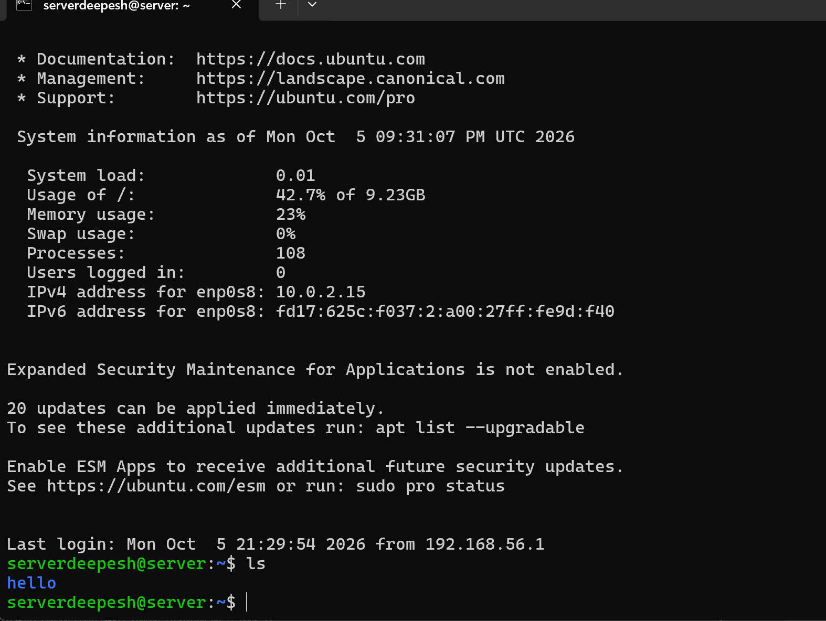
Steps so far:
- Created Server and Admin Ubuntu VMs.
- Configured NAT for Internet access.
- Configured a Host-Only private network.
- Assigned static IPs:
- Server: 192.168.56.10
- Admin: 192.168.56.20
- Configured and tested SSH on both VMs.
- Verified Windows ↔ VMs connectivity.
- Verified Admin ↔ Server connectivity using ping and SSH.

Web Service and test approach
Installing webserver nginx on server
Sudo apt install nginx -y
Sudo systemctl status nginx
Fig: Nginx is working as stated from powershell from client to server using ssh
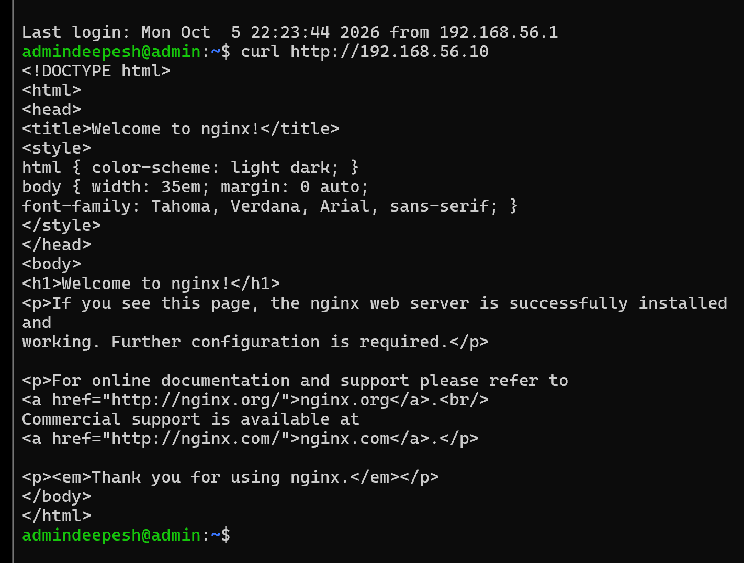

Troubleshooting method
Case | Fault | Recovery
1 | Data file system at 99 percent | Usage reduced, found what file causing high disk usauge
2 | Data disk detached | Disk detected, remounted, and original file read
3 | Nginx stopped | Nginx active, TCP 80 listening, page return normal
4 | Host-only interface down | Interface up and ping replies received
5 | HTTP denied by UFW | Deny rule removed and page is working again
Troubleshooting
CASE 1: Data filesystem full
Problem: The Server is running, but available disk space has become critically low, which could prevent applications from writing files or logs.
Troubleshoot:
- Checking the filesystem usage:
99 percent usage found on my sdb harddrive
df -h
Figure 1 Data filesystem is at 99 percent usage
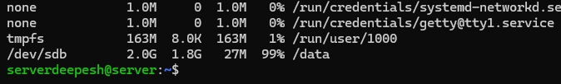
- Checking actual file what caused disk overload:
File wise consumption found:
Sudo du -sh /data/*
Figure 2 The lab file bigfile consumes approximately 1.8 GB
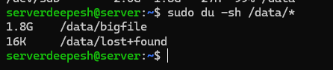
Root Cause:
A large file was consuming almost all available space on the /data filesystem. The usage is shown at 99 percent which is approx. 1.8G on 2 GB disk file.
Fix:
I removed the unnecessary big file. The deletion is only done to the disposable test file case in this scanario
Sudo rm /data/bigfile
Figure 3 Data filesystem usage is reduced to 1 percent
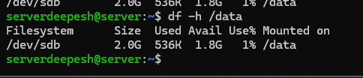
The disk space is available again and sufficient storage was available again for applications to use.
CASE 2: Data disk unavailable
Problem: An application or administrator tries to access /data, but the data disk is no longer available.
Troubleshoot:
- Checking the disks
The 2 GB data disk /dev/sdb, which was previously mounted at /data, was no longer listed.
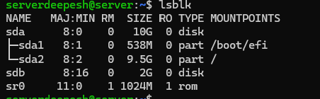
Figure 4 The data disk is detected but has no mount point
- Checking mounted filesystem.
df -h
/data is not mounted
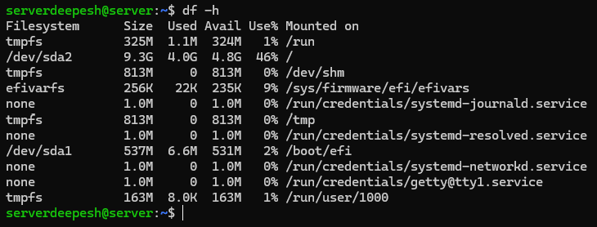
Figure 5 Filesystem listing does not show sdb mounted

- Investing what os/kernel detected.
sudo dmesg | tail -30.
I checked recent kernel messages using: sudo dmesg | tail -30 and no clear disk failure message is found.
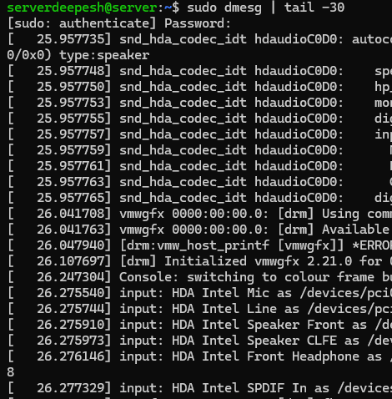
Figure 6: kerne dmesg message
Root Cause:
The secondary 2 GB data disk was disconnected from the Server, causing /dev/sdb and the /data filesystem to become unavailable.
Fix: I reconnected the existing 2 GB virtual disk to the server.
lsblk
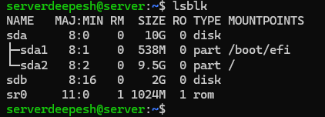
Figure 7 The system shows the sdb disk
Linux detects the disk but it is not mounted yet so I mounted on /data
Sudo mount /dev/sdb /data
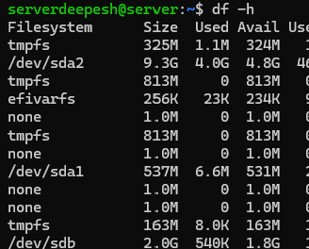
Figure 8 sbd is mounted on to the system /dev/dba
Verification:
Checking the original file
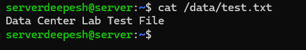
Figure 9: The original file “Data Center Lab Test File” is readable
After reconnecting the disk, lsblk showed /dev/sdb again. The disk was manually mounted to /data, and df -h /data confirmed that the filesystem was available. The original test file was successfully accessed, confirming that the data was preserved.
Case 3: Nginx service stopped
Problem: The Nginx web server on Server (192.168.56.10) was unavailable from the Admin machine.
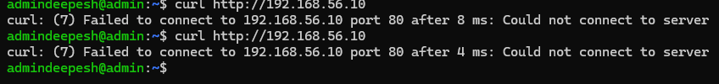
Initial Test:
From Admin, I tested the web server:
curl -I http://192.168.56.10
Result: Could not connect to server.
Troubleshooting:
I first tested basic network connectivity:
ping -c 4 192.168.56.10
The ping was successful, confirming that the Server was reachable and the basic network connection was working.
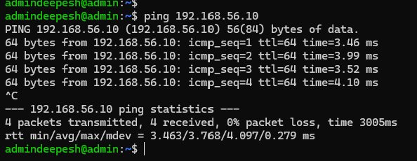
I then checked whether anything was listening on HTTP port 80:
ss -tulpn | grep :80
No result was returned, indicating that no service was listening on port 80.
I checked the Nginx service:
sudo systemctl status nginx
Result: Nginx was inactive.
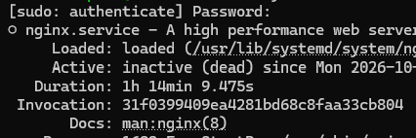
Root Cause:
The Nginx service was stopped, so the Server was reachable but there was no web service listening on TCP port 80.
Resolution:
sudo systemctl start nginx
Verification:
sudo systemctl status nginx
ss -tulpn | grep :80
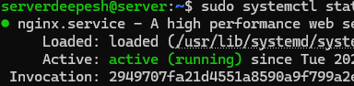
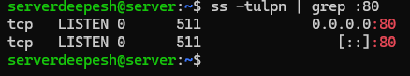
Then from Admin:
curl -I http://192.168.56.10
The server returned HTTP 200 OK, confirming that the web service was restored.
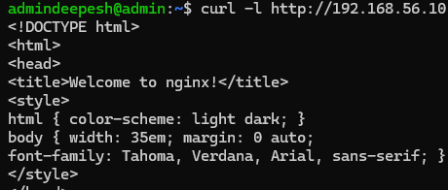

CASE 4: Host only interface down
Problem: Server running but admin cannot reach it. The ping reported 100 percent packet loss
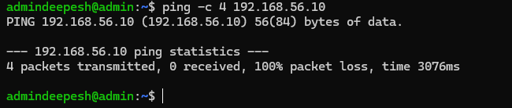
Troubleshooting
Checking network interface:
Ip addr
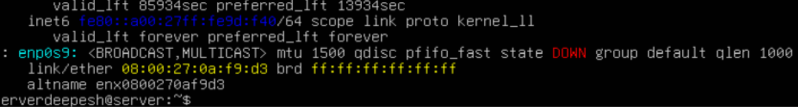
Root Cause
The server host-only enp0s9 interface was down.
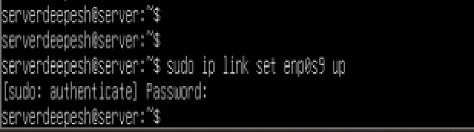
Resolution
Getting Network interface from down to up
Sudo ip link set enp0s9 up
Ip link show enp0s9
Verification
ping -c 4 192.168.56.10
Ping from admin pc to server pc was successful
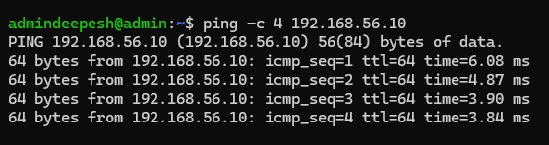

CASE 5: HTTP Blocked by Firewall (UFW)
Problem: The Server was reachable from the Admin machine, but the Nginx website at 192.168.56.10 could not be accessed over HTTP.
Troubleshooting:
sudo systemctl status nginx
ss -tulpn | grep :80
sudo ufw status
- Ping works but http do not work
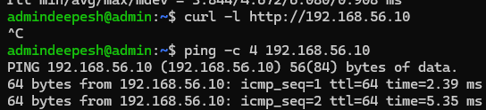
- Checking nginx server on server
Nginx is running.
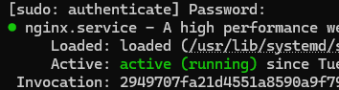
- Checking http port
Port 80 is also listening
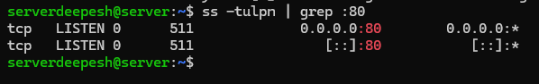
- Checking firewall configuration
Firewall is blocking any connection to port 80.
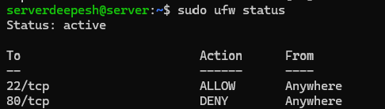
Ping is working, server is working, http port 80 is also listening however firewall configuration blocked all the tcp connection to port 80

Fix:
I removed the deny rule and allowing connection through tcp port 80.
sudo ufw delete deny 80/tcp
sudo ufw allow 80/tcp

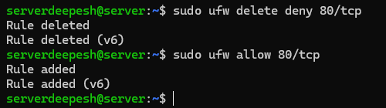

Verification:
The http service is working again. The request from admin returned the default Nginx page.
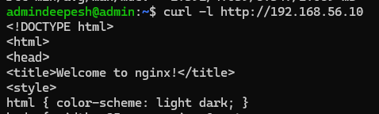

References
Oracle VirtualBox User Manual, Virtual Networking. NAT and host-only networking behavior. https://docs.oracle.com/en/virtualization/virtualbox/7.2/user/networkingdetails.html
Ubuntu Server documentation, Firewall. UFW status, rule removal, and port permissions. https://documentation.ubuntu.com/server/how-to/security/firewalls/index.html
Ubuntu manual, netplan. DHCP and static address configuration. https://manpages.ubuntu.com/manpages/noble/man5/netplan.5.html
util-linux manual, lsblk. Block device detection and mount point reporting. https://man7.org/linux/man-pages/man8/lsblk.8.html

