**PYCITY SCHOOL REPORT**

Wayne Mitchell

30.9.2024

**Summary**

PyCity operates fifteen ‘high schools’ ( a high school encompasses grades 9 through 12 in the PyCity system). There are seven “district” schools and eight “charter” schools, together serving 39,170 students.

District level statistics for all fifteen school were prepared and summarized in a table, including:

* School Count
* Total Students
* Total Budget
* Average Math Score
* Percent of Students Passing Math
* Average Reading Score
* Percent of Student Passing Reading
* Overall Pass Rate

Several metrics of performance were calculated and tabulated on a school-by-school basis:

* School type
* School Size (student population)
* Total School Budget
* Average Math Score
* Number of Students Passing Math
* Math Pass Rate
* Average Reading Score
* Number of Students Passing Reading
* Reading Pass Rate
* Overall Pass Rate

The five highest performing schools by **overall pass rate** are:

* Cabrera High School (best)
* Thomas High School
* Griffin High School
* Wilson High School
* Pena High School
* The five lowest performing schools by **overall pass rate** are:
* Rodriguez High School (worst)
* Figueroa High School
* Huang High School
* Hernandez High School
* Johnson High School

Math and reading scores, and math, reading and overall pass rates were calculated separately for each school and for each grade with in each school, then compared against school spending, school size and school type.

**Conclusions**

The data summarized in this report suggests two factors contribute strongly to overall student pass rates. First, **charter schools outperform district schools** (Table 1., %90.4 overall pass rate for charter schools, versus %53.7 for district schools). Second, **small and medium sized schools outperform large schools** (Table 2., %89.9 and %90.6 overall pass rate for small and medium sized schools, versus 58.3% for large schools). Spend per student does *not* seem to correlate with performance in these data; the best overall pass rates are achieved by schools spending both the lowest and highest amounts per student (Table 3.)

Table 1. School Type by Scores and Pass Rates

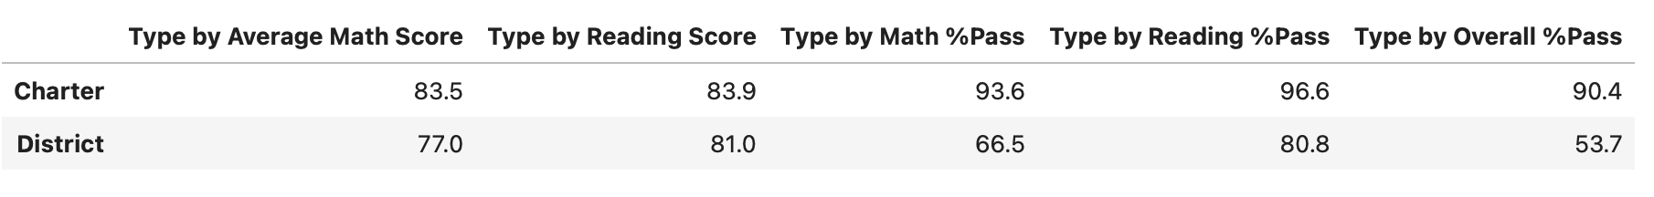

Table 2. School Size by Scores and Pass Rates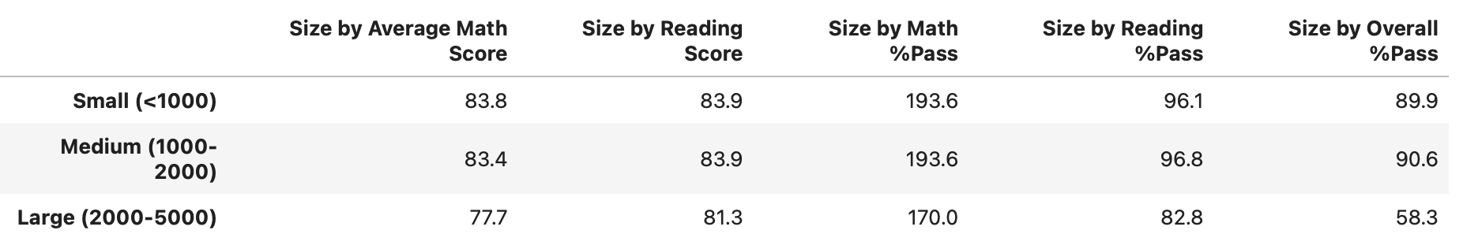Table 3. per Student Spend by Scores and Pass Rates

