# StreamEye script

# 1 Usage:

**Step 1, generate mp4 files index and stream .csv file**

Example:

ABC.mp4

ABC.mp4_stream.csv

ABC.mp4_index.csv

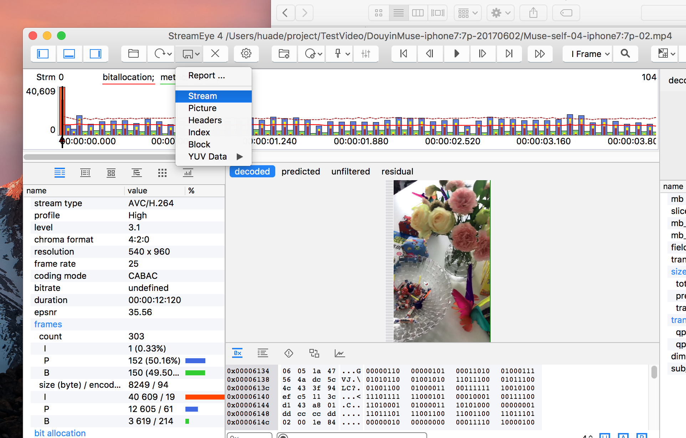

**Step 2. run scripts for generating static info report files**

echo "**********************************************"

echo " $0 \$MP4FilesDir \$Option "

echo " example: "

echo " $0 ./AllMP4 . All "

echo " single report for all mp4files "

echo " $0 ./AllMP4 MuseDouyin "

echo " report for Muse and douyin "

echo "**********************************************"

Example:

1. parse for all mp4 files—single report for all

./run_Main.sh $TestMP4Dir All

2. parse for all douyin mp4 files—single report for douyin

. /run_Main.sh ./DouyinMP4 All

3. parse for all muse mp4 files—single report for muse

. /run_Main.sh ./MuseMp4 All

4. parse for all douyin and muse mp4 files—comparison report

. /run_Main.sh ./DouyinMuseMp4 MuseDouyin

5.Default —comparison report for Muse and Douyin

. /run_Main.sh ./DouyinMuseMp4

The output csv files:

StaticInfoDetail.csv

StaticInfoForAllFrames.csv

StaticInfoForAllSequences.csv

--All

EncoderParametersAverage.csv

--Default(MuseDouyin)

Douyin: EncoderParametersAverage_Douyin.csv

Muse: EncoderParametersAverage_Muse.csv

All: EncoderParametersAverage_DouyinMuse.csv

## 2. Usage for script run_ParseStreamEyeCSVFiles.sh

run scripts for generating static info report files

runUsage()

{

echo "**********************************************************"

echo "**********************************************************"

echo " Usage: "

echo " $0 \${MP4FilesDir} \${Option} "

echo " \${Option}: all parse all mp4 files "

echo " \${Option}: pattern=\${Option} "

echo " example: "

echo " douyin parse all douyin's *douyin*.mp4 files "

echo " muse parse all muse's *muse*.mp4 files "

echo " 'douyin muse' "

echo " parse all douyin's/muse's mp4 files "

echo ""

echo " \${Option}: one \$mp4 parse given mp4 file "

echo "**********************************************************"

echo "**********************************************************"

}

Example:

1. parse for all mp4 files

./run_ParseStreamEyeCSVFiles.sh $TestMP4Dir

2. parse for all douyin mp4 files

. /run_ParseStreamEyeCSVFiles.sh $TestMP4Dir "douyin"

3. parse for all muse mp4 files

. /run_ParseStreamEyeCSVFiles.sh $TestMP4Dir "muse"

4. parse for all mp4 files which name with pattern abc

. /run_ParseStreamEyeCSVFiles.sh $TestMP4Dir "abc"

5. parse for all mp4 files which name with pattern abc or def

. /run_ParseStreamEyeCSVFiles.sh $TestMP4Dir "abc def"

6. parse for ABC.mp4 file . only

. /run_ParseStreamEyeCSVFiles.sh $TestMP4Dir one ABC.mp4

The output csv files:

StaticInfoDetail.csv

StaticInfoForAllFrames.csv

StaticInfoForAllSequences.csv

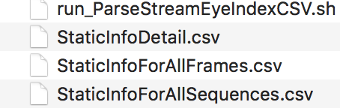

# 3. Example data

* + - Test mp4 files

Please refer to repos:

<https://github.com/shihuade/TestVideo/tree/master/muse-douyin-ios>

* + - Test output files

Please refer to repos:

<https://github.com/shihuade/MultiMedia-Scripts/tree/master/StreamEye>