Polynomial Regression (Handwriting Assignment)

Name: Konstantin Deputatov

Student ID: 50231577

Instructor: Professor Kyungjae Lee October 9, 2023

# Introduction

In the mid-term project, we will look at a polynomial regression algorithm which can be used to fit non-linear data by using a polynomial function. The polynomial Regression is a form of regression analysis in which the relationship between the independent variable *x* and the dependent variable *y* is modeled as an *n*th degree polynomial in *x*.

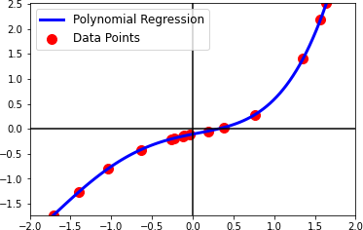

Figure 1: Example of Polynomial Regression

First, what is a regression? we can find a definition from the book as follows: *Regression analysis is a form of predictive modelling technique which investigates the relationship between a dependent and independent variable.* Actually, this definition is a bookish definition, in simple terms the regression can be defined as *finding a function that best explain data which consists of input and output pairs.* Let assume that we have 100 data points,

(*x*1*, y*1)*,* (*x*2*, y*2)*,* (*x*3*, y*3)*, · · ·* (*x*98*, y*98)*,* (*x*99*, y*99)*,* (*x*100*, y*100)*.*

The goal of regression is to find a function *f*ˆ such that

*f*ˆ(*x*1) = *y*1*, f*ˆ(*x*2) = *y*2*, f*ˆ(*x*3) = *y*3*, · · · , f*ˆ(*x*99) = *y*100*, f*ˆ(*x*100) = *y*100*.*

This is the simplest definition of the regression problem. Note that many details about regression analysis are omitted here, but, you will learn more rigorous definition in other courses such as

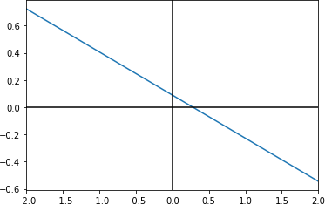 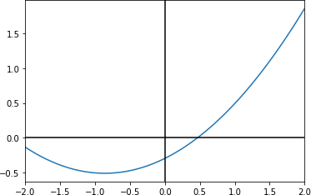

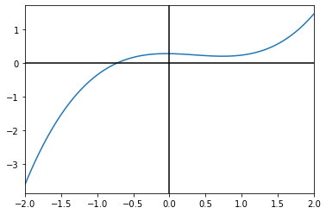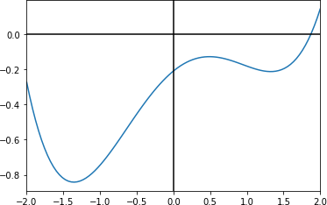(a) 0*.*089 *−* 0*.*32*x* (b) *−*0*.*29 + 0*.*50*x* + 0*.*29*x*2

(c) 0*.*28 *−* 0*.*03*x −* 0*.*34*x*2 + 0*.*32*x*3 (d) *−*0*.*21 + 0*.*34*x −* 0*.*35*x*2 *−* 0*.*06*x*3 + 0*.*1*x*4

Figure 2: Examples of polynomial functions

machine learning or statistics. Then, the polynomial regression is the regression framework that employs the polynomial function to fit the data.

So, what is the polynomial function? I guess you may remember, from high school, the following functions:

Degree of 0 : *f* (*x*) = *w*0

Degree of 1 : *f* (*x*) = *w*1 *· x* + *w*0

Degree of 2 : *f* (*x*) = *w*2 *· x* + *w*1 *· x* + *w*0

2

Degree of 3 : *f* (*x*) = *w*3 *· x* + *w*2 *· x* + *w*1 *· x* + *w*0

3 2

.

*d*

Degree of *d* : *f* (*x*) = *wi · xi,*

Σ

*i*=0

where *w*0*, w*1*, · · · , wd* are a coefficient of polynomial and *d* is called a degree of a polynomial. So, we can determine a polynomial function *f* (*x*) by deciding its degree *d* and corresponding coefficients *{w*0*, w*1*, · · · , wd}*. Figure 2 illustrates some examples of polynomial functions.

Then, the polynomial regression is a regression problem to find the best polynomial function to fit the given data points. Especially, the polynomial function is determined by coefficients (let just assume that *d* is fixed). We can restate the polynomial regression as *finding coefficients*

*of polynomials such that, for all data point,* (*xi, yi*)*, yi* = *f*ˆ(*xi*) *holds* (if we have noise free data).

Figure 1 shows the example of polynomial regression. In the following problems, you have to study how to compute the coefficients of the polynomial to fit the data points.

# Problems

**1. (80 pt. in total)**

Assume that we have *n* data points, (*x*1*, y*1)*,* (*x*2*, y*2)*, · · · ,* (*xn, yn*). Let the degree of polynomial be *d*. Then, we want to find *w*0*, w*1*, w*2*, · · · , wd* of the polynomial such that

*f*ˆ(*x*1) = *w*0 + *w*1*x*1 + *w*2*x*2 + *· · ·* + *wdxd* = *y*1*,*

1

1

*f*ˆ(*x*2) = *w*0 + *w*1*x*2 + *w*2*x*2 + *· · ·* + *wdxd* = *y*2*,*

2

2

*f*ˆ(*x*3) = *w*0 + *w*1*x*3 + *w*2*x*2 + *· · ·* + *wdxd* = *y*3*,*

3

3

*f*ˆ(*x*4) = *w*0 + *w*1*x*4 + *w*2*x*2 + *· · ·* + *wdxd* = *y*4*,*

4

4

*f*ˆ(*x*5) = *w*0 + *w*1*x*5 + *w*2*x*2 + *· · ·* + *wdxd* = *y*5*,*

5 5

.

*f*ˆ(*xn*) = *w*0 + *w*1*xn* + *w*2*x*2 + *· · ·* + *wdxd* = *yn.*

*n*

*n*

Now, we reformulate the equations into the vector and matrix form. First, let **w** = [*w*0*, w*1*, · · · , wd*]*T*

and **y** = [*y*1*, y*2*, · · · , yn*]*T* . Then, the above equations can be rewritten as

*w*0

*w*1

*f*ˆ(*x* ) = [1*, x , x*2*, x*3*, · · · , xd*] *·* *w*2 = [1*, x , x*2*, x*3*, · · · , xd*]**w** = *y*

1 1 1 1

1 *w*3

.

 

*wd*

1 1 1 1 1

Similarly, we have,

[1*, x*2*, x*2*, x*3*, · · · , xd*]**w** = *y*2*,*

2

2

2

[1*, x*3*, x*2*, x*3*, · · · , xd*]**w** = *y*3*,*

3

3

3

[1*, x*4*, x*2*, x*3*, · · · , xd*]**w** = *y*4*,*

4

4

4

[1*, x*5*, x*2*, x*3*, · · · , xd*]**w** = *y*5*,*

5 5 5

.

[1*, xn, x*2 *, x*3 *, · · · , xd* ]**w** = *yn.*

*n*

*n*

*n*

Then, all equations can be written as the form of linear equation,

*A***w** = **y***,*

where *A* is the stack of [1*, xi, x*2*, x*3*, · · · , xd*] for *i* = 1*, · · · , n*. Under this setting, answer the

following questions.

*i i i*

**1-(a) What is the size of vector w and y? (10pt)**

**1-(b) What is the size of matrix** *A***? Write** *A***. (10pt)**

**1-(c) Let** *d* + 1 = *n***, then,** *A* **becomes a square matrix. Compute the determinant of**

*****A***. (40pt in total, Derivation: 30pt, Answer: 10pt)**

**1-(d) What is the condition that makes the determinant of** *A* **non-zero? (10pt)**

**1-(e) Assume that the determinant of** *A* **is non-zero, then, what is the solution of linear equation,** *A***w** = **y, with respect to w? (10pt)**

# 2. (20pt)

Suppose that *n > d* + 1. Then, we cannot compute the inverse of *A* since *A* is not a square matrix. In this case, how can we solve the linear equation *A***w** = **y**?

