Sales Performance Report & Data Storytelling
Prepared by: Daniel Essuman Quainoo
Date: April 2025
Confidential Business Report

Figure 1: Sales Dashboard Overview
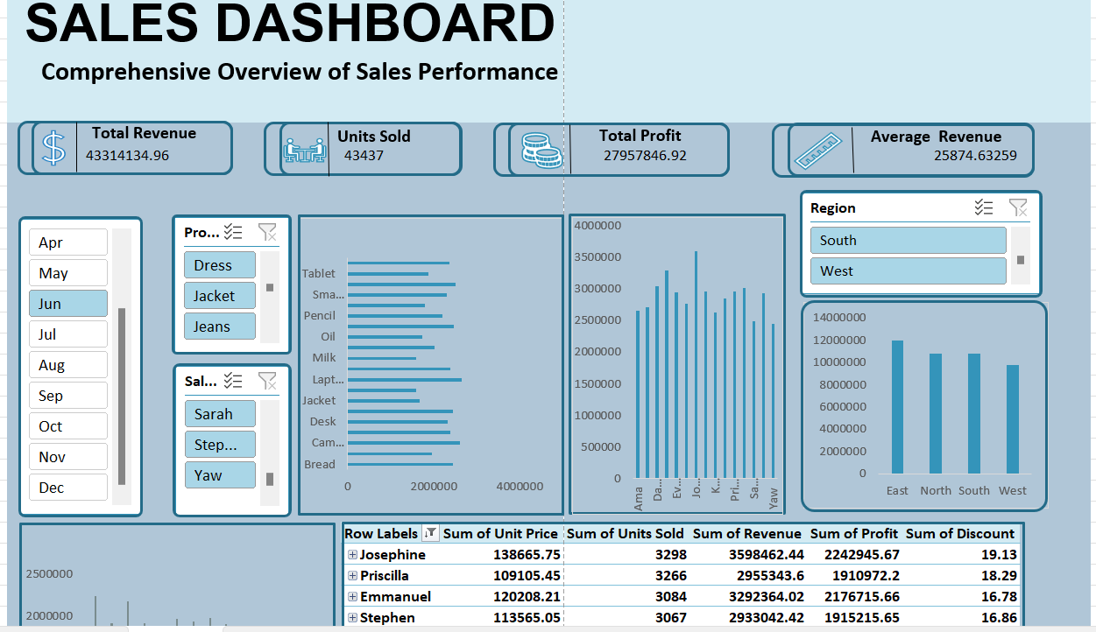

Figure 2: Detailed Sales Visuals

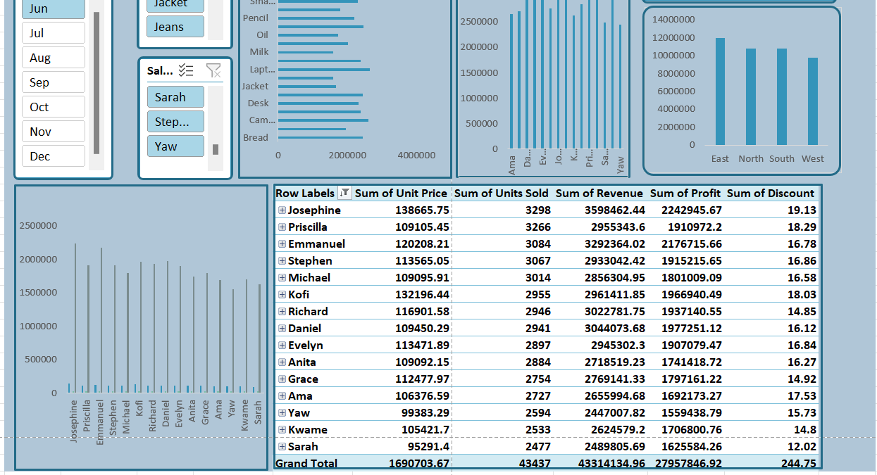
Sales Data Storytelling

1. Overview
The dataset represents the company’s sales performance over three years (January 2021 to December 2023), capturing monthly sales transactions across multiple regions and product categories.
A total of $508,451,643.49 in revenue was recorded during the period under review, demonstrating consistent business growth. The data provides valuable insights into the company’s regional performance, product contribution, and overall sales trends.

2. Overall Sales Performance
Sales have shown a generally upward trend throughout the three years, with occasional monthly fluctuations. The most recent period (December 2023) recorded $14,662,226.42 in total sales, marking a 5.85% month-over-month growth compared to November 2023. When comparing year-on-year figures, the company experienced a steady increase in total revenue, reflecting effective marketing strategies, better inventory control, and customer retention. The overall sales growth trend indicates resilience and a healthy performance trajectory.

3. Regional Analysis
The company operates across several regions, with each contributing differently to overall performance.
From the data:
The East Region emerged as the highest-performing region, generating $129,080,381.18, representing approximately 25.4% of total company revenue.
The South Region followed with $115,427,902.17, while the West Region contributed $103,819,228.04.
The North Region, though the lowest performer, still recorded $79,432,091.53, reflecting notable customer engagement in that area.
This distribution reveals that the eastern and southern territories dominate sales activities, likely due to higher customer density, better distribution networks, or established retail partnerships.

4. Product Analysis
The company offers multiple product categories, each showing varying degrees of contribution to total revenue.
From the data:
Dresses emerged as the top-selling product, generating $26,698,193.33 during the analysis period. Shoes and Accessories followed closely, indicating a strong fashion-oriented demand pattern. Other items, such as Tops, Bags, and Trousers, recorded consistent but smaller contributions.
The Pareto analysis principle (80/20 rule) suggests that roughly 20% of the products account for 80% of sales, confirming that focusing on high-performing product lines (like Dresses and Shoes) could yield higher profitability.

5. Monthly Trend Analysis
A month-by-month review of sales shows noticeable seasonal patterns. Peak sales often occurred in June, August, November, and December, aligning with festive and promotional periods, while slower months were typically recorded in February and September. These fluctuations are normal in retail cycles and reflect customer purchasing behavior tied to holidays, fashion releases, and discount campaigns. The company’s ability to maintain consistent upward trends after low months indicates effective recovery and sustained customer loyalty.

6. Key Insights

1. Sustained Growth: The company achieved steady sales growth, particularly in the second half of each year.

2. Regional Strength: The East and South regions are strategic strongholds, contributing almost half of total sales.

3. Product Focus: Dresses and Shoes dominate product performance and should remain central in marketing and inventory planning.

4. Seasonality: Sales surges during mid-year and end-of-year months suggest strong opportunities for targeted campaigns.

5. Profitability Optimization: The company could leverage insights from low-performing regions and product lines for growth interventions.

7. Strategic Recommendations
Expand operations in high-performing regions (East and South) while exploring localized marketing for lower-performing areas.
Increase stock levels and marketing efforts for top-selling product lines during peak seasons.
Implement data-driven demand forecasting to anticipate future trends and align production capacity accordingly.
Enhance customer engagement through loyalty programs and regional promotional events to strengthen brand presence.

8. Conclusion
The analysis highlights a strong and progressive sales performance over the three-year period, with total revenue exceeding $508 million. This consistent growth underscores the company’s solid market presence and effective operational strategies. The dominance of the East and South regions, coupled with the high demand for Dresses and Shoes, reveals where strategic focus yields the greatest returns. Seasonal patterns also emphasize the importance of capitalizing on mid-year and end-of-year peaks through targeted promotions and inventory planning.
By continuously leveraging these insights—optimizing top-performing regions, strengthening product portfolios, and aligning sales efforts with customer behavior—the company is well-positioned to sustain its growth momentum and drive long-term profitability.

