The Combined Effects of Academic Workload and Programming Difficulty on Self Assessed Academic Performance of CCIS Students

A Research Paper
Presented to:
The Faculty of Surigao Del Norte State University
Surigao Del Norte State University
Surigao City
In Partial Fulfillment of the Requirements for the Subject
IT 224 – Quantitative Methods
Bachelor of Science in Information and Communication Technology
By:
JIANE T. CASTONES
CYREL C. DEQUIT
CREAMIER EJANDRA
FERMILLAN EARL

KYLE CHRISTIAN YBANEZ
April 2026
Chapter 1

THE CASE AND THE VARIABLES

Background of the Case
Students enrolled in the College of Computing and Information Sciences (CCIS) find themselves in one of the most demanding academic environments in higher education. Their programs require not only strong analytical thinking but also deep technical competencies in programming and computational problem-solving. As Cabrera and Villanueva (2022) point out, students in computing-related fields often carry a dual burden, they must keep up with abstract theoretical concepts while simultaneously applying those ideas in hands-on programming tasks. This combination makes CCIS one of the more cognitively intensive programs in any university setting.
Managing this kind of workload is no small feat. Students regularly juggle multiple assignments, laboratory activities, and projects across several technical subjects at the same time. According to Lim and Reyes (2021), the volume of coursework in IT and computer science programs is consistently rated by students as one of their top sources of academic stress. When deadlines converge and the difficulty of course material peaks, many students begin to feel overwhelmed, and this eventually takes a toll on how they perceive their own academic performance.
What makes this situation even more complex is that not all students respond the same way. Some manage to stay on top of their workload and report high levels of academic confidence, while others with access to the same resources, professors, and support systems struggle considerably. This uneven pattern of outcomes suggests that the relationship between workload, programming difficulty, and performance is far from simple. As noted by Estacio and Raga (2017), understanding the specific stressors that affect computing students is essential to designing academic support that actually works.
This research takes a closer look at how academic workload and programming difficulty work together to shape how CCIS students evaluate their own academic performance. Rather than examining these variables in isolation, the study treats them as interconnected pressures that, when combined, may produce outcomes different from what either factor alone would predict.
The findings are expected to be useful not only to students who are looking for ways to manage their academic load, but also to instructors and administrators who want to build more effective and responsive learning environments within CCIS programs.

Statement of the Problem
This study aims to investigate the combined effects of academic workload and programming difficulty on the self-assessed academic performance of students enrolled in the College of Computing and Information Sciences (CCIS), specifically those in the programs of Information and Communication Technology, Computer Science, and Information Systems. Specifically, this study seeks to answer the following questions:
- What is the profile of the CCIS students in terms of:
  - age;
  - sex;
  - year level; and
  - program or course?
- What are the perceptions of the CCIS students regarding their academic workload in terms of:
  - Number of assignments and projects
  - Study time demands
  - Ability to meet deadlines
  - Level of stress related to academic workload
- What are the challenges faced by the CCIS students in programming courses in terms of:
  - Understanding programming concepts
  - Completing programming assignments
  - Debugging and problem-solving difficulties
  - Motivation and confidence in programming
- How do CCIS students assess their own academic performance in terms of:
  - Ability to complete coursework on time
  - Satisfaction with performance in programming subjects
  - Confidence in overall academic standing
  - Ability to balance workload and academic success
- Is there a significant relationship between academic workload and self-assessed academic performance of CCIS students?
- Is there a significant relationship between programming difficulty and self-assessed academic performance of CCIS students?
- What combined effect do academic workload and programming difficulty have on the academic performance of CCIS students?
Variable Classification
The study focuses on three main variables:
- Academic Workload (AW)
- Programming Difficulty (PD)
- Self-Assessed Academic Performance (AP)
Each variable is measured using ten (10) Likert-scale questions included in the survey questionnaire. The responses are rated using a five-point scale ranging from “Strongly Disagree” to “Strongly Agree.”
To prepare the data for statistical analysis, the responses for each category are averaged to produce a Composite Score. By averaging the ten Likert-scale items per category, the variables are classified as Quantitative Continuous Variables and are measured on an Interval Scale.
This classification allows the use of statistical tools such as Pearson Correlation and Multiple Linear Regression in R Studio to analyze the relationships and combined effects among the variables.

HYPOTHESIS
Ho1: There is no significant relationship between academic workload and the self-assessed academic performance of CCIS students.
Ha1: There is a significant relationship between academic workload and the self-assessed academic performance of CCIS students.
Ho2: There is no significant relationship between programming difficulty and the self-assessed academic performance of CCIS students.
Ha2: There is a significant relationship between programming difficulty and the self-assessed academic performance of CCIS students.
Ho3: There is no significant combined effect of academic workload and programming difficulty on the academic performance of CCIS students.
Ha3: There is a significant combined effect of academic workload and programming difficulty on the academic performance of CCIS students.
These null (Ho) and alternative (Ha) hypotheses provide a clear basis for statistical testing, such as Pearson correlation and multiple regression analysis, depending on the analytical plan of the study.

Significance of the Study
The findings of this study are expected to provide valuable insights into the academic environment of the College of Computing and Information Sciences (CCIS). The results will be beneficial to the following stakeholders:
For the CCIS Students. This study will help students identify how academic workload and the technical difficulty of programming affect their performance. By understanding these factors, students can develop better time-management strategies and build the mental resilience needed to cope with the specific demands of their course. As Datu and Mateo (2020) emphasize, self-awareness of academic stressors is a key first step toward developing more effective coping strategies.
For the CCIS Faculty. The results will give instructors a clearer picture of the challenges students face on a daily basis. This awareness can lead to more balanced assignment scheduling and encourage the adoption of teaching methods that make complex programming concepts more approachable, thereby reducing student frustration (Villarreal & Santos, 2023).
For School Administrators. This research can serve as a basis for evaluating current curriculum loads and may inform decisions about academic support services such as peer tutoring programs or student wellness initiatives specifically designed for students in high-pressure technical programs (Barrot, Llenares, & del Rosario, 2021).
For Parents and Guardians. This study offers parents a clearer picture of how rigorous Information and Communication Technology and Computer Science programs are, helping them understand why their children may sometimes feel overwhelmed. With this understanding, they can provide more effective emotional and practical support at home.
For Future Researchers. This paper will serve as a foundational reference for future studies on academic stress and technical education. It offers a specific framework for analyzing the combined effects of workload and task difficulty that can be applied in other technical disciplines (Cabrera & Villanueva, 2022).

Scope of the Study
This research focuses on examining the combined effects of Academic Workload and Programming Difficulty on the Self-Assessed Academic Performance of CCIS students at Surigao Del Norte State University (SNSU), Surigao City. The respondents are students currently enrolled in the Bachelor of Science in Information and Communication Technology (BSICT), Computer Science (BSCS), and Information Systems (BSIS) programs for the academic year 2025–2026.
The study specifically analyzes the relationships and combined effects among Academic Workload, Programming Difficulty, and Self-Assessed Academic Performance using survey data collected through Google Forms and analyzed in R Studio.

Limitations of the Study
Self-Reported Bias
Because data is collected through an online survey questionnaire (Google Forms), the findings depend on the honesty and personal perceptions of the respondents. These self-assessments may differ from their actual recorded grades (GPA).
Geographical Constraint
The study is limited to one institution (SNSU), and as such, findings may not be generalizable to CCIS students in other universities with different curricula, resources, or institutional cultures.
Sample Size
The findings are shaped by the number of students who voluntarily participated during data collection. A larger sample would naturally produce more reliable results.
Temporal Constraint
The study captures student perceptions at a single point in the semester, and these perceptions may shift during high-pressure periods such as midterm or final examination weeks.
Chapter 2

DATA QUALITY AND METHODOLOGY
This chapter outlines the research design, data collection process, and the technical procedures used to ensure the quality and integrity of the data gathered from CCIS students. The data covers three main areas: academic workload, programming difficulty, and self-assessed academic performance.
The study employs a quantitative, descriptive-correlational research design. According to Field (2018), this approach is well-suited for examining relationships between measured variables when the goal is to determine how strongly two or more factors are associated. For a study involving student perceptions measured through Likert-scale surveys, this design provides a structured and statistically sound framework for drawing meaningful conclusions.

Data Collection Process
Instrument: Data is gathered using a structured online questionnaire created in Google Forms. The use of online survey instruments in academic research has become widely accepted due to its accessibility and efficiency (Cabrera & Villanueva, 2022).
Survey Structure: The questionnaire contains items organized into three main variables Academic Workload, Programming Difficulty, and Self-Assessed Academic Performance each measured using a five-point Likert scale. Likert-type instruments are commonly used in educational research for capturing student attitudes and self-perceptions (Hair et al., 2019).
Distribution: The survey is distributed to students across the Bachelor of Science in Information and Communication Technology (BSICT), Computer Science (BSCS), and Information Systems (BSIS) programs.
Data Export: Responses are exported from Google Forms as a comma-separated values (CSV) file for analysis in R Studio.

R Studio Setup and Analysis
Data Import: The raw CSV file is imported into R Studio using the read.csv() function (R Core Team, 2023).
Likert Conversion: A custom function is applied to convert textual Likert responses (e.g., “Strongly Agree,” “Agree,” “Neutral,” “Disagree,” “Strongly Disagree”) into numeric values ranging from 1 to 5.
Variable Scoring: Composite scores for each research variable are computed by averaging the numerical responses across their respective 10-item indicators:
- Academic Workload (AW): Average of items 1-10.
- Programming Difficulty (PD): Average of items 11-20.
- Academic Performance (AP): Average of items 21-30.
Data Cleaning:
Before statistical analysis, the dataset was checked for incomplete responses and missing values. The na.omit() function in R Studio was used to remove records with missing data to ensure consistency and accuracy of the analysis.
Data Quality Assessment
Accuracy - The questionnaire items were carefully constructed to align with the objectives of the study and accurately measure academic workload, programming difficulty, and self-assessed academic performance.
Completeness - Survey responses were reviewed for missing data. Incomplete responses were removed during data cleaning using na.omit() in R Studio.
Consistency - All respondents answered the same standardized questionnaire using a uniform five-point Likert scale to maintain consistency in data collection.
Timeliness - Data was collected during the Academic Year 2025–2026 to ensure that the responses reflected the current experiences of CCIS students.
Validity - The survey questions were based on the study objectives and related literature to ensure that the instrument measured the intended variables.
Reliability - The use of composite scores and standardized Likert-scale indicators improved the reliability and stability of the measurements across respondents.

Ethical Considerations
The researchers ensured that participation in the survey was voluntary. Respondents were informed about the purpose of the study before answering the questionnaire.
To maintain privacy and confidentiality, no personal identifying information was collected, and all responses were treated anonymously and used strictly for academic purposes only.
Transparency was observed by clearly explaining the objectives of the study and how the collected data would be analyzed.
To avoid bias, the survey questions were written objectively, and the same questionnaire was distributed equally among CCIS students.

Chapter 3

DESCRIPTIVE ANALYTICS
This chapter presents the descriptive analytics of the data gathered from CCIS respondents regarding their academic workload, programming difficulty, and self-assessed performance. The analysis covers measures of central tendency and dispersion to provide a preliminary understanding of the dataset before inferential testing is conducted.

3.1 Evaluation Instrument
The study used a primary data collection instrument rated on a five-point Likert scale. As Tabachnick and Fidell (2019) note, Likert-scale instruments are appropriate for capturing subjective perceptions in social science and educational research, provided that composite scores are computed carefully. The following parameters are used to interpret the mean scores for all three variables:
Scale | Parameters | Verbal Interpretation | Qualitative Interpretation
5 | 4.20 – 5.00 | Strongly Agree | Highly Evident
4 | 3.40 – 4.19 | Agree | Evident
3 | 2.60 – 3.39 | Neutral | Moderately Evident
2 | 1.80 – 2.59 | Disagree | Slightly Evident
1 | 1.00 – 1.79 | Strongly Disagree | Not Evident

3.2 Measures of Central Tendency and Dispersion
Composite scores were computed for Academic Workload (AW), Programming Difficulty (PD), and Academic Performance (AP) by averaging the item responses within each category.

Table 3.1. Summary of Descriptive Statistics
Category | Mean | SD | Verbal Interpretation
Academic Workload | 3.61 | 0.68 | Agree
Programming  Difficulty | 3.77 | 0.64 | Agree
Academic Performance | 3.52 | 0.69 | Agree

3.2.1 Analysis of Academic Workload

The mean score for Academic Workload is 3.61 (SD = 0.68), which falls under the “Agree” category. This indicates that CCIS students generally experience considerable academic demands, including multiple assignments, laboratory activities, and overlapping deadlines. The standard deviation suggests moderate variability in student responses, meaning that while most respondents experience similar levels of workload, some students perceive the workload differently depending on their academic situation.
3.2.2 Analysis of Programming Difficulty
Programming Difficulty obtained the highest mean score of 3.77 (SD = 0.64), indicating that students generally perceive programming subjects as challenging. This result suggests that understanding programming concepts, debugging, and completing coding-related tasks are among the most difficult academic experiences encountered by CCIS students. The relatively moderate standard deviation implies that many respondents share similar perceptions regarding the complexity of programming courses.
3.2.3 Analysis of Academic Performance
Self-Assessed Academic Performance recorded a mean score of 3.52 (SD = 0.69), interpreted as “Agree.” This indicates that students generally believe they are able to manage their coursework and maintain acceptable academic performance despite the demands of workload and programming difficulty. However, the lower mean compared to the predictor variables suggests that academic pressures may still influence students’ confidence and overall academic satisfaction.
3.3 Outlier Analysis Using IQR Method
The Interquartile Range (IQR) method was used to check for unusually high or low scores in the data. In Academic Workload, one outlier value (1.1) was identified. In Programming Difficulty, two outlier values (1.0 and 2.2) were found. Academic Performance also showed two outlier values (1.0 and 1.0).
These outliers were not removed because they were considered valid responses from actual respondents. The unusual scores may reflect differences in the experiences of some students compared to the majority of respondents. Therefore, all responses were retained and included in the final analysis.
3.4 Data Visualization
Histograms and boxplots were used to visually present the distribution of the composite scores for Academic Workload (AW), Programming Difficulty (PD), and Academic Performance (AP). These graphs help show the spread of the data, the center of the responses, and the presence of possible outliers.
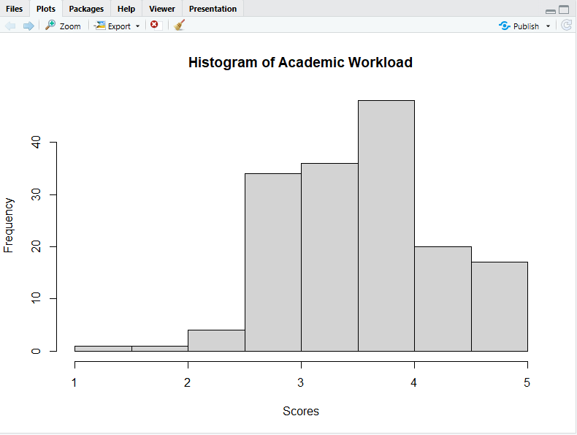
Histogram of Academic Workload

The histogram shows that most students gave scores between 3 and 4 for Academic Workload. This indicates that many respondents experience a moderate to high level of academic demands. The distribution is concentrated around the center, which suggests that responses are relatively consistent among students.
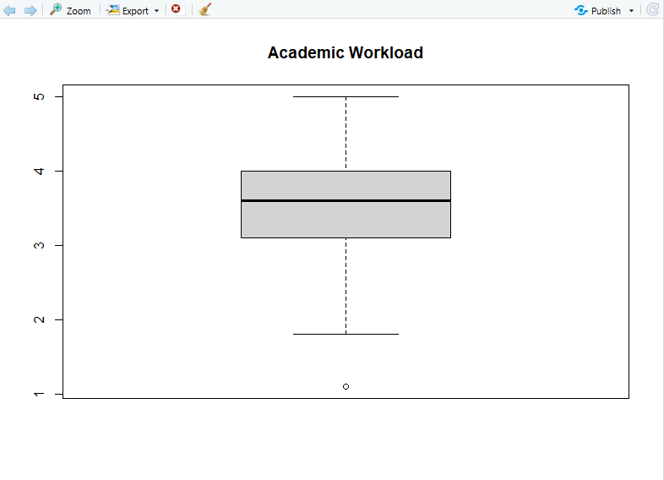
Boxplot of Academic Workload

The boxplot shows the median, interquartile range (IQR), and spread of Academic Workload scores. One outlier is identified below the lower whisker, indicating a respondent with a much lower score compared to others. Despite this, most responses remain closely grouped, showing consistent perceptions of academic workload.
Histogram of Programming Difficulty
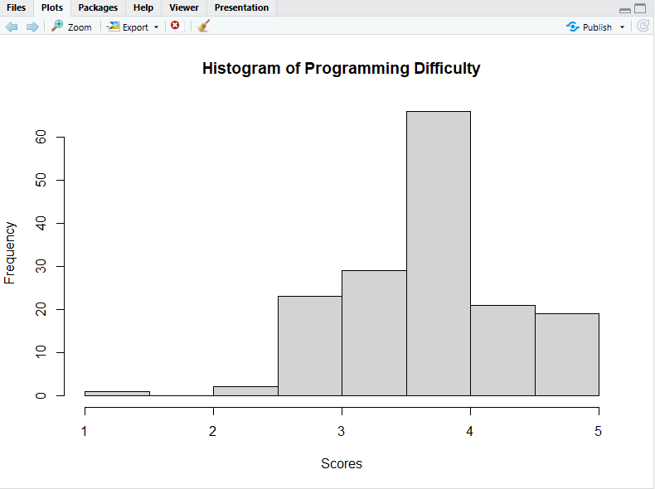

The histogram shows that most respondents rated Programming Difficulty between 3.0 and 4.0. This means that students generally perceive programming subjects as challenging. The distribution is slightly concentrated in the higher range, indicating a generally high level of difficulty experienced by students.
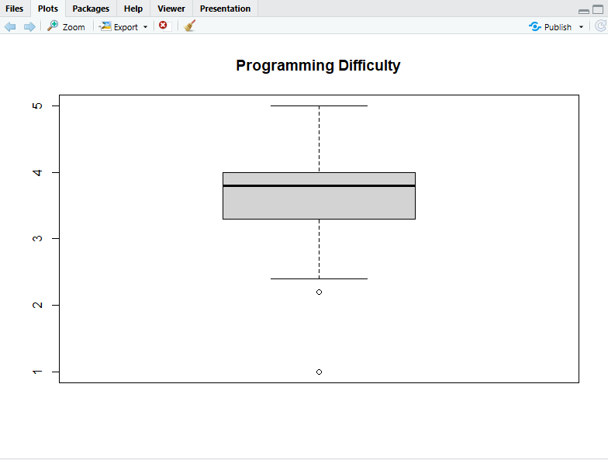
Boxplot of Programming Difficulty

The boxplot shows the distribution of Programming Difficulty scores using the IQR method. Two outliers are identified below the lower whisker, representing respondents with unusually low difficulty ratings compared to the majority. However, most values remain within the interquartile range, showing overall consistency in responses.
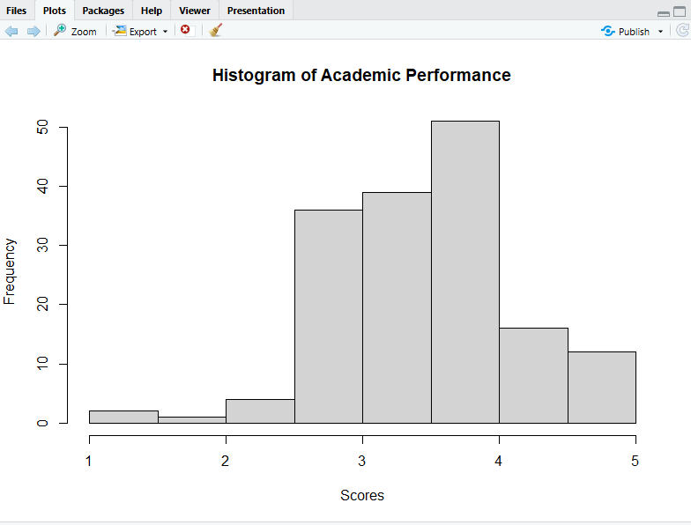
Histogram of Academic Performance

The histogram shows that most students rated their Academic Performance between 3.0 and 4.0. This suggests that respondents generally perceive their academic performance as satisfactory. The distribution is fairly centered, indicating moderate variation among responses.
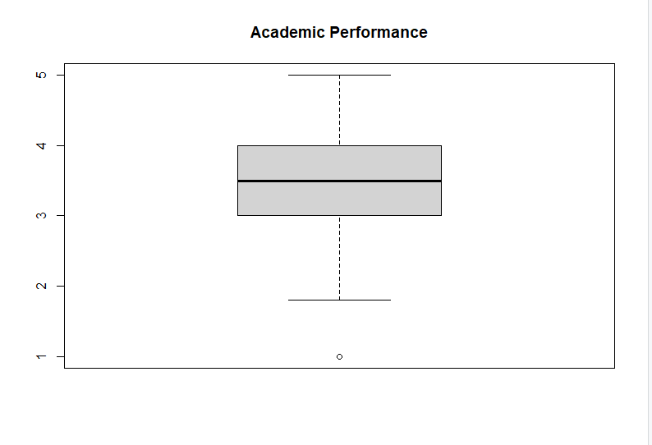
Boxplot of Academic Performance

The boxplot shows the median and spread of Academic Performance scores. Two outliers are identified below the lower whisker, representing respondents with very low self-assessed performance compared to others. Despite these outliers, most responses fall within a similar range, indicating consistency in self-assessment.

Chapter 4

INFERENTIAL RESULTS AND CONCLUSION
This chapter presents the results of the inferential statistical tests conducted to address the research questions and evaluate the three hypotheses of this study. The analysis draws on the composite scores of Academic Workload (AW), Programming Difficulty (PD), and Self Assessed Academic Performance (AP) derived from Likert-scale survey responses of 161 CCIS students.
As recommended by Field (2018), Pearson correlation was first used to assess the strength and direction of relationships among the three variables, followed by Multiple Linear Regression to determine the combined predictive power of Academic Workload and Programming Difficulty on Academic Performance. Both analyses were performed using R Studio (R Core Team, 2023).

4.1 Correlation Analysis
A Pearson correlation test was performed prior to the regression analysis to examine how strongly the three variables are associated with one another. The results are displayed in the table below.

Table 4.1. Correlation Matrix of Variables
Variable | AW (X₁) | PD (X₂) | AP (Y)
Academic Workload | 1.00 | 0.70 | 0.37
Programming  Difficulty | 0.70 | 1.00 | 0.33
Academic  Performance | 0.37 | 0.33 | 1.00
The results show that Academic Workload and Academic Performance have a low positive relationship (r = 0.37). This means students with heavier workloads tend to report slightly better academic performance. According to Field (2018), a positive correlation means that as one variable increases, the other variable also tends to increase. Programming Difficulty and Academic Performance also showed a low positive relationship (r = 0.33). This means students who experience more difficulty in programming subjects also tend to report slightly higher academic performance. According to Hair et al. (2019), low positive correlations show that the relationship exists, but it is not very strong. Meanwhile, Academic Workload and Programming Difficulty showed a strong positive relationship (r = 0.70). This means students with heavier workloads also tend to experience greater programming difficulty. According to Tabachnick and Fidell (2019), a strong correlation between predictor variables may indicate multicollinearity, which can affect regression analysis results.

4.2 Multiple Linear Regression Analysis
To determine the combined effect of Academic Workload and Programming Difficulty on Academic Performance, a Multiple Linear Regression analysis was conducted in R Studio using the lm() function. The general form of the regression model is:
Ŷ = B₀ + B₁X₁ + B₂X₂ + ε
Where Ŷ represents the predicted Academic Performance score, X₁ represents Academic Workload, X₂ represents Programming Difficulty, and ε represents the error term.
Based on the R Studio results, the regression equation is:
Ŷ = 1.95 + 0.27X₁ + 0.16X₂
This means that when both predictor variables are equal to zero, the predicted Academic Performance score is 1.95. A one-point increase in Academic Workload is associated with an increase of 0.27 points in Academic Performance. Similarly, a one-point increase in Programming Difficulty is associated with an increase of 0.16 points in Academic Performance. However, Programming Difficulty did not show a statistically significant effect because its p-value (0.1596) is greater than the 0.05 level of significance.

4.3 Model Fit — ANOVA and R²
The ANOVA table below was used to evaluate whether the overall regression model provides a statistically useful prediction of Academic Performance.

Table 4.2. ANOVA Table for the Regression Model
Source | SS | df | F | p-value | MS
Regression | 11.09 | 2 | 13.39 | <0.001 | 5.54
Residual | 65.41 | 158 | ___ | __ | 0.41
Total | 76.50 | 160 | ___ | __ | ___

Table 4.3. R² and Model Summary
R² | Adjusted R² | F-Statistic | p-value
0.145 | 0.13 | 13.39 | < 0.001
The overall regression model is statistically significant (F = 13.39, p < 0.001). This means that Academic Workload and Programming Difficulty, when combined, significantly predict Academic Performance. The R² value of 0.145 means that the two predictor variables explain about 14% of the variation in students’ self-assessed academic performance. Although the R² value is not very high, it still shows that the model has a meaningful contribution in explaining Academic Performance. According to Tabachnick and Fidell (2019), R² values between 0.10 and 0.20 are common in educational and behavioral studies because student performance is influenced by many different factors.

4.4 Coefficient Analysis
The table below presents the individual effect of each predictor variable on Academic Performance.

Table 4.4. Regression Coefficients
Predictor | B | Std Error | t-value | p-value | Result | Beta (β)
Intercept (B₀) | 1.95 | 0.32 | 6.19 | < 0.001 | Significant | —
Academic  Workload  (X₁) | 0.27 | 0.10 | 2.60 | 0.010 | Significant | 0.27
Programming  Difficulty  (X₂) | 0.16 | 0.11 | 1.41 | 0.160 | Not  Significant | 0.16
Academic Workload (β = 0.27, p = 0.010) was found to be a statistically significant predictor of self-assessed Academic Performance. This means that students with heavier academic workloads tend to report slightly better academic performance. One possible reason is that students who are more active in their studies may also develop better study habits and time management skills. According to Datu and Mateo (2020), students who manage their academic responsibilities well often develop stronger academic confidence.
Programming Difficulty (β = 0.16, p = 0.160), on the other hand, was not statistically significant because its p-value is greater than 0.05. This means that Programming Difficulty alone does not significantly predict Academic Performance when Academic Workload is already included in the model. However, this does not mean that programming difficulty has no effect on students. According to Hair et al. (2019), when two predictor variables are strongly related, multicollinearity may happen, making it harder to identify the unique effect of each variable. In this study, Academic Workload and Programming Difficulty showed a strong positive relationship (r = 0.70).

4.5 Hypothesis Testing Results
Based on the results of the Pearson correlation and Multiple Linear Regression tests, the following decisions were made regarding the three hypotheses:

Table 4.5. Summary of Hypothesis Decisions
Hypothesis | Test Result | p-value | Decision
Ho1: No significant relationship between Academic Workload and  Academic Performance | t = 2.595 | 0.0104 | Reject Ho1 — Significant
Ho2: No significant relationship between Programming Difficulty and Academic Performance | t = 1.413 | 0.1596 | Fail to Reject Ho2 — Not  Significant
Ho3: No significant combined effect of both variables on  Academic Performance | F = 13.39 | < 0.001 | Reject Ho3 — Significant
For the first hypothesis, the p-value of 0.0104 is less than 0.05. Therefore, Ho1 is rejected. This means there is a significant relationship between Academic Workload and Academic Performance.
For the second hypothesis, the p-value of 0.1596 is greater than 0.05. Therefore, Ho2 is not rejected. This means Programming Difficulty does not significantly predict Academic Performance.
For the third hypothesis, the p-value is reported as p < 0.001, which is less than 0.05. Therefore, Ho3 is rejected. This means that Academic Workload and Programming Difficulty, when combined, significantly predict Academic Performance.

4.6 Conclusion
This study examined the influence of Academic Workload and Programming Difficulty on the self-assessed Academic Performance of CCIS students at Surigao Del Norte State University.
Based on the data from 161 respondents and analyzed using Pearson correlation and Multiple Linear Regression in R Studio (R Core Team, 2023), the following conclusions were drawn.
First, Academic Workload was found to be a significant predictor of Academic Performance. This means that students who experience heavier academic workloads tend to report slightly higher academic performance.
Second, Programming Difficulty was not found to be a significant predictor of Academic Performance when combined with Academic Workload in the regression model. This suggests that programming difficulty alone does not have a strong independent effect on students’ perceived performance in this study.
Third, the combined effect of Academic Workload and Programming Difficulty significantly predicts Academic Performance. However, the model explains only about 14.5% of the variation in Academic Performance (R² = 0.145), which indicates that other factors not included in this study also influence student performance.
Finally, it is important to note that these results are based on relationships between variables and do not imply causation. This means that while the variables are related, one does not directly cause changes in the other.

4.7 Recommendations
Based on the findings and conclusions of this study, the following recommendations are offered:
For CCIS Faculty and Department Heads, it is recommended that the scheduling and distribution of academic tasks such as assignments, quizzes, and projects be regularly reviewed. Since Academic Workload was found to have a significant relationship with Academic Performance, balancing deadlines across the semester may help students manage their workload more effectively and reduce unnecessary pressure that can affect their learning experience.
For CCIS Faculty Teaching Programming Subjects, although Programming Difficulty was not found to be a significant independent predictor of Academic Performance, it still contributes to students’ overall academic experience. It is recommended that instructors continue to provide structured learning support such as step-by-step coding demonstrations, guided exercises, and hands-on practice activities to help students better understand programming concepts and reduce learning difficulty.
For School Administrators, the results suggest the need to strengthen academic support systems for students enrolled in computing-related programs. Programs such as peer tutoring, programming support sessions, and academic mentoring may help students cope with both academic workload and technical subject demands, which together influence their academic experience.
For Students, it is recommended that they practice effective time management and consistent study habits in handling their academic responsibilities. Since Academic Workload and Programming Difficulty together significantly influence academic performance, students are encouraged to plan their tasks properly, avoid procrastination, and seek assistance when encountering difficulties in programming subjects.
For Future Researchers, it is recommended that further studies include additional variables that may influence Academic Performance, such as study habits, motivation, sleep quality, internet access, learning environment, and stress levels. Since the current model explains only about 14.5% of the variation in Academic Performance, future research should explore other contributing factors to obtain a more comprehensive understanding of student performance.

REFERENCES
Barrot, J. S., Llenares, I. I., & del Rosario, L. S. (2021). Students’ online learning challenges during the pandemic and how they cope with them: The case of the Philippines. Education and Information Technologies, 26(6), 7321–7338.
https://doi.org/10.1007/s10639-021-10589-x
Cabrera, M. A., & Villanueva, R. T. (2022). Academic workload and student performance in Philippine higher education: A structural analysis. Asia Pacific Journal of Education, 42(3), 455–471. https://doi.org/10.1080/02188791.2022.2045123
Datu, J. A. D., & Mateo, N. J. (2020). Academic engagement, self-efficacy, and well-being among Filipino college students. Current Psychology, 39(4), 1420–1430. https://doi.org/10.1007/s12144-018-9883-3
Estacio, R. R., & Raga, R. C. (2017). Analyzing students’ online learning behavior in blended courses using Moodle. Asian Association of Open Universities Journal, 12(1), 52–68. https://doi.org/10.1108/AAOUJ-01-2017-0016
Field, A. (2018). Discovering statistics using IBM SPSS statistics (5th ed.). SAGE Publications.
Hair, J. F., Black, W. C., Babin, B. J., & Anderson, R. E. (2019). Multivariate data analysis (8th ed.). Cengage Learning.
Lim, C. P., & Reyes, D. M. (2021). Stress, workload, and academic performance in undergraduate computing programs: Evidence from Southeast Asia. Computers & Education, 162, 104085. https://doi.org/10.1016/j.compedu.2020.104085
R Core Team. (2023). R: A language and environment for statistical computing. R Foundation for Statistical Computing. https://www.r-project.org/
Tabachnick, B. G., & Fidell, L. S. (2019). Using multivariate statistics (7th ed.). Pearson.
Villarreal, A. G., & Santos, M. C. (2023). Programming anxiety and academic motivation among computing students: Implications for instructional design. Journal of Educational Technology & Society, 26(2), 88–101. https://doi.org/10.30191/ETS.202304_26(2).0007

