Name: Alveniz, Kristine Nicole E. Date:________________
Course: BEEd-2A

Activity 10- Natural Climate Cycles

Task 1. Make a graphic organizer millennial, century and interannual and decadal climate cycles.
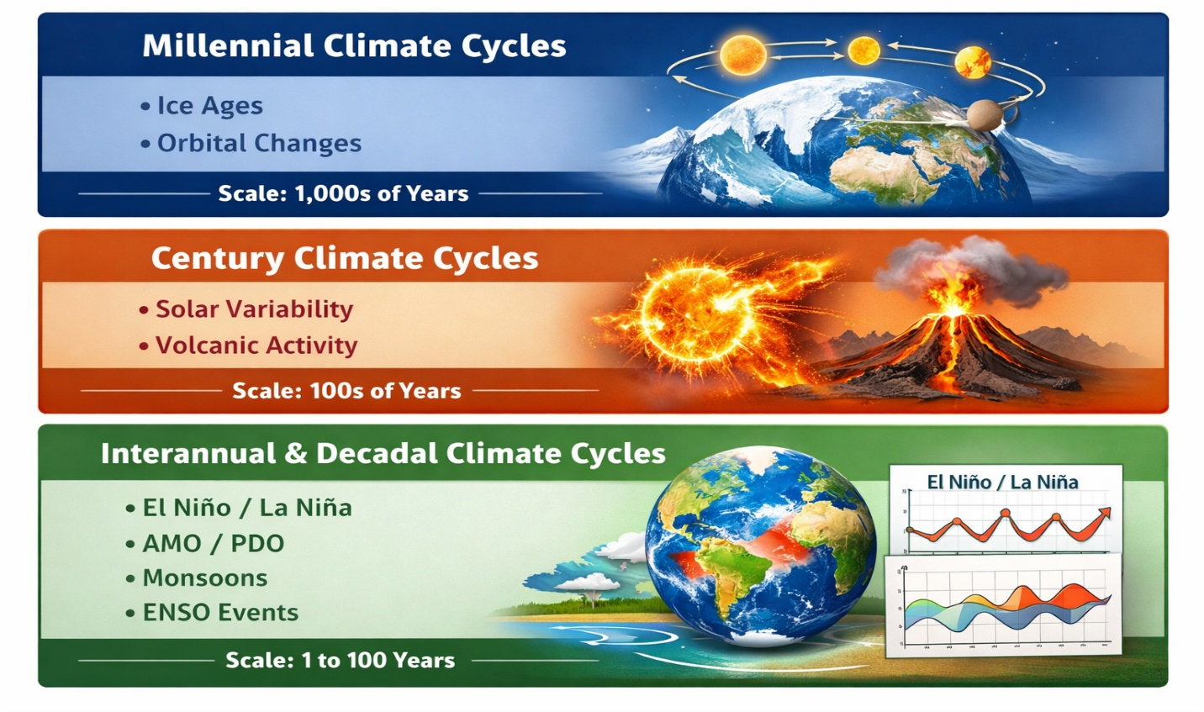

Task 2. Make a video presentation of any of the weather patterns and climatic cycles( hurricanes, typhoons indicating easterlies, southeast/northeast monsoon, tail end of the cold front and/or ITCZ.

Guide Questions:

1.How do the two Milankovitch feedback mechanisms differ from each other?

The Milankovitch Cycles affect Earth’s climate through changes in its orbit.

- Eccentricity – change in the shape of Earth’s orbit around the Sun (~100,000 years).

- Axial Tilt (Obliquity) – change in the tilt of Earth’s axis, affecting the strength of seasons (~41,000 year

2.Differentiate the 4 climate cycles. Give example on each.
- Millennial Cycle – lasts thousands of years (Example: Ice Ages).

- Century Cycle – about 100 years (Example: solar activity changes).

- Decadal Cycle – 10–30 years (Example: Pacific Decadal Oscillation).

- Interannual Cycle – 1–7 years (Example: El Niño–Southern Oscillation).

3. In your video presentation, what are those factors need to consider during typhoon, LPA or simply ITCZ?How they contribute to raining, thunder and lightning.

- Warm ocean water

- Low air pressure

- High moisture

- Converging winds

