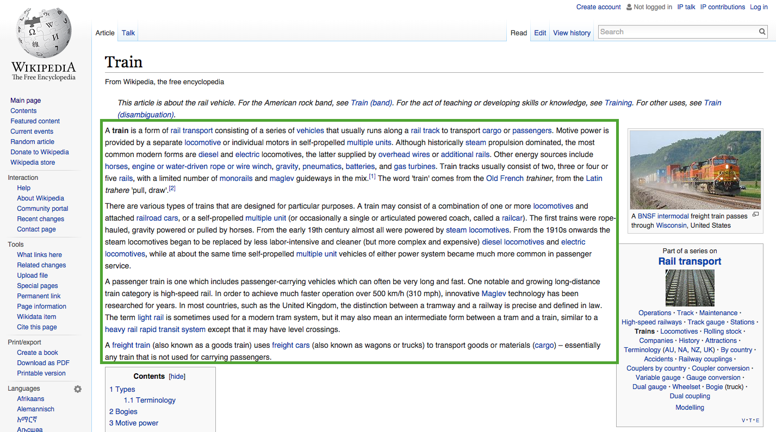

**First Links**

“Train”

Rain Transport 🡪

Conveyance of Passengers and Goods 🡪

Goods 🡪

Economics 🡪

Social Science 🡪

Academic Disciplines 🡪

Knowledge 🡪

Awareness 🡪

Consciousness 🡪

Quality 🡪

Philosophy.