Shaping your identity – Text A: You are what you eat (blog post)

|  |  |
| --- | --- |
| Thema | Shaping your identity – Text A: You are what you eat |
| Ziel | Sich mit gesundheits-/planetenfördernden und -schädigenden Faktoren auseinandersetzen  Einen Blogeintrag (blog post) verfassen |
| Zeitumfang | 90 Min (entspricht xx Doppelstunde(n) ohne Vor- und Nachbereitungszeit) |
| Arbeitsmaterialien | Lehrbuch, Challenge 12/13, S. 14–16 u. S. 208  OPAL-Kurs: Unterrichtsthemen/ |
| Abzugebende Dateien | Klasse_Nachname_blog_post_campaign_V1.docx |
| Abgabe bis |  |

# Preparing for writing a blog post on one of the campaigns mentioned in the text

**Tasks:**

1. Read the instruction below on how to write a blog post

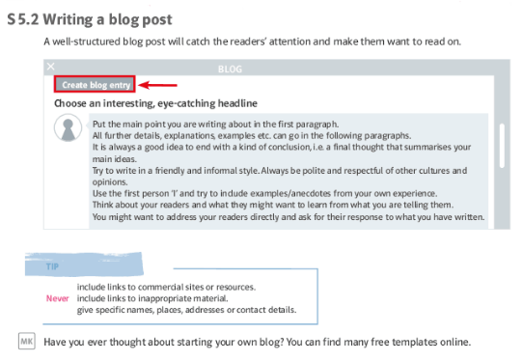

|  |
| --- |
| **Note**: Writing or mediation tasks often ask you to write a blog post, or blog entry. This is an online diary or informational website to showcase aspects of the blogger's life and/or attitudes.  Blog posts have a range of formats and may resemble:   * an article * a review or * a short, direct and conversational response to a point of view or an event   They are always written with a specific audience in mind, normally in an informal style unless the expected readership is more intellectual. Even if the post is informal, it **must not** contain slang, offensive terms or incorrect information.  A typical blog post consists of:   * a catchy headline * an introduction ('lead') which captivates the reader and explains why he/she should read on * a main part divided into short paragraphs, ideally with subheadings * a conclusion which relates to the headline and includes a call to action or invites a response to the points the blogger made * a timestamp/date indicating when the blog post was published.   Additionally, it could include:   * pictures and illustrations that catch the reader's attention * tags or hashtags which cross-reference other content that addresses the topic of the post |

**Planning stage**

1. Read the task carefully.

* Who is the blog post aimed at? The target group determines the style and structure of the blog entry.
* What are you going to write about?
* Do you want to post an idea or a topic, start a discussion or contradict somebody else's viewpoint?
* Is it a 'How to ...' guide?

1. Gather ideas about factors of the campaign you chose, which have a positive and negative effect on either people’s health or our planet.

|  |  |
| --- | --- |
| **Factors with positive effects** | **Factors with negative effects** |
|  |  |
|  |  |
|  |  |
|  |  |
|  |  |
|  |  |
|  |  |
|  |  |
|  |  |
|  |  |

**Writing stage**

Step 1 Headline

1. Formulate an interesting, eye-catching headline which particularly attracts people who do not positively contribute to either their health or the state of our planet.

|  |
| --- |
| * The headline should not be too long (as with real blog posts, it must fit on the screen). * It shouId relate to the main topic of your post * It should attract the reader’s attention, e.g.:   + by giving numbers or lists (Four ways to ..., The ten most important reasons for ... )   + by asking a provocative question (Do you really believe in ... ?}   + by giving good advice (How to ...) |

________________________________________________________________________________________________________________

1. Explain why you think your headline will attract your target group.
2. Organise your ideas for your blog post to convince people who do not positively contribute to either their health or the state of our planet.

**Hinweis**: In die Tabelle können Sie Ihre Ideen zunächst stichpunktartig eintragen   
(ggf. auch erst einmal auf Deutsch bzw. in Ihrer Muttersprache)

|  |  |  |  |  |
| --- | --- | --- | --- | --- |
| **main structure** | **more detailed structure** | | | **no. of words** |
| Introduction  see step 2 | Topic sentence: | | | 50 to 100 |
| *Leave space!* | | | | |
| 1st paragraph  see step 3 | Supporting sentence 1: |  | | ca. 20 |
| Detail 1: |  | | 20 to 50 |
| Detail 2: |  | | 20 to 50 |
| Conclusion regarding supporting sentence 1: |  | | 20 to 50 |
| *Leave space!* | | | | |
| 2nd paragraph  see step 3 | Supporting sentence 2: |  | | ca. 20 |
| Detail 1: |  | | 20 to 50 |
| Detail 2: |  | | 20 to 50 |
| Conclusion regarding supporting sentence 2: |  | | 20 to 50 |
| *Leave space!* | | | | |
| Conclusion | Summarizing main ideas from the two paragraphs with reference to the topic sentence for drawing a final conclusion by evaluation of conclusions from paragraph 1 and 2. | |  | 50 to 100 |
| **Total** | | | | **260 bis 540** |

**Step 2 Introduction**

* Write a captivating introduction.
* Mention the most important, attention-grabbing elements of your post in the first paragraph, e.g.:
  + how you came across the topic of your blog post
  + why it is so important
  + answers to the five wh-questions of a story you are going to tell.

**Step 3 Main part (body)**

* Divide your main part into paragraphs.
* Introduce each paragraph with a topic sentence or highlight the main points of your topic.
* Use subheadings to add structure to your blog post
* You may add pictures/illustrations, but remember to name your sources.

# Writing a blog post on healthy lifestyle

Task: Write your final version of your blog post according to the structure outlined in task A5.

Headline of your blogpost (see task A3): ____________________________________________________