T1 Text C: Ways of learning – pros and cons of technology-free learning

|  |  |
| --- | --- |
| Thema | Produktion: Verfassen eines Kommentars |
| Ziel | Kommentar verfassen, um sich zu positionieren zum Für und Wider technologiefreien Lernens |
| Zeitumfang | ca. 90 Min |
| Aufgaben abrufbar unter | Unterrichtsthemen/.../Topic 1: Shaping your identity/… |
| Arbeitsmaterialien | Datei: Ch12_T1_Text_C_comment_Vorlage.docx |
| Abzugebende Dateien | Klasse_Nachname_T1_Comment_V1.docx |
| Abgabe bis |  |

|  |  |
| --- | --- |
| Nr. | Aufgabe(n) |
| 1 | Diese Word-Datei umbenennen in: Klasse_Nachname_T1_Comment_V1.docx |
| 2 | Kopfzeile ausfüllen. Dazu gelbe Markierungen durch Ihre Einträge ersetzen (Klasse, Name, Datum). Dann alle weiteren Aufgaben direkt in diesem Dokument **bearbeiten und abspeichern**. |
| 3 | Aufgaben 1 bis 2 bearbeiten |
| 4 | Bearbeitete und abgespeicherte Datei im Rückgabeordner hochladen unter:  Unterrichtsthemen/.../Topic 1: Shaping your identity/… |

# T1 Text C, Aufgabe 7: Produktion (Kommentar schreiben)

Read the following online comments on the article, and add your own comment on the effectiveness and suitability of technology-free learning in schools.

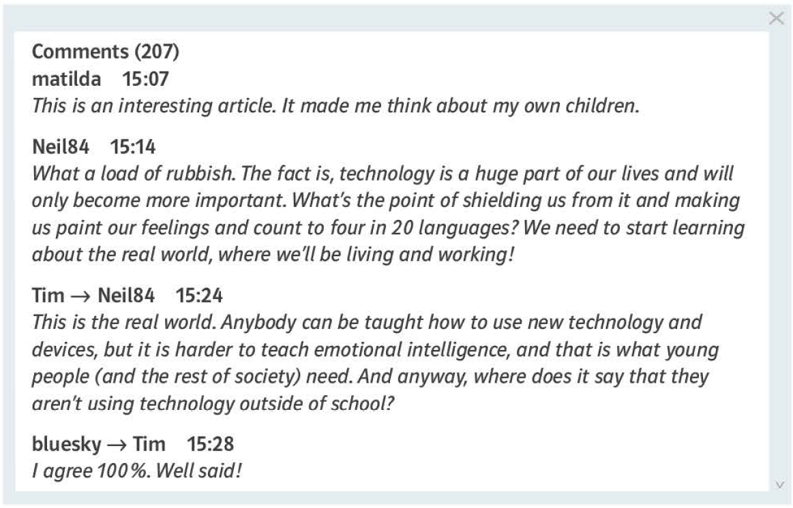

**Now do the following subtasks:**

1. Thoroughly read the information in figure 1 to see what has to be considered when writing a comment.

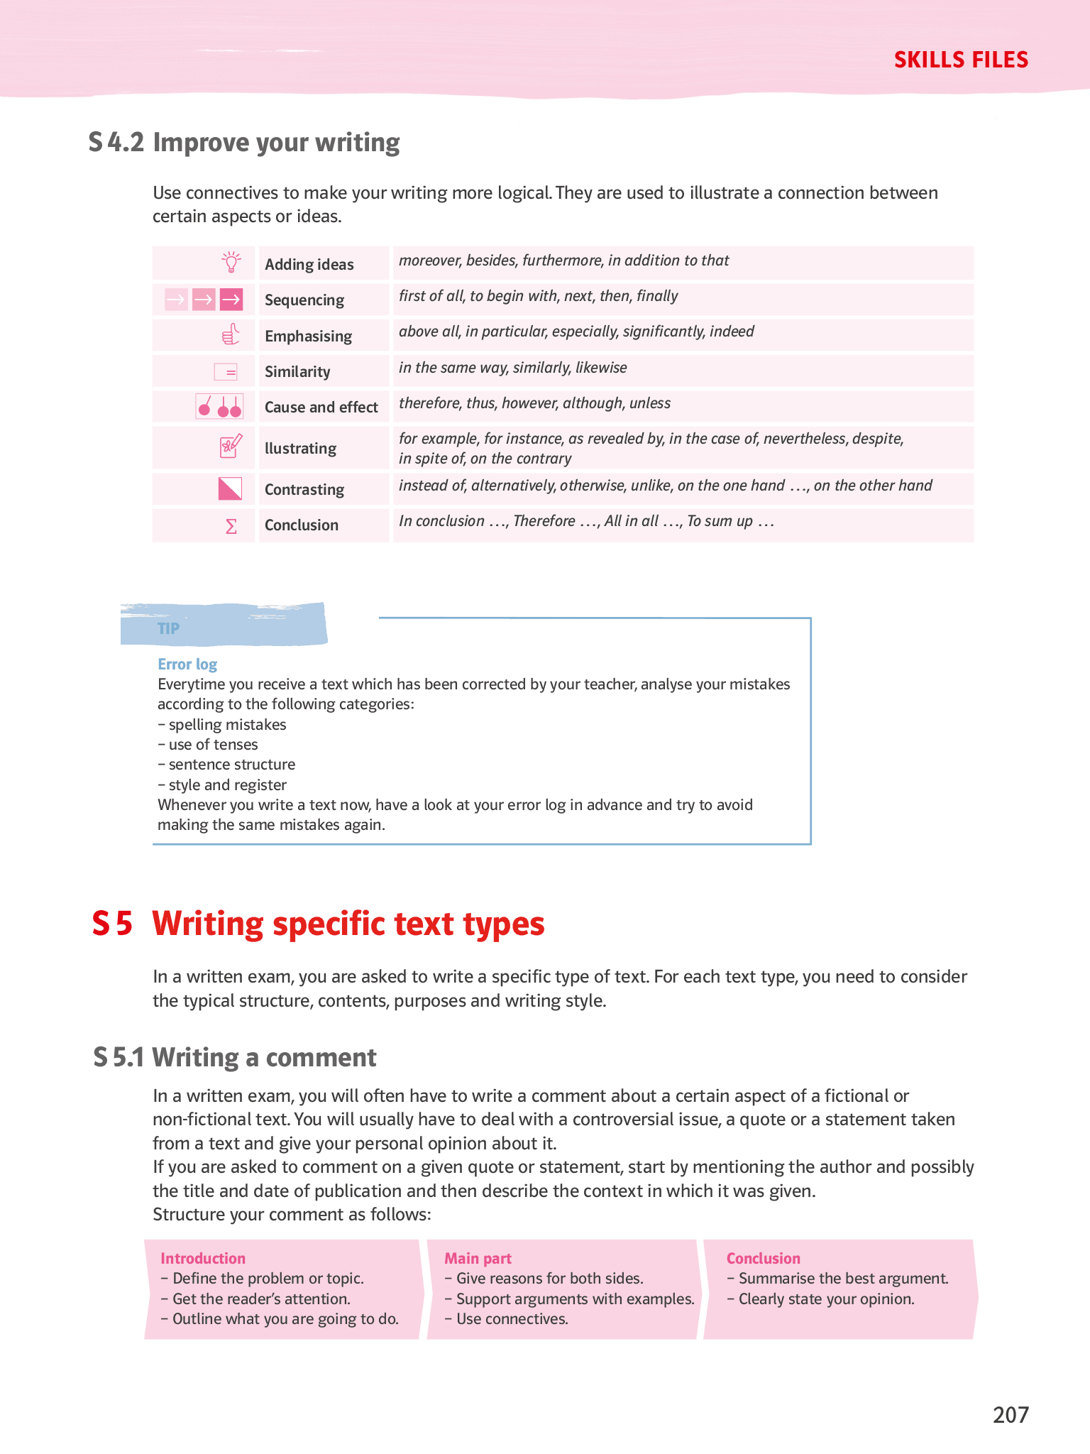

Figure 1: Excerpt from the Skills Files in your textbook on writing a comment (textbook, Challenge 12/13, Klett, p. 207)

1. Read text C again to mark passages dealing with pros and cons of technology-free learning.
2. Mark passages dealing with pros and cons of technology-free learning in the additional text material you have researched.
3. Make a list of some pros and cons of technology-free learning. Comment on each point.

**Feel free to add further rows!**

|  |  |  |  |
| --- | --- | --- | --- |
| technology-free learning | | | |
| aspect | pros | cons | comment on aspect |
| teaching through physical activity |  |  |  |
| learning through creative tasks |  |  |  |
| arousing curiosity |  |  |  |
|  |  |  |  |
|  |  |  |  |
|  |  |  |  |

1. Decide whether you want to mention only positive or negative points in your comment, or both positive and negative.
2. Structure your comment according to the table 1 below.

Tab. 1: Content structure of comment on pros and cons of technology-free learning

Headline of your comment: _______________________________________________________________________________

|  |  |  |  |
| --- | --- | --- | --- |
| **main structure** | **more detailed structure** | | **no. of words** |
| Introduction | **Topic sentence** (thesis statement, i. e. sentence that clearly states the basic question, argument or problem): Does Technology help or distract learning  Note: First sentence of the introduction should be an interesting introduction that presents the problem your argumentative essay will discuss. The last sentence of the paragraph should be your *topic sentence/thesis statement*. | | 50 to 100 |
| *Leave space!* | | | |
| 1st paragraph | Supporting sentence 1: | The absence of technological distractions enhances students' ability to concentrate and develop critical thinking skills. | ca. 20 |
| Detail 1: | Research indicates that students engaging with printed materials and handwritten notes exhibit better retention and conceptual understanding than those using digital resources. | 20 to 50 |
| Detail 2: | Cognitive studies suggest that writing by hand promotes analytical thinking and deeper processing of information, which can improve long-term knowledge acquisition. | 20 to 50 |
| Conclusion regarding supporting sentence 1: | By eliminating digital distractions, technology-free learning environments may cultivate stronger academic engagement and intellectual rigor, leading to improved educational performance. | 20 to 50 |
| *Leave space!* | | | |
| 2nd paragraph | Supporting sentence 2: | Despite its benefits, technology-free learning can limit access to diverse learning materials and interactive educational tools. | ca. 20 |
| Detail 1: | Digial platforms provide instant access to a wealth of scholarly resources, enabling students to explore topics beyond the confines of traditional textbooks. | 20 to 50 |
| Detail 2: | The integration of multimedia tools, such as interactive simulations and virtual laboratories, has been shown to enhance understanding, particularly in complex scientific and technical disciplines. | 20 to 50 |
| Conclusion regarding supporting sentence 2: | While technology-free learning strengthens focus and cognitive engagement, modern educational advancements highlight the necessity of digital resources in facilitating comprehensive learning experiences. | 20 to 50 |
| *Leave space!* | | | |
| Conclusion | Summarizing main ideas from the two paragraphs with reference to the topic sentence for drawing a final conclusion by evaluation of conclusions from paragraph 1 and 2. | Both technology-free and technology-integrated learning models offer distinct advantages. While eschewing technology can bolster concentration and knowledge retention, digital tools provide unparalleled access to educational resources and interactive learning opportunities. A hybrid approach that strategically integrates traditional and digital methodologies may offer the most effective pathway to academic success.  To be honest if learning without technology help’s you, then that’s a skill issue. | 50 to 100 |
| **Total** | | | **260 bis 540** |

1. Now study the examples of argumentative language to make use of them in your comment. They are examples of signposts that are used in argumentative essays. Signposts enable the reader to follow your arguments easily.

*When pointing out opposing arguments (Cons):*

* Opponents of this idea claim/maintain that…
* Those who disagree/ are against these ideas may say/ assert that…
* Some people may disagree with this idea,
* Some people may say that…however…

*When stating specifically why they think like that:*

* They claim that…since…
* Reaching the turning point:
* However,
* But
* On the other hand,

*When refuting the opposing idea, we may use the following strategies:*

* compromise but prove their argument is not powerful enough:
  + They have a point in thinking like that.
  + To a certain extent they are right.
* completely disagree:
  + After seeing this evidence, there is no way we can agree with this idea.
* say that their argument is irrelevant to the topic:
  + Their argument is irrelevant to the topic.

Here are further useful phrases often used when writing a comment.

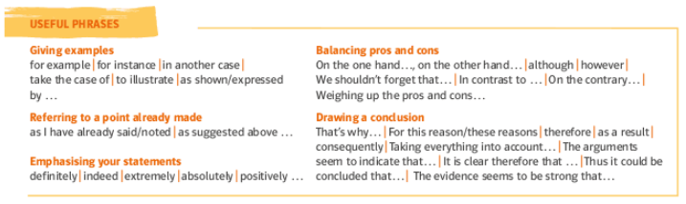

1. Write your comment (ca. 400 words)

*Your comment:*

1. Now proof-read your comment according to the checklist.
2. 3. Person Singular -s beim Verb im *simple present*
3. Pronomen (his/her/its/their; this/these oder that/those)
4. there is/are = es gibt
5. unregelmäßige Pluralformen (man/men; child/children; criterion/criteria; half/halves etc.)
6. unregelmäßige Verben
7. Präposition (in the picture, at the top; on Sundays; from/of; contributing to sth etc.)
8. Groß-/Kleinschreibung (I, Substantive im Satz; Nationalitäten, Ländernamen. Wochentage etc.)
9. Unterschied zw. do/make (do sports/homework; make mistakes)
10. Rechtschreibung (cannot, etc.; y --> ies)
11. Apostroph   
    (nur bei Kurzformen: it is 🡪 it‘s; Genitiv -s: the book of the student 🡪 the student’s book)
12. kein Apostroph bei Plural -s und 3.Person Singular -s
13. Relativpronomen (who 🡪 nur bei Personen; which 🡪 nur bei Objekten;   
    that 🡪 bei Personen und Objekten, wenn es notwendige Relativsätze sind
14. a/an
15. Verwendung Passiv statt umgangssprachl. Ersatzform mit „get"
16. Improve your writing according to the information in S4.2.



