Evidencia “DÍA 5 SEMANA 11” del 09/07:

Avance del ejercicio anterior del 08/07.

Solución:

1.- CheckBox

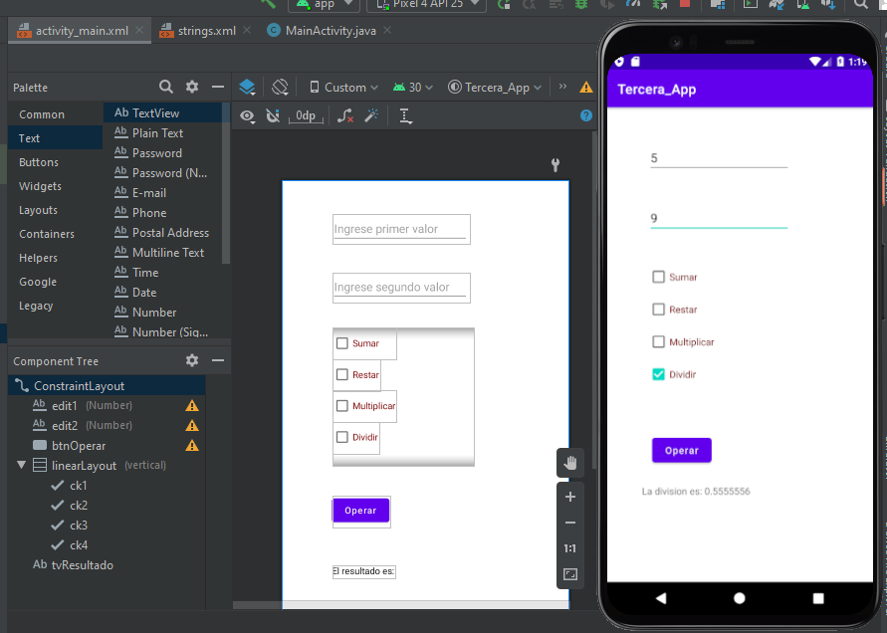

Codigo:

package com.debora.tercera_app;  
  
import androidx.appcompat.app.AppCompatActivity;  
  
import android.os.Bundle;  
import android.view.View;  
import android.widget.CheckBox;  
import android.widget.EditText;  
import android.widget.TextView;  
import android.widget.Toast;  
  
public class MainActivity extends AppCompatActivity {  
  
 private TextView tvr;  
 private EditText ed1, ed2;  
 private CheckBox ck1, ck2, ck3, ck4;  
  
  
 @Override  
 protected void onCreate(Bundle savedInstanceState) {  
 super.onCreate(savedInstanceState);  
 setContentView(R.layout.*activity_main*);  
  
 ed1 = findViewById(R.id.*edit1*);  
 ed2 = findViewById(R.id.*edit2*);  
 tvr = findViewById(R.id.*tvResultado*);  
 ck1 = findViewById(R.id.*ck1*);  
 ck2 = findViewById(R.id.*ck2*);  
 ck3 = findViewById(R.id.*ck3*);  
 ck4 = findViewById(R.id.*ck4*);  
  
 }  
  
 public void Operar(View v){  
  
 if("".equals(ed1.getText().toString()) || "".equals(ed2.getText().toString())){  
 Toast.*makeText*(this,"Debe definir valores", Toast.*LENGTH_LONG*).show();  
 } else {  
  
 if(ck1.isChecked()){  
 sumar();  
 } else if (ck2.isChecked()){  
 restar();  
 } else if (ck3.isChecked()){  
 multiplicar();  
 } else if (ck4.isChecked()) {  
 dividir();  
 }  
  
 }  
 }  
  
 private void sumar(){  
  
 int valor1 = Integer.*parseInt*(ed1.getText().toString());  
 int valor2 = Integer.*parseInt*(ed2.getText().toString());  
  
 int suma = valor1 + valor2;  
 tvr.setText("El resultado de la suma: " + suma);  
 }  
  
 private void restar(){  
  
 int valor1 = Integer.*parseInt*(ed1.getText().toString());  
 int valor2 = Integer.*parseInt*(ed2.getText().toString());  
 int resta = valor1 - valor2;  
 tvr.setText("El resultado de la resta: " + resta);  
 }  
  
 private void multiplicar(){  
  
 int valor1 = Integer.*parseInt*(ed1.getText().toString());  
 int valor2 = Integer.*parseInt*(ed2.getText().toString());  
 int mult = valor1 * valor2;  
 tvr.setText("La multiplicación es: " + mult);  
 }  
  
 private void dividir(){  
  
 float valor1 = Float.*valueOf*(ed1.getText().toString());  
 float valor2 = Float.*valueOf*(ed2.getText().toString());  
 if (valor2 == 0) {  
 Toast.*makeText*(this, "El segundo valor no puede ser 0", Toast.*LENGTH_LONG*).show();  
 } else {  
 float div = valor1 / valor2;  
 tvr.setText("La division es: " + div);  
 }  
  
 }  
}

Strings.xml

<resources>  
 <string name="app_name">Tercera_App</string>  
 <string name="tvResultado">El resultado es:</string>  
 <string name="edit1">Ingrese primer valor</string>  
 <string name="edit2">Ingrese segundo valor</string>  
 <string name="ck1">Sumar</string>  
 <string name="ck2">Restar</string>  
 <string name="ck3">Multiplicar</string>  
 <string name="ck4">Dividir</string>  
 <string name="btnOperar">Operar</string>  
</resources>

3.- Switch

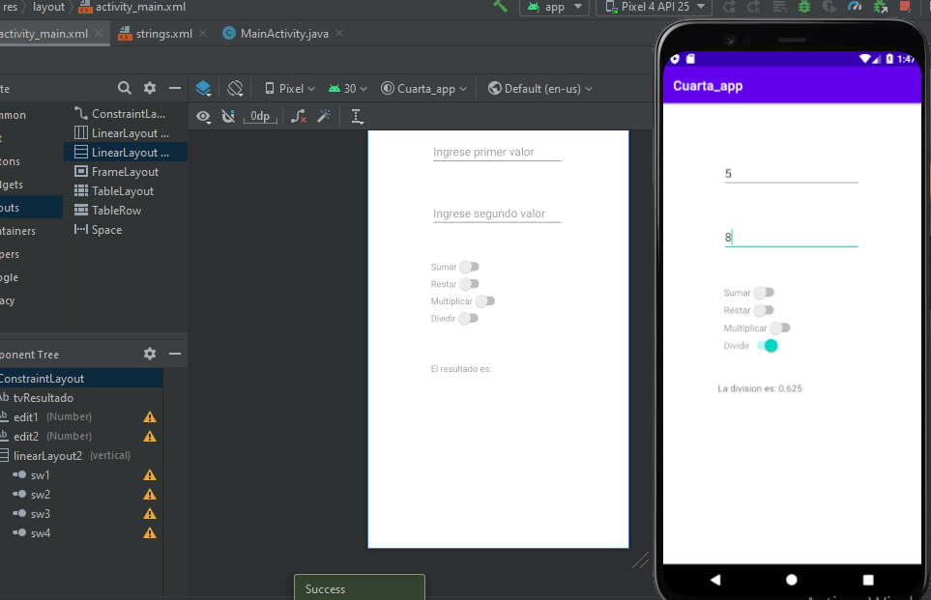

<resources>  
 <string name="app_name">Cuarta_app</string>  
 <string name="tvResultado">El resultado es:</string>  
 <string name="edit1">Ingrese primer valor</string>  
 <string name="edit2">Ingrese segundo valor</string>  
 <string name="sw1">Sumar</string>  
 <string name="sw2">Restar</string>  
 <string name="sw3">Multiplicar</string>  
 <string name="sw4">Dividir</string>  
</resources>

package com.debora.cuarta_app;  
  
import androidx.appcompat.app.AppCompatActivity;  
  
import android.os.Bundle;  
import android.view.View;  
import android.widget.EditText;  
import android.widget.Switch;  
import android.widget.TextView;  
import android.widget.Toast;  
  
public class MainActivity extends AppCompatActivity {  
  
 private TextView tvr;  
 private EditText ed1, ed2;  
 private Switch sw1, sw2, sw3, sw4;  
  
 @Override  
 protected void onCreate(Bundle savedInstanceState) {  
 super.onCreate(savedInstanceState);  
 setContentView(R.layout.*activity_main*);  
  
 ed1 = findViewById(R.id.*edit1*);  
 ed2 = findViewById(R.id.*edit2*);  
 tvr = findViewById(R.id.*tvResultado*);  
 sw1 = findViewById(R.id.*sw1*);  
 sw2 = findViewById(R.id.*sw2*);  
 sw3 = findViewById(R.id.*sw3*);  
 sw4 = findViewById(R.id.*sw4*);  
 }  
  
 public void Operar(View v){  
  
 if("".equals(ed1.getText().toString()) || "".equals(ed2.getText().toString())){  
 Toast.*makeText*(this,"Debe definir valores", Toast.*LENGTH_LONG*).show();  
 } else {  
  
 if(sw1.isChecked()){  
 sumar();  
 } else if (sw2.isChecked()){  
 restar();  
 } else if (sw3.isChecked()){  
 multiplicar();  
 } else if (sw4.isChecked()){  
 dividir();  
 }  
  
 }  
 }  
  
 private void sumar(){  
  
 int valor1 = Integer.*parseInt*(ed1.getText().toString());  
 int valor2 = Integer.*parseInt*(ed2.getText().toString());  
  
 int suma = valor1 + valor2;  
 tvr.setText("El resultado de la suma: " + suma);  
 }  
  
 private void restar(){  
  
 int valor1 = Integer.*parseInt*(ed1.getText().toString());  
 int valor2 = Integer.*parseInt*(ed2.getText().toString());  
 int resta = valor1 - valor2;  
 tvr.setText("El resultado de la resta: " + resta);  
 }  
  
 private void multiplicar(){  
  
 int valor1 = Integer.*parseInt*(ed1.getText().toString());  
 int valor2 = Integer.*parseInt*(ed2.getText().toString());  
 int mult = valor1 * valor2;  
 tvr.setText("La multiplicación es: " + mult);  
 }  
  
 private void dividir(){  
  
 float valor1 = Float.*parseFloat*(ed1.getText().toString());  
 float valor2 = Float.*parseFloat*(ed2.getText().toString());  
 if (valor2 == 0) {  
 Toast.*makeText*(this, "El segundo valor no puede ser 0", Toast.*LENGTH_LONG*).show();  
 } else {  
 float div = valor1 / valor2;  
 tvr.setText("La division es: " + div);  
 }  
  
 }  
  
}