**MINI PROJECT 1: SOLUTIONS**

**First downloaded AgentPerformance.csv and AgnetLogingReport.csv files.**

1. ***Create a schema based on the given dataset***

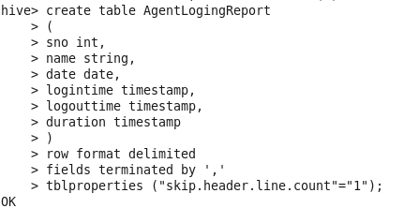

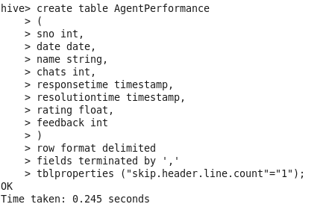

1. ***Dump the data inside the hdfs in the given schema location.***





1. ***List of all agents' names.***

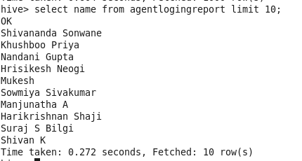

***\*\* I used LIMIT 10 here because there are more than 1000 agents and its not possible to capture screenshot of result with more than 1000 names.***

1. ***Find out agent average rating.***

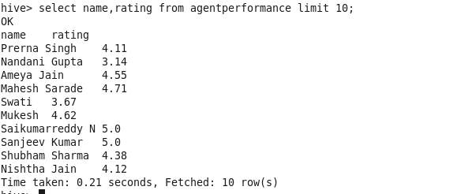

1. ***Total working days for each agents.***
2. ***Total query that each agent have taken.***

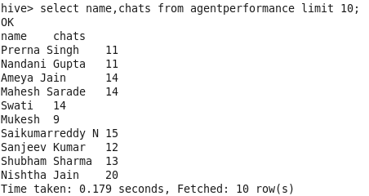

1. ***Total Feedback that each agent have received***

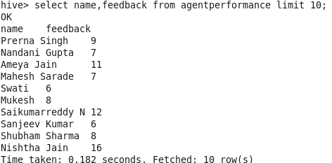

1. ***Agent name who have average rating between 3.5 to 4.***

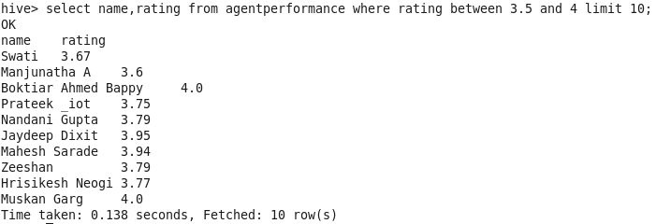

1. ***Agent name who have rating less than 3.5.***

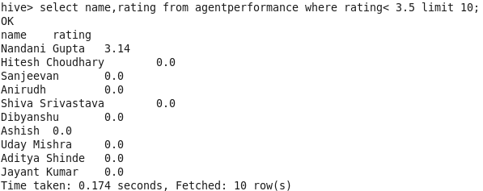

1. ***Agent name who have rating more than 4.5.***

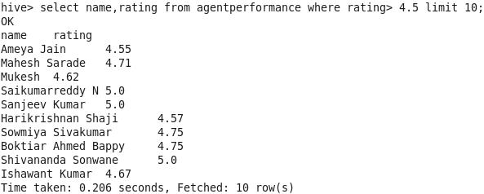

1. ***How many feedback agents have received more than 4.5 average.***

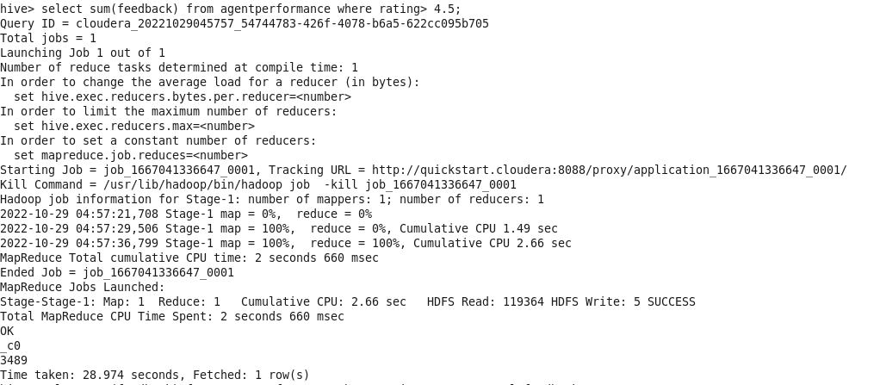

1. ***average weekly response time for each agent.***

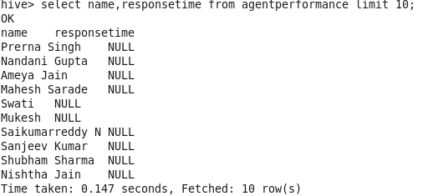

1. ***average weekly resolution time for each agents.***

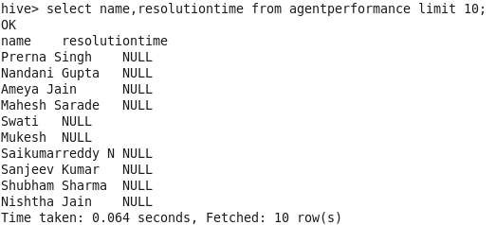

1. ***Find the number of chat on which they have received a feedback.***

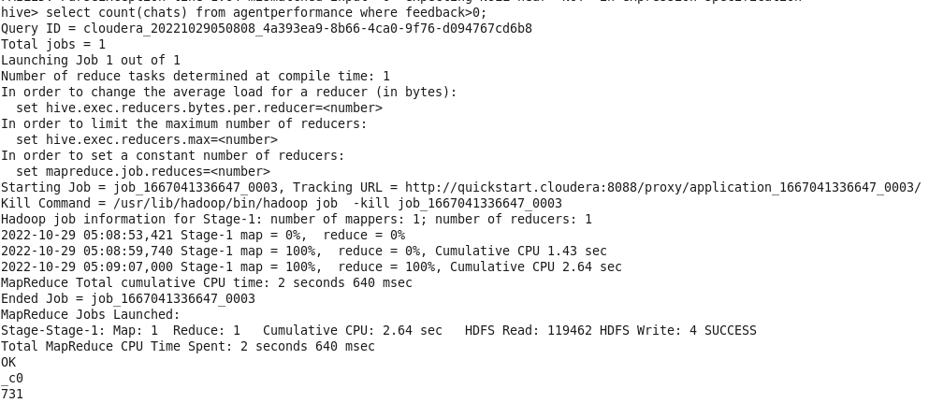

1. ***Total contribution hour for each and every agents weekly basis.***
2. ***Perform Inner join, left join and right join based on the agent column and after joining the table export that data into your local system.***

* ***INNER JOIN***

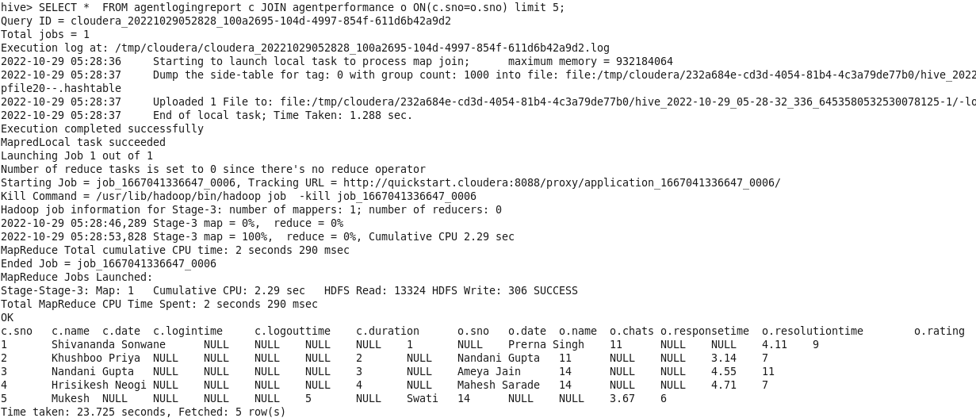

* ***LEFT JOIN***

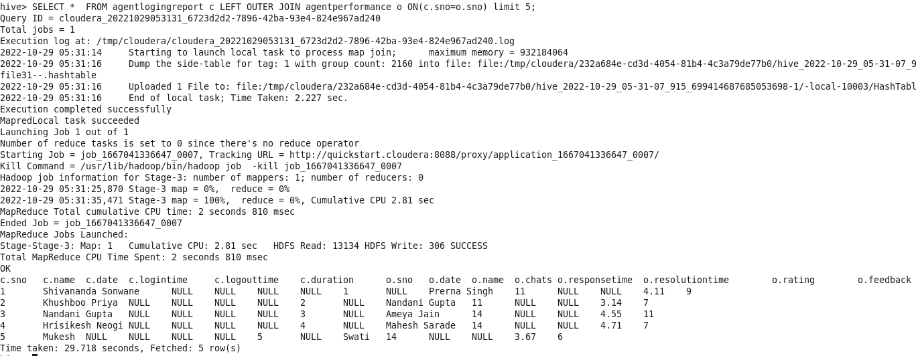

* ***RIGHT JOIN***

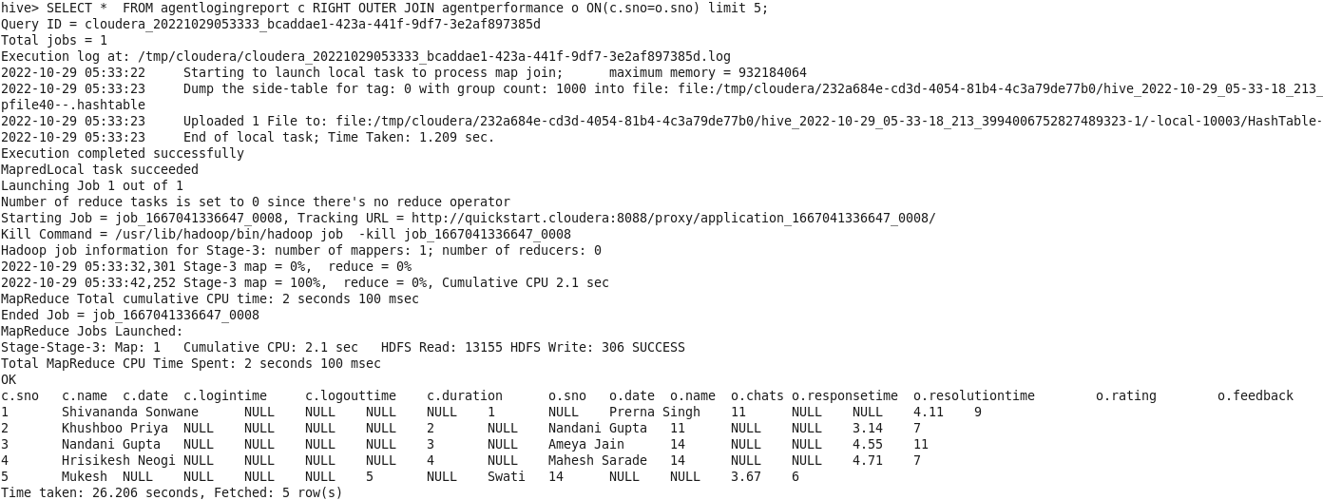

1. ***Perform partitioning on top of the agent column and then on top of that perform bucketing for each partitioning.***

* ***First create DynamicAgent table and partitioned by Agent name.***

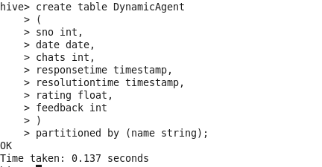

* ***Now do dynamic partitioning on AgentPerformance table with help of DynamicAgent table.***

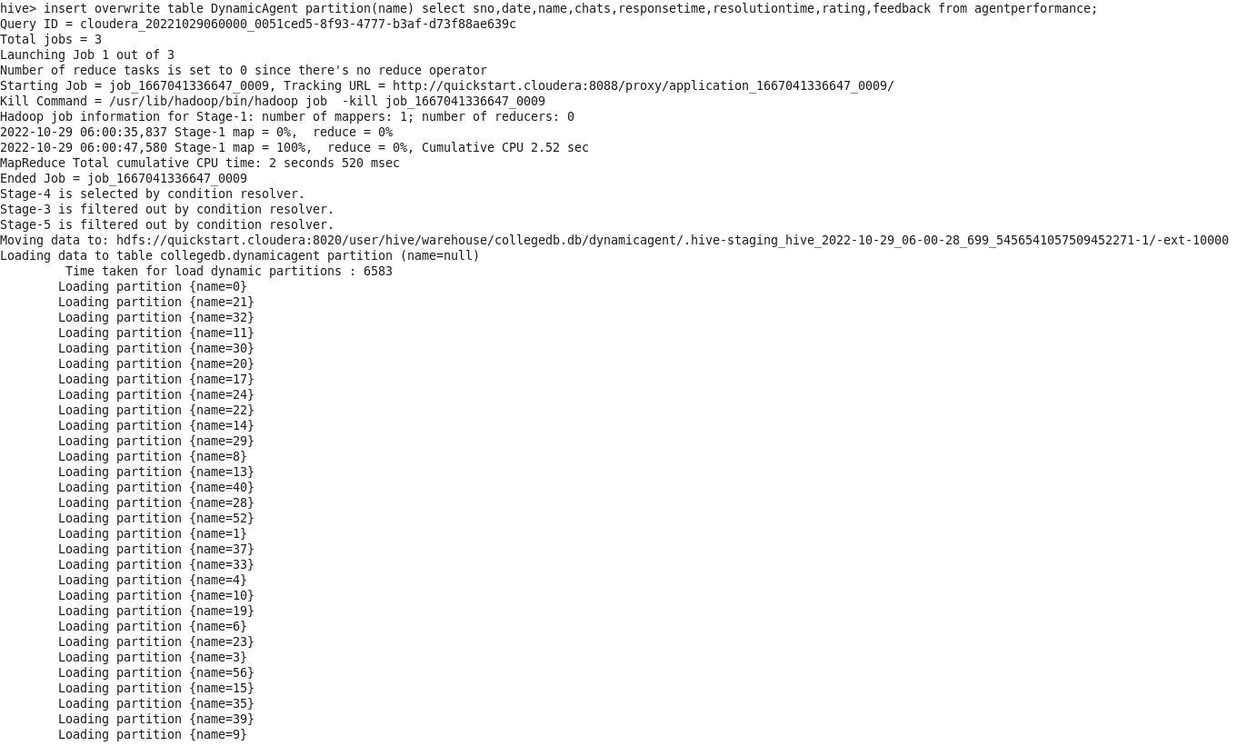

* ***Now create a bucketed table BucketAgent.***

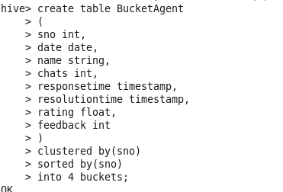

* ***Now perform bucketing on DynamicAgent table which is already partitioned.***

