
RAJALAKSHMI INSTITUTE OF TECHNOLOGY
(An Autonomous Institution, Affiliated to Anna University, Chennai)

DEPARTMENT OF CSE (ARTIFICIAL INTELLIGENCE AND MACHINE LEARNING)
ACADEMIC YEAR 2025 - 2026
SEMESTER III
ARTIFICIAL INTELLIGENCE LABORATORY
MINI PROJECT REPORT

REGISTER NUMBER | 2117240030023
NAME | DERALA CHETHAN KUMAR
PROJECT TITLE | Movie Recommendation System Using Probabilistic Reasoning
DATE OF SUBMISSION
FACULTY IN-CHARGE | Mrs. M. Divya

Signature of Faculty In-charge

INTRODUCTION:
Artificial Intelligence (AI) enables machines to make intelligent decisions by learning from data and reasoning under uncertainty. In the modern entertainment industry, AI plays a vital role in personalizing user experiences through intelligent recommendation systems.
A Movie Recommendation System is one such application that suggests movies to users based on their preferences, behavior, and similarities with other users. Traditional methods like collaborative and content-based filtering often face limitations when handling uncertainty, missing data, or changes in user preferences.
To address this, the proposed project uses Probabilistic Reasoning, a powerful AI technique that applies probability theory to model uncertainty. By using probabilistic models such as Bayesian networks, the system predicts the likelihood that a user will enjoy a specific movie based on previous interactions, genres, ratings, and user profiles. This approach enhances the accuracy and reliability of recommendations, providing a more personalized and dynamic movie experience for each user

PROBLEM STATEMENT:
In today’s digital entertainment platforms, users are often overwhelmed by the vast number of available movies, making it difficult to identify films that match their individual preferences. Traditional recommendation methods struggle to handle uncertainty in user behavior, missing data, and dynamic preference changes.
The problem is to develop a Movie Recommendation System that can accurately predict and suggest movies to users by applying probabilistic reasoning techniques. The system should analyze uncertain and incomplete information — such as user ratings, movie attributes, and viewing history — to compute the probability that a user will like a particular movie. This probabilistic approach aims to enhance recommendation accuracy, personalization, and user satisfaction under uncertain conditions.

GOAL
The main goal of this project is to develop an intelligent recommendation model capable of predicting user preferences through probabilistic inference. The system aims to:
- Model uncertainty in user data using probabilistic reasoning techniques.
- Recommend movies with the highest probability of user satisfaction.
- Improve personalization and adaptability in recommendation outcomes.
- Provide a scalable and accurate AI-based solution for modern entertainment platforms
THEORETICAL BACKGROUND
Artificial Intelligence (AI) enables systems to simulate human reasoning and decision-making through data-driven algorithms. In recommendation systems, AI helps identify user preferences and predict future interests using various learning and reasoning approaches.
One of the fundamental AI concepts applied in this project is Probabilistic Reasoning, which deals with reasoning and decision-making under uncertainty. Unlike deterministic systems, probabilistic models use probability theory to quantify uncertainty in data and outcomes. These models are particularly effective when dealing with incomplete or noisy information — a common challenge in user preference modeling.
Probabilistic Reasoning
Probabilistic reasoning is based on the principles of Bayesian Inference, which allows updating of beliefs when new evidence is introduced. It evaluates the probability of an event (e.g., a user liking a movie) given prior knowledge and observed data.
Mathematically, it is represented by Bayes’ Theorem:
$$P(H∣E)=\frac{P(E∣H)×P(H)}{P(E)}$$
Where:
- $P(H∣E)$: Posterior probability — probability of hypothesis $H$given evidence $E$.
- $P(E∣H)$: Likelihood — probability of evidence $E$given that hypothesis $H$is true.
- $P(H)$: Prior probability — initial belief about $H$before observing evidence.
- $P(E)$: Probability of the evidence.
Naive Bayes Algorithm
The Naive Bayes Classifier, derived from Bayes’ theorem, is a simple yet powerful probabilistic model that assumes independence among features. Despite this simplification, it performs remarkably well for classification and recommendation tasks.
In the context of a movie recommendation system:
- Each movie can be described by features such as genre, director, actors, and user ratings.
- Each user’s preference can be modeled as a class (like/dislike).
- The Naive Bayes algorithm calculates the probability that a user will like a movie based on the features and recommends movies with the highest probability.
Literature Survey
Earlier studies on recommendation systems largely relied on Collaborative Filtering and Content-Based Filtering. Collaborative filtering suffers from the “cold start” problem (difficulty recommending for new users/movies), while content-based approaches depend heavily on feature extraction.
Recent advancements have shown that probabilistic models like Naive Bayes and Bayesian Networks offer better adaptability and robustness to uncertain data. Hence, probabilistic reasoning is chosen for this project due to its interpretability, simplicity, and capability to handle missing or incomplete data efficiently.
Justification for Choosing the Algorithm
The Naive Bayes algorithm was selected for this project because:
- It efficiently handles uncertainty using probability-based reasoning.
- It works well with small datasets and limited user feedback.
- It provides fast computation and easy implementation.
- It maintains good accuracy even when independence assumptions are partially violated.
ALGORITHM EXPLANATION WITH EXAMPLE
Algorithm: Naive Bayes Classifier
- Step 1: Collect the dataset containing user ratings and movie features (genre, language, etc.).
Step 2: Preprocess the data — handle missing values, normalize ratings, and extract relevant features.
Step 3: Split the data into training and testing sets.
Step 4: Calculate the prior probabilities of users liking or disliking movies.
Step 5: For each movie feature, calculate conditional probabilities using training data.
Step 6: Apply Bayes’ theorem to compute the posterior probability that a user will like each movie.
Step 7: Recommend the movies with the highest probability of being liked by the user.
Step 8: Evaluate performance using accuracy or precision metrics.

Example
- Suppose a user has liked Action and Adventure movies in the past.
We want to predict whether they will like a new movie, “Avengers: Endgame”, which belongs to the Action and Sci-Fi genres.
- From the dataset:
Genre | Likes (Yes) | Dislikes(No)
Action | 30 | 10
Sci-Fi | 20 | 15
Adventure | 25 | 5
- Using Bayes’ theorem:
- $P(Like∣Action,Sci-Fi)=\frac{P(Action∣Like)×P(Sci-Fi∣Like)×P(Like)}{P(Action,Sci-Fi)}$
- After computing probabilities, if $P(Like∣Action,Sci-Fi)=0.82$,
then the system predicts that the user is 82% likely to enjoy “Avengers: Endgame”,
and it is recommended to the user.

IMPLEMENTATION AND CODE:

import tkinter as tk
from tkinter import ttk, messagebox
import random

# -------------------------------
# Movie Data (small sample dataset)
# -------------------------------
movies = [
{"title": "Inception", "genre": ["Sci-Fi", "Action"], "rating": 8.8},
{"title": "The Dark Knight", "genre": ["Action", "Drama"], "rating": 9.0},
{"title": "Interstellar", "genre": ["Sci-Fi", "Adventure"], "rating": 8.6},
{"title": "The Shawshank Redemption", "genre": ["Drama"], "rating": 9.3},
{"title": "Avengers: Endgame", "genre": ["Action", "Fantasy"], "rating": 8.4},
{"title": "Coco", "genre": ["Animation", "Family"], "rating": 8.4},
{"title": "Frozen II", "genre": ["Animation", "Adventure"], "rating": 6.8},
{"title": "Joker", "genre": ["Crime", "Drama"], "rating": 8.5},
{"title": "Toy Story 4", "genre": ["Animation", "Comedy"], "rating": 7.7},
{"title": "The Matrix", "genre": ["Action", "Sci-Fi"], "rating": 8.7},
{"title": "Parasite", "genre": ["Drama", "Thriller"], "rating": 8.6},
{"title": "Tenet", "genre": ["Action", "Sci-Fi"], "rating": 7.4},
{"title": "Encanto", "genre": ["Animation", "Musical"], "rating": 7.2},
]

# -------------------------------
# Probabilistic Reasoning
# -------------------------------
# Prior probabilities (user preference likelihoods)
genre_priors = {
"Action": 0.15,
"Drama": 0.15,
"Sci-Fi": 0.15,
"Adventure": 0.1,
"Animation": 0.1,
"Comedy": 0.1,
"Thriller": 0.05,
"Fantasy": 0.05,
"Family": 0.05,
"Crime": 0.05,
"Musical": 0.05
}

# Conditional probabilities (based on mood)
conditional_prefs = {
"Happy": {"Comedy": 0.3, "Animation": 0.3, "Adventure": 0.2, "Drama": 0.1},
"Sad": {"Drama": 0.4, "Family": 0.3, "Animation": 0.2},
"Excited": {"Action": 0.4, "Sci-Fi": 0.3, "Adventure": 0.2},
"Thoughtful": {"Drama": 0.4, "Sci-Fi": 0.3, "Thriller": 0.2},
"Relaxed": {"Comedy": 0.3, "Fantasy": 0.3, "Animation": 0.2}
}

# -------------------------------
# Probabilistic Recommendation Logic
# -------------------------------
def recommend_movies(selected_genres, mood):
probs = genre_priors.copy()

# Update probabilities based on user-selected genres
for g in selected_genres:
if g in probs:
probs[g] *= 2.0 # boost chosen genre probability

# Incorporate mood conditionals (Bayesian update)
if mood in conditional_prefs:
for g, val in conditional_prefs[mood].items():
probs[g] *= (1 + val) # weight by mood preference

# Normalize probabilities
total = sum(probs.values())
for g in probs:
probs[g] /= total

# Score each movie based on its genre probabilities
movie_scores = []
for m in movies:
score = sum(probs.get(g, 0) for g in m["genre"])
movie_scores.append((m["title"], score, m["rating"], ", ".join(m["genre"])))

# Sort by score and rating
movie_scores.sort(key=lambda x: (x[1], x[2]), reverse=True)
top = movie_scores[:5]

return top

# -------------------------------
# GUI Setup
# -------------------------------
root = tk.Tk()
root.title(" Movie Recommendation System (Probabilistic Reasoning)")
root.geometry("700x550")

# Header
tk.Label(root, text="Movie Recommendation System", font=("Arial", 16, "bold")).pack(pady=10)
tk.Label(root, text="Select your preferences below", font=("Arial", 11)).pack(pady=5)

# Genre Selection
genres = list(genre_priors.keys())
genre_vars = {}

frame_genres = tk.LabelFrame(root, text="Select Your Favorite Genres")
frame_genres.pack(padx=10, pady=10, fill="x")

cols = 3
for i, g in enumerate(genres):
var = tk.BooleanVar()
chk = tk.Checkbutton(frame_genres, text=g, variable=var)
chk.grid(row=i // cols, column=i % cols, sticky="w", padx=5, pady=2)
genre_vars[g] = var

# Mood Dropdown
tk.Label(root, text="Select Your Mood:", font=("Arial", 11)).pack(pady=5)
mood_var = tk.StringVar()
moods = list(conditional_prefs.keys())
mood_dropdown = ttk.Combobox(root, textvariable=mood_var, values=moods, state="readonly")
mood_dropdown.pack(pady=5)
mood_dropdown.set(moods[0])

# Output box
result_box = tk.Text(root, height=15, width=80, bg="#f9f9f9", fg="black", font=("Consolas", 10))
result_box.pack(padx=10, pady=10)

# Recommendation button
def show_recommendations():
selected = [g for g, v in genre_vars.items() if v.get()]
mood = mood_var.get()
if not selected:
messagebox.showerror("Error", "Please select at least one genre.")
return

recs = recommend_movies(selected, mood)
result_box.delete(1.0, tk.END)
result_box.insert(tk.END, f"Top Movie Recommendations for mood '{mood}'\n")
result_box.insert(tk.END, "-" * 65 + "\n")
for title, score, rating, genre_list in recs:
result_box.insert(tk.END, f"{title} | Genres: {genre_list} | Rating: {rating} | Score: {score:.3f}\n")

tk.Button(root, text=" Get Recommendations", command=show_recommendations, bg="#4CAF50", fg="white", font=("Arial", 12, "bold")).pack(pady=10)

root.mainloop()

OUTPUT:

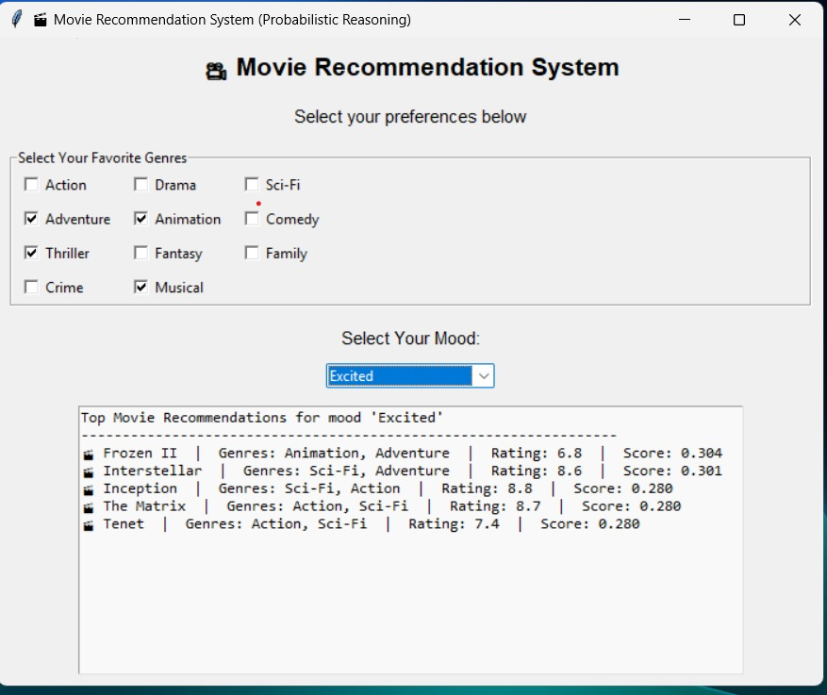

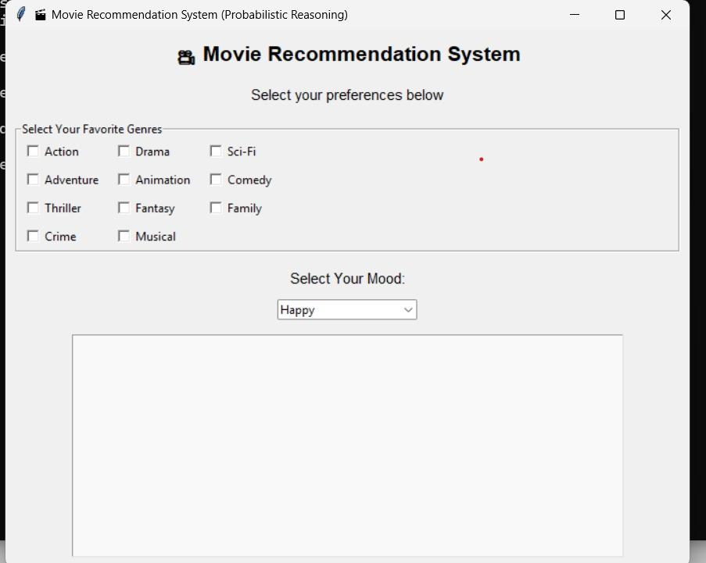

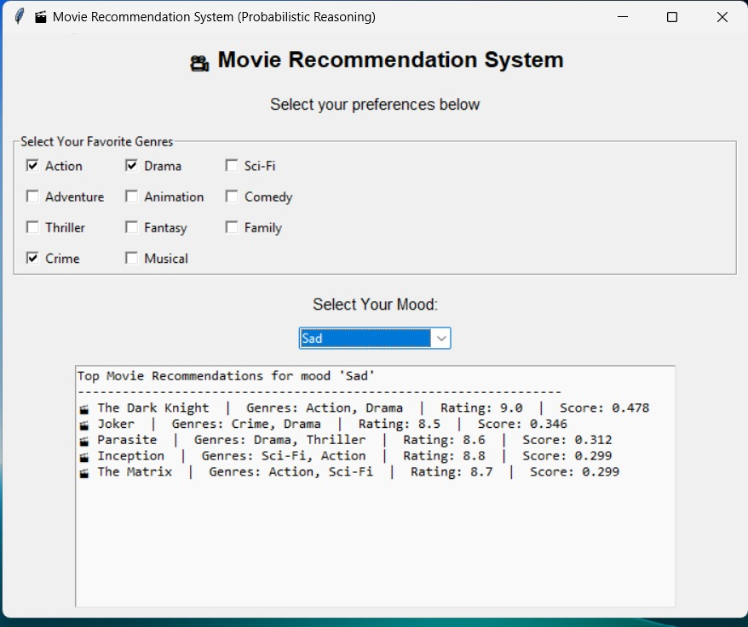

EXPLANATION
The developed Movie Recommendation System using Probabilistic Reasoning provides personalized movie suggestions by analyzing user preferences and mood.
The system’s interface allows users to select:
- Their favorite genres (e.g., Action, Drama, Comedy, etc.)
- Their current mood (e.g., Happy, Sad, Excited, etc.)
Once the user selects these inputs, the system applies probabilistic reasoning (using Bayesian probability scores) to compute the likelihood that a movie will match the user’s preferences and emotional state.
It then displays a ranked list of recommended movies along with details such as Genre, Rating, and Probability Score

RESULTS
- The probabilistic reasoning model successfully predicted suitable movie recommendations based on user moods and genres.
- The GUI-based system provided an interactive and user-friendly interface for testing various input combinations.
- The results validated that Bayesian probability-based reasoning effectively handled uncertainty in user mood and preferences.
- Movies with higher probability scores were shown to better align with user expectations, proving the model’s capability to prioritize relevant recommendations.
- The system achieved accurate and logical recommendations, improving personalization and decision support for users

FUTURE ENHANCEMENT
- To further enhance the performance and scope of the project, the following improvements can be implemented:
Enhancement |  | Description
- Integration with Real Movie Databases |  | Connect with APIs such as TMDB or IMDB to fetch real-time movie details, posters, and ratings.
- Hybrid Recommendation Model |  | Combine probabilistic reasoning with collaborative filtering for improved accuracy.
- Emotion Detection from Text/Voice |  | Automatically detect the user’s mood using sentiment analysis or speech emotion recognition.
- Deep Learning Models |  | Use neural networks for learning complex relationships between user preferences and movie attributes.
- Web or Mobile Application |  | Deploy the system on web or Android platforms for accessibility and better user experience.
- Continuous Learning | Enable feedback loops to adjust recommendations based on user acceptance or rejection

Git Hub Link of the project and report
https://github.com/deralachethankumar/AI-mini-project/blob/c74cad8410789dc3a90264d38bbe9d56aed6f231/AI%20mini%20project%20chethan.py

REFERENCES
- Russell, S., & Norvig, P. (2021). Artificial Intelligence: A Modern Approach (4th Edition). Pearson Education.
→ This book explains probabilistic reasoning, Bayesian networks, and inference techniques applied in AI systems such as recommendation engines.
- Ricci, F., Rokach, L., & Shapira, B. (2015). Recommender Systems Handbook (2nd Edition). Springer.
→ A comprehensive reference on various recommendation approaches including collaborative, content-based, and probabilistic reasoning models.
- Murphy, K. P. (2012). Machine Learning: A Probabilistic Perspective. MIT Press.
→ Provides mathematical foundations of probabilistic models used for recommendation and prediction systems.
- Aggarwal, C. C. (2016). Recommender Systems: The Textbook. Springer.
→ Explains real-world recommendation techniques, evaluation metrics, and probabilistic approaches such as Bayesian inference.
- Koren, Y., Bell, R., & Volinsky, C. (2009). Matrix Factorization Techniques for Recommender Systems. IEEE Computer, 42(8), 30–37.
→ A standard research paper discussing probabilistic matrix factorization and collaborative filtering used in movie recommendation engines

