DotTalk++ / x64base
Manual Preview V1
A reader-facing assembled manual with diagrams, anchor map, maturity model, command-reference seed, and generated topical index.
Status | Inspection draft assembled from current repository manual sources.
Audience | Human developer, AI development agent, documentation maintainer, and early reader.
Source root | D:\code\ccode\x64base
Generated from | Reader manual, anchor map, diagram registry, maturity model, command usage harvest.
Design preset | compact_reference_guide.

Table of Contents
Right-click and update field in Word to refresh page numbers.

Illustrations
The figures in this preview are anchored manual assets. They clarify current structure but do not increase a section's proof state; proof still comes from source contracts, catalogs, and runtime transcripts.
Figure | Purpose | Anchor | Asset ID
Figure 1 | Four-layer working model. | ANCHOR-X64BASE-README | DIAG-ARCH-LAYERS
Figure 2 | Evidence-to-manual promotion path. | ANCHOR-MANUAL-DIAGRAMS | DIAG-EVIDENCE-PIPELINE
Figure 3 | Trinity header dependency and roles. | ANCHOR-X64-TRINITY | DIAG-TRINITY-HEADERS
Figure 4 | In-file X64M self-description. | ANCHOR-X64-VECTOR-NAMES | DIAG-X64-SELF-DESCRIBING
Figure 5 | Source usage contracts into guide entries. | ANCHOR-COMMAND-USAGE-HARVEST | DIAG-COMMAND-HARVEST
Figure 6 | Current area and current record model. | ANCHOR-CURSOR-WORKAREAS | DIAG-WORKAREAS-CURSOR
Figure 7 | Lock mutate unlock lifecycle. | ANCHOR-LOCKING | DIAG-LOCKING-LIFECYCLE
Figure 8 | Buffered mutation closure. | ANCHOR-TABLE-BUFFER; ANCHOR-COMMIT-ROLLBACK | DIAG-BUFFER-COMMIT-ROLLBACK
Figure 9 | Logical order versus backend storage. | ANCHOR-X64-INDEXING | DIAG-INDEX-ORDER
Figure 10 | DBF memo object ID to DTX payload. | ANCHOR-X64-MEMOS | DIAG-MEMO-DTX
Figure 11 | Full manual family shape. | ANCHOR-MANUAL-DIAGRAMS | DIAG-MANUAL-FAMILY
Figure 12 | M0-M6 manual maturity ladder. | ANCHOR-MANUAL-DIAGRAMS | DIAG-MATURITY-MODEL
Figure 13 | Run capture readback promote loop. | ANCHOR-RUNTIME-PROOFS | DIAG-PROOF-LOOP

Manual Body

DotTalk++ Reader Manual v1
Status: reader-facing manual
Audience: new DotTalk++ user, human developer, AI development agent
Source root: D:\code\ccode
Promoted from curated harvest material and runtime proofs on 2026-06-28
This manual is the first clean reader-facing pass over the current DotTalk++ documentation harvest. It is intentionally smaller than the harvest bundle. The goal is to explain what to run, what each workflow means, and what evidence a developer or AI agent should collect before changing runtime behavior.
The raw source pool remains available in:
- DEVELOPER_MANUAL_HARVEST_INSPECTION_V1.md
- DEVELOPER_MANUAL_HARVEST_QUALITY_SCAN_V1.md
- DEVELOPER_MANUAL_HARVEST_MANIFEST_V1.csv
- DOTTALKPP_DOTSCRIPT_AND_DEV_HANDOFF_V1.md
The manual generation anchor map is:
- DOTTALKPP_MANUAL_ANCHOR_MAP_V1.md
- docs/manuals/anchors/manual_generation_anchor_map_v1.csv
- docs/manuals/assets/diagrams/MANUAL_DIAGRAM_ASSET_REGISTRY_V1.md
- docs/manuals/assets/diagrams/manual_diagram_asset_registry_v1.csv
The prose guide for turning anchors into readable sections is:
- DOTTALKPP_MANUAL_PROSE_GUIDE_V1.md
- DOTTALKPP_PROFESSIONAL_MANUAL_BLUEPRINT_V1.md
- DOTTALKPP_MANUAL_MATURITY_MODEL_V1.md

1. What DotTalk++ Is
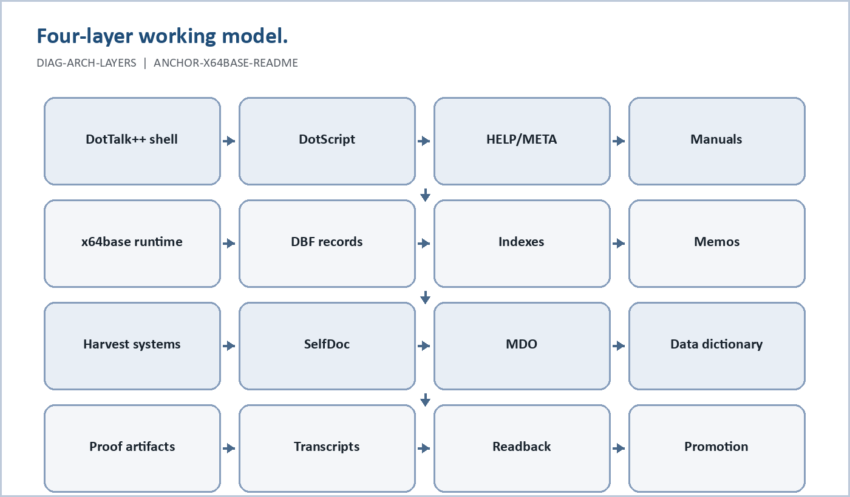
Figure 1. Four-layer working model. (DIAG-ARCH-LAYERS, ANCHOR-X64BASE-README).
DotTalk++ / x64base is a working educational xBase / FoxPro-inspired database runtime, command shell, and architecture lab built in modern C++.
It is not presented as a finished commercial database product. It is a working educational and research system: part DBF database runtime, part command shell, part historical teaching environment, part metadata experiment, and part architecture laboratory.
The project draws inspiration from the classic xBase lineage:
dBase - early interactive database shell
Clipper - compiled xBase systems
FoxPro - relational navigation and index-driven querying
DotTalk++ preserves useful ideas from those systems while extending them with modern C++ structure, help catalogs, relation traversal, tuple projection, scripting, automation, metadata tables, validation tools, browsers, and simple text user interface surfaces.
It is not a direct port of an older product. It is a broader reimplementation and expansion.
DotTalk++ sits between FoxPro and Clipper:
interactive and stateful like FoxPro
extensible and compilable like Clipper
The project is intended to serve as:
- a working DBF database runtime
- a relational exploration environment
- a scripting and automation shell
- a teaching system for database concepts
- an architecture lab for metadata, HELP, validation, and browser design
A major design goal is for DotTalk++ to become increasingly self-documenting. Commands, functions, arguments, aliases, subcommands, metadata tables, HELP output, validation reports, scripts, browsers, and TUI surfaces are being designed to reinforce each other instead of living as separate hand-written descriptions.
Some subsystems are runtime-proven. Other subsystems are canaries, source-supported features, or integration work. The repository is intentionally honest about that distinction. The goal is to build finished educational tools, database utilities, and applications from proven layers, not to pretend every subsystem is complete at the same time.

History
DotTalk++ traces back to 1993, when Derald Grimwood wrote a small ANSI C database program as a practical and experimental system. That early program included fixed-length record storage and a simple in-memory B-tree.
In 2025, the earlier work was revived and used as the conceptual basis for a modern 64-bit rebuild in C++. The result became DotTalk++: not a direct port, but a broader reimplementation and expansion.
The project honors the xBase tradition while extending it into a modern, teachable, experiment-friendly database runtime.
Part of the educational value is historical. DotTalk++ shows students a transitional period in computing: the 8-bit and early-16-bit personal-computer era of the 8088, 8086, DOS, text UIs, command systems, DBF files, and direct file-based data work.
This is not nostalgia for its own sake. It is a way to make the layers visible.

Educational Purpose
DotTalk++ is built for learning as much as for execution. The system is intended to help students see concepts that are usually hidden:
table files
records
fields
field types
work areas
indexes
index tags
relations
tuple traversal
schemas
metadata
HELP generation
runtime validation
simple text interfaces
command discovery
Instead of presenting the database as a black box, DotTalk++ exposes the moving parts. A student can open a table, inspect its structure, browse records, change order, see relation trees, follow child records, inspect metadata tables, use HELP, run validation checks, and compare command documentation against runtime reflection.
The goal is not to teach old software as a museum piece. The goal is to use an understandable historical model to explain modern ideas:
classic DBF tables -> structured storage
records and fields -> physical data modeling
indexes -> access paths
work areas -> runtime context
relations -> graph navigation
tuple grids -> joined views
metadata tables -> self-description
HELP and CMDHELPCHK -> documentation as executable contract
simple TUI menus -> command discovery and reinforcement
scripts -> repeatable workflows

Design Philosophy
DotTalk++ is built around a few practical beliefs:
- Preserve the engineering behavior of FoxPro/xBase where it still makes sense.
- Avoid copying branding or unnecessary legacy constraints.
- Separate engine, interface, metadata, HELP, validation, and storage concerns.
- Keep the command surface understandable.
- Let runtime behavior prove architecture.
- Teach by exposing records, fields, indexes, relations, work areas, metadata, HELP, and validation.
- Use the command surface as a learning tool, not just an operator interface.
- Treat the simple TUI as reinforcement for command discovery and historical context.
- Design toward a self-documenting runtime: commands, functions, metadata, HELP, reports, browsers, and validators should agree.
A useful project rule:
Source defines.
Runtime proves.
HELP explains.
Metadata organizes.
CMDHELPCHK validates.
SelfDoc preserves provenance.
DotScript executes reviewed procedures.
Manualgen and maintenance packages preserve development intent.
The README form of the same rule is:
Conventions suggest.
Registration declares.
Metadata records.
Runtime proves.
Validators enforce.
DotTalk++ is intentionally stateful and interactive. It exposes important runtime concepts directly:
current work area
current record pointer
active order/index
active filter
relation graph
buffering state
workspace state
The goal is to make database behavior visible during live operation rather than hiding it behind abstraction.

Working Model
DotTalk++ can be understood as four cooperating layers:
1. Command Layer
interactive commands, scripts, command discovery, and automation
2. Data Layer
tables, records, fields, work areas, indexes, and storage behavior
3. Logic Layer
expressions, predicates, functions, validation, and control flow
4. Projection Layer
LIST, SMARTLIST, TUPLE, REL ENUM, ERSATZ, SMARTBROWSE, SIMPLEBROWSE, and other browsers
This model separates:
what the user types
what the data engine stores
how logic is evaluated
how results are projected back to the screen
The important architectural parts are:
- x64base: storage/runtime foundation, including DBF and index work.
- DotTalk++ shell: command surface, work areas, table commands, HELP, scripts, and runtime validation.
- DotScript: repeatable script/proof layer for running command sequences.
- Schema and data dictionary files: contracts for tables, indexes, imports, and generated reports.
- SelfDoc and manualgen: provenance, documentation, and maintenance workflow.
- LabTalk: optional educational overlay and case catalog.
Keep these boundaries clear. LabTalk and story/case material should not become a dependency for the professional runtime. Manualgen and maintenance internals should not be presented as ordinary user commands.

Current Status Snapshot
The x64base README describes the project as a working beta under active development. The current manual should preserve that honesty:
| Component | Manual stance |
|---|---|
| Engine | Working beta. |
| Indexing | INX/CNX/CDX/LMDB are active; promoted reader claims require transcripts. |
| Memo system | Active with canaries; large-object and repair/compaction claims need proof. |
| CLI and DotScript | Active and usable. |
| Tuple, relations, and browsers | Active; selected relation and browser paths are runtime-proven in the README development checkpoint. |
| HELP and metadata | Active; reflection-backed HELP exists and SYS* congruence validation is a next-step target. |
| DDL | Active / partial. |
| Python binding | Active with read-only smoke coverage. |
| Simple TUI | Active / experimental; discovery and teaching layer, not the canonical runtime surface. |
Manual rule: use this status snapshot as orientation, not as a substitute for proof. A feature becomes a reader workflow only when the manual has an anchor and a current transcript or an explicit maturity status.

2. The Trinity Headers
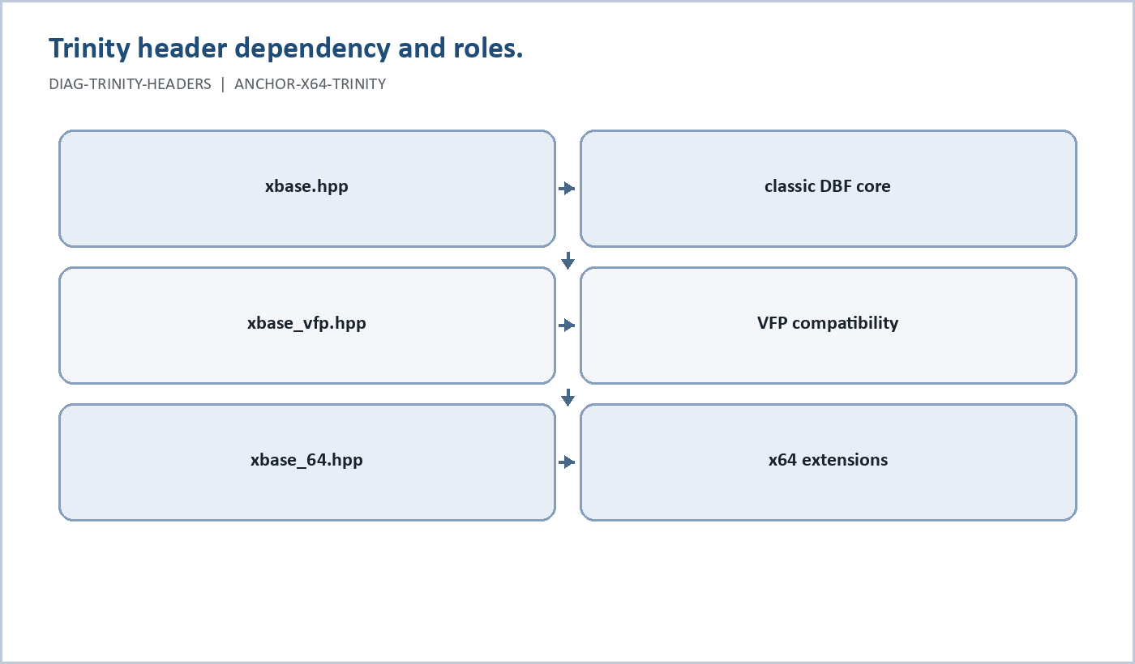
Figure 2. Trinity header dependency and roles. (DIAG-TRINITY-HEADERS, ANCHOR-X64-TRINITY).
When this project says "the trinity headers," it means the three main xBase data-structure headers:
include/xbase.hpp
include/xbase_vfp.hpp
include/xbase_64.hpp
They are the "three in one" data-structure spine for the runtime.
| Header | Role | Reader meaning |
|---|---|---|
| xbase.hpp | Core xBase engine types, constants, DbArea/engine contracts, runtime area kind, capabilities, memo/index hooks. | The neutral runtime foundation. |
| xbase_vfp.hpp | FoxPro / Visual FoxPro descriptor bridge, DBF level/flavor detection, VFP field extras, classic/VFP compatibility helpers. | The compatibility layer from classic DBF/FoxPro/VFP into DotTalk++. |
| xbase_64.hpp | x64 dialect expansion layer, x64 version byte, large header extension, X64 metadata blocks, fallback descriptor policy, name resolution. | The x64base extension layer that carries modern 64-bit and metadata-aware structure. |
The dependency direction matters:
xbase.hpp
-> xbase_vfp.hpp
-> xbase_64.hpp
xbase.hpp stays neutral. xbase_vfp.hpp adds classic/FoxPro/VFP interpretation. xbase_64.hpp owns x64 extension structures, vector metadata, fallback descriptor policy, and authoritative name handling.
This is separate from, but connected to, the reader-facing data model:
DBF/XDBF table storage
CNX/CDX/INX order and index containers
schema, HELP, and metadata contracts
The headers define the data structure spine. The reader-facing model explains how users experience that spine through tables, indexes/orders, schemas, HELP, and metadata.

3. xBase Lineage and Compatibility
DotTalk++ should be introduced as an xBase/FoxPro-inspired runtime, not as a blind clone. Its vocabulary deliberately overlaps with the world of dBASE, Clipper, FoxPro, and Visual FoxPro: tables, work areas, commands, record navigation, USE, LIST, APPEND, REPLACE, SEEK, SET ORDER, and index tags.
Reader-facing lineage:
| Era/family | Manual stance |
|---|---|
| MS-DOS-era dBASE/xBase | Historical root for DBF tables, command navigation, work areas, and visible record operations. |
| Clipper and DOS xBase applications | Useful lineage for compiled business workflows and direct command/data thinking. |
| FoxPro and Visual FoxPro | Strongest vocabulary bridge for commands, indexes, tags, work areas, browse/list behavior, and business database workflows. |
| Microsoft data pipeline era | Access, Excel, ODBC, SQL Server, and VFP are useful context for why xBase mattered in business data work. |
| DotTalk++ / x64base | Modern C++ continuation: visible xBase-style operation plus schema, metadata, HELP evidence, DotScript, and x64-oriented storage/index work. |
Compatibility rule: use lineage to explain vocabulary, but do not claim a specific dBASE/FoxPro/VFP behavior is supported unless the current runtime proves it. In the final manual, every compatibility claim should be marked as one of:
- supported and transcript-proven
- supported by current HELP/source contract
- lineage/background only
- future or experimental
Current classification for this manual:
| Claim area | Status | Evidence |
|---|---|---|
| DBF-style tables, fields, records, APPEND, REPLACE, LIST, STRUCT | Supported and transcript-proven | x64 walkthrough v2 transcript. |
| CREATE X64 v64 table creation | Supported and transcript-proven | x64 walkthrough v2 transcript. |
| CDX tag order on v64 tables with LMDB backing | Supported and transcript-proven | CDX order v2 transcript. |
| SET INDEX TO <cdx> and SET ORDER TO TAG <tag> | Supported and transcript-proven for the CDX/LMDB v64 path | CDX order v2 transcript. |
| DDL CREATE DBF ... FROM schema.json | Supported and transcript-proven for the tested schema path | schema DDL v2 transcript. |
| LOCATE, GO TOP, GO BOTTOM, SKIP, RECNO, DISPLAY, SMARTLIST | Supported and transcript-proven for the tested forms | navigation/import/export probe transcript. |
| CSV EXPORT and matching-table IMPORT | Supported and transcript-proven | export probe and import probe v2 transcripts. |
| BROWSE PAGE ... QUIET and BROWSE ALL QUIET | Supported and transcript-proven for non-interactive listing | browse probe v1 transcript. |
| CNX tag order on v32/schema-created tables | Supported and transcript-proven | CNX order v1 transcript. |
| dBASE, Clipper, FoxPro, Visual FoxPro behavior beyond the tested command forms | Lineage/background only unless separately proven | case catalog and source harvest. |
| DO X64 as setup/profile ceremony | Existing script vocabulary, but retired from the reader quickstart until an X64.dts profile is provided or a command form is proven | x64 walkthrough v1 transcript. |

4. Build and Run
Current proof-oriented runs should use the built executable:
& D:\code\ccode\build\src\Release\dottalkpp.exe
Verification status: transcript-proven in the proof runs in docs/manuals/developer/proofs; the current Release executable path was used for those runs.
From the shell, use normal DotTalk++ commands interactively, or run repeatable command sequences through DotScript.

5. Shell Basics
The shell is the live command surface. Use it to open tables, inspect structures, add or edit records, build indexes, navigate records, and run scripts.
Useful readback commands after table or schema work include:
STRUCT
FIELDS
LIST
TUPLE
STATUS
Use a readback command after every creation or mutation example. A command that creates a table is not fully proven until the table is opened and inspected.

6. DotScript
DotScript is the repeatable procedure layer for DotTalk++. Use it when a workflow needs to be replayed, reviewed, or captured as proof.
Use DotScript for:
- reproducible runtime procedures
- smoke tests
- schema and table creation candidates
- import/export experiments
- guarded maintenance execution
- command transcript generation
- repeatable proof capture
Run scripts from inside the DotTalk++ shell:
DOTSCRIPT <file.dts>
DOTSCRIPT <file.dts> OUT <transcript-file>
DOTSCRIPT TRACE <file.dts> OUT <transcript-file>
Use DOTSCRIPT ... OUT ... when the result is meant to be reviewed later. The transcript is the evidence artifact.
DotScript comments are skipped when they begin with one of these prefixes after trimming:
*
//
&&
;
Script resolution tries the typed path, then .dts, then scripts/, then tests/. Nesting is intentionally limited to a main script plus one subscript.

7. The x64 Workflow
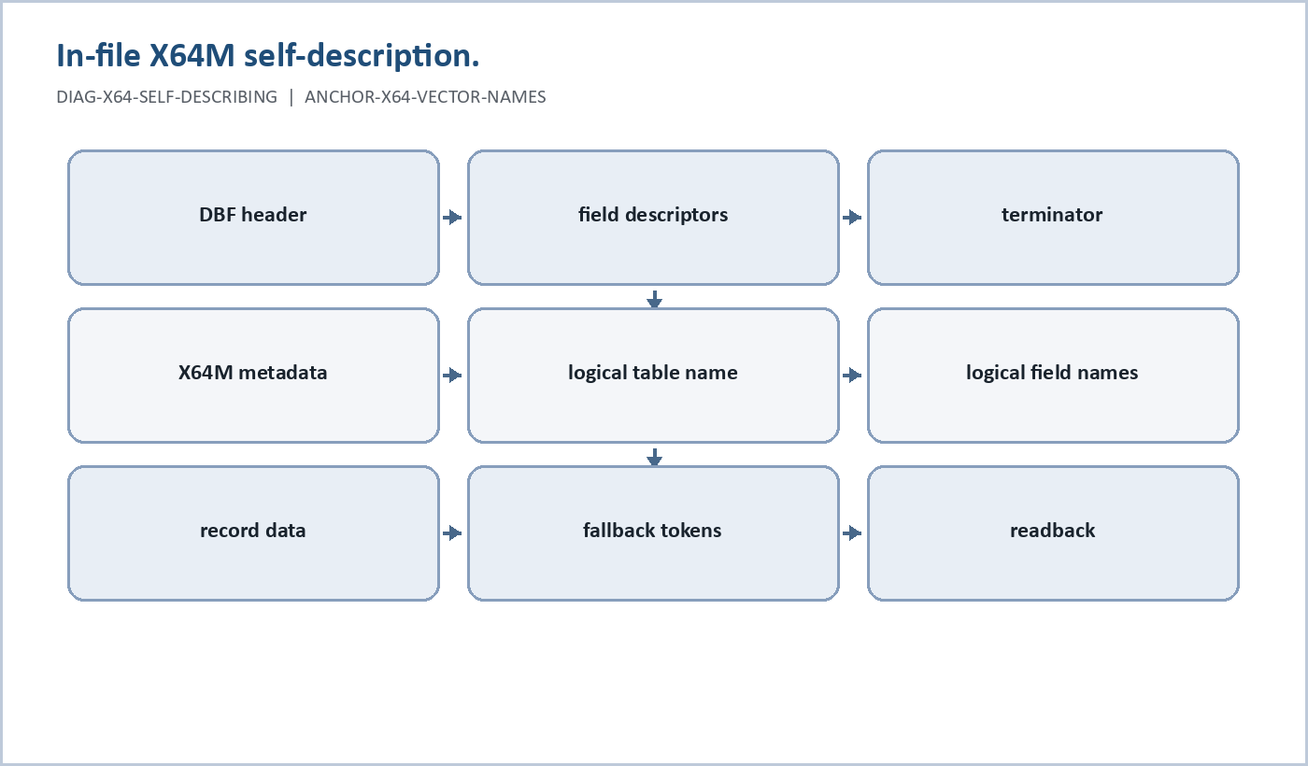
Figure 3. In-file X64M self-description. (DIAG-X64-SELF-DESCRIBING, ANCHOR-X64-VECTOR-NAMES).
Existing x64 scripts commonly begin with:
DO X64
Treat DO X64 as legacy/profile script vocabulary, not as the proven reader quickstart command. Do not remove it from existing x64 scripts as noise, but do not teach it as required for new readers until an X64.dts profile script or native command behavior is proven.
Current Release proof note: in the 2026-06-28 proof run, DO X64 was interpreted through script resolution and reported script not found when no X64.dts profile script existed in the proof path. CREATE X64 itself still created and opened v64 DBFs successfully. For now, document DO X64 as legacy/profile ceremony used by existing scripts, and document CREATE X64 as the proven table-creation command.
The reader-facing proven pattern is:
CREATE X64 <table> (<field> <type>, <field> <type>, ...)
STRUCT
Concrete example:
CREATE X64 DEV_STUDENTS (SID N(6,0), LNAME C(20), FNAME C(15), GPA N(4,2), ACTIVE L)
STRUCT
APPEND
REPLACE LNAME WITH "MARTIN"
REPLACE FNAME WITH "ADA"
REPLACE GPA WITH 3.75
REPLACE ACTIVE WITH .T.
LIST
Verification status: transcript-proven with docs/manuals/developer/proofs/reader_manual_x64_walkthrough_v2.transcript.txt.
Observed behavior from the proof:
- CREATE X64 RM_X64_V2 (...) created D:\code\ccode\build\src\Release\dbf\RM_X64_V2.dbf.
- The table opened immediately after creation.
- STRUCT showed the expected five fields.
- APPEND created an auto-numbered SID value.
- Character, numeric, and logical REPLACE commands ran.
- LIST and STATUS proved readback.
Do not use the older REPLACE SID WITH 1001 pattern in the reader manual without another transcript. In the v1 proof, numeric SID replacement failed while the append path auto-assigned SID values.
Important CREATE X64 behavior:
- CREATE X64 <name> (...) writes a DBF through the configured DBF path slot.
- It closes the current area before creating the table.
- It opens the new table after successful creation.
- It clears active order state.
- Memo fields attempt memo attach after open.
- Long or colliding field names may receive descriptor-safe fallback tokens while retaining authoritative logical names where supported.

Theoretical Limits of x64base
x64base has two kinds of limits:
- Format limits: what the x64 file structures can theoretically describe.
- Runtime limits: what the current DbArea, loader, command surface, and proofed workflows can actually use today.
The x64 header extension in include/xbase_64.hpp is a 64-byte structure with 64-bit fields:
record_count uint64
data_start_64 uint64
record_size_64 uint64
autoq_next uint64
That means the theoretical file-format direction is not the classic DBF ceiling. The design is aimed at very large record counts, large data offsets, large row geometry, and 64-bit autoincrement/sequence state.
Current runtime caveat: the loader validates the x64 extension, then mirrors data_start_64 and record_size_64 into current DbArea fields that are still constrained by compatible 16-bit ranges. DbArea also exposes 64-bit record number/count state, but legacy APIs clamp the visible 32-bit versions. So the theoretical x64base ceiling is 64-bit, while the current reader-proven runtime should be described as a compatibility-stage x64 implementation.
Reader rule: do not claim "unlimited" tables. Say x64base is designed around 64-bit record counts, offsets, record sizes, and sequence values, but current proven behavior is bounded by the active loader/runtime path.

x64 Indexing Limits
x64 indexing has the same split.
For v64 tables, the proven reader workflow is:
CDX container
LMDB backing environment
SET INDEX TO <table>.cdx
SET ORDER TO TAG <tag>
The logical xBase concept is still simple: records have physical order, and an index/tag supplies logical order. The x64 implementation can back that logical order with a CDX container and LMDB environment.
The theoretical limit of x64 indexing is therefore not just "how many records fit in an old .idx file." The direction is:
- many records addressed through 64-bit table state
- multi-tag logical containers
- backend index environments capable of scaling beyond flat legacy index assumptions
- physical backend hidden behind SET INDEX and SET ORDER
Current runtime caveat: the reader manual has proven CDX/LMDB ordering for a small v64 table and CNX ordering for a v32/schema-created table. It has not proven billion-row traversal, huge LMDB maps, multi-gigabyte index rebuilds, or all index families at x64 scale.

x64 Memo Limits
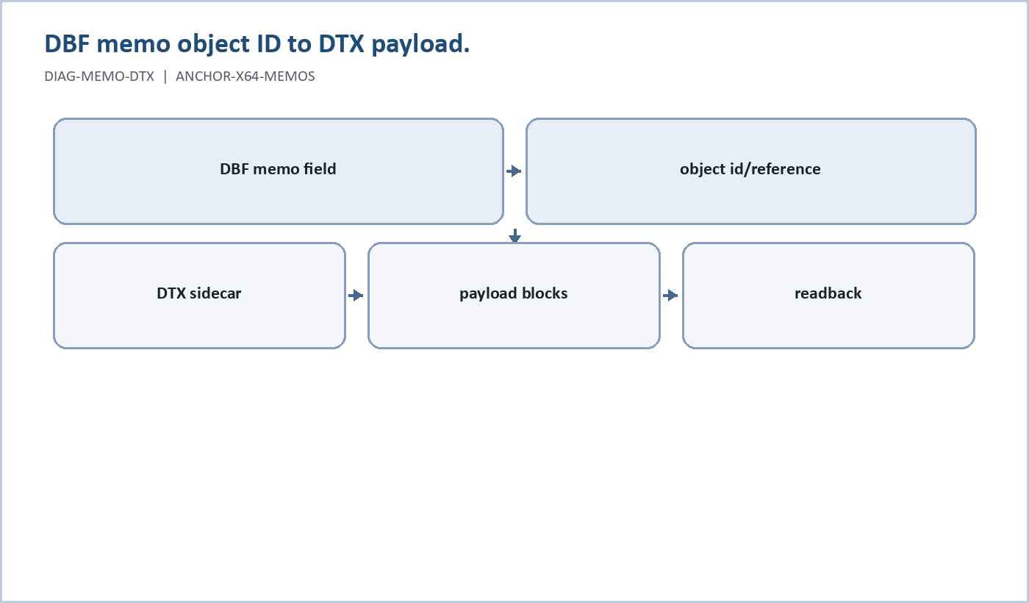
Figure 4. DBF memo object ID to DTX payload. (DIAG-MEMO-DTX, ANCHOR-X64-MEMOS).
x64 memos move away from old in-row memo text slots. include/xbase.hpp defines:
LEGACY_MEMO_FIELD_LEN = 10
X64_MEMO_FIELD_LEN = 8
The x64 memo slot is an 8-byte uint64 object-id reference. The live memo backend is the DTX sidecar store. include/memo/dtx_format.hpp defines a DTX1 file with:
next_object_id uint64
object_count_live uint64
object_count_dead uint64
first_object_offset uint64
append_offset uint64
payload_bytes uint64
logical_bytes uint64
previous_version_of uint64
The theoretical direction is large memo object IDs, large append offsets, large payload sizes, tombstones, version chains, and future roots for index/free-list/metadata structures.
Current runtime caveat: the DTX backend is text-first, append-mostly, and keeps a live object map in memory after scan/open. The header comments explicitly defer free-space reuse and advanced repair. So x64 memos are architected for large-object sidecar storage, but the current reader manual should not claim mature garbage collection, compaction, free-list reuse, or huge-object operational proof until those paths are tested.

Vectored Table Names and Field Names
Classic DBF/VFP descriptors have short compatibility names. In this codebase, descriptor field names remain 10-byte fallback tokens. x64base adds an optional metadata vector so the authoritative names can be longer and cleaner than the fallback descriptor tokens.
This feature exists because the project outgrew MS-DOS-era naming. Classic xBase systems were built around strict table and field-name limits, and the DBF descriptor still carries a short field-name slot for compatibility. Visual FoxPro opened parts of the model up, and DotTalk++ currently uses 128-byte x64 logical table and field names as its default policy. That 128-byte policy is not the theory of the format; it is the current compile-time contract.
SelfDoc and the Master Doc Organizer (MDO) made the need obvious. Documentation, provenance, command identity, source harvesting, and generated catalog tables naturally produce names such as COMMAND_REFERENCE_ASSEMBLY_ALIAS_STATUS or MANUAL_GENERATION_ANCHOR_MAP_ENTRY. Those names should explain themselves to the runtime and to future readers. Truncating them to 10-byte DBF tokens would destroy the meaning the system is trying to preserve.
In include/xbase_64.hpp:
X64_TABLE_NAME_LENGTH = 128
X64_FIELD_NAME_LENGTH = 128
X64_TABLE_NAME_LENGTH_MAX = 128
X64_FIELD_NAME_LENGTH_MAX = 128
X64_FALLBACK_FIELD_TOKEN_BYTES = 10
Those values are C++ constants. A build can change the x64 vector-name policy by changing the compile-time constants and rebuilding, but that is a storage-contract change, not a cosmetic setting. Any longer-name build must also audit metadata serialization, loaders, command syntax, HELP/META rows, data dictionary tables, import/export, and proof scripts so the system agrees about the new maximum.
The optional metadata block is named X64M. It contains:
- table-name offset and length
- field-entry offset and count
- string-pool offset and length
- per-field metadata entries with field index, name offset, name length, flags, and field length
That is what "vectored table names and field names" means in this system: the short DBF/VFP descriptor token remains as compatibility fallback, while the x64 metadata vector carries the authoritative logical table name and field names.
The x64 DBF should therefore be self-describing. When DBF64_FLAG_HAS_META_BLOCK is set, the file carries the name vector needed to resolve its logical table and field names. In the current source, X64M is stored immediately after the descriptor terminator and before record data, with data_start_64 and compatible header size pointing after that metadata. X64MetaLocator is reserved for later locator geometry. That means the current name-vector contract is header-resident metadata, not an external sidecar. Sidecar metadata could become a future extension, but it should be documented separately from the current in-file X64M block and from the DTX memo sidecar.
Example concept:
Descriptor fallback token: CUSTOMER_O
Vector field name: CUSTOMER_ORDER_HISTORY_STATUS
The runtime should resolve the vector name when DBF64_FLAG_HAS_META_BLOCK is present and the metadata is valid. If the metadata is missing, invalid, or the name is too long for the current contract, the system falls back to the descriptor token.
Reader rule: the vector name is the authoritative x64 name when present and valid. The 10-byte descriptor token is a compatibility fallback, not the real semantic name.
Developer rule: if the vector-name limit is raised beyond 128, the manual, data dictionary, HELP/META harvest, and proof suite must all be regenerated under the same compiled contract. A DBF created under a longer-name build should carry enough X64M metadata for the runtime to explain the file back to itself.

Harvest Rule for Mentioned Concepts
This material should be harvested now because it was explicitly named and because the trinity headers already contain the contracts. It should also be harvested later by the systematic SelfDoc/manualgen path.
Immediate harvest captures the doctrine:
- x64base theoretical limits
- x64 indexing direction
- x64 memo direction
- vectored table and field names
- compile-time x64 vector-name policy
- self-describing x64 name metadata
- current runtime caveats
Systematic harvest should later attach source-level and runtime proof:
- source extraction from include/xbase_64.hpp, include/xbase.hpp, and include/memo/dtx_format.hpp
- proof scripts for 128-byte table/field names
- proof scripts for a deliberately longer compile-time vector-name build if the constants are changed
- proof scripts proving that a vectored DBF can explain its logical names from X64M
- proof scripts for x64 memo object IDs
- proof scripts for larger CDX/LMDB index scale
- reader-safe language once those paths are proven

8. Creating DBFs
There are two main creation paths:
- Direct x64 creation with CREATE X64.
- Schema-driven creation with DDL CREATE DBF.
Use direct creation when the table is small, local, and part of a runtime proof. Use schema-driven creation when the table contract must be explicit, reusable, or connected to data dictionary work.
Schema-driven pattern:
DDL CREATE DBF <out.dbf> FROM <schema.json>
DDL CREATE DBF <out.dbf> FROM <schema.json> OVERWRITE
DDL CREATE DBF <out.dbf> FROM <schema.json> SEED BLANK <n>
DDL CREATE DBF <out.dbf> FROM <schema.json> EMIT SIDECARS
Path rules:
- Relative schema inputs resolve under the SCHEMAS path first, then the current working directory.
- Relative DBF outputs resolve under the TMP path by default.
- Existing DBF output is refused unless OVERWRITE is supplied.
- SEED CSV is recognized in the command surface but is not implemented in the current drop-in.
- EMIT SIDECARS writes companion schema/load/index metadata files.
Minimal schema shape:
{
"version": "1.0",
"name": "students",
"encoding": "UTF-8",
"date_policy": "ISO",
"null_policy": "EMPTY_AS_EMPTY",
"logical_policy": "TF",
"fields": [
{ "name": "SID", "type": "N", "length": 9, "decimals": 0, "required": true },
{ "name": "LNAME", "type": "C", "length": 20, "required": true, "trim": "right" },
{ "name": "FNAME", "type": "C", "length": 15, "required": true, "trim": "right" },
{ "name": "DOB", "type": "D", "length": 8, "zero_date": "ALLOW" },
{ "name": "ACTIVE", "type": "L" }
],
"indexes": [
{ "name": "SID_PK", "engine": "CNX", "order": ["SID ASC"], "unique": true, "nullable": "DISALLOW" },
{ "name": "NAME1", "engine": "CNX", "order": ["LNAME ASC", "FNAME ASC"], "collation": "nocase", "trim": "right" }
]
}
The active schema contract is src\cli\schema_json_v1.schema.json. The DDL CREATE DBF schema path supports field types C, N, D, L, and M. Do not assume every direct CREATE type is valid in the JSON schema path.
Verification status: transcript-proven with docs/manuals/developer/proofs/reader_manual_schema_ddl_v2.transcript.txt.
Observed DDL proof:
- DDL CREATE DBF RM_SCHEMA_V2.dbf FROM docs\manuals\developer\proofs\reader_manual_schema_v1.json OVERWRITE SEED BLANK 2 EMIT SIDECARS succeeded.
- The relative DBF output resolved to D:\code\ccode\build\src\Release\tmp\RM_SCHEMA_V2.dbf.
- Opening the TMP output path succeeded.
- STRUCT showed the five schema fields.
- LIST showed two seeded blank rows.
- STATUS reported DBF flavor v32 for the schema-created table.
Reader rule: after schema-driven creation, open the actual output path reported by DDL. A relative output name goes to the runtime TMP path, not the runtime DBF path.

9. Schema Rules

Figure 5. In-file X64M self-description. (DIAG-X64-SELF-DESCRIBING, ANCHOR-X64-VECTOR-NAMES).
Classify a schema before using it:
| Schema kind | Meaning | Handling |
|---|---|---|
| schema.json | Table field/index/relation contract for DDL/import work. | Candidate until runtime-created and read back. |
| .dtschema / .dtschemas | x64base workspace/session schema for areas and optional relations. | Do not confuse with SQL schemas. |
| JSON Schema | Validator/specification for another artifact. | Use for structural validation, not runtime proof by itself. |
| Data dictionary package schema | Contract for generated reports/import candidates. | Keep package-local until promoted. |
Rules for schema work:
- Keep candidate schemas separate from active schemas.
- Never overwrite active schemas without an explicit promotion package.
- If a schema has indexes, also define how those indexes are created or activated at runtime.
- If a schema has relations, capture workspace/relation proof separately from table creation proof.
- A schema that parses is not proven.
- A schema is proven only after runtime creation, open, structure readback, and at least one navigation/readback command.
- For DBF work, prove with STRUCT and at least one data readback command.
- For index work, prove physical order versus logical order.

10. Indexes, CNX, CDX, and SET ORDER
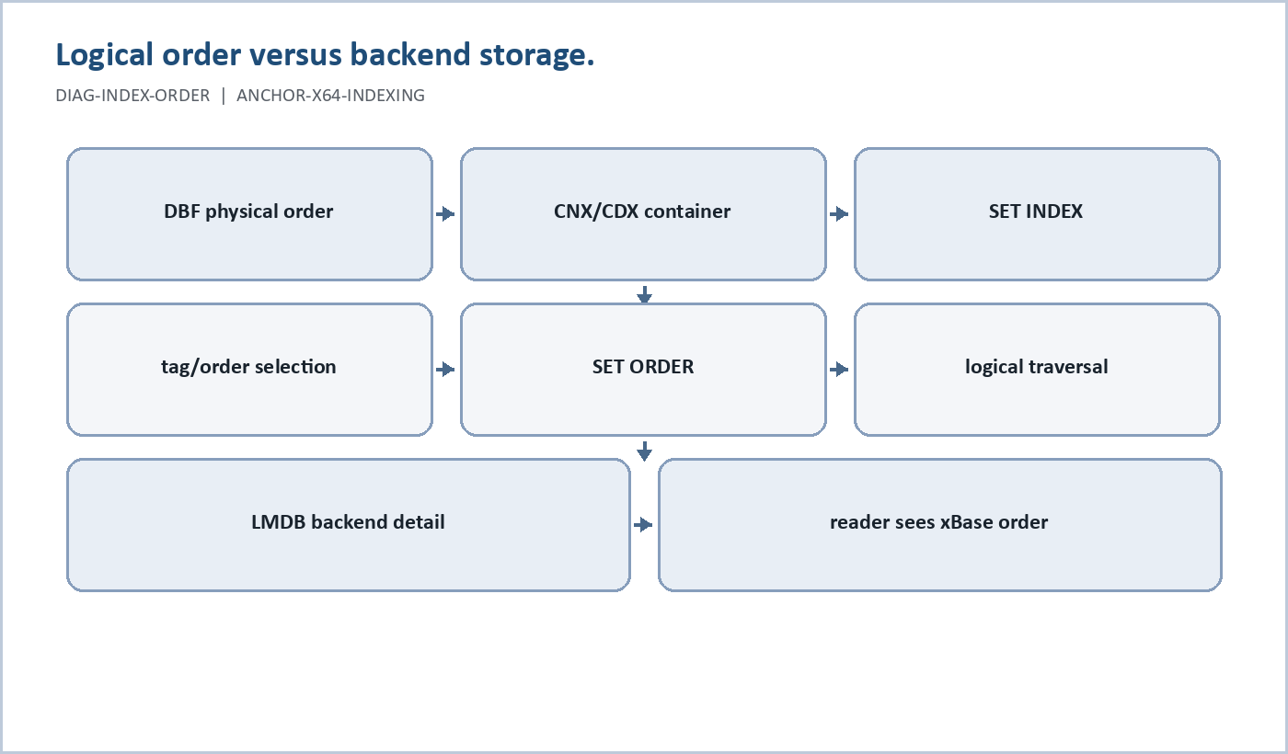
Figure 6. Logical order versus backend storage. (DIAG-INDEX-ORDER, ANCHOR-X64-INDEXING).
The direct index command builds an INX file from the current open table.
Pattern:
USE <table>
INDEX ON <field> TAG <name>
INDEX ON <field> TAG <name> DESC
INDEX ON <field> TAG <name> ASC 2INX
SET INDEX TO <name>.inx
Important rules:
- INDEX requires an open table.
- It reads records and writes an index file.
- It does not mutate table records.
- Deleted records are excluded.
- Default direction is ASC.
- Default output format is 2INX.
- TAG names an INX file target.
- Non-.inx extensions are refused.
- Field-number tokens are accepted by the parser, but field names are clearer in docs and proof.
Index examples should prove both the underlying record data and the indexed navigation order.

CNX, CDX, and LMDB Boundary
Keep the index terms distinct:
| Concept | Reader meaning |
|---|---|
| INX | Direct single index file path created by INDEX ON ... TAG ..., currently the simplest reader-facing index example. |
| CNX | DotTalk++ container concept for named tags and order metadata. Current tools include CNX CREATE, CNX INFO, CNX TAGS, CNX ADDTAG, CNX DROPTAG, CNX WALK, and CNX TRACE. |
| CDX | User-facing logical multi-tag index container concept. Current tools include CDX CREATE, CDX INFO, CDX TAGS, CDX ADDTAG, and CDX DROPTAG. |
| LMDB | Physical backend/index environment detail in some CDX paths. Do not expose it as the ordinary user concept unless the section is explicitly backend-facing. |
The reader model is:
DBF/XDBF stores records.
CNX/CDX/INX describe or provide logical order.
SET INDEX attaches the container.
SET ORDER selects the active traversal order or tag.
LMDB may back a CDX path, but it is not the ordinary teaching abstraction.

SET INDEX Versus SET ORDER
Use SET INDEX TO <container> to attach an index container. Use SET ORDER to choose the active logical traversal order.
Patterns:
SET INDEX TO students.cdx
SET ORDER TO TAG LNAME
SET ORDER TO 0
SET ORDER PHYSICAL
Key distinction:
INDEX creates an INX file from the current open table.
SET INDEX names or attaches the index container.
SET ORDER chooses the active logical traversal order.
Do not claim an index works until runtime output proves the order changed or a seek uses the expected access path. The important lesson is physical order versus logical order:
physical record order
logical order
active tag/order
current cursor
filtered or predicate view
projected tuple output
persisted table state
buffered or dirty state

Proven CDX Order Workflow
For v64 tables, the current proven order path is CDX plus LMDB backing store.
Transcript: docs/manuals/developer/proofs/reader_manual_order_cdx_v2.transcript.txt
Proof script: docs/manuals/developer/proofs/reader_manual_order_cdx_v2.dts
Pattern:
CREATE X64 RM_ORDER_V2 (SID N(6,0), LNAME C(20), FNAME C(15), GPA N(4,2))
APPEND
REPLACE LNAME WITH "ZEKE"
APPEND
REPLACE LNAME WITH "ADAMS"
APPEND
REPLACE LNAME WITH "MARTIN"
GO TOP
LIST
CDX CREATE
CDX ADDTAG LNAME
CDX TAGS
BUILDLMDB YES
SET INDEX TO RM_ORDER_V2.cdx
SET ORDER TO TAG LNAME
GO TOP
LIST
SEEK "MARTIN"
RECNO
DISPLAY
SET ORDER TO 0
GO TOP
LIST
Observed proof:
- Physical order listed ZEKE, ADAMS, MARTIN.
- CDX CREATE created RM_ORDER_V2.cdx under the runtime indexes path.
- CDX ADDTAG LNAME added the LNAME tag.
- BUILDLMDB YES rebuilt the LMDB backing store and reported done OK=1 tags rebuilt.
- SET INDEX TO RM_ORDER_V2.cdx attached the CDX container.
- SET ORDER TO TAG LNAME selected the LNAME tag.
- Ordered LIST returned ADAMS, MARTIN, ZEKE.
- SEEK "MARTIN" found the record at physical recno 3.
- SET ORDER TO 0 returned traversal to physical order.
Current caveat: the v1 proof showed that a v64 table refuses direct INX attachment with SET INDEX: v64 tables require CDX (LMDB-backed). Keep INX examples for legacy/v32 or explicitly marked index-file examples until v64 INX behavior is separately proven.

Proven CNX Order Workflow
For v32/schema-created tables, the current proven order path is CNX plus REBUILD.
Transcript: docs/manuals/developer/proofs/reader_manual_order_cnx_v1.transcript.txt
Proof script: docs/manuals/developer/proofs/reader_manual_order_cnx_v1.dts
Pattern:
DDL CREATE DBF RM_CNX_V1.dbf FROM docs\manuals\developer\proofs\reader_manual_schema_v1.json OVERWRITE EMIT SIDECARS
USE D:\code\ccode\build\src\Release\tmp\RM_CNX_V1.dbf
IMPORT docs\manuals\developer\proofs\reader_manual_nav_export_v1.csv
GO TOP
LIST
CNX CREATE
CNX ADDTAG LNAME
CNX TAGS
REBUILD RM_CNX_V1.cnx
SET INDEX TO RM_CNX_V1.cnx
SET ORDER TO TAG LNAME
GO TOP
LIST
SEEK "CLARK"
RECNO
DISPLAY
SET ORDER TO 0
GO TOP
LIST
Observed proof:
- DDL CREATE DBF created a v32 table in the runtime TMP path.
- IMPORT loaded three records.
- CNX CREATE created RM_CNX_V1.cnx under the runtime indexes path.
- CNX ADDTAG LNAME added the LNAME tag.
- REBUILD RM_CNX_V1.cnx rebuilt the CNX container and reported OK=1.
- SET INDEX TO RM_CNX_V1.cnx attached the CNX container.
- SET ORDER TO TAG LNAME selected the CNX tag.
- SEEK "CLARK" found the matching row at record 2.
Reader rule: v32/schema-created DBFs can use CNX; v64 CREATE X64 DBFs should use CDX/LMDB unless another path is separately proven.

11. Navigation, Search, and Browse
Navigation and search are transcript-backed by docs/manuals/developer/proofs/reader_manual_nav_import_export_probe_v1.transcript.txt.
Useful commands:
USE
GO TOP
GO BOTTOM
SKIP
LIST
LOCATE
SEEK
BROWSE
SMARTLIST
Basic navigation pattern:
GO TOP
RECNO
DISPLAY
SKIP
RECNO
DISPLAY
GO BOTTOM
RECNO
DISPLAY
Search/filter pattern:
LOCATE FOR LNAME = "CLARK"
RECNO
DISPLAY
LOCATE FOR GPA >= 3.5
RECNO
DISPLAY
SMARTLIST SID,LNAME,FNAME,GPA NEXT 10
SMARTLIST SID,LNAME,FNAME,GPA NEXT 10 FOR GPA >= 3.0
Observed proof:
- GO TOP, SKIP, and GO BOTTOM moved through the three-record test table.
- LOCATE FOR LNAME = "CLARK" moved to the matching record.
- LOCATE FOR GPA >= 3.5 found the first matching numeric predicate.
- SMARTLIST listed selected fields.
- SMARTLIST ... FOR GPA >= 3.0 returned only matching rows.
Browse status: non-interactive BROWSE listing is transcript-backed by docs/manuals/developer/proofs/reader_manual_browse_probe_v1.transcript.txt.
Proven non-interactive browse pattern:
GO TOP
BROWSE PAGE 2 QUIET
GO TOP
BROWSE ALL QUIET
Observed proof:
- BROWSE PAGE 2 QUIET rendered two tuple rows and returned to the script.
- BROWSE ALL QUIET rendered all rows and returned to the script.
Interactive BROWSE, BROWSER, and BROWSETUI remain separate terminal workflows. Do not promote interactive browse recipes until they are tested in a suitable terminal session.

12. Editing Data
Basic editing flow:
APPEND
REPLACE <field> WITH <value>
LIST
For examples that matter, include a readback step after each mutation group. If buffering or transaction behavior is involved, the final manual should explain whether changes are immediate, buffered, committed, or rolled back.

13. Work Areas and Cursor Control
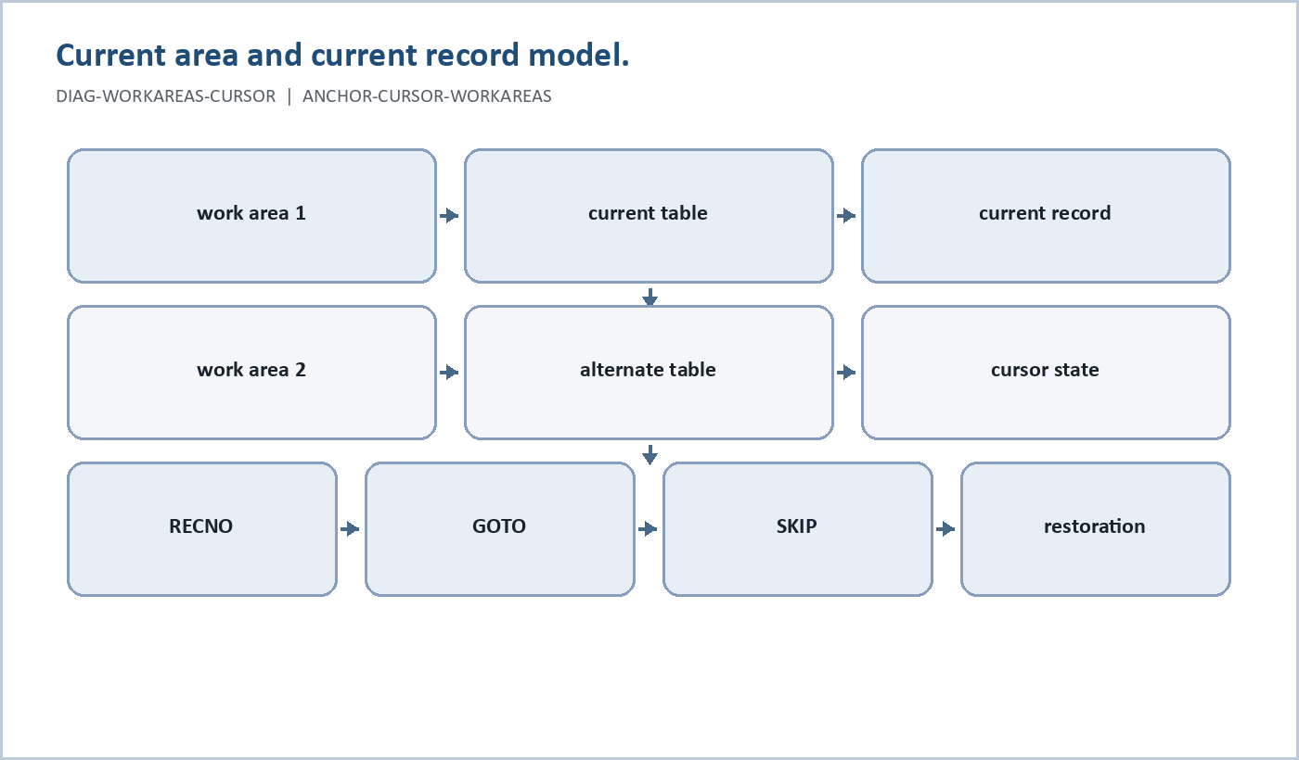
Figure 7. Current area and current record model. (DIAG-WORKAREAS-CURSOR, ANCHOR-CURSOR-WORKAREAS).
Anchor: ANCHOR-CURSOR-WORKAREAS
Maturity: M2 source-supported. The source and command surface are present; this section still needs current runtime transcripts before it becomes a promoted cursor tutorial.
DotTalk++ follows the xBase work-area model. A work area is an engine-owned table slot. Commands run against the current area unless they explicitly name another area or all areas.
Current source evidence:
- src/cli/workareas.hpp wraps engine-owned DbArea slots without taking ownership away from the engine.
- src/cli/cmd_recno.cpp implements RECNO as both a report command and a navigation command.
- Browser and status code report record number, deleted state, physical record, and logical row where available.
The reader-facing rule is simple:
Open table -> current area -> current record -> command effect
Commands such as LIST, REPLACE, LOCK, UNLOCK, COMMIT, and ROLLBACK only make sense when the current area is clear. When proof scripts exercise cursor behavior, they should report the current record before and after mutation-sensitive commands.
Basic cursor pattern:
USE CUSTOMER
RECNO
RECNO 3
LIST
RECNO
RECNO with no argument reports the current record number. RECNO <n> moves the cursor to record n and reports the resulting record number. It mutates cursor position but does not mutate table data.
Important manual distinction:
- Cursor movement changes what record is current.
- Record editing changes table data.
- Buffering may delay when edits become physical table data.
- Commit/rollback may preserve or discard buffered edits.
- Some commands restore the cursor best-effort after scans or aggregate operations.
Proof gap: this section is source-supported and command-supported, but still needs a dedicated transcript for current-area selection, RECNO, GOTO, SKIP, scan cursor restoration, and multi-area behavior.
Maturity target: M3 after reader_manual_cursor_control_v1 proves cursor movement and readback; M4 after the section includes transcript paths and expected output.

14. Record and Table Locking
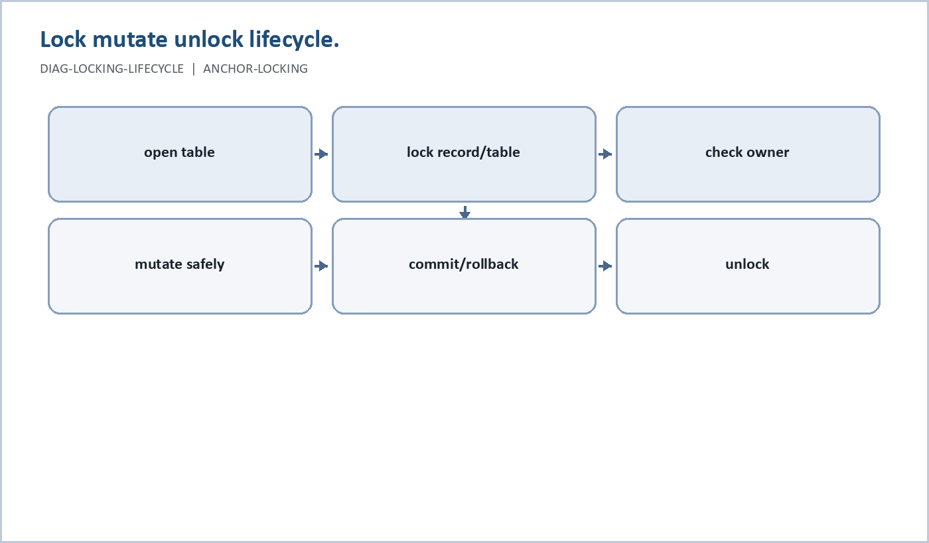
Figure 8. Lock mutate unlock lifecycle. (DIAG-LOCKING-LIFECYCLE, ANCHOR-LOCKING).
Anchor: ANCHOR-LOCKING
Maturity: M2 source-supported. LOCK and UNLOCK are implemented command surfaces with HELP messages, but this section still needs fresh lock transcripts before it is a full operational tutorial.
DotTalk++ has a locking surface for coordinating access to records and tables. The user-facing commands are:
LOCK USAGE
LOCK
LOCK <n>
LOCK ALL
LOCK TABLE
LOCK STATUS
LOCK WHO <n>
UNLOCK USAGE
UNLOCK
UNLOCK <n>
UNLOCK ALL
UNLOCK TABLE
LOCK mutates lock state, not table data. UNLOCK releases lock state, not table data.
Reader-facing behavior from source:
- LOCK with no arguments locks the current record.
- LOCK <n> locks record n.
- LOCK ALL and LOCK TABLE lock the table.
- LOCK STATUS reports table lock state and current-record lock state.
- LOCK WHO <n> reports the recorded owner for a locked record.
- UNLOCK with no arguments unlocks the current record.
- UNLOCK <n> unlocks record n.
- UNLOCK ALL and UNLOCK TABLE release the table lock.
Operational pattern:
USE CUSTOMER
RECNO 3
LOCK STATUS
LOCK
LOCK STATUS
REPLACE LNAME WITH "SMITH"
UNLOCK
LOCK STATUS
Commit-time locking matters. COMMIT applies buffered changes by locking each affected record at commit time. If a record cannot be locked, commit can be partial and the remaining buffered changes stay buffered so the user can retry.
Manual caveat: the command surface is supported in source and HELP messages, but this manual still needs fresh lock proof transcripts before presenting a full multi-user tutorial. Until then, locking prose should be direct but conservative.
Maturity target: M3 after reader_manual_lock_unlock_v1 proves record lock, table lock, status, ownership, failed mutation under lock, and unlock readback.

15. Table Buffering
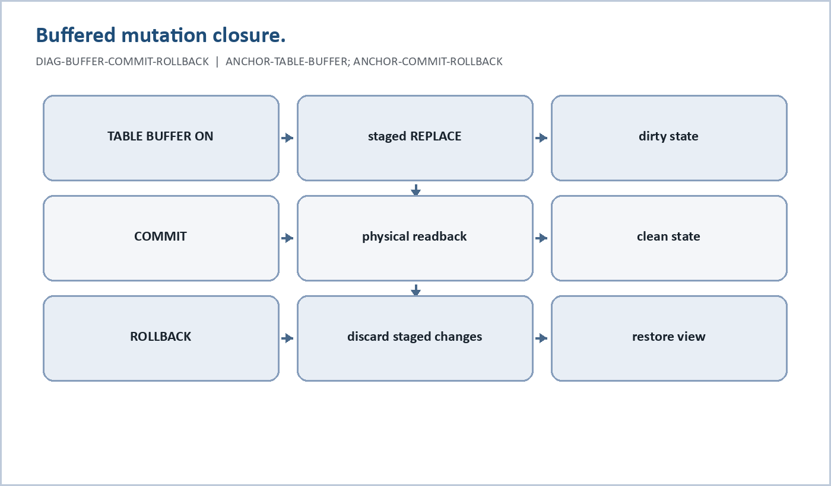
Figure 9. Buffered mutation closure. (DIAG-BUFFER-COMMIT-ROLLBACK, ANCHOR-TABLE-BUFFER; ANCHOR-COMMIT-ROLLBACK).
Anchor: ANCHOR-TABLE-BUFFER
Maturity: M2 source-supported. TABLE BUFFER and per-area buffer state exist; full reader promotion requires proof transcripts for staged changes, status/dump, commit, and rollback.
Table buffering lets DotTalk++ hold changes in a per-area buffer before they are physically applied to the DBF. It is one of the features that makes the system feel like a serious database runtime instead of a simple file editor.
Current command surface includes:
TABLE BUFFER ON [PERSISTENT|RAM] [<n>|ALL|n,m,...]
TABLE BUFFER OFF [<n>|ALL|n,m,...]
TABLE BUFFER PERSISTENT [ON|OFF] [<n>|ALL|n,m,...]
TABLE BUFFER DIRTY [<n>|ALL|n,m,...]
TABLE BUFFER CLEAN [<n>|ALL|n,m,...]
TABLE BUFFER STALE [<n>|ALL|n,m,...]
TABLE BUFFER FRESH [<n>|ALL|n,m,...]
TABLE BUFFER STATUS [area|ALL]
TABLE BUFFER DUMP [area|ALL]
TABLE BUFFER TESTADD <recno> [flags] [field1] [value]
TABLE BUFFER RESET
The runtime model is per-area:
- enabled or disabled
- dirty or clean
- stale or fresh
- RAM-only or persistent-mode selection
- buffered change rows keyed by record number
- optional history mode where newer field changes win by priority
The current TableBuffer stores change entries by record number. A change can represent insert, update, or delete intent. Field-level changes store one-based field numbers and new values.
Reader-facing rule:
TABLE BUFFER controls whether changes are staged.
COMMIT applies staged changes.
ROLLBACK discards staged changes.
Persistent buffering caveat: src/cli/table_state.cpp contains persistent journal hooks, but they are currently deliberate stubs. The manual should not claim crash-recovery journaling until a proof script shows journal creation, replay, commit closure, and rollback cleanup.
Maturity target: M3 after reader_manual_table_buffer_commit_v1 and reader_manual_table_buffer_rollback_v1 prove buffer state, physical readback, and rollback readback.

16. Commit and Rollback

Figure 10. Buffered mutation closure. (DIAG-BUFFER-COMMIT-ROLLBACK, ANCHOR-TABLE-BUFFER; ANCHOR-COMMIT-ROLLBACK).
Anchor: ANCHOR-COMMIT-ROLLBACK
Maturity: M2 source-supported. COMMIT and ROLLBACK have source-level contracts and command handlers; promoted reader workflows need current transcripts.
COMMIT and ROLLBACK define the lifecycle of buffered changes.
COMMIT usage:
COMMIT USAGE
COMMIT
COMMIT ALL
COMMIT MANUAL
COMMIT INTERACTIVE
COMMIT AUTO
COMMIT ALL MANUAL
COMMIT ALL INTERACTIVE
COMMIT ALL AUTO
ROLLBACK usage:
ROLLBACK USAGE
ROLLBACK
ROLLBACK ALL
COMMIT applies buffered table changes for the current area, or for all open buffered areas when ALL is supplied. It locks affected records at commit time. If all buffered record applications succeed, it clears the buffer, clears dirty/stale state, flushes memo changes when a memo manager is present, and runs only the appropriate legacy index maintenance path.
Important commit policy:
- COMMIT does not rebuild CDX/LMDB containers.
- CDX/LMDB update lifecycle belongs to runtime mutation hooks.
- CNX remains rebuild-based.
- INX/IDX remains reindex-based.
- MANUAL, INTERACTIVE, and AUTO are accepted for compatibility, but do not make COMMIT rebuild CDX/LMDB.
Partial commit is possible. If one or more records cannot be applied, successful records are committed and failed record changes remain buffered. The user can inspect the state, unlock or resolve the conflict, and retry COMMIT.
ROLLBACK discards buffered/uncommitted changes. ROLLBACK without arguments clears the current area's buffered state. ROLLBACK ALL clears buffered state across all areas. It mutates buffer state and dirty/stale flags, but it does not mutate physical table data.
Professional manual rule: every buffering example must end with either COMMIT plus readback or ROLLBACK plus readback. A database manual that teaches buffering without closure teaches unsafe habits.
Maturity target: M3 after successful commit, rollback, and partial-conflict transcripts exist; M4 after the manual includes expected output and recovery steps.

17. Operational Safety Checklist
Anchor: ANCHOR-TABLE-BUFFER, ANCHOR-COMMIT-ROLLBACK, ANCHOR-LOCKING, ANCHOR-CURSOR-WORKAREAS
Maturity: M1 anchored checklist. This is a reader-facing safety frame; each individual command still matures through its own proof transcripts.
Before running a data-changing command, identify five states:
| State | Question |
|---|---|
| Current area | Which table slot is active? |
| Current record | Which record will record-oriented commands affect? |
| Lock state | Is the record or table locked, and by whom? |
| Buffer state | Are changes immediate or staged in TABLE BUFFER? |
| Index/order state | Is logical order controlled by CNX, CDX, INX, IDX, or physical order? |
Safe mutation pattern:
USE <table>
RECNO
LOCK STATUS
TABLE BUFFER STATUS
<mutation command>
<readback command>
COMMIT
<readback command>
UNLOCK
Safe rollback pattern:
USE <table>
TABLE BUFFER ON
<mutation command>
TABLE BUFFER DUMP
ROLLBACK
LIST
TABLE BUFFER STATUS
Reader rule: never treat a mutation as complete until the intended closure is visible. For immediate edits, closure is physical readback. For buffered edits, closure is COMMIT plus readback or ROLLBACK plus readback.
Operational caveats:
- A cursor move can change which record is edited.
- A lock can prevent a commit from applying all buffered records.
- A partial commit leaves failed changes buffered.
- ROLLBACK discards buffered changes; it does not undo already committed physical table changes.
- COMMIT does not rebuild CDX/LMDB containers; their lifecycle belongs to mutation hooks.
- Persistent buffer journal recovery is future/stubbed until proven.
This checklist should eventually become a full Database Administration Guide chapter with transcripts for normal operation, lock conflict, partial commit, rollback, and recovery cases.

18. Import and Export
CSV export and import are now transcript-backed.
Export transcript: docs/manuals/developer/proofs/reader_manual_nav_import_export_probe_v1.transcript.txt
Import transcripts:
- docs/manuals/developer/proofs/reader_manual_import_probe_v1.transcript.txt
- docs/manuals/developer/proofs/reader_manual_import_probe_v2.transcript.txt
HELP reports:
IMPORT <csv>
EXPORT <csv>
Export pattern:
EXPORT docs\manuals\developer\proofs\reader_manual_nav_export_v1.csv
EXPORT TO docs\manuals\developer\proofs\reader_manual_nav_export_to_v1.csv
Observed export proof:
- EXPORT <csv> wrote three records to the target CSV.
- EXPORT TO <csv> also wrote three records.
- The exported file contained the header SID,LNAME,FNAME,GPA and three rows.
Import pattern:
CREATE X64 RM_IMPORT_V2 (SID N(6,0), LNAME C(20), FNAME C(15), GPA N(4,2))
IMPORT docs\manuals\developer\proofs\reader_manual_nav_export_v1.csv
STRUCT
LIST
STATUS
Observed import proof:
- IMPORT <csv> with no open table did not create a table; the transcript reported No file open.
- After creating and opening a matching x64 table, IMPORT <csv> reported Imported 3 records.
- STRUCT, LIST, and STATUS confirmed the imported table and record count.
Reader rule: import requires an open compatible table. Export requires an open table and writes CSV.

19. Commands and Functions Reference
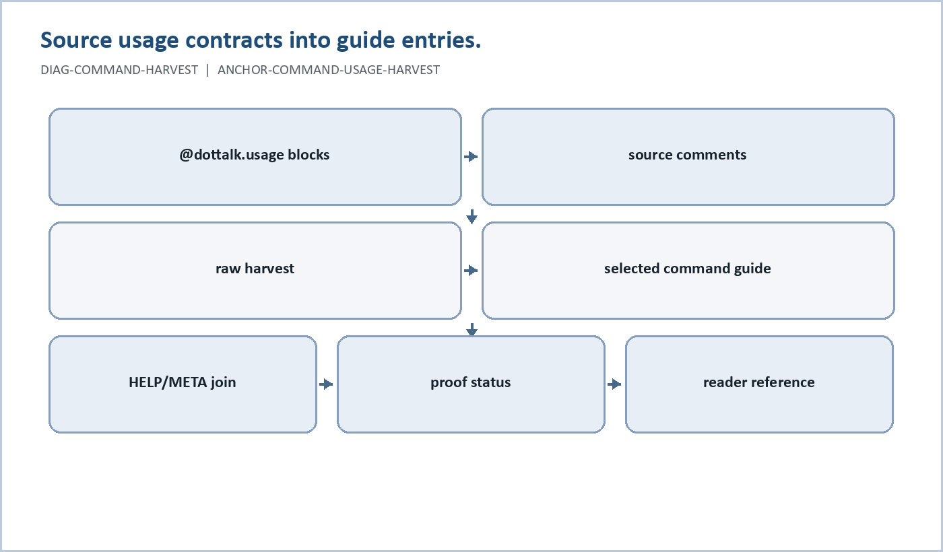
Figure 11. Source usage contracts into guide entries. (DIAG-COMMAND-HARVEST, ANCHOR-COMMAND-USAGE-HARVEST).
The command and function reference must be generated from the system catalogs, not hand-invented from memory.
Current anchors:
- ANCHOR-HELP-COMMANDS: dottalkpp/data/help/COMMANDS.dbf
- ANCHOR-HELP-CMDARGS: dottalkpp/data/help/CMD_ARGS.dbf
- ANCHOR-HELP-TOPICS: dottalkpp/data/help/HELP_TOPIC.dbf
- ANCHOR-HELP-ARTIFACTS: dottalkpp/data/help/HELP_ARTIFACTS.dbf and dottalkpp/data/help/HELP_ARTIFACTS.dtx
- ANCHOR-META-COLLECT: META semantic facts and comparison output.
- ANCHOR-CMDHELPCHK: HELP/META validation.
- ANCHOR-RUNTIME-PROOFS: transcript-backed behavior.
- ANCHOR-COMMAND-USAGE-HARVEST: source-local @dottalk.usage v1 blocks and nearby command comments.
Current command-reference artifacts:
- DOTTALKPP_COMMAND_REFERENCE_GUIDE_V1.md: readable source-contract guide with one selected entry per command declaration where possible.
- docs/manuals/command_reference/COMMAND_REFERENCE_USAGE_CONTRACT_HARVEST_V1.md: raw source harvest preserving all usage blocks.
- docs/manuals/command_reference/command_reference_guide_v1.csv: structured selected guide rows.
- docs/manuals/command_reference/command_reference_usage_contract_harvest_v1.csv: structured raw harvest rows.
- docs/manuals/developer/manualgen/accepted_docs/man_cli_v1/manualgen_man_cli_command_reference.md: existing manualgen CLI command reference.
The reader-facing reference should be generated with one row per command, function, or operator identity:
primary_name
kind
aliases
syntax
arguments
help_topic
meta_identity
proof_status
reader_status
manual_section
Reader status should use these values:
| Status | Meaning |
|---|---|
| promoted | Safe to describe as a normal user command because HELP/META and runtime proof agree. |
| documented | Appears in HELP/META and can be described, but still needs a fresh proof transcript. |
| developer | Useful to maintainers, but not a normal reader command. |
| legacy | Compatibility or historical surface; explain only with caveats. |
| deferred | Known name, but not enough evidence for reader-facing documentation. |
The first generated pass should focus on commands already used in this manual: CREATE X64, DDL CREATE DBF, USE, STRUCT, FIELDS, LIST, APPEND, REPLACE, RECNO, LOCK, UNLOCK, TABLE BUFFER, COMMIT, ROLLBACK, IMPORT, EXPORT, BROWSE, SET INDEX, SET ORDER, DOTSCRIPT, and HELP.
Functions and expression operators should follow the same rule: catalog first, proof second, reader prose third. If a function appears in a catalog but has no current proof example, it belongs in the generated reference with reader_status=documented or deferred, not in tutorial prose.

20. LabTalk Case Catalog
LabTalk is an optional educational overlay for DotTalk++ and x64base. It should help readers understand why data systems, DBF records, indexes, schemas, and runtime proof matter.
The current case catalog lives under:
docs/cases
The catalog currently includes:
- 15 runtime-readable CASE_*.md files
- CASE_FRAMEWORK.md
- REGISTRY_CASES_v0.csv
- REGISTRY_CASES_v0.md
- MEDIA_ASSET_REGISTRY_v0.csv
- runtime proof scaffolds for engineering cases
First-wave review candidates:
- HIST-000 The Data Trail Overview
- HIST-020 JUMPS / 73C Army System
- HIST-030 Unisys / CODASYL at ALCOA
- HIST-040 xBase as a Major Platform
- HIST-090 DotTalk++ / LabTalk and the AI Future
Boundary rule: LabTalk case files are optional. Core x64base and professional DotTalk++ runtime behavior must remain usable without case media, storyboards, or source document files.

21. Troubleshooting
Use this checklist before changing code or docs:
- Can the executable be found at the expected path?
- Does the command appear in HELP or the command registry?
- Is a table open before table-dependent commands run?
- Did the script run through DOTSCRIPT ... OUT ...?
- Did the workflow produce a transcript?
- Did table creation include STRUCT, FIELDS, LIST, TUPLE, or STATUS readback?
- Did index creation prove logical order and table contents separately?
- Did SET INDEX attach the intended container?
- Did SET ORDER select the intended tag or return to physical order?
- Are CNX/CDX described as user-facing logical containers and LMDB as backend detail?
- Is the schema a candidate, active contract, workspace schema, JSON Schema, or package-local schema?
- Is the xBase/FoxPro material runtime-supported, source-supported, or only lineage/background?
- Is the material reader-facing, or should it live in the developer appendix?

22. Developer Appendix
The following material is important for maintainers but should not dominate the reader body:
- MAN* catalog internals
- manualgen lifecycle
- maintenance package and MDO terminology
- drift/canary/review notes
- harvest manifests
- raw proof logs
- deferred command-family reviews
Current manualgen caveat: manual catalog status reported DRIFT because the accepted MAN* DBFs also appear as duplicate EXTRA_MAN_DBF rows. The expected table counts passed. Treat this as a catalog visibility issue until repaired or explicitly waived.

23. Evidence Anchors and Manual Generation
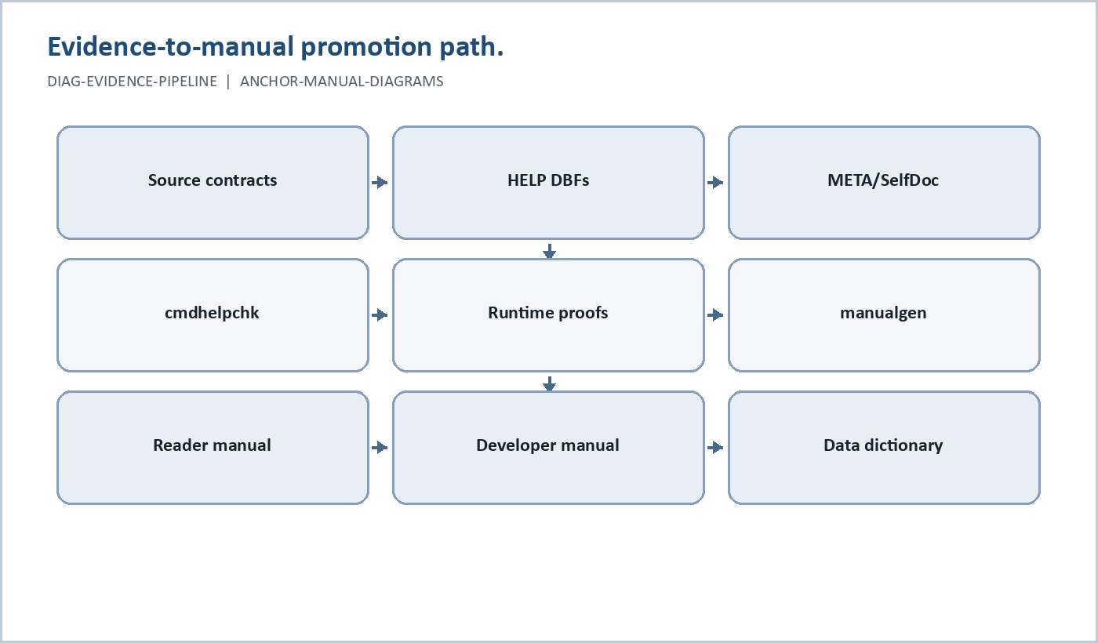
Figure 12. Evidence-to-manual promotion path. (DIAG-EVIDENCE-PIPELINE, ANCHOR-MANUAL-DIAGRAMS).
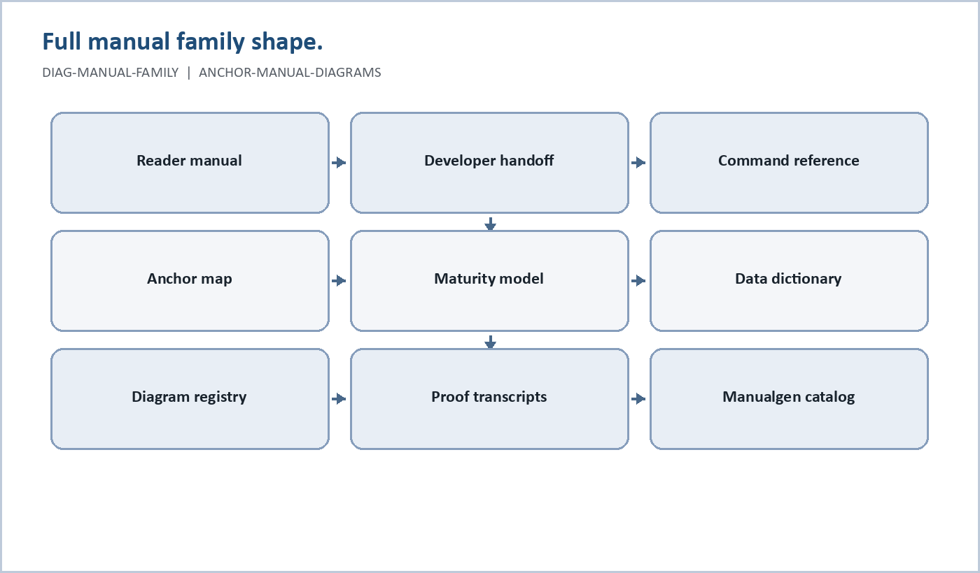
Figure 13. Full manual family shape. (DIAG-MANUAL-FAMILY, ANCHOR-MANUAL-DIAGRAMS).
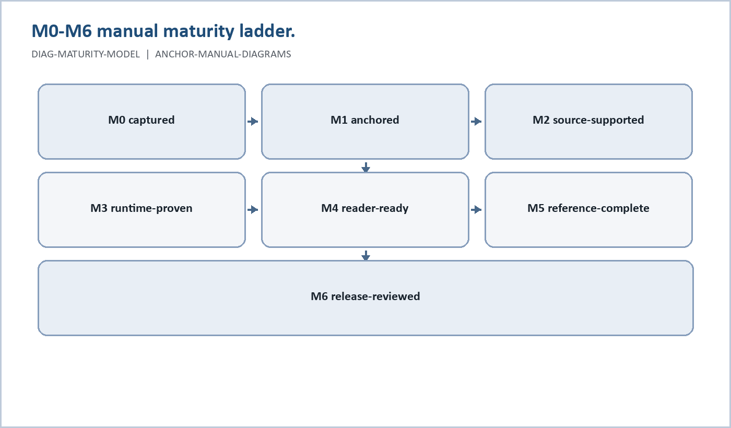
Figure 14. M0-M6 manual maturity ladder. (DIAG-MATURITY-MODEL, ANCHOR-MANUAL-DIAGRAMS).
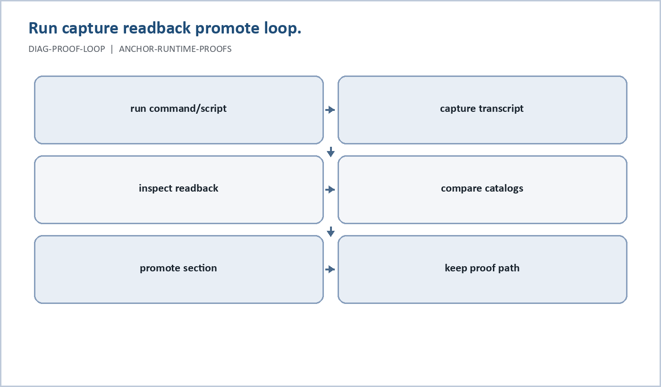
Figure 15. Run capture readback promote loop. (DIAG-PROOF-LOOP, ANCHOR-RUNTIME-PROOFS).
This manual now uses DOTTALKPP_MANUAL_ANCHOR_MAP_V1.md as the bridge between bottom-up harvest evidence and top-down reader prose.
It uses DOTTALKPP_MANUAL_PROSE_GUIDE_V1.md as the rulebook for turning those anchors into readable orientation, tutorial, reference, concept, caveat, handoff, and data dictionary prose.
The core pipeline is:
Source contracts
-> HELP DBFs and metadata
-> META/selfdoc inventories
-> cmdhelpchk and maintenance validation
-> runtime proof transcripts
-> manualgen reviewed/published artifacts
-> reader manual, developer manual, data dictionary
Reader-facing claims should be promoted from anchors, not from memory. The important current anchors are:
- ANCHOR-X64-TRINITY: include/xbase.hpp, include/xbase_vfp.hpp, and include/xbase_64.hpp.
- ANCHOR-X64-VECTOR-NAMES: x64 vectored table and field names.
- ANCHOR-X64-INDEXING: CNX/CDX/SET ORDER behavior and x64 indexing direction.
- ANCHOR-X64-MEMOS: x64 memo structure and limits.
- ANCHOR-HELP-COMMANDS, ANCHOR-HELP-CMDARGS, ANCHOR-HELP-TOPICS, ANCHOR-HELP-ARTIFACTS: HELP DBF surfaces.
- ANCHOR-META-COLLECT: semantic collection facts and comparison outputs.
- ANCHOR-CMDHELPCHK: HELP/META validation.
- ANCHOR-SELFDOC-POLICY: provenance and collection policy.
- ANCHOR-MANUALGEN-LIFECYCLE and ANCHOR-MANUALGEN-CATALOG: publication lifecycle and catalog state.
- ANCHOR-DATADICT-SCHEMAS: data dictionary schema and proof reports.
- ANCHOR-RUNTIME-PROOFS: transcript-backed command paths.
- ANCHOR-CURSOR-WORKAREAS: work areas and cursor control.
- ANCHOR-LOCKING: record and table locking.
- ANCHOR-TABLE-BUFFER: table buffering.
- ANCHOR-COMMIT-ROLLBACK: commit and rollback lifecycle.
- ANCHOR-MANUAL-DIAGRAMS: simple SVG diagrams and their registry.
The diagram registry is a visual companion to this anchor map. Diagrams may clarify architecture, harvest flow, locking, buffering, indexing, memo storage, and manual maturity, but they do not raise a claim's proof level by themselves. A visual should inherit the maturity state of the section and anchors it explains.
The next command/function manual pass should generate a skeleton from HELP plus META with these columns:
command_id
primary_name
aliases
argument_rows
help_topic
meta_identity
proof_status
manual_section
reader_status
The simple usage-contract harvest is the first direct source-backed seed for that reference. It does not replace HELP/META/manualgen. It gives the manual a practical per-command prose source: usage contract, purpose, notes, risk/mutation profile, related commands, and nearby source comments.
That is the point where the richly cataloged system starts producing a reader-facing command and function reference instead of only a developer harvest ledger.
Prose rule: catalogs identify what exists, anchors identify what is safe to say, and prose explains why a reader should care and what they should do next.

Proof Artifacts
Reader manual proof scripts and transcripts live in docs/manuals/developer/proofs.
Key transcripts:
- reader_manual_x64_walkthrough_v2.transcript.txt
- reader_manual_order_cdx_v2.transcript.txt
- reader_manual_order_cnx_v1.transcript.txt
- reader_manual_browse_probe_v1.transcript.txt
- reader_manual_nav_import_export_probe_v1.transcript.txt
- reader_manual_import_probe_v1.transcript.txt
- reader_manual_import_probe_v2.transcript.txt
- reader_manual_schema_ddl_v2.transcript.txt
Known caveat transcripts:
- reader_manual_x64_walkthrough_v1.transcript.txt: shows DO X64 resolving as a missing script when no X64.dts profile exists.
- reader_manual_order_cnx_cdx_v1.transcript.txt: shows v64 direct INX attach refused, CNX path not proven, and CDX requiring an LMDB build step.
- reader_manual_schema_ddl_v1.transcript.txt: shows DDL succeeded but bare USE RM_SCHEMA_V1.dbf searched the DBF path instead of the TMP output path.

Publication Notes
This v1 manual promotes the transcript-backed command paths only. Interactive BROWSER and BROWSETUI are intentionally not promoted here; this manual covers non-interactive BROWSE listing.
DO X64 is preserved as legacy/profile script vocabulary, but the reader quickstart uses proven CREATE X64 directly. If an X64.dts profile script is later restored or a native command form is proven, this manual can add it back to the quickstart.

Appendix A: Anchor Map Summary
Anchor | Layer | State | Manual Target
ANCHOR-X64-TRINITY | Source contract | observed | Trinity Headers; xBase Lineage; x64 Workflow
ANCHOR-X64-VECTOR-NAMES | Source contract | candidate | Vectored Table Names and Field Names
ANCHOR-X64-MEMOS | Source contract | candidate | Theoretical Limits; x64 Memo Limits
ANCHOR-X64-INDEXING | Runtime/indexing | proven/candidate | Indexes, CNX, CDX, and SET ORDER
ANCHOR-HELP-COMMANDS | HELP runtime | observed | Commands and Functions Reference
ANCHOR-HELP-CMDARGS | HELP runtime | observed | Command syntax and arguments
ANCHOR-HELP-TOPICS | HELP runtime | observed | Help topics and reader navigation
ANCHOR-HELP-ARTIFACTS | HELP runtime | observed | Embedded help artifacts
ANCHOR-META-COLLECT | META semantic layer | observed | Manual evidence and command identity
ANCHOR-CMDHELPCHK | Validation | observed | HELP/META alignment
ANCHOR-COMMAND-USAGE-HARVEST | Source usage contracts | observed | Commands and Functions Reference
ANCHOR-MANUAL-DIAGRAMS | Visual/manual assets | observed | Visual Manual Assets; Evidence Anchors and Manual Generation; section-level diagrams
ANCHOR-SELFDOC-POLICY | SelfDoc policy | observed | Developer Appendix; provenance rules
ANCHOR-MANUALGEN-LIFECYCLE | Manualgen | observed | Developer manual lifecycle
ANCHOR-MANUALGEN-CATALOG | Manualgen catalog | drift | Published manual references
ANCHOR-DATADICT-SCHEMAS | Data dictionary | observed | Data Dictionaries
ANCHOR-RUNTIME-PROOFS | Runtime proof | proven | Promoted command paths
ANCHOR-LABTALK-CASES | Case/manual overlay | observed | LabTalk Case Catalog
ANCHOR-X64BASE-README | Project positioning | observed | What DotTalk++ Is; History; Educational Purpose; Design Philosophy; Working Model; Current Status Snapshot
ANCHOR-CURSOR-WORKAREAS | Runtime state | observed | Work Areas and Cursor Control
ANCHOR-LOCKING | Concurrency | observed | Record and Table Locking
ANCHOR-TABLE-BUFFER | Buffering | observed | Table Buffering
ANCHOR-COMMIT-ROLLBACK | Transaction-like lifecycle | observed | Commit and Rollback

Appendix B: Maturity Model
| Level | Name | Meaning | Reader use |
| M0 | Captured | The concept was named by a user, source file, HELP row, META row, or harvest artifact. | Do not teach yet. Track it. |
| M1 | Anchored | The concept has an anchor ID and evidence paths. | Can appear in planning, appendix, or caveat prose. |
| M2 | Source-Supported | Source code, headers, or message catalogs show the command or structure exists. | Can be described with source-support caveats. |
| M3 | Runtime-Proven | A transcript proves the behavior in the current runtime. | Can be taught as a workflow. |
| M4 | Reader-Ready | The section has purpose, syntax, example, readback, caveats, anchors, and proof references. | Can appear in the user guide. |
| M5 | Reference-Complete | HELP, META, command syntax, arguments, aliases, proof status, and related commands are cataloged. | Can appear in command/function reference. |
| M6 | Release-Reviewed | Human or designated review accepted the prose, examples, and caveats. | Can be considered publication-grade. |

Required Fields Per Manual Section
Every serious section should eventually carry:
```text
Section title
Prose role
Anchor IDs
Maturity level
Reader purpose
Source evidence
Runtime proof
Command/function surface
Preconditions
Example
Expected readback
Caveats
Next closure action
```
Short sections can imply some of this, but the information must exist somewhere in the manual family.

Promotion Rules
M0 and M1 material may be harvested but should not be presented as normal user instructions.
M2 material may be described as source-supported. Use phrases such as:
```text
The command surface exists in source and HELP, but this section still needs a current runtime transcript.
```
M3 material may be taught as a workflow if the transcript is current and repeatable.
M4 material is reader-ready when it includes:
- what the reader is trying to accomplish
- command syntax
- a minimal example
- expected readback
- known caveats
- anchor IDs
- proof path or proof task
M5 material belongs in the command/function reference.
M6 material is the publication target.

Maturity Matrix For Current Advanced Sections
| Section | Current level | Why | Next step |
| Work Areas and Cursor Control | M2 | Source and command surface found for work areas and `RECNO`. | Add transcript for `RECNO`, `GOTO`, `SKIP`, current area, and cursor restoration. |
| Record and Table Locking | M2 | `LOCK` and `UNLOCK` source and HELP messages exist. | Add transcript for record lock, table lock, status, ownership, blocked mutation, and unlock. |
| Table Buffering | M2 | `TABLE BUFFER` command and table state machinery exist. | Add transcript for buffer on/off, dirty/clean/stale/fresh, buffered replace, dump, commit, rollback. |
| Commit and Rollback | M2 | `COMMIT` and `ROLLBACK` source contracts exist. | Add transcript for successful commit, rollback, partial commit, memo flush if applicable, and index policy. |
| Indexes, CNX, CDX, and SET ORDER | M3 | Existing reader proof transcripts cover promoted CDX/CNX order paths. | Promote command reference entries and add stress/edge proofs. |
| Creating DBFs | M3 | x64 and schema DDL proof transcripts exist. | Add 128-byte vector-name proof, self-describing `X64M` readback, optional longer-name compile-time proof, and data dictionary linkouts. |
| Vectored Table and Field Names | M2 | `include/xbase_64.hpp` defines `X64M`, name-vector metadata, 128-byte compile-time defaults, and 10-byte fallback tokens. | Prove a file can explain its logical table and field names from in-file `X64M`; prove any changed compile-time name limit before documenting it as a supported build profile. |
| Project Overview and Educational Purpose | M2 | `x64base/README.md`, `x64base/README_NEW.md`, and harvested README prose define project positioning, history, and teaching goals. | Treat as reader-ready orientation after volatile status claims are checked against current runtime/proof state. |
| Manual Diagram Assets | M1 | A diagram registry and simple SVG assets now exist under `docs/manuals/assets/diagrams`. | Embed visuals section-by-section after checking each diagram against its anchor, proof state, and rendered output target. |

Appendix C: Command Reference Seed
Selected command entries: 197
Raw harvested usage blocks: 457
## Existing Command Reference Material
You already have command-reference material in the manualgen lane:
- docs/manuals/developer/manualgen/accepted_docs/man_cli_v1/manualgen_man_cli_command_reference.md
- docs/manuals/developer/manualgen/reports/manualgen_command_reference_assembly_summary_v1.csv
- docs/manuals/developer/manualgen/reports/command_reference_promoted_draft_summary_v1.csv
This file is different: it is a direct source-contract harvest intended to seed the reader-facing command guide.
## Promotion Rule
A command entry becomes reader-ready only after its usage contract, HELP/META catalog identity, and runtime proof agree. Until then, treat this guide as source-supported reference seed.

ABOUT
Source: src/cli/cmd_about.cpp
Owner: DOT|ABOUT
Category: report
Status: supported
Effect: report
Mutates: none
Usage access: ABOUT USAGE

Purpose
Print DotTalk++ project identity, lineage, author, runtime environment, and
current session summary.

Usage
ABOUT
ABOUT USAGE

Notes
ABOUT with no arguments prints the full project/runtime report.
ABOUT USAGE prints command usage only.
ABOUT is read-only and does not mutate table data or session state.

Related
VERSION
SQLVER

AGGS
Source: src/cli/cmd_aggs.cpp
Owner: DOT|AGGS
Category: aggregate
Status: supported
Effect: report
Mutates: cursor
Usage access: AGGS USAGE

Purpose
AGGS is the aggregate family/owner for the direct aggregate verbs
SUM, AVG, MIN, and MAX.

Usage
AGGS USAGE
SUM USAGE
SUM <value_expr> [FOR <pred>] [WHERE <pred>] [DELETED|NOT DELETED|!DELETED]
AVG USAGE
AVG <value_expr> [FOR <pred>] [WHERE <pred>] [DELETED|NOT DELETED|!DELETED]
MIN USAGE
MIN <value_expr> [FOR <pred>] [WHERE <pred>] [DELETED|NOT DELETED|!DELETED]
MAX USAGE
MAX <value_expr> [FOR <pred>] [WHERE <pred>] [DELETED|NOT DELETED|!DELETED]

Notes
AGGS with no arguments prints aggregate-family usage.
SUM, AVG, MIN, and MAX are the direct aggregate verbs; AGGS owns the aggregate family.
Persistent SET FILTER and optional FOR/WHERE predicates both participate in visibility.
Cursor position is restored best-effort after the aggregate scan.
Aggregate commands report values; they do not mutate table data.

Related
COUNT
WHERE
SETFILTER

APPEND
Source: src/cli/cmd_append.cpp
Owner: DOT|APPEND
Category: data
Status: supported
Effect: mutate
Mutates: table-data index memo record-pointer
Usage access: APPEND USAGE

Purpose
Append one or more blank records to the current table, using smart append
paths that maintain keys and active indexes, or raw append paths when requested.

Usage
APPEND USAGE
APPEND
APPEND <count>
APPEND MANY <count>
APPEND RAW
APPEND RAW MANY <count>

Notes
APPEND with no arguments appends one blank record through the shared smart append path.
APPEND <count> is shorthand for APPEND MANY <count>.
APPEND MANY <count> performs smart batch append under one lock.
APPEND RAW appends one record without inline index update.
APPEND RAW MANY <count> performs raw batch append under one lock.
Count values must be positive integers.
APPEND is a table-data mutation command; do not classify it as read-only.

Related
APPEND_BLANK
REPLACE
MULTIREP
TABLE
COMMIT

APPEND_BLANK
Source: src/cli/cmd_append_blank.cpp
Owner: DOT|APPEND_BLANK
Category: data
Status: supported
Effect: mutate
Mutates: table-data index memo record-pointer
Usage access: APPEND_BLANK USAGE

Purpose
Append one blank record using the shared append support path so APPEND
and APPEND BLANK behavior stay aligned.

Usage
APPEND_BLANK USAGE
APPEND_BLANK
APPEND BLANK

Notes
APPEND_BLANK with no arguments appends one blank record.
APPEND BLANK is the friendly command spelling when routed by the dispatcher.
The implementation delegates to dottalk_append_blank_core.
APPEND_BLANK is a table-data mutation command; do not classify it as read-only.

Related
APPEND
REPLACE
TABLE
COMMIT

AREA
Source: src/cli/cmd_area.cpp
Owner: DOT|AREA
Category: workspace
Status: supported
Effect: report
Mutates: no
Usage access: AREA USAGE

Purpose
Report the current work-area slot and current area file/session state.

Usage
AREA
AREA USAGE

Notes
AREA with no arguments reports the current work-area number, open file,
record count, current record, DBF flavor, runtime kind, logical name,
absolute path, and active order/index line.
AREA is read-only; it reports current area state and does not mutate table data.

Related
DBAREA
DBAREAS
STATUS
STRUCT
WORKSPACE

ASCEND
Source: src/cli/cmd_ascend.cpp
Owner: DOT|ASCEND
Category: index
Status: supported
Effect: configure
Mutates: order-state
Usage access: ASCEND USAGE

Purpose
Set the active order/tag direction to ascending for the current work area.

Usage
ASCEND
ASCEND USAGE

Notes
ASCEND requires an active order except for ASCEND USAGE.
ASCEND with no arguments mutates order direction to ascending.
ASCEND does not mutate table records or rebuild indexes.

Related
DESCEND
SET ORDER
ORDER

ASCEND/DESCEND
Source: src/cli/cmd_order.cpp
Owner: DOT|ORDER_IMPL
Category: order-helper
Status: implementation-helper
Effect: order-support
Mutates: none-here
Usage access: owned-by ASCEND/DESCEND command handlers

Purpose
Consolidated order helper/prototype translation unit for ASCEND/DESCEND.

Usage
This file is not the SET ORDER or ORDER command owner.
User-visible ASCEND/DESCEND usage is owned by their command handlers.

Notes
The file is intentionally low-behavior in this source drop.
Keep active-order mutation in the actual command handlers/order_state layer.

ASCII
Source: src/edu/edu_ascii_table.cpp
Owner: EDU|ASCII
Category: education-reference
Status: supported
Effect: report
Mutates: none
Usage access: ASCII USAGE

Purpose
Print ASCII/extended ASCII reference tables and selected ranges.

Usage
ASCII USAGE
ASCII
ASCII ASCII
ASCII EXT
ASCII PRINT
ASCII CTRL
ASCII RANGE <lo> <hi>

Examples
ASCII
ASCII ASCII
ASCII EXT
ASCII RANGE 32 126

Notes
ASCII USAGE/HELP/? prints usage and does not emit table rows.
This command is read-only reference output.
The older source comment name "EDU ASCII TABLE" is not the registered
command surface in the current runtime.

AUTODBF
Source: src/cli/cmd_autodbf.cpp
Owner: DOT|AUTODBF
Category: io schema
Status: experimental
Effect: create import
Mutates: filesystem session schema table-data cursor
Usage access: AUTODBF USAGE

Purpose
Create an X64 DBF from a CSV file and import the CSV rows into the newly
created table. CSV headers may become field names; when there is no header,
deterministic FIELDnnn names are generated.

Usage
AUTODBF USAGE
AUTODBF <table> FROM <csvfile>
AUTODBF X64 <table> FROM <csvfile>
AUTODBF <table> FROM <csvfile> HEADER
AUTODBF <table> FROM <csvfile> NOHEADER
AUTODBF <table> FROM <csvfile> AUTO
AUTODBF <table> FROM <csvfile> TEXTONLY
AUTODBF <table> FROM <csvfile> INFER
AUTODBF <table> FROM <csvfile> OVERWRITE

Notes
AUTODBF defaults to X64, AUTO header detection, INFER types, comma CSV.
AUTO is conservative: it chooses HEADER only when the first row looks like
names and later data strongly indicates typed data. Use HEADER or NOHEADER
to remove ambiguity.
Field names are normalized to command-safe x64 logical names, uniquified,
capped to the current x64 logical-name limit, and then passed through the
existing x64 descriptor fallback/mangling policy.
Long text is not auto-promoted to M yet; values must fit current fixed-field
x64base limits. This avoids silently writing memo object id 0.
Existing target DBFs are not overwritten unless OVERWRITE is supplied.

Related
CREATE
IMPORT
IMPORTSQL
SETPATH
STRUCT

BANG
Source: src/cli/cmd_bang.cpp
Owner: DOT|BANG
Category: shell
Status: supported
Effect: execute
Mutates: external-process delegates-command-effects
Usage access: BANG USAGE

Purpose
Launch the host operating-system shell or execute a host shell command.

Usage
BANG
BANG USAGE
BANG <command>
!
! <command>

Notes
BANG with no arguments opens an interactive host shell.
BANG <command> executes the host command and returns.
The exclamation mark is a shell shortcut/alias for BANG.
BANG USAGE prints usage and does not launch a shell.
BANG may indirectly read, write, delete, or execute anything the host shell command does.

Related
PSHELL
SFTP
WEB

BBOX
Source: src/cli/cmd_bbox.cpp
Owner: DOT|BBOX
Category: education
Status: experimental
Effect: report
Mutates: none
Usage access: no-open-table

Purpose
Teach and inspect the Blackbox model: data enters a processing system and information comes out.

Usage
BBOX
BBOX USAGE
BBOX MODEL
BBOX LANES
BBOX COMMENTS
BBOX HELP
BBOX MANUALGEN
BBOX DATADICT
BBOX MESSAGING
BBOX MAINT

BELL
Source: src/cli/cmd_bell.cpp
Owner: DOT|BELL
Category: ui
Status: supported
Effect: configure
Mutates: bell-setting audible-notification
Usage access: BELL USAGE

Purpose
Ring the bell when enabled, or turn the shell bell setting on or off.

Usage
BELL
BELL USAGE
BELL ON
BELL OFF

Notes
BELL with no arguments rings the bell when bell is ON; otherwise reports that bell is OFF.
BELL ON enables the bell and rings it once.
BELL OFF disables the bell.
BELL mutates only the shell bell setting and audible notification state.

Related
SET
COLOR

BETA
Source: src/cli/cmd_beta.cpp
Owner: DOT|BETA
Category: help
Status: supported
Effect: mixed
Mutates: beta-status-overrides filesystem
Usage access: BETA USAGE

Purpose
List, inspect, and update beta tracking items and runtime beta-status overrides.

Usage
BETA
BETA USAGE
BETA LIST
BETA <id>
BETA DONE <id>
BETA DEFER <id>
BETA DEFERRED <id>
BETA OPEN <id>
BETA CLEAR <id>
BETA CLEAR ALL
BETA SAVE
BETA LOAD

Notes
BETA with no arguments lists beta items.
BETA <id> shows a beta item when the id begins with BETA-.
DONE, DEFER, DEFERRED, OPEN, CLEAR, and CLEAR ALL mutate runtime beta status overrides.
SAVE writes beta status overrides to the default status path.
LOAD reads beta status overrides from the default status path.
BETA mutates only beta tracking/status data, not table records.

Related
ABOUT
HELP
FOXHELP

BOOLEAN
Source: src/edu/edu_boolean.cpp
Owner: EDU|BOOLEAN
Category: education-expression
Status: supported
Effect: evaluate-expression
Mutates: none
Usage access: BOOLEAN USAGE

Purpose
Evaluate a boolean expression through xexpr and print .T. or .F.

Usage
BOOLEAN USAGE
BOOLEAN <expr>

Examples
BOOLEAN 1 = 1
BOOLEAN GPA >= 3.0

Notes
BOOLEAN USAGE prints usage before expression evaluation.
When a table is open, field-aware expressions use the current record.
This command does not mutate table data.

BOTTOM
Source: src/cli/cmd_bottom.cpp
Owner: DOT|BOTTOM
Category: navigation
Status: supported
Effect: navigate
Mutates: cursor
Usage access: BOTTOM USAGE

Purpose
Move the current work-area cursor to the last visible/logical record.

Usage
BOTTOM
BOTTOM USAGE

Notes
BOTTOM with no arguments moves to the last visible/logical record.
BOTTOM requires an open table except for BOTTOM USAGE.
BOTTOM uses the AutoByFilter last-record navigation selector.
BOTTOM mutates cursor position but does not mutate table data.
TALK ON prints the resulting record number when movement succeeds.

Related
TOP
BOTTOM
FIRST
LAST
NEXT
PRIOR
SKIP
GOTO
GPS

BROWSE
Source: src/cli/cmd_browse.cpp
Owner: DOT|BROWSE
Category: ui
Status: supported
Effect: interactive
Mutates: delegates browse module commands
Usage access: BROWSE USAGE

Purpose
Enter the refactored BROWSE module through the legacy global command
symbol, preserving existing callers while delegating implementation.

Usage
BROWSE USAGE
BROWSE
BROWSE EDIT

Notes
BROWSE is a thin forwarder to the browse module.
BROWSE with no arguments enters interactive browse mode.
BROWSE EDIT requests edit-capable browse behavior where supported by the module.
Side effects depend on browse actions and delegated commands.

Related
BROWSER
BROWSETUI
LIST
DISPLAY
REPLACE

BROWSER
Source: src/cli/cmd_browser.cpp
Owner: DOT|BROWSER
Category: ui
Status: supported
Effect: interactive
Mutates: delegates LIST DISPLAY GOTO REPLACE
Usage access: BROWSER USAGE

Purpose
Enter a minimal interactive browser with list, display, goto, edit,
help, and quit commands, delegating work to existing command handlers.

Usage
BROWSER USAGE
BROWSER
BROWSER EDIT

Notes
BROWSER with no arguments enters interactive browse mode.
BROWSER EDIT displays edit mode in the banner; edit command is available inside the browser.
Inside BROWSER, L lists records, D displays current record, G moves to a record, E edits via REPLACE, H or question-mark shows help, and Q quits.
BROWSER itself is interactive; side effects come from delegated GOTO and REPLACE actions.

Related
BROWSE
BROWSETUI
LIST
DISPLAY
GOTO
REPLACE

BROWSETUI
Source: src/cli/cmd_browsetui.cpp
Owner: DOT|BROWSETUI
Category: ui
Status: supported
Effect: interactive
Mutates: delegates create append delete goto replace-like staged edits
Usage access: BROWSETUI USAGE

Purpose
Enter the full-screen Turbo/console browse UI with create, read, update,
delete, append, navigation, and staged edit support.

Usage
BROWSETUI USAGE
BROWSETUI

Notes
BROWSETUI with no arguments enters the interactive TUI browser.
The TUI uses function keys and single-key commands for create, read/list, update/edit, delete, append, goto, help, and quit.
Edits may be staged and then saved or discarded when navigating or exiting.
BROWSETUI delegates to existing command handlers for create, append, delete, list/display, goto, and update-like operations.
BROWSETUI is interactive and may mutate table data or session state depending on user actions.

Related
BROWSE
BROWSER
CREATE
APPEND
DELETE
GOTO

BUILDLMDB
Source: src/cli/cmd_buildlmdb.cpp
Owner: DOT|BUILDLMDB
Category: index
Status: supported
Effect: rebuild
Mutates: lmdb-index-backend filesystem order-state
Usage access: BUILDLMDB USAGE

Purpose
Build or rebuild the LMDB backing store for a CDX container using one LMDB
environment per table container and named databases for tags.

Usage
BUILDLMDB USAGE
BUILDLMDB
BUILDLMDB YES
BUILDLMDB AUTO
BUILDLMDB NOPROMPT
BUILDLMDB CLEAN YES
BUILDLMDB FORCE YES
BUILDLMDB QUIET
BUILDLMDB SILENT
BUILDLMDB TINY
BUILDLMDB SMALL
BUILDLMDB MEDIUM
BUILDLMDB LARGE
BUILDLMDB XL
BUILDLMDB HUGE
BUILDLMDB MAPSIZE <size> YES
BUILDLMDB CLEAN MAPSIZE <size> YES

Notes
BUILDLMDB requires an open table except for usage/help requests.
The public CDX container resolves under INDEXES and the LMDB backend environment resolves under LMDB.
If an existing LMDB environment would be destructively rebuilt, explicit YES, AUTO, NOPROMPT, QUIET, or SILENT is required.
CLEAN and FORCE archive the existing environment before rebuild.
BUILDLMDB releases active index/order state before destructive rebuild.
BUILDLMDB rebuilds tag databases from current table data.

Related
CDX
LMDB
SET ORDER
INDEX
REINDEX

CALC
Source: src/cli/cmd_calc.cpp
Owner: DOT|CALC
Category: expression
Status: supported
Effect: evaluate
Mutates: none unless assignment targets an open field
Usage access: CALC USAGE

Purpose
Evaluate an xexpr scalar expression and print the result. When the input
is an assignment to a real field in the current area, CALC delegates to
CALCWRITE for mutation semantics.

Usage
CALC USAGE
CALC <expr>
CALC (<expr>)
CALC <field> = <expr>

Examples
CALC 1 + 2
CALC DATE()
CALC UPPER(LNAME)
CALC BALANCE = BALANCE + 10

Notes
CALC with an empty expression preserves existing behavior and prints .F.
CALC prints Bool, Number, String, and Date results.
CALC uses xexpr for scalar and field-aware expression evaluation.
CALC assignment mutates only when the LHS is a real field in the open area.
Field assignment is delegated to CALCWRITE so table-buffer, memo, validation,
and direct-write/index semantics stay centralized.
CALC expression-only mode is read-only; CALC field-assignment mode is a data mutation path.

Related
CALCWRITE
REPLACE
MULTIREP
XEXPR

CALCWRITE
Source: src/cli/cmd_calcwrite.cpp
Owner: DOT|CALCWRITE
Category: data
Status: supported
Effect: mutate
Mutates: table-data table-buffer memo stale-state index
Usage access: CALCWRITE USAGE

Purpose
Evaluate an expression and write the result into a field in the current
record, preserving type normalization, validation, memo conversion,
table-buffer semantics, and direct-write index maintenance.

Usage
CALCWRITE USAGE
CALCWRITE <field> = <expr>

Examples
CALCWRITE BALANCE = BALANCE + 10
CALCWRITE LNAME = UPPER(LNAME)
CALCWRITE POSTED = TODAY

Notes
CALCWRITE requires an open table and a current record.
CALCWRITE requires assignment syntax using '='.
RHS expressions are evaluated with xexpr against the current area.
Result values are normalized for the target field type before storage.
Currency pair fields are validated and normalized through currency helpers.
X64 memo fields update memo payloads and store memo object-id text.
When TABLE buffering is ON, CALCWRITE buffers the change and marks the field stale/dirty.
When TABLE buffering is OFF, CALCWRITE writes through DbArea::replaceFieldStored.
Direct-write mode uses the engine mutation funnel so active indexes stay consistent.
CALCWRITE is a table-data mutation command; do not classify it as read-only.

Related
CALC
REPLACE
MULTIREP
TABLE
COMMIT

CASE
Source: src/edu/edu_case.cpp
Owner: EDU|CASE
Category: education-reference
Status: supported
Effect: report
Mutates: none
Usage access: CASE USAGE

Purpose
List and show educational case-study catalog entries.

Usage
CASE USAGE
CASE HELP
CASE LIST
CASE SHOW <id>

Examples
CASE
CASE LIST
CASE SHOW normalization

Notes
CASE USAGE/HELP/? prints usage before catalog lookup.
CASE is read-only catalog/reference output.

CATALOGCANARY
Source: src/cli/cmd_catalogcanary.cpp
Owner: DOT|CATALOGCANARY
Category: metadata-dev
Status: dev-canary
Effect: report
Mutates: none
Usage access: CATALOGCANARY USAGE

Purpose
Dev canary for the metadata catalog reader adapter. Reads the current
already-open SYSCMD area and reports adapter row/distribution counts.

Usage
CATALOGCANARY
CATALOGCANARY USAGE

Notes
CATALOGCANARY does not open SYSCMD.dbf.
CATALOGCANARY does not call USE or WORKSPACE OPEN.

CATALOGCANARY expects DotTalk++ to have already prepared the area
DO METADATA
WORKSPACE OPEN DBF
SELECT SYSCMD
It calls load_commands_from_area(current_area).
Registration is intentionally left to the house shell command registry.

Related
METADATA
WORKSPACE
USE
FIELDS
LIST
CMDHELPCHK

CDX
Source: src/cli/cmd_cdx.cpp
Owner: DOT|CDX
Category: index
Status: supported
Effect: mixed
Mutates: index-metadata filesystem
Usage access: CDX USAGE

Purpose
Manage CDX index container metadata: create containers, inspect header/tag
directories, add tags, and drop tags.

Usage
CDX USAGE
CDX INFO [<path.cdx>]
CDX TAGS [<path.cdx>]
CDX CREATE [<path.cdx>]
CDX ADDTAG <name> [<path.cdx>]
CDX DROPTAG <name> [<path.cdx>]

Notes
CDX with no arguments shows usage and does not default to INFO.
If no path is supplied, CDX first uses the active CDX path from order state when available.
Otherwise CDX derives <current_dbf_basename>.cdx through the INDEXES path slot.
CREATE refuses to overwrite an existing file.
INFO and TAGS are read-only inspection operations and require an existing file.
ADDTAG and DROPTAG mutate the CDX container tag directory and require an existing file.
CDX manages container header/tag metadata; backend tag build data persistence is owned elsewhere.

Related
CNX
INDEX
SET CDX
SET ORDER
REINDEX
The full harvested command guide remains in DOTTALKPP_COMMAND_REFERENCE_GUIDE_V1.md.

Generated Topical Index
Term | See
Anchors | Evidence Anchors and Manual Generation; Appendix A
Buffering | Table Buffering; Commit and Rollback
CDX | Indexes, CNX, CDX, and SET ORDER
CNX | Indexes, CNX, CDX, and SET ORDER
Command reference | Commands and Functions Reference; Appendix C
Commit | Commit and Rollback
Cursor control | Work Areas and Cursor Control
Data dictionary | Schema Rules; Evidence Anchors and Manual Generation
DotScript | DotScript
DTX memos | Theoretical Limits; x64 Memo Limits
HELP | Commands and Functions Reference; Evidence Anchors and Manual Generation
Indexing | Indexes, CNX, CDX, and SET ORDER
Locking | Record and Table Locking
Maturity | Evidence Anchors and Manual Generation; Appendix B
MDO | Developer Appendix; Evidence Anchors and Manual Generation
META | Commands and Functions Reference; Evidence Anchors and Manual Generation
Rollback | Commit and Rollback
SelfDoc | Evidence Anchors and Manual Generation
SET ORDER | Indexes, CNX, CDX, and SET ORDER
Trinity headers | The Trinity Headers
Vectored names | Schema Rules; The x64 Workflow
Work areas | Work Areas and Cursor Control
X64M | The x64 Workflow; Schema Rules

