Week 03: Project Introduction and Graphical Identity
Daniel Rasmuson
Image file for logo:
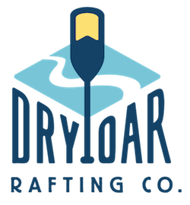
primary-color: 083D77
secondary-color: 1DAEE8
accent1-color: F4D35E
accent2-color: F77E44
heading-font: Rubik Dirt
text-font: Raleway
Color palette url: https://coolors.co/083d77-1daee8-f4d35e-f77e44

