Seattle Traffic Accidents Model

There are on average 35 traffic accidents in Seattle every day. This study analyzed factors related to daily accident counts over the four year period of 2012 through 2015. In particular, I wanted to explore the relationship between the number of active street work zones and accident counts.

For this analysis, I combined the following data sources:
- Accidents As recorded by WA State Department of Transportation, provided by data.seattle.gov
- Work zones Incidents of lane closures as recorded on Seattle city street use permits, provided by data.seattle.gov
- Traffic Hourly traffic volume passing across the 520 bridge (separately east and west bound), provided on request from the WA State Department of Transportation
- Weather Hourly weather data at Boeing Field just south of Seattle, provided by weatherunderground.com
  - Used the location's (airport) timezone when calculating datetimes
  - Interpolated missing values (-9999) for many fields

In addition to these sources, as additional features I calculated whether the accident occurred during daytime, and the number of daytime hours in each day.

For accident counts, originally I use Seattle 911 incident response data from data.seattle.gov. However ultimately I switched to using SDOT collisions data because it is much cleaner.

Accident Count Distributions
Since traffic accidents are rare events, their counts over short periods of time drop off rapidly, as seen in the hourly counts distribution on the left below. The drop off for counts higher than zero is particularly pronounced since counts for all hours of the day are mixed in the same distribution, showing a mean of 1.46 and variance of 3.21. Looking at the counts for only one hour of the day more approaches a poisson distribution. For example the distribution of all 1:00 PM – 2:00 PM counts displays downward-sloping asymptotic behavior with mean of 1.97 and variance of 2.14 (not shown).
Aggregating accident counts for each day shows good fit to a normal distribution with mean of 36 and variance of 91 (below right).

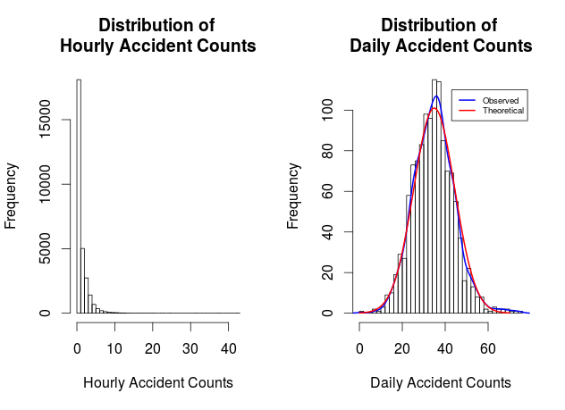

Modeling Approach
I used linear regression to analyze the relationship of predictors to the dependent variable (accident count). Daily counts were used since they are normally distributed. Lasso regression was used to pare down the number of predictors, followed by rejecting those with less than 0.10 p-values for the final model (lm_day_lasso_reduced).
In preparation for applying regression, missing numerical weather data points were interpolated, and all outliers were retained. Of anecdotal note, there was a group of hourly accident count outliers appearing just after midnight on four days in early May 2013 during the May Day protests.

Predictor Results
Estimate Std. Error t value Pr(>|t|)
(Intercept) 7.151e+00 1.694e+00 4.222 2.60e-05 ***
temp 2.041e-01 3.407e-02 5.989 2.78e-09 ***
min_dew_pt -6.262e-02 3.770e-02 -1.661 0.097034 .
wind_speed -1.824e-02 8.806e-03 -2.071 0.038552 *
max_gust_speed 4.075e-02 1.949e-02 2.091 0.036767 *
precipitation 1.727e+01 1.269e+00 13.608 < 2e-16 ***
season 8.630e-01 1.981e-01 4.356 1.44e-05 ***
isSunTRUE -2.407e+00 8.908e-01 -2.702 0.006990 **
tomorrowIsWeekendTRUE 2.023e+00 5.499e-01 3.680 0.000244 ***
isFedHolidayTRUE -4.028e+00 1.346e+00 -2.992 0.002830 **
traffic_east 1.049e-04 4.748e-05 2.210 0.027296 *
traffic_west 2.958e-04 4.691e-05 6.306 4.02e-10 ***
workzone_cnt 1.276e-04 5.746e-05 2.221 0.026521 *
accident_cntLag1Day 7.416e-02 2.437e-02 3.043 0.002395 **

Model Interpretation
Among the predictor effects having the least probability of being seen by chance, we see that the daily accident count is predicted to increase by 17 for every inch of precipitation, by 0.2 for each degree increase in the Fahrenheit temperature, and by 0.000296 for every westbound car crossing the 520 bridge. Among the binary predictors, Federal holidays are predicted to have 4 fewer accidents, Sundays 2.4 fewer, and Fridays and Saturdays (tomorrowIsWeekend) 2 more.
Looking in particular at the workzone_cnt predictor, we see that accidents are predicted to increase by 0.00013 for each additional active work zone involving a lane closure.
Compared to the average daily accident count of 35, the model predictions were off by 7.4 accidents on average (residual standard error). While 13 statistically significant predictors were identified, the adjusted R² was only 0.40, meaning that 60% of the accident counts variability remains unexplained.

Some Areas for Improvement

Traffic Volume Data
Since it takes vehicles passing over a road to get accidents, it is obvious that traffic volume is an important predictor of accident counts. Hourly or daily traffic volume along Seattle city streets is not readily available, however since the WA SDOT provides data on request for some key state roads, I used hourly traffic volume crossing over the 520 bridge as a proxy for city traffic. While this did show a statistically significant relationship with city accident counts—especially for traffic volume west bound entering Seattle—finding traffic volume data at several other dispersed geographical points would have provided a richer view into this relationship, and may have allowed for a geographical model of accidents by neighborhood, or at least by map cell since all accidents and work zones are marked with latitude and longitude.

Weather Data
When I aggregated the hourly weather data to create daily measurements I did not handle the discrete variables such as events and conditions. These could have been preserved at the daily level to possibly improve the model's capture of weather effects. Also for weather, I suspect there are some interactions among predictors to be discovered. For example, precipitation behaves very differently at lower temperatures.

Events Data
It would be interesting to incorporate attendance data for major events that happened in the city during this period, such as sports games or large concerts / festivals.

Stephen Snyder <derauma@gmail.com>

