This document gives the description and guidelines for the GUI software.
Pediatric Perimeter Graphical User Interface
- Description of various elements of the Interface.
- How to Setup the Device and few trouble shoot techniques.

Heading On
The software built for Pediatric Perimeter was a perimeter designed exhaustively for Pediatric population.
The GUI in Software consists of a three main components.
- The input panel for patient data (patient details are entered here).
- Live Stream and text status.
- Perimeter LED controls.

Input Panel
This panel is the first segment of the interface where in the Patient details are entered and this part consists of 4 text boxes for text input of Name, Age, MR Number and Description, additionally it consists of a drop down list to choose sex of the patient .This segment also consists of three buttons i.e Save button to save the text data and Clear button to clear the text within the text boxes, the third button is the stop button which stops any test running.
As we can see in the Figure 1.1 below there are individual textboxes and the buttons above the text boxes are Save and Clear. The test doesn’t start until we save the patient data.

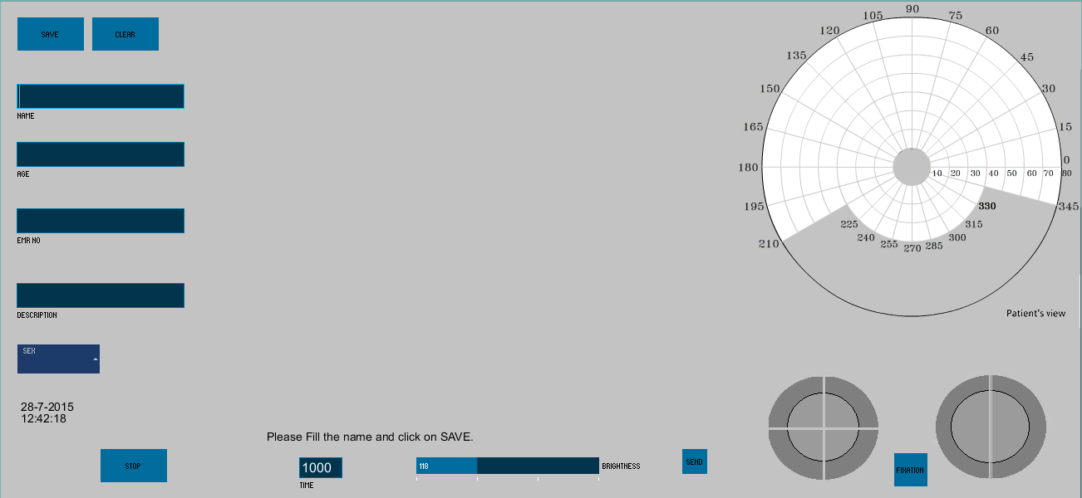
Fig 1.1 Screen shot of the GUI before the data is entered and saved.

Live Stream and text Status
The live feed from the camera shows up on the screen once the patient data is entered. Now, looking at the feed from the camera after the fixation on the dome is active clinician can start the test. Additionally we have the status text just below the video which gives dynamic status of test running during any instant. There are two more additional options to control the brightness and time delay between two LEDs during the kinectic perimtery. The brightness control done by setting the level on the slider and delay is altered by entering the delay duration in milli seconds and then clicking on the Send button beside the video. The video stream has a water mark to adjust the reference point for fixating the vision of babies.

Perimeter LED control
Depending the current status of the gaze and cooperation of the baby the practitioner would conduct the tests. Fixing the gaze is very important for the baby as it would help us map more accurate visual field reading.
Hemispheres and Quadrants of the device can be lighted up using the bottom parts of the LED control panel. Individual Meridians of the perimeter can be lighted by clicking on that particular meridian (angle) in the Isopter image.
Live feedbacks of the LEDs which are in ON state is dynamically updated on the screen. As shown in the Figure

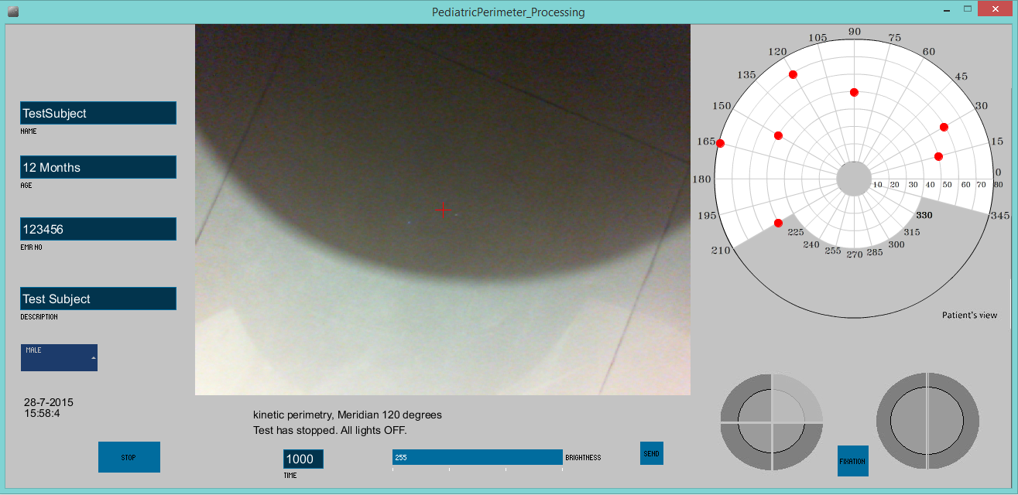
Fig 1.2 showing the Video with water mark and control for delay and Brightness .This image also shows the status of the LEDs lighted in meridians.
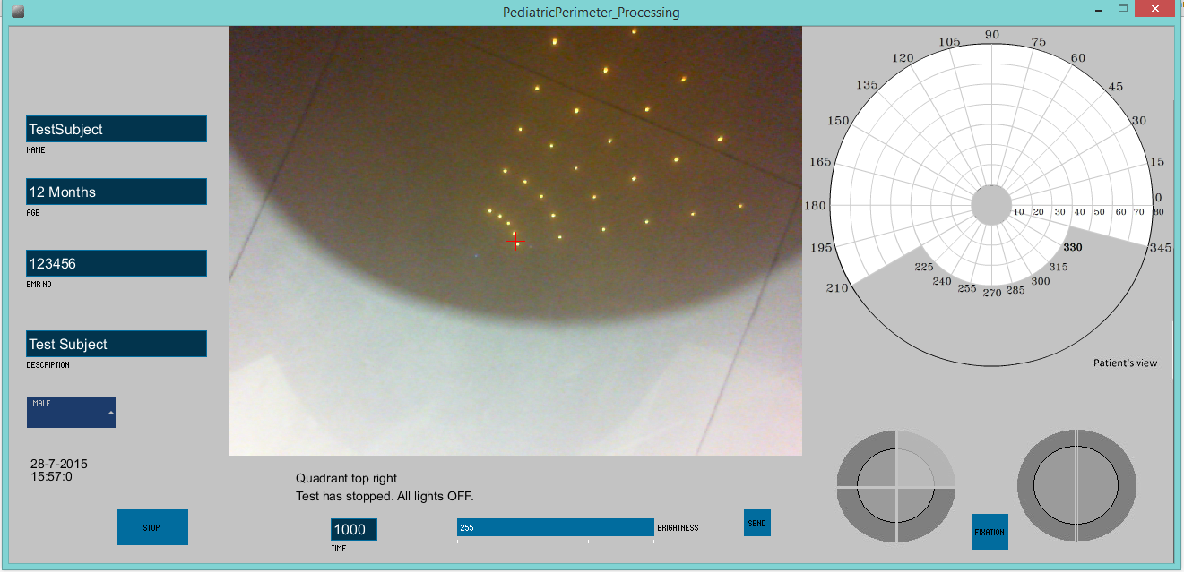

Fig 1.3 showing the live feedback of a Quadrant being lighted up.

Reports
Detailed analysis and reports are generated after the test which include the a video file, text file with the detailed report which includes patient data, detailed information on the type of test and parameters generated as a consequence of the response of the baby and additional features tested on the patient (brightness and delay), an Isopter image generated after the test.

