DFSS Pilot Measurement Activation - Historical Special Cause Case
P-HIST-SC-01 | TeamFlex Fast-Track DIN 77200 | Filled with real historical project data
Cert-Expert | DMADV / Pilot Measurement Activation | 2026-06-05
Working boundary: No invented pilot data, no invented target values, no Product Design, no UI, no data model, no software architecture. This document captures a historical special-cause baseline case and separates confirmed data, estimates, source-backed facts and open evidence fields.
Data status: Historical real project data from user interview plus uploaded TeamFlex audit plan and supporting files/screenshot. This is usable for fast-track learning and reverse-constraint validation, not for standard lead-time target calibration.

0. Quick Status / Schnellstatus
Question / Frage | Answer / Antwort
Are real historical pilot/baseline values available? | [x] Partly to strongly - real historical dates, scope, audit plan, audit time, employee counts, effort estimate, blocker and process data available. Audit report/certificate decision not yet attached.
Can this case be used for DFSS design input? | [x] Yes, as Special Cause / Fast-Track baseline evidence. Not as normal standard-project baseline.
Can a Pilot Validation Report be created from this alone? | [x] No - combine with P05 SecuGuard, P-HIST-01 LC Security and additional cases.
Decision / Entscheidung | [x] Use as historical special-cause measurement input [ ] Rework [ ] Exclude

1. Project Portfolio Overview / Projektportfolio-Uebersicht
Project ID | Type | Norms | SDLs / Services | Service model | Start / KSA | Audit | Main blocker / driver | Readiness
P-HIST-SC-01 | Special Cause / Fast-Track certification case | DIN 77200-1/-2; ISO 9001 already available through group multi-site certification context | DIN 77200-1: stationary control service; DIN 77200-2: protection of refugee/asylum facilities on documentation basis | Emergency / fast-track done-for-you support | KSA 2025-05-27 | Audit plan: 2025-06-05/06; audit time 1.375 days | Extreme time pressure; DEKRA/KSA fast-track; narrow DIN-relevant staff scope; daily calls; many customer documents already available | Special-case ready; not representative for normal lead-time

2. Project Setup Record / Projekt-Steckbrief
Field / Feld | Input / Eingabe | Notes / Hinweise
Project ID | P-HIST-SC-01 | Historical special-cause case; keep separate from normal P-HIST cases.
Project name | TeamFlex Solution GmbH / Teamflex Solution GmbH | Customer name used as historical working reference; audit plan states Teamflex Solution GmbH.
Project type | [x] Initial DIN certification [x] Special Cause / Fast Track [ ] Normal baseline | Emergency rescue / accelerated certification.
Norms | DIN 77200-1:2022 and DIN 77200-2:2020; ISO 9001 already present via group/multi-site context | Fast-track possible because ISO 9001 system foundation did not need to be built from scratch.
DIN 77200-1 SDL | Stationary security service - control service / stat. SDL - Kontrolldienst | Confirmed by audit plan.
DIN 77200-2 scope | SDL zum Schutz von Fluechtlings- und Asyleinrichtungen, on documentation basis | Officially in certificate/scope according to user; real project proof required at first surveillance after 12 months.
KSA date | 2025-05-27 | KSA filled/submitted; also project folder / DEKRA folder sent same day according to user.
Audit plan date | 2025-06-04 | Confirmed in audit plan.
Audit period | 2025-06-05 / 2025-06-06 | Audit plan evidence supersedes earlier memory of 2025-06-10 as audit date.
Audit time | 1.375 days | Audit plan: 8h on-site on 2025-06-05 and 3h remote on 2025-06-06.
Employees total | 282 | Confirmed in audit plan.
DIN 77200 relevant personnel | 8 employees | Confirmed in audit plan.
Employee files sampled/checked | 3 employee files for measurement dataset | User sets conservative value at 3; includes leadership / supervisor and security employee logic.
Cert-Expert effort | Approx. 3 working days x 8h = approx. 24h | Estimate from user; mark as historical effort estimate, not calibrated target.
Collaboration model | Daily calls and direct task execution with HR lead/personnel chief, managing director and on-site project lead | Multiple contacts instead of single point of contact due to urgency.

3. Timeline Capture / Zeitpunkterfassung
Timepoint | Value | Comment | Evidence ID
First contact / recommendation chain | June 2025; prior recommendation via AFAS; later emergency referral | Original large email overwhelmed recipient; later re-entry as emergency rescue case. | EV-TF-SC-001
KSA filled/submitted | 2025-05-27 | Kundenselbstauskunft for DIN 77200 certification; fast-track route. | EV-TF-SC-002
DEKRA/project folder sent | 2025-05-27 | DEKRA folder sent in advance to project manager / DEKRA contact before normal final processing. | EV-TF-SC-003
Estimated DEKRA offer / release path | Approx. 2025-05-29 to 2025-05-30 | User estimate: 2-3 days later. Keep as estimate, not hard evidence. | EV-TF-SC-EST-001
Audit plan created | 2025-06-04 | Confirmed by audit plan. | EV-TF-SC-004
Audit period | 2025-06-05 / 2025-06-06 | Confirmed by audit plan. KSA-to-audit-start = 9 days; KSA-to-audit-end = 10 days. | EV-TF-SC-004
Audit time | 1.375 days | Audit plan shows 8h on-site and 3h remote. | EV-TF-SC-004
Audit result | Passed according to user; no deviations / no follow-up requests reported | Hard audit report not attached. Keep as interview evidence until audit report/certificate decision is attached. | EV-TF-SC-005
2026 follow-up / continuity | Separate Obsidian DFSS case exists | Not included in this fast-track dataset; later link as TeamFlex Continuity case. | EV-TF-FU1-TBD

4. Scope, SDL and Audit-Time Driver Addendum
Driver / Treiber | Observed value / Beobachtung | DFSS relevance / DFSS-Relevanz
Norm mix | DIN 77200-1/-2 with ISO 9001 already covered through group multi-site structure | Not comparable to a full ISO 9001 + DIN 77200 build from scratch.
Certification body / fast-track path | DEKRA; KSA fast-track plus direct auditor availability check | External path / auditor availability is a critical fast-track gate.
Employees total vs DIN relevant | 282 total at location/organization; 8 DIN-relevant personnel | Confirms employee-count split as audit-time, scope and pricing driver.
Audit time | 1.375 days | Fast-track not equal to minimal audit effort; formal audit time still planned.
Chosen SDL DIN 77200-1 | Stationary control service | Reduced complexity vs multiple SDLs.
DIN 77200-2 documentation basis | Refugee/asylum facility protection on documentation basis | Valid for initial certification but creates 12-month surveillance/real-project proof trigger.
Performance locations | 1 site according to audit plan | Site count is an audit planning and sampling driver.
Daily calls | Daily task clearing with multiple customer stakeholders | High-touch project rescue mechanism; not scalable as default model.

5. Evidence Requirement Map / Nachweisanforderungen
Evidence group | Required / delivered evidence | Observed handling in TeamFlex
KSA / certification request | KSA_DIN 77200_NEU.xlsx | KSA completed 2025-05-27 and used as fast-track trigger.
Employee / service location list | C-10P-07_ger_Auflistung_der_Sicherheitsmitarbeiter und Leistungsorte.xlsx | Supports DIN-relevant personnel / service location logic.
Audit plan | Teamflex_auditplan din 77200.docx | Hard source for audit scope, audit period, audit time, employee counts and reference documents.
DEKRA folder / procedures | DIN 77200 DEKRA folder structure incl. organizational data, staff list, GZR, clearance certificates, declarations, procedures, complaint management, service ID, qualification, training, reporting, key management, organigram, DIN 77200-2 security concept, QM evidence | Screenshot used as folder-structure evidence and coverage map.
Cert-Expert delivered | Anforderungsprofil, Qualifikationsmatrix, DIN 77200 procedure package, DIN 77200-2 special training package, document collection/coordination, parts of DEKRA folder such as organigram | Delivered under emergency time pressure.
Customer delivered | Company records, clearance certificates, contract / service description, existing ODA/object documents, risk assessment, logbook / Wachbuch | Customer was comparatively professional and had many documents already available.
Employee files | 3 employee files checked / sampled for measurement dataset | Use value 3 for dataset; exact audit sample mechanism remains source-dependent.

6. DEKRA Folder Structure Snapshot / Ordnerstruktur
Screenshot evidence used to capture delivered/prepared DIN 77200 DEKRA folder groups. Exact file-level contents should be indexed later if needed for a final evidence pack.
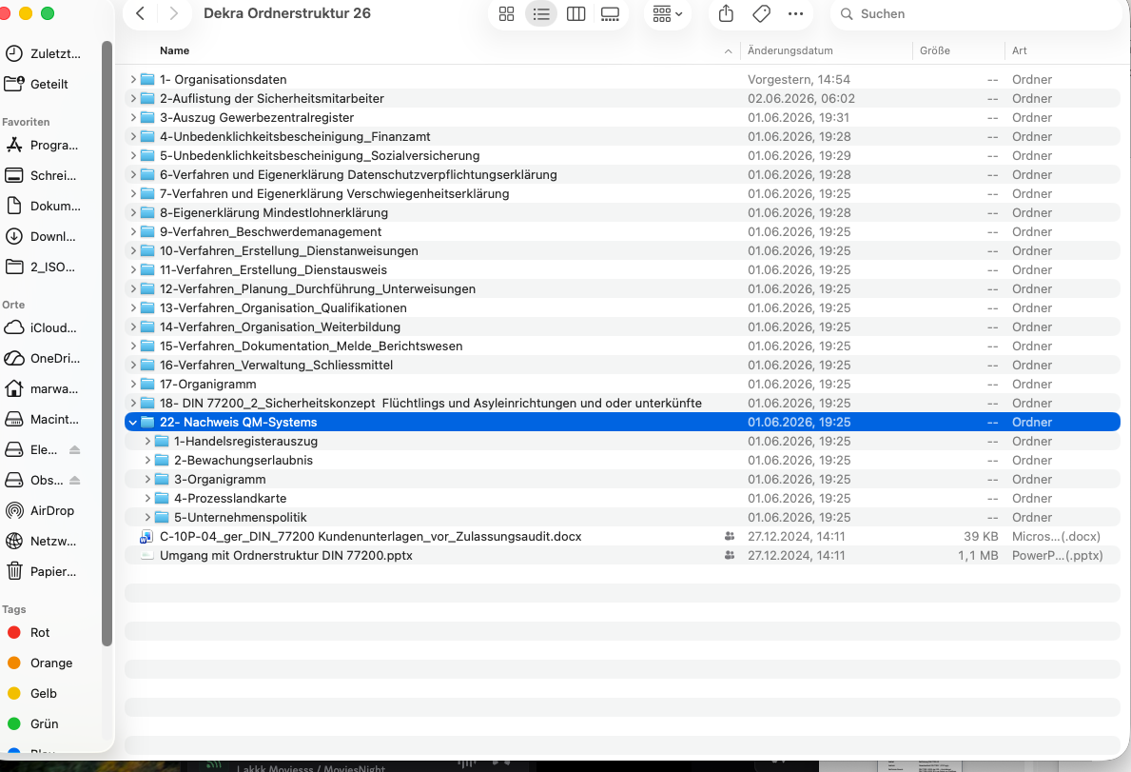

7. Blocker, Rework and Fast-Track Log / Blocker- und Fast-Track-Log
ID | Issue / Thema | Type | Owner / Path | Status | DFSS impact
B-TF-01 | Initial large request email overwhelmed recipient in earlier contact | Reverse factor / overload | Cert-Expert | Historical | RC-02 platform/data capture overload; RC-01 task clarity.
B-TF-02 | Emergency deadline: certification required within 2-3 weeks / by end of month | Time pressure | Cert-Expert + customer + DEKRA | Resolved | Fast-track special cause; not normal baseline.
B-TF-03 | Auditor availability was critical | External gate | Auditor / DEKRA | Resolved | DR-09 external path; PF/S0 gate relevance.
B-TF-04 | KSA / offer / audit release needed fast processing | External process path | DEKRA / Herr Lindemann path | Resolved | DR-05 lead-time and DR-06 escalation cycles.
B-TF-05 | DIN-relevant staff qualification risk limited by narrow SDL relevant group | Workforce readiness risk | Customer + Cert-Expert | Managed | DR-22 workforce readiness; RC-05 no unrealistic success guarantees.
B-TF-06 | Documentation basis for DIN 77200-2 creates 12-month real-project proof trigger | Continuity trigger | Customer + Cert-Expert | Open for follow-up case | DR-17 continuity; DR-19 recurrence/deadlines; S0-08 renewal logic.

8. Pilot Data Collection V-01 to V-10 / Pilotdatenerfassung
V-ID | Data requirement | TeamFlex value / observation | Status
V-01 | Days from complete start dataset to readiness status | Not fully measurable; KSA and project folder sent 2025-05-27; audit started 2025-06-05. Complete dataset timestamp TBD. | Partly
V-02 | Days before audit when audit package is ready | DEKRA folder/project folder sent on 2025-05-27 before final release; audit plan 2025-06-04; exact readiness date TBD. | Partly
V-03 | Client effort by service model: hours, interactions, tasks | Daily calls; multiple customer stakeholders; customer supplied many documents; exact customer hours TBD. | Partly
V-04 | Audit-readiness gaps by severity | No NC / no follow-up requests reported; hard audit report not attached. | Partly
V-05 | Software-only / done-for-you segment fit | Emergency done-for-you fast-track. Software-only would have been unsuitable. | Captured
V-06 | CEKS/knowledge coverage | DIN 77200-1/-2, KSA, DEKRA folder, qualification, documentation-basis logic, SDL logic required. | Captured
V-07 | Auditor/expert review of audit package | Auditplan confirms objective evidence available and audit conducted. Audit report not attached. | Partly
V-08 | SDL/object file completeness | DIN 77200-1 project folder existed; customer provided GBU, contract, Wachbuch, object documents; folder not as clean as later target structure. | Captured
V-09 | Continuity: ZKM, deadlines, renewal, effectiveness | DIN 77200-2 documentation basis creates 12-month real-project proof trigger; 2026 follow-up exists separately. | Captured
V-10 | Reverse factors: overload, norm language, wrong model, complexity | Initial giant email overwhelmed customer; fast-track must not become standard promise; scope/staff split can create hidden readiness risk. | Captured

9. DR / S0 / RC Trace Impact
Trace area | TeamFlex evidence | Interpretation
DR-02 / S0-02 Scope assignment | Scope split: 282 total, 8 DIN relevant, DIN 77200-1 stationaerer Kontrolldienst, DIN 77200-2 refugee/asylum documentation basis | Scope must distinguish organization, SDL, object, employees and evidence.
DR-03 / S0-03 Critical evidence | DEKRA folder sent early; objective evidence available per audit plan | Critical evidence can be accelerated if folder is complete and sent before final audit release.
DR-05 Speed / Lead-time | KSA-to-audit-start 9 days | Special-cause speed value; do not convert into target.
DR-07 Effort | Approx. 24h Cert-Expert effort plus daily customer calls | Fast-track consumes high consultant intensity despite short calendar time.
DR-08 / RC-01 Task clarity | Old giant email overwhelmed recipient | Future task requests must be action-oriented and not overload customers.
DR-09 / S0-06 External evidence path | Auditor availability, DEKRA project manager path and KSA route were critical | External partner/process path is a hard fast-track gate.
DR-11 / S0-07 SDL/object file | Project folder existed but was not as clean as later target architecture | Fast-track success does not prove robust object-file structure.
DR-22 Workforce readiness | 8 DIN relevant employees; 3 files checked/sampled in dataset; special trainings delivered | Workforce readiness is critical and must be visible.
RC-05 No unrealistic guarantees | Fast-track achieved under exceptional conditions | Must not be marketed as standard lead-time.
RC-10 No broad expansion before stable security logic | Follow-up/continuity needed for 12-month real-project proof | Fast-track requires a controlled continuity model.

10. Data Quality Memo / Datenqualitaetsmemo
Question / Frage | Answer / Antwort | Comment / Kommentar
Are all sources identified? | Partly yes | Audit plan, KSA file, staff/service-location file, folder screenshot, user interview. Audit report/certificate decision still optional/open.
Are owner, date and status available for each evidence item? | Partly | KSA, audit plan and folder screenshot have dates; exact DEKRA offer date and audit report status remain TBD.
Are any data contradictory? | Yes, resolved with source priority | Interview memory mentioned 10.06.2025; audit plan confirms 05.06./06.06.2025. Use audit plan as hard evidence.
Is data sufficient for interpretation? | Yes for special-cause measurement activation | Not sufficient for normal target calibration or final validation report alone.
Which data must not be used? | Do not use 9-10 day fast-track as normal lead-time target | Only use as special-cause / best-case under constraints.
Which data is still missing? | Audit report/certificate decision if hard proof of 0 NC is required; exact offer date; exact file-level evidence index | Optional for proceeding to design-oriented cross-case interpretation, but should be added later if available.

11. Gate Decision Record / Gate-Entscheidungsprotokoll
Gate question | Decision | Evidence / basis | Comment
Can P-HIST-SC-01 be added to DFSS sources? | [x] Yes | Audit plan + KSA + staff/service-location file + screenshot + interview | Add as Special Cause / Fast-Track baseline, not normal case.
Can it be used to calibrate standard lead-time target? | [x] No | Special-cause conditions | Use only to define fast-track prerequisites and reverse constraints.
Can it support design-phase transition? | [x] Yes with controls | Confirms fast-track gates, evidence path, workforce readiness and scope logic | Proceed only with cross-case comparison against normal/historical/live cases.
Overall decision | [x] ACCEPT AS SPECIAL-CAUSE MEASUREMENT INPUT | P-HIST-SC-01 | Ready to add to DFSS source set.

12. Source / Evidence Register
Evidence ID | Source | Date / status | Use
EV-TF-SC-001 | User interview / project recollection | 2026-06-05 | Historical context, working mode, effort, no-NC/no-follow-up statement.
EV-TF-SC-002 | KSA_DIN 77200_NEU.xlsx | Uploaded 2026-06-05; KSA date stated 2025-05-27 | KSA / certification request and fast-track start.
EV-TF-SC-003 | C-10P-07_ger_Auflistung_der_Sicherheitsmitarbeiter und Leistungsorte.xlsx | Uploaded 2026-06-05 | Employee/service-location logic.
EV-TF-SC-004 | Teamflex_auditplan din 77200.docx | Audit plan date 2025-06-04 | Audit period, audit time, scope, employees total, DIN-relevant personnel.
EV-TF-SC-005 | Screenshot DEKRA Ordnerstruktur 26 | Captured/uploaded 2026-06-05 | DEKRA folder/procedure package coverage.
EV-TF-SC-TBD | Audit report / certificate decision | Open | Optional hard proof for 0 NC / 0 follow-up requests.

