CST2120

**Web Application and Databases**

Coursework 2- First submission

M00843707

Contents

1 Introduction 3

2 Ecommerce website 3

2.1 Welcoming page 3

2.1.1 Design 5

2.1.2 Functionalities 5

2.2 Cart page 6

2.2.1 Design 7

2.2.2 Functionalities 7

2.3 Account page 8

2.3.1 Design 9

2.3.2 Functionalities 9

2.4 Login page 10

2.4.1 Design 10

2.4.2 Functionalities 10

2.5 Registration page 11

2.5.1 Design 11

2.5.2 Functionalities 11

3 CMS 11

3.1.1 Design 12

3.1.2 Functionalities 13

4 MongoDB Database Design 14

4.1 Database structure 14

4.1.1 Users table 15

4.1.2 Products table 16

4.1.3 Orders table 17

5 Conclusion 18

# Introduction

This report presents the design and development of our e-commerce website for our fruit company. The website provides an easy way for customers to browse and purchase a variety of fresh fruits online. For this project many programming language and technologies were used such as HTML, CSS and JavaScript link with some module such as jQuery and jQuery UI. In this report, we will cover the functionality and design of the website and the CMS, follow by the structure of the MongoDB database structure who will be used to manage the website different data.

# Ecommerce website

For the e-commerce website we chose a minimalist design to be the more user friendly possible. Each page of the website is sharing a common header and footer.

The Header is composed of the logo of the site on the left, then follow by the home, catalogue, account, basket, and login button linking the different pages for the user to travel across our website.

The footer of the website is designed to be simple and clean. It contains 3 columns, the first one is for social media links, the second is for contact information, and the third one is for quick links. The social media links include icons for popular social media platforms such as Facebook, Twitter, and Instagram. Contact information includes an email address and a phone number. Quick links include links to the company's policies and frequently asked questions

## Welcoming page

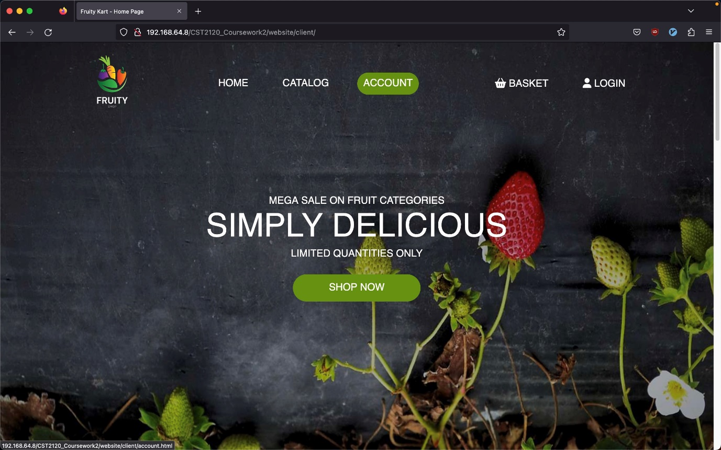

Figure 1- Welcoming page header

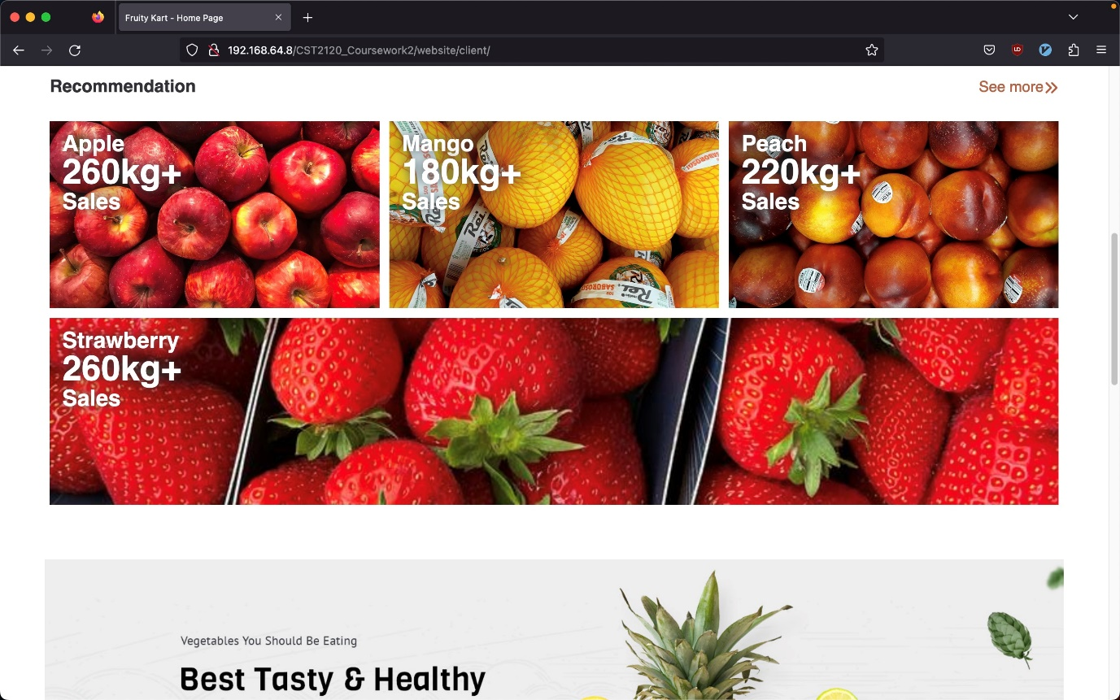

Figure 2 – Welcoming page recommendation

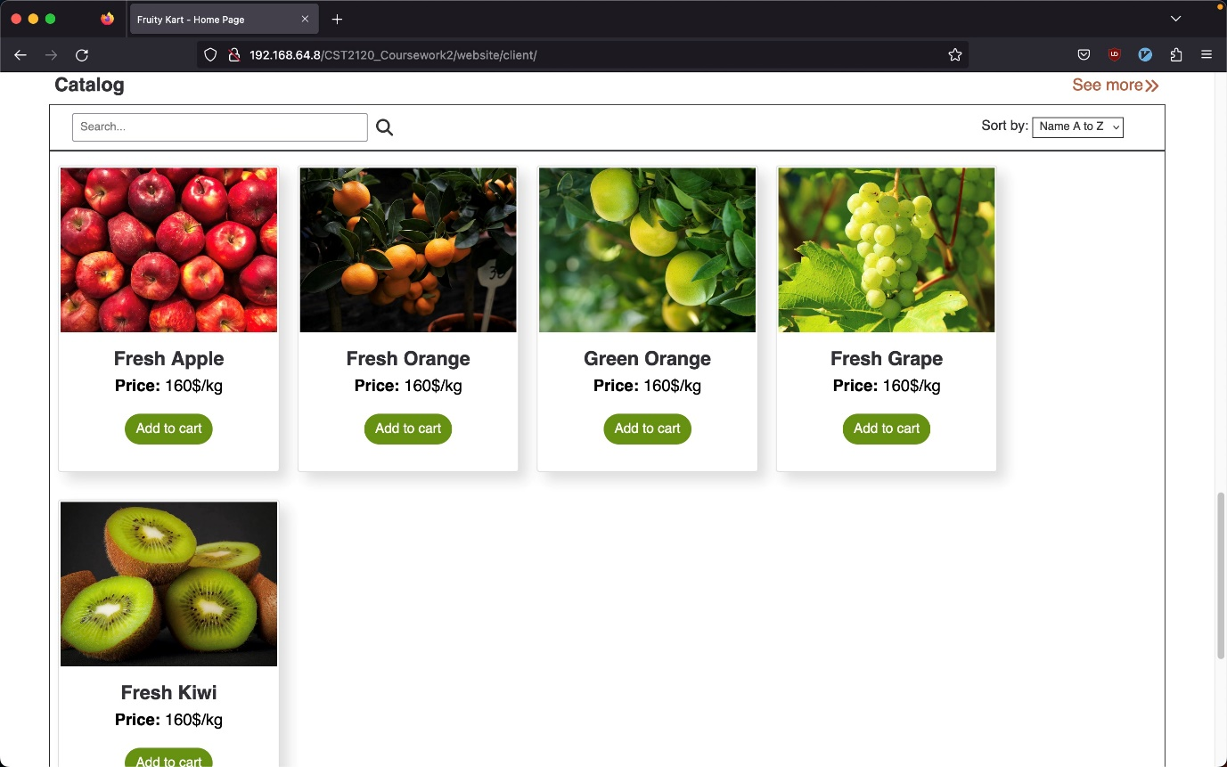

Figure 3 - Welcoming page catalogue

### Design

The welcoming is the main page of the website and is compose od three parts in addition of the header on the top and the footer at the bottom. The first part is composed of decoration part with a shop now button in the centre of the screen, follow by the recommendation section of rectangle image for the different recommendation for the user and finally the catalogue section which list all the different fruits buyable in a rectangle with the image, name price per kilo and finally a button “Add to cart”.

### Functionalities

The welcoming page contain key features for the website such as the different button “Add to cart” which add the product to the user’s basket, all the data will be stored in session storage to be use in basket page for the checkout of the order. Also, for the catalogue part, all the product will be dynamically display from the product present in the database. The user will be able to search with a search and sort product on the top of the catalogue section and the list of products will be display based on it.

For the recommendation section, the picture display will be based on the user’s orders historic to recommend dynamically and display the best possible set of fruit for this client.

Finally for the welcoming section there is the “SHOP NOW” button who will bring the user down the catalogue section.

## Cart page

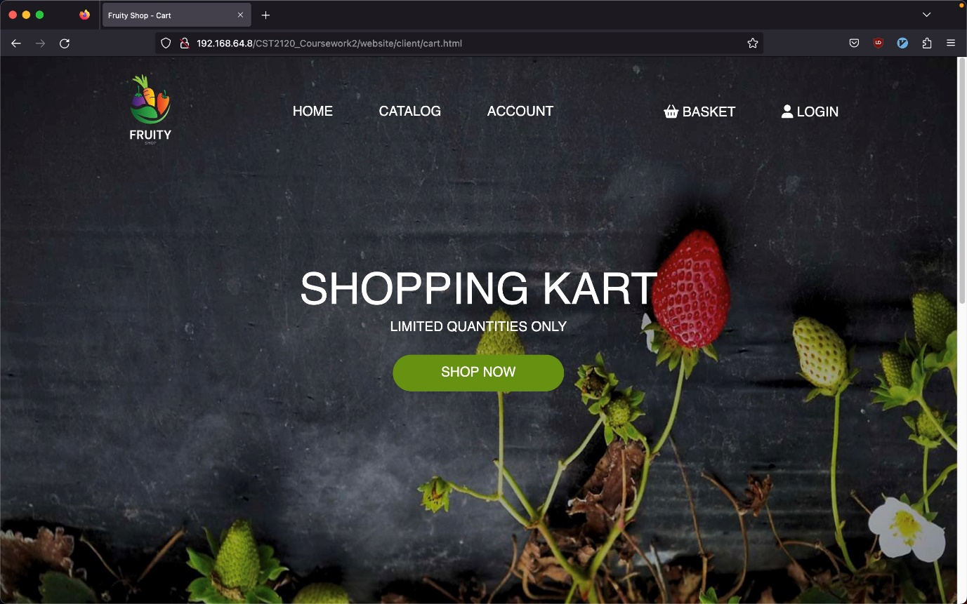

Figure 4 - Cart page header

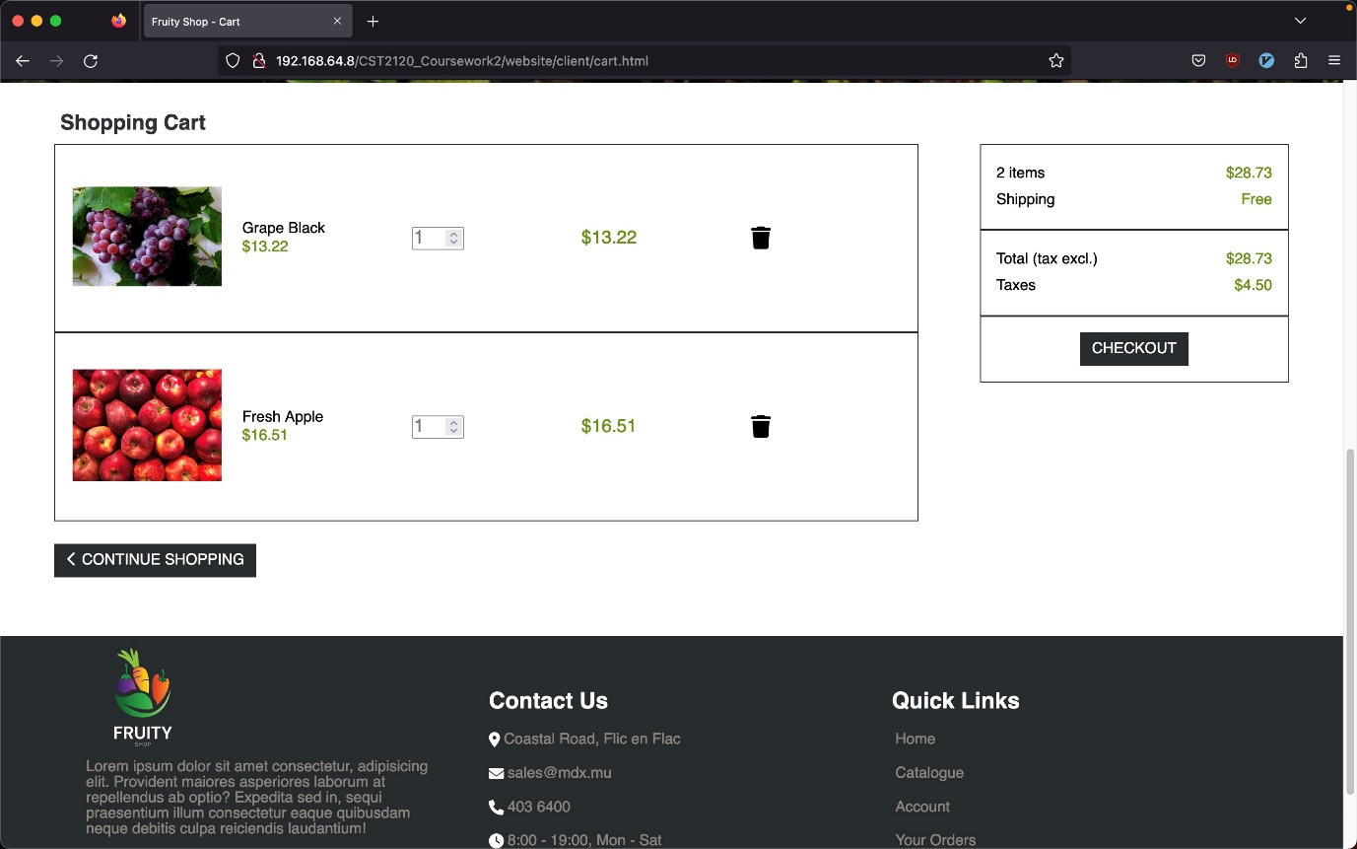

Figure 5 - Cart page shopping cart

### Design

The cart page or basket page will serve the client to see his current basket and proceed to the checkout to buy some product. The page is composed of the same header and decoration section with the “SHOP NOW” button like the welcoming page.

the page continues with the basket section listing on the three-quarter left of the screen the list of product added to client’s basket with the number of item add, the product image, the price and a delete button per item. On the space left on the right there is a summary in a receipt format showing the number of items buy, the shipping price, the total price and the taxes apply. Below the receipt information is a checkout button to validate the order. Under these two basket and summary there is a “CONTINUE SHOPPING” button.

### Functionalities

On this page, the basket section has a high importance on the well execution of the order’s client process and user experience. The list fruit in the basket will be display dynamically with all the different fruits information and an input which the user can modify to change the quantity of fruit buy. Modifying the quantity will automatically readjust the information displayed relate to the quantity such as the total price.

## Account page

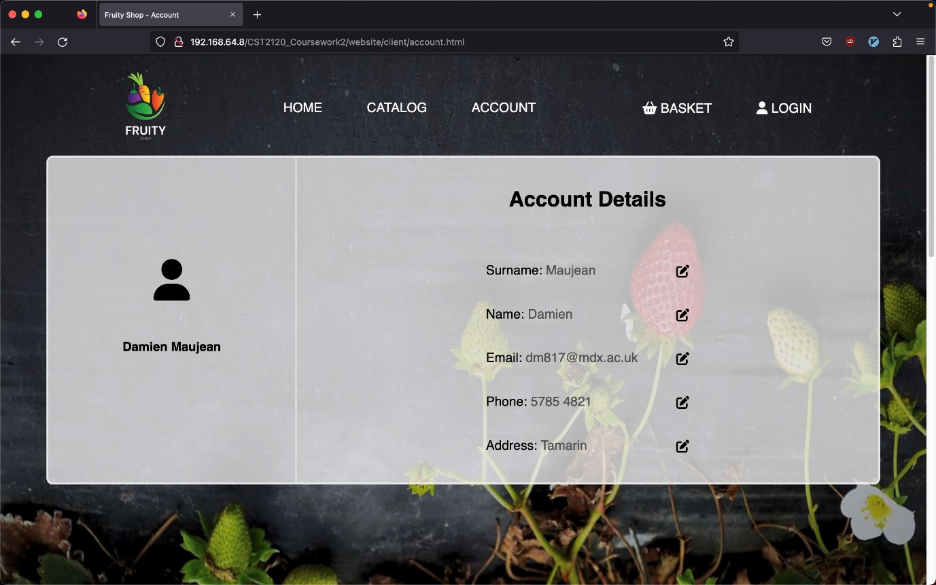

Figure 6 - Account page details

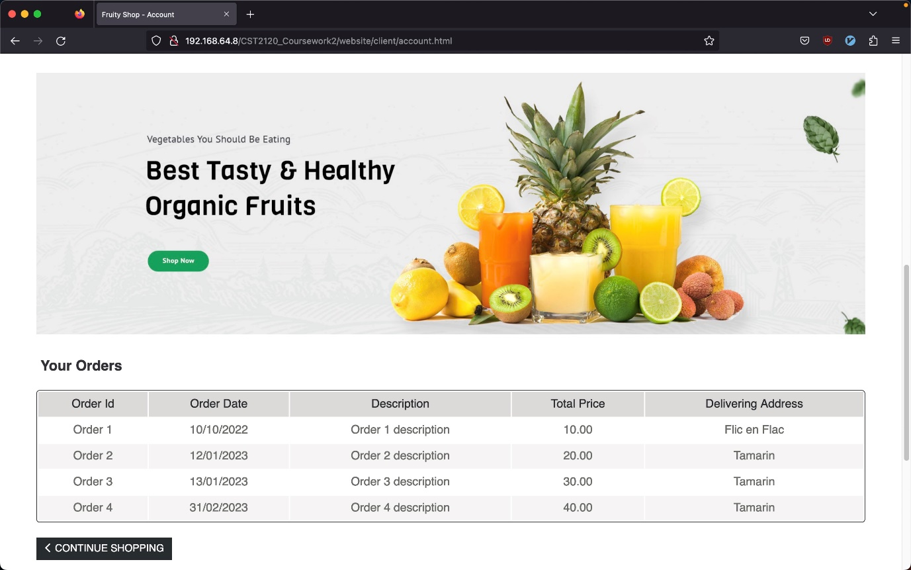

Figure 7 - Account page orders

### Design

The Account page serve the user to check is personal information and olds orders. The first part of the website consists of the user’s information split in two parts. Firstly, there is an icon with the user’s name and surname on the left, then on the right is display all the account details with an icon to modify the different information. Under the account section there is a decorative picture.

Below all these elements there is the orders section which list a summary of the different orders done by the user in a table format. And finally, a “CONTINUE SHOPPING” button followed by the footer.

### Functionalities

The Account section display dynamically the user’s information and allow the user to change this information with a button next to the wanted information, clicking in it will display a popup to fill the entry with the new information. All the data enter by the user will be verify before applying to avoid problem with the database.

The Orders section will display dynamically the history of the different orders done by the user, this data will be call from the MongoDB database and process to be display in a user-friendly format.

## Login page

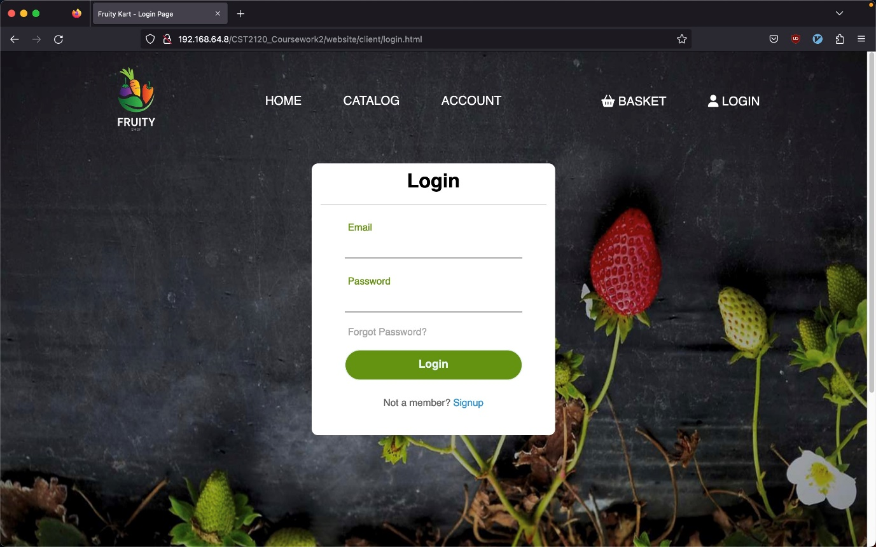

Figure 8 - Login page

### Design

The Login page is composed of a floating box to allow the user to login with their credential (email and password) followed by a login button and a little text clickable if for user’s not registered to sign up

### Functionalities

When the user will try to login, the website will call the data to check the validity of the credentials entered, if the credentials correspond to a user in the database, the user will be move to welcoming page and his user id will be stored in the session storage to keep the user login. If the credential doesn’t correspond, a message will appear to the user showing the corresponding error message and the user will be able to click on sign up to be move to the sign up page.

## Registration page

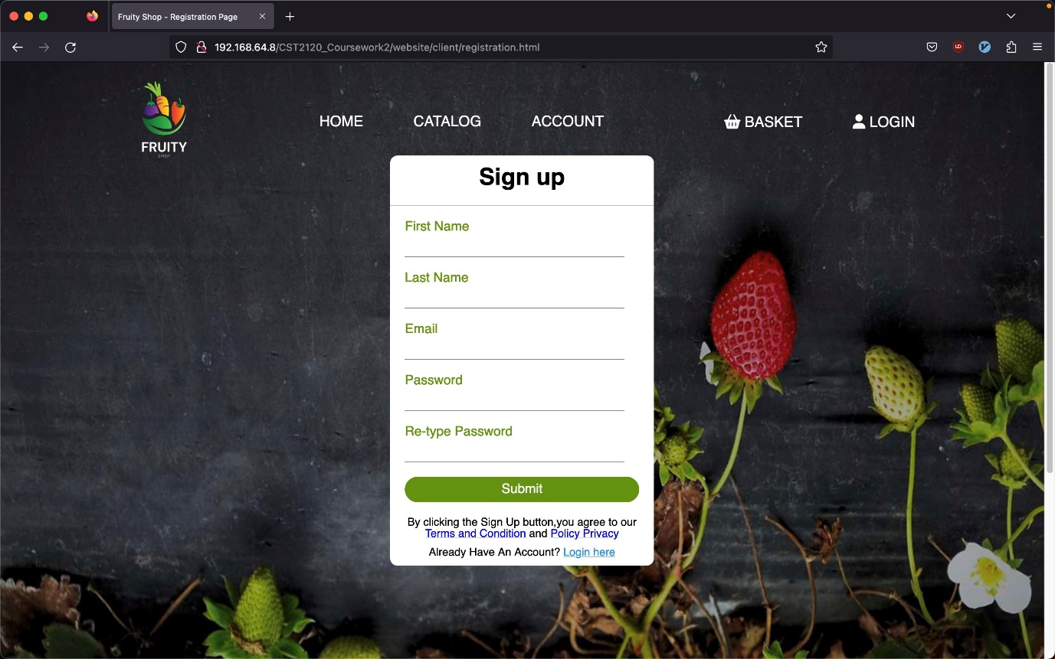

Figure 9 - Registration page

### Design

The registration page or sign-up page is very similar with the sign-in page and is compose of a floating box where the user can input the different information such as his first name, his last name, his email address and finally his password, another input is also there to make the user-retype his password. Below these entry field there is the submit button to submit the registration form and finally some information about the terms and conditions and a clicking text “Login here” if the user want to login instead.

### Functionalities

When the user fill the form for the registration, during this process some verification will be done on the type and the validity of the different entry probably using REGEX technologies and some verification on the current user’s list from the database to avoid duplication.

# CMS

The Content Management System or CMS is a separate website accessible only by staff to manage, edit ,delete and list products and orders.

(In case of access denied when opening the file, in the URL remove “cms.html” and press enter)

### Design

For the CMS, since the purpose of this website is to be use only by the staff, the design of the website is set to the bare minimum to be focus on the functionalities. It is composed of three parts, firstly on the left border there is a menu with the different option available to the staff, a button to list the product, another to list the orders, one to add a product and finally one to remove a product.

Next to the menu there is a big container split in two, firstly an searching section with different entry to filter and search product and orders. And below it a table to display the different information wanted.

Figure 10 - CMS Order view

Figure 11 - CMS product view

### Functionalities

For the different button from the left menu, the add and remove button will display a jQuery UI dialog box to allow the staff to enter data for new product or search for product to delete. These modifications will be directly processed, verified, and send to the database

For the “List Products” and “List Orders” button, a lot of modifications will be make on the page, firstly it will call the wanted data from the database (orders or products information) to dynamically populate the table with the right column name and data, the modification from these button will be the text before the entries filed on the top to correspond to the type header’s filterable.

To get access to the CMS, the user will have to login with the login page which is a derivation of the client-side login. It will call the database and check if the user has credentials to access this page.

Figure 12 - CMS login

# MongoDB Database Design

For the website, we have used MongoDB as our database management system. MongoDB is a NoSQL database that allows for scalability and flexibility in storing and querying data. In our website, we use MongoDB to store information such as customer information, product information, and order information. The CMS (Content Management System) also utilizes MongoDB to manage and manipulate the data on the website. With MongoDB, we can easily update and retrieve data, ensuring that the website runs smoothly and efficiently.

## Database structure

To use MongoDB in the more efficient way possible, we have created 3 table to contain all the data need: a user’s table, an orders table and finally a products table

Figure 13 - Database Class Diagram

### Users table

The users table has is name say’s is to keep all our users data for the login and tracking use. The user_id will be generated automatically by MongoDB; the email and password will serve for the login and finally the rest is stored for to keep tract of the user.

Figure 14 - User structure exemple

Figure 15 - User table structure

### Products table

The products table will keep all the information of all the product. These information’s are essential for the well being of the website to populate it. We keep the basic information such as name, price and stock availability, we have the season and category for the recommendation system and finally the image link to be able to dynamically display it

Figure 16 - Product structure exemple

Figure 17 - Product table structure

### Orders table

The orders table will keep the orders information. It is composed of an order, the client user_id, the total price, the date and for the product and their quantity, multiple products and quantity can be stored in one order. This way of structuring the order allow a reduction of the row per orders.

Figure 18 - Order structure exemple

Figure 19 - Order table structure

# Conclusion

In conclusion, the e-commerce website for our fruit company has been designed and developed with the user in mind, with a minimalist design and easy navigation. The website includes important features such as the ability to browse and purchase a variety of fresh fruits online, with a dynamic display of products from the MongoDB database and the option to search and sort products. Additionally, the website includes a CMS for the staff to manage and manipulate products and orders, with login verification from the MongoDB database. Overall, the website provides a seamless and efficient experience for both customers and staff, making it easy to purchase and manage fresh fruits online.