

**PDE3413 Systems Engineering for Robotics**

**Deliverable 1 - Initial Draft Proposal**

**Dereck Lam Hon Wah**

**M00826933**

**Date of Submission: 13.10.22**

**Lab Tutor: Praveer Towakel**

Table of Contents

Table of Figures 3

Introduction 4

Background Research 4

Analysis & Review 5

Proposal Description and Concept Behaviour 6

Physical Architecture 6

Sensors & Data Collection Methods 7

System Testing 9

Potential Pitfalls 9

Future Developments 9

Reference Lists 10

# Table of Figures

[Figure 1 ROBART 2 (Space and Naval Warfare Systems Center Pacific, n.d.) 5](https://livemdxac-my.sharepoint.com/personal/dl661_live_mdx_ac_uk/Documents/Year%202/PDE3413/PDE3413%20Coursework%201%20final.docx#_Toc116934000)

[Figure 2 Nimbo (hellonimbo.com, n.d.) 5](https://livemdxac-my.sharepoint.com/personal/dl661_live_mdx_ac_uk/Documents/Year%202/PDE3413/PDE3413%20Coursework%201%20final.docx#_Toc116934001)

Figure 3 System Architecture 7

Figure 4 DC Gear Motor (grobotronics.com, n.d.) 7

Figure 5 Piezo Speaker (grobotronics.com, n.d.) 8

Figure 6 PIR Sensor (grobotronics.com, n.d.) 8

Figure 7 Raspberry Pi Camera (grobotronics.com, n.d.) 8

Figure 8 Ultrasonic Distance Sensor - HC-SR04 (Sparkfun.com, 2017) 8

Figure 9 Servo Motor (Instructables, 2015) 8

# Introduction

One of the technologies with the fastest rate of evolution is robotics, which has found usage in different applications. And today, because of the power of artificial intelligence, a robot's capacity to be aware of its surroundings and to think more intelligently has made it qualified to execute even the most difficult duties. Social robots are physical machines designed to interact with humans and other robots by expressing social behaviours like speaking, listening, and expressing human-like emotions.

According to research, reports of thefts and break-ins are increasing, and they are becoming more frequent every day. Every 25.7 seconds, or around 3,300 each day, a burglary occurs. (FBI Crime Data, n.d.) and the New York Police Department (NYPD) has reported an increase of 32.7% increase in burglaries from 2021 to 2022. (Hooman, n.d.). A forced entrance is necessary in 95% of all home invasions, whether it is by smashing a window, picking a lock, or kicking in a door. (Alarms.orgs, 2015) and homes without any security system are 300% more likely to be burglarized. The global smart home security market is expecting an impressive compound annual growth rate increase during the forecasted period, 2023 – 2027. (researchandmarkets.com, 2022).

Unfortunately, less than 30% of homes have an effective security system installed (Homan, n.d.). Many of these devices need arduous installation, and it is challenging to maintain and monitor each one of them.

When you consider all the possible savings that you may lose in a single burglary, this project proposal of autonomous burglar detection robots will mitigate the risk of becoming a victim. Moreover, studies have proved that security robots are as effective as or can be more effective than humans in terms of surveillance.

# Background Research

Autonomous burglar detection robots are intelligent machines that will respond without any human interventions and in an adaptive fashion to a potential disturbance reported by a range of sensors. For any autonomous/mobile robot, the predominant challenge is the very nature of its mobility as it introduces a never-ending sequence of dynamically changing variables that continuously alter the physical relationships between the robot and its surrounding. The development of autonomous security robots so far may be divided into three broad categories:

1. getting from point A to point B;
2. doing so without colliding with anything;
3. carrying out some tasks.

The Mobile Detection Assessment Response System (MDARS) program run by the project manager, Physical Security Equipment (PM-PSE), Ft. Belvoir, Virginia, is one of the first applications of an autonomous robot to be successfully tackled (IEEE Instrumentation & Measurement Magazine, 2003). The primary issue with any physical security system is if its sensors’ sensitivity increases to achieve a higher probability of detection, the alarm triggering rate also goes up, and thus users subsequently lose confidence in the system.

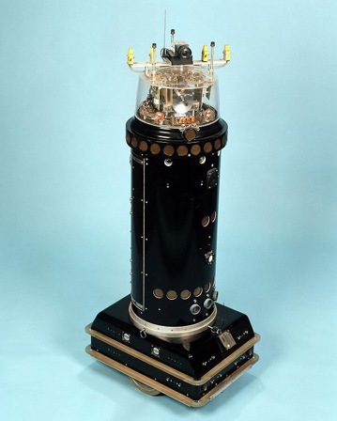 The ROBART series of research prototypes helped the development of a technological solution to address the issue under the MDARS program. While ROBART I (1980–1982) could only detect an intrusion, ROBART II (1982–1992) could both detect and assess, with the assessment goal being the elimination of triggering alarms. (Naval Ocean Systems Center, n.d.).

Figure 1 ROBART 2 (Space and Naval Warfare Systems Center Pacific, n.d.)

Many companies have joined the party by producing or leasing security robots. Their features are relatively identical to the ROBART series, with the only difference in their physical design. Some features of nowadays security robots are:

1. Autonomous mobility. Using GPS and a laser-ranging device enables them to travel and wander in a geo-fenced area with virtual boundaries generated by utilizing a mapping program by themselves.
2. 360-degree vision. It features a high-definition camera on each side of the robot, so everything around it is captured. It doesn't just record activity and notifies the security staff of any questionable behavior.
3. A real-time alert feature enables us to use various types of sensors to collect data that are viewed by any authorized person.

# Analysis & Review

At CES 2018, Turing Video presents Nimbo, a new intelligent security robot that is both clever and cost-effective. Nimbo is built with cutting-edge A.I. capabilities.

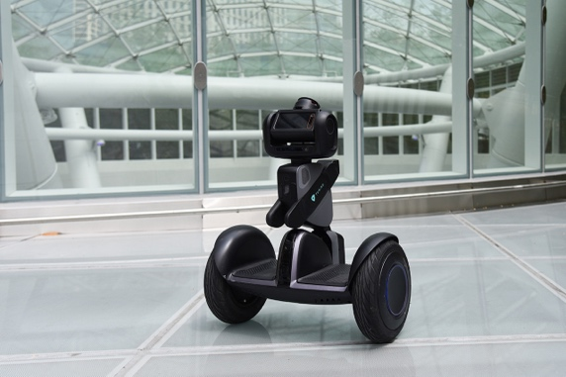

Figure 2 Nimbo (hellonimbo.com, n.d.)

They employ a range of technologies to patrol, communicate, record, and even pursue intruders. These digital guards include everything a security guard might possibly need, including LIDAR, videography, photography, artificial intelligence, machine learning, simultaneous location and mapping (SLAM), sensors, the Internet of Things, and GPS.

Nimbo may be pre-programmed to patrol predetermined routes or self-optimized paths while continuously monitoring nearby environs and human activity. It intends to spot security infractions or abnormalities and alert others in the vicinity with appropriate light, audio, and visual cues. It gathers HD video evidence, transmits alerts to security staff, and streams live video to mobile devices. Additionally, it enables auto charging stations, two-way audio, and 24/7 continuous video history (www.securityinfowatch.com, n.d.)

In warehouses, malls, jails, offices, gas stations, and other places, robot surveillance is a relatively recent trend that is spreading around the globe. The market for these devices in the United States alone reached $2.11 billion in 2018 and has anticipated reaching $3.33 billion by 2024, per one research (www.mordorintelligence.com, n.d.).

Nimbo still costs more than $2,000 despite being such a benefit to society. Due to the ridiculous price margin, such an item is not yet suitable for residential usage.

Despite everything stated, the NIMBO security robot has its flaws:

1. Outdoor surveillance is difficult as, for LIDAR to map surveillance areas, walls must be present to bounce the signal back.
2. Small robots may not be suitable for parking lot patrols since they can be difficult for automobiles and trucks to see.
3. They can be attacked by humans who view them with distrust or even hostility.

The social impact such systems have on jobless individuals is the danger. Such technology tries to lower corporate expenses across the market, which is advantageous from a business standpoint. But it hasn't yet been beneficial to those fired for reducing extra costs to the company.

# Proposal Description and Concept Behaviour

AlarmBuzz is a proposed system that will wander and recognize any human intrusions in a designated area, reducing the risk of burglary. Any unauthorized activity in the room, the owner informed. A text message/email transmitted over the (IoT) Internet of Things, and the robot’s webcam would target the intruder and capture his/her image. A buzzer is activated to alert the surrounding persons of the intrusion. The photograph is forwarded to the authorized user via email. In the future, if the intrusion is confirmed to be a theft case, the authorized user can access the cloud to view the captured images.

Commercial security systems employ more advanced tools and technology. Small businesses and homeowners sometimes cannot afford the very advanced technologies for security systems. Therefore, we created this project for small enterprises at a low cost.

# Physical Architecture

AlarmBuzz patrols the area using DC motors to power its wheel and avoids any collisions with any structures using proximity sensors situated at specific points mounted on the robot. When an unauthorized person enters the area, the person’s movement is detected depending on the temperature variations by a PIR sensor. The PIR sensor sends a signal to the Arduino monitor, confirming the movement detection. The system connects to IoT, which will send an alert via email/text message to the user about the intruder. The servo motor helps the calibration of the camera to focus on the unauthorized person and capture his/her image. The captured images are uploaded to the cloud. In case of a human intruder, the robot triggers the buzzer or else if the intruder is an animal, it won’t trigger the buzzer. An Arduino and a Raspberry Pi are used, as the computing platforms for this project.

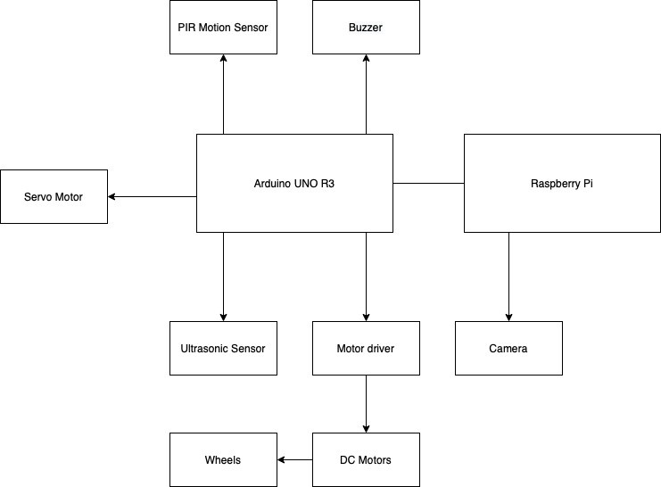

Figure System Architecture

The Arduino microcontroller features digital and analog pins, and input/output ports are used for data input and output. Arduino is cheaper but less powerful than a raspberry pi. However, its chip links most sensors as it has a built-in CPU, memory, and I/O. The raspberry pie runs a Debian OS, and even though there is no integrated memory and I/O, it has a stronger CPU and better memory and address space since it has external buses.

# Sensors & Data Collection Methods

|  |  |
| --- | --- |
| **Sensor** | **Application and uses** |
| Figure 4 DC Gear Motor (grobotronics.com, n.d.) | DC motors only have two leads: a positive lead and a negative lead. The motor will turn if you connect these two lines directly to a battery. The DC motor turn in the other direction if we switch the leads.  A motor driver (L293D) will be connected to the Arduino microcontroller to receive commands and run the DC motor with a high current. (Arduino Project Hub, n.d.) |
| Figure 5 Piezo Speaker (grobotronics.com, n.d.) | Piezo Buzzer is connected to the Arduino and emits an alarm if an intrusion is detected. |
| Figure 6 PIR Sensor (grobotronics.com, n.d.) | A human movement is picked up by a PIR sensor within about 10 meters of the sensor and detects any infrared radiation corresponding to human body IR light. It can be connected to the Arduino directly as it requires 5V to power up. |
| Figure 7 Raspberry Pi Camera (grobotronics.com, n.d.) | Raspberry pi has a port for connecting the camera module. Raspberry pi uses fewer resources than an Arduino, so it is faster. Its image processing is more efficient than an Arduino. |
| Ultrasonic Distance Sensor - HC-SR04  Figure 8 Ultrasonic Distance Sensor - HC-SR04 (Sparkfun.com, 2017) | An ultrasonic sensor measures distance by emitting an ultrasound of a frequency of 40kHz, which will bounce back to the sensor if an item or obstruction is in its path. (Jabbaar, 2019). AlarmBuzz will avoid collisions with walls or obstacles and always has a clear route ahead. |
| DC Motor in Micro Servo Body and 0.1" power cable  Figure 9 FS90R Servo Motor (Instructables, 2015) | The servo motor has an output shaft that allows precise angular positions by receiving directly a signal from an Arduino. A servo mounted under the camera will help its calibration and the direction to focus and capture an image of the intruder. |

# System Testing

The initial test will be carried to AlarmBuzz to wander autonomously in an area without collisions using the ultrasonic sensor. A test track with obstacles and walls will be built to test the autonomous features.

The second test will be on the PIR sensor. We test that it detects movement from the biggest to the smallest, like a handshake. If the sensor successfully passed the previous test, we now need to check whether it differentiates between moving objects and warm-blooded beings. PIR sensors can detect moving objects that emit IR light. A simple test is to stand or place a non-living being in front of it.

The third test is on the servo motor and camera to help find the proper calibration and direction to focus the camera. A test intruder is placed at different angles. Using a combination of the PIR sensor and the camera, it detects in which direction the test intruder is and rotates the servo motor accordingly.

The last test will be on the camera, IoT and buzzer. It needs to capture a proper image, upload it to the cloud and send the necessary alerts to the authorized person. Using the camera and AI, it will analyze if the test subject is human or animal and trigger an alarm with the buzzer.

# Potential Pitfalls

This project seems easy in concept, but an accurate detection of the human intruder and collision avoidance with an obstacle is hard to implement as the proper sensors with their calibration will need more research and time. AlarmBuzz will need a portable source of power to operate as its behavior is to wander in an area.

Another pitfall of this project is finding the proper way to calibrate the servo motor to focus on the intruder and an AI for the camera to distinguish a human being.

# Future Developments

In the future, as AlarmBuzz is just university coursework, more powerful sensors might be used to increase its accuracy and efficiency.

We can also create a whole security system using multiple AlarmBuzz stationed in an operation room and PIR sensors. If an intrusion is detected, they would autonomously drive to the location to access and pursue the intruders. However, the robustness of AlarmBuzz must be revisited as the materials used are fragile for this proposed project.

# Reference Lists

1. Alarms.org. (2015). *Burglary Statistics: The Hard Numbers | National Council For Home Safety and Security*. [online] Available at: <https://www.alarms.org/burglary-statistics/>. [Accessed: 15 Oct. 2022]
2. Arduino Project Hub. (n.d.). *The Beginner’s Guide To Control Motors by Arduino and L293D*. [online] Available at: <https://create.arduino.cc/projecthub/electropeak/the-beginner-s-guide-to-control-motors-by-arduino-and-l293d-139307>. [Accessed: 13 Oct. 2022]
3. Arduino Project Hub. (n.d.). *Arduino with PIR Motion Sensor*. [online] Available at: <https://create.arduino.cc/projecthub/biharilifehacker/arduino-with-pir-motion-sensor-fd540a>. [Accessed: 15 Oct. 2022]
4. Furhat Robotics. (2020). *What Are Social Robots? An Introduction to the Furhat Robot*. [online] Available at: <https://furhatrobotics.com/blog/what-are-social-robots/>. [Accessed: 13 Oct. 2022]
5. grobotronics.com. (n.d.). *Buzzer 2-5V 30mA*. [online] Available at: https://grobotronics.com/buzzer-2-5v-30ma.html [Accessed: 17 Oct. 2022].
6. grobotronics.com. (n.d.). *DC Gear Motor TT - 125 RPM*. [online] Available at: https://grobotronics.com/dc-gear-motor.html?sl=en [Accessed: 17 Oct. 2022].
7. ‌ grobotronics.com. (n.d.).  *PIR Sensor Module - HC-SR501*. [online] Available at: https://grobotronics.com/pir-sensor-module.html [Accessed: 17 Oct. 2022].
8. grobotronics.com. (n.d.). *Raspberry Pi Camera Module V2 (8MP,1080p)*. [online] Available at: https://grobotronics.com/raspberry-pi-camera-module-v2-8mp-1080p.html [Accessed: 17 Oct. 2022].
9. Homan, R. (n.d.). *Burglary Statistics 2022*. [online] Bankrate. Available at: <https://www.bankrate.com/insurance/homeowners-insurance/house-burglary-statistics/#stats>. [Accessed: 15 Oct. 2022]
10. IEEE Instrumentation & Measurement Magazine. (2003). [online] Available at: https://www.hsdl.org/?view&did=451029. [Accessed: 13 Oct. 2022]
11. in.micron.com. (n.d.). *To Catch a Thief: How Security Robots Help Make Our Lives Safer*. [online] Available at: <https://in.micron.com/insight/to-catch-a-thief-how-security-robots-help-make-our-lives-safer> [Accessed 4 Nov. 2022].
12. Instructables (2015). *Arduino Servo Motors*. [online] Instructables. Available at: <https://www.instructables.com/Arduino-Servo-Motors/>. [Accessed: 14 Oct. 2022]
13. Jabbaar, A.A. (2019). *Ultrasonic Sensor HC-SR04 with Arduino Tutorial*. [online] Arduino Project Hub. Available at: <https://create.arduino.cc/projecthub/abdularbi17/ultrasonic-sensor-hc-sr04-with-arduino-tutorial-327ff6>. [Accessed: 17 Oct. 2022]
14. Sparkfun.com. (2017). *Ultrasonic Distance Sensor - HC-SR04 - SEN-15569 - SparkFun Electronics*. [online] Available at: <https://www.sparkfun.com/products/15569>. [Accessed: 17 Oct. 2022]
15. ‌Suryavamsi, P.S.N. and Arockia Selvakumar, A. (2018). IoT Controlled Mobile Robot for Home Security and Surveillance. *International Conference on Intelligent Data Communication Technologies and Internet of Things (ICICI) 2018*, pp.431–438. doi:10.1007/978-3-030-03146-6_48.
16. www.amazon.com. (n.d.). *Amazon.com : Segway Ninebot LOOMO Advanced Personal Robot and Personal Transporter, Black : Sports & Outdoors*. [online] Available at: https://www.amazon.com/Segway-Robotics-S1RC340-Loomo-Dev/dp/B071K61RPD [Accessed: 17 Oct. 2022].
17. www.securityinfowatch.com. (n.d.). *StackPath*. [online] Available at: <https://www.securityinfowatch.com/perimeter-security/robotics/product/12390271/segway-nimbo-security-robot-from-segway-and-turing-video> [Accessed: 15 Oct. 2022].
18. www.micron.com. (n.d.). *To Catch a Thief: How Security Robots Help Make Our Lives Safer*. [online] Available at: <https://www.micron.com/insight/to-catch-a-thief-how-security-robots-help-make-our-lives-safer>. [Accessed: 15 Oct. 2022]
19. www.mordorintelligence.com. (n.d.). *Security Robot Market Share, Size | 2022 - 27 | Industry Growth*. [online] Available at: https://www.mordorintelligence.com/industry-reports/security-robots-market [Accessed: 16 Oct. 2022].

‌

‌

‌

‌