

**PDE3413 Systems Engineering for Robotics**

**Deliverable 2 -Final Proposal and Presentation**

**Dereck Lam Hon Wah**

**M00826933**

**Date of Submission: 06.11.22**

**Lab Tutor: Praveer Towakel**

Table of Contents

Introduction 3

Background Research 3

Analysis & Review 5

Proposal Description 6

Concept Behaviour 6

Physical Architecture 7

Sensors & Data Collected Uses 8

Actuators and Interaction with People/Environment 10

System Testing 10

Potential Pitfalls 12

Future Developments 12

Reference Lists 13

# Introduction

Robotics, among any technological advancement, is evolving at an exponential rate and found usage in multiple scenarios. And, nowadays, a robot's ability to be aware of its environment and to think more autonomously has made it fit to carry out even the most elaborate tasks thanks to the strength of artificial intelligence. Social robots must exhibit social behaviours like speaking, listening, and showing human-like emotions to communicate with people and other robots.

Research shows that complaints of burglaries and housebreaking are rising but also growing more common these days. A robbery happens every 25.7 seconds or around 3,300 times per day (FBI Crime Data, n.d.). According to the New York Police Department (NYPD), burglaries rate figures increased by 32.7% between 2021 and 2022 (Hooman, n.d.). 95% of all home invasions involve a forcible entry by breaking a window, cracking a lock, or smashing a door (Alarms.orgs, 2015). Residences without any surveillance systems are 300% more likely to be breached. During the predicted period, 2023 to 2027, the global market for smart home security is forecasted to have a remarkable increase in the compound annual growth rate (researchandmarkets.com, 2022).

However, less than 30% of buildings nowadays have a reliable security system (Homan, n.d.). The installation of these systems is tedious, and regular monitoring and maintenance of every one of them are challenging.

The latest advancement in technology demonstrates that the implementation of security robots can be just as efficient as people or better for building surveillance. However, commercial security robots like Knightscope, typically rented by a casino, residential complex, bank, or in one instance, a police force, are charged annually around $70,000 to $80,000, which is unaffordable for low-income earners and small businesses (NBC News, n.d.).

The risk of being a victim will be mitigated by this project proposal of autonomous burglar detection robots when you think of all the potential savings to fight against this increasing world-wide problem.

# Background Research

Like humans, autonomous robots can decide for themselves and take appropriate action. A robot that can observe its surroundings, decide based on what it sees or taught to recognize, and then actuate a movement or manipulation within that environment is considered autonomous (Hart, 2022). Examples of these decision-based behaviours in terms of robot mobility include, but are not limited to, simple operations like starting, stopping, and swerving to avoid impediments.

Perception, choice, and actuation are the three key ideas that make up an autonomous robot. Perception means the wide range of sensors used as input devices for a robot to help it visualize and perceive its environment. For any decision-making process, an autonomous robot uses a safety system, an embedded system that operates faster and with higher authority than the computer, which executes a mission plan and parses data. (Hart, 2022). Robots use a variety of actuators like muscles to carry out numerous tasks, and most actuators contain a motor of some sort. There is always a motor creating movement, whether it has a hydraulic ram, linear actuator, or wheel.

Intelligent security robots can track people and assets, patrol physical places, or capture data to detect issues that humans might miss. They also don't sleep (Plain Concepts, 2022). Instead of relying on electrical cables or predetermined routes, they calculate routes and interpret the best alternative using a sophisticated system of sensors, AI, and machine learning. With cameras and sensors, the next generation of robots use obstacle collision avoidance system to avoid obstacles while moving and use navigational strategies to slow down, stop, or recalculate the path without colliding.

Cameras like Raspberry pi cameras are used by machine vision to collect visual data from the environment. It then prepares the data for usage in various applications by processing the photos using a combination of hardware and software. Specialized optics are frequently used in machine vision technology to capture images. With this method, specific image properties can be processed, examined, and assessed (SearchEnterpriseAI, n.d.).

To identify any potential obstacles, the obstacle collision avoidance system uses sensors to gather data about the area using digital image processing or distance measurements. Although cameras, positioning systems, and ultrasonic sensors are frequently employed to move in an unfamiliar area, they are not the best option to make the robot structure more organized. To achieve specific performance goals, some infrared sensors are employed to follow the best non-collision path from source to destination (Almasri, Alajlan and Elleithy, 2016).

One of the earliest implementations of an autonomous robot to be successfully solved is the Mobile Detection Assessment Response System (MDARS) program operated by the project manager, Physical Security Equipment (PM-PSE), Ft. Belvoir, Virginia (IEEE Instrumentation & Measurement Magazine, 2003). Any security management system's key concern is that as sensors become more sensitive to enhance the accuracy of detection, more alarms start to go off, which makes consumers less confident in the system.

Under the MDARS initiative, a technological solution to the problem was developed with the assistance of the ROBART series of research prototypes. In contrast to ROBART I (1980–1982), which could only detect intrusions, ROBART II (1982–1992) could detect and analyze intrusions with the assessment's primary objective being the abolition of alarm-triggering activities. n.d. (Naval Ocean Systems Center).

A lot of businesses have gotten involved by creating or renting security robots. Except for their physical design, their features are nearly identical to those of the ROBART series. Among the characteristics of modern security robots are:

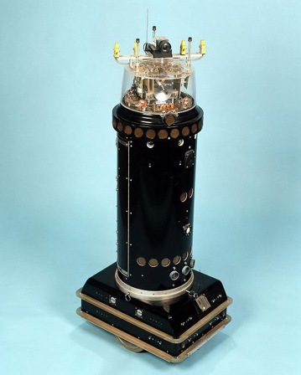

1. autonomy in movement. They can move and roam in a geo-fenced region with virtual bounds created by using a mapping application on their own using GPS and a laser-ranging instrument.
2. 360-degree vision. It has a high-definition camera on either side of the robot, allowing it to record anything around it. It does more than just log activities and alerts the security team to any suspicious behaviour.
3. Using a real-time alert function, we may employ a variety of sensors to gather information that can be seen by anybody with permission.

Figure 1 ROBART 2 (Space and Naval Warfare Systems Center Pacific, n.d.)

# Analysis & Review

Nimbo, a new intelligent security robot that is both smart and economical, is displayed at CES 2018 by Turing Video (www.securityinfowatch.com, n.d.). Nimbo was created with state-of-the-art artificial intelligence technologies.

To monitor, interact with, capture, and even chase burglars, they make use of a variety of technology. LIDAR, videography, photography, artificial intelligence, machine learning, simultaneous location and mapping (SLAM), sensors, the Internet of Things, GPS, and other technologies are all included in these digital guardians (in.micron.com, n.d.).

LiDAR (Light Detection and Ranging) is a technology of remote sensing. The laser pulse from LiDAR technology is used to gather data. These are employed to generate 3D representations of objects and surroundings, including maps. LiDAR systems estimate the time it takes for light beams to strike an object or surface and reflect the laser scanner. The velocity of light is used to determine the distance called "Time of Flight" measurements. (GeoSLAM, n.d.).

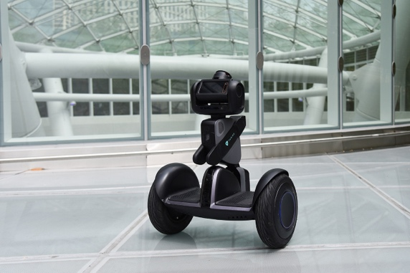

Moreover, artificial intelligence teaches Nimbo to think critically and creatively like a human mind (Kelley, 2022). AI is achieved by examining the cognitive process and researching the patterns of the human brain. These research projects produce systems and software that are intelligent. A form of artificial intelligence called machine learning allows Nimbo to learn from its past performance without being explicitly programmed. Its goal is for Nimbo to access data and use it to acquire knowledge on its own. It can patrol any indoor environment, deliver personalized alarms, stream live video surveillance, and initiate automatic responses like detecting human and animal intrusions because it is equipped with a powerful video analytics platform and A.I. technology.

Figure 2 Nimbo (hellonimbo.com, n.d.)

Using the simultaneous localization and mapping (SLAM) problem, it is conceivable for Nimbo to be deployed in an uncharted environment and incrementally create a reliable map of that environment while detecting its position within that map (Durrant-Whyte and Bailey, 2006).

The network of physical objects implanted with sensors, software, and other technologies to communicate and exchange data with other devices and systems through the internet refers to the Internet of Things (IoT) (Oracle, 2021). It helps Nimbo to push notifications, email notifications, evidence Review, and cloud storage in case of intrusions.

Nimbo can be pre-programmed to patrol specified routes or self-optimized courses while constantly keeping an eye on the immediate surroundings and human activity. It seeks to identify security violations or anomalies and warn those nearby with the proper audible, visual, and lighting cues. It compiles HD video evidence, sends security personnel notifications, and streams real-time footage to mobile devices. Additionally, it supports two-way audio, auto charging stations, and 24/7 continuous video history (www.securityinfowatch.com, n.d.)

Robotic surveillance is a relatively new concept that is catching on worldwide in warehouses, shopping centers, jails, offices, gas stations, and other places. According to one research, the market for these devices in the United States alone reached $2.11 billion in 2018 and will expect to reach $3.33 billion by 2024. (www.mordorintelligence.com, n.d.). Nevertheless, according to research, Nimbo costs $12 per hour, making it unsuited for domestic use.

# Proposal Description

AlarmBuzz, a low-budget version of Nimbo, a commercial autonomous burglar detection robot, is the proposed system that provides a solution to fight against the rising rates of robberies and housebreaking. Compared to conventional monitoring cameras in buildings that suffer from increasing intrusion rates due to blind spots, AlarmBuzz, equipped with a vision sensor, uses a map of the environment, and detects more intruders by employing its mobility and real-time monitoring capabilities.

Sometimes, when considering getting an alarm monitoring system, its biggest drawback is the cost because commercial security systems or autonomous security robots use more sophisticated sensors and technologies. Households and smaller companies cannot afford the most cutting-edge security system technologies. As a result, we developed this project at a minimal cost for small businesses and individuals, making it accessible to everyone to protect their property. Moreover, AlarmBuzz keeps the owners safe, as there is no intimation or contact between the owner and intruders about a breakdown compared to someone without a monitoring system.

Conventional monitoring cameras alongside security staff might encounter difficulties detecting human intrusions from animal intrusions in a dark area and keeping real-time records of any intrusions. AlarmBuzz, equipped with a vision and infrared sensor, will detect movement intrusions using AI and Machine Learning to identify if it is human and keeps a record in the cloud using the IoT.

# Concept Behaviour

AlarmBuzz is a proposed robotic system that will independently patrol a designated zone while detecting and identifying human intrusions. In case human intrusion is confirmed, it alerts the owner and keeps a record in the cloud.

It will be a 3-wheeled robot powered by a motor driver module alongside 2 DC motors providing it the mobility it requires to travel from point A to point B. A collision Obstacle Avoidance System is implemented in the robot to automatically sense an obstacle in front of it and avoid them by turning itself using an HC-SR04 Ultrasonic Sensor. An ultrasonic sensor's fundamental idea is to keep track of how long it takes the sensor to broadcast ultrasonic beams and how long it takes to receive them after they have struck a surface. If an object is detected ahead, the robot will halt before moving rearward, then briefly pause again before turning in a defined different direction.

When an unauthorized person enters AlarmBuzz's patrol area, a PIR sensor will detect the area's occupancy and movement from the infrared light emitted from the human body, sending a signal directly to the Arduino (docs.arduino.cc, n.d.).

The signal will trigger the servo motor mounted under a raspberry pi camera, which will be positioned at various angles to calibrate and focus the camera on the intruder. Machine vision equipped with the camera, Raspberry Pi is capable of image analysis, object recognition, and even face and text recognition. (Monk, 2016). If the raspberry pi concludes that the movement comes from humans and is not animal-based, it will capture an image and sends a signal to the Arduino.

The signal of human intrusion from the Raspberry pi will initiate the connection to the Arduino IoT cloud, a platform with a user-friendly interface and an all-in-one solution for configuration, coding, uploading, and visualization to create IoT projects. Webhooks with Arduino IoT Cloud enable automatic message sending and receiving to and from other services. Webhooks will send a message alongside an "action" link and an email containing the captured image of the intruder to any of the owner’s devices to notify him/her of a possible human intrusion. Upon confirmation of action, it will use a buzzer or piezo speaker with Arduino to alert the surrounding about the intrusion.

The authorized user can access the cloud in the future to review the photographs taken if determined that the intrusion was a theft case.

# Physical Architecture

As computer platforms for this project, both an Arduino and a Raspberry Pi are utilized in terms of their respective advantages. Arduino has 20 I/O pins: 6 Analog Inputs and 14 Digital Input/Output pins. (Miller, 2019) It features built-in headers and a USB port for simple programming and prototyping. The Arduino Uno is a better option for portable, battery-powered projects as it comes with an affordable price and low power consumption (50 mA) (Miller, 2019). The Raspberry Pi Foundation developed the single-board computer known as the Raspberry Pi. It boasts a ton of features, including an SD card reader, 4X USB ports, built-in LAN, WiFi, Bluetooth, and more! Additionally, it has 500,000 times more RAM than the Arduino Uno has (Miller, 2019).

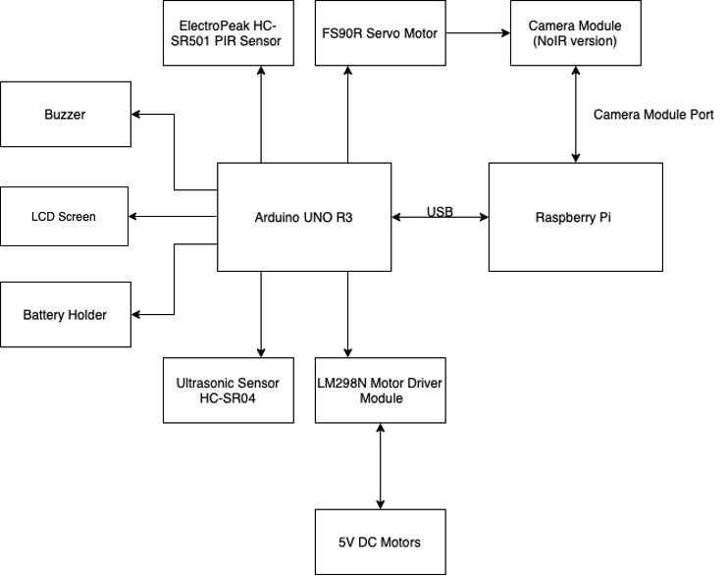

Figure 3 System Architecture

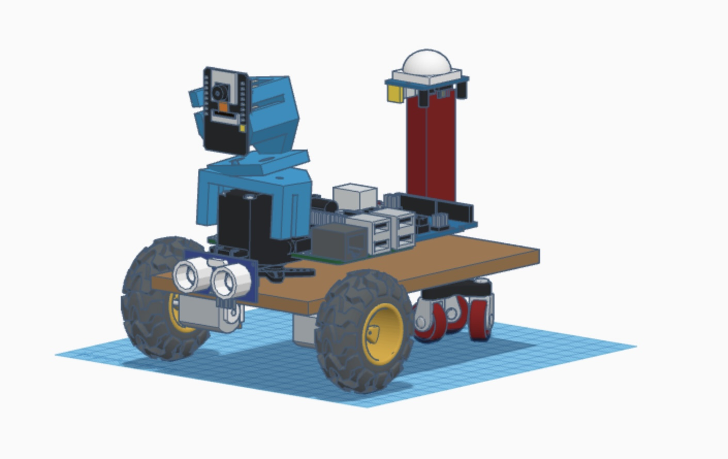

5V DC Motors

Ultrasonic sensor

Raspberry pi

LN298N Motor Driver

Arduino UNO R3

SR501 PIR Sensor

FS90R Servo Motor

Raspberry pi camera v2

Figure 4 Prototype

# Sensors & Data Collected Uses

|  |  |  |
| --- | --- | --- |
| **Sensors** | **Description** | **Uses** |
| Figure 3 Raspberry Pi Camera Module 2 (grobotronics.com, n.d.) | It is an HD camera module that works with all Raspberry Pi models. high sensitivity, minimal crosstalk, and noise-free image capture are all provided in a remarkably compact and light-weight build. Connected via the CSI bus on the raspberry pi, it transfers exclusively pixel data at very high speed to the processor.  The NoIR version equipped without an infrared filter will enable night vision in an area illuminated with infrared light for image capture. | Machine/computer vision on the raspberry pi will help AlarmBuzz to analyze its environment and provide the data for the servo motor to calibrate and focus on the intruder. Moreover, AlarmBuzz will distinguish between a human or animal intrusion and proceed to the necessary steps.  The picamera, python module, is used on the raspberry pi camera module to capture images and OpenCV, an open-source computer vision and machine learning software library, alongside SimpleCV, a python wrapper for image analysis. |
| Figure 4 ElectroPeak HC-SR501 PIR Sensor (grobotronics.com, n.d.) | The PIR sensor catches any human or animal movement in its sensor range by detecting any heat energy of infrared radiation nature. This radiation is not visible to the human eye because it is emitted at infrared wavelengths.  The HC-SR501 PIR sensor is low power(5V-12V), inexpensive, easy to interface, and has proper documentation available online.  The PIR sensor has a potentiometer to adjust its sensitivity and time delay. A trigger on how the sensor will react to motion is also available. (Last Minute Engineers, 2018) | The PIR sensor’s pin value will be set to 1 when motion is detected and 0 when idle (no motion detection).  For this project, move the jumper to the H position (multiple trigger mode). As soon as a movement is detected, the output becomes HIGH and stays HIGH for the duration of the Time-Delay potentiometer. The time delay is reset each time motion is detected, unlike the single trigger mode, which stops any further detection until the time delay.  Another additional component of AlarmBuzz is the RL for the Light Dependent Resistor (LDR), which improves the sensor operation in a dark area. Since AlarmBuzz needs to be operational during the night or in dark spaces. |
| Ultrasonic Distance Sensor - HC-SR04  Figure 5 Ultrasonic Distance Sensor - HC-SR04 (Sparkfun.com, 2017) | HC-SR04 is capable of reporting object distances up to 13 feet away.  It is inexpensive, simple to interface with, and requires low power (5V ideal for battery-operated devices).  There are two ultrasonic transducers in HR-SR04. One functions as a transmitter, converting the electrical signal into pulses of ultrasonic sound at a frequency of 40 kHz. One operates as a receiver and searches for the transmitted pulses. It generates an output pulse whose width is related to the object's proximity in front. | Equipped with a motor driver and 2 DC motors for mobility, AlarmBuzz requires an obstacle avoidance system to avoid running into walls or objects.  Based on the distance converted from HR-SR04 by bursting an ultrasonic beam and receiving it, it changes the motor direction.  If the distance exceeds the specified, there are no obstacles ahead, and it will continue to move forward.  If the distance is closer than the specified distance, then an obstacle is in front of AlarmBuzz. It will therefore stop in this position, go backward, pause briefly again, and then turn in a different direction. |

# Actuators and Interaction with People/Environment

An actuator is a machine's component that aids in generating mechanical force by converting energy, frequently electrical, air, or hydraulic. It is the part of any machine that permits movement (Progressive Automations, n.d.).

AlarmBuzz is a burglary detection robot designed to patrol an area autonomously and take the necessary steps for any intrusions. Mounted on three wheels powered by 2 DC motors and a motor driver for its mobility, AlarmBuzz uses an object avoidance collision system with a PIR sensor to avoid collision with any walls or objects in the area. DC motors have two leads, positive and negative, which rotate when connected, and in the opposite direction if connections switch. L298N Motor driver is a controller that conveniently controls the direction and speed of up to 2 DC motors using an H-Bridge.

Any intrusion detected will trigger the servo motor alongside the raspberry pi camera to calibrate and focus on the intruder. The servo motor has an output shaft that will position to a specific angular position if the signal remains unchanged (www.tutorialspoint.com, n.d.). If the signal changes, the shaft's angular position changes. With machine vision from the raspberry pi camera, the servo motor will obtain different input signals and find the proper calibration to capture the intruder's image.

Confirmed human intrusion will trigger the connection to the arduino IoT cloud, which sends an "action" message alongside a captured image of the intruder by mail. If the owner sees the human intrusion as a threat, he clicks on the message's action link, which will trigger the buzzer and alert the intruder and surrounding persons that a burglary is detected.

For the actual scope of this project, AlarmBuzz will be battery-powered, which batteries are replaced by the owner when the LCD screen displays low power.

# System Testing

Testing will assess and confirm that AlarmBuzz performs its intended function. Testing has advantages like bug prevention, lower development costs, and better performance. There are three recognized phases of testing: unit/complement testing, integration testing, and system testing (Ulf Eriksson, 2014).

Unit/component testing performs at the earliest stages of any development process. By separating each component of AlarmBuzz, unit testing seeks to confirm that each one is correct in meeting their requirements and having the required functionality.

* Raspberry pi camera – After performing the basic installation with the Raspberry pi and the camera module, take a test image to see if it is working. If everything goes as planned, you should be able to open the image by looking for it in the defined directory. (Reiss, n.d.)
* FS90R Servo Motor, SR501 PIR sensor, Buzzer, LCD Screen, HC-SR04 Ultrasonic sensor, LM298N Motor Driver and DC motors – Every component mentioned can be tested by uploading some available code from the Arduino Official Website. The criteria of success have already been established.

Integration testing tests various system components in combination to determine whether they are successfully implemented. Any issues with how the units work together can be found by testing the units in groups (Ulf Eriksson, 2014).

* Obstacle Collision Avoidance System - DC motors, motor driver, and ultrasonic sensor are mounted on the Arduino UNO to test this concept. The success criteria are AlarmBuzz ability to patrol a test track without any collision with walls or objects.

If the distance detected by the ultrasonic sensor exceeds the defined one, there is no obstacle ahead. DC motors will continue to rotate forward for AlarmBuzz to move forward. If the distance detected by the ultrasonic sensor is less than the defined one, there is an obstacle ahead. DC motors will stop, rotate backward, and turn in different directions, stop again and continue their course.

* Movement Detection and Machine Vision – PIR sensor, FS90R Servo motor, and raspberry pi camera module are mounted on the Arduino UNO and Raspberry Pi. The success criteria are detection of intrusion and proper calibration of the camera to focus and capture a good image of the intruder.

Upon motion detected from the PIR sensor, it shall trigger the servo motor and raspberry pi camera operation. The raspberry pi camera using machine vision and machine learning identifies and analyzes its view of the intruder. It sends a signal to the Arduino to change the angle of the servo motor until the camera finds the proper focus to take a picture of the intruder. Multiple tests on the intruder's position, with respect to the servo motor and camera starting position, are performed to find the best initial rotational pattern of the servo motor to calibrate itself for focusing on the intruder. The speed of the servo motor calibration to a fast-moving intruder is to be tested and improved by looking at the perfect algorithms.

* A.I and Machine Learning – The success criteria are the raspberry pi alongside its camera module to distinguish between humans and animals, enabling AlarmBuzz to initiate the connection to the Arduino IoT cloud. The testing procedure is to find the proper python library/modules and test them using different illustrations of humans and animals until a correct sequence of pass identification test follows.
* Arduino IoT Cloud - The success criteria are upon raspberry confirming if the intruder is human and initializing a connection to the Arduino IoT cloud to alert the owner of the intrusion. A message with an "action" link and an email attached with the captured image sent to any of the owner's devices. If the user clicks the link, it sends a signal to the Arduino IoT cloud to trigger the buzzer.

Tests to be carried out are as follows:

* Initialization of the connection to the Arduino IoT cloud.
* Arduino IoT cloud sends the alerts to the owners.
* The owner clicks the link, which will trigger the buzzer.
* Captured image to be stored in the cloud.

System testing is the ultimate level of testing. As the name suggests, the completed robot is tested to know if the finished product satisfies the set standards. Multiple scenarios of AlarmBuzz are written to test every possible outcome where when a criterion is unfulfilled, AlarmBuzz shall continue patrolling instead like below:

* Motion detected by PIR sensor and the intruder is an animal.
* Motion detected by the PIR sensor and the intruder is a human, but the owner does not click the link, and after a defined time, AlarmBuzz will continue patrolling.

# Potential Pitfalls

The raspberry pi with AI and machine learning implemented will need enough accurate data set to compare and distinguish the captured intruder's image, whether it is a human or animal.

For the Object Collision Avoidance System, one ultrasonic sensor might not be enough for the size of the AlarmBuzz. If its front is larger than the sensor range, it might run into objects or walls. Multiples test would be necessary to calibrate the turning of AlarmBuzz.

Calibration of the servo motor and raspberry pi camera towards fast-moving objects might cause a problem with the rotational axis of the servor motor when it tries to follow the intruder's speed. Multiple intruders might crash the machine vision of the raspberry pi as it would not know which intruder to focus on, need more research on this implementation.

The biggest pitfall of AlarmBuzz is its mobility and solidity. Being a school project and with limited financial resources, AlarmBuzz is not built for rough terrain and outside. Its wheel and motor would not sustain to patrol on a steep slope as AlarmBuzz is not equipped with a brake to prevent it from sliding. The alarm won't sustain any shock from falling or kicking from an intruder because of its cheap plastic build.

# Future Developments

The complete build of AlarmBuzz needs improvements, as it lacks robustness and mobility for such a security robot to patrol in rough terrain. If AlarmBuzz have the build necessary to patrol outdoor areas like a forest it can be deployed to discourage unauthorized individuals from poaching or may even be converted into firefighting robots when the situation becomes too dangerous for humans.

Our current society is opting for eco-friendly machines. AlarmBuzz can switch from battery-powered to solar energy by mounting solar panels and a rechargeable battery. This will help towards the preservation of the earth but provide a point for its outdoor use.

A security network with multiple Alarmbuzz can replace the current monitoring camera which need security staff to monitor. This system will be operational 24/7 without any rest time or downtime. It must have a control center where the AlarmBuzz will station during the day and be deployed for patrol at night. PIR sensors installed in defined areas will alert the AlarmBuzz of an intrusion and storm into the area to check for any infraction. Being more strongly built, AlarmBuzz may even be equipped with robotic arms and try to prevent the intruders escape before the arrival of the police. An association with the police force may be implemented, where in case of confirmed infractions, captured images are sent to them to accelerate the process of stopping the culprit.

# Reference Lists

1. admin (2018). *Let’s start talking seriously about robots*. [online] Defsec. Available at: https://defsec.net.nz/2018/08/02/lets-start-talking-seriously-robots/ [Accessed 4 Nov. 2022].
2. Alarms.org. (2015). *Burglary Statistics: The Hard Numbers | National Council For Home Safety and Security*. [online] Available at: <https://www.alarms.org/burglary-statistics/>. [Accessed: 15 Oct. 2022]
3. Almasri, M.M., Alajlan, A.M. and Elleithy, K.M. (2016). Trajectory Planning and Collision Avoidance Algorithm for Mobile Robotics System. *IEEE Sensors Journal*, 16(12), pp.5021–5028. doi:10.1109/jsen.2016.2553126. [Accessed: 2 Nov. 2022]
4. Arduino Project Hub. (n.d.). *The Beginner’s Guide To Control Motors by Arduino and L293D*. [online] Available at: <https://create.arduino.cc/projecthub/electropeak/the-beginner-s-guide-to-control-motors-by-arduino-and-l293d-139307>. [Accessed: 13 Oct. 2022]
5. Arduino Project Hub. (n.d.). *Arduino with PIR Motion Sensor*. [online] Available at: <https://create.arduino.cc/projecthub/biharilifehacker/arduino-with-pir-motion-sensor-fd540a>. [Accessed: 15 Oct. 2022]
6. docs.arduino.cc. (n.d.). *Arduino Cloud | Arduino Documentation*. [online] Available at: <https://docs.arduino.cc/arduino-cloud/>. [Accessed: 3 Nov. 2022]
7. Dudam, R. (2018). *Arduino Tutorials for Testers: LCD Display*. [online] Qxf2 BLOG. Available at: https://qxf2.com/blog/arduino-tutorials-testers-lcd-display/ [Accessed 6 Nov. 2022].
8. Durrant-Whyte, H. and Bailey, T. (2006). Simultaneous localization and mapping: part I. *IEEE Robotics & Automation Magazine*, [online] 13(2), pp.99–110. doi:10.1109/mra.2006.1638022. [Accessed: 4 Nov. 2022]
9. Expert.AI Team (2020). *What is Machine Learning? A definition - Expert System*. [online] Expert.ai. Available at: <https://www.expert.ai/blog/machine-learning-definition/>. [Accessed: 4 Nov. 2022]
10. Furhat Robotics. (2020). *What Are Social Robots? An Introduction to the Furhat Robot*. [online] Available at: <https://furhatrobotics.com/blog/what-are-social-robots/>. [Accessed: 13 Oct. 2022]
11. GeoSLAM. (n.d.). *What is LiDAR and How Does it Work?* [online] Available at: <https://geoslam.com/what-is-lidar/>. [Accessed: 4 Nov. 2022]
12. ‌ grobotronics.com. (n.d.).  *PIR Sensor Module - HC-SR501*. [online] Available at: https://grobotronics.com/pir-sensor-module.html [Accessed: 17 Oct. 2022].
13. grobotronics.com. (n.d.). *Raspberry Pi Camera Module V2 (8MP,1080p)*. [online] Available at: https://grobotronics.com/raspberry-pi-camera-module-v2-8mp-1080p.html [Accessed: 17 Oct. 2022].
14. Hart, M. (2022). *What are Autonomous Robots? 8 Applications for Today’s AMRs*. [online] Locus Robotics. Available at: <https://locusrobotics.com/what-are-autonomous-robots/>. [Accessed: 2 Nov. 2022]
15. Homan, R. (n.d.). *Burglary Statistics 2022*. [online] Bankrate. Available at: <https://www.bankrate.com/insurance/homeowners-insurance/house-burglary-statistics/#stats>. [Accessed: 15 Oct. 2022]
16. IEEE Instrumentation & Measurement Magazine. (2003). [online] Available at: https://www.hsdl.org/?view&did=451029. [Accessed: 13 Oct. 2022]
17. Industries, A. (n.d.). *DC Motor in Micro Servo Body*. [online] www.adafruit.com. Available at: <https://www.adafruit.com/product/2941>. [Accessed 4 Nov. 2022]
18. Jabbaar, A.A. (2019). *Ultrasonic Sensor HC-SR04 with Arduino Tutorial*. [online] Arduino Project Hub. Available at: <https://create.arduino.cc/projecthub/abdularbi17/ultrasonic-sensor-hc-sr04-with-arduino-tutorial-327ff6>. [Accessed: 17 Oct. 2022]
19. Kelley, K. (2022). *What is Artificial Intelligence: Types, History, and Future*. [online] Simplilearn.com. Available at: <https://www.simplilearn.com/tutorials/artificial-intelligence-tutorial/what-is-artificial-intelligence>. [Accessed: 4 Nov. 2022]
20. Last Minute Engineers. (2019). *How HC-SR04 Ultrasonic Sensor Works & How to Interface It With Arduino*. [online] Available at: <https://lastminuteengineers.com/arduino-sr04-ultrasonic-sensor-tutorial/>. [Accessed: 5 Nov. 2022]
21. Last Minute Engineers. (2018). *How HC-SR501 PIR Sensor Works & How To Interface It With Arduino*. [online] Available at: <https://lastminuteengineers.com/pir-sensor-arduino-tutorial/>. [Accessed: 5 Nov. 2022]
22. Miller, L. (2019). *Arduino vs Raspberry Pi for Robotics*. [online] Learn Robotics. Available at: https://www.learnrobotics.org/blog/arduino-vs-raspberry-pi/ [Accessed 5 Nov. 2022].
23. Monk, S. (2016). *Computer vision with the Raspberry Pi*. [online] O’Reilly Media. Available at: https://www.oreilly.com/content/raspberry-pi-cookbook-computer-vision/ [Accessed 5 Nov. 2022].
24. NBC News. (n.d.). *Security robots expand across U.S., with few tangible results*. [online] Available at: <https://www.nbcnews.com/business/business-news/security-robots-expand-across-u-s-few-tangible-results-n1272421>. [Accessed: 1 Nov. 2022]
25. Oracle (2021). *What is the Internet of Things (IoT)?* [online] oracle. Available at: <https://www.oracle.com/internet-of-things/what-is-iot/>. [Accessed: 4 Nov. 2022]
26. Plain Concepts. (2022). *Autonomous Robots: The Future of Security and Surveillance?* [online] Available at: <https://www.plainconcepts.com/autonomous-robots-security/>. [Accessed: 3 Nov. 2022]
27. Progressive Automations. (n.d.). *Actuators: what is it, definition, types and how does it work*. [online] Available at: <https://www.progressiveautomations.com/pages/actuators>. [Accessed: 5 Nov. 2022]
28. Reiss, K. (n.d.). *How Do I Know if My Raspberry Pi Camera is Working?* [online] Raspberry tips. Available at: <https://raspberrytips.com/troubleshooting-camera-module/>. [Accessed: 5 Nov. 2022]
29. Santhana_krishnanMore (n.d.). *SERVO MOTOR TEST*. [online] Instructables. Available at: <https://www.instructables.com/SERVO-MOTOR-TEST/>. [Accessed: 6 Nov. 2022]
30. SearchEnterpriseAI. (n.d.). *What is machine vision (computer vision)? - Definition from WhatIs.com*. [online] Available at: <https://www.techtarget.com/searchenterpriseai/definition/machine-vision-computer-vision>. [Accessed: 30 Oct. 2022]
31. Sparkfun.com. (2017). *Ultrasonic Distance Sensor - HC-SR04 - SEN-15569 - SparkFun Electronics*. [online] Available at: <https://www.sparkfun.com/products/15569>. [Accessed: 17 Oct. 2022]
32. ‌Suryavamsi, P.S.N. and Arockia Selvakumar, A. (2018). IoT Controlled Mobile Robot for Home Security and Surveillance. *International Conference on Intelligent Data Communication Technologies and Internet of Things (ICICI) 2018*, pp.431–438. doi:10.1007/978-3-030-03146-6_48.
33. S, V., S, D. and S, A.K. (2019). Surveillance Robot Capturing Intruder Using PIR Sensor. *Journal of Remote Sensing GIS & Technology*, [online] 5(3), pp.36–40. doi:10.5281/zenodo.3576712. [Accessed: 15 Oct. 2022
34. Ulf Eriksson (2014). *Levels of Testing - Understand the Difference b/w Different Levels & Types*. [online] ReQtest. Available at: <https://reqtest.com/testing-blog/different-levels-of-testing/>. [Accessed: 6 Nov. 2022]
35. www.amazon.com. (n.d.). *Amazon.com : Segway Ninebot LOOMO Advanced Personal Robot and Personal Transporter, Black : Sports & Outdoors*. [online] Available at: https://www.amazon.com/Segway-Robotics-S1RC340-Loomo-Dev/dp/B071K61RPD [Accessed: 17 Oct. 2022].
36. www.avsupply.com. (n.d.). *Ganz NIMBO Robot | Audio Video Supply*. [online] Available at: https://www.avsupply.com/ITM/34344/NIMBO%20Robot.html [Accessed 4 Nov. 2022].
37. www.securityinfowatch.com. (n.d.). *StackPath*. [online] Available at: https://www.securityinfowatch.com/perimeter-security/robotics/product/12390271/segway-nimbo-security-robot-from-segway-and-turing-video [Accessed: 15 Oct. 2022].
38. www.micron.com. (n.d.). *To Catch a Thief: How Security Robots Help Make Our Lives Safer*. [online] Available at: <https://www.micron.com/insight/to-catch-a-thief-how-security-robots-help-make-our-lives-safer>. [Accessed: 15 Oct. 2022]
39. www.mordorintelligence.com. (n.d.). *Security Robot Market Share, Size | 2022 - 27 | Industry Growth*. [online] Available at: https://www.mordorintelligence.com/industry-reports/security-robots-market [Accessed: 16 Oct. 2022].
40. www.tutorialspoint.com. (n.d.). *Arduino - Servo Motor - Tutorialspoint*. [online] Available at: <https://www.tutorialspoint.com/arduino/arduino_servo_motor.htm>. [Accessed: 5 Nov. 2022]