

**School of Digital Technologies**

**PDE3413 Systems Engineering for Robotics**

**Deliverable 3 -Design Report**

**AlarmBuzz – Autonomous Burglar Detection Robot**

**Dereck Lam Hon Wah**

**M00826933**

**Date of Submission:** 15.01.23

**Lab Tutor:** Praveer Towakel

Table of Contents

Introduction 3

Aim & Objectives 3

Background Research 4

System Proposal 6

System Breakdown 6

Logical Structure 7

Concept Behaviour 9

Physical Construction 9

Functionality Test Cases 11

Functionality 11

Test Cases 12

Project Plan 16

The Gantt Chart 16

Bill of Materials 17

Conclusion 17

Reference Lists 18

# Introduction

Robotics is a technological innovation, developed exponentially and finding use in many contexts. And today, a robot can complete even the most complex jobs due to the power of artificial intelligence, which has given them the capacity to be aware of their environment and think more independently (Suryavamsi and Arockia Selvakumar, 2018). Social robots must display social behaviors like speaking, listening, and human-like emotions to interact with people and other robots (Furhat Robotics, 2020).

According to research, it is noted that there is an increase in reports of home invasions and burglaries but also becoming more frequent these days. Every 25.7 seconds, or over 3,300 times every day, a robbery takes place (FBI Crime Data, n.d.). The New York Police Department (NYPD) reports that between 2021 and 2022, the rate of burglaries climbed by 32.7%. (Hooman, n.d.). 95% of all home invasions include forced entry by a broken window, a broken lock, or a smashed door (Alarms.orgs, 2015). Homes without security cameras are 300% more likely to be burglarized. The global market for smart home security anticipates experiencing a notable rise in its compound annual growth rate from 2023 to 2027. (researchandmarkets.com, 2022).

But nowadays, fewer than 30% of buildings have an effective security system (Homan, n.d.). These systems require time-consuming installation and regular monitoring and maintenance.

The most recent technological development shows that using security robots to monitor buildings is as effective as using people or even more effective. However, the cost of commercial security robots like Knightscope, which casino, apartment complex, bank, or in one case, a police force rents, is roughly $70,000 to $80,000 per year, making them expensive for low-income individuals and small enterprises (NBC News, n.d.).

This project concept implementation of an autonomous burglar-detection robot will reduce the chance of being a victim and the potential savings to combat this growing global problem.

# Aim & Objectives

The proposed project, AlarmBuzz, a low-cost variant of Nimbo, a commercial autonomous burglar-detection robot, offers a defence against the escalating rates of robberies and home invasions. AlarmBuzz, fitted with a vision sensor, uses a map of the area to detect more intruders by utilizing its mobility and real-time monitoring capabilities, as opposed to typical monitoring cameras in buildings that see rising infiltration rates due to blind spots.

Because commercial security systems or autonomous security robots use more advanced sensors and technologies, an alarm monitoring system's cost is occasionally its major disadvantage. Smaller businesses and households cannot afford such advanced security system technologies. Therefore, this project was created at a low cost for individuals and small enterprises, making it available to anyone who desires to secure their property. Additionally, AlarmBuzz protects the owners because, in contrast to someone without a monitoring system, there is no communication or direct contact between its owner and the intruders in case of a break in.

In a dark environment, traditional monitoring cameras and security personnel may have trouble distinguishing between human and animal invasions and recording any intrusions in real-time. With a vision and infrared sensor, AlarmBuzz can detect movement invasions, use AI and machine learning to determine whether the intrusion is human, and record the intrusions in the cloud using the IoT.

# Background Research

Autonomous robots can make their own decisions and act appropriately, much like people. An autonomous robot examines its environment, makes decisions based on what it sees or learns to recognize, and then carries out a movement or manipulation inside that environment (Hart, 2022). Simple motions like the beginning, stopping, and swerving to avoid obstacles are only a few examples of these decision-based behaviors of robot mobility.

Three fundamental concepts—perception, decision-making, and actuation—make up an autonomous robot. A robot's ability to percept its environment is fulfilled using a variety of sensors as input devices. An autonomous robot employs a safety and embedded system for decision-making that is faster and more powerful than the computer, which executes a mission plan and parses data. (Hart, 2022). Robots use a range of actuators, such as muscles, to perform several jobs, and most of these actuators come with a motor of some kind. Whether it contains a hydraulic ram, a linear actuator, or a wheel, there is always a motor driving the movement.

Intelligent security robots can monitor assets and people, patrol real-world locations, or gather data to identify problems, that humans might overlook. They don't sleep either (Plain Concepts, 2022). They calculate routes and interpret the best alternative utilizing a sophisticated system of sensors, AI, and machine learning rather than depending on electrical lines or predetermined paths. The next generation of robots uses navigational algorithms to slow down, stop, or recalculate its route without colliding, using cameras and sensors to avoid obstacles while moving.

Machine vision uses the camera like Raspberry Pi cameras to get visual information from the environment. It then processes the images using a combination of hardware and software to get the data ready for use in other applications. Machine vision technology usually uses specialized optics to take pictures. Specific image attributes can be processed, looked at, and evaluated using this technique (SearchEnterpriseAI, n.d.).

The obstacle collision avoidance system uses sensors to collect information about the surroundings and analyze it using digital image processing or distance measurements in order to identify any potential obstructions. Although they are widely used to move in an unfamiliar environment, cameras, positioning systems, and ultrasonic sensors are not the best choice to organize the robot structure. Some infrared sensors are used to follow the optimum non-collision path from source to destination and meet specific performance goals (Almasri, Alajlan and Elleithy, 2016).

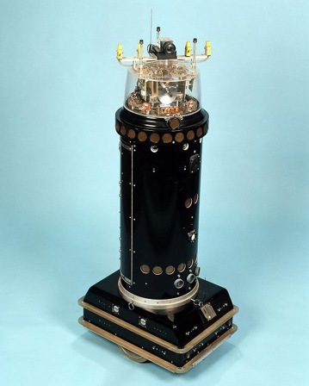

Figure 1 ROBART 2 (Space and Naval Warfare Systems Center Pacific, n.d.)

The Mobile Detection Assessment Response System (MDARS) program, run by the project manager, Physical Security Equipment (PM-PSE), Ft. Belvoir, Virginia, is one of the early autonomous robot implementations to be solved (IEEE Instrumentation & Measurement Magazine, 2003). The primary worry with any security management system is that when sensors become more sensitive to improve their detection's accuracy, more alerts start to go off, which causes users to lose faith in the system.

With the aid of the ROBART series of research prototypes, a technological solution to the issue was created under the MDARS effort. ROBART II (1982–1992), in contrast to ROBART I (1980–1982), which could only detect intrusions, could intercept and evaluate intrusions,with its primary goal of the evaluation being the elimination of alarm-triggering behaviors. n.d. (Naval Ocean Systems Center) (Naval Ocean Systems Center).

Many companies have participated by building or hiring security robots. Their features are closely identical to those of the ROBART series, except for their physical design. The following are some of the traits of contemporary security robots:

1. Freedom of movement. They are free to travel and roam in a virtual space built by a mapping application employing GPS and a laser-ranging device.
2. Having a full-body vision. Each side of the robot includes a high-definition camera that allows it to record anything around it. In addition to logging activity, it will notify the security staff of any unusual activity.
3. They use a variety of sensors to collect data that may be viewed by authorized parties using a real-time alert mechanism.

Turing Video showcased Nimbo, a new intelligent security robot that is both clever and affordable, at CES 2018. (www.securityinfowatch.com, n.d.). The most recent artificial intelligence technology utilized to design and construct Nimbo.

They use a range of technology to keep an eye on, communicate with, apprehend, and even chase intruders. These digital guardians incorporate LIDAR, video, photography, artificial intelligence, machine learning, simultaneous location and mapping (SLAM), sensors, the Internet of Things, GPS, and other technologies (in.micron.com, n.d.).

One type of distant sensing technology is LiDAR (Light Detection and Ranging). Data gathering using the laser pulse produced by LiDAR technology, which is used to create 3D models of any objects and environments, including maps. LiDAR systems calculate the time it takes for light beams to hit a surface or an item and reflect back to the laser scanner. The so-called "Time of Flight" measures of distance are based on the speed of light. (GeoSLAM, undated)

Using artificial intelligence, Nimbo thinks critically and creatively like a human intellect (Kelley, 2022). Artificial intelligence is created by studying cognitive function and investigating patterns in the human brain. These research initiatives result in intelligent software and systems. Nimbo is able to learn from its prior performance without being explicitly programmed by a type of artificial intelligence known as machine learning. Nimbo is supposed to be able to access data and use it to learn. Because of its outfitted and powerful video analytics platform and A.I. technology, Nimbo can patrol any indoor location, issue customized alarms, stream live video surveillance, and start automatic responses like recognizing human and animal invasions.

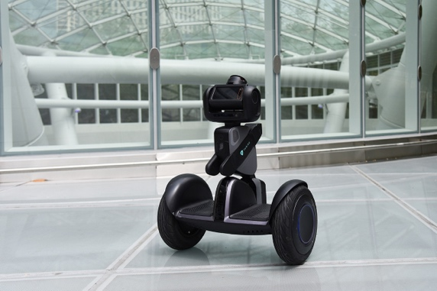

Figure 2 Nimbo (hellonimbo.com, n.d.)

It is possible for Nimbo to be in an undiscovered environment and incrementally build a trustworthy map of that environment while sensing its position inside that map by using the simultaneous localization and mapping (SLAM) problem (Durrant-Whyte and Bailey, 2006).

The Internet of Things (IoT) is a network of physical things embedded with sensors, software, and other technologies to connect and exchange data with other equipment and systems over the internet (Oracle, 2021). In the event of intrusions, Nimbo benefits from push notifications, email notifications, evidence review, and cloud storage.

Nimbo can be pre-programmed to patrol predetermined paths or self-optimized routes while continuously monitoring its immediate surroundings and human activities. It looks for security infractions or irregularities and alerts surrounding users with the appropriate lighting, sound, and visual cues. It assembles HD video proof, alerts security staff, and transmits live video to mobile devices. It also has two-way audio, auto charging, and 24/7 continuous video history (www.securityinfowatch.com, n.d.)

Robotic surveillance is a relatively new idea spreading worldwide in businesses, gas stations, warehouses, malls, and jails. To one study, the market for these gadgets was worth $2.11 billion in the United States alone in 2018 and is projected to grow to $3.33 billion by 2024. (www.mordorintelligence.com, n.d.). Nimbo is not suitable for residential use because it costs $12 per hour, according to studies.

# System Proposal

The system proposal will be divided into two categories: system breakdown and logical structure diagram for the successful implementation of AlarmBuzz. These categories will be further assessed under the functionality test case and help detect the potential pitfalls.

## System Breakdown

The AlarmBuzz system is divided into distinct blocks and a list of its integrations, which are then successively subdivided into smaller and smaller pieces. They are tested independently and in terms of how they integrate with the rest of the system. A map of the system's components, from the most general to the most detailed, virtually down to specific test cases, is the output of the system breakdown.

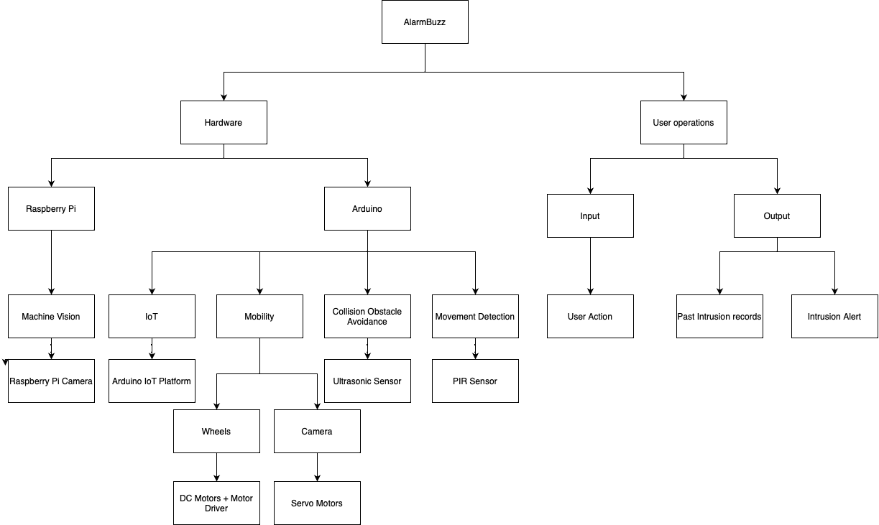

Figure 3 System Breakdown

## Logical Structure

The logical structure demonstrates AlarmBuzz's interconnection between its hardware and software components and the built-in logic of the different approaches for its smooth running.

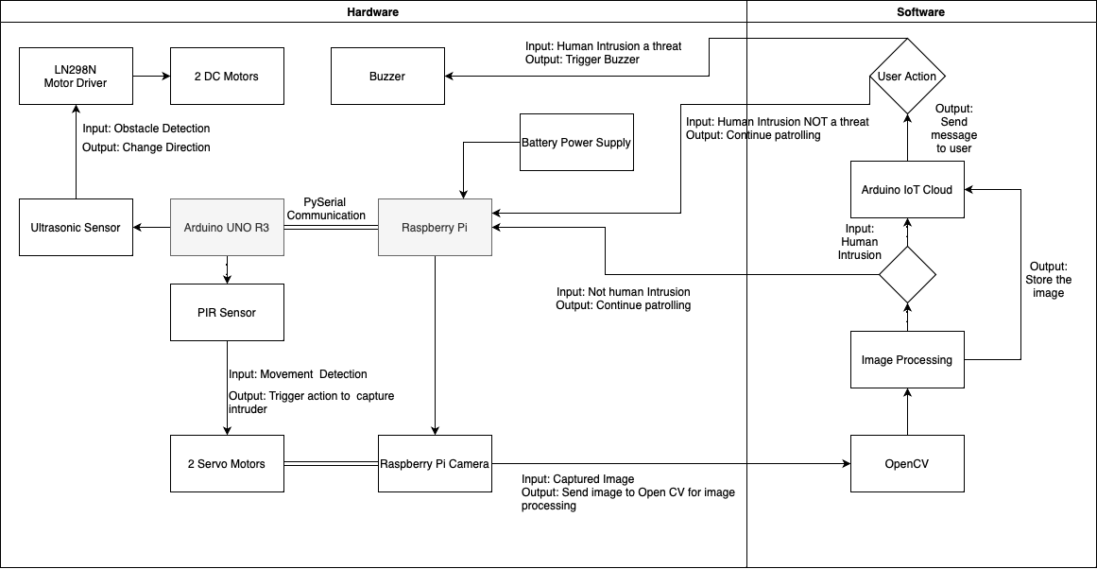

Figure 4 Logical Structure

The Arduino's key responsibility is the data collection and processing of all the changes in its environment using different sensors. The HR-SR04 ultrasonic sensor will report any object detected up to 13 feet away by bursting an ultrasonic beam and receiving it. Equipped with an LN298N motor driver and 2 DC motors for its mobility, AlarmBuzz will operate autonomously and requires a collision obstacle avoidance system to avoid running into objects or walls. Based on the distance collected from the ultrasonic sensor, the DC motors' rotation will change to simulate the robot changing direction. If the distance exceeds the specified, AlarmBuzz will move forward as it concludes that there is no obstacle. However, if the distance shortens, AlarmBuzz stops, goes backward, stops briefly, and turns 45 degrees from its initial position. The PIR sensor will detect human or animal movement by interpreting any heat changes in its range. If a motion is detected, the PIR sensor pin value sets to 1, triggering the servo motor and PI camera. Using an Arduino script will allow the data to be analyzed and processed effectively to the appropriate action.

Using the raspberry pi camera and 2 servo motor, the pan-tilt mount will move smoothly and find the proper calibration for the camera to focus on the intruder and take the intruder snapshot. This locomotion will require optimum high-definition video to be fed for the different servo motors to move independently to avoid any disruption.

The OpenCV library is responsible for computer vision and deep learning using python. For this project, OpenCV’s emphasis will be on object detection by detecting a change of color in the environment. The assumption behind a motion detection script if the first frame of the video frame is the background of our model. Any change from the current model will conclude with motion detection, indicating object detection.

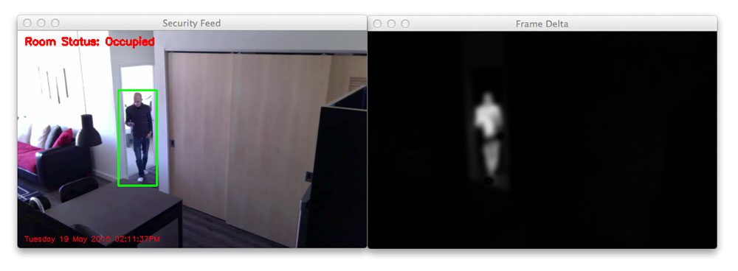

Figure 5 Difference between the current model and new frame (PyImageSearch, n.d.)

Furthermore, OpenCV will help us with image processing by using contour approximation and image segmentation. With Mask R-CNN and Grabcut, it will automatically compute pixel-wise masks for objects in the image, allowing us to segment the foreground from the background, and this helps deduct if the detected object is an animal or human (PyImageSearch, 2020).

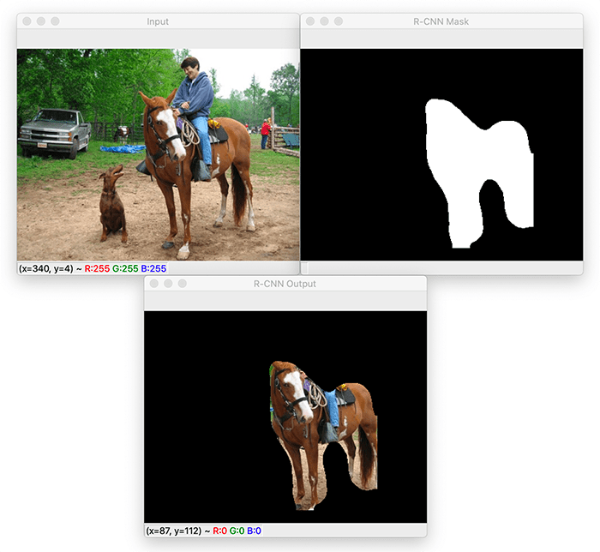

Figure 6 Image segmentation (PyImageSearch, 2020)

The pyserial communication between the Arduino and raspberry pi is essential to allow python scripts to and from the microcontroller and microprocessor. One key aspect is the baud rate which is the transmission rate of the data packages.

Every year, the number of connected devices increases by billions worldwide. With an intuitive user interface and an all-in-one solution for configuration, coding, uploading, and visualization, the Arduino IoT Cloud is a platform that develops IoT projects. (docs.arduino.cc, n.d.)

Users can send and receive automatic messages to and from other services using webhooks. Webhooks, for instance, alert the user if AlarmBuzz detects a human intrusion. Third-party platforms like IFTTT exist, linking the properties of your Arduino Cloud projects to the necessary trigger action to accomplish this. (docs.arduino.cc, n.d.)

# Concept Behaviour

The proposed robotic system AlarmBuzz will independently patrol a defined area while spotting and identifying human incursions. It notifies the owner and saves a record in the cloud if a human intrusion is confirmed.

It will be a three-wheeled robot with two DC motors and an LN298N motor driver module to provide the mobility needed to move from point A to point B. The robot has a collision obstacle avoidance system that uses multiple HC-SR04 ultrasonic sensors to detect any obstacles in front of it and take the necessary to avoid them. The main goal of an ultrasonic sensor is to measure the time it takes to broadcast ultrasonic beams and the time it takes to receive them after they have impacted a surface. The robot will stop, move backward after detecting an object, then momentarily stop again before turning 45 degrees in a specific programmed direction.

Multiple PIR sensors around the robot will help detect occupancy and movement when an unauthorized person enters the AlarmBuzz patrol area using the infrared light given off by their bodies. This sensor then sends a signal to the Arduino (docs.arduino.cc, n.d.) to trigger the two-servo motor rotation to the angle of intrusion position alongside the raspberry pi.

The raspberry pi camera will do the proper calibration and focus on the intruder to take a proper snapshot of the intruder. With the camera and machine vision software, the Raspberry Pi analyses images identify objects, and recognize faces and language. (Monk, 2016). The raspberry pi will process the picture and transmit a signal to the Arduino if it concludes that the detected motion is human-initiated and not animal-based.

The Arduino IoT cloud, a platform with a user-friendly interface and an all-in-one solution for configuration, coding, uploading, and visualization to develop IoT projects will initialize when the Raspberry Pi detects human intrusion. With the Arduino IoT Cloud, Webhooks enable automatic message transmission to and from other services. Webhooks will send a message with an "action" link alongside an email that attaches the intruder’s image to alert the owner. If the intrusion is confirmed as a threat by the user, he clicks on the “action link”, which will send a signal back to AlarmBuzz and use an Arduino buzzer or piezo speaker to alert the area of the intruder.

For legal actions, only authorized users may access the cloud in the future to evaluate the pictures taken. For the scope of this project, AlarmBuzz will be battery-powered to remain low-cost, but the batteries must be replaced by the owner manually. When the battery level will hit the 25% level, a signal is sent by the Arduino to connect to the Arduino IoT cloud to send a message to the user alerting him of the low power level.

# Physical Construction

An Arduino UNO R3 and a Raspberry Pi 4B are used as computer platforms for this project based on their benefits. Six analog inputs and fourteen digital input/output pins make up Arduino's 20 I/O pins (Miller, 2019). It has integrated headers and a USB connection for easy prototyping and programming. The Arduino Uno is preferable for portable, battery-powered projects because of its reasonable price and low power consumption (50 mA) (Miller, 2019). The single-board computer known as the Raspberry Pi was created by the Raspberry Pi Foundation. There are numerous features it claims, such as an SD card reader, 4X USB ports, built-in LAN, WiFi, Bluetooth, and 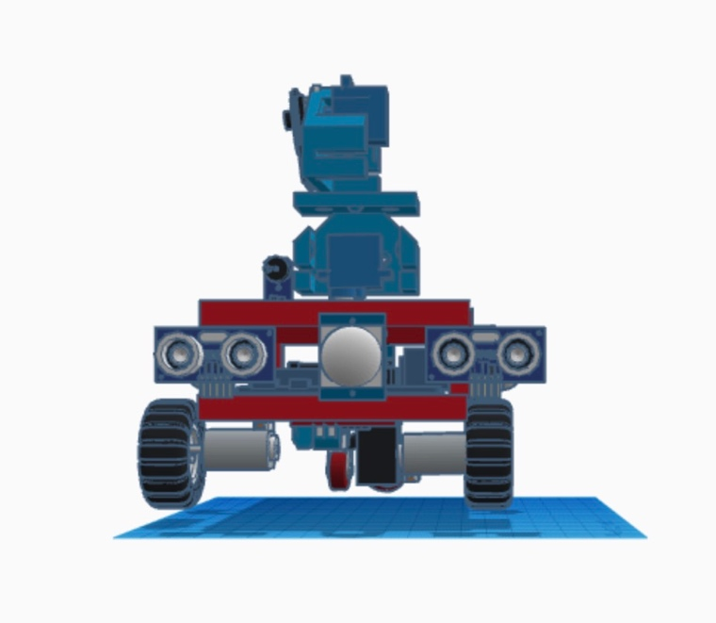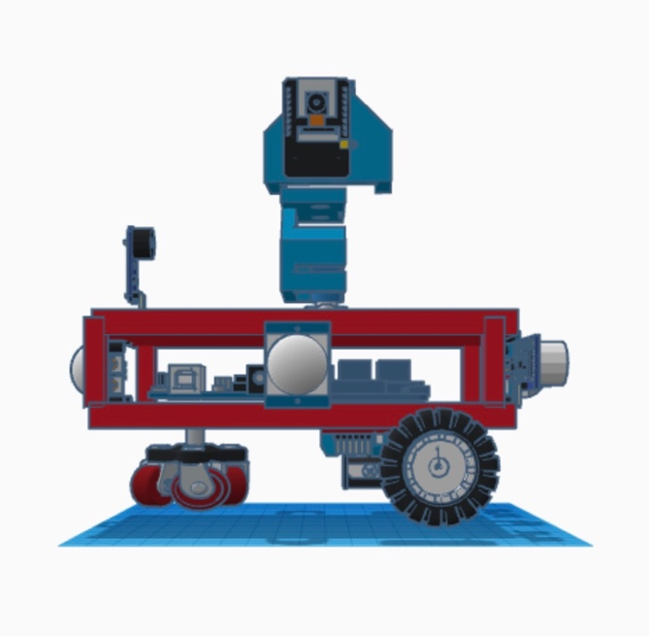more. Additionally, compared to the Arduino Uno, it has 500,000 times more RAM (Miller, 2019).

Ultrasonic Sensor

PIR Sensor

Servo Motor

Raspberry Pi 4B

Arduino UNO R3

Figure 8 Side View

Figure 7 Front View

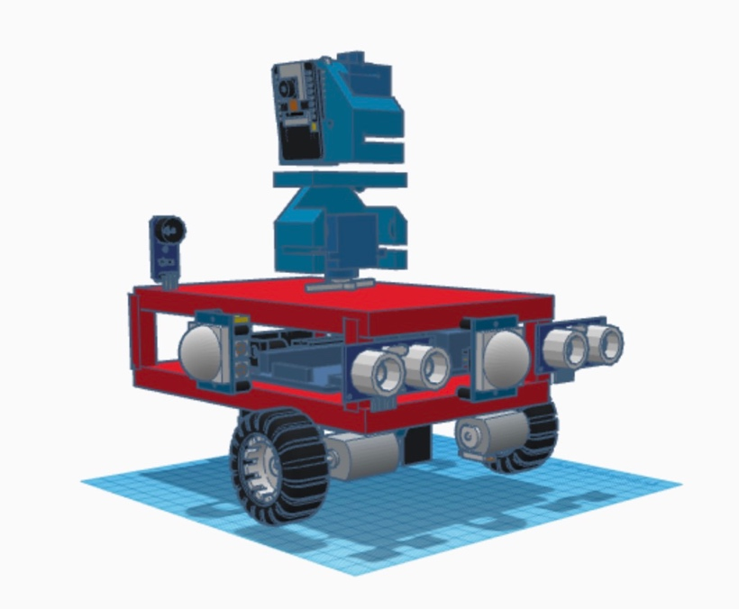

Servo Motor

Pi Camera V2

Motor Driver

DC Motors

PIR Sensor

Buzzer

Figure 9 AlarmBuzz

AlarmBuzz, the proposed burglary detection robot, will autonomously patrol a designated area and respond to any human or animal intrusion. It mounts on three wheels with two DC gear motors, an L293D motor driver, and an object avoidance collision system with two ultrasonic sensors to prevent collision into nearby walls or objects. Positive and negative leads on DC motors will revolve in their rotation when connected to power, and in the opposite direction if leads connections switch. Using an H-Bridge, the L298N Motor Driver is a handy controller that manages the direction and speed of up to 2 DC motors. Two ultrasonic sensors are placed at the front of AlarmBuzz to detect any obstacle in its route. It will prevent any collision from arising. Moreover, during the assembling phase, infrared proximity sensors might be placed at each corner to test optimizing the collision avoidance system making AlarmBuzz less prone to crash onto objects or walls.

AlarmBuzz, equipped with a PIR sensor on each side will detect human or animal movement. Any trespass will cause the raspberry pi camera and servo motor to trigger and start to calibrate and focus on the invader. If the signal does not change, the two servo motor's output shafts will rotate to a given angular position (www.tutorialspoint.com, n.d.). The shaft's angular position changes if the signal does. The servo motor will acquire various input signals and determine the proper calibration using computer vision from the raspberry pi to capture the intruder's image.

Finally, the Arduino UNO R3 and raspberry pi 4B are placed in a container to avoid any weather damage affecting the main components of AlarmBuzz.

# Functionality Test Cases

## Functionality

Using a systematic approach AlarmBuzz was developed with events occurring that will change the system flow. For the smooth running of AlarmBuzz, each of its functionalities is essential and will later be tested using functional and system testing.

**System Requirements**

|  |  |  |
| --- | --- | --- |
| System requirements | | |
| Hardware | ID | Requirements |
| Arduino Uno R3 | HA01 | Communication established with Raspberry PI 4 |
| HA02 | Communication with Ultrasonic and PIR sensor should be established |
| HA03 | Communication with actuators (motor driver, dc motors, servo motors and buzzer) should be established. |
| HA04 | Instructions written in C++ using the Arduino IDE. |
| HA05 | Connection with the Arduino IoT cloud. |
| HA06 | Process instructions to use Arduino IoT cloud webhooks to send communication to alert the user. |
| HA06 | Process instructions to send the snapchats for storage on the cloud. |
| Pi Camera V2 | HPC01 | Communication established with Raspberry PI 4 |
| HPC02 | Instructions written in python using OpenCV for object detection and image processing to distinguish between human and animal intruder. |
| HPC03 | Communication with Arduino when PIR sensor detect a movement to trigger the camera functionality. |
| HPC04 | Communication with servo motors and Arduino to calibrate itself to focus and take a snapshot of the intruder. |
| Ultrasonic Sensor  HC-SR04 | HUS01 | Communication with the Arduino to be established. |
| HUS02 | Read and update distance. |
| HUS03 | Data collected should be communicated to Arduino for process. |
| FS90R Servo Motor | HSM01 | Communication with the Arduino to be established. |
| HSM02 | Smooth and stable movement to calibrate the camera. |
| HSM03 | Follow instructions provided by the pi camera and Arduino. |
| SR501 PIR sensor | HPIR01 | Communication with the Arduino to be established. |
| HPIR02 | Read and detect movement. |
| HPIR03 | Data collected should be communicated to Arduino for process. |
| Raspberry Pi 4 | HRP01 | Communication established with Arduino UNO R3. |
| HRP02 | Instruction written in python. |
| HRP03 | Connection with the Pi camera v2 using OpenCV for image processing and object detection. |
| HRP04 | Connection with the servo motors as intermediate for the PI camera for its calibration. |
| Buzzer | HBUZ01 | Communication with the Arduino to be established. |
| HBUZ02 | Follow instructions provided by the Arduino. |
| Motor Driver LM298N | HMD01 | Communication with the Arduino to be established. |
| HMD02 | Follow instructions provided by the Arduino. |
| HMD03 | Avoid collision with obstacle. |
| HMD04 | Lightweight but powerful. |
| 5V DC Motors | HDC01 | Communication with the Motor driver to be established. |
| HDC02 | Follow instructions provided by the motor driver. |
| HDC03 | In good condition for smooth mobility. |

Figure 10 System requirement

**User Requirements**

|  |  |  |
| --- | --- | --- |
|  |  |  |
| User requirements | | |
| Mode | **ID** | **Requirements** |
| User Interaction | US01 | User should receive an alert message with action link from Arduino IoT cloud. |
| US02 | User should receive an email with intruder image from Arduino IoT cloud. |
| US03 | User should receive alert message when AlarmBuzz battery is 25%. |
| US04 | When user clicks the action link, shall send a signal back to AlarmBuzz to trigger the buzzer. |
| US05 | Authorized user shall connect to Arduino IoT cloud to view past intrusions. |

Figure 11 User requirement

## Test Cases

|  |  |  |
| --- | --- | --- |
| Unit Test Cases | | |
| Hardware | ID | Requirements |
| Arduino Uno R3 | HA01 | Test communication established with Raspberry PI 4 |
| HA02 | Test Communication with Ultrasonic and PIR sensor. |
| HA03 | Test Communication with actuators (motor driver, dc motors, servo motors and buzzer). |
| HA05 | Test connection with the Arduino IoT cloud. |
| HA06 | Use Arduino IoT cloud webhooks to send dummy communication to alert the user. |
| HA06 | Trial access of the snapchats for storage on the cloud. |
| Pi Camera V2 | HPC01 | Test Communication established with Raspberry PI 4 |
| HPC02 | Using OpenCV test for object detection and image processing to distinguish between human and animal intruder. |
| HPC03 | Test Communication with Arduino when PIR sensor detect a movement to trigger the camera functionality. |
| HPC04 | Test the movement of the servo motors and Arduino to calibrate itself to focus and take a snapshot of the intruder. Implement sudden movement to test if the servo motor can cope with. |
| Ultrasonic Sensor  HC-SR04 | HUS01 | Test Communication with the Arduino. |
| HUS02 | Compare distance with real life values. |
| HUS03 | Using the serial to see if the Arduino are reading the data correctly. |
| FS90R Servo Motor | HSM01 | Test Communication with the Arduino to be established. |
| HSM02 | Test the Smooth and stable movement to calibrate the camera. Implementing sudden movement. |
| HSM03 | Test the Smooth and stable movement to calibrate the camera. Implementing sudden movement. |
| SR501 PIR sensor | HPIR01 | Test Communication with the Arduino to be established. |
| HPIR02 | Using the serial to see if the Arduino are reading the data correctly. |
| HPIR03 | Using the serial to see if the Arduino are reading the data correctly. |
| Raspberry Pi 4 | HRP01 | Test Communication established with Arduino UNO R3. |
| HRP03 | Using OpenCV test for object detection and image processing to distinguish between human and animal intruder. |
| HRP04 | Test the Smooth and stable movement to calibrate the camera. Implementing sudden movement. |
| Buzzer | HBUZ01 | Test Communication with the Arduino to be established. |
| HBUZ02 | Test when instructions passed if it emit a sound. |
| Motor Driver LM298N | HMD01 | Test Communication with the Arduino to be established. |
| HMD02 | Using the serial to see if the Arduino are reading the data correctly from the ultrasonic sensor. |
| HMD03 | Create a track to test the avoid collision with obstacle. |
| HMD04 | Test if powerful enough to run with all components on. |
| 5V DC Motors | HDC01 | Test Communication with the Motor driver to be established. |
| HDC02 | Using the serial to see if the Arduino are reading the data correctly from the ultrasonic sensor. |
| HDC03 | Do a test run to see if it is operating smoothly |

Figure 12 Unit test case table

User testing will basically involve a test to see if the communication from the user action to the Arduino IoT cloud is responding in a timely manner.

**Integration Testing**

* To test the notion of an obstacle collision avoidance system, an Arduino UNO is mounted with DC motors, a motor driver, and an ultrasonic sensor. AlarmBuzz must be able to patrol a test track without colliding with any walls or other objects.

There are no obstacles in front of you if the ultrasonic sensor measures a distance greater than the defined one. AlarmBuzz will continue to travel forward by rotating DC motors. There is an obstruction in front of you if the distance the ultrasonic sensor measures is smaller than the defined one. DC motors have the ability to stop, rotate counterclockwise, turn in multiple directions, stop once more, and resume motion.

* Movement Detection and Machine Vision - The Arduino UNO and Raspberry Pi are mounted with a PIR sensor, FS90R Servo motor, and camera module. The ability to identify intrusions and calibrate the camera so that it can focus and take clear pictures of the intruders are success criteria.

The servo motor and raspberry pi camera will operate when the PIR sensor detects motion. The Raspberry Pi camera recognizes and evaluates its view of the intruder using machine learning and machine vision. It signals the Arduino to adjust the servo motor's angle so that the camera can focus properly and capture an image of the intruder. To determine the ideal initial rotating pattern of the servo motor to calibrate itself for focusing on the intruder, numerous tests on the intruder's position with regard to the servo motor and camera starting position are carried out. By examining the ideal algorithms, the speed of the servo motor calibration to a swift invader is to be examined and enhanced.

* A.I. and Machine Learning - The Raspberry Pi and its camera module are the success criteria because they can differentiate between people and animals, allowing AlarmBuzz to start the connection to the Arduino IoT cloud. Finding the appropriate Python library/modules and testing them with various human and animal pictures until a proper sequence of pass identification test follows are the testing steps.
* Arduino IoT Cloud - The Raspberry must determine whether the intrusion is caused by a human before initiating a connection to the Arduino IoT cloud to notify the owner of the intrusion. Any of the owner's devices will receive a message with a "action" link and an email with the taken image attached. The buzzer is activated when the user clicks the link, which sends a message to the Arduino IoT cloud.

The following tests must be performed:

• Connection establishment with the Arduino IoT cloud.

Owners receive warnings from the Arduino IoT cloud.

• The owner clicks the link, causing the buzzer to sound.

• Cloud storage for captured images.

The highest level of testing is system testing. As the name implies, the finished robot is evaluated to determine whether it meets the requirements. When a requirement is not met, AlarmBuzz shall instead continue patrolling, as seen below. Multiple scenarios of AlarmBuzz are built to test every possible outcome.

* Motion detected by a PIR sensor and the intruder is an animal; • Motion detected by a PIR sensor and the intruder is a human; however, if the owner does not click the link, AlarmBuzz will resume patrolling after a certain amount of time.

# Project Plan

For the success of any project even on a small scale like AlarmBuzz, a proper planning is necessary using Bill of Materials and the Gantt Chart. The bill of materials will represent the costing of AlarmBuzz while the Gant chart will illustrate the time allocation over the span of the projects.

|  |  |  |  |  |  |  |  |  |  |  |  |  |
| --- | --- | --- | --- | --- | --- | --- | --- | --- | --- | --- | --- | --- |
| **Making of AlarmBuzz** | | | | | | | | | | | | |
|  | Project start: 03/01/2022 | | | | | |  |  |  |  |  |  |
|  | January | | | | February | | | | March | | | |
|  | W1 | W2 | W3 | W4 | W5 | W6 | W7 | W8 | W9 | W10 | W11 | W12 |
| **Planning and acquiring components** |  |  |  |  |  |  |  |  |  |  |  |  |
| Purchase main components |  |  |  |  |  |  |  |  |  |  |  |  |
| Testing and validating each components |  |  |  |  |  |  |  |  |  |  |  |  |
|  |  |  |  |  |  |  |  |  |  |  |  |  |
| **Construction** |  |  |  |  |  |  |  |  |  |  |  |  |
| Assembling the chassis |  |  |  |  |  |  |  |  |  |  |  |  |
| Connecting sensors and motors |  |  |  |  |  |  |  |  |  |  |  |  |
| Testing status of sensors and motors performance |  |  |  |  |  |  |  |  |  |  |  |  |
| Assembling the pan tilt and servo motor |  |  |  |  |  |  |  |  |  |  |  |  |
| Assembling and validating the final design |  |  |  |  |  |  |  |  |  |  |  |  |
|  |  |  |  |  |  |  |  |  |  |  |  |  |
| **Coding** |  |  |  |  |  |  |  |  |  |  |  |  |
| Programming the servo motors to move smoothly. |  |  |  |  |  |  |  |  |  |  |  |  |
| Programming the computer vision for object detection and image processing |  | |  |  |  |  |  |  |  |  |  |  |
| Programming motors to move according to reading from sensors |  | |  |  |  |  |  |  |  |  |  |  |
| Programming the integration of the Arduino IoT cloud |  | |  |  |  |  |  |  |  |  |  |  |
| Merging the code together and tweaking its performance. |  |  |  |  |  |  |  |  |  |  |  |  |
|  |  |  |  |  |  |  |  |  |  |  |  |  |
| **Testing** |  |  |  |  |  |  |  |  |  |  |  |  |
| Unit testing |  |  |  |  |  |  |  |  |  |  |  |  |
| Integration testing |  |  |  |  |  |  |  |  |  |  |  |  |
| System testing |  |  |  |  |  |  |  |  |  |  |  |  |
| User testing |  |  |  |  |  |  |  |  |  |  |  |  |
|  |  |  |  |  |  |  |  |  |  |  |  |  |
| **Completion of AlarmBuzz** |  |  |  |  |  |  |  |  |  |  |  |  |
| Project Showcase and presentation report |  |  |  |  |  |  |  |  |  |  |  |  |

## The Gantt Chart

Figure 13 Gantt Chart

The Gantt chart represent the 12 weeks of progression for the realization of AlarmBuzz. It helps by setting deadlines and provide a visual representation of the key steps of the project. Testing is also included as it remains a very important part of any project and the necessary time has to be allocated. The last two weeks has been planned to prepare the project showcase and presentation report or in unexpected circumstance cope with any tweaking in AlarmBuzz.

## Bill of Materials

All successful project comes with its expenses and a bill of materials can be used as budget reference for future implementations of the project. All components were bought locally, and the standard price is in Mauritian rupees.

|  |  |  |  |  |
| --- | --- | --- | --- | --- |
| Component Name | Model Number | Quantity | Price (Rs) | Supplier |
| Raspberry Pi 4B | R-PI4-4 | 1 | 9250 | Transcom |
| Ultrasonic Distance Measuring | HC-SR04 | 4 | 240 | Transcom |
| Micro Servo Motor SG90 | A-SG90 | 2 | 180 | Transcom |
| Micro Servo Pan Tilt Mount for SG90 | A-BSG90 | 1 | 60 | Transcom |
| L298 DC Stepper Motor Driver D.H Bridge | A-L298HB | 1 | 115 | Transcom |
| 2PCS TT Gear Motor DC 3-6V + Wheel 65mm | A-MTTW | 1 | 245 | Transcom |
| Raspberry Pi 4 Camera | R-PI-CAM | 1 | 250 | Transcom |
| Abs Plastic Eclosure Raspberry Pi 4 | A-ACRY PI4 | 1 | 150 | Transcom |
| Buzzer Module LY-44 | LY-44 | 1 | 50 | Transcom |
| Arduino UNO | ARD | 1 | 500 | Transcom |
| Dupont Cable | - | 60 | 120 | Transcom |
| IR Pyroelectric infrared PIR Motion | A-HC-SR501 | 4 | 240 | Transcom |
|  |  | Total | 11,400 |  |

# Conclusion

To compare and distinguish between the image of the intruder that was caught and whether it was a human or an animal, the raspberry pi with AI and machine learning applied will need a sufficient precise data set.

One ultrasonic sensor might not be sufficient for the Object Collision Avoidance System given the size of the AlarmBuzz. It may run into things or walls if the front of it is greater than the sensor's detection range. It would take several tests to tune the AlarmBuzz's spinning.

When the servo motor and raspberry pi camera are calibrated for swiftly moving objects, the rotational axis of the servo motor may experience issues as it tries to keep up with the intruder's speed. There has to be more investigation into this approach because several attackers could cause the Raspberry Pi's machine vision to crash because it would not know which intruder to focus on.

AlarmBuzz's mobility and stability are its greatest weaknesses. AlarmBuzz was developed as a school project with minimal funding, so it is not designed for outside use or harsh terrain. As AlarmBuzz lacks a brake to stop it from sliding, its wheel and motor could not withstand patrol on a steep slope. Due to its poor plastic construction, the alarm won't withstand any shock from falling or being kicked by an intruder.

AlarmBuzz's overall design requires work because it lacks the resilience and mobility necessary for a security robot to patrol difficult terrain. AlarmBuzz might be used to deter unauthorized people from poaching if it has the build to roam outdoor places like a forest. When the situation becomes too dangerous for humans, it could even be transformed into firefighting robots.

Today's society favors environmentally friendly machinery. By attaching solar panels and a rechargeable battery, AlarmBuzz may convert from battery power to solar power. This will promote the use of it outside while also contributing to the preservation of the planet.

The present monitoring cameras that require security personnel to watch can be replaced by a security network with several Alarmbuzz. There will be no downtime or breaks in service for this system. It must have a control center from which the AlarmBuzz will be launched for patrol at night and stationed throughout the day. When PIR sensors are installed in certain places, the AlarmBuzz will be notified of an intrusion and will storm the area to look for any violations. Due to its stronger construction, AlarmBuzz might possibly have robotic arms and attempt to stop the invaders from fleeing before the police arrive. In order to speed up the process of catching the offender, a partnership with the police may be put into place where, in the event of confirmed offenses, captured photographs are submitted to them.

# Reference Lists

1. admin (2018). *Let’s start talking seriously about robots*. [online] Defsec. Available at: https://defsec.net.nz/2018/08/02/lets-start-talking-seriously-robots/ [Accessed 4 Nov. 2022].
2. Alarms.org. (2015). *Burglary Statistics: The Hard Numbers | National Council For Home Safety and Security*. [online] Available at: <https://www.alarms.org/burglary-statistics/>. [Accessed: 15 Oct. 2022]
3. Almasri, M.M., Alajlan, A.M. and Elleithy, K.M. (2016). Trajectory Planning and Collision Avoidance Algorithm for Mobile Robotics System. *IEEE Sensors Journal*, 16(12), pp.5021–5028. doi:10.1109/jsen.2016.2553126. [Accessed: 2 Nov. 2022]
4. docs.arduino.cc. (n.d.). *Arduino Cloud | Arduino Documentation*. [online] Available at: <https://docs.arduino.cc/arduino-cloud/>. [Accessed: 3 Nov. 2022]
5. docs.arduino.cc. (n.d.). *Webhooks with Arduino IoT Cloud | Arduino Documentation*. [online] Available at: https://docs.arduino.cc/arduino-cloud/features/webhooks [Accessed 15 Jan. 2023].
6. Durrant-Whyte, H. and Bailey, T. (2006). Simultaneous localization and mapping: part I. *IEEE Robotics & Automation Magazine*, [online] 13(2), pp.99–110. doi:10.1109/mra.2006.1638022. [Accessed: 4 Nov. 2022]
7. Expert.AI Team (2020). *What is Machine Learning? A definition - Expert System*. [online] Expert.ai. Available at: <https://www.expert.ai/blog/machine-learning-definition/>. [Accessed: 4 Nov. 2022]
8. Furhat Robotics. (2020). *What Are Social Robots? An Introduction to the Furhat Robot*. [online] Available at: <https://furhatrobotics.com/blog/what-are-social-robots/>. [Accessed: 13 Oct. 2022]
9. GeoSLAM. (n.d.). *What is LiDAR and How Does it Work?* [online] Available at: <https://geoslam.com/what-is-lidar/>. [Accessed: 4 Nov. 2022]
10. Hart, M. (2022). *What are Autonomous Robots? 8 Applications for Today’s AMRs*. [online] Locus Robotics. Available at: <https://locusrobotics.com/what-are-autonomous-robots/>. [Accessed: 2 Nov. 2022]
11. Homan, R. (n.d.). *Burglary Statistics 2022*. [online] Bankrate. Available at: <https://www.bankrate.com/insurance/homeowners-insurance/house-burglary-statistics/#stats>. [Accessed: 15 Oct. 2022]
12. IEEE Instrumentation & Measurement Magazine. (2003). [online] Available at: https://www.hsdl.org/?view&did=451029. [Accessed: 13 Oct. 2022]
13. Kelley, K. (2022). *What is Artificial Intelligence: Types, History, and Future*. [online] Simplilearn.com. Available at: <https://www.simplilearn.com/tutorials/artificial-intelligence-tutorial/what-is-artificial-intelligence>. [Accessed: 4 Nov. 2022]
14. Last Minute Engineers. (2019). *How HC-SR04 Ultrasonic Sensor Works & How to Interface It With Arduino*. [online] Available at: <https://lastminuteengineers.com/arduino-sr04-ultrasonic-sensor-tutorial/>. [Accessed: 5 Nov. 2022]
15. Last Minute Engineers. (2018). *How HC-SR501 PIR Sensor Works & How To Interface It With Arduino*. [online] Available at: <https://lastminuteengineers.com/pir-sensor-arduino-tutorial/>. [Accessed: 5 Nov. 2022]
16. Miller, L. (2019). *Arduino vs Raspberry Pi for Robotics*. [online] Learn Robotics. Available at: https://www.learnrobotics.org/blog/arduino-vs-raspberry-pi/ [Accessed 5 Nov. 2022].
17. Monk, S. (2016). *Computer vision with the Raspberry Pi*. [online] O’Reilly Media. Available at: https://www.oreilly.com/content/raspberry-pi-cookbook-computer-vision/ [Accessed 5 Nov. 2022].
18. NBC News. (n.d.). *Security robots expand across U.S., with few tangible results*. [online] Available at: <https://www.nbcnews.com/business/business-news/security-robots-expand-across-u-s-few-tangible-results-n1272421>. [Accessed: 1 Nov. 2022]
19. Oracle (2021). *What is the Internet of Things (IoT)?* [online] oracle. Available at: <https://www.oracle.com/internet-of-things/what-is-iot/>. [Accessed: 4 Nov. 2022]
20. Plain Concepts. (2022). *Autonomous Robots: The Future of Security and Surveillance?* [online] Available at: <https://www.plainconcepts.com/autonomous-robots-security/>. [Accessed: 3 Nov. 2022]
21. Progressive Automations. (n.d.). *Actuators: what is it, definition, types and how does it work*. [online] Available at: <https://www.progressiveautomations.com/pages/actuators>. [Accessed: 5 Nov. 2022]
22. PyImageSearch. (2020). *Image Segmentation with Mask R-CNN, GrabCut, and OpenCV*. [online] Available at: <https://pyimagesearch.com/2020/09/28/image-segmentation-with-mask-r-cnn-grabcut-and-opencv/>. [Accessed 15 Jan. 2023]
23. PyImageSearch. (n.d.). *Image Processing Archives*. [online] Available at: https://pyimagesearch.com/category/image-processing/ [Accessed 15 Jan. 2023].
24. PyImageSearch. (n.d.). *Object Detection Archives*. [online] Available at: <https://pyimagesearch.com/category/object-detection/>. [ Accessed: 14 Jan. 2023]
25. <https://pyimagesearch.com/2015/06/01/home-surveillance-and-motion-detection-with-the-raspberry-pi-python-and-opencv/> [ Accessed: 14 Jan. 2023]
26. Qualitest. (n.d.). *System Breakdown*. [online] Available at: https://qualitestgroup.com/insights/white-paper/system-breakdown/ [Accessed 15 Jan. 2023].
27. Reiss, K. (n.d.). *How Do I Know if My Raspberry Pi Camera is Working?* [online] Raspberry tips. Available at: <https://raspberrytips.com/troubleshooting-camera-module/>. [Accessed: 5 Nov. 2022]
28. Santhana_krishnanMore (n.d.). *SERVO MOTOR TEST*. [online] Instructables. Available at: <https://www.instructables.com/SERVO-MOTOR-TEST/>. [Accessed: 6 Nov. 2022]
29. SearchEnterpriseAI. (n.d.). *What is machine vision (computer vision)? - Definition from WhatIs.com*. [online] Available at: <https://www.techtarget.com/searchenterpriseai/definition/machine-vision-computer-vision>. [Accessed: 30 Oct. 2022]
30. S, V., S, D. and S, A.K. (2019). Surveillance Robot Capturing Intruder Using PIR Sensor. *Journal of Remote Sensing GIS & Technology*, [online] 5(3), pp.36–40. doi:10.5281/zenodo.3576712. [Accessed: 15 Oct. 2022)
31. Ulf Eriksson (2014). *Levels of Testing - Understand the Difference b/w Different Levels & Types*. [online] ReQtest. Available at: <https://reqtest.com/testing-blog/different-levels-of-testing/>. [Accessed: 6 Nov. 2022]
32. www.avsupply.com. (n.d.). *Ganz NIMBO Robot | Audio Video Supply*. [online] Available at: https://www.avsupply.com/ITM/34344/NIMBO%20Robot.html [Accessed 4 Nov. 2022].
33. www.securityinfowatch.com. (n.d.). *StackPath*. [online] Available at: https://www.securityinfowatch.com/perimeter-security/robotics/product/12390271/segway-nimbo-security-robot-from-segway-and-turing-video [Accessed: 15 Oct. 2022].
34. www.securityinfowatch.com. (n.d.). *StackPath*. [online] Available at: https://www.securityinfowatch.com/perimeter-security/robotics/product/12390271/segway-nimbo-security-robot-from-segway-and-turing-video [Accessed: 15 Oct. 2022].
35. www.micron.com. (n.d.). *To Catch a Thief: How Security Robots Help Make Our Lives Safer*. [online] Available at: <https://www.micron.com/insight/to-catch-a-thief-how-security-robots-help-make-our-lives-safer>. [Accessed: 15 Oct. 2022]
36. www.mordorintelligence.com. (n.d.). *Security Robot Market Share, Size | 2022 - 27 | Industry Growth*. [online] Available at: https://www.mordorintelligence.com/industry-reports/security-robots-market [Accessed: 16 Oct. 2022].
37. www.tutorialspoint.com. (n.d.). *Arduino - Servo Motor - Tutorialspoint*. [online] Available at: <https://www.tutorialspoint.com/arduino/arduino_servo_motor.htm>. [Accessed: 5 Nov. 2022]