

**School of Digital Technologies**

**PDE3413 Systems Engineering for Robotics**

**Deliverable 4 -Final Project Report**

**Submission Deadline: 02.04.23**

**AlarmBuzz – Autonomous Burglar Detection Robot**

**Dereck Lam Hon Wah**

**M00826933**

**Date of Submission:** 02.04.23

**Lab Tutor:** Praveer Towakel

# Abstract

The increasing rates of burglaries and home invasions necessitate the development of efficient and affordable security systems. This project presents AlarmBuzz, a low-cost autonomous burglar-detection robot designed to protect households and small businesses from potential intrusions. The proposed robot is equipped with computer vision, an obstacle avoidance system, and real-time monitoring capabilities for autonomous navigation and human intrusion detection, offering a more effective solution compared to traditional monitoring cameras.

AlarmBuzz utilizes a PIR sensor and a pre-trained human detection algorithm to differentiate between human and animal intrusions, reducing the chances of false alarms. The robot captures images of intruders and stores them in the cloud, providing reliable evidence for legal actions. The primary goal of this project is to create an affordable, user-friendly, and efficient security system that increases the sense of safety for homeowners and small businesses while being accessible to a wider market share.

Future improvements to the AlarmBuzz system include enhancing the robot's mobility, stability, and durability to adapt to various terrains and environments. The integration of solar panels and rechargeable batteries could make the robot more environmentally friendly and suitable for outdoor use. Additionally, creating a security network with multiple AlarmBuzz units working in tandem could improve overall coverage and detection capabilities.

In conclusion, AlarmBuzz offers a promising solution to address the growing need for reliable and cost-effective security systems. By providing real-time monitoring, accurate human intrusion detection, and easy accessibility, AlarmBuzz has the potential to significantly impact the security system market and contribute to the safety and well-being of homeowners and small businesses.

Table of Contents

Abstract 2

Introduction 4

Aims and Objectives 4

Literature Review 5

Technologies Used 5

Existing Similar System 6

Sensors/Equipment used. 7

Design 10

Concept Behaviour 10

Design of Functional Components 11

System Breakdown 11

Logical Structure 12

Physical Design 14

Implementation 15

Arduino Sensor Shield V5.0 Pin out Diagram. 15

Main.py 16

Obstacle Avoidance 18

Motion detection and pan tilt sweep movement 19

Human Detection Algorithm 20

Discord Webhook 21

Testing 22

Component testing 22

Functional Component testing 24

Unit Test cases 24

Integration Testing 25

System testing 26

Conclusion 27

Reference List 28

# Introduction

Robotics is a technological innovation, developed exponentially and finding use in many contexts. And today, a robot can complete even the most complex jobs due to the power of artificial intelligence, which has given them the capacity to be aware of their environment and think more independently (Suryavamsi and Arockia Selvakumar, 2018). Social robots must display social behaviors like speaking, listening, and human-like emotions to interact with people and other robots (Furhat Robotics, 2020).

According to research, we noted that there is an increase in reports of home invasions and burglaries also becoming more frequent these days, which can negatively impact the country’s economy. Every 25.7 seconds, or over 3,300 times each day, a robbery takes place (FBI Crime Data, n.d.). The New York Police Department (NYPD) reports that between 2021 and 2022, the rate of burglaries climbed by 32.7%. (Hooman, n.d.). 95% of all home invasions include forced entry by a broken window, lock, or smashed door (Alarms.orgs, 2015). Homes without security cameras are 300% more likely to be burglarized. The global market for smart home security anticipates experiencing a notable rise in its compound annual growth rate from 2023 to 2027. (researchandmarkets.com, 2022). Additionally, the cost of law enforcement and emergency services will build up and burden more taxpayers and the government.

A quarter of victims (40 percent of all female victims) reported being shocked or distressed when their homes were burglarized, and only one-third feel healed from the ordeal more than a month later (www.ojp.gov, n.d.). In the worst cases of distress, the encounter might have exacerbated underlying psychological issues such as emotional distress and trauma and feeling violated and unsafe in their homes (www.ojp.gov, n.d.). For already distressed victims, the expense incurred during the housebreaking, like replacing stolen goods and fixing property damage adds significantly to their financial burden.

But nowadays, fewer than 30% of buildings have an effective security system (Homan, n.d.). These systems require time-consuming installation and regular monitoring and maintenance.

The most recent technological development shows that using security robots to monitor buildings is as effective as using people or even more effective. However, the cost of commercial security robots like Knightscope, which casino, apartment complex, bank, or in one case, a police force rents, is roughly $70,000 to $80,000 per year, making them expensive for low-income individuals and small enterprises (NBC News, n.d.).

This project concept implementation of an autonomous burglar-detection robot will reduce the chance of being a victim and the potential savings to combat this growing global problem. ￼

# Aims and Objectives

The proposed project, AlarmBuzz, a low-cost variant of Nimbo, a commercial autonomous burglar-detection robot, offers a defense against the escalating rates of robberies and home invasions. AlarmBuzz is fitted with computer vision and an obstacle avoidance system to navigate autonomously in an area while detecting human intruders and alerting its owners by utilizing its mobility and real-time monitoring capabilities, as opposed to typical monitoring cameras in buildings that see rising infiltration rates due to blind spots.

Because commercial security systems or autonomous security robots use more advanced sensors and technologies, an alarm monitoring system's cost is occasionally its major disadvantage. Smaller businesses and households cannot afford such advanced security system technologies. Therefore, this project is at a lower cost for homeowners to protect their property and family and for small enterprises to protect their inventory and assets, making AlarmBuzz affordable and easier to use, which will help reach a broader market share and increase its potential success in the security system market. Additionally, AlarmBuzz protects the owners in contrast to someone without a monitoring system, as there is no communication or direct contact between its owner and the intruders in case of a break-in.

In a dark environment, traditional monitoring cameras and security personnel may have trouble distinguishing between human and animal invasions and recording any intrusions in real time. With its camera and a PIR sensor, AlarmBuzz can pick any infrared ray light corresponding to human movement and classify if the intrusion is human or not using artificial intelligence and machine learning through implementation of computer vision with a pre-trained human detection model algorithm. With access to examine the footage remotely, which is captured in real-time and stored in the cloud, the owners can use them as evidence in a court case.

Adding all these up AlarmBuzz will provide a reliable and easy way to detect human intrusion, prevent burglary, and increase the sense of security for homeowners and small businesses at an affordable price.

# Literature Review

## Technologies Used

Autonomous robots can make their own decisions and act appropriately, much like people. An autonomous robot examines its environment, makes decisions based on what it sees or learns to recognize, and then carries out a movement or manipulation inside that environment (Hart, 2022). Simple motions like the beginning, stopping, and swerving to avoid obstacles are only a few examples of these decision-based behaviours of robot mobility.

Three fundamental concepts—perception, decision-making, and actuation—make up an autonomous robot. A robot's ability to percept its environment is fulfilled using a variety of sensors as input devices. An autonomous robot employs a safety and embedded system for decision-making that is faster and more powerful than the computer, which executes a mission plan and parses data. (Hart, 2022). Robots use a range of actuators, such as muscles, to perform several jobs, and most of these actuators come with a motor of some kind. Whether it contains a hydraulic ram, a linear actuator, or a wheel, there is always a motor driving the movement.

Intelligent security robots can monitor assets and people, patrol real-world locations, or gather data to identify problems, that humans might overlook. They don't sleep either (Plain Concepts, 2022). They calculate routes and interpret the best alternative utilizing a sophisticated system of sensors, AI, and machine learning rather than depending on electrical lines or predetermined paths. The next generation of robots uses navigational algorithms to slow down, stop, or recalculate its route without colliding, using cameras and sensors to avoid obstacles while moving.

Machine vision uses the camera like Raspberry Pi cameras to get visual information from the environment. It then processes the images using a combination of hardware and software to get the data ready for use in other applications. Machine vision technology usually uses specialized optics to take pictures. Specific image attributes can be processed, looked at, and evaluated using this technique (SearchEnterpriseAI, n.d.).

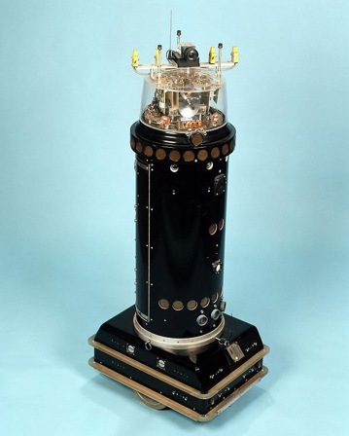The obstacle collision avoidance system uses sensors to collect information about the surroundings and analyze it using digital image processing or distance measurements to identify any potential obstructions. Although they are widely used to move in an unfamiliar environment, cameras, positioning systems, and ultrasonic sensors are not the best choice to organize the robot structure. Some infrared sensors are used to follow the optimum non-collision path from source to destination and meet specific performance goals (Almasri, Alajlan and Elleithy, 2016).

The Mobile Detection Assessment Response System (MDARS) program, run by the project manager, Physical Security Equipment (PM-PSE), Ft. Belvoir, Virginia, is one of the early autonomous robot implementations to be solved (IEEE Instrumentation & Measurement Magazine, 2003). The primary worry with any security management system is that when sensors become more sensitive to improve their detection's accuracy, more alerts start to go off, which causes users to lose faith in the system.

Figure 1 ROBART 2 (Space and Naval Warfare Systems Center Pacific, n.d.)

With the aid of the ROBART series of research prototypes, a technological solution to the issue was created under the MDARS effort. ROBART II (1982–1992), in contrast to ROBART I (1980–1982), which could only detect intrusions, could intercept and evaluate intrusions,with its primary goal of the evaluation being the elimination of alarm-triggering behaviors. n.d. (Naval Ocean Systems Center) (Naval Ocean Systems Center).

Many companies have participated by building or hiring security robots. Their features are closely identical to those of the ROBART series, except for their physical design. The following are some of the traits of contemporary security robots:

1. Freedom of movement. They are free to travel and roam in a virtual space built by a mapping application employing GPS and a laser-ranging device.
2. Having a full-body vision. Each side of the robot includes a high-definition camera that allows it to record anything around it. In addition to logging activity, it will notify the security staff of any unusual activity.
3. They use a variety of sensors to collect data that may be viewed by authorized parties using a real-time alert mechanism.

## Existing Similar System

Turing Video showcased Nimbo, a new intelligent security robot that is both clever and affordable, at CES 2018. (www.securityinfowatch.com, n.d.). The most recent artificial intelligence technology utilized to design and construct Nimbo.

They use a range of technology to keep an eye on, communicate with, apprehend, and even chase intruders. These digital guardians incorporate LIDAR, video, photography, artificial intelligence, machine learning, simultaneous location and mapping (SLAM), sensors, the Internet of Things, GPS, and other technologies (in.micron.com, n.d.).

One type of distant sensing technology is LiDAR (Light Detection and Ranging). Data gathering using the laser pulse produced by LiDAR technology, which is used to create 3D models of any objects and environments, including maps. LiDAR systems calculate the time it takes for light beams to hit a surface or an item and reflect back to the laser scanner. The so-called "Time of Flight" measures of distance are based on the speed of light. (GeoSLAM, undated)

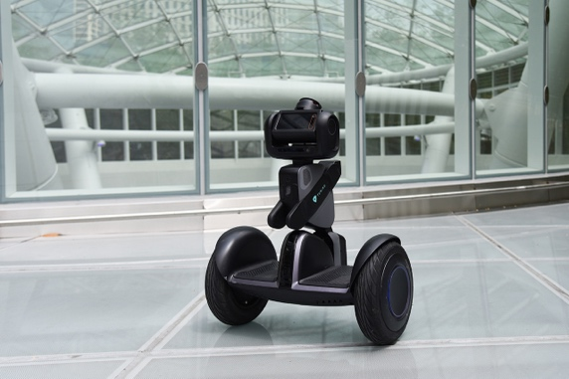Using artificial intelligence, Nimbo thinks critically and creatively like a human intellect (Kelley, 2022). Artificial intelligence is created by studying cognitive function and investigating patterns in the human brain. These research initiatives result in intelligent software and systems. Nimbo is able to learn from its prior performance without being explicitly programmed by a type of artificial intelligence known as machine learning. Nimbo is supposed to be able to access data and use it to learn. Because of its outfitted and powerful video analytics platform and A.I. technology, Nimbo can patrol any indoor location, issue customized alarms, stream live video surveillance, and start automatic responses like recognizing human and animal invasions.

Figure 2 Nimbo (hellonimbo.com, n.d.)

It is possible for Nimbo to be in an undiscovered environment and incrementally build a trustworthy map of that environment while sensing its position inside that map by using the simultaneous localization and mapping (SLAM) problem (Durrant-Whyte and Bailey, 2006).

The Internet of Things (IoT) is a network of physical things embedded with sensors, software, and other technologies to connect and exchange data with other equipment and systems over the internet (Oracle, 2021). In the event of intrusions, Nimbo benefits from push notifications, email notifications, evidence review, and cloud storage.

Nimbo can be pre-programmed to patrol predetermined paths or self-optimized routes while continuously monitoring its immediate surroundings and human activities. It looks for security infractions or irregularities and alerts surrounding users with the appropriate lighting, sound, and visual cues. It assembles HD video proof, alerts security staff, and transmits live video to mobile devices. It also has two-way audio, auto charging, and 24/7 continuous video history (www.securityinfowatch.com, n.d.)

Robotic surveillance is a relatively new idea spreading worldwide in businesses, gas stations, warehouses, malls, and jails. To one study, the market for these gadgets was worth $2.11 billion in the United States alone in 2018 and is projected to grow to $3.33 billion by 2024. (www.mordorintelligence.com, n.d.). Nimbo is not suitable for residential use because it costs $12 per hour, according to studies.

## Sensors/Equipment used.

|  |  |  |
| --- | --- | --- |
| **Sensors/Equipment** | **Description** | **Uses** |
| Figure 3 Raspberry Pi Camera Module 2 (grobotronics.com, n.d.) | It is an HD camera module that works with all Raspberry Pi models. high sensitivity, minimal crosstalk, and noise-free image capture are all provided in a remarkably compact and light-weight build.  Connected via the CSI bus on the raspberry pi, it transfers exclusively pixel data at very high speed to the processor.  The NoIR version equipped without an infrared filter will enable night vision in an area illuminated with infrared light for image capture. | The picamera, python module, is used on the raspberry pi camera module to capture images/videos and OpenCV, an open-source computer vision and machine learning software library, alongside SimpleCV, a python wrapper for image analysis.  Machine/computer vision on the raspberry pi will help AlarmBuzz to scan its environment and distinguish between a human or non-human intrusion using HOG descriptor algorithm and proceed to the following necessary steps. |
| Figure 4 ElectroPeak HC-SR501 PIR Sensor (grobotronics.com, n.d.) | The PIR sensor catches any human or animal movement in its sensor range by detecting any heat energy of infrared radiation nature. This radiation is not visible to the human eye because it is emitted at infrared wavelengths.  The HC-SR501 PIR sensor is low power(5V-12V), inexpensive, easy to interface, and has proper documentation available online.  The PIR sensor has a potentiometer to adjust its sensitivity and time delay. A trigger on how the sensor will react to motion is also available. (Last Minute Engineers, 2018) | The PIR sensor’s pin value will be set to 1 when motion is detected and 0 when idle (no motion detection).  For this project, move the jumper to the H position (multiple trigger mode). As soon as a movement is detected, the output becomes HIGH and stays HIGH for the duration of the Time-Delay potentiometer. The time delay is reset each time motion is detected, unlike the single trigger mode, which stops any further detection until the time delay.  Another additional component of AlarmBuzz is the RL for the Light Dependent Resistor (LDR), which improves the sensor operation in a dark area. Since AlarmBuzz needs to be operational during the night or in dark spaces. |
| Ultrasonic Distance Sensor - HC-SR04  Figure 5 Ultrasonic Distance Sensor - HC-SR04 (Sparkfun.com, 2017) | HC-SR04 is capable of reporting object distances up to 13 feet away.  It is inexpensive, simple to interface with, and requires low power (5V ideal for battery-operated devices).  There are two ultrasonic transducers in HR-SR04. One functions as a transmitter, converting the electrical signal into pulses of ultrasonic sound at a frequency of 40 kHz. One operates as a receiver and searches for the transmitted pulses. It generates an output pulse whose width is related to the object's proximity in front. | Equipped with a motor driver and 2 DC motors for mobility, AlarmBuzz requires an obstacle avoidance system to avoid running into walls or objects.  Based on the distance converted from HR-SR04 by bursting an ultrasonic beam and receiving it, it changes the motor direction.  If the distance exceeds the specified, there are no obstacles ahead, and it will continue to move forward.  If the distance is closer than the specified distance, then an obstacle is in front of AlarmBuzz. It will therefore stop in this position, go backward, pause briefly again, and then turn in a different direction. |
| Figure 6 DC Gear Motor (grobotronics.com, n.d.)  Amazon.com: Qunqi L298N Motor Drive Controller Board Module Dual H Bridge  DC Stepper For Arduino : Electronics  Figure 7 L298N Motor Driver (Amazon, n.d.) | DC motors only have two leads: a positive lead and a negative lead. The motor will turn if you connect these two lines directly to a battery. The DC motor turn in the other direction if we switch the leads.  A motor driver (L293D) will be connected to the Arduino microcontroller to receive commands and run the DC motor with a high current. (Arduino Project Hub, n.d.) | The 2 DC motors are connected to the motor driver which helps AlarmBuzz to go forward, backward, turn left and turn right at a controlled speed. |
| Picture  Figure 8 Passive Buzzer Module (Ardumotive Arduino Greek Playground, n.d.) | The lack of internal circuitry to produce a tone or sound renders this buzzer module passive (grobotronics.com, n.d.).  To make the gadget create sound, external electronics, or a microcontroller-based device, like an Arduino, is required (grobotronics.com, n.d.).  The gadget doesn't buzz; instead, it functions more like a small loudspeaker because it is passive (grobotronics.com, n.d.). | If a human intrusion is confirmed by the raspberry PI, it will emit an alarm to alert the surrounding environment. |
| DC Motor in Micro Servo Body and 0.1" power cable  Figure 9 FS90R Servo Motor (Instructables, 2015) | The servo motor has an output shaft that allows precise angular positions by directly receiving a signal from an Arduino. | Two servo motors will be mounted in a pan tilt which will fit the Pi camera v2 and will sweep for 20 secs when the PIR sensor will detect motion. |

# Design

## Concept Behaviour

The proposed robotic system AlarmBuzz will independently patrol a defined area while spotting and identifying human incursions. It notifies the owner and saves a record in the cloud if a human intrusion is confirmed.

It will be a three-wheeled robot with two DC motors and an LN298N motor driver module to provide the mobility needed to move from point A to point B. The robot has a collision obstacle avoidance system that uses one HC-SR04 ultrasonic sensor to detect any obstacles in front of it and take the necessary to avoid them. The main goal of an ultrasonic sensor is to measure the time it takes to broadcast ultrasonic beams and the time it takes to receive them after they have impacted a surface. The robot will stop, move backward after detecting an object, then momentarily stop again before turning in a random programmed direction.

One PIR sensor in front of the robot will help detect occupancy and movement when an unauthorized person enters the AlarmBuzz patrol area using the infrared light given off by their bodies. This sensor then sends a signal to the Arduino (docs.arduino.cc, n.d.) to trigger the two-servo motor sweeping motion alongside the raspberry pi camera v2 activation for 20 seconds.

The raspberry pi camera will do the proper calibration and focus on the intruder to take a proper snapshot of the intruder. With the camera and machine vision software, the Raspberry Pi analyses images identify objects, and recognize faces and language. (Monk, 2016). The raspberry pi will process the picture and transmit a signal to the Arduino if it concludes that the detected motion is human-initiated.

The Arduino IoT cloud, a platform with a user-friendly interface and an all-in-one solution for configuration, coding, uploading, and visualization to develop IoT projects will initialize when the Raspberry Pi detects human intrusion. With the Arduino IoT Cloud, Webhooks enable automatic message transmission to and from other services. Webhooks will send a message with an "action" link alongside an email that attaches the intruder’s image to alert the owner. If the intrusion is confirmed as a threat by the user, he clicks on the “action link”, which will send a signal back to AlarmBuzz and use an Arduino buzzer or piezo speaker to alert the area of the intruder.

For legal actions, only authorized users may access the cloud in the future to evaluate the pictures taken. For the scope of this project, AlarmBuzz will be powered by a power bank to remain low-cost, but must be recharged by the owner manually. When the battery level will hit the 25% level, a signal is sent by the Arduino to connect to the Arduino IoT cloud to send a message to the user alerting him of the low power level.

## Design of Functional Components

The system proposal will be divided into two categories: system breakdown and logical structure diagram for the successful implementation of AlarmBuzz. These categories will be further assessed under the testing and help detect the potential pitfalls.

### System Breakdown

The AlarmBuzz system is divided into distinct blocks and a list of its integrations, which are then successively subdivided into smaller and smaller pieces. They are tested independently and in terms of how they integrate with the rest of the system. A map of the system's components, from the most general to the most detailed, virtually down to specific test cases, is the output of the system breakdown.

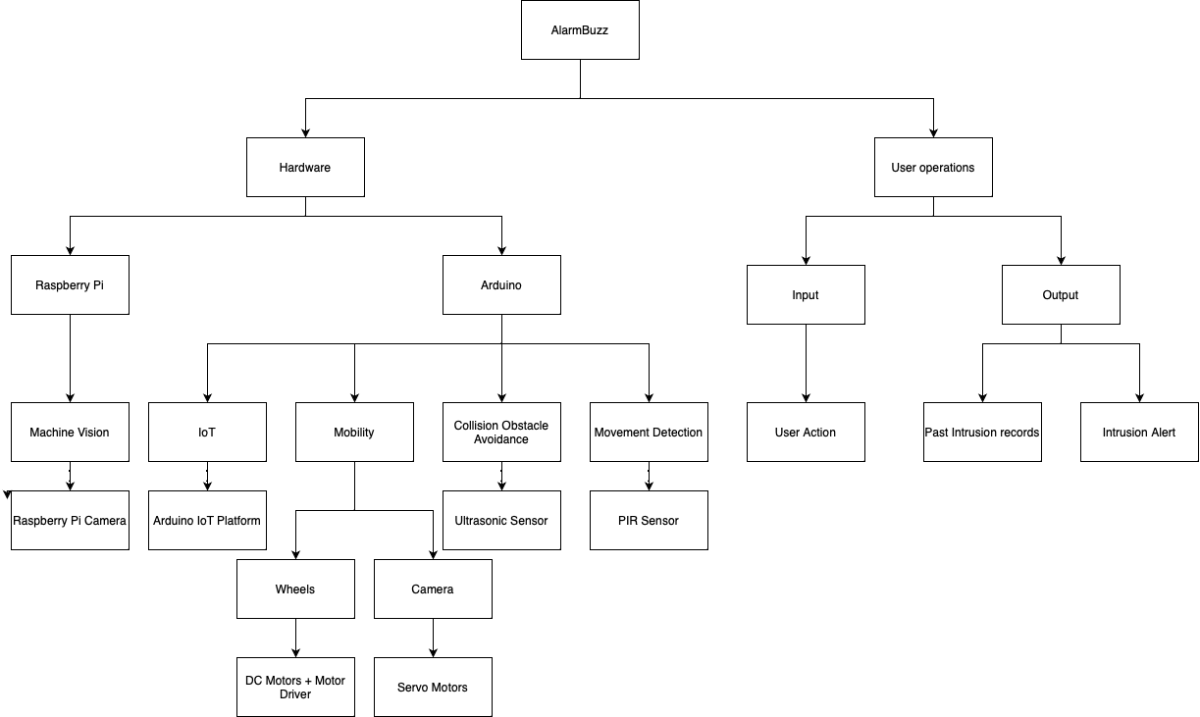

Figure 10 System Breakdown

### Logical Structure

The logical structure demonstrates AlarmBuzz's interconnection between its hardware and software components and the built-in logic of the different approaches for its smooth running.

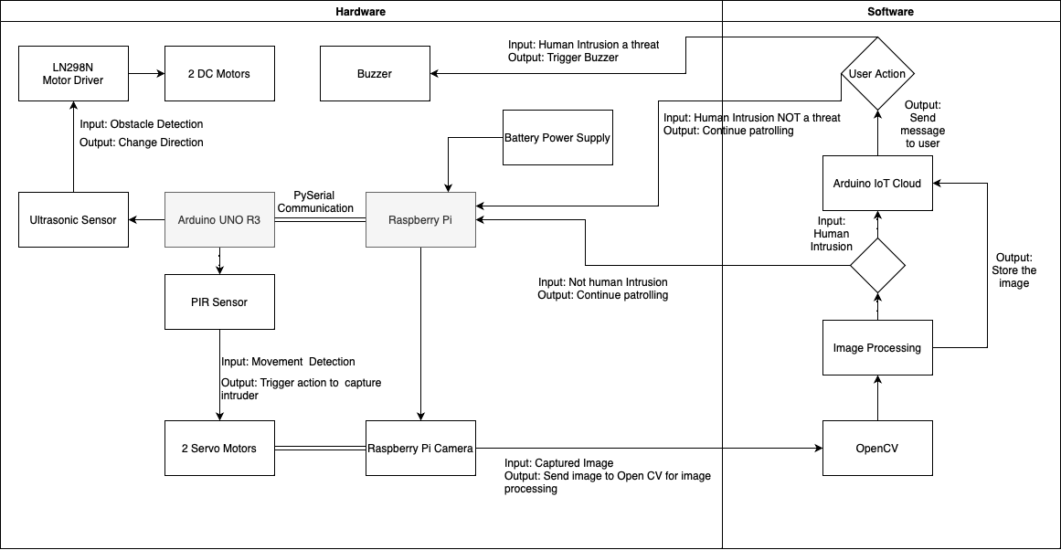

Figure 11 Logical Structure

The Arduino's key responsibility is the data collection and processing of all the changes in its environment using different sensors. The HR-SR04 ultrasonic sensor will report any object detected up to 12 feet away by bursting an ultrasonic beam and receiving it. Equipped with an LN298N motor driver and 2 DC motors for its mobility, AlarmBuzz will operate autonomously and uses a collision obstacle avoidance system to avoid running into objects or walls. Based on the distance collected from the ultrasonic sensor, the DC motors' rotation will change to simulate the robot changing direction. If the distance exceeds the specified, AlarmBuzz will move forward as it concludes that there is no obstacle. However, if the distance shortens, AlarmBuzz stops, goes backward, stops briefly, and turns to the left randomly from its initial position.

The PIR sensor will detect human or animal movement by interpreting any heat changes in its range. If a motion is detected, the PIR sensor pin value sets to 1, triggering the servo motor to position the pan tilt and PI camera activation.

Using the raspberry pi camera and the two servo motors, the pan-tilt mount will sweep smoothly in a 180-degree motion for 20 secs if human detection is confirmed by the raspberry pi using OpenCV library and a pre-trained human detection algorithm called HOG Descriptor, the camera will take the intruder snapshot. This locomotion will require optimum high-definition video and high-performance power from the raspberry pi to be fed to avoid any disruption or delay.

The OpenCV library is responsible for computer vision and deep learning using python. For this project, OpenCV’s emphasis will be on object detection by detecting a change of colour in the environment.

As a human detection algorithm, AlarmBuzz will implement a feature descriptor, a condensed version of the image that only highlights its most crucial details (only the shape and the edges), called HOG, or Histogram of Oriented Gradients, which is frequently employed to extract features from image data for object detection in computer vision tasks by counting the occurrences of gradient orientation in localized portions of an image. Its implementation uses tools like OpenCV and requires only a few lines of code (Analytics Vidhya, 2019).

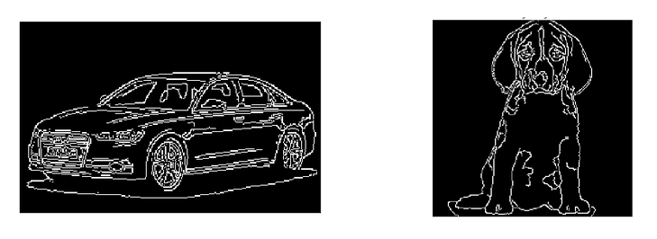

Figure 12 Difference between a normal image and implement HOG descriptor (Analytics Vidhya, 2019).

The pyserial communication between the Arduino and raspberry pi is essential to allow python scripts to and from the microcontroller and microprocessor. One key aspect is the baud rate which is the transmission rate of the data packages.

Every year, the number of connected devices increases by billions worldwide. With an intuitive user interface and an all-in-one solution for configuration, coding, uploading, and visualization, the Arduino IoT Cloud is a platform that develops IoT projects. (docs.arduino.cc, n.d.)

Users can send and receive automatic messages to and from other services using webhooks. Webhooks, for instance, alert the user if AlarmBuzz detects a human intrusion. Third-party platforms like IFTTT exist, linking the properties of your Arduino Cloud projects to the necessary trigger action to accomplish this. (docs.arduino.cc, n.d.)

Unfortunately, due to shortage of time, Arduino IOT cloud has not been implemented but an easier alternative which is using discord webhooks to connect to a discord server and send a bot message consisting of the time of the intrusion and an image of the intruder. Moreover, the captured image can be retrieved either from the discord server by any users or from the raspberry pi local storage.

## Physical Design

An Arduino UNO R3 and a Raspberry Pi 4B are used as computer platforms for this project based on their benefits. Six analog inputs and fourteen digital input/output pins make up Arduino's 20 I/O pins (Miller, 2019). It has integrated headers and a USB connection for easy prototyping and programming. The Arduino Uno is preferable for portable, battery-powered projects because of its reasonable price and low power consumption (50 mA) (Miller, 2019). The single-board computer known as the Raspberry Pi was created by the Raspberry Pi Foundation. There are numerous features it claims, such as an SD card reader, 4X USB ports, built-in LAN, WiFi, Bluetooth, and more. Additionally, compared to the Arduino Uno, it has 500,000 times more RAM (Miller, 2019).

Pi camera V2

Pan tilt

Arduino UNO R3

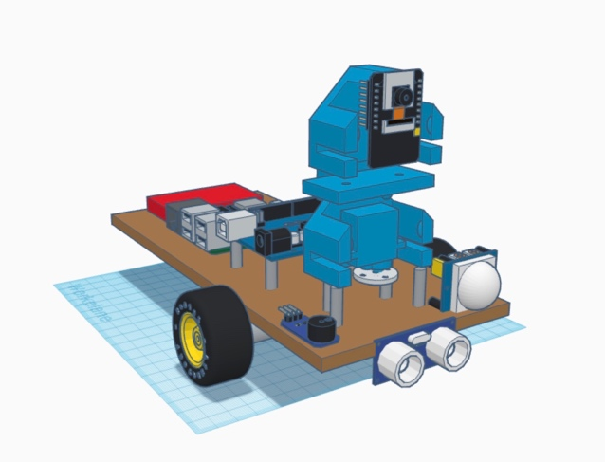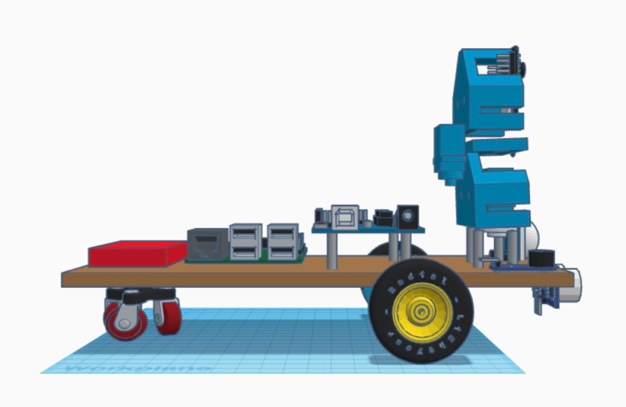

Servo motor

2 DC motor and motor driver

PIR sensor

Buzzer

Raspberry Pi4

Powerbank

Figure 13 Tinkercad Physical Structure

Ultrasonic Sensor

AlarmBuzz, the proposed burglary detection robot, will autonomously patrol a designated area and respond to any human intrusion. It mounts on three wheels with two DC gear motors, an L293D motor driver, and an object avoidance collision system with one ultrasonic sensor to prevent collision into nearby walls or objects. Positive and negative leads on DC motors will revolve in their rotation when connected to power, and in the opposite direction if leads connections switch. Using an H-Bridge, the L298N Motor Driver is a handy controller that manages the direction and speed of up to 2 DC motors. Two ultrasonic sensors are placed at the front of AlarmBuzz to detect any obstacle in its route. It will prevent any collision from arising.

AlarmBuzz, equipped with a PIR sensor will detect human or animal movement. Any intrusion will trigger the raspberry pi camera and servo motor to start the pan tilt calibration and start a sweeping motion from left to right for 20 seconds. If the signal does not change, the two servo motor's output shafts will rotate to a given angular position (www.tutorialspoint.com, n.d.). The shaft's angular position changes if the signal does. The servo motor will acquire various input signals and determine the proper calibration using computer vision from the raspberry pi to capture the intruder's image.

# Implementation

Below images demonstrate the actual robot final design which has been mounted and connected to the Arduino UNO R3. As mentioned in the system breakdown section, the PI camera V2 is the only hardware connected to the raspberry pi apart from the Arduino UNO R3 to improve performance and to mitigate any latency. The connections of the sensors and actuators will be tackled by the Arduino, however as the number of connections is quite limited, I deemed useful to use an Arduino sensor shield v5.0 to increase the capacity and for better cable management. From the previous reports, it can be noted that the number of ultrasonic and PIR sensors implemented has been decreased as it wasn’t required anymore due to the smaller size of AlarmBuzz. For maintenance purposes, AlarmBuzz components are primarily screwed together and not clued. The whole system will be powered by a 5V == 3A power bank which during the testing phase has been proven to be enough.

## Arduino Sensor Shield V5.0 Pin out Diagram.

Digital IO Ports D0-D13

|  |  |
| --- | --- |
| Pin Number | Component |
| D0 | - |
| D1 | - |
| D2 | SG90 Vertical Servo Motor |
| D3 | SG90 Horizontal Servo Motor |
| D4 | A-HC-SR501 PIR sensor |
| D5 | L298N Motor Driver IN1 |
| D6 | L298N Motor Driver IN2 |
| D7 | L298N Motor Driver IN3 |
| D8 | L298N Motor Driver IN4 |
| D9 | L298N Motor Driver ENA |
| D10 | L298N Motor Driver ENB |
| D11 | LY-44 Buzzer Passive Module |
| D12 | - |
| D13 | - |

Analogue IO Ports A0-A5

|  |  |
| --- | --- |
| Pin Number | Component |
| A0 | HC-SR04 Trigger Pin |
| A1 | HC-SR04 Echo Pin |
| A2 | - |
| A3 | - |
| A4 | - |
| A5 | - |

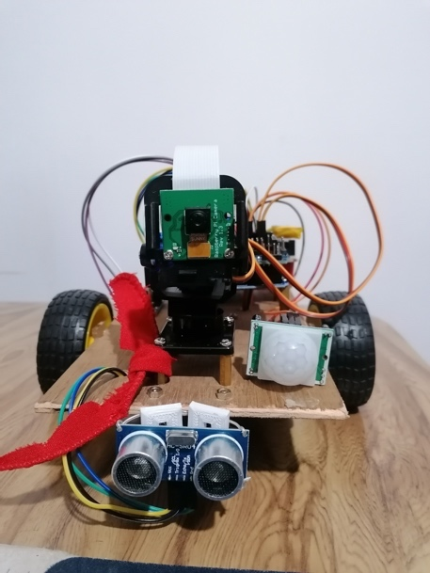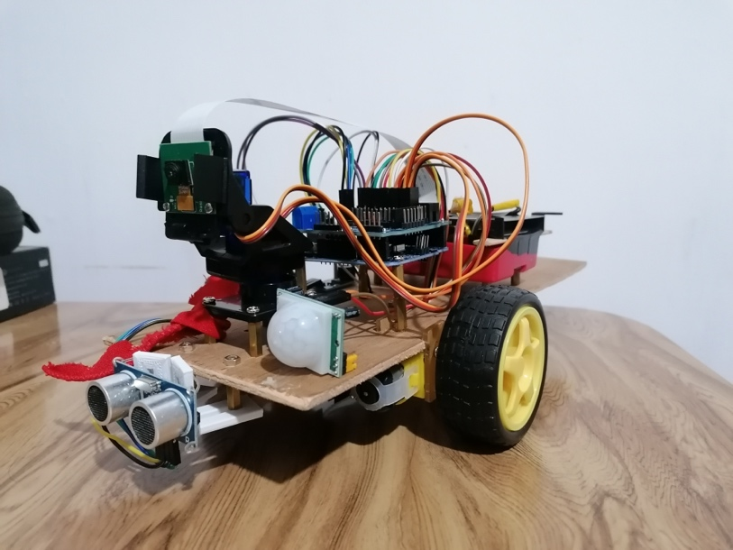

Figure 14 AlarmBuzz Physical Implementation

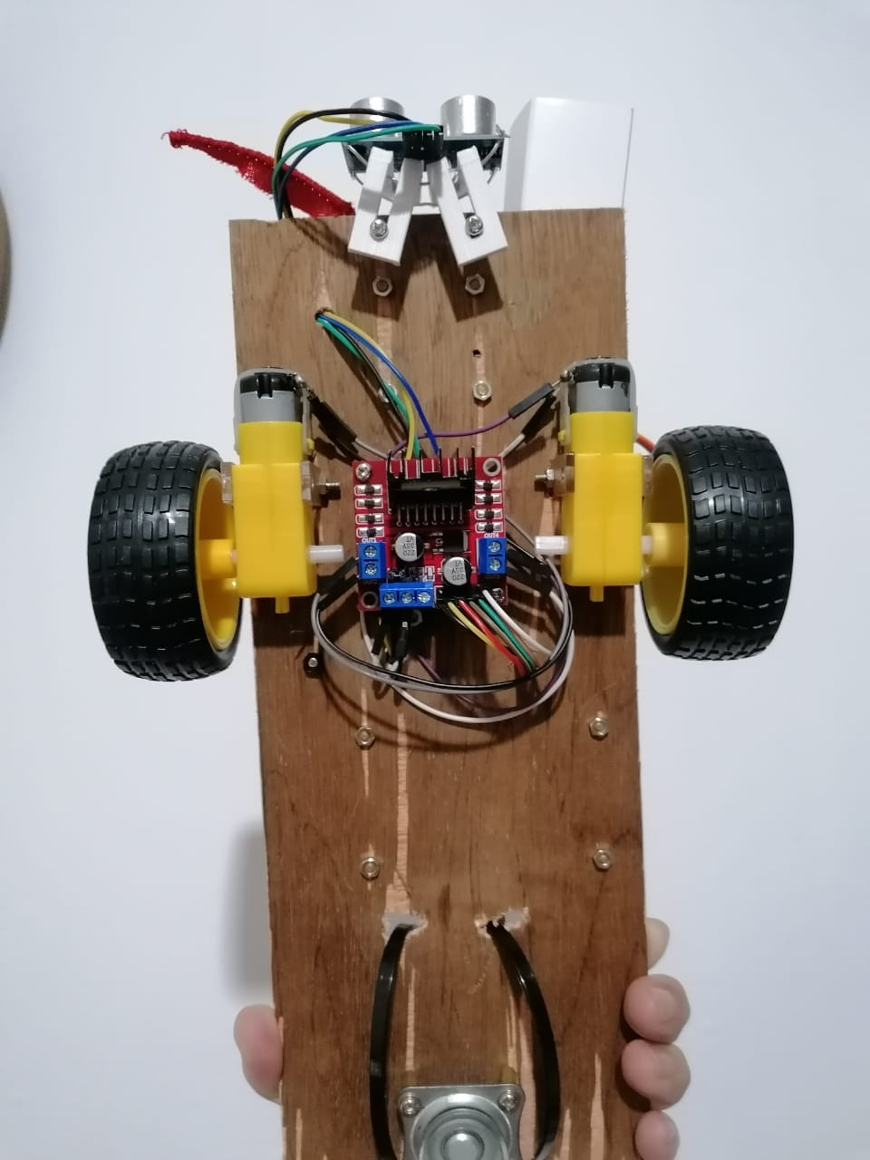

Figure 15 AlarmBuzz bottom view

## Main.py

For the AlarmBuzz process to start the user shall execute the main.py code either from the raspberry pi4 or by connecting from another machine to the raspberry pi through SSH (Secure shell connection) connected on the same network. It will ask the user to input his/her name and the number of seconds AlarmBuzz will operate. It will send a serial signal “start” to the Arduino to start its process, which is autonomous navigation and motion detection. After X number of seconds, the main.py script will send another serial signal “end” to the Arduino to stop the execution of its process.

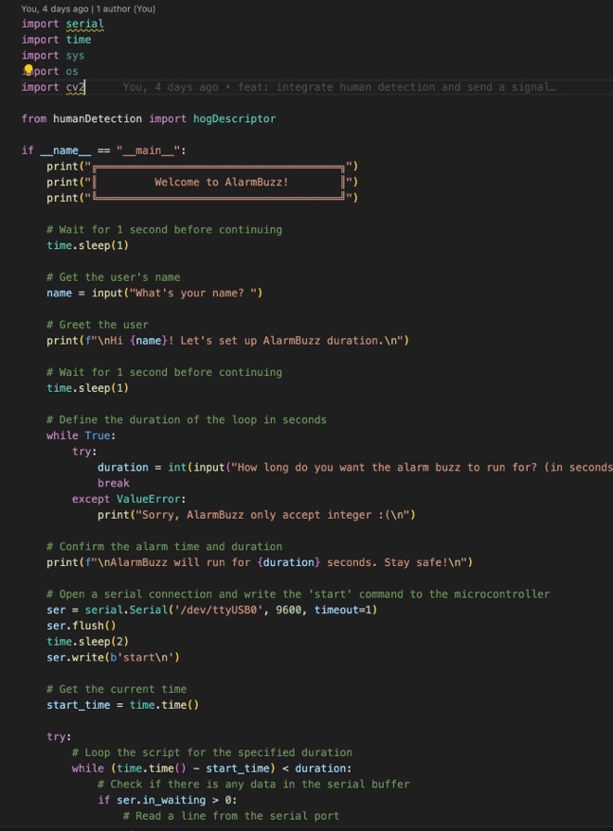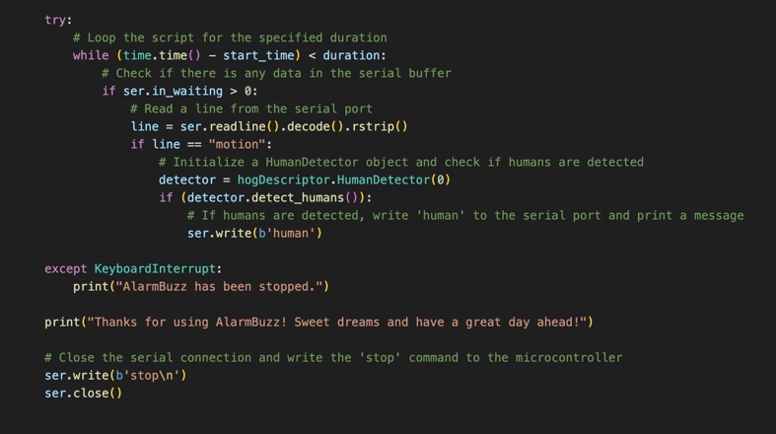

Figure 16 main.py code snippet

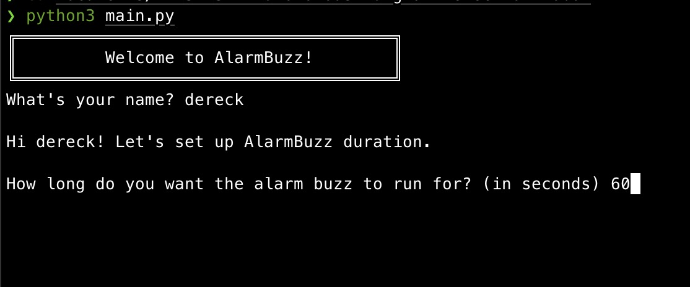

Figure 17 AlarmBuzz TUI

## Obstacle Avoidance

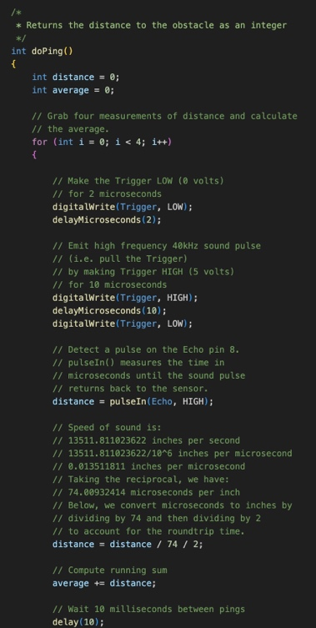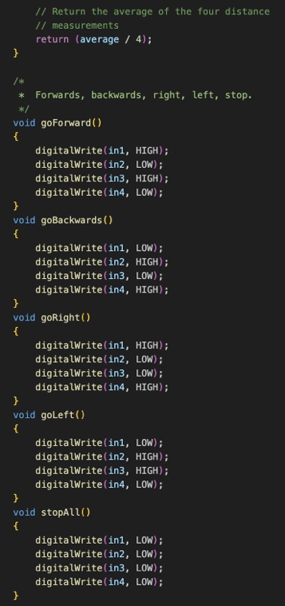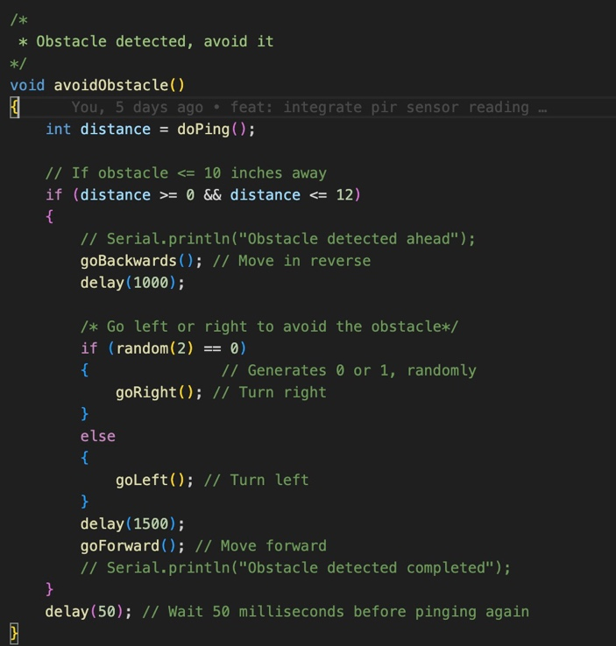

Figure 18 Obstacle Avoidance Code Snippet

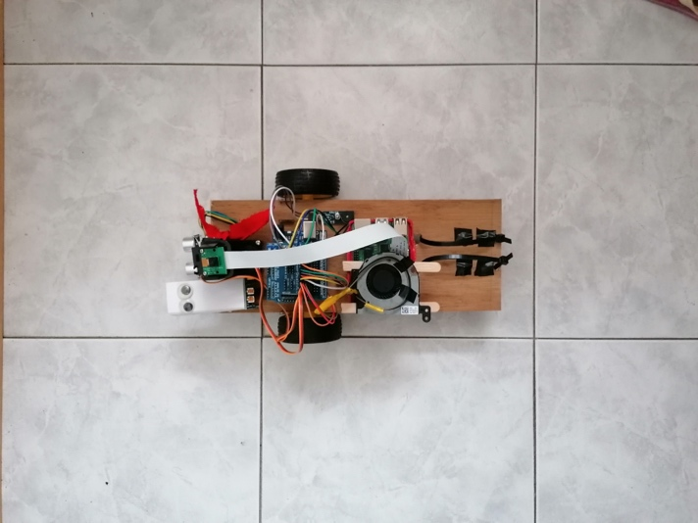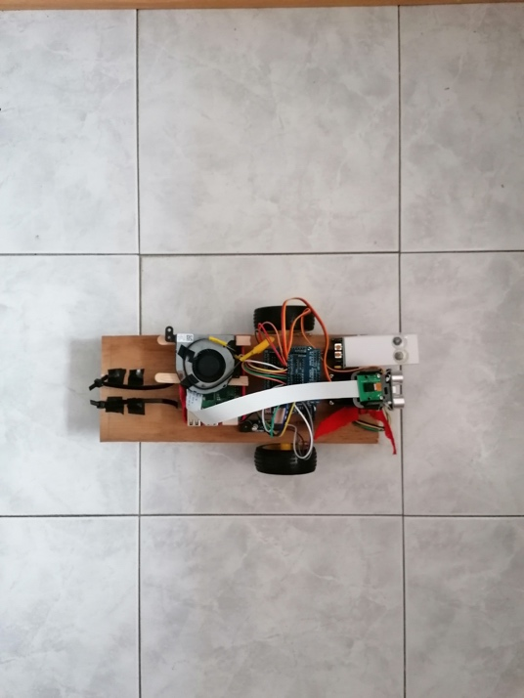

Wall

Wall

Figure 19 Obstacle Avoidance Logic

DC Motors rotate backwards and rotate left or right and then go forward.

Ultrasonic Sensor HR-SR04 detects a surface.

## Motion detection and pan tilt sweep movement

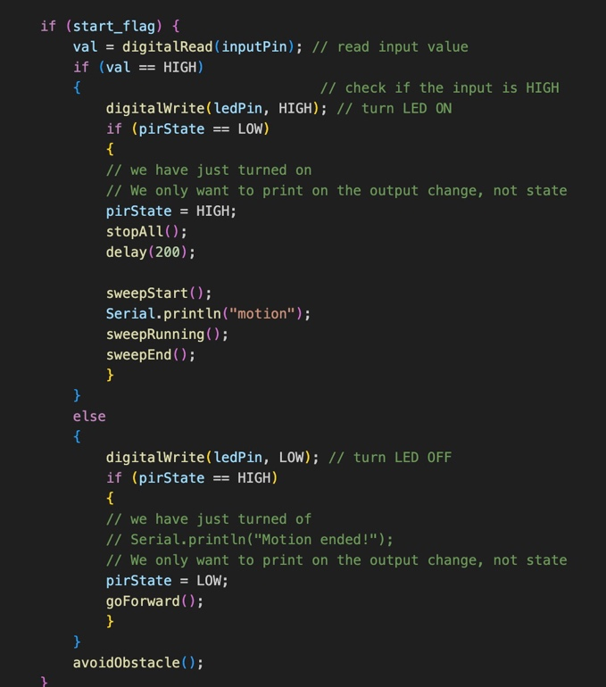

Figure 20 Motion detection Code Snippet

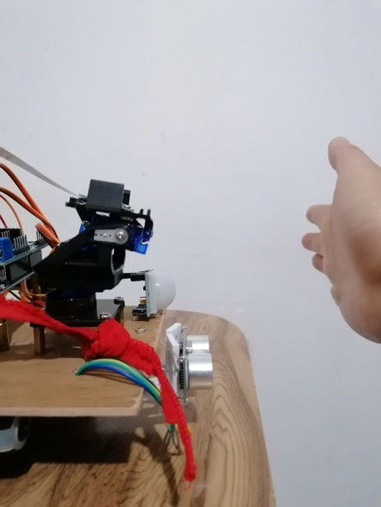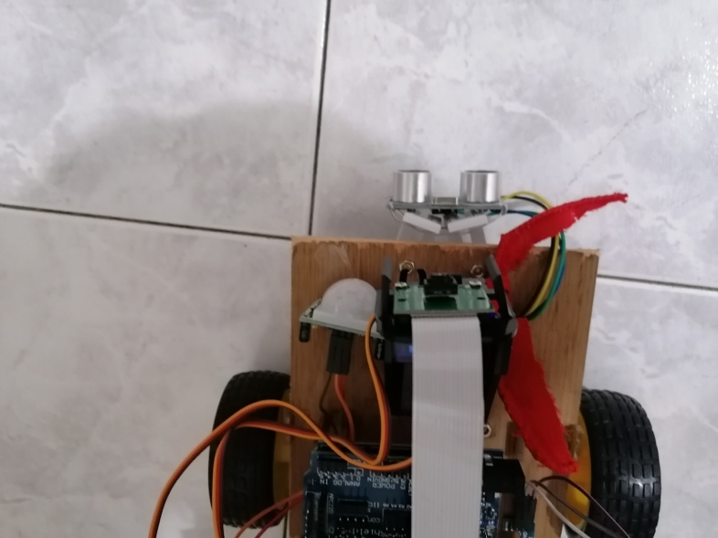

Pi camera v2 mounted on a pan tilt with 2 servo motors.

Servo motors are triggered and position the pan tilt to start sweeping the area in a 180-degree motion for 20secs.

PIR sensor picks up an infrared ray pertaining to a human.

Figure 21 PIR Motion Detection Flow

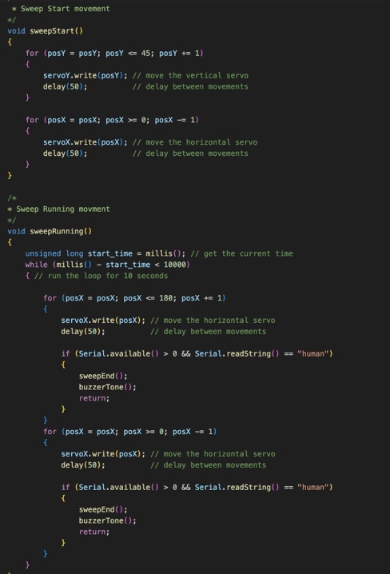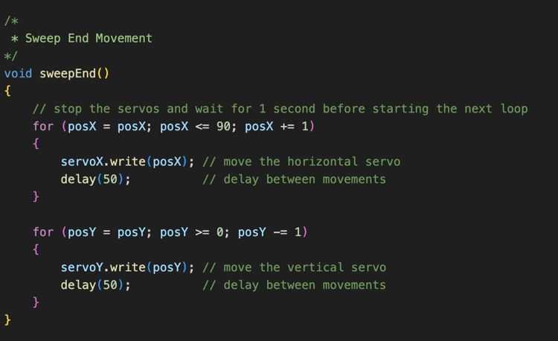

Figure 22 Pan tilt Sweeping code snippets.

## Human Detection Algorithm

During the selection of the proper human detection algorithm, three algorithms were tested in terms of their overall execution speed and performance.

1. Haarcascade – it functions as a classifier. It distinguishes between positive data points that are a part of the object we have discovered and negative data points that do not (Jaiswal, 2022).

2. HOG descriptor

3. Dataset training – using Kaggle dataset consisting of pictures with human and non-human environment, we trained our model using keras and tensorflow, then create a python script using the trained model to detect human and non-human intrusion.

After comparison in terms of overall execution speed and performance, it was concluded that HOG descriptor was the best fit for this robot.

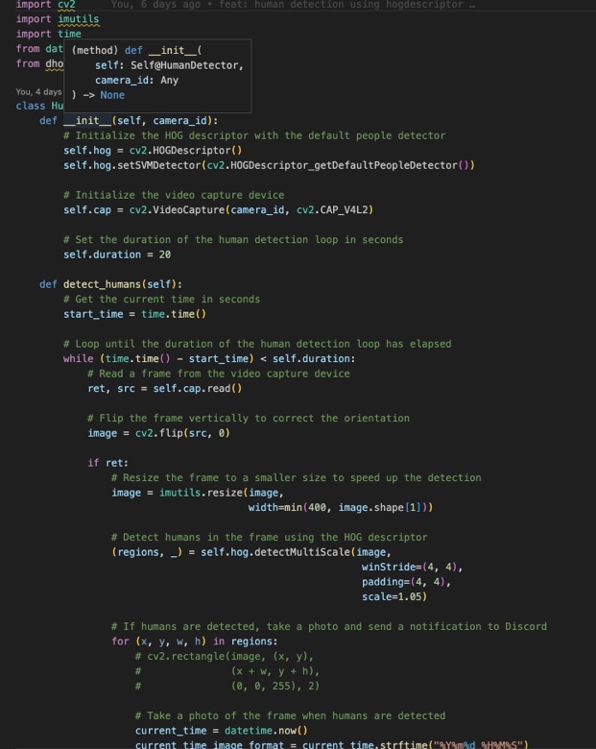

Figure 23 Hog Description Code Snippets

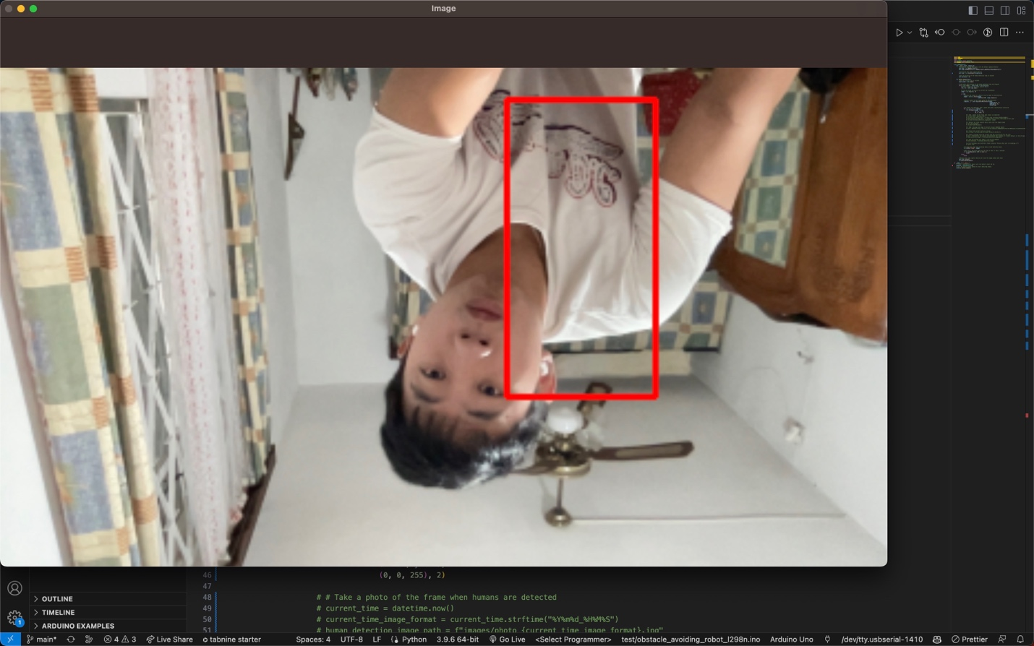

Figure 24 HOG Descriptor Human detection

## Discord Webhook

Due to a shortage of time, Arduino IOT cloud wasn’t successfully implemented, so I have chosen to use discord webhook as an alternative which will connect to a discord server and send a bot message containing the date time of the intrusion and the captured image to notify the owner and friends in the discord server. It will also serve as a temporary cloud storage for all the captured images which can be retrieved easily.

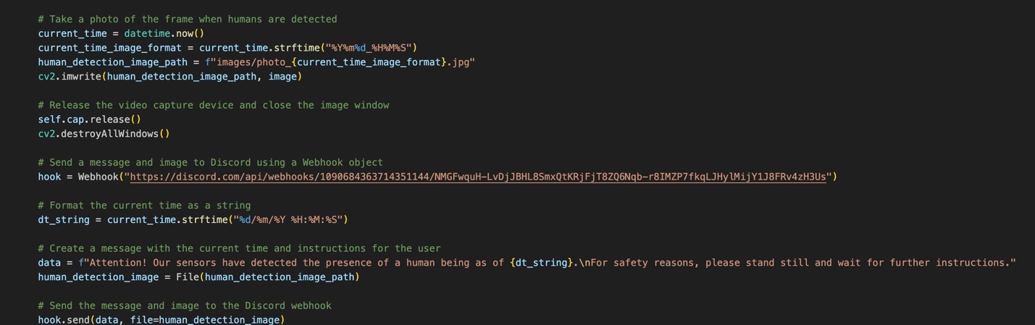

Figure 25 Discord Webhook code snippets

# Testing

Using a systematic approach AlarmBuzz was developed with events occurring that will change the system flow. For the smooth running of AlarmBuzz, each of its functionalities is essential and will later be tested using functional and system testing.

## Component testing

|  |  |  |
| --- | --- | --- |
| System requirements | | |
| Hardware | ID | Requirements |
| Arduino Uno R3 | HA01 | Communication established with Raspberry PI 4 |
| HA02 | Communication with Ultrasonic and PIR sensor should be established |
| HA03 | Communication with actuators (motor driver, dc motors, servo motors and buzzer) should be established. |
| HA04 | Instructions written in C++ using the Arduino IDE. |
| HA05 | Connection with the Arduino IoT cloud. |
| HA06 | Process instructions to use Arduino IoT cloud webhooks to send communication to alert the user. |
| HA06 | Process instructions to send the snapchats for storage on the cloud. |
| Pi Camera V2 | HPC01 | Communication established with Raspberry PI 4 |
| HPC02 | Instructions written in python using OpenCV for object detection and image processing to distinguish between human and animal intruder. |
| HPC03 | Communication with Arduino when PIR sensor detect a movement to trigger the camera functionality. |
| HPC04 | Communication with servo motors and Arduino to calibrate itself to focus and take a snapshot of the intruder. |
| Ultrasonic Sensor  HC-SR04 | HUS01 | Communication with the Arduino to be established. |
| HUS02 | Read and update distance. |
| HUS03 | Data collected should be communicated to Arduino for process. |
| FS90R Servo Motor | HSM01 | Communication with the Arduino to be established. |
| HSM02 | Smooth and stable movement to calibrate the camera. |
| HSM03 | Follow instructions provided by the pi camera and Arduino. |
| SR501 PIR sensor | HPIR01 | Communication with the Arduino to be established. |
| HPIR02 | Read and detect movement. |
| HPIR03 | Data collected should be communicated to Arduino for process. |
| Raspberry Pi 4 | HRP01 | Communication established with Arduino UNO R3. |
| HRP02 | Instruction written in python. |
| HRP03 | Connection with the Pi camera v2 using OpenCV for image processing and object detection. |
| HRP04 | Connection with the servo motors as intermediate for the PI camera for its calibration. |
| Buzzer | HBUZ01 | Communication with the Arduino to be established. |
| HBUZ02 | Follow instructions provided by the Arduino. |
| Motor Driver LM298N | HMD01 | Communication with the Arduino to be established. |
| HMD02 | Follow instructions provided by the Arduino. |
| HMD03 | Avoid collision with obstacle. |
| HMD04 | Lightweight but powerful. |
| 5V DC Motors | HDC01 | Communication with the Motor driver to be established. |
| HDC02 | Follow instructions provided by the motor driver. |
| HDC03 | In good condition for smooth mobility. |

|  |  |  |
| --- | --- | --- |
|  |  |  |
| User requirements | | |
| Mode | **ID** | **Requirements** |
| User Interaction | US01 | User should receive an alert message with action link from Arduino IoT cloud. |
| US02 | User should receive an email with intruder image from Arduino IoT cloud. |
| US03 | User should receive alert message when AlarmBuzz battery is 25%. |
| US04 | When user clicks the action link, shall send a signal back to AlarmBuzz to trigger the buzzer. |
| US05 | Authorized user shall connect to Arduino IoT cloud to view past intrusions. |

## Functional Component testing

### Unit Test cases

|  |  |  |
| --- | --- | --- |
| Unit Test Cases | | |
| Hardware | ID | Requirements |
| Arduino Uno R3 | HA01 | Test communication established with Raspberry PI 4 |
| HA02 | Test Communication with Ultrasonic and PIR sensor. |
| HA03 | Test Communication with actuators (motor driver, dc motors, servo motors and buzzer). |
| HA05 | Test connection with the Arduino IoT cloud. |
| HA06 | Use Arduino IoT cloud webhooks to send dummy communication to alert the user. |
| HA06 | Trial access of the snapchats for storage on the cloud. |
| Pi Camera V2 | HPC01 | Test Communication established with Raspberry PI 4 |
| HPC02 | Using OpenCV test for object detection and image processing to distinguish between human and animal intruder. |
| HPC03 | Test Communication with Arduino when PIR sensor detect a movement to trigger the camera functionality. |
| HPC04 | Test the movement of the servo motors and Arduino to calibrate itself to focus and take a snapshot of the intruder. Implement sudden movement to test if the servo motor can cope with. |
| Ultrasonic Sensor  HC-SR04 | HUS01 | Test Communication with the Arduino. |
| HUS02 | Compare distance with real life values. |
| HUS03 | Using the serial to see if the Arduino are reading the data correctly. |
| FS90R Servo Motor | HSM01 | Test Communication with the Arduino to be established. |
| HSM02 | Test the Smooth and stable movement to calibrate the camera. Implementing sudden movement. |
| HSM03 | Test the Smooth and stable movement to calibrate the camera. Implementing sudden movement. |
| SR501 PIR sensor | HPIR01 | Test Communication with the Arduino to be established. |
| HPIR02 | Using the serial to see if the Arduino are reading the data correctly. |
| HPIR03 | Using the serial to see if the Arduino are reading the data correctly. |
| Raspberry Pi 4 | HRP01 | Test Communication established with Arduino UNO R3. |
| HRP03 | Using OpenCV test for object detection and image processing to distinguish between human and animal intruder. |
| HRP04 | Test the Smooth and stable movement to calibrate the camera. Implementing sudden movement. |
| Buzzer | HBUZ01 | Test Communication with the Arduino to be established. |
| HBUZ02 | Test when instructions passed if it emit a sound. |
| Motor Driver LM298N | HMD01 | Test Communication with the Arduino to be established. |
| HMD02 | Using the serial to see if the Arduino are reading the data correctly from the ultrasonic sensor. |
| HMD03 | Create a track to test the avoid collision with obstacle. |
| HMD04 | Test if powerful enough to run with all components on. |
| 5V DC Motors | HDC01 | Test Communication with the Motor driver to be established. |
| HDC02 | Using the serial to see if the Arduino are reading the data correctly from the ultrasonic sensor. |
| HDC03 | Do a test run to see if it is operating smoothly |

### Integration Testing

|  |  |  |  |
| --- | --- | --- | --- |
| Integration Test Cases | | |  |
| Test Name | ID | Requirements | Results |
| Obstacle Avoidance System | IT01 | Two 5V DC motors are connected to a L298N motor driver which will read the output of an ultrasonic sensor to see if there is a surface in front of AlarmBuzz. | If the distance read from the ultrasonic exceeds the specified, there are no obstacles ahead, and it will continue to move forward.  If the distance is closer than the specified distance, then an obstacle is in front of AlarmBuzz. It will therefore stop in this position, go backward, pause briefly again, and then turn in a random different direction. |
| Motion Detection trigger Pan tilt and pi camera activation | IT02 | A PIR sensor is connected to the front of AlarmBuzz which will detect an IR light emitted from a hot-blooded creature which will trigger the positioning of the pan tilt by the two servos and activate the pi camera live stream. | Motion detected by the PIR sensor triggered the positioning of the pan tilt in a timely manner and activate the camera for 20 secs and if no human detection found reposition the pan tilt to the unactive mode. |
| Human Detection Algorithm | IT03 | Among the three selected algorithm, haarcascade, HOG descriptor and trained model, execution speed and performance to detect a human figure and no ghost human detected in the background. | After some tests, HOG descriptor has been selected as human detection algorithm for its execution speed and accuracy compared to the other two. |
| Human Detection and Pan tilt unactive mode | IT04 | IT02 and IT03 need to be satisfied for the following test to be carried. It consists of moving the pan tilt position to unactive mode when a human has been detected. | Overall good performance, sometimes has a small delay in terms of repositioning of the horizontal servo but is okay in terms of prototype. |
| Connect to Arduino IoT cloud | IT05 | IT03 need to be satisfied for the following test to be carried. Upon human detection, the date time of the intrusion and captured image is sent to the Arduino cloud for processing. | Failed. Lack of time for implementation |
| Connect to Discord webhooks | IT06 | IT03 need to be satisfied for the following test to be carried. Upon human detection, the date time of the intrusion and captured image is sent to the discord for processing using a webhook. | Successfully connected to the defined server and received the picture and time of intrusion without delay. |
| Continue patrolling following no human or human intrusion | IT07 | IT03 need to be satisfied for the following test to be carried. Following a human/non-human intrusion, AlarmBuzz shall continue to patrol until the predefined time. | Successfully continue to patrol the area until the predefined time, some form of delays detected when the main.py end while the human detection script is being run. |

## System testing

|  |  |  |  |
| --- | --- | --- | --- |
| Integration Test Cases | | |  |
| Test Name | ID | Requirements | Results |
| Patrolling without any motion | ST01 | IT01, IT02, IT03, IT07 are mandatory to be satisfied for the following test to be carried. AlarmBuzz will patrol an area with any hot-blooded creature intrusion | Passed. It continues to patrol without detecting any motion. |
| Patrolling, motion detected and it is a human intrusion. | ST02 | IT01, IT02, IT03, IT04, IT06, IT07 are mandatory to be satisfied for the following test to be carried. Patrolling then the PIR sensors detect a motion and the Pi camera classify the intrusion as human and send a discord bot message. | Passed. Patrolling then the PIR sensors detect a motion and the Pi camera classify the intrusion as human and send a discord bot message. |
| Patrolling, motion detected and it is not a human intrusion | ST03 | IT01, IT02, IT03, IT04, IT06, IT07 are mandatory to be satisfied for the following test to be carried. Patrolling then the PIR sensors detect a motion and the Pi camera classify the intrusion as non-human and continue to patrol the area for 20 second sweeping the area | Passed but have a 20% chance of detecting ghost human. |
| Patrolling, motion detected, human intrusion and continue to patrol until X sec execution. | ST04 | IT01, IT02, IT03, IT04, IT06, IT07 are mandatory to be satisfied for the following test to be carried. Patrolling then the PIR sensors detect a motion and the Pi camera classify the intrusion as human and send a discord bot message. After X seconds, AlarmBuzz stops | Passed. Patrolling then the PIR sensors detect a motion and the Pi camera classify the intrusion as human and send a discord bot message. After X seconds, AlarmBuzz stops |

# Conclusion

To compare and distinguish between the image of the intruder that was caught and whether it was a human or an animal, the raspberry pi with AI and machine learning applied will need a sufficient precise data set to train a better model and a better human detection algorithm as the one we tried to applied was too slow for this implementation..

One ultrasonic sensor might be sufficient for the Object Collision Avoidance System given the size of the AlarmBuzz. However, if it was to become bigger in size to increase its robustness, it may run into objects or walls as the front will become larger than the sensor's detection range. It would require more ultrasonic or even IR sensors to cater for the problem and will require additional tests to accurately merge the readings of all additional sensors to have the proper reading.

Have a live feed of the intrusion might be a good future implementation but the servo motors and raspberry pi camera will have to calibrate for swiftly moving objects, the rotational axis of the servo motor may experience issues as it tries to keep up with the intruder's speed. There has to be more investigation into this approach because several attackers could cause the Raspberry Pi's machine vision to crash because it would not know which intruder to focus on.

AlarmBuzz's mobility and stability are its greatest weaknesses. AlarmBuzz was developed as a school project with minimal funding, so it is not designed for outside use or harsh terrain. As AlarmBuzz lacks a brake to stop it from sliding, its wheel and motor could not withstand patrol on a steep slope. Due to its poor plastic construction, the alarm won't withstand any shock from falling or being kicked by an intruder. The current components of AlarmBuzz are not protected to withstand weather damage like rains and snow, so a cover might be a good option.

AlarmBuzz's overall design requires work because it lacks the resilience and mobility necessary for a security robot to patrol difficult terrain. AlarmBuzz might be used to deter unauthorized people from poaching if it has the build to roam outdoor places like a forest. When the situation becomes too dangerous for humans, it could even be transformed into firefighting robots.

Today's society favors environmentally friendly machinery. By attaching solar panels and a rechargeable battery, AlarmBuzz may convert from battery power to solar power. This will promote the use of it outside while also contributing to the preservation of the planet.

The present monitoring cameras that require security personnel to watch can be replaced by a security network with several Alarmbuzz. There will be no downtime or breaks in service for this system. It must have a control center from which the AlarmBuzz will be launched for patrol at night and stationed throughout the day. When PIR sensors are installed in certain places, the AlarmBuzz will be notified of an intrusion and will storm the area to look for any violations. Due to its stronger construction, AlarmBuzz might possibly have robotic arms and attempt to stop the invaders from fleeing before the police arrive. In order to speed up the process of catching the offender, a partnership with the police may be put into place where, in the event of confirmed offenses, captured photographs are submitted to them.

# Reference List

1. admin (2018). *Let’s start talking seriously about robots*. [online] Defsec. Available at: https://defsec.net.nz/2018/08/02/lets-start-talking-seriously-robots/ [Accessed 4 Nov. 2022].
2. Alarms.org. (2015). *Burglary Statistics: The Hard Numbers | National Council For Home Safety and Security*. [online] Available at: <https://www.alarms.org/burglary-statistics/>. [Accessed: 15 Oct. 2022]
3. Almasri, M.M., Alajlan, A.M. and Elleithy, K.M. (2016). Trajectory Planning and Collision Avoidance Algorithm for Mobile Robotics System. *IEEE Sensors Journal*, 16(12), pp.5021–5028. doi:10.1109/jsen.2016.2553126. [Accessed: 2 Nov. 2022]
4. Analytics Vidhya. (2019). Feature Descriptor | Hog Descriptor Tutorial. [online] Available at: <https://www.analyticsvidhya.com/blog/2019/09/feature-engineering-images-introduction-hog-feature-descriptor/#:~:text=HOG%2C%20or%20Histogram%20of%20Oriented>. [Accessed: 1 April 2023]
5. Ardumotive Arduino Greek Playground. (n.d.). How to use a passive buzzer module with Arduino. [online] Available at: <https://www.ardumotive.com/how-to-use-a-passive-buzzer-module-en.html> [Accessed: 2 Nov. 2022].
6. docs.arduino.cc. (n.d.). *Arduino Cloud | Arduino Documentation*. [online] Available at: <https://docs.arduino.cc/arduino-cloud/>. [Accessed: 3 Nov. 2022]
7. docs.arduino.cc. (n.d.). *Webhooks with Arduino IoT Cloud | Arduino Documentation*. [online] Available at: https://docs.arduino.cc/arduino-cloud/features/webhooks [Accessed 15 Jan. 2023].
8. Durrant-Whyte, H. and Bailey, T. (2006). Simultaneous localization and mapping: part I. *IEEE Robotics & Automation Magazine*, [online] 13(2), pp.99–110. doi:10.1109/mra.2006.1638022. [Accessed: 4 Nov. 2022]
9. Expert.AI Team (2020). *What is Machine Learning? A definition - Expert System*. [online] Expert.ai. Available at: <https://www.expert.ai/blog/machine-learning-definition/>. [Accessed: 4 Nov. 2022]
10. Furhat Robotics. (2020). *What Are Social Robots? An Introduction to the Furhat Robot*. [online] Available at: <https://furhatrobotics.com/blog/what-are-social-robots/>. [Accessed: 13 Oct. 2022]
11. GeoSLAM. (n.d.). *What is LiDAR and How Does it Work?* [online] Available at: <https://geoslam.com/what-is-lidar/>. [Accessed: 4 Nov. 2022]
12. grobotronics.com. (n.d.).  PIR Sensor Module - HC-SR501. [online] Available at: https://grobotronics.com/pir-sensor-module.html [Accessed: 17 Oct. 2022].
13. grobotronics.com. (n.d.). Raspberry Pi Camera Module V2 (8MP,1080p). [online] Available at: https://grobotronics.com/raspberry-pi-camera-module-v2-8mp-1080p.html [Accessed: 17 Oct. 2022].
14. grobotronics.com. (n.d.). Passive Buzzer Module. [online] Available at: https://grobotronics.com/passive-buzzer-module.html?sl=en [Accessed 2 Apr. 2023].
15. Hart, M. (2022). *What are Autonomous Robots? 8 Applications for Today’s AMRs*. [online] Locus Robotics. Available at: <https://locusrobotics.com/what-are-autonomous-robots/>. [Accessed: 2 Nov. 2022]
16. Homan, R. (n.d.). *Burglary Statistics 2022*. [online] Bankrate. Available at: <https://www.bankrate.com/insurance/homeowners-insurance/house-burglary-statistics/#stats>. [Accessed: 15 Oct. 2022]
17. IEEE Instrumentation & Measurement Magazine. (2003). [online] Available at: https://www.hsdl.org/?view&did=451029. [Accessed: 13 Oct. 2022]
18. Jaiswal, A. (2022). Object Detection Using Haar Cascade: OpenCV. [online] Analytics Vidhya. Available at: https://www.analyticsvidhya.com/blog/2022/04/object-detection-using-haar-cascade-opencv/#:~:text=What%20are%20Haar%20Cascades%3F [Accessed 2 Apr. 2023].
19. Kelley, K. (2022). *What is Artificial Intelligence: Types, History, and Future*. [online] Simplilearn.com. Available at: <https://www.simplilearn.com/tutorials/artificial-intelligence-tutorial/what-is-artificial-intelligence>. [Accessed: 4 Nov. 2022]
20. Last Minute Engineers. (2019). *How HC-SR04 Ultrasonic Sensor Works & How to Interface It With Arduino*. [online] Available at: <https://lastminuteengineers.com/arduino-sr04-ultrasonic-sensor-tutorial/>. [Accessed: 5 Nov. 2022]
21. Last Minute Engineers. (2018). *How HC-SR501 PIR Sensor Works & How To Interface It With Arduino*. [online] Available at: <https://lastminuteengineers.com/pir-sensor-arduino-tutorial/>. [Accessed: 5 Nov. 2022]
22. Miller, L. (2019). *Arduino vs Raspberry Pi for Robotics*. [online] Learn Robotics. Available at: https://www.learnrobotics.org/blog/arduino-vs-raspberry-pi/ [Accessed 5 Nov. 2022].
23. Monk, S. (2016). *Computer vision with the Raspberry Pi*. [online] O’Reilly Media. Available at: https://www.oreilly.com/content/raspberry-pi-cookbook-computer-vision/ [Accessed 5 Nov. 2022].
24. NBC News. (n.d.). *Security robots expand across U.S., with few tangible results*. [online] Available at: <https://www.nbcnews.com/business/business-news/security-robots-expand-across-u-s-few-tangible-results-n1272421>. [Accessed: 1 Nov. 2022]
25. Oracle (2021). *What is the Internet of Things (IoT)?* [online] oracle. Available at: <https://www.oracle.com/internet-of-things/what-is-iot/>. [Accessed: 4 Nov. 2022]
26. Plain Concepts. (2022). *Autonomous Robots: The Future of Security and Surveillance?* [online] Available at: <https://www.plainconcepts.com/autonomous-robots-security/>. [Accessed: 3 Nov. 2022]
27. Progressive Automations. (n.d.). *Actuators: what is it, definition, types and how does it work*. [online] Available at: <https://www.progressiveautomations.com/pages/actuators>. [Accessed: 5 Nov. 2022]
28. PyImageSearch. (2020). *Image Segmentation with Mask R-CNN, GrabCut, and OpenCV*. [online] Available at: <https://pyimagesearch.com/2020/09/28/image-segmentation-with-mask-r-cnn-grabcut-and-opencv/>. [Accessed 15 Jan. 2023]
29. PyImageSearch. (n.d.). *Image Processing Archives*. [online] Available at: https://pyimagesearch.com/category/image-processing/ [Accessed 15 Jan. 2023].
30. PyImageSearch. (n.d.). *Object Detection Archives*. [online] Available at: <https://pyimagesearch.com/category/object-detection/>. [ Accessed: 14 Jan. 2023]
31. <https://pyimagesearch.com/2015/06/01/home-surveillance-and-motion-detection-with-the-raspberry-pi-python-and-opencv/> [ Accessed: 14 Jan. 2023]
32. Qualitest. (n.d.). *System Breakdown*. [online] Available at: https://qualitestgroup.com/insights/white-paper/system-breakdown/ [Accessed 15 Jan. 2023].
33. Reiss, K. (n.d.). *How Do I Know if My Raspberry Pi Camera is Working?* [online] Raspberry tips. Available at: <https://raspberrytips.com/troubleshooting-camera-module/>. [Accessed: 5 Nov. 2022]
34. Santhana_krishnanMore (n.d.). *SERVO MOTOR TEST*. [online] Instructables. Available at: <https://www.instructables.com/SERVO-MOTOR-TEST/>. [Accessed: 6 Nov. 2022]
35. SearchEnterpriseAI. (n.d.). *What is machine vision (computer vision)? - Definition from WhatIs.com*. [online] Available at: <https://www.techtarget.com/searchenterpriseai/definition/machine-vision-computer-vision>. [Accessed: 30 Oct. 2022]
36. Sparkfun.com. (2017). Ultrasonic Distance Sensor - HC-SR04 - SEN-15569 - SparkFun Electronics. [online] Available at: <https://www.sparkfun.com/products/15569>. [Accessed: 17 Oct. 2022]
37. S, V., S, D. and S, A.K. (2019). Surveillance Robot Capturing Intruder Using PIR Sensor. *Journal of Remote Sensing GIS & Technology*, [online] 5(3), pp.36–40. doi:10.5281/zenodo.3576712. [Accessed: 15 Oct. 2022)
38. Ulf Eriksson (2014). *Levels of Testing - Understand the Difference b/w Different Levels & Types*. [online] ReQtest. Available at: <https://reqtest.com/testing-blog/different-levels-of-testing/>. [Accessed: 6 Nov. 2022]
39. www.avsupply.com. (n.d.). *Ganz NIMBO Robot | Audio Video Supply*. [online] Available at: https://www.avsupply.com/ITM/34344/NIMBO%20Robot.html [Accessed 4 Nov. 2022].
40. www.securityinfowatch.com. (n.d.). *StackPath*. [online] Available at: https://www.securityinfowatch.com/perimeter-security/robotics/product/12390271/segway-nimbo-security-robot-from-segway-and-turing-video [Accessed: 15 Oct. 2022].
41. www.securityinfowatch.com. (n.d.). *StackPath*. [online] Available at: https://www.securityinfowatch.com/perimeter-security/robotics/product/12390271/segway-nimbo-security-robot-from-segway-and-turing-video [Accessed: 15 Oct. 2022].
42. www.micron.com. (n.d.). *To Catch a Thief: How Security Robots Help Make Our Lives Safer*. [online] Available at: <https://www.micron.com/insight/to-catch-a-thief-how-security-robots-help-make-our-lives-safer>. [Accessed: 15 Oct. 2022]
43. www.mordorintelligence.com. (n.d.). *Security Robot Market Share, Size | 2022 - 27 | Industry Growth*. [online] Available at: https://www.mordorintelligence.com/industry-reports/security-robots-market [Accessed: 16 Oct. 2022].
44. www.ojp.gov. (n.d.). Impact of Burglary Upon Victims | Office of Justice Programs. [online] Available at: <https://www.ojp.gov/ncjrs/virtual-library/abstracts/impact-burglary-upon-victims>. [Accessed: 1 April. 2022]
45. www.tutorialspoint.com. (n.d.). *Arduino - Servo Motor - Tutorialspoint*. [online] Available at: <https://www.tutorialspoint.com/arduino/arduino_servo_motor.htm>. [Accessed: 5 Nov. 2022]