

**CST3130 Advanced Web Development with Big Data**

**Coursework 1: Price Comparison Website**

**Project Proposal**

**Dereck Lam Hon Wah**

**M00826933**

**Date of Submission: 20.10.22**

**Lab Tutor: Waseemah Moedeen**

Table of Contents

Table of Figures 2

Brief Description 3

Introduction 3

Features 3

Homepage 3

Result Page 3

Product Page 3

Technology Stack 3

Wireframes Sketches 5

Home Page 5

Results Page 5

Product Page 6

List of Websites and URLs to be scrapped. 6

Database Design 7

# Table of Figures

Figure 1 Wireframe Home Page 5

Figure 2 Wireframe Results Page 5

Figure 3 Wireframe Product Page 6

Figure 4 MoLarak Database Design 7

# Brief Description

Introduction

“MoLarak” is an Alcoholic Beverage Price Comparison Website designed to help users easily compare and find the best deals on different alcoholic drinks from various websites. Through a user-friendly interface, the consumers will be able to search for their favourite alcoholic drinks, browse a list of suggested featured products, sort and filter their search results, and access detailed product information with links on various websites to finalize their purchase.

Features

### Homepage

On the home page, users will find a search bar where they can input the name of their preferred alcoholic beverage and the web page will also feature a list of suggested alcoholic drinks for quick browsing.

### Result Page

Depending on the user’s search criteria, the page will dynamically populate a list of results and offer convenient pagination functionality to navigate through extensive product data. Users can sort products in ascending, descending, and default order based on the product names using a dropdown button and additionally, the user and search experience is further enhanced with another search bar to refine their queries.

### Product Page

Upon selecting a product, users will be redirected to a dedicated product page, which will provide comprehensive details about the selected alcoholic drink, including its name, description, and image. The page will display the product’s lowest price available on the market and a list of options to explore various volumes of the same product to cater for individual needs. Furthermore, the web page will feature a price comparison section for the selected product with the details and external links to the vendors’ original websites. This feature ensures you make an informed decision and get the most value out of your choice.

## Technology Stack

The website will be developed using a combination of front-end and back-end technologies to deliver a seamless user experience:

|  |  |  |
| --- | --- | --- |
|  | **Technologies** | **Description** |
| **Front-end** | HTML, CSS and JavaScript | To create an engaging and responsive user interface. |
| **Back-end** | JavaScript using Node.js | To handle server-side operations efficiently. |
| **Database** | MySQL or MariaDB | A SQL database to store data related to alcoholic beverages, pricing information, and user preferences. |
| **API Integration** | REST API via Ajax | To fetch and update data, ensuring real-time accuracy and availability of information. |
| **Data Collection** | Java | Using web scraping and multi-threading to pull and download data from various alcoholic beverage provider websites. |
| **Build and Dependency Management** | Maven | To build Java software, manage project dependencies, and automate the build process. |
| **Data Persistence** | Hibernate | To handle object-relational mapping and simplify database operations for storing and managing data in the SQL database. |
| **Dependency Management** | Spring Framework | To manage the dependencies between various Java classes, enhancing modularity and making the application more maintainable. |
| **Unit Testing** | Java | To ensure the reliability and correctness of the software, minimizing the chances of errors. |

# 

# Wireframes Sketches

## Home Page

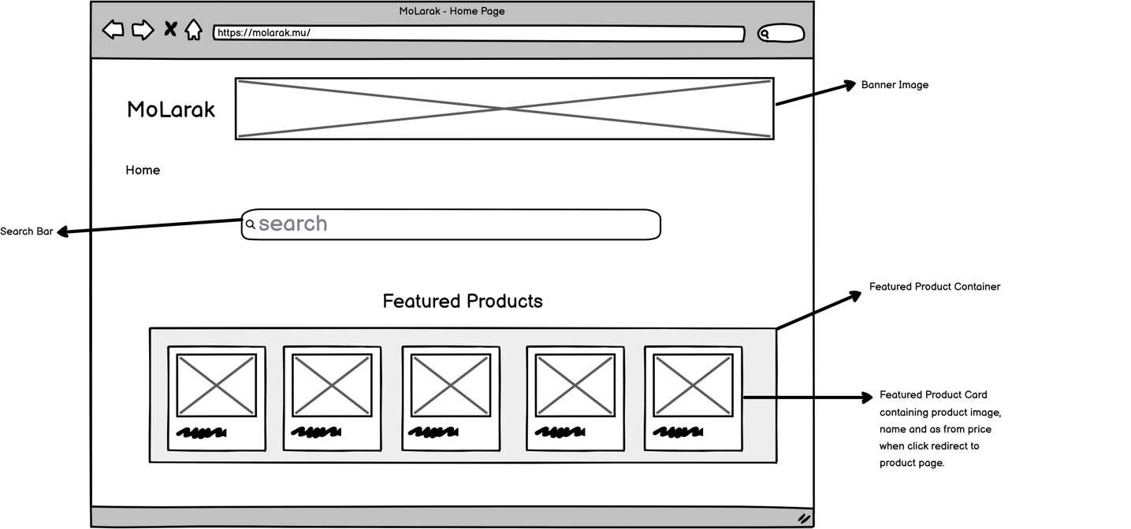

Figure 1 Wireframe Home Page

Results Page

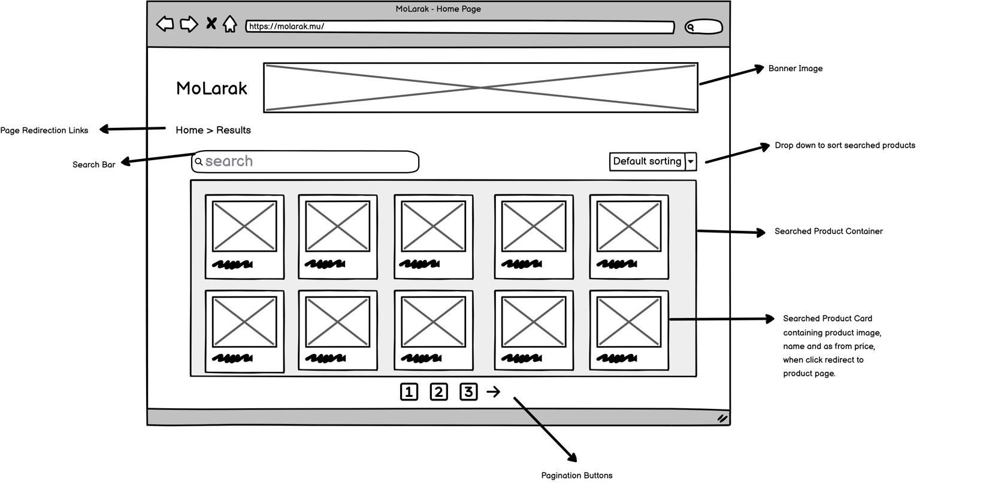

Figure 2 Wireframe Results Page

Product Page

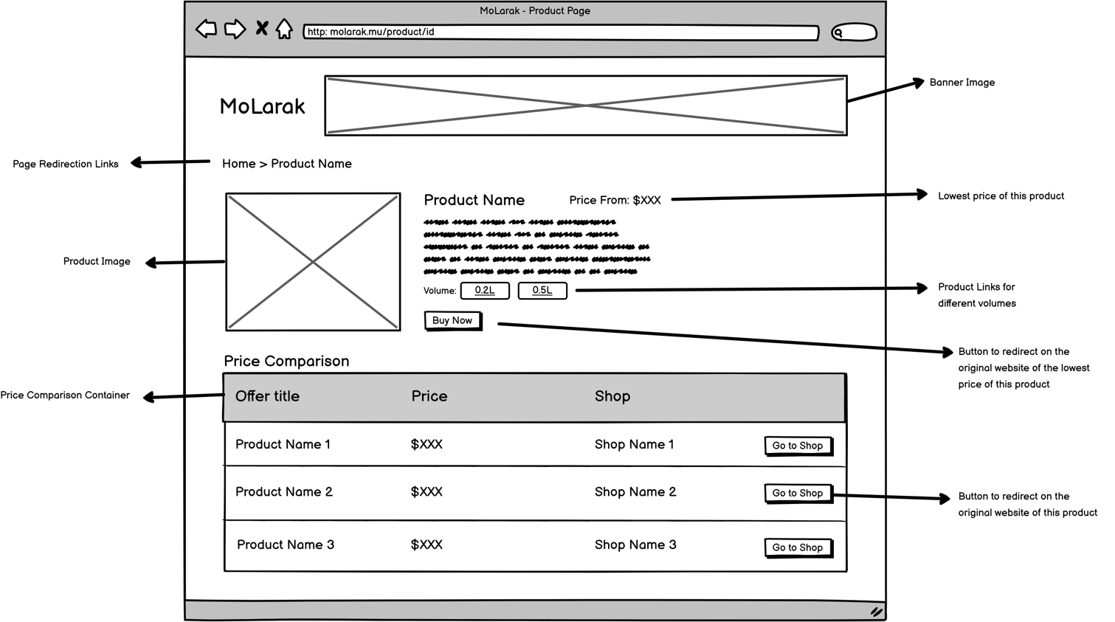

Figure 3 Wireframe Product Page

# List of Websites and URLs to be scrapped.

1. The Whisky Shop - [www.whiskyshop.com](http://www.whiskyshop.com)
2. Master of Malt - [www.masterofmalt.com](http://www.masterofmalt.com)
3. Amazon - [www.amazon.co.uk](http://www.amazon.co.uk)
4. The Whisky Exchange - [www.thewhiskyexchange.com](http://www.thewhiskyexchange.com)
5. Vinatis Wein & Champagne - [www.vinatis.de](http://www.vinatis.de)

# Database Design

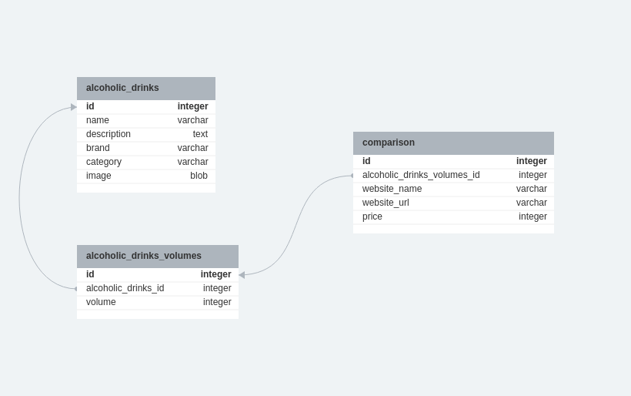

Figure MoLarak Database Design