Dear enemy a tale of many graphs

Derek Corcoran

October 31, 2015

# Map

It all starts with the map, all the graphs made after that follow the same colour scheme

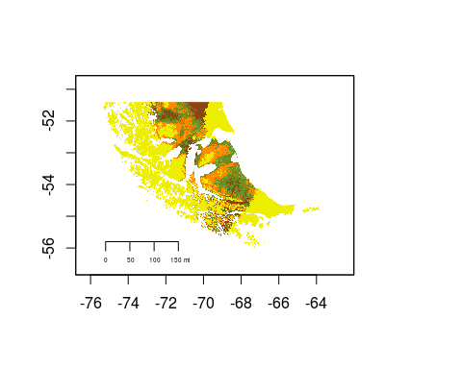

# Chemical resemblance

This graph shows the chemical resemblance between the scents we developed, as it is mentioned before, the colors are the same as in the map above. The closer the scents are in this graph, the more chemicaly similar they are, Giorgia and mine are the closest, and Camila's is the most different

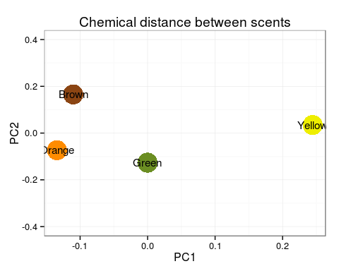

# Popularity contest

The votes for scent mounds and years are shown in the following graphs, of course for the timeline we don't have the colors, but we can work on the texts

