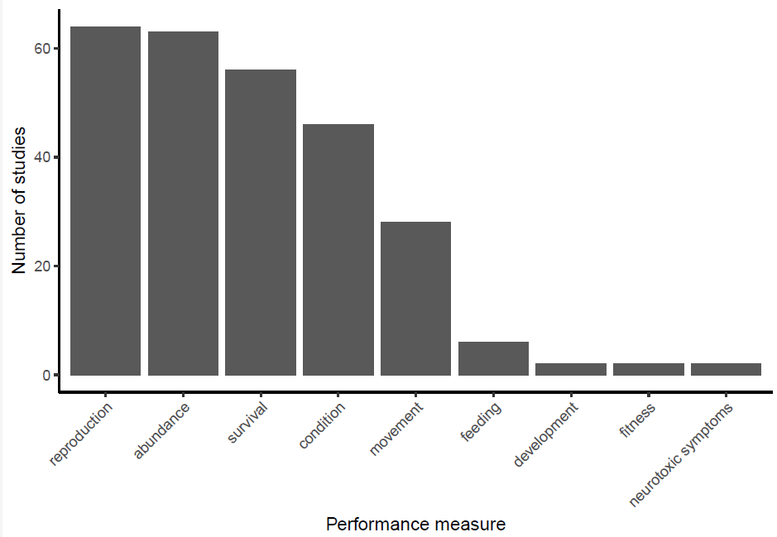

**Methods**

We reported nine performance measures, but we only analyzed the four with more studies as separate meta-analysis (fig 1).

We used the metafor package (Viechtbauer, 2010), from the R environment (R Core Team, 2016). We compared the studies using Standardized Mean Differences due to studies using different scales to measure each of the performances, (e.g. Total, Total females, % of total). The fixed effect model assumes that the estimated effects from the component studies in a meta-analysis come from a single homogeneous population, on the other hand, the random effects model seeks to account for the fact that the study effect estimates are often more variable than assumed in the fixed effect model and come from different populations, which is why we used the random effects model (Schwarzer, 2015). We used functional group as moderator and calculated the effect size using Hedge’s g.

**Results**

The overall model without moderators shows, that abundance is 1.4 times standard errors lower in treated vs untreated sites. When we take a look at different functional groups, omnivores and pollinators have a very high effect size with abundances 3.04 and 2.68 standard errors lower than the control groups(Fig 2, table 1). The predators on the other hand did not have any statistical differences between the control and treatments. The model using only functional group as moderator for abundance explains 24.48% of the variance

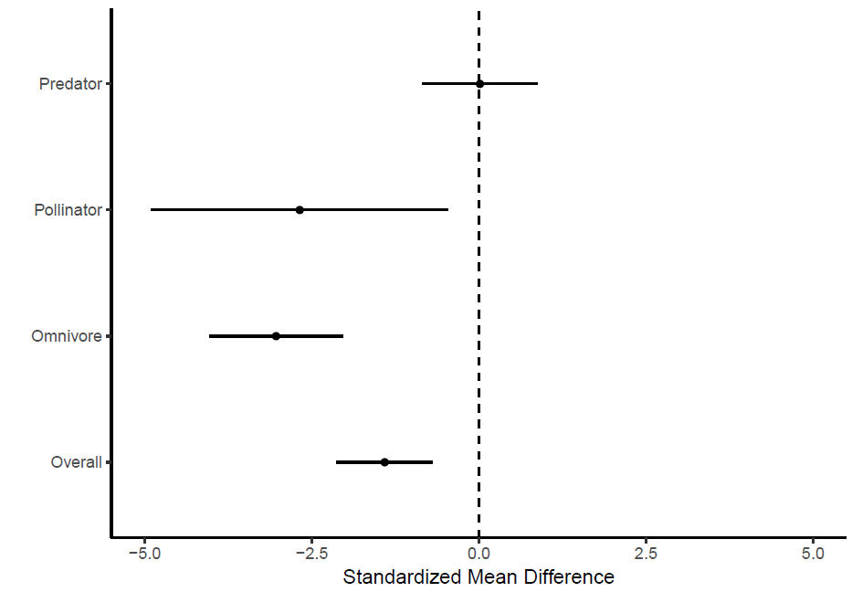

Fioadgiadjgpoajgteaqpt

|  |  |  |  |  |
| --- | --- | --- | --- | --- |
| Hedge’s d | ci.lb | ci.ub | mlab | p-Value |
| -1.41 | -2.13 | -0.69 | Overall | **0.0001** |
| -3.03534 | -4.03127 | -2.0394 | Omnivore | **<.0001** |
| -2.68123 | -4.9019 | -0.46057 | Pollinator | **0.0180** |
| 0.015636 | -0.84877 | 0.88004 | Predator | 0.9717 |

**References**

Schwarzer, G., Carpenter, J. R., & Rücker, G. (2015). Meta-analysis with R. Springer.

R Core Team (2016). R: A language and environment for statistical computing. R Foundation for Statistical Computing, Vienna, Austria. URL https://www.R-project.org/

Viechtbauer, W. (2010). Conducting meta-analyses in R with the metafor package. Journal of Statistical Software, 36(3), 1-48. URL: http://www.jstatsoft.org/v36/i03/