ProtocolWD

Derek Corcoran

14 November, 2016

# Background

## Bats

### General information

Bats are one of the most diverse group of mammals with around 1240 species (Tudge 2000; Schipper et al. 2008), second only in number of species to rodents. The distinctive characteristic of this group is their ability to fly.

There are two main group of bats (see dendrogram bellow, extracted from Agnarsson et al. (2011)), the Megachiropterans, or flying foxes, which are large frugivorous bats that inhabit exclusively in the tropics. There are around 170 species of megachiropterans, they search their food using the sense of sight and smell and are mostly diurnal. The large flying fox (*Pteropus vampyrus*) is the largest species of bats and belongs to this group, which can have a wingspan of 1.7 meters (5 feet 7 inches). Within this group only the bats of the genus *Rosettus* use a very primitive form of echolocation, and are nocturnal.

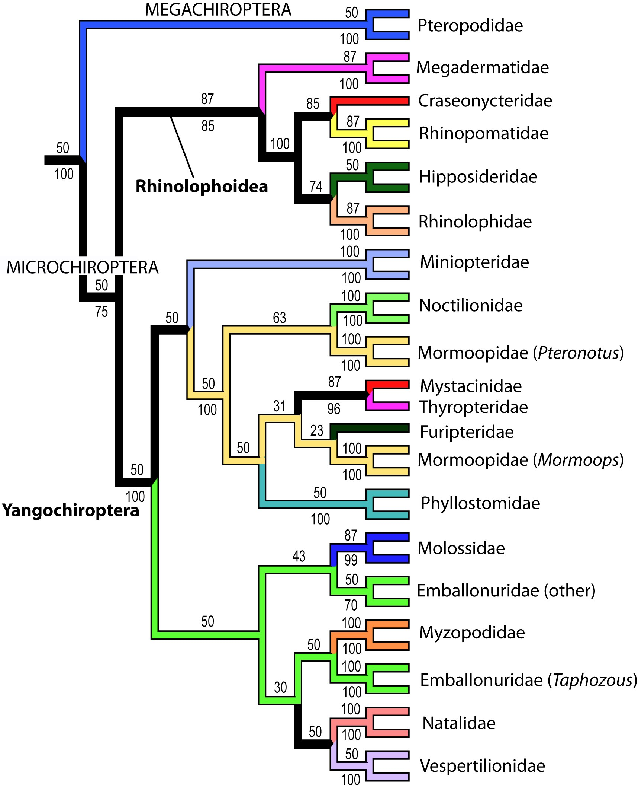

Phyllogeny of bats

Microchiropterans are the most diverse and specialized group of bats, and they live in every continent but Antarctica. Most of them are insectivores, but some of them are pollinators and some very specialized species are hematofagous or carnivorous. Usually these bats are a lot smaller than megachiropterans, they are nocturnal, and rely on echolocation to detect their preys and navigate through space

#### Adaptations for flight

Chiropterans are the only mammals to achieve powered flight, bats have several adaptations for this (Norberg 1998). It is supposed that ancient bats started flying around 50 million years ago (Cooper, Cretekos, and Sears 2012), developing an enlarged hand with a thin membrane between the enlarged fingers, which is very different from the wings of birds. Little is known of the evolution of flight in bats, since the earliest fossils found of these groups were already winged (Gunnell and Simmons 2005; Jepsen 1966). However wings are not the only adaptation that bats and birds share, they both have higher metabolism and internal temperature than other flightless vertebrates of the same size, their bones are lighter, and have enlarged pectoral muscles that allow them to fly (Norberg 1998).

#### reproduction

Bats a very diverse group, and their reproductive habits are very diverse aswell. One of the most peculiar aspect of bat reproduction is the differences between hibernating and nonhibernating bats.

Generally, in nonhibernating bats there is a synchrony between male and female reproductive processes (P. Krutzsch 1979). Spermatozoa are most often produced and accessory sex glands are secretorily active at a time consistent with the onset of the oestrous cycle in the females. Copulation, ovulation and fertilization usually happens at the same time.

On the other hand, for hibernating bats there are two basic patterns of reproduction: type I and Type II. In reproduction of type I, oestrus and copulation are initiated in late summer and early autumn. Intermittent arousal and additional copulations may occur throughout the hibernation period. Spermatozoa are then stored in the female reproductive tract until spring when ovulation, fertilization and gestation takes place. The life span of spermatozoa in females is approximately the duration of the oestrus. When metabolism is greatly reduced (as in hibernation) storage could last longer (Crichton and Krutzsch 2000).

In bats with reproduction of type II, copulation ocurrs in autumn, and it is followed immediately by ovulation, fertilization and initial embryogenesis. The females enter hibernation in a pregnant condition without blastocysts implantation in their uteri. During hibernation, implantation is delayed and it does not occur until springtime (Oxberry 1979).

Female reproductive patterns based on if it has one, two or several reproductive seasons during the year (monoestry, bimodal polyoestry or polyoestry), and if females are or not synchronous in their reproductive cycle with other females of the same species (seasonal and aseasonal respectively) have been categorized in four broad categories : "aseasonal polyoestry", "seasonal polyoestry" (Beck and Lim 1973), "bimodal polyoestry" (T. H. Fleming 1971) and "seasonal monoestry" [Crichton and Krutzsch (2000); @ fleming1972three; @ wilson1973bat]. Polyestry typically results in the production of two litter a year and is a process frequently facilitated by the occurrence of a postpartum estrus (Myers 1978). It is not clear whether the males in species in which the females are polyoestrous are reproductively active throughout the year (P. Krutzsch 1979).

Male reproductive activity may be accompanied by a wide variety of behavioral performances (vocalization, body movements, special flight patterns, roost defense) and secondary sexual structural characteristics (i.e. odoriferous secretions from dermal glad, pelage adornments, often associated with dermal glands and urinary track markings). These can be a significant part of the mating repertoire and it seems that the male reproductive pattern is determined by female reproductive receptivity (Crichton and Krutzsch 2000) and probably is under the control of testicular androgens with seasonal activity (P. Krutzsch 1979)

The social behavior of bats has made people think that most bat species are apparently polygamous, however a surprising number appear to be monogamous (Crichton and Krutzsch 2000), with some promiscuity, where females mates with several males (Mayer 1995).

#### Hibernation or migration

Most north-american bats hibernate during the winter, but this is not true for all chiropterans. Some species migrate regionally (140 to 350 miles), in order to get to central hybernacula. Some other bats however can migrate up to 1180 miles to get to warmer latitudes (T. H. Fleming et al. 2003, McGuire et al. (2012)) and avoid hibernating all together. Some species such as the silver-haired bats (*Lasionycteris noctivagans*) may migrate over 155 miles a day (McGuire et al. 2012). In general bats that live in higher latitudes tend to be migratory whereas bats that live in lower latitudes usually don't migrate, this is partly due to colder temperatures in higher latitudes, but also there is a higher Temperature Annual Range in higher latitudes as seen in the graph below (data extracted from Hijmans et al. (2005)).

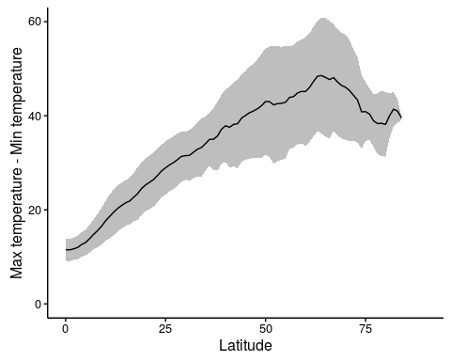

Degrees of difference by latitude

Bats in higher latitudes migrate to escape lower temperatures, which bring scarcity of invertebrates (T. H. Fleming et al. 2003). It has also been established that there are important difference between sexes in terms of migration patterns, where in most species, females migrate more often and further away than males. There are several studies that show that there are different metabolic needs between males and females, since males spend more energy in autumn due to spermatogenesis, and females spend more energy in spring due to pregnancy and lactation, this would result in the differences in migration between them (Cryan and Wolf 2003).

#### echolocation

Echolocation is a biological process exclusive to bats, toothed whales, and a few species of birds, it was a termed coined in 1938 by Griffin, who was the first author to thoroughly study the phenomenon (Griffin and Galambos 1941).

The mechanism of echolocation is that the animal producess a sound, an then it bounces against an object, the intensity of the returning sound, plus the time difference between the returning sound at reaching both ears gives information regarding the distance and angle of the detected object (G. Jones 2005).

Bats use this mechanism to detect their preys (Griffin, Webster, and Michael 1960), avoid obstacles, and even to detect water sources. Most bat calls are beyond the human hearing range, and they range in frequency from 14,000 to well over 100,000 Hz.

Most species of bats produce very disctint calls, that has been used to detect and differenciate bat species by recording and analysing such calls as in the image below (M. B. Fenton and Bell 1981).

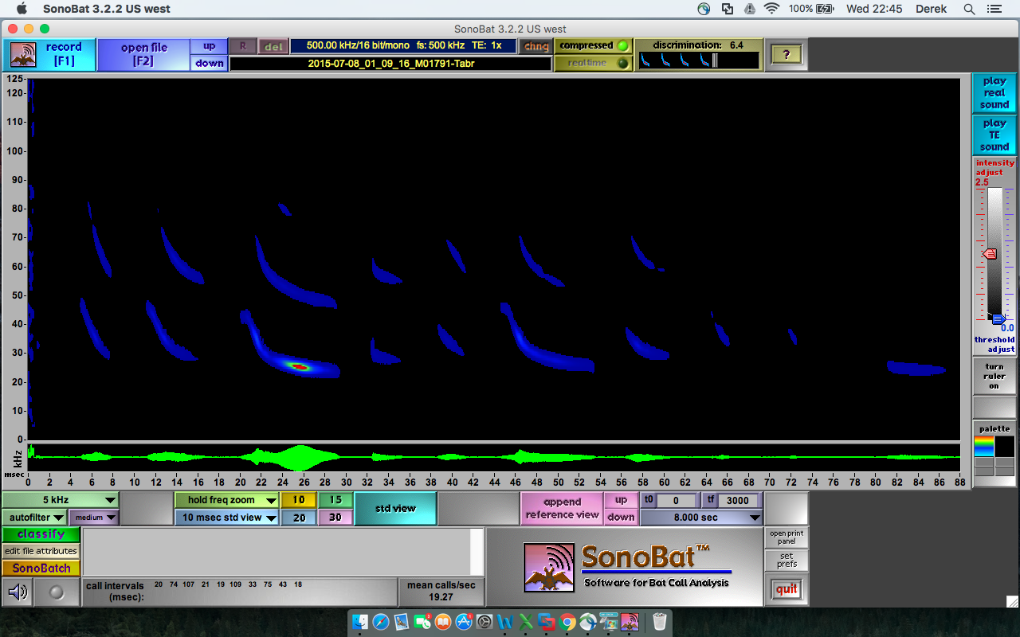

echo

There is strong evidence that ancient bats did echolocate, and that megachiropterans lost that trait. Only to appear again in the only megachiropteran genus that navigates through sound (G. Jones and Teeling 2006)

### Bats in northamerica

There are 51 species of bats in North-america, those bats belong to four distinct families (Molossidae, Mormoopidae, Phyllostomidae, and Vespertilionidae) (R. D. Bradley et al. 2014). The patterns of diversity are shown in the map below, where we see that bats are more abundant in the southwestern portion of the United States (Jenkins, Pimm, and Joppa 2013)

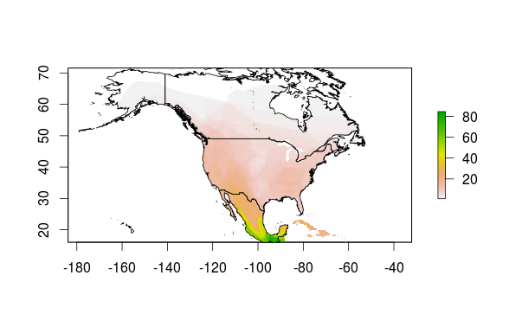

map

Of the 51 species present in northamerica, eleve are federally endangered (Bogan, O’Shea, and Ellison 1996). The bat species that are considered federally endangered are the Florida bonneted bat (*Eumops floridanus*), the gray bat (*Myotis grisescens*) ,Hawaiian hoary bat (*Lasiurus cinereus semotus*), Indiana bat (*Myotis sodalis*), lesser long-nosed bat (*Leptonycteris curasoae yerbabuenae*), little Mariana fruit bat (*Pteropus tokudae*), Mariana fruit (*Pteropus mariannus mariannus*), Mexican long-nosed bat (*Leptonycteris nivalis*), Northern long-eared bat (*Myotis septentrionalis*), Ozark big-eared bat (*Corynorhinus townsendii ingens*), Pacific sheath-tailed bat (*Emballonura semicaudata rotensis*), Virginia big-eared bat (*Corynorhinus townsendii virginianus*).

All northamerican species are insectivorous but three leaf-nosed bats species from the Phyllostomidae family, these species are dependent on nectar and pollen.

## Why Bats Matter

### Ecosystem services delivered by bats

Bats are very important economically in the world. Their most important benefit without a doubt is that they feed on invertebrates and thus they are one of the major natural pest controls for crops, since over two thirds of all bats are obligated insectivorous(T. H. Kunz et al. 2011). Due to their insect control, only in agriculture, it has been calculated that bats save farmers in the United States 72 dollars/acre (Boyles et al. 2011), which projects to an economic value of $22.9 billion dollars a year in the United States for the agricultural industry.

At the same time there are bats that are pollinators of flowers, and there are other frugivorous bats that help spreading seeds (T. H. Kunz et al. 2011). Bat pollination occurs in about 528 species of angiosperms world-wide. Even though most of north american bats are insectivorous, in arid habitats two families of succulent plants, Agavaceae and Cactaceae, rely on bats to be pollinated. Several of those species are very importance economically in northern and central america and supply food, fiber, tools, soaps, and medicine to the community as well as being the base of the multimillion dollar industry of tequila (Forster, Fleming, and Valiente-Banuet 2003).

## Threats to bats

### White nose syndrom

The White Nose Syndrome (WNS) is a fatal bat disease produced by a fungus, the origin of its name is the white color left on the infected skin of the muzzle, ears, and wings of bats. The syndrome is characterized by the presence of abundant and delicate hyphae and conidia on bat muzzles, wing membranes, and/or pinnae (D. S. Blehert et al. 2009). This disease usually causes aberrant behavior of bats during hibernation, including bats prematurely staging at hibernacula entrances, failure of bats to arouse normally in response to disturbance, and diurnal and mid-winter emergence (Langwig et al. 2012). The fungus that produces the disease its called *Pseudogymnoascus destructans*.

Until 2009 WNS was poorly understood, so it was necessary to compare the disease with other dermatological issues of bats (C. U. Meteyer et al. 2009). The same year, it was published that histological examination using microscope was needed to confirm the presence of the fungus (C. U. Meteyer et al. 2009). Even more, it was demonstrated that this wasn´t a typical disease where the fungus is an opportunistic pathogen, the exposure of healthy little brown bats (*Myotis lucifugus*) to pure cultures of *G. destructans* causes WNS (Lorch et al. 2011)

*P. destructans* is capable of living at relatively low temperatures. Thermal performance curves generated for each isolate indicated thermal optima for growth between 12.5 and 15.8°C (54.5 to 60.44 °F) and an upper critical temperature for growth between 19.0 and 19.8°C (66.2 to 67.6°F) (Verant et al. 2012), no growth at 24°C (75.2°F) or above (Gargas et al. 2009). This makes this fungus to grow optimally at the temperatures found in winter bat hibernacula. Bats are thought to have a lowered immune responses during hibernation torpor (Carey, Andrews, and Martin 2003), this may predispose hibernating bats to infection by *P. destructans* (Gargas et al. 2009).

In general terms, novel pathogens introduced to new host communities can have devastating effects on wildlife populations, driving species to extinction and thereby decreasing biodiversity (Daszak, Cunningham, and Hyatt 2000; Smith, Sax, and Lafferty 2006). To this date WNS has been estimated to have killed over five million North American bats (Verant et al. 2012).

It has been shown that differences in temperature at locations within underground sites occupied by hibernating bats may influence both progression and severity of WNS among infected bats and environmental persistence and transmission of the fungus (Verant et al. 2012). Some models suggests that localized thermal refugia of 28°C (82.4°F) could improve survival by up to 75% (Boyles and Willis 2009). It seems to be that in hibernating bats infected with *P. destructans* the impacts of disease on solitary species were lower, whereas in socially gregarious species declines were equally severe in populations spanning four orders of magnitude. However, as the populations of these gregarious species declined, a decrease in social group size was predicted that reduced the likelihood of extinction (Langwig et al. 2012)

WNS is dispersing notoriously trough North America. The first evidence of WNS in bats was detected on February 2006 in New York, and it was documented by a photograph taken at Howes Cave, 52 km west of Albany (D. S. Blehert et al. 2009). Until 2009, the disease was present only in the northeastern United States and it was confirmed at 33 sites in Connecticut, Massachusetts, New York, and Vermont (D. S. Blehert et al. 2009).

The USGS detected cases of WNS in Michigan and Wisconsin IN 2014, and on 2016 in the first case was detected in the west coast in the State of Washington (see the map below (USGS 2016)).

A new study indicates that six *Pseudomonas* isolates can inhibit the growth of *P. destructans* in vitro and should be studied further as a possible probiotic to protect bats from white-nose syndrome (Hoyt et al. 2015).

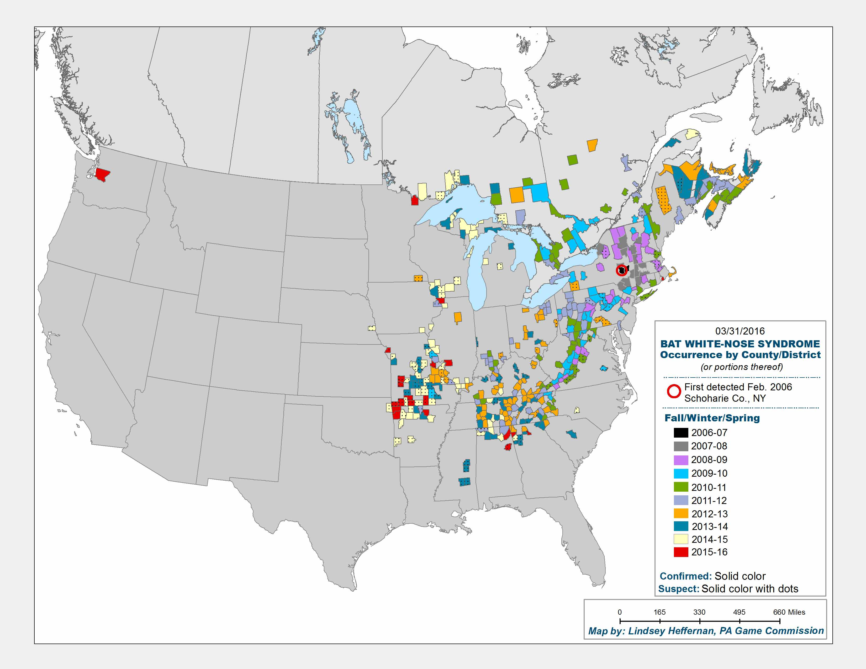

Map2

### Eolic energy and bats

Besides WNS, the biggest threat to bats in north america is wind turbines. Every autumn high mortality occur when migrating bats crash into this turbines (Cryan 2011). In a review of all multiple mortality events, defined as events where more than 10 bats died at a specific location on the same date, it was estimated that wind turbines have been the cause of more cumulative multiple mortality events than any other reason, followed closely by WNS (O’Shea et al. 2016). From 2003 to 2013 at least 5,626 bats of 27 species in 18 countries where registered to have died in wind turbines (L. Rodrigues et al. 2015), and this should be only a fraction of the likely mortality, with estimations of 888,000 bat deaths only in north america for the year 2012 (Smallwood 2013). It is also important to note that mortality in not equally distributed among bat species most deaths that happen in wind turbines correspond to migratory species that roost in trees (Arnett et al. 2008).

## Bats in the Plumas National Forest

### Species present in the Plumas National Forest

For California, as we see in the map below, the Plumas National Forest is on a low diversity area, but we can still detect 17 different species there.

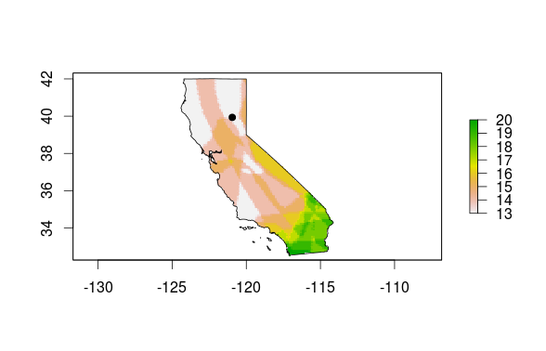

map3

Small description on each of the species

#### *Myotis yumanensis* (Myyu)

The Yuma myotis ocassionally roosts in mines or caves, but are most often found in buildings or bridges. Bachelors also sometimes roost in abandoned cliff swallow nests, but tree cavities were probably the original sites for most nursery roosts. These bats typically forage over water in forested areas.

A study in western Oregon showed that feeding activity was up to eight times higher along forested edges of streams compared to those in logged areas, apparently because the wooded areas contain greater insect diversity. Although Yuma myotis feed predominantly over water, they eat a variety of insects that includes moths, froghoppers, leafhoppers, June beetles, ground beetles, midges, mosquitoes, muscid flies, caddisflies, and crane flies. Yuma myotis are threatened by loss of riparian habitats and the decline in permanent water sources in the southwest.

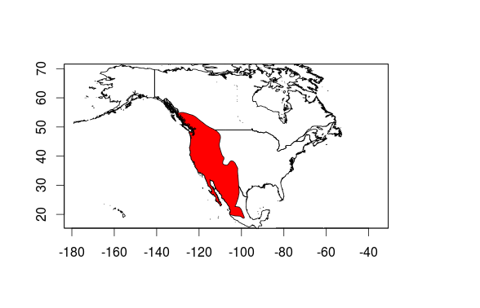

myyu

#### *Myotis californicus* (Myca)

* Wingspan:
* Feeding: flies, moths and beetles
* Biomes: desert or dune, forest, mountains

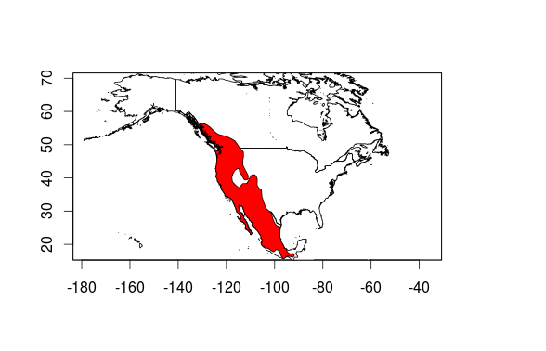

myca

#### *Myotis ciliolabrum* (Myci)

* Distribution:
* Wingspan:
* Feeding:
* Biomes

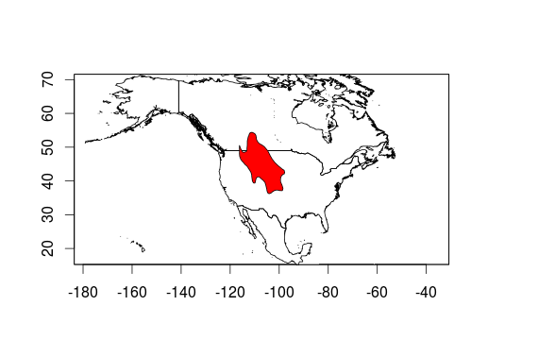

myci

#### *Myotis volans* (Myvo)

* Distribution:
* Wingspan:
* Feeding:
* Biomes

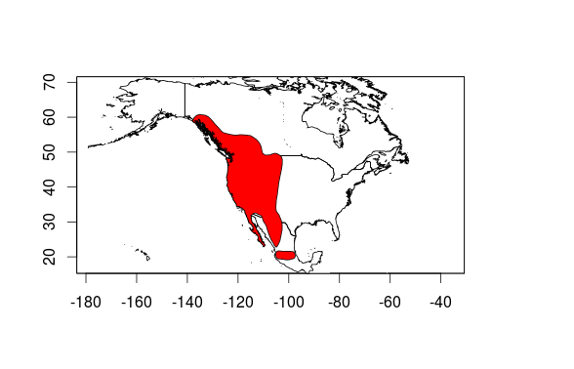

myvo

#### *Myotis lucifugus* (Mylu)

* Distribution:
* Wingspan:
* Feeding:
* Biomes

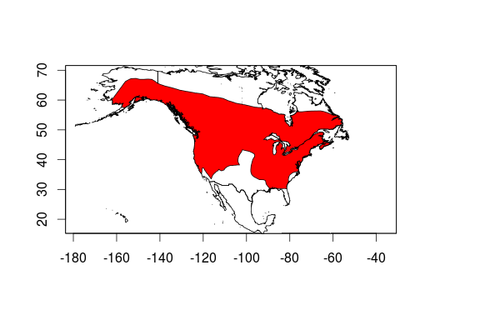

mylu

#### *Parastrellus hesperus* (Pahe)

* Distribution:
* Wingspan:
* Feeding:
* Biomes

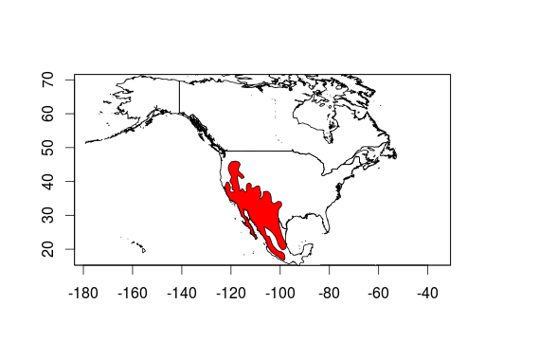

pahe

#### *Lasiurus blossevillii* (Labo)

* Distribution:
* Wingspan:
* Feeding:
* Biomes

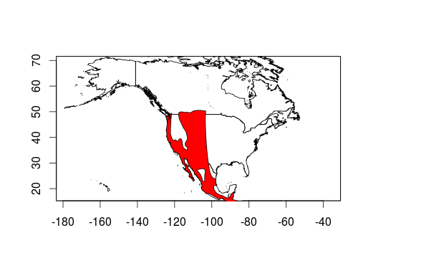

labl

#### *Myotis evotis* (Myev)

* Distribution:
* Wingspan:
* Feeding:
* Biomes

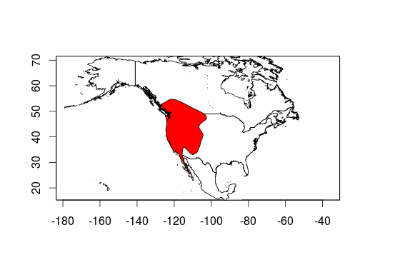

myev

#### *Antrozous pallidus* **(Anpa)**

* Distribution:
* Wingspan:
* Feeding:
* Biomes

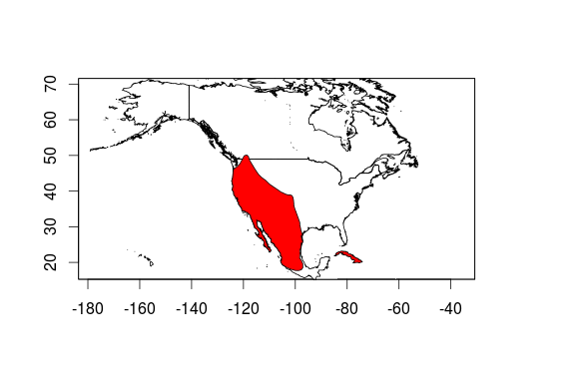

anpa

#### *Eptesicus fuscus* (Epfu)

* Distribution:
* Wingspan:
* Feeding:
* Biomes

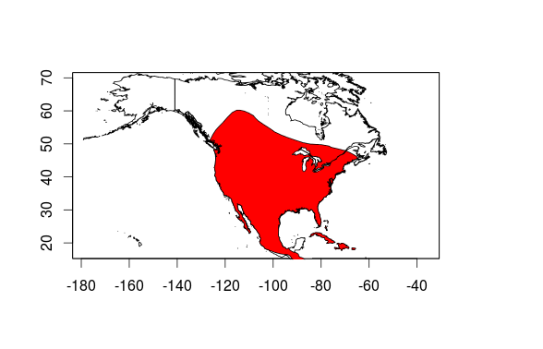

epfu

#### *Lasionycteris noctivagans* (Lano)

* Distribution:
* Wingspan:
* Feeding:
* Biomes

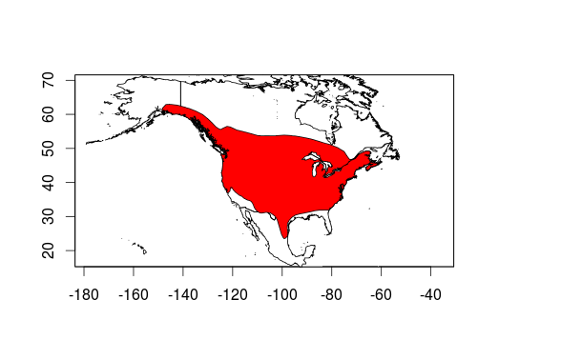

lano

#### *Myotis thysanodes* **(Myth)**

* Distribution:
* Wingspan:
* Feeding:
* Biomes

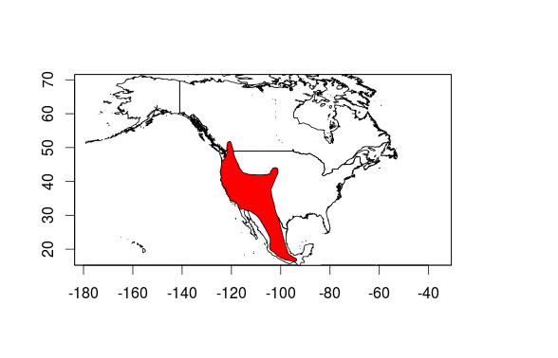

myth

#### *Tadarida brasiliensis* (Tabr)

* Distribution:
* Wingspan:
* Feeding:
* Biomes

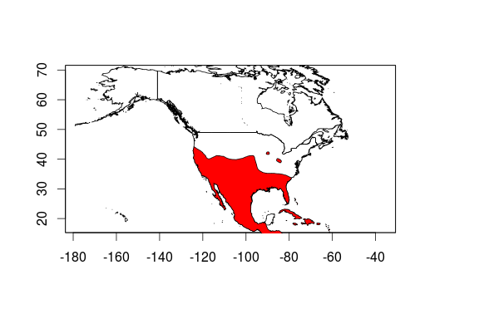

tabr

#### *Lasiurus cinereus* (Laci)

* Distribution:
* Wingspan:
* Feeding:
* Biomes

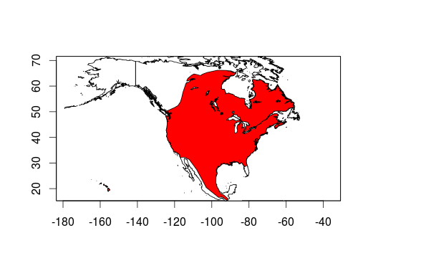

laci

#### *Corynorhinus townsendii* **(Coto)**

* Distribution:
* Wingspan:
* Feeding:
* Biomes

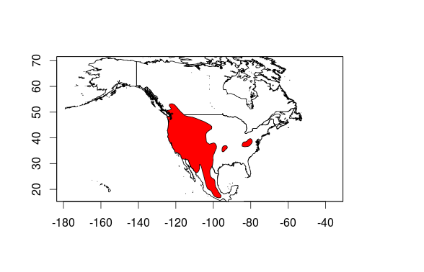

COTO

#### *Euderma maculatum* (Euma)

* Distribution:
* Wingspan:
* Feeding:
* Biomes

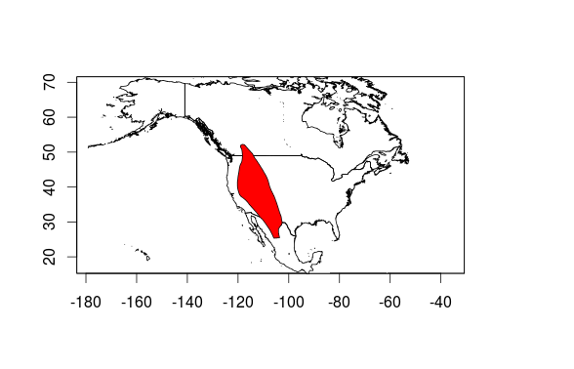

EUMA

#### *Eumops perotis* (Eupe)

* Distribution:
* Wingspan:
* Feeding:
* Biomes

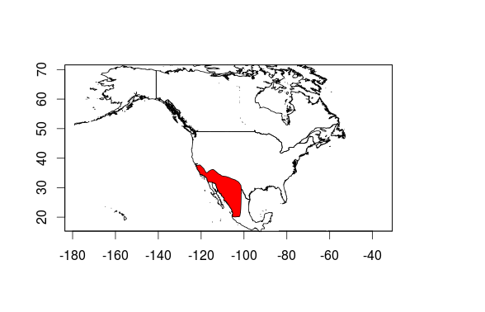

EUPE

#### Product Occupancy map for species studied in the Plumas National Forest

### Bat species of Concern in the Plumas national Forest

Longer description of this species and reasons of why is a species of Concern

* *Antrozous pallidus* **(Anpa)**
* *Myotis thysanodes* **(Myth)**
* *Corynorhinus townsendii* **(Coto)**

# Site Selection

## The importance in selecting heterogeneus environments

This often improves the representativeness of the sample by reducing sampling error. It can produce a weighted mean that has less variability than the arithmetic mean of a simple random sample of the population.

In computational statistics, stratified sampling is a method of variance reduction when Monte Carlo methods are used to estimate population statistics from a known population.

The reasons to use stratified sampling rather than simple random sampling include[1]

If the population density varies greatly within a region, stratified sampling will ensure that estimates can be made with equal accuracy in different parts of the region, and that comparisons of sub-regions can be made with equal statistical power. For example, in Ontario a survey taken throughout the province might use a larger sampling fraction in the less populated north, since the disparity in population between north and south is so great that a sampling fraction based on the provincial sample as a whole might result in the collection of only a handful of data from the north.

Randomized stratification can also be used to improve population representativeness in a study.

## Classifying Plumas National Forest into different environments

### Layers used to classify the Plumas National Forest

* Elevation (m.a.s.l)
* Burn intensity basal
* Burn intensity canopy
* Burn intensity soil
* Distance to fire edge
* Distance to roads
* Distance to water bodies
* Fire interval
* Vegetation type

### Methods used to classify the Plumas National Forest

* K-means

### Product GIS layer of the Plumas National Forest Classified into 5 different environments

* Raster, and shapefile of the classification of the Plumas National forest

### General Characteristics of the five types of environment

* Graphic output as a classification tree
* Table output as means and standard deviation of each of the variables for each environment type

## Stratified random site-selection

### Product 2000 stratified random points

* 400 points per habitat delivered in KML and shp formats
* Contemplates 200 sampling points per year for the next ten years, 40 points per habitat per year

# Data collection

## Before you depart check that you have:

* One bat detector for each sampling point
* One ibutton for each sampling point
* One data sheet for each sampling point
* One three meter pipe for each sampling point
* One iron rod for each sampling point
* One clamp for each sampling point
* One mallet
* One wedged prism
* One diametrical tape
* One 50 mts measuring tape
* One densitometer
* Pencils
* Duct tape
* A GPS with all the sampling points
* A detailed map of the sampling points

## Getting to the sampling points

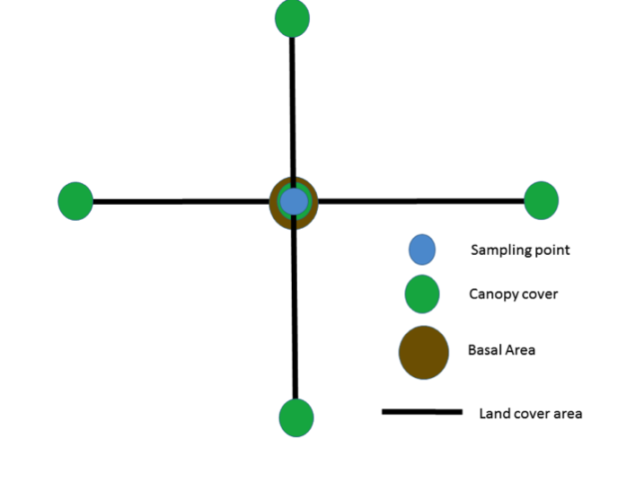

Drawing of the sampling site showing where to take each measurement

Head to the sampling points appointed for the day using the GPS and maps, once you get to the point use the mallet to stick an iron rod on the sampling point about half way through. This will help you to remember where the point is and it will be used later on to install the bat detector. Before putting up the detector, measurements of vegetation attributes will be measured from the sampling site; the measurements that will be taken are Canopy cover, land cover area and basal area. In the next paragraphs the sampling methods will be explained. In figure 1 a drawing of the sampling site is shown.

## Vegetation plot

### Canopy cover

#### Description

The canopy cover is the percentage of overhead sky covered with canopy. This is measured with a gridded concave densiometer. These measurements are taken at 50 meters towards each of the four cardinal points from the sampling point and at the sampling point (figure 1).

#### Activity

To use the densitometer, hold the instrument at 12 to 18 inches in front of you at elbow height, use the level bubble to make sure that the densiometer is flat. If the densiometer is in the right position you should be able to see your forehead in the mirror of the densiometer but it shouldn't overlap with the grid (Figure 2), you should also see a bubble within the drawn circle . For each one of the 24 squares in the grid imagine 4 equidistant dots and count the ones that are not in the open sky. Write down that number and repeat it for all of the 5 points in each sampling area.

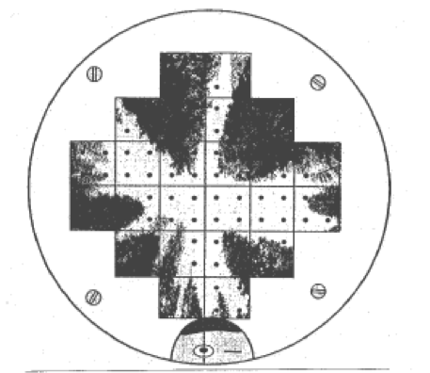

Drawing of how an image should be seen in a spherical densiometer when collecting data, notice that you should see your head in the reflection, but it should not touch the grid, extracted from Standard Operating Procedure for Determining Canopy Closure using a Concave Spherical Densiometer – Model C for the Extensive Riparian Status and Trends Monitoring Program Washington state Department of Ecology

### Land cover area

#### Description

Land cover area, is the percentage of land covered by each vegetation type, in order to measure this the type of vegetation of 50 plots in each cardinal point will be determined from the sampling point.

#### Activity

From the sampling point take the measuring tape and walk 50 meters straight with the compass

##### Use of the compass to walk a straight line towards a cardinal point.

Place the compass horizontal to the ground and point towards the cardinal point you need to walk to. Place one of your eyes on the optics (figure 3), turn around until you find the needed number to follow, if you are heading South that number will be 180, East 90, West 270, and North 0. Keeping both eyes open, use the eye you have in the optics of the compass to keep your bearing, and the other one to navigate through obstacles while you take the measuring tape to 50 meters of distance in that direction. After that, go back looking in each meter interval. For each meter imagine a square of 1 by 1 meter and determine if the dominant land cover type as woody growth, herbaceous growth, Grass, Naked Soil, Rocky Scree, Down wood or leaf Litter.

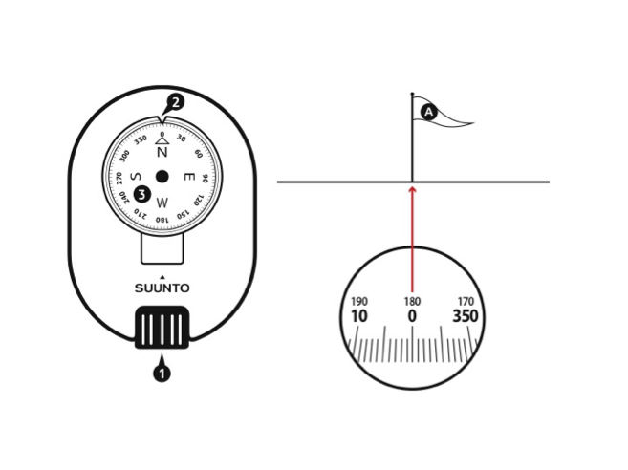

Drawing of a compass showing 1 optics, 2 bearing index and 3 compass card: right, looking throught the optics, figures extracted from Suunto KB-20 compass user guide.

### Basal area

#### Description

Basal area is the square meters per hectare covered by the trunk of a tree within the plot, this is measured using a diametrical tape to measure the diameter of the tree, and a wedge prism to check which trees are in or out of the vegetation plot.

#### Activity

The first person stands in the sampling point and uses the wedge prism to check every tree starting on the north rotating in a clockwise direction in the spot. To check weather a tree is in or out of the sampling plot, standing in the sampling point, look at a tree through the wedge prism; if the image of the tree trunk that you see in the prism overlaps with the one outside of the prism, the tree is in the vegetation plot, and it should be measured. If they don’t overlap, the tree is out of the vegetation plot and shouldn’t be measured (Figure 4).

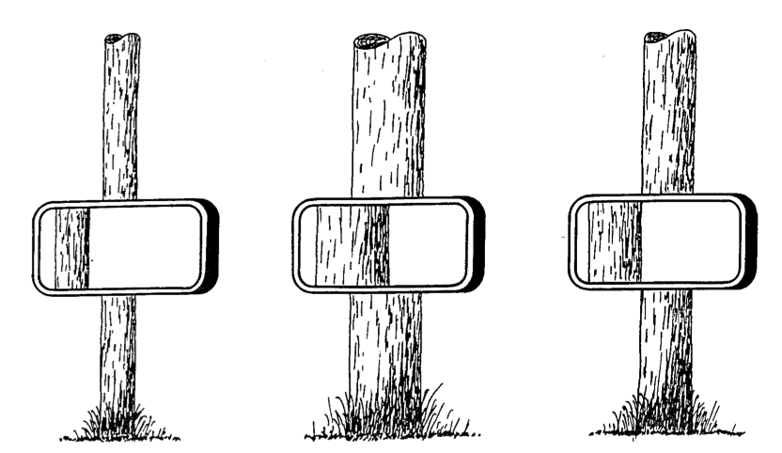

Figure showing three trees as seen through a wedge prism, in this case from left to right, the first tree is out, the second is in and the third one is questionable, extracted from Mitchell, W. A., Hughes, H. G., & Marcy, L. E. (1995). Prism Sampling: Section 6.2. 3, US Army Corps of Engineers Wildlife Resources Management Manual(No. WES/TR/EL-95-24). ARMY ENGINEER WATERWAYS EXPERIMENT STATION VICKSBURG MS ENVIRONMENTAL LAB.

## Acoustic monitoring

### Day 1

#### Setting of the Pettersson D500x bat detector

Open the lower case of the Petterson d500x (Figure 5) and Set the toggle to INT, carefully close the lower case To protect the memory cards.

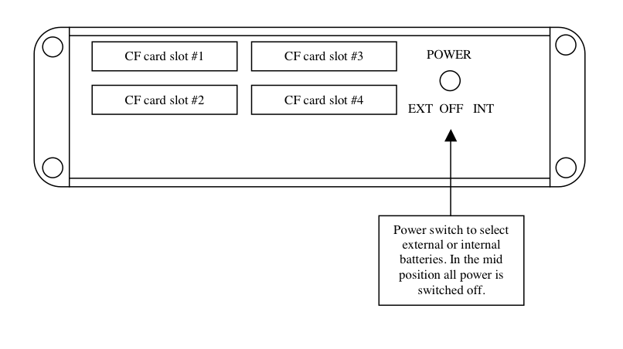

Lower case of the Pettersson bat detector, extracted from D500X USER’S MANUAL Firmware

In the front of the bat detector (Figure 6), press F1 and go to “RECORDING SETTINGS”, press enter, and set INPUT GAIN=80, TRIG LEV=80, INTERVAL=0, and press ENTER again. Return the detector to the box, close it, and leave only the microphone out trying to leave the box hidden from casual visitors.

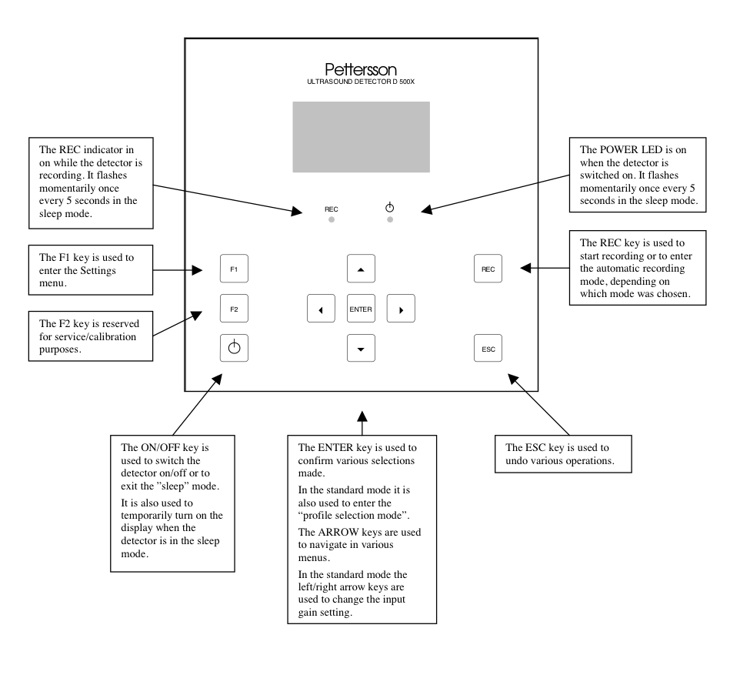

Front of the Pettersson bat detector extracted from D500X USER’S MANUAL Firmware version 2.2.5

Attach the microphone to the PVC pipe in the clamp, and attach the clamp to the metal pipe, then put the metal pipe in the iron rod set in the sampling point. Attach the ibutton to the box of the detector using duct tape.

### Day 4

#### Retrieving the detector

Return to the sampling point, open the box, and put the toggle in OFF before you do anything else. Make sure to put everything neatly in the box, and return with the detector, pipe, iron rod, clamp, ibutton and microphone.

## Extracting audio files from the CF cards

Once you have retrieved the bat detectors it is important to extract the audiofiles from the CF cards before you can classify the calls. The best way is to use the D500X Utility Windows programs that facilitates the use of the CF cards with the detectors and can be downloaded from <http://www.batsound.com>. We recommend that you upgrade to the most recent version of the software, as older versions might not be fully compatible with Vista and 7.

## Using sonobat to automatically classify bat calls into species

### Filter low quality calls

Besides the classification of bat calls sonobat has several utilities, such as the Batch Scrubber.

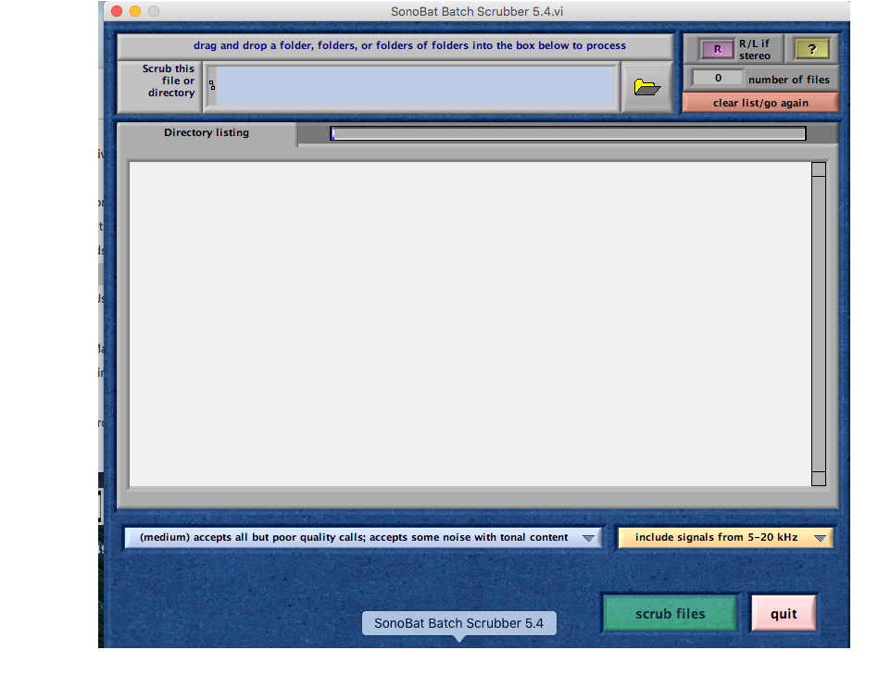

Screenshot of the Sonobat Scrubber Utility

The Batch Scrubber will scan through a specified directory to recognize files lacking bat calls, for example files triggered by noise and move them into a directory named "Scrubbed Files" in the same directory as the searched files. In order to use the Scrubber just press the button that looks like a folder on the upper-right corner and select the folder with the files to scrubb

### Classify bat calls

Sonobat uses 74 acousitc features to classify bats into different species, in the version of the program that classifies the western species in the US, the automatic classification of Sonobat has an average accuracy of 98.6, with no species being correctly classified in less than 96% of the time.

The easiest way of using sonobat for automatically classifing bat calls is using the batch classify feature after scrubbing the data (see previous section).

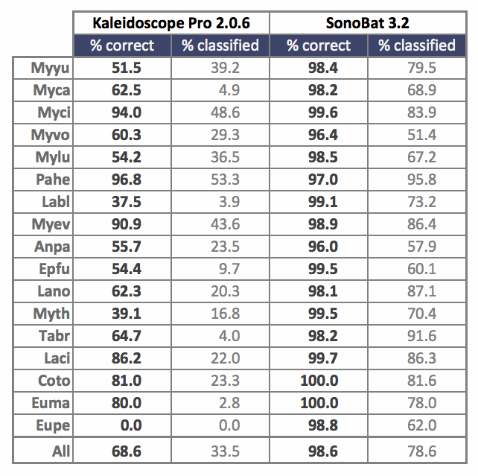

Comparative classification performance of Kaleidoscope and SonoBat on 5224 good quality species-known recordings collected and processed by T. Malloy of Stanford Jasper Ridge Biological Preserve in California (2014). "% classified" indicates the percentage of known recordings given a decision, and "% correct" indicates the rate of correct classification of those outputted with a decision.

### Interpret the results made by sonobat

* Reading sonobat's output files
* How to see which species are present according to sonobat

### Get sonobat's help to manually vet inconlcusive calls

* How to get sonobat's help to manually vet species that are uncertain to be present

# References

Agnarsson, Ingi, Carlos M Zambrana-Torrelio, Nadia Paola Flores-Saldana, and Laura J May-Collado. 2011. “A Time-Calibrated Species-Level Phylogeny of Bats (Chiroptera, Mammalia).” *PLoS Currents* 3. Public Library of Science.

Arnett, Edward B, W Brown, Wallace P Erickson, Jenny K Fiedler, Brenda L Hamilton, Travis H Henry, Aaftab Jain, et al. 2008. “Patterns of Bat Fatalities at Wind Energy Facilities in North America.” *The Journal of Wildlife Management* 72 (1). Wiley Online Library: 61–78.

Beck, Albert J, and Boo Liat Lim. 1973. “Reproductive Biology of Eonycteris Spelaea, Dobson (Megachiroptera) in West Malaysia.” *Acta Tropica* 30 (4): 251.

Blehert, David S, Alan C Hicks, Melissa Behr, Carol U Meteyer, Brenda M Berlowski-Zier, Elizabeth L Buckles, Jeremy TH Coleman, et al. 2009. “Bat White-Nose Syndrome: An Emerging Fungal Pathogen?” *Science* 323 (5911). American Association for the Advancement of Science: 227–27.

Bogan, Michael, Thomas J O’Shea, and Laura Ellison. 1996. “Diversity and Conservation of Bats in North America.” *Endangered Species Update* 13 (4): 5.

Boyles, Justin G, and Craig KR Willis. 2009. “Could Localized Warm Areas Inside Cold Caves Reduce Mortality of Hibernating Bats Affected by White-Nose Syndrome?” *Frontiers in Ecology and the Environment* 8 (2). Eco Soc America: 92–98.

Boyles, Justin G, Paul M Cryan, Gary F McCracken, Thomas H Kunz, and others. 2011. “Economic Importance of Bats in Agriculture.” *Science* 332 (6025): 41–42.

Bradley, Robert Douglas, Loren K Ammerman, Robert J Baker, Lisa C Bradley, Joseph A Cook, Robert C Dowler, Clyde Jones, et al. 2014. *Revised Checklist of North American Mammals North of Mexico, 2014*. Museum of Texas Tech University.

Carey, Hannah V, Matthew T Andrews, and Sandra L Martin. 2003. “Mammalian Hibernation: Cellular and Molecular Responses to Depressed Metabolism and Low Temperature.” *Physiological Reviews* 83 (4). Am Physiological Soc: 1153–81.

Cooper, Lisa Noelle, Chris J Cretekos, and Karen E Sears. 2012. “The Evolution and Development of Mammalian Flight.” *Wiley Interdisciplinary Reviews: Developmental Biology* 1 (5). Wiley Online Library: 773–79.

Crichton, Elizabeth G, and Philip H Krutzsch. 2000. *Reproductive Biology of Bats*. Academic Press.

Cryan, Paul M. 2011. “Wind Turbines as Landscape Impediments to the Migratory Connectivity of Bats.” *Envtl. L.* 41. HeinOnline: 355.

Cryan, Paul M, and Blair O Wolf. 2003. “Sex Differences in the Thermoregulation and Evaporative Water Loss of a Heterothermic Bat, Lasiurus Cinereus, During Its Spring Migration.” *Journal of Experimental Biology* 206 (19). The Company of Biologists Ltd: 3381–90.

Daszak, Peter, Andrew A Cunningham, and Alex D Hyatt. 2000. “Emerging Infectious Diseases of Wildlife–threats to Biodiversity and Human Health.” *Science* 287 (5452). American Association for the Advancement of Science: 443–49.

Fenton, M Brock, and Gary P Bell. 1981. “Recognition of Species of Insectivorous Bats by Their Echolocation Calls.” *Journal of Mammalogy* 62 (2). The Oxford University Press: 233–43.

Fleming, Theodore H. 1971. “Artibeus Jamaicensis: Delayed Embryonic Development in a Neotropical Bat.” *Science* 171 (3969). American Association for the Advancement of Science: 402–4.

Fleming, Theodore H, Peggy Eby, TH Kunz, and MB Fenton. 2003. “Ecology of Bat Migration.” *Bat Ecology*. Chicago: The University of Chicago Press, 156–208.

Forster, Paul I, TH Fleming, and A Valiente-Banuet. 2003. “Columnar Cacti and Their Mutualists. Evolution, Ecology and Conservation.” JSTOR.

Gargas, Andrea, MT Trest, Martha Christensen, Thomas J Volk, and DS Blehert. 2009. “Geomyces Destructans Sp. Nov. Associated with Bat White-Nose Syndrome.” *Mycotaxon* 108 (1). Mycotaxon: 147–54.

Griffin, Donald R, and Robert Galambos. 1941. “The Sensory Basis of Obstacle Avoidance by Flying Bats.” *Journal of Experimental Zoology* 86 (3). Wiley Online Library: 481–506.

Griffin, Donald R, Frederic A Webster, and Charles R Michael. 1960. “The Echolocation of Flying Insects by Bats.” *Animal Behaviour* 8 (3). Elsevier: 141–54.

Gunnell, Gregg F, and Nancy B Simmons. 2005. “Fossil Evidence and the Origin of Bats.” *Journal of Mammalian Evolution* 12 (1-2). Springer: 209–46.

Hijmans, Robert J, Susan E Cameron, Juan L Parra, Peter G Jones, and Andy Jarvis. 2005. “Very High Resolution Interpolated Climate Surfaces for Global Land Areas.” *International Journal of Climatology* 25 (15). Wiley Online Library: 1965–78.

Hoyt, Joseph R, Tina L Cheng, Kate E Langwig, Mallory M Hee, Winifred F Frick, and A Marm Kilpatrick. 2015. “Bacteria Isolated from Bats Inhibit the Growth of Pseudogymnoascus Destructans, the Causative Agent of White-Nose Syndrome.” *PloS One* 10 (4). Public Library of Science: e0121329.

Jenkins, Clinton N, Stuart L Pimm, and Lucas N Joppa. 2013. “Global Patterns of Terrestrial Vertebrate Diversity and Conservation.” *Proceedings of the National Academy of Sciences* 110 (28). National Acad Sciences: E2602–10.

Jepsen, Glenn L. 1966. “Early Eocene Bat from Wyoming.” *Science* 154 (3754). American Association for the Advancement of Science: 1333–39.

Jones, Gareth. 2005. “Echolocation.” *Current Biology* 15 (13). Elsevier: R484–88.

Jones, Gareth, and Emma C Teeling. 2006. “The Evolution of Echolocation in Bats.” *Trends in Ecology & Evolution* 21 (3). Elsevier: 149–56.

Krutzsch, PH. 1979. “Male Reproductive Patterns in Nonhibernating Bats.” *Journal of Reproduction and Fertility* 56 (1). Soc Reprod Fertility: 333–44.

Kunz, Thomas H, Elizabeth Braun de Torrez, Dana Bauer, Tatyana Lobova, and Theodore H Fleming. 2011. “Ecosystem Services Provided by Bats.” *Annals of the New York Academy of Sciences* 1223 (1). Wiley Online Library: 1–38.

Langwig, Kate E, Winifred F Frick, Jason T Bried, Alan C Hicks, Thomas H Kunz, and A Marm Kilpatrick. 2012. “Sociality, Density-Dependence and Microclimates Determine the Persistence of Populations Suffering from a Novel Fungal Disease, White-Nose Syndrome.” *Ecology Letters* 15 (9). Wiley Online Library: 1050–57.

Lorch, Jeffrey M, Carol U Meteyer, Melissa J Behr, Justin G Boyles, Paul M Cryan, Alan C Hicks, Anne E Ballmann, et al. 2011. “Experimental Infection of Bats with Geomyces Destructans Causes White-Nose Syndrome.” *Nature* 480 (7377). Nature Publishing Group: 376–78.

Mayer, Frieder. 1995. “Genetic Population Structure of the Noctule Bat Nyctalus Noctula: A Molecular Approach and First Results.” In *Symposia of the Zoological Society of London*, 67:387–96. London: The Society, 1960-1999.

McGuire, Liam P, Christopher G Guglielmo, Stuart A Mackenzie, and Philip D Taylor. 2012. “Migratory Stopover in the Long-Distance Migrant Silver-Haired Bat, Lasionycteris Noctivagans.” *Journal of Animal Ecology* 81 (2). Wiley Online Library: 377–85.

Meteyer, Carol Uphoff, Elizabeth L Buckles, David S Blehert, Alan C Hicks, D Earl Green, Valerie Shearn-Bochsler, Nancy J Thomas, Andrea Gargas, and Melissa J Behr. 2009. “Histopathologic Criteria to Confirm White-Nose Syndrome in Bats.” *Journal of Veterinary Diagnostic Investigation* 21 (4). SAGE Publications: 411–14.

Myers, Philip. 1978. “Sexual Dimorphism in Size of Vespertilionid Bats.” *The American Naturalist* 112 (986). JSTOR: 701–11.

Norberg, UM. 1998. “Morphological Adaptations for Flight in Bats.” *Bat Biology and Conservation (TH KUNZ and PA RACEY, Eds.). Smithsonian Institution Press, Washington DC*, 93–108.

Oxberry, BA. 1979. “Female Reproductive Patterns in Hibernating Bats.” *Journal of Reproduction and Fertility* 56 (1). Soc Reprod Fertility: 359–67.

O’Shea, Thomas J, Paul M Cryan, David TS Hayman, Raina K Plowright, and Daniel G Streicker. 2016. “Multiple Mortality Events in Bats: A Global Review.” *Mammal Review*. Wiley Online Library.

Rodrigues, L, L Bach, MJ Duborg-Savage, B Karapandza, D Kovac, T Kervyin, J Dekker, et al. 2015. “Guidelines for Consideration of Bats in Wind Farm Projects—Revision 2014.” *EUROBATS Publication Series*, no. 3.

Schipper, Jan, Janice S Chanson, Federica Chiozza, Neil A Cox, Michael Hoffmann, Vineet Katariya, John Lamoreux, et al. 2008. “The Status of the World’s Land and Marine Mammals: Diversity, Threat, and Knowledge.” *Science* 322 (5899). American Association for the Advancement of Science: 225–30.

Smallwood, K Shawn. 2013. “Comparing Bird and Bat Fatality-Rate Estimates Among North American Wind-Energy Projects.” *Wildlife Society Bulletin* 37 (1). Wiley Online Library: 19–33.

Smith, Katherine F, Dov F Sax, and Kevin D Lafferty. 2006. “Evidence for the Role of Infectious Disease in Species Extinction and Endangerment.” *Conservation Biology* 20 (5). Wiley Online Library: 1349–57.

Tudge, Colin. 2000. *The Variety of Life*. Oxford University Press Oxford.

USGS. 2016. “White-Nose Syndrome Map.” <https://www.whitenosesyndrome.org/resources/map>.

Verant, Michelle L, Justin G Boyles, William Waldrep Jr, Gudrun Wibbelt, and David S Blehert. 2012. “Temperature-Dependent Growth of Geomyces Destructans, the Fungus That Causes Bat White-Nose Syndrome.” *PLoS One* 7 (9). Public Library of Science: e46280.