User Manual for Network Interface

Team BitsPlease

To start the user interface run the java class *NetworkController*. Once the program has initiated the graphical interface shown below will open.

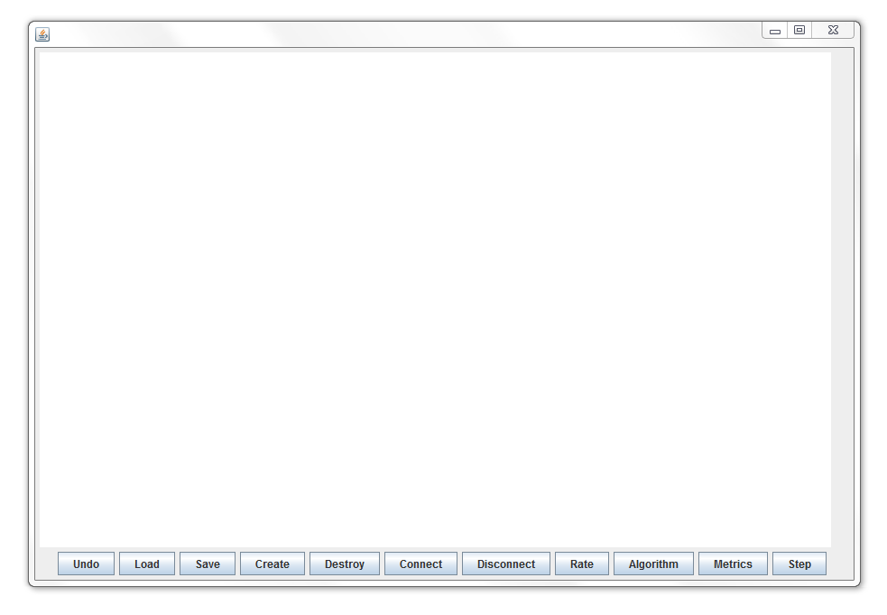

The user interface fairly straight forward and simple to use however this document will outline the all the functions of the different aspects of the gui in detail.

**Getting Started:**

To begin you will want to select the desired ‘*Routing Algorithm*’ you wish use you can choose from four options *‘Flooding, Fastest Route (shortest path), Random or the Local Algorithm’*. Failure to select a routing algorithm will result in the preset routing algorithm being used. For this program that is the random routing algorithm. An example is shown below:

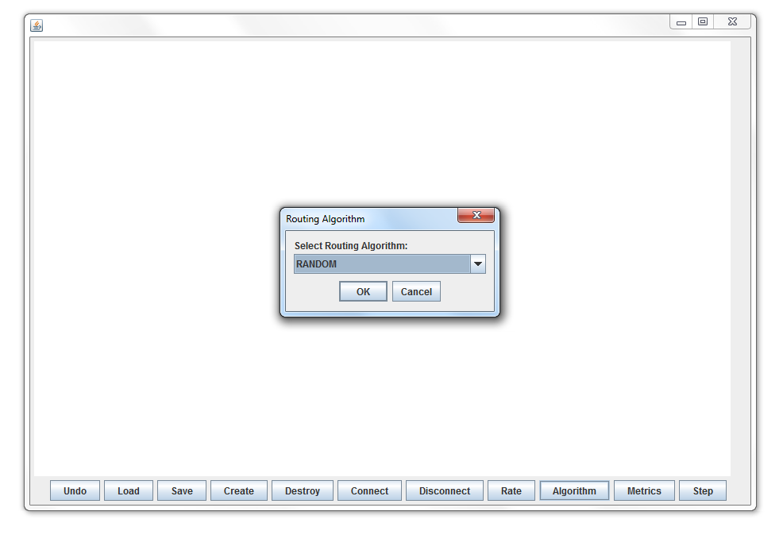

Using the drop down menu select the desired Routing Algorithm

Once algorithm is selected next a Rate should be entered as an integer. If not entry a rate of 1 will be used.

**Adding a New Node:**

Once a routing algorithm has been selected it is time to start populating the network with nodes. To add a new node to the network click the ‘*create’* button and enter the name you wish to call the node in the text pane that appears. You may not a node with no name or a name consisting only of ‘whitespace’, you can also not add nodes with the same names.

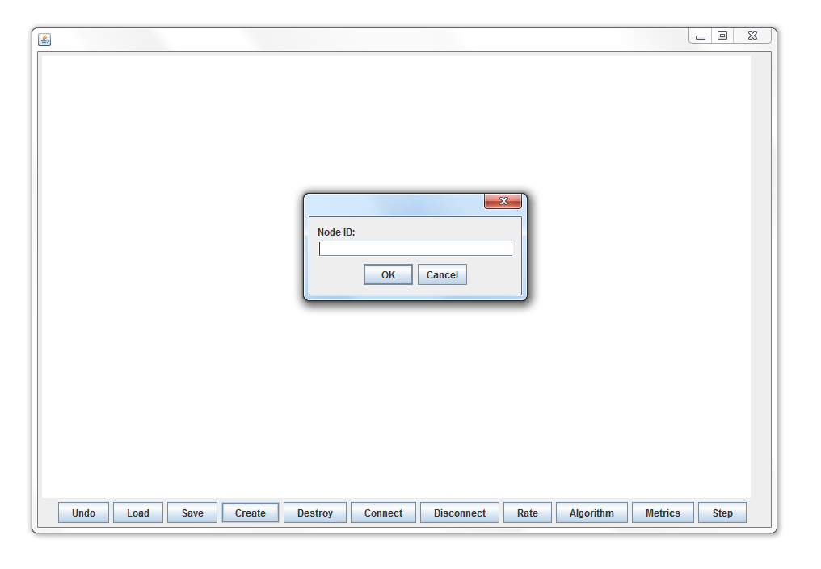

Enter the shown example above will result in a node named “a” appearing in the network graph.

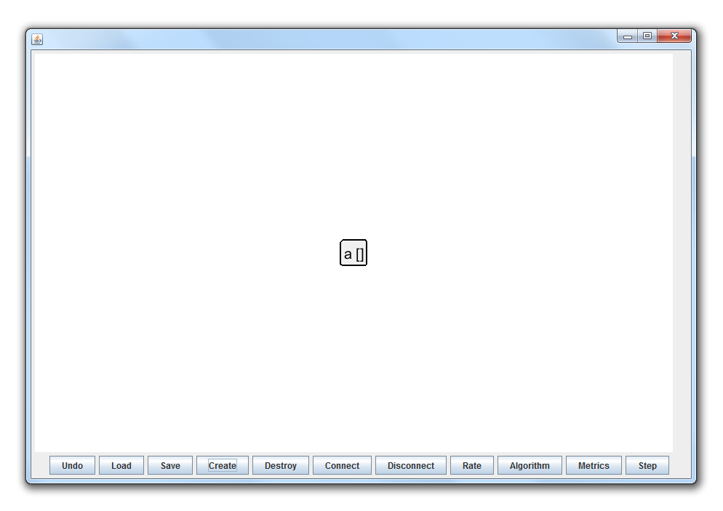

Once a new node has been added the node can be dragged to be repositioned as desired. If multiple nodes are added without being moved the nodes will appear on top one another.

**Deleting a Node from the Network:**

If a node is no longer needed or needs to be removed from the network it is essentially the same process. One need only click the ‘*Destroy*’ button and type the name of the desired node to be deleted. An example of this is shown below:

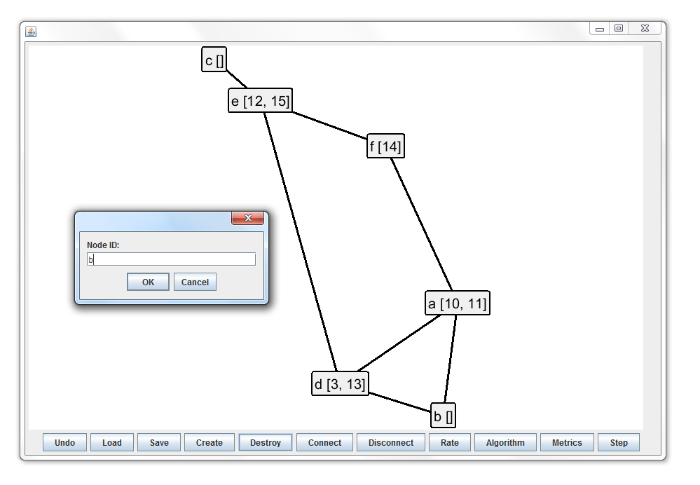

This will result in the specified node being deleted from the network. Deleting a node with connections will result in the node entered being deleted and any connections that node has to other nodes also being deleted. The example below shows “b” being deleting below which had a connection to “d” and “a” as shown above before the deletion, after the deletion the connections will be removed.

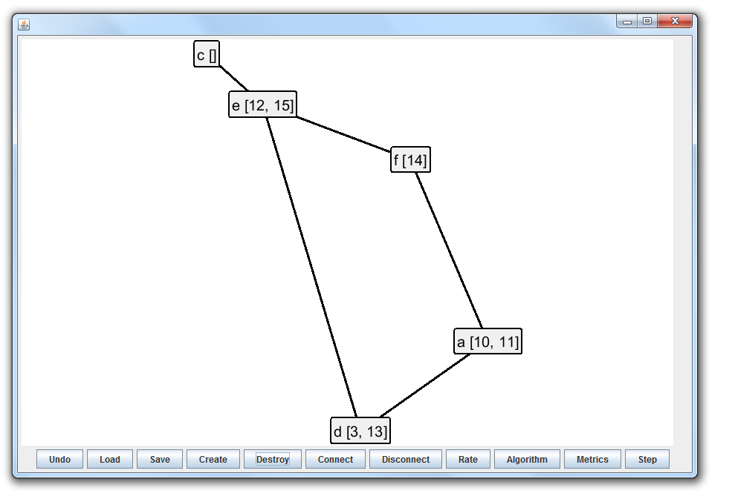

**Connecting and Disconnecting Nodes:**

Adding and removing connections to the networks nodes is just a simple as adding a node. Simply select the ‘Connect’ or ‘Disconnect’ buttons and type the name of your first node in the first dialog box to open then the name of your second node in the next dialog box to appear after you have pressed ‘OK’ or hit the ‘enter’ key.

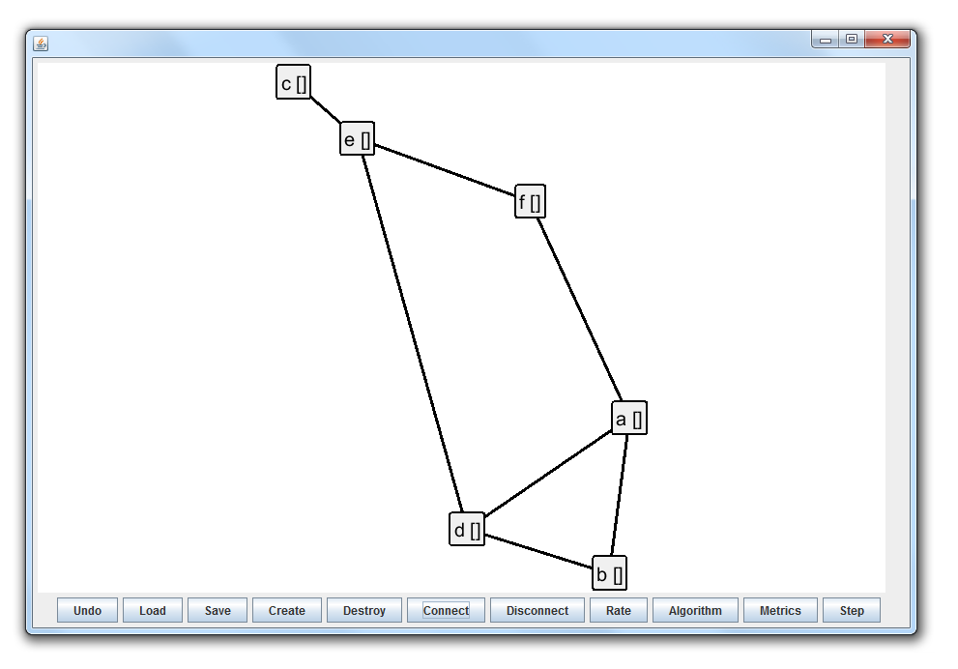

After finishing the steps above the network will be updated with the newly connected or disconnected nodes. In the provide example a connected graph is shown.

**Running the Simulator:**

Now that the network has been created the network can now be ran. To run the simulated network click ‘*step*’. This begin stepping threw the network at the specified rate. The results of the simulation such as the stored messages at each node and the final metrics will be displayed beside the node as a message id. If the networks output is very long the panel will enable scrolling to allow you to view your full results.

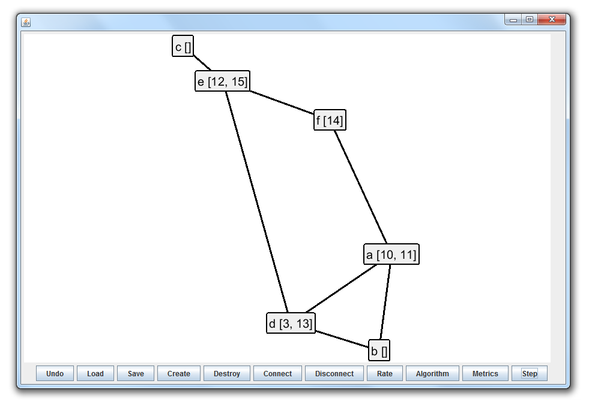

The metric button uses another dialog pane to ask the user for a source node and destination node. Once a valid source and destination is given the metrics “average hops” and “average transmissions” will be displayed in an information pane. The undo button will essentially step backwards in the program.

