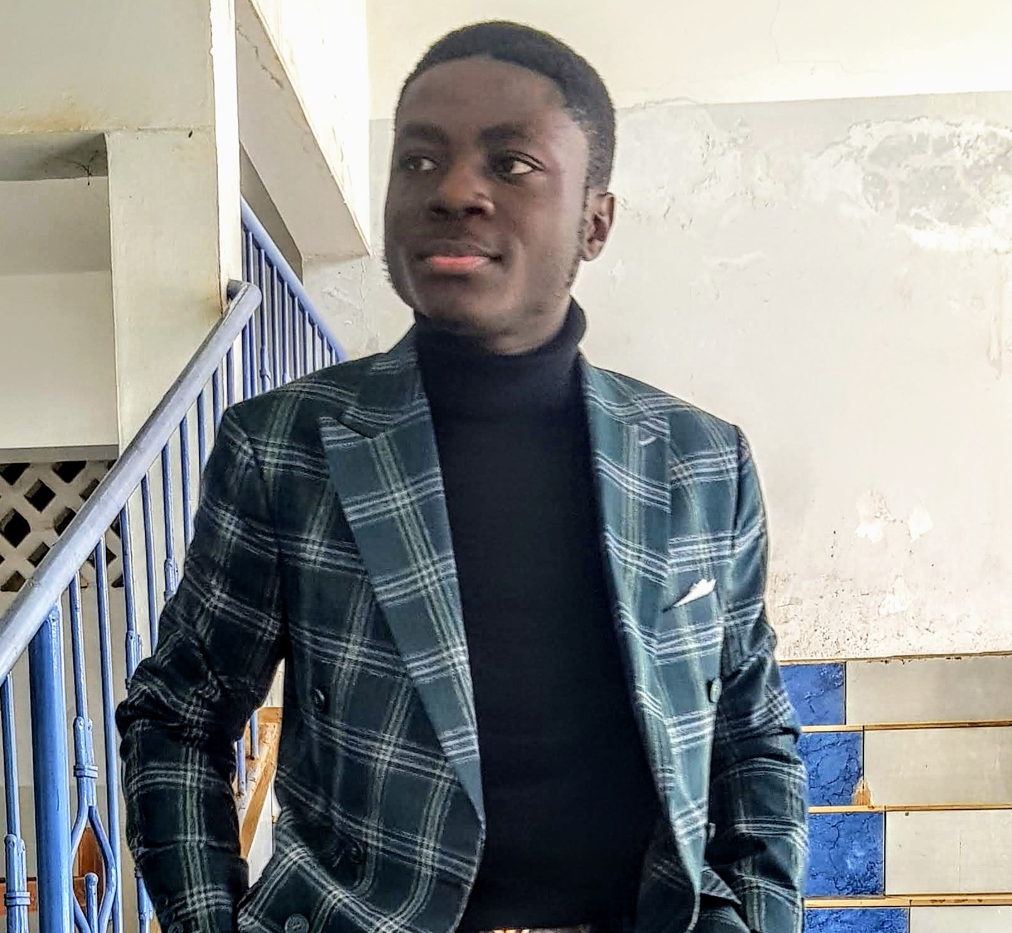

**EDUCATION**

**FULLSTACK DEVELOPER**

Professional, Hardworking, Determined, Organized and Well-mannered

**Msc. Information Technology, Specialized in Software**

* February 2021 – October 2022:

**NJIOLEFACK WAMBA HERMANN**

**The ICT University, Yaoundé**

School:

[wambahermann084@gmail.com](mailto:wambahermann084@gmail.com)

(+237) 653 98 02 59 / 697 75 25 64

RondPoint Express, Yaounde

**Bachelors of Technology in Computer Engineering, Specialized in Software**

* October 2019 – August 2020:

**Siantou University Institute, Yaoundé**

School:

www.linkedin.com/in/wambahermann22

* October 2018 – August 2019:

**Higher National Diploma (HND) in Computer Engineering, Specialized in Software**

**PROFESSIONAL SKILLS**

School:

**Siantou University Institute, Yaoundé**

**HTML5/CSS3**

**JAVASCRIPT**

**JQUERY**

**PHP**

**MySQL**

**WORK EXPERIENCE**

**Freelance Developer**

Enterprise**: GLOBEXCAM GROUP LTD**

Date: **October 2022 – (ongoing)**

**Activities I contributed to**

* Analysis of user requirements and technical requirements for websites and web applications
* Development of websites using HTML, CSS, JavaScript, Ajax
* Development of frontend applications using VueJs
* Development of backend and admin applications using PHP and Laravel Framework
* Development of REST APIs using Laravel to connect with mobile applications and single page applications

**CMS**

**WORDPRESS**

**BOTPRESS**

**FRAMEWORKS**

**BOOTSTRAP**

**CODEIGNITER**

**LARAVEL**

**ANGULAR**

**IONIC**

**VUEJS**

**REACTJS**

**Fullstack Developer**

Enterprise**: VAHO HOLDING**

Date: **February 2022 – (ongoing)**

**Activities I contributed to**

* Analysis of user requirements and technical requirements for websites and web applications
* Development of state-owned and company web applications using HTML, CSS, JavaScript, jQuery and Laravel and deployment on cPanel
* Development of REST APIs using Laravel to connect with mobile applications
* Integration and remodeling of ERP applications to suit customer needs

**SOURCE CONTROLS**

**Git**

**Activities**

* Analysis of user requirements and technical requirements for websites and web applications
* User Interface design for websites using Figma, HTML, CSS, JavaScript and Bootstrap Framework
* Backend Development for web applications using PHP, CodeIgniter and Laravel Frameworks

**Professional Internship as Fullstack Developer**

Enterprise**: GLOBEXCAM GROUP**

Date: **October 2020 – January 2021**

**Activities I contributed to**

* Development of web applications using Webdev
* Development of Desktop applications using Windev
* Develop frontend interfaces using ReactJs

**Freelance Developer**

Enterprise**: BWANA SERVICES**

Date: **June 2021 – January 2022**

**Activities I contributed to**

* Analysis of user requirements and technical requirements for websites and web applications
* Development of websites using HTML, CSS, JavaScript, Ajax and WordPress
* Development of frontend applications using VueJs, Angular and Ionic Frameworks
* Development of mobile applications using Ionic Framework
* Development of backend and admin applications using PHP, CodeIgniter and Laravel Framework
* Development of REST APIs using Laravel to connect with mobile applications
* Integrate and implement payments on web applications and mobile applications
* Development and deployment of chatbots using Botpress, to be used on Facebook messenger and telegram

**Fullstack Developer**

Enterprise**: BRIGHT WORLD GROUP LTD**

Date:**February 2021 – (ongoing)**

**ENGLISH**

**FRENCH**

**GERMAN**

**LANGAUGES**