Derek Belsky
Emmitt Frankenberry
10/5/17
Fuzzy Line Following Lab

1.) The problems that occurred were physical changes ,swapped sensors, problem with pins, and broken sensors.
The changes to the robot were the arms had to be removed and the sensors had to be added onto the robot. The legos on the robot that held the wheels had to be removed so the sensors could be added. These legos were added back later.
The second problem was the sensors were swapped. Basically the bot would go the opposite way then was expected when the sensor read the value on the black line. At first, it was assumed that this was a software issue, but after some investigation it was realized that it made sense to do a quick swap of the sensors.
The third problem was the problem with pins. The pins on the right motor caused the motors not to move. This had to be periodically had to be adjusted to work. This was as simple just moving the rubber part of the pin downward.
The final problem was the broken sensors. The original sensor from the previous lab had a disconnected wire which caused it not to work. After this, two more sensors were grabbed for this lab. From the two that were grabbed, one of the sensors that was put on the robot didn’t read properly. This was fixed by asking another group that had an extra sensor to give us.

2.)

The graph for input fuzzification is shown below:
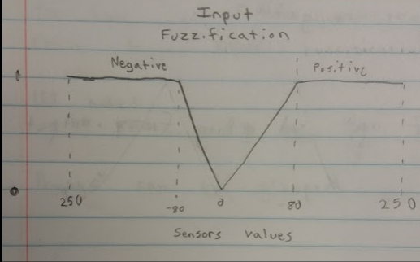
The equation used for the positive line when it is less than or equal to 80 and greater than 0 is y = .0125x
The equation used for the negative line when it is less than 0 and greater than or equal to -80 is y = -.0125x
The equation used for the positive line when it is greater than 80 is y = 1
The equation used for the negative line when it is less than -80 is y = 1

The graph for output fuzzification is shown below:

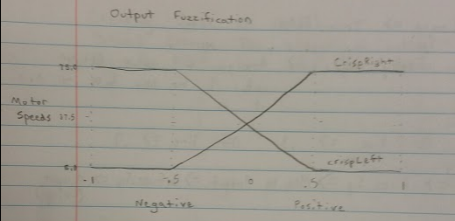
The equation used for the crispRight line when it is less than .5 and greater than -.5 is y = 75.0x + 37.5.
The equation used for the crispLeft line when it is less than .5 and greater than -.5 is y = -75.0x + 37.5.

The equation used for the crispRight line when it is greater than .5 is y = 75.0
The equation used for the crispLeft line when it is greater than .5 is y = 5.0

The equation used for the crispRight line when it is less than -.5 is y = 5.0
The equation used for the crispLeft line when it is less than -.5 is y = 75.0

3.) The Reflective-Opto Sensors were chosen because they gave a bigger change when on the line versus off the line. This allowed for a larger range for the sharpness of the turn of the robot. This is better as it would not constantly make sharp turns when it hits a shadow.

