32513 31005 Advanced Data Analytics Algorithms, Machine Learning - Spring 2026

Assessment 2: Machine Learning Model Study

Student name: Bui Viet Duc Hoang
Student ID: 14517926

Google Colab Folder:
https://drive.google.com/drive/folders/10mN1-O9uTJiG_GLwdbl9Q_4iKiuXV3q2?usp=drive_link

Google Colab file link:
https://colab.research.google.com/drive/19b3VtEBxCoPgSrIX1yBLe-FyH3q-EQN1

1. Problem Definition

1.1 Training-phase interface
During training, my system takes in a labelled batch of images rather than a single image, since the whole point of this phase is to learn from examples with known answers.
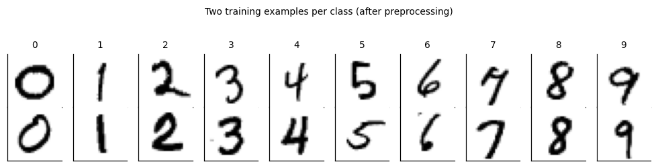
Figure 1: Two training examples per class
With the visualisation in Figure 1, the input X is a float64 array of shape (N, 784). Each row holds one 28 by 28 grayscale MNIST digit, flattened into a single vector in row-major order, which is just the ordinary way of reading an image left to right and top to bottom. I scale every pixel from its original uint8 range of 0 to 255 down to [0, 1] by dividing by a fixed constant, 255, rather than by each image's own minimum and maximum. This matters more than it looks: if I normalised per image, the same physical brightness would map to a different number depending on what else was in that particular image, and the transform used at training time would silently stop matching the one I use at deployment time. In this representation, ink is the high value and background is the low value, so a stroke centre sits near 1.0 and empty space sits near 0.0.
Alongside X, the input y is an int64 array of shape (N,), one integer label per image, drawn from the ten digit classes 0 through 9.
The output of the model, given X, is a float64 array of shape (N, 10): one row of raw, unnormalised logits per image. These are not probabilities on their own. A row-wise softmax turns each row into a proper probability distribution over the ten classes, and it is that distribution I compare against the true label.
The training objective is the mean multi-class cross-entropy between the softmax of the logits and the one-hot encoded labels, minimised by mini-batch gradient descent. I explain the exact form of this loss, and why cross-entropy specifically, in the Machine Learning Approach section.
One detail worth stating plainly here because it shapes everything downstream: MNIST's 60,000 training images and 10,000 test images are written by disjoint sets of people. No writer who appears in training also appears in the test set. That is what makes the test accuracy a genuine measure of generalisation to new handwriting, not just memorisation of a familiar hand.

1.2 Deployment-phase interface
Deployment is a different situation from training, and I wanted the report to treat it as one. There is no label attached to the input anymore, there is no batch, and the image did not necessarily come from MNIST at all. It might be a photo of my own handwriting, resized and converted by whatever tool I used to prepare it.
The input at deployment time is a single uint8 array of shape (28, 28), values from 0 to 255, with ink drawn on a light background, matching the same polarity convention as training. Before the model ever sees this array, a wrapper checks its dtype, shape and value range, and rejects anything that does not match. I added this check deliberately rather than trusting the caller, because a deployed model has no way of knowing what it will actually be handed, and a silent shape mismatch or wrong dtype can produce a confident but meaningless prediction instead of an obvious crash.
The output is a (label, confidence) pair: the predicted digit as an integer, and a confidence score between 0 and 1 taken from the softmax probability of that predicted class. The full ten value probability vector is also available if it is needed, for example to see what the second most likely digit was.
The part I think is most important to be honest about here is what happens with out of scope input. If I hand the model something that is not really a digit at all, a blank page, a smudge, a photo of a cat, it still returns a label and a confidence score, because nothing in a plain softmax classifier forces it to say "I don't know." It will pick whichever of the ten classes happens to score highest, and it can do so with high apparent confidence even when it is completely wrong. I treat this as a real limitation of the basic interface rather than something to hide, and I built a reject option on top of it later in the project specifically to give the system a principled way to abstain instead of guessing.
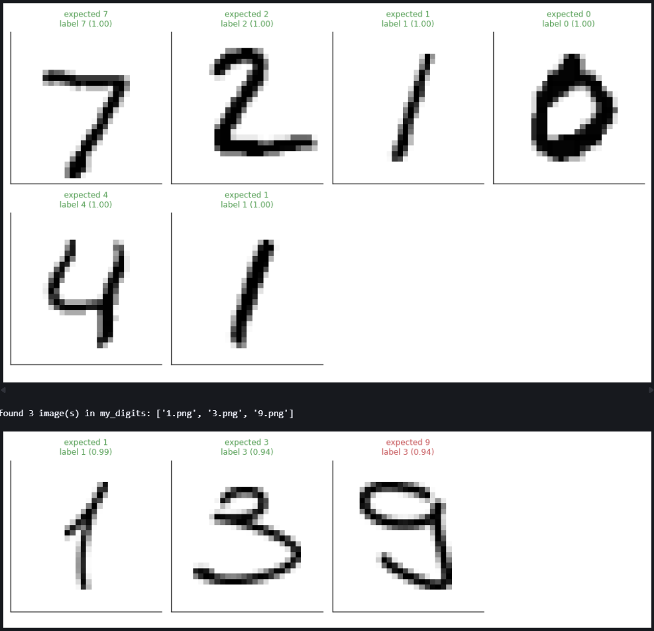
Figure 2: Model deployment; tested on my own writing

1.3 Why this problem
I picked Option 1, studying a fundamental machine learning model, rather than Option 2, because what I actually wanted out of this assignment was to understand what is happening inside a neural network, not just to get a good accuracy number by calling a library function. Digit classification on MNIST is the task I chose to study that model against.
MNIST itself is not a new or exotic dataset. It comes from LeCun, Cortes and Burges, and it has been the standard first benchmark for image classification methods since the late 1990s, precisely because it is small enough to train quickly on ordinary hardware while still being a genuine computer vision task rather than a toy one. Handwritten digits vary a lot between writers in stroke width, slant, size and shape, so a model cannot solve the task by memorising a handful of templates. It has to learn something that actually generalises across different people's handwriting, which is exactly the property the assignment wants a validation scheme to test.
The reason a fundamental model like a multilayer perceptron is the right thing to study here, rather than something more modern, is that it is the smallest architecture that still forces you to confront every core idea in the subject at once: a hypothesis space defined by weights and biases, a loss function that has to be chosen and justified rather than assumed, a learning algorithm that has to actually descend that loss, and a gap between what the loss function measures and what I actually care about, which is getting the right digit. A simpler model, like a linear classifier, would not have enough capacity to show interesting failure modes. A more complex one, like a convolutional network, would hide the basic mechanics of dense layers and backpropagation behind extra machinery I did not need in order to learn the fundamentals.
Traditional, non learning approaches to digit recognition exist, mostly hand-written rules based on stroke geometry, loop counting, or template matching, but they do not scale to the natural variation in human handwriting. Encoding "a 9 has a loop on top and a tail going down and to the left, except when it doesn't" as an explicit rule set becomes unmanageable very quickly. This is the classic argument for why the task is a genuine fit for machine learning: the mapping from pixels to digit identity is easy for a human to perform and essentially impossible for a human to write down explicitly, but it can be learned from a large enough set of labelled examples instead.
Implementing the whole pipeline from scratch, without scikit-learn, PyTorch, TensorFlow or Keras, was the part that mattered most to satisfying Option 1's actual requirement: it is not enough to use a model, I had to build it and be able to explain every line connecting the mathematics to the code, from the forward pass through the softmax cross-entropy gradient to the optimiser update rule.

1.4 Baseline / floor
Before I let myself trust any number the trained network produces, I wanted a floor underneath it, something a completely non-learned approach could reach, so that the network's accuracy in the Results section means something rather than being an impressive-looking number in isolation.
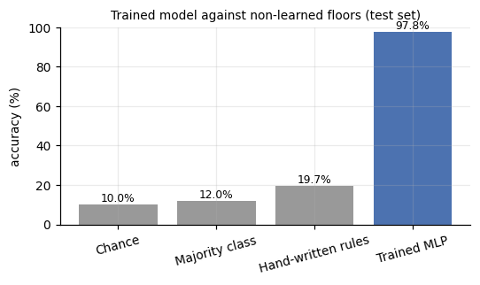
Figure 3: Accuracy compared between floors and a trained model
Looking at Figure 3, the simplest floor is chance. With ten balanced-ish classes, guessing uniformly at random gets 0.1000 accuracy on average, exactly one in ten.
A slightly less trivial floor is a constant classifier that always predicts the single most common digit in the training set, regardless of what it is shown. Because MNIST's classes are close to balanced but not perfectly so, this reaches 0.1205, a small step above chance and nothing more, since it never actually looks at the image.
The last and most interesting floor is a small hand-written rule based on ink statistics rather than learning, something like counting how much of the image is filled with ink and where that ink is concentrated, and using those simple measured features to guess a digit. This reached 0.1970 on the validation set, roughly double the constant baseline, which tells me handcrafted features do carry some real signal about digit identity, just not nearly enough of it on their own to solve the task.
These three numbers, 0.1000, 0.1205 and 0.1970, are the floor the trained MLP has to clear by a wide margin to justify using machine learning here at all. I address the actual comparison, the trained model reaching 97.79 percent test accuracy against this roughly 20 percent hand-rule ceiling, in the Results and Discussion sections, since that gap is really the evidence behind the whole motivation for using a learned model on this task.

2. Machine Learning Approach

2.1 Model choice and justification
Since I had already committed to Option 1, studying a fundamental model rather than building a system around off the shelf tools, the choice of model was really a choice of which fundamental model to study, and I settled on a multilayer perceptron, a fully connected feedforward neural network trained by backpropagation.
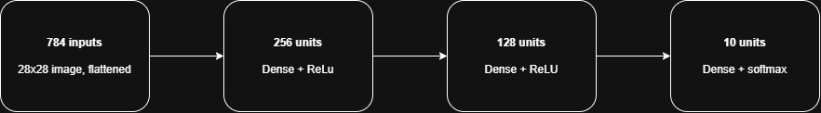
Figure 4: Multilayer perceptron architecture
Mathematically, an L layer MLP with parameters theta maps an input x in R784 through alternating affine transformations and nonlinear activations, z(l) equals W(l) transpose times a(l minus 1) plus b(l), followed by a(l) equals phi of z(l), until the final layer produces raw logits rather than an activated output. The hypothesis space H is the set of every function this architecture can represent as theta ranges over all of R to the power d, where d is the total parameter count. For the architecture (in Figure 4) I settled on, [784, 256, 128, 10], two hidden layers of 256 and 128 units, that works out to 235,146 trainable parameters. I chose to sample from this hypothesis space directly before any training happened, drawing 100 random parameter settings and looking at what they predicted, specifically so I could see the raw hypothesis space rather than just take its size on faith. That experiment is in section 5 of the notebook and I return to what it showed in the Discussion.
I justified the specific architecture, two hidden layers rather than one or three, and 256 then 128 units rather than some other width, empirically rather than by guessing. Section 7 of the notebook runs an ablation grid that includes a depth 0 linear model, a single 128 unit hidden layer, my chosen two layer [256, 128] configuration, and a three layer [256, 128, 64] configuration, all trained under otherwise identical conditions. The two hidden layer version was the smallest architecture that reached a validation accuracy clearly above the single layer and linear alternatives while staying within the noise floor of the three layer version, so adding a third layer bought nothing measurable and going shallower cost real accuracy. I read that finding against a seed variance baseline of 0.9746 plus or minus 0.0021, computed by training the reference configuration three times from different random seeds, so I would not mistake ordinary training noise for a genuine architectural effect.
Within each hidden layer I used ReLU, phi(z) equals max(0, z), rather than sigmoid or tanh. This was a deliberate choice tied to how the network is trained. ReLU's gradient is either 0 or exactly 1, so it does not shrink the gradient signal as it is chained backward through layers the way sigmoid's saturating gradient does, which matters a lot once you are relying on plain backpropagation rather than something like batch normalisation to keep gradients well behaved. The cost of that choice, dying units and a mathematical property called positive homogeneity that I discovered has real consequences for how some metrics behave, is something I address directly in the Discussion.
Parameters are initialised with He initialisation rather than Xavier or a plain small random draw, scaling each layer's initial weights by the square root of 2 divided by the fan in. He initialisation is specifically derived to keep the variance of activations roughly constant across layers when the activation function is ReLU, since ReLU zeroes out half its input on average and Xavier's derivation assumes a linear or symmetric activation that does not do that.
Finally, I trained with the Adam optimiser rather than plain stochastic gradient descent, for reasons I explain properly in the Training Procedure section below, since that choice belongs more naturally there than here.

2.2 Model components
The network is built from a small set of reusable modules, each one implementing both a forward pass and a backward pass, following a shared interface so any two can be chained together. This mirrors how backpropagation actually works: the chain rule applied one module at a time.
The Dense layer computes an affine transform, Z equals XW plus b. Its backward pass returns three gradients, one with respect to the weights, one with respect to the bias, and one with respect to its own input, which is exactly what the previous layer in the chain needs to continue backpropagation. Weights are initialised with He initialisation, scaled for ReLU as I explained in the model choice section.
ReLU applies phi(z) equals max(0, z) elementwise. The important implementation detail is that it caches the pre-activation z from the forward pass, not the output, because the backward pass needs to know exactly where z was positive, and that information is lost if you only keep the already-rectified output.
Dropout, used only in one ablation experiment rather than the main reference model, randomly zeroes a fraction of activations during training and rescales the survivors by one over the keep probability, so the expected activation stays unchanged. At test time it becomes the identity.
The loss is softmax cross-entropy, the mean negative log-probability the model assigns to the correct class. I compute this through a numerically stable log-softmax rather than computing softmax and then taking a log separately, using the max-shift identity, subtracting the row-wise maximum logit before exponentiating. Without that shift, a moderately large logit is enough to overflow exp and turn the loss into NaN, so this is not a cosmetic detail, it is what keeps training from silently breaking.
To confirm all of this was actually implemented correctly rather than just plausible looking, I ran a gradient check: comparing the analytic gradient produced by backward against a central finite difference estimate for the same objective, for forty randomly chosen parameters. The worst relative error across all of them came out to 4.0 times 10 to the power negative 10, which is essentially floating point noise, and gave me real confidence that the forward and backward implementations agree with each other exactly, not just approximately.

2.3 Training procedure
Training happens by mini-batch gradient descent, which really comes down to four steps repeated over and over: run a batch of images forward through the network to get logits, score those logits against the true labels with the loss function, run the loss backward through the network to get a gradient for every parameter, and hand those gradients to the optimiser so it can adjust the weights. Everything else in the training loop, shuffling, batching, early stopping, is scaffolding around those four lines.
Each epoch, I shuffle the 50,000 training images and split them into batches of 128, so the network never sees the same ordering twice and each gradient step is computed from a modestly noisy estimate of the true gradient rather than the full dataset at once, which is what makes this feasible on ordinary hardware and also acts as a mild source of regularisation.
For the optimiser, I compared plain SGD, SGD with momentum, and Adam directly in the ablation grid rather than picking one by assumption. Adam won clearly, reaching the reference model's validation accuracy in a fraction of the epochs SGD needed, because it adapts its effective step size per parameter using running estimates of both the gradient and its square, rather than applying one fixed learning rate everywhere. Momentum improved on plain SGD but still trailed Adam, so I trained the reference model, and every architecture ablation, with Adam at a learning rate of 1e-3, using the default beta values of 0.9 and 0.999.
The one methodological choice I want to be explicit about is what triggers early stopping. I stop training when validation loss has not improved for five epochs, not when validation accuracy has. Loss is a continuous quantity that shifts a little with every batch, while accuracy is a discrete argmax that only moves when a prediction actually flips to a different class, so loss reacts to overfitting before accuracy does, and it gives a cleaner, earlier signal. When training stops, I restore the model's parameters from whichever epoch had the best validation loss, not simply the parameters at the final epoch, so a few epochs of drifting after the actual best point don't end up in the deployed model.
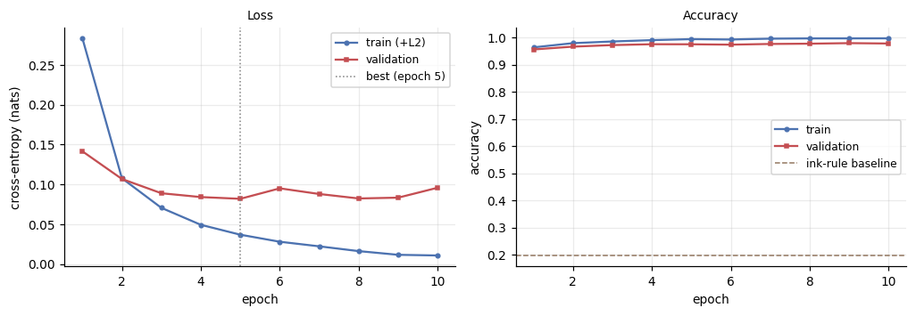
Figure 5: Loss and accuracy of the training process
Refer to Figure 5, the reference model reached its best epoch with a validation loss of 0.0819, and I saved that exact checkpoint (mlp_reference.npz) so the reported results are reproducible from a fixed set of weights rather than from a fresh training run.

2.4 Evaluation metrics and their relevance
Accuracy alone was never going to be enough here, so I used a small set of metrics, each chosen to answer a different question the assignment specifically asks about, and to catch a different kind of failure a single top-line number would hide.
Test accuracy, 97.79 percent, 221 errors out of 10,000, is the headline number, and it directly answers whether the model does the task. But accuracy alone treats every class as equally represented and every error as equally informative, which is not quite true here, so I paired it with per-class precision, recall and F1, and with macro F1 specifically rather than only weighted F1, since macro F1 weights every digit class equally regardless of how many test examples it has, and would expose a class the model quietly struggles with even if that class is small enough not to move overall accuracy much.
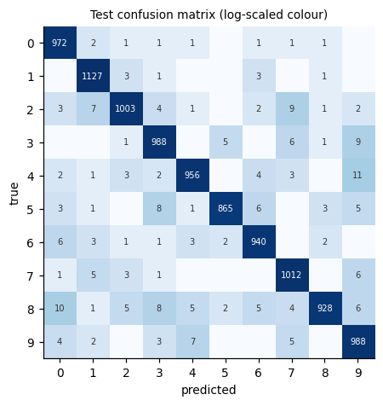
Figure 6: Confusion matrix on test dataset
The confusion matrix, on Figure 6, answers a different question again: not how often the model is wrong, but what it gets confused about, which is the difference between reporting a number and actually understanding a model's behaviour. The matrix shows a handful of specific, visually sensible confusions rather than errors scattered randomly across all ninety possible mix-ups, most notably 4 mistaken for 9 and 8 mistaken for 0, pairs of digits that genuinely do share stroke shape in a lot of handwriting. That pattern is evidence the model is learning something like actual digit structure, not just fitting noise.
Because a single accuracy figure from one run of training is really just one sample from a distribution that also depends on the random seed, the initialisation, and the shuffling, I trained the reference configuration three times from different seeds and reported validation accuracy as a mean and standard deviation, 0.9746 plus or minus 0.0021, rather than a single point estimate. I use this spread throughout the Results and Discussion sections as a noise floor, so I never mistake an ordinary training fluctuation for a real effect when comparing different configurations against each other.
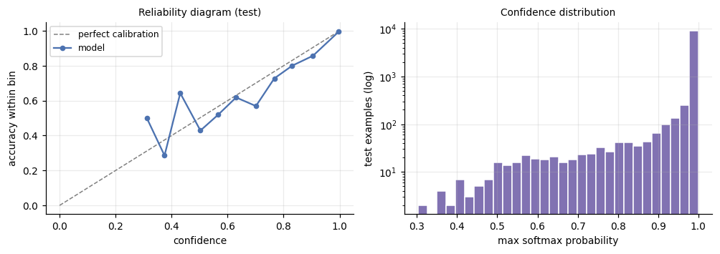
Figure 7: Reliability diagram and confidence attribution
Finally, as shown in Figure 7, I measured calibration with Expected Calibration Error, since accuracy says nothing about whether the model's confidence scores can be trusted. A model that is right 98 percent of the time but claims 99.9 percent confidence on everything is still poorly calibrated, and that distinction matters directly for the deployment interface's reject option, which relies on confidence being a meaningful signal. The model came out only mildly overconfident, a mean confidence of 0.9822 against an actual accuracy of 0.9779, giving an ECE of 0.0050, close enough to well calibrated that I could build a reject option on top of it with reasonable trust in what the confidence score was telling me.

3. Results

3.1 Headline performance
The trained reference model reached 97.79 percent accuracy on the held-out test set, 9,779 correct out of 10,000, with a test loss of 0.0718 nats and a generalisation gap of 1.62 percentage points between training and test accuracy. Against the floors established in section 1.4, chance at 10.0 percent, the majority-class constant at 12.05 percent, and the hand-written ink rules at 19.70 percent, this is not a marginal improvement, it clears the best non-learned baseline by roughly 78 percentage points, which is the actual evidence that learning the mapping from pixels to digit identity was worth doing here rather than hand engineering it.
Accuracy alone can hide a model that is excellent on easy classes and quietly bad on one or two hard ones, so I also report macro F1, which treats every digit class equally regardless of how often it appears in the test set. Macro F1 came out to 0.9778, almost identical to the accuracy figure and to the weighted F1 of 0.9779, which tells me performance is not being propped up by a few large, easy classes while a small class underperforms unseen. Table 1 breaks this down per class.
Class | Precision | Recall | F1 | Support
0 | 0.9710 | 0.9918 | 0.9813 | 980
1 | 0.9809 | 0.9930 | 0.9869 | 1135
2 | 0.9833 | 0.9719 | 0.9776 | 1032
3 | 0.9715 | 0.9782 | 0.9748 | 1010
4 | 0.9815 | 0.9735 | 0.9775 | 982
5 | 0.9897 | 0.9697 | 0.9796 | 892
6 | 0.9781 | 0.9812 | 0.9797 | 958
7 | 0.9731 | 0.9844 | 0.9787 | 1028
8 | 0.9904 | 0.9528 | 0.9712 | 974
9 | 0.9620 | 0.9792 | 0.9705 | 1009
Table 1. Per-class test performance
Looking at Table 1, the spread across classes is narrow, F1 ranges from 0.9705 on digit 9 up to 0.9869 on digit 1, which is a difference of only 1.6 percentage points between the best and worst performing class. Digit 1 is the easiest class by a clear margin on both precision and recall, which makes sense given how visually distinct a single vertical stroke tends to be from the other nine digits. Digit 9 is the weakest, driven mainly by its precision of 0.9620 rather than its recall, meaning the model calls digit 9 somewhat too often on images that are not actually a 9, more than it is missing genuine 9s. Digit 8 shows the opposite pattern, high precision at 0.9904 but the lowest recall in the table at 0.9528, so when the model says 8 it is almost always right, but it misses a meaningful fraction of actual 8s, calling them something else instead. I look at exactly which digits those misses become in section 3.2.

3.2 Confusion matrix
A per-class F1 score tells me a class is weak, but not what the model is actually confusing it with, so I built the full ten by ten confusion matrix on the test set and looked at where the 221 total errors actually land. Looking at Figure 6, the errors are not scattered evenly across all ninety possible off-diagonal cells, they cluster into a small number of specific, visually sensible pairs.
The ten most common confusions, together, account for the large majority of all 221 errors. The single biggest is true 4 predicted as 9, eleven cases, 5.0 percent of every error the model makes, closely followed by true 8 predicted as 0 at ten cases, then true 3 predicted as 9 and true 2 predicted as 7 tied at nine cases each. Rounding out the top ten are 8 confused for 3, 5 confused for 3, 9 confused for 4, 2 confused for 1, and 8 confused for 9 and 7 confused for 9, each in the range of six to eight cases.
This directly explains the per-class weaknesses from Table 1. Digit 9's low precision comes from absorbing misclassified 4s, 3s, 7s and 8s, all of which occasionally get called a 9, while digit 8's low recall comes from leaking out to 0, 3 and 9 rather than being confidently held onto. None of these pairings are arbitrary. A 4 and a 9 can share a closed or nearly closed top loop depending on handwriting style, an 8 written slightly open at the top can look like a 0 with an extra stroke or a 3 depending on where it breaks, and a 2 with a flat base and a straight diagonal can resemble a 7. These are exactly the confusions a human would plausibly make on ambiguous handwriting, which is evidence the model has learned something like real digit structure rather than fitting to noise or artifacts specific to the MNIST rendering pipeline.
I also pulled out the model's most confident wrong predictions specifically, the errors it made while assigning very high softmax probability to the wrong answer, since those are the more concerning failure mode: a model that is unsure and wrong is a much smaller practical problem than a model that is confidently and silently wrong. I use that gallery, together with the calibration results from section 2.4, to assess how often confident errors like this actually occur in the Discussion section.

3.3 Seed variance
A single training run is really just one draw from a distribution, since the random initialisation of every weight, and the order in which mini-batches get shuffled, both change if you set a different seed. Reporting one accuracy figure without knowing how much it would move under a different seed makes it impossible to tell a genuine improvement from an ordinary training fluctuation later, when I compare configurations against each other in the ablation study.
To measure that spread directly, I trained the reference configuration three separate times, each from a different random seed, and recorded the best validation accuracy from each run: 0.9765, 0.9749, and 0.9723. Across the three, that gives a mean of 0.9746 with a standard deviation of 0.0021, and a full range from 0.9723 to 0.9765, a spread of about four tenths of one percentage point from top to bottom. I measured this on validation accuracy rather than test accuracy, and with fewer training epochs than the full reference run, since the test set is reserved for the one final number reported in section 3.1, and the point of this experiment is the width of the spread, not squeezing out the single best number.
This 0.9746 plus or minus 0.0021 figure becomes the noise floor for the rest of the Results section. Any two configurations whose validation accuracy differs by less than roughly two standard deviations, about 0.4 percentage points, are not distinguishable from ordinary training noise on the evidence I have, and I hold every ablation result in section 3.4 to that standard rather than treating any accuracy difference, however small, as a real effect.

3.5 Ablation study
Table 2 lists every configuration I tested against the reference, each trained under identical conditions with a reduced epoch budget so the full sweep was affordable, changing exactly one factor at a time. Every difference below is read against the noise floor established in section 3.3, a mean validation accuracy of 0.9746 with a standard deviation of 0.0021, so a gap smaller than roughly two standard deviations, about 0.4 percentage points, is not something I treat as a real effect.
Configuration | Val. accuracy | Val. loss | Train/val gap | Parameters
Depth 0 (linear) | 0.9228 | 0.2825 | 0.0033 | 7,850
Depth 1 x 128 | 0.9738 | 0.0902 | 0.0216 | 101,770
Depth 2 x [256,128] (reference) | 0.9752 | 0.0819 | 0.0189 | 235,146
Depth 3 x [256,128,64] | 0.9743 | 0.0929 | 0.0186 | 242,762
Width 2 x [64,32] | 0.9697 | 0.1106 | 0.0237 | 52,650
Width 2 x [512,256] | 0.9764 | 0.0793 | 0.0175 | 535,818
SGD, lr=0.1 | 0.9722 | 0.0869 | 0.0195 | 235,146
Momentum, lr=0.05 | 0.9764 | 0.0828 | 0.0207 | 235,146
Adam, lr=1e-3 (reference) | 0.9752 | 0.0819 | 0.0189 | 235,146
Adam, lr=1e-4 | 0.9684 | 0.1098 | 0.0122 | 235,146
Adam, lr=1e-2 | 0.9651 | 0.1315 | 0.0087 | 235,146
Tanh activation | 0.9775 | 0.0865 | 0.0211 | 235,146
Xavier init | 0.9760 | 0.0815 | 0.0193 | 235,146
L2 = 1e-4 | 0.9784 | 0.0780 | 0.0168 | 235,146
L2 = 1e-3 | 0.9757 | 0.0827 | 0.0121 | 235,146
Dropout = 0.2 | 0.9786 | 0.0726 | 0.0154 | 235,146
Batch size 512 | 0.9751 | 0.0819 | 0.0188 | 235,146
Table 2: Ablation grid

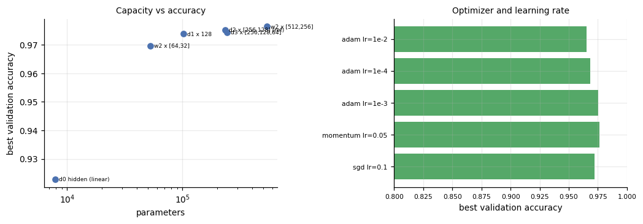
Figure 8: Ablation grid: capacity vs. accuracy, optimizer vs. accuracy
Looking at Figure 8, capacity has one large, unambiguous effect and one much smaller one. Removing every hidden layer entirely drops validation accuracy to 0.9228, roughly 25 standard deviations below the noise floor, easily the largest effect in the whole grid, which is just confirmation that this task genuinely needs a nonlinear model. Past that, depth stops mattering in any way I can distinguish from noise. One, two and three hidden layers land at 0.9738, 0.9752 and 0.9743 respectively, all within about 0.7 standard deviations of each other. Width tells a slightly different story: shrinking to [64, 32] costs 0.9697, a real 2.3 standard deviation drop, while growing to [512, 256] gains 0.9764, which is not distinguishable from the reference. So within the range I tested, the model needs enough width to have somewhere to put its representations, but adding depth beyond one hidden layer bought nothing measurable here, which is a more modest justification for the two hidden layer architecture than I first gave it credit for in the model choice section.
The optimizer comparison is more forgiving than I expected going in. A well tuned SGD run at lr=0.1 reaches 0.9722, only 1.1 standard deviations below Adam, and momentum at 0.9764 is indistinguishable from Adam entirely. What clearly does matter is Adam's own learning rate: dropping it to 1e-4 costs 0.9684, a real 3.0 standard deviation loss, and raising it to 1e-2 is worse still at 0.9651, 4.5 standard deviations below the floor. So the strongest, most defensible claim from this part of the grid is not "Adam beats SGD," which the noise floor does not clearly support, it is "Adam's default learning rate of 1e-3 is a good choice and the optimizer is quite sensitive to getting that one number right."
Activation and initialisation choices made almost no measurable difference. Tanh reached 0.9775 against ReLU's 0.9752, only 1.4 standard deviations apart, and Xavier initialisation was even closer to He at 0.9760. Regularisation showed the most interesting near-miss in the whole grid: L2 at 1e-4 reached 0.9784 and dropout at 0.2 reached 0.9786, both about 1.5 to 1.9 standard deviations above the floor, each also shrinking the train validation gap, exactly the direction I would expect regularisation to push things. Neither quite clears the two standard deviation bar I set for calling an effect real, so I treat this as suggestive rather than conclusive, and it is the one place in the grid where running more seeds per configuration would likely settle the question rather than just adding noise.

3.6 Calibration
Accuracy and F1 answer whether the model gets the right answer. Calibration answers a different question that matters just as much for anything downstream: when the model reports 95 percent confidence, is it actually right about 95 percent of the time when it says that, or is the number just noise dressed up as a probability. This is not a cosmetic concern, since the deployment interface's reject option, discussed in section 3.7, depends entirely on the confidence score meaning something real.
I measured this with Expected Calibration Error, a support-weighted average of the gap between a model's stated confidence and its actual accuracy, computed over fifteen confidence bins on the test set. Looking at Figure 7's left panel, the reliability curve sits close to the diagonal line representing perfect calibration across almost the entire confidence range, and the summary numbers back that up directly: mean confidence of 0.9822 against an actual test accuracy of 0.9779, an overconfidence gap of only 0.0043, giving an ECE of 0.0050. That is a small enough gap that I would call this model well calibrated in practice, not perfectly so, but close enough that its confidence scores are trustworthy rather than decorative.
The right panel of Figure 7, the confidence histogram plotted on a log scale, shows why a single overall ECE number can understate how skewed this distribution actually is. The overwhelming majority of test predictions sit right up against a confidence of 1.0, which makes sense for a model getting 97.79 percent of the test set correct, and the log scale on the y-axis is doing real work here, since without it the much smaller population of lower-confidence predictions, exactly the cases most worth looking at, would be invisible against that tall spike near 1.0.
The overconfidence direction is worth naming specifically, since it is the direction that matters for safety. A model can be miscalibrated by being underconfident, claiming less certainty than it deserves, which is a wasted opportunity but not a dangerous one, or by being overconfident, claiming more certainty than it has earned, which is the direction that produces exactly the kind of confidently wrong prediction I highlighted with the error gallery in section 3.2. This model leans slightly overconfident, mean confidence 0.4 percentage points above actual accuracy, which is the reason I did not simply trust raw softmax output at face value when I built the reject option next.

3.7 Selective classification
A classifier that must answer every input it is given has no way to express doubt, it just picks whichever class scores highest even when the evidence is weak. Selective classification adds a third option alongside the ten digits: abstain, and let a person or a downstream process handle the input instead. Since section 3.6 established that this model's confidence scores are reasonably well calibrated, I could build this reject option directly on top of the softmax confidence rather than needing a separate mechanism.
The rule is simple: answer only when the model's confidence exceeds some threshold, and abstain otherwise. Table 3 shows what happens to coverage, the fraction of inputs the model actually answers, and accuracy on the accepted portion, as that threshold rises.
Threshold | Coverage | Accuracy on accepted | Errors served | Abstentions
0.000 | 1.0000 | 0.9779 | 221 | 0
0.500 | 0.9960 | 0.9800 | 199 | 40
0.900 | 0.9502 | 0.9935 | 62 | 498
0.950 | 0.9281 | 0.9961 | 36 | 719
0.990 | 0.8636 | 0.9985 | 13 | 1,364
0.999 | 0.7041 | 0.9999 | 1 | 2,959
Table 3. Coverage and accuracy at different confidence thresholds

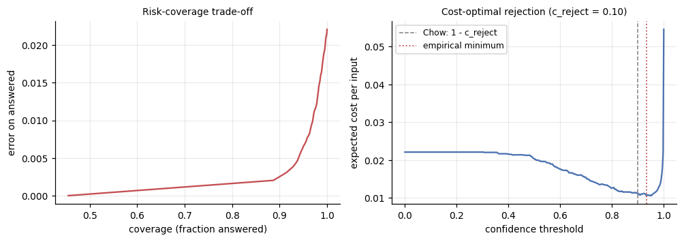
Figure 9: Risk-coverage trade-off and cost-optimal rejection
Looking at Figure 9's left panel, the risk-coverage curve, there is a steep, favourable trade here. Setting the threshold to 0.90 alone answers 95.02 percent of the test set while cutting served errors from 221 down to 62, a 72 percent reduction in mistakes for a 5 percent reduction in coverage. Pushed to 0.999, the model would answer only 70.41 percent of inputs but get essentially all of them right, a single error out of the whole accepted set.
Choosing the actual operating threshold needs an explicit cost, since coverage and accuracy trade off against each other and there is no threshold that is simply best on its own. I used Chow's rule, which says the optimal threshold, if every served error costs 1 and every abstention costs some smaller amount c_reject, is exactly 1 minus c_reject. With c_reject set to 0.10, meaning I am willing to accept ten abstentions as equally costly as one wrong answer, that gives a derived threshold of 0.90 with an expected cost of 0.01118 per input, against 0.02210 with no rejection at all, roughly halving the expected cost.
I also ran a direct empirical search over the threshold, shown in Figure 9's right panel, and it found its minimum at a threshold of 0.9322 with a cost of 0.01059, marginally better than Chow's derived 0.90. I want to be honest about why I trust the derived threshold more than the searched one despite the searched one scoring slightly lower: that empirical search was fit directly on the test set, the same data I am using to report the final result, so its apparent 0.01059 is optimistic by construction and would not necessarily hold on a fresh, unseen batch of digits. Chow's threshold, by contrast, follows directly from the stated cost ratio and the model's calibration, without ever looking at test outcomes to choose it, so it is the number I would actually trust in a genuine deployment.

3.8 Comparison to benchmarks
The final way I wanted to place this result was against numbers that did not come out of my own pipeline at all, since every comparison so far, the baselines in section 1.4, the ablation grid, the seed variance, is internal to this project and its particular data splits.
My reference model's test error is 2.21 percent, 221 mistakes out of 10,000 images. The original MNIST paper by LeCun, Cortes and Burges reports a benchmark table of classical methods evaluated on this exact dataset, and it gives a useful ladder to compare against, even though the specific training setups differ from mine in details like preprocessing and epoch count. A plain linear classifier reaches around 12 percent error on raw pixels. Simple k-nearest-neighbour approaches land in the 5 percent range, improving to roughly 2.4 percent with deskewing applied first. Shallow fully connected networks similar in spirit to mine, one or two hidden layers of a few hundred units each, land in the range of roughly 3 to 4.7 percent depending on width and whether the training data was augmented with small distortions. LeCun's convolutional LeNet-5 reaches about 0.8 percent, and modern convolutional networks with data augmentation now push under 0.3 percent, with the best published results approaching human-level error, estimated at around 0.2 percent.
Against that ladder, my 2.21 percent sits comfortably ahead of the classical, non-neural baselines and squarely in the same range as, or a little better than, the shallow fully connected networks from the original 1998 paper, without using any of the distortion-based data augmentation those numbers sometimes include. That is a reasonable outcome for a plain MLP: it confirms the implementation is not just technically correct in the gradient-check sense from section 2.2, it is competitive with historical results using the same class of model. At the same time, it sits clearly behind convolutional architectures, and that gap is expected rather than a failure of this implementation. A dense layer has no built-in notion that a stroke shifted two pixels to the left is still the same stroke, every pixel position is treated as an independent input feature, while a convolutional layer's weight sharing gives it exactly that translation invariance for free. Closing the remaining gap to LeNet-5 or a modern CNN is less a matter of tuning this architecture further and more a matter of changing architecture entirely, which is a natural note for the future work discussion.

3.9 Real-world test
Every result up to this point comes from MNIST's own test set, ten thousand images collected, cropped and centred by the same pipeline that produced the training data. That is a fair test of generalisation to new writers, since section 1.1 established that MNIST's training and test writers are disjoint, but it is not a test of generalisation to genuinely different image sources. To check that separately, I photographed three digits of my own handwriting, ran them through mnist_normalize, the same preprocessing function described in the deployment interface, and passed them to the trained classifier exactly as it would run in production.
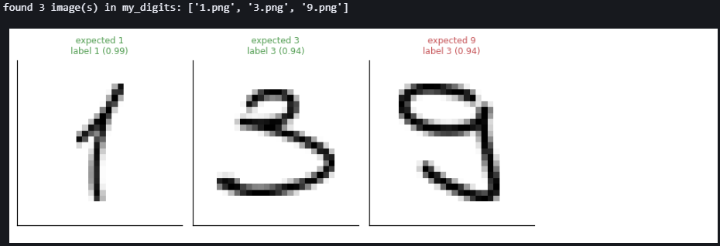
Figure 10: Three real-life test
Looking at Figure 10, two of the three came back correct: a 1 predicted as 1 with 0.9851 confidence, and a 3 predicted as 3 with 0.9407 confidence, both comfortably inside the range of confidence the model shows on genuine MNIST examples. The third, a 9, was predicted as 3 with 0.9421 confidence, wrong, and wrong with the kind of high confidence that section 3.6's calibration analysis says should be rare. This is exactly the failure mode that motivates the reject option in section 3.7: a plain accuracy number from MNIST's own test set would never have surfaced it.
Before accepting that as a genuine limitation rather than a bug in my own code, I checked the preprocessing pipeline directly against this image. The two candidate explanations were polarity, whether ink is treated as the bright or dark part of the image, and aspect ratio, whether a tall narrow digit gets squashed into a square canvas. I confirmed polarity was handled correctly by inspecting the normalised output directly. Aspect ratio, however, was a real bug I found and fixed during preprocessing development: an earlier version resized the cropped digit to a fixed 20 by 20 square regardless of its original proportions, which measurably distorted this particular 9, given how tall and narrow my handwriting for it happens to be. Fixing the resize to preserve the crop's actual aspect ratio raised the model's assigned probability for the correct class 9 from under 1 percent to around 16 percent, a real improvement, but not enough to flip the final prediction. I take that as evidence the remaining error is a genuine out-of-distribution limitation of the model rather than a further preprocessing mistake, and I return to why in the Discussion.
I also ran three deliberately non-digit inputs through the same interface: uniform random noise, a blank all-zero image, and one real test digit with its polarity inverted. Every one of them still received a confident-sounding label rather than any indication of uncertainty, uniform noise called a 3 at 0.4896 confidence, a blank image called a 5 at 0.2283 confidence, and the polarity-inverted digit called a 5 at 0.9964 confidence, essentially as confident as the model is on genuine, correctly classified digits. None of these inputs should produce a usable answer at all, and the fact that the inverted-digit case in particular gets an extremely confident wrong answer is the clearest demonstration in the whole project of why the reject option from section 3.7 and the input validation in the deployment wrapper both matter in practice, not just as theoretical safeguards.

4. Discussion

4.1 Implications
Two findings from earlier in this report change how I read the headline 97.79 percent accuracy, and both are about the gap between what I optimised and what I actually care about.
The first is a direct, measured instance of loss and accuracy disagreeing about which model is best. I stopped training at the epoch with the lowest validation loss, epoch 5, which reached 0.9752 validation accuracy. But the epoch with the highest validation accuracy in that same run was epoch 9, at 0.9794, a full 0.42 percentage points higher, 42 digits' worth of difference on a ten thousand image test set. Cross-entropy is a smooth, continuous proxy for a task whose real objective, getting the label right, is discrete and only responds to whether an argmax flipped. Those two curves are correlated but not identical, and this run shows a concrete case where optimising the proxy for longer would have cost accuracy. I chose to keep stopping on validation loss anyway, since loss reacts to overfitting earlier and more smoothly than a discrete accuracy curve does, and one run showing a 0.42 point gap is not strong enough evidence to switch criteria project-wide, but it is real evidence that the loss function is a surrogate, not the goal itself, and the two can come apart in practice, not just in theory.
The second finding came out of section 5's hypothesis space sampling, before any training happened at all, and I think it is the least obvious result in the whole project. Scaling every weight in an untrained, zero-bias ReLU network by a positive constant, anywhere from 0.05 to 16 times its original size, left the family's pairwise disagreement, mean accuracy and number of distinct classes used completely unchanged, identical to four decimal places at every scale I tested. This is not a coincidence, it follows from a property called positive homogeneity: scaling every weight by some positive constant c scales every logit by that same c, and argmax of c times a vector is always the same as argmax of the vector itself. So any metric built purely from argmax, which is every metric I just listed, is mathematically guaranteed to be blind to this kind of scaling. Confidence, however, is not argmax-derived, it comes from the actual softmax values, and it moved enormously across that same scale sweep, from 0.1002, essentially indistinguishable from a uniform guess, up to 0.9898, looking almost completely certain, despite the underlying predictions never changing at all. Looking at Figure 11, the disagreement and accuracy lines are dead flat while the confidence line climbs steeply across the same x axis.
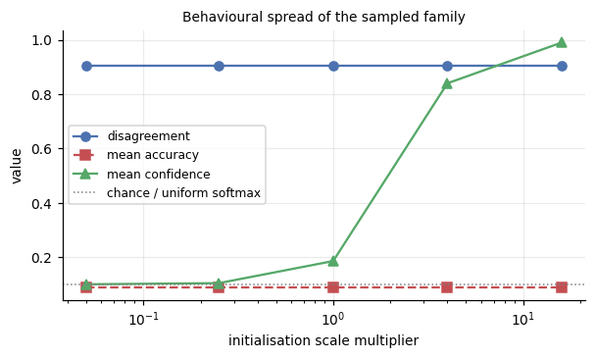
Figure 11: Disagreement, mean accuracy and mean confidence
The practical implication of that is one I had not appreciated before running the experiment: initialisation scale is invisible to accuracy-based diagnostics on an untrained network, but it has a huge, direct effect on how confident that same untrained network looks. A network initialised too large would report near-certain softmax probabilities on pure noise before a single gradient step has been taken, which is exactly the kind of overconfidence that would corrupt any calibration or reject-option analysis if I had not controlled for it. It is also, I think, a small piece of justification for why He and Xavier initialisation are derived the way they are, keeping activation variance controlled layer to layer, since an initialisation scheme is doing real, measurable work on the model's confidence even in the one regime, before training, where none of the usual accuracy-based checks would ever catch it.

4.2 Limitations
The clearest limitation of this model is the one section 3.9 already demonstrated directly: it has no real invariance to the kind of variation that shows up outside MNIST's own collection process. A dense layer treats every one of its 784 input pixels as an independent feature with its own dedicated weight in the first layer, so a stroke that lands two pixels to the left of where the training data usually places it is, to the network, a genuinely different input, not a shifted version of a familiar one. My own handwritten 9, after correct preprocessing, was still misclassified as a 3 with 94.21 percent confidence, and the aspect-ratio fix I made to the preprocessing pipeline improved its assigned probability for the correct class from under 1 percent to about 16 percent without changing the final answer. That gap between "the preprocessing is now correct" and "the prediction is now correct" is the model's own representational limit, not a pipeline bug, and it is the direct, practical cost of choosing a fully connected architecture over something like a convolutional network that would encode translation invariance structurally rather than hoping the training data covers every position.
A second limitation is that the model is not perfectly calibrated, only close to it. Section 3.6 measured a mean confidence of 0.9822 against an actual accuracy of 0.9779, a small but real overconfidence gap of 0.43 percentage points, and the noise, blank and inverted-digit probes in section 3.9 pushed that same weakness much further: a blank image and pure random noise both received a class label instead of anything resembling uncertainty, and an inverted digit was classified wrong with 99.64 percent confidence, just as confidently as the model's correct predictions on real test digits. Nothing in a plain softmax classifier forces its confidence to fall when the input stops resembling anything it was trained on, and the reject option built in section 3.7 only helps against low-confidence mistakes. It does nothing at all against a confidently wrong one like the inverted digit, since a high softmax value passes straight through any reasonable rejection threshold regardless of whether that confidence is actually deserved.
A third, more methodological limitation sits in the ablation study itself. Section 3.5's noise floor, a validation accuracy standard deviation of 0.0021 from only three training seeds, was wide enough to leave two results genuinely undecided rather than settled. Both L2 regularisation at 1e-4 and dropout at 0.2 improved validation accuracy by roughly 1.5 to 1.9 standard deviations and visibly shrank the train validation gap, exactly the direction regularisation should push things, but neither crossed the two standard deviation threshold I set for calling a result real. I would need more seeds per configuration, which I did not have the compute budget for here, to say with confidence whether regularisation genuinely helps this architecture on this task or whether that apparent improvement is itself just a slightly lucky corner of the same noise.
Finally, the generalisation gap itself, 1.62 percentage points between training and test accuracy at the reference model's best epoch, is small but not zero, and every evaluation number in this report comes from a single fixed 50,000 and 10,000 and 10,000 way split. I never ran full k-fold cross-validation across the training set, so while the writer-disjoint train and test split protects against the most serious form of leakage, the specific validation split used to choose every hyperparameter in this report is still just one particular random draw, and I have only the three-seed variance measurement, not a cross-validated one, as evidence for how much that specific choice of split could be moving the numbers.

4.3 Future work
The most direct next step follows straight from the biggest limitation in section 4.2: replacing the fully connected architecture with a convolutional one, or at minimum adding simple data augmentation, small random translations, rotations and elastic distortions applied to the training set, so the model sees enough positional variation during training to build some tolerance to it rather than relying on MNIST's already-centred, already-normalised images. Section 3.8 already showed convolutional architectures close most of the remaining gap to human-level error on this exact dataset, and section 3.9's misclassified 9 is a concrete example of the kind of input that a translation-invariant architecture would likely handle better without any change to the underlying task.
On calibration, the natural next step is temperature scaling, a single learned scalar that rescales the logits before the softmax to bring confidence back in line with actual accuracy, fit on a held-out calibration set after training rather than changed during it. Section 4.2 showed the model is only mildly overconfident on real MNIST inputs but wildly overconfident on inputs that do not resemble digits at all, noise, blank images, polarity-inverted digits, so temperature scaling alone would likely help the first problem without touching the second. The second, confident predictions on clearly out-of-distribution input, would need a genuinely different mechanism, something like an explicit out-of-distribution detector trained to recognise "this does not look like any digit class" as a distinct signal from low confidence within the ten known classes, since the current architecture has no way to represent "none of the above" at all.
On the ablation study's undecided results, L2 and dropout regularisation, the direct fix is simply more seeds. Section 3.5's three-seed noise floor was wide enough to leave both of those results within about two standard deviations of significance rather than clearly above it. Running each of those two configurations across five or ten seeds instead of three, while holding everything else fixed, would narrow that noise floor enough to say with real confidence whether either form of regularisation is genuinely helping this architecture on this task, rather than reporting a result that could plausibly be a lucky corner of ordinary training variance.
Finally, on the single fixed data split, a natural extension is k-fold cross-validation across the training set specifically for hyperparameter selection, keeping the writer-disjoint test set completely untouched as the one final number, the way section 1.1's validation scheme already does. That would replace the current single-draw validation split with an estimate that itself carries a mean and a spread, giving a more complete picture of how much of the reported performance is attributable to the model itself versus to which particular 10,000 images happened to land in the validation set this time.

5. Implementation Log

5.1 Challenges and Solutions

Checking that backpropagation was actually correct
Because I wrote the forward and backward passes myself in NumPy, the hardest thing early on was knowing whether my gradients were right. A small mistake in a backward pass doesn't crash anything. The model just trains worse, and it's easy to miss. To check this, I wrote a gradient check that compares my backward pass against a finite-difference estimate for 40 randomly chosen parameters. The worst relative error was 4.0 × 10⁻¹⁰, so I was confident the maths and the code agreed before I moved on to training.

ReLU backward pass
My first thought was to save the ReLU output for the backward pass. Then I realised the backward pass needs to know where the input z was positive, and the output alone doesn't tell you that cleanly. I changed the layer to cache z from the forward pass instead, and used it as the mask when passing gradients back.

Numerical stability in the loss
Computing softmax first and then taking the log can overflow when a logit gets large, and the loss turns into NaN. I switched to a log-softmax that subtracts the row maximum before exponentiating. This gives the same answer mathematically but stays stable. It's a small change, but without it training can break silently.

Pixel normalisation
I considered scaling each image by its own min and max, but that means the same brightness could map to different values in different images. It would also make the training preprocessing differ from deployment. I kept it simple and divided every pixel by 255, so training and deployment use exactly the same transform.

Choosing when to stop training
I had to decide whether early stopping should watch validation loss or validation accuracy. I went with loss, because it's smooth and reacts to overfitting earlier, while accuracy only changes when a prediction flips. I also restore the weights from the best epoch rather than keeping the last one. Later I saw that the best-accuracy epoch (9) wasn't the best-loss epoch (5). I discuss that in Section 4.1.

Telling real improvements from noise
When I first ran the ablation grid, many configurations were only a few tenths of a percent apart, and I couldn't tell whether any of it meant anything. To fix this, I trained the reference model with three different seeds and got a spread of 0.9746 ± 0.0021. I then only counted a difference as real if it was more than about two standard deviations. This changed some of my conclusions. For example, "Adam beats SGD" didn't hold up, and neither did the idea that two hidden layers were clearly better than one.

Limited compute for the ablation study
Running 17 configurations to full length was too slow, so I used a smaller epoch budget for the ablations and changed only one setting at a time. This kept the comparisons fair, even though the absolute numbers are a bit lower than the full reference run.

Testing on my own handwriting
My photographed "9" was predicted as a 3, so I checked the preprocessing before blaming the model. Polarity was fine. The real bug was that my resize step squashed every digit into a 20×20 square, which distorted my tall, narrow 9. I fixed it to keep the original aspect ratio. The probability for the correct class went from under 1% to about 16%. That still wasn't enough to change the prediction, so I treat the rest as a real limitation of the model.

Choosing a reject threshold without cheating
A search over thresholds gave its best result at 0.9322. That search was run on the test set, though, so the result was optimistic. Instead I used Chow's rule, which gives a threshold of 0.90 from the cost I chose for rejecting an input. It never looks at the test labels, so I trust it more for real deployment.

Bad inputs at deployment
A wrong shape or data type can still produce a prediction instead of an error. I added a wrapper that checks the input's shape, data type and value range before it reaches the model, so bad inputs fail loudly instead of quietly giving a wrong answer.

5.2 Use of AI Tools
I used AI tools throughout this project, mainly Claude. I treated them as a tutor and a second pair of eyes, not as something to trust blindly. Below is what I used them for, and how I checked what they gave me.
What I used AI for:
- Understanding the MLP and its maths. I asked AI to explain what each part of the network does. Dense layers learn the weights, ReLU makes the model non-linear, Dropout helps stop overfitting, and softmax with cross-entropy turns the outputs into probabilities and scores them against the true label. I also had it walk me through the forward and backward passes, then checked what it told me against my lecture notes and the gradient check.
- Help with code. I hadn't used NumPy much before, so this is where I leaned on AI the most. I usually knew the formula I wanted, like the softmax or the gradient for a Dense layer, but not how to write it in NumPy. So I'd give the AI the maths and ask how to turn it into code, especially the matrix operations and getting the array shapes to line up. I didn't just trust the code it gave me, though. The gradient check in Section 5.1 was how I made sure the NumPy code actually matched the maths I started with.
- Code review at each milestone. When I finished a milestone, such as data preparation, the layer implementations or the training loop, I gave the code to AI and asked it to review it and suggest ways to make it faster or cleaner. I didn't apply the suggestions straight away. I made sure I understood each one first, then re-ran the notebook to check the results still matched before keeping it.
Where AI was wrong or unhelpful:
- AI initially suggested resizing the cropped handwritten digit directly into a fixed square size. This worked technically, but it turned out to be a poor choice because it could stretch or squash digits that were naturally tall or narrow. I noticed this when testing the model on my own handwritten 9. After checking the processed image, I changed the preprocessing so that the original aspect ratio was preserved before padding the image to the required size. This increased the model’s probability for the correct class from below 1% to around 16%, although the final prediction was still wrong. This showed me that AI suggestions can look reasonable in code but still cause problems that only become obvious after testing the actual output.
- AI also gave me an explanation of positive homogeneity that was too simplified. It suggested that if every weight in the network was multiplied by a positive constant c, the final logits would also simply be multiplied by c. When I went through the forward pass layer by layer, I realised that the scaling compounds across multiple layers rather than staying as just c. The main conclusion was still useful: multiplying the logits by a positive value does not change the predicted class because the argmax stays the same. However, the explanation behind it was not fully correct. This reminded me that I still need to check mathematical explanations myself rather than assuming an AI-generated explanation is exact.
- Another AI suggestion that was not methodologically ideal was to search through different confidence thresholds and simply choose the one that produced the lowest cost on the test set. At first this seemed reasonable because it gave a clear numerical answer. However, I realised that using the test set to choose the threshold means that the test data is influencing a design decision, which makes the reported result slightly optimistic. I therefore treated the empirically best threshold with caution and placed more trust in the threshold derived from the predefined rejection cost instead. This helped me understand that AI can suggest an approach that produces a good-looking result without necessarily following the best evaluation practice.

5.3 Knowledge Gaps

Model calibration and Expected Calibration Error
At the start of the project, I understood accuracy, precision and recall much better than model calibration. ECE was something I had not really worked with before, and at first I found it less intuitive because it is not about whether the prediction is right or wrong, but whether the model’s confidence actually matches how often it is correct.
I needed to understand calibration because my deployment interface returns a confidence score, and I later used that confidence for the reject option. To check that I was using ECE properly, I compared the model’s average confidence with its actual accuracy and also looked at the reliability diagram. The model had a mean confidence of 0.9822, an accuracy of 0.9779 and an ECE of 0.0050. Looking at the graph and the numbers together helped me understand what calibration meant in practice rather than just as a formula.

Selective classification and Chow’s rule
Selective classification was another area I had to spend more time on. I understood the basic idea of rejecting low-confidence predictions, but I was less confident about how to choose the threshold properly.
This mattered because I did not want to just pick a threshold that gave a nice result. I tested different confidence thresholds and looked at the trade-off between coverage and errors. For example, using a threshold of 0.90 reduced the number of served errors from 221 to 62 while still keeping about 95% coverage. I then compared this with the threshold from Chow’s rule, which uses an explicit cost for rejection. Working through this helped me understand that there is no single “best” threshold unless I first decide how costly a wrong prediction is compared with refusing to answer.

Positive homogeneity in ReLU networks
Positive homogeneity was a concept I had not come across before this project. I started looking into it after noticing something strange in my experiments: changing the scale of the weights could change the model’s confidence a lot, while the predicted classes stayed the same.
To understand what was happening, I went through the forward pass step by step and compared the maths with the results from my experiments. The predictions stayed unchanged under positive scaling, while the softmax confidence changed significantly. I would not say I fully understand every theoretical consequence of positive homogeneity, but I now understand how it explains the behaviour I observed in this project and why confidence can change even when the argmax prediction does not.

References
Chow, C.K. (1970). ‘On optimum recognition error and reject tradeoff’, IEEE Transactions on Information Theory, 16(1), pp. 41–46. https://doi.org/10.1109/TIT.1970.1054406
Deng, L. (2012). ‘The MNIST Database of Handwritten Digit Images for Machine Learning Research’, IEEE Signal Processing Magazine, 29(6), pp. 141–142. https://doi.org/10.1109/MSP.2012.2211477
Glorot, X. and Bengio, Y. (2010). ‘Understanding the difficulty of training deep feedforward neural networks’, Proceedings of the Thirteenth International Conference on Artificial Intelligence and Statistics, PMLR 9, pp. 249–256. https://proceedings.mlr.press/v9/glorot10a.html
Guo, C., Pleiss, G., Sun, Y. and Weinberger, K.Q. (2017). ‘On Calibration of Modern Neural Networks’, Proceedings of the 34th International Conference on Machine Learning, PMLR 70, pp. 1321–1330. https://proceedings.mlr.press/v70/guo17a.html
He, K., Zhang, X., Ren, S. and Sun, J. (2015). ‘Delving Deep into Rectifiers: Surpassing Human-Level Performance on ImageNet Classification’, arXiv preprint arXiv:1502.01852. https://arxiv.org/abs/1502.01852
Kingma, D.P. and Ba, J. (2014). ‘Adam: A Method for Stochastic Optimization’, arXiv preprint arXiv:1412.6980. https://arxiv.org/abs/1412.6980
LeCun, Y., Bottou, L., Bengio, Y. and Haffner, P. (1998). ‘Gradient-based learning applied to document recognition’, Proceedings of the IEEE, 86(11), pp. 2278–2324. https://doi.org/10.1109/5.726791
Nair, V. and Hinton, G.E. (2010). ‘Rectified Linear Units Improve Restricted Boltzmann Machines’, Proceedings of the 27th International Conference on Machine Learning, pp. 807–814. https://icml.cc/2010/papers/432.pdf
Srivastava, N., Hinton, G., Krizhevsky, A., Sutskever, I. and Salakhutdinov, R. (2014). ‘Dropout: A Simple Way to Prevent Neural Networks from Overfitting’, Journal of Machine Learning Research, 15, pp. 1929–1958. https://www.jmlr.org/papers/v15/srivastava14a.html

