**Adaptive Position Control of a Levitating Ball**

Course Project - Project Description

ELG7113 - Machine Learning for Adaptive and Intelligent Control Systems

By

Derek Boase, Clive Plante, Alfa Budiman and Zeinab Keserwan

Department of Electrical Engineering

Faculty of Engineering

University of Ottawa

27 Feb 2022

System Description

*“Each group has to submit a short report describing the system selected for the project, and a preliminary description of the type of analysis that is going to be conducted. Feedback will be given.”*

The system consists of a ball in a vertical tube. The ball’s position can be controlled by a fan. This is show in Figure 1. The input to the system is the desired vertical position, with the output being the ball’s actual position, . The system will convert the desired position into a control signal to adjust the duty cycle and fan speed. Changing the fan speed will adjust the force balance, resulting in a net force either up or down, accelerating the ball. This is the method in which the ball’s position is controlled.

Figure 1 - Schematic

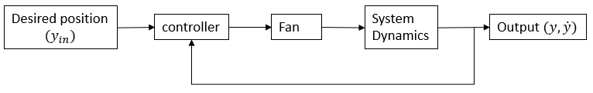

Figure 2 - System Diagram

Problem Formulation

The system is nonlinear because ….

#Something something about regular PID controller not working well

#Something something linearize around a set point is not a generalized solution for all points on the system

Dynamic Model

The dynamics of ball are described in [1]. This model consists of a force balance between the drag force, buoyance force and gravity force. From this model, the acceleration can be calculated and then used to estimate the ball’s position and velocity. The estimated position and velocity can be compared to the actual values as well as the desired velocity.

#insert equations and math stuff here

Work Plan

The overall plan is to model the system and implement multiple adaptive control structures, comparing their performance to each other as well as a baseline set of responses from a previous implementation of this project.

1 - Model the dynamics of our system in accordance with the literature and implement control strategies from the linearized model (i.e. empirical tuning and gain scheduling)

2 - Perform parameter estimation on the model to increase the correlation of the constantly updating model and the physical output.

3 - Perform system identification on the physical system with the purpose of control

4 - Implement multiple adaptive control structures (example: model reference control, model-free control, self-tuning regulator).

5 - Compare the performance of the implemented control structures

Performance metrics include overshoot, settling time, ….

Bibliography

[1] A. Tootchi, S. Amirkhani, and A. Chaibakhsh, “Modeling and Control of an Air Levitation Ball and Pipe Laboratory Setup,” in *2019 7th International Conference on Robotics and Mechatronics (ICRoM)*, Tehran, Iran, Nov. 2019, pp. 29–34. doi: 10.1109/ICRoM48714.2019.9071827.